  LOCATION Swansea | LLEOLIAD abertawe
LEVEL 4 | LEFEL 4
EXAMINATION PERIOD | CYFNOD ARHOLIADAU
Jan 2025 | Ionawr 2025

MODULE CODE: ACCA4022
COMPUTER ARCHITECTURE and OPERATING SYSTEMS

MARKING SHEME

ANSWER ALL FOUR QUESTIONS

QUESTION ONE (35 marks total)

Attempt all of the following. Electronic Calculators are not permitted. Write down and show all your manual calculations in your exam book.

a) Convert the following decimal numbers to Binary (3 marks each)

- 81 01010001
- 123 01111011

b) Convert the following binary numbers to base 10 (3 marks each)

- 11011101 221
- 10010 18

c) Convert the following hex numbers to binary (2 marks each)

- 6A 01101010
- 3C 00111100

d) Convert the following Hex numbers to decimal (3 marks each)

- B3 179
- 4C 76

e) How many different/unique values can be represented by a 4 bit number? (3 marks)

2^4 = 16

f) You are required to calculate the file size of a full colour graphic image of dimensions 200*300 pixels where each pixel can be one of 16 million colours. Calculate:
i) The file size if you saved it in an uncompressed .BMP format (5 marks)
ii) The file size if you saved it as a JPG with a compression ratio of 10:1 (2marks)

Ans = Total number of pixels = 200*300 = 60000
16 million colours in RGB BMP = 3 bytes per pixel
I.e. total storage for .BMP = 60000*3 = 180000 bytes or 180KB

For the JPG, the size will be /10 = 18KB

g) Approximately how long it would take to upload a 200MB file if you were using an internet link with a 80Mb/s transfer speed (3 marks)

80Mb/s = 10MB/s (divide by 8)

So a 200MB file will take:
200/10 = 20sec

QUESTION TWO (20 marks total)

- Sketch a typical block diagram that depicts the Harvard computer architecture. Ensure you name/identify all items in your diagram. (10 marks)
5 marks for each correctly identified block
5 marks for the overall layout
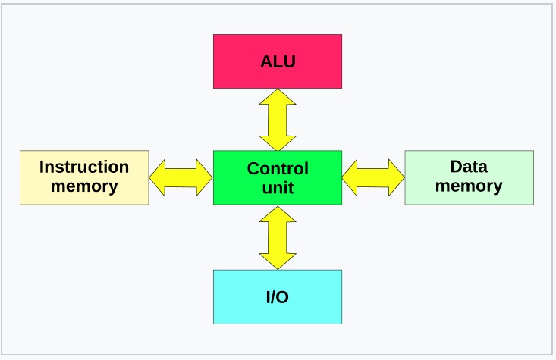

- What is Cache when referred to in the context of a CPU? Also briefly explain its purpose and how it achieves this (10 marks)
Answer to include a description of how the CPU needs to slow down (wait states) when accessing main RAM, therefore frequently accessed, or burst accessed data is stored in local (on chip) high speed cache RAM. 10 marks

QUESTION THREE (20 marks total)

- Quote typical data capacities for the following devices: (2 marks each)
i) A writeable BluRay optical disk 25GB (SL)
ii) A typical £80 rotating Hard Disk in a desktop computer approx. 2-4TB
iii) A £100 M.2 SSD 1-2TB

- Quote typical data transfer rates for the following: (2 marks each)
- Modern, high specification M.2 NVME sticks 2000-7000MB/s
ii) An average rotating Hard Disk 100MB/s
iii) A SATA SSD 500MB/s

- What does the term DHCP stand for in a local area network context? Explain its purpose. (8 marks)
DHCP stands for Dynamic Host Configuration Protocol. (4 marks)

In a local area network (LAN) context, DHCP serves the following key purpose:
Automatic IP address assignment: DHCP automatically assigns IP addresses to devices when they connect to the network, eliminating the need for manual configuration (4 marks)

QUESTION FOUR (25 marks total)

Produce a typical, cost effective specification for a medium specification PC aimed predominantly at gaming but will be also used for simple tasks such as word processing, accounts, email and surfing the net. The only potentially out of the ordinary function is that the computer needs to connect to a modern 42” living room television and will be required to be able to watch full HD movies on both purchased disks as well as from streamed internet sources.
Produce a specification with as a minimum, detail on:
- A suitable CPU
- What is a sensible amount of RAM
- What type and size of non-volatile storage would be suitable
- The input/output features/ports needed
- The features a suitable graphics card would require.
For all of the above areas, you should justify your choice with reasoning and where possible, explain why you chose that particular option, over the alternatives.

5 marks per section

Example answer:

CPU
A suitable CPU for this build would be an Intel Core i5-12600K or AMD Ryzen 5 5600X. These processors offer excellent gaming performance and can handle multitasking for everyday tasks
1 The Intel option provides slightly better single-core performance, which is beneficial for gaming, while the AMD chip offers better value and power efficiency

RAM
16GB of DDR4 RAM is a sensible amount for this build. This capacity provides ample memory for gaming and multitasking without being overkill. While 8GB is the minimum for most modern games, 16GB ensures smooth performance and future-proofing
Storage
A combination of a 500GB NVMe SSD and a 2TB HDD would be suitable for this build. The SSD provides fast boot times and quick loading for frequently used games and applications, while the HDD offers ample storage for movies, documents, and less frequently accessed files

This setup balances speed and capacity, providing a good compromise between performance and cost-effectiveness.

Input/Output Features
For connectivity, the PC should include:
HDMI 2.1 port for connecting to the 42" TV
Multiple USB 3.0/3.1 ports for peripherals
Ethernet port for wired internet connection
Wi-Fi and Bluetooth for wireless connectivity
Audio jacks for speakers or headphones
These ports ensure compatibility with various devices and provide options for both wired and wireless connections

Graphics Card
A suitable graphics card for this build would be an NVIDIA GeForce RTX 3060 or AMD Radeon RX 6600 XT. These GPUs offer excellent 1080p gaming performance and can handle 1440p gaming as well

Key features to look for include:
At least 8GB of VRAM for handling modern games
Support for ray tracing and DLSS (for NVIDIA cards) or FSR (for AMD cards)
HDMI 2.1 output for 4K@120Hz support on the TV
Hardware video decoding for smooth playback of HD and 4K content
These mid-range GPUs provide a good balance between performance and cost, allowing for high-quality gaming and smooth video playback on the 42" TV

