Embracing Rurality and Business opportunity
Coursework Project
Gower Fresh Christmas tree farm
Kelly Lewis-Bennett
1907952

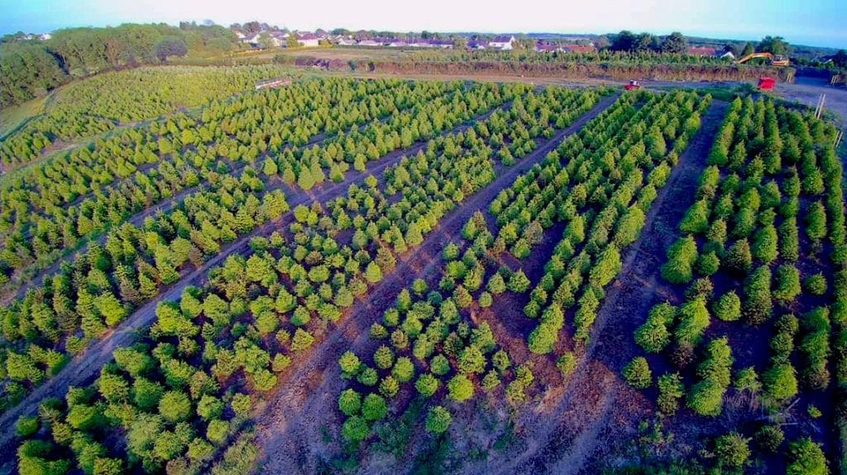

Table of Contents
Front cover………………………………………………………1
Contents…………………………………………………………..2
Executive Summary…………………………………………3
Introduction……………………………………………………..4
Company Background………………………………………..5
Rural Business…………………………………………………….6
Diversifying…………………………………………………………6
Three pillars of Sustainability……………………………..8
Finding a Balance……………………………………………….11
Circular Economy……………………………………………….11
Recommendations……………………………………………..12
Conclusion………………………………………………………….14
References…………………………………………………………..15

Executive summary
This paper explores the rural locality and business opportunities of Gower Christmas tree farm based around the three pillars of sustainability. Included are recommendations based on data gathered from a recent visit to farm and suggest ways in which the business can become more sustainable and environmentally friendly.

Introduction
This paper will explore and critically evaluate Gower Christmas tree farm’s engagement with sustainability through using the three pillars of sustainability framework as a guide. It will also include data gathered from a recent visit based around the three pillars as well as detailed recommendations on how the business can improve in some areas based on the findings. Suggestions will also include recommendations on how the business to become more Circular.

Company Background
Gower Fresh Christmas Trees is run by Robert Morgan, the company which produces over 500,000 Christmas trees on the Gower Peninsula. The family-run farm also has Wales' largest reindeer herd, with over 34 reindeer wandering freely around the farm's 20 acres. Robert began planting trees in 1997 with the help of his father, the late David Morgan. Mr Morgan explains that the first few thousand plants were eaten by rabbits, and the rest were over-fertilized, but they continued to plant and care for the trees until 2006, when they were finally able to sell them. The company specialise in growing only high-quality Christmas trees and are now regarded Wales' largest Christmas tree farmers in 2021. Gower Fresh Trees was named Grower of the Year by the British Christmas Trees Growers Association in 2017 and had the honour of supplying the Prime Minister's Christmas tree, which was proudly displayed outside 10 Downing Street (Gower Christmas tree farm. 2021).
The experience they aim to provide
From the time visitors enter the farm's gates, the company aims to create a fantastic Christmas experience for both children and adults. Whether it's meeting Santa for the first time and believing in him, seeing and feeding the Reindeer in their natural habitat, or the whole family finding that perfect tree among the fields that will be the focal point at home for a lovely and magical Christmas, there's something for everyone. You can also visit the icy kingdom when you arrive to choose your tree (Gower fresh Christmas trees, 2021). The company also provides a breakfast with santa experience.
Personal experience
The following data was gathered from visiting the farm in the run us to Christmas 2021. On arrival the carpark is surrounded by fields of Christmas trees off all different sizes and in the distance a pumpkin field is visible as well as a field growing lavender. Some trees were tagged ready for collection others stood next to a barn waiting to be bought. The average price of a cut Christmas tree is around £45, they also sell small potted Christmas trees at £25. As you enter the barn its a welcoming environment with elves there to greet you as you arrive. Parking at the farm costs £2.50 and entry to the grotto costs adults £7.50 and children’s Wrist bands to the grotto collected at the onsite shop. The farm Busy attraction with people attending to choose and collect their Christmas trees as well as family’s attending for the grotto experience and to see the reindeer. Theres a small kitchen area in the barn selling hot food and drinks and a small pen with baby goats.
Upon entering the snowy kingdom, there are many passages which lead to variety of different themed rooms such as the grinch, frozen, Santa’s toy shop, the arctic filled with 1000s of fairy lights and mechanical props. As you make your way through a various rooms and passages you will come across Father Christmas and have the chance to tell him your Christmas wish, after visiting father Christmas you continue to make your way through the grotto experience until you arrive at a Mrs Christmas’ story room where children receive a gift and find out if they are on the naughty or nice list, children also receive a certificate. Theres also a pen of reindeers inside the grotto as well as another field of reindeer outside. A truly magical experience for any child in the run up to Christmas.
Rural Business
Gower Christmas tree farm is Based at Sunnyside Farm in a rural area of West Glamorgan. It’s a large farm within the small community of Three crosses. To access the farm travel along a narrow winding road surrounded by fields and the small village to the right of the farm. It is suggested that a rural business is one that is based outside of a city, town, or suburb. While agriculture and farming supply businesses make up a significant proportion of rural businesses, the process of rural business growth has inspired many businesses to go to rural areas for the foundations of manufacturing and other sorts of facilities. In some ways, the character of rural business is similar to that of a larger town or a small city (Tatum. M. 2021).
Diversifying
Mr Morgan explained in a recent Wales online interview that due to the challenges of farming, he decided to diversify and try something new, and after being granted a field by his father, he began planting Christmas trees. At first, he described the procedure as a learning curve, but after seven years, he had a field full with Christmas trees of various sizes. Mr Morgans chose to sell the farm's animals, including the sheep dog, due to the tragic circumstances surrounding his father's death, and concentrate on cultivating Christmas trees. He explains that farming is dying on Gower as a result of the low prices farmers receive from supermarkets for their produce, and that society needs to provide more support to farmers in order to help them diversify and improve their businesses, whether it be camp sites or whatever they choose, because the average age of a farmer is around 59, and there is no inspiration for young people to go into farming these days. (Dalling. R. 2021). With the business currently doing so well in the winter months the family is now thinking more creatively and taking advantage of seasonal more opportunities.
Pumpkins
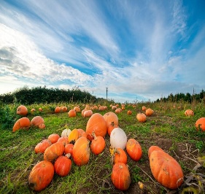
Due of the ever-increasing popularity of Halloween, the company began farming pumpkins this year. They concede that the procedure has been a learning curve because the Pumpkins got off to a sluggish start due to the harsh weather, but they were able to grow hundreds of them in time for Halloween, in a range of sizes and colours, with prices ranging from £1.50 to £7.00 each. (Gower Fresh Christmas trees. 2021). When they opened to the public for “pick your own pumpkins” they were surprised by the response (Gower Fresh Christmas trees. 2021). Similar to the Christmas experience the offer, they also provide a Halloween themed experience with a visit with a witch included.
Reindeer
Wales' largest reindeer herd can also be found on the farm. They currently have 34 reindeer, some of whom have been there for almost 14 years. Our herd is treated as a member of the family and is allowed to roam freely in their 20 acres. They provide the reindeer native moss, which is imported from Scandinavia and which the reindeer adore. The majority of the reindeer were born on the farm and are familiar with the operation. (Gower fresh Christmas tree farm. 2021).
Sunflowers
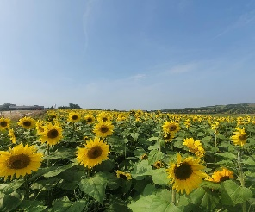
During the summer, the Morgan family grows roughly 8 acres of sunflowers on farmland near the historic Vile in Rhossili. Years ago, the Vile was known for vegetable production, producing some of the best vegetables in the UK; however, as with farming on the Gower, demand has declined, and most of the land is now owned by the National Trust, with the exception of the sunflower fields, which are owned by Robert Morgan of Gower Fresh Christmas trees. In 2020, they will plant their first sunflowers on the land, creating a spectacular sight and a fun day out, in addition to their Food Hut, which will include local vegetables and ingredients. The sunflower fields, according to Mr Morgan, were a huge success in 2020, providing a much-needed break from the covid issue. (Gower fresh Christmas tree farm. 2021).

Three Pillars of sustainability
Three interwoven pillars comprising economic, social, and environmental factors are used in one popular definition of "sustainability." This three-part description is frequently depicted as three overlapping circles of society, environment, and economy, with sustainability at the centre. (Purvis, B., Mao, Y., & Robinson, D. 2019).
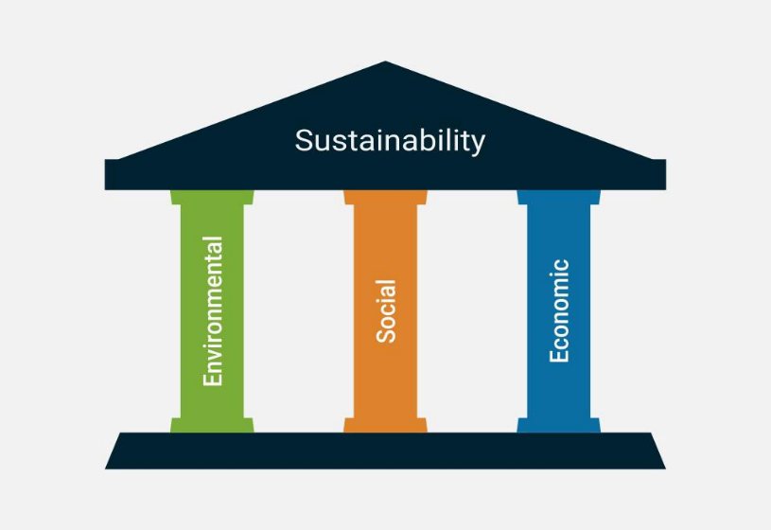

The following data was collected from a recent visit to the farm during one of the seasonal experiences the farm provides. The findings are as follows.
Environmental impact
Carbon footprint
Due to the rural locality of the farm and it being a popular seasonal attraction with many, people are travelling from afar to enjoy the experience it offers. The company also state that reindeer feed is imported from Scandinavia which increases their carbon footprint.
Recycling
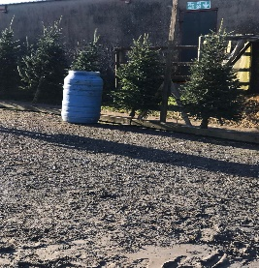
It seems there is no thought with regards to recycling at the farm, instead there are blue rubbish bins dotted around the farm with all kinds of mixed waste such as food, paper and plastic packaging.

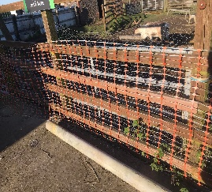
The outdoor reindeer pens had wooden fencing, but it also had plastic fencing attached to them.

Energy consumption
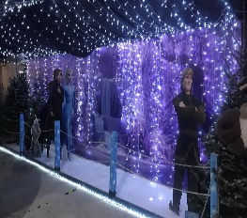
The grotto uses a considerable amount of energy in its different themed room/passages in order to provide the experience it does to the public. Rooms and passages are filled with 1000s of fairy lights, many mechanical props, snow machine According to research, global climate change, often known as global warming or the greenhouse effect, is potentially the most serious environmental concern related to energy use. (Dincer, I., & Rosen, M. A. (1999). Since the dawn of the industrial period, increased usage of fossil fuels has boosted carbon dioxide levels in the atmosphere by 35 percent, as well as the earth's temperature. (Hinrichs, R. A., & Kleinbach, M. H. 2012).
Cafe
The small café at the farm is fuelled by gas. The menu includes Burgers, Bacon rolls, nachos, pizza, hot dogs as well as hot and cold drinks. It is unclear whether some of the food is sourced locally such as the burgers and bacon however other options such as hot dogs, nachos and pizza all seem to be mass produced.
Single use plastic
Many of the grotto’s props were made from single use plastic such as the mechanical Gruffalo tree, the many musical father Christmas’ and unforgetting the singing abominable snowman. The term "single-use plastic" refers to a sort of throwaway plastic object that is only used once. Because single-use plastic was created in this fashion, most consumers threw it away at random, resulting in an accumulation of disposable plastic garbage. Plastic packaging, such as bottles, cups, containers, straws, and other items, is another form of single-use plastic. Furthermore, single-use plastic does not biodegrade and takes a long time to breakdown. Single-use plastics are frequently disposed of in landfills. (Van, L. 2021).
Reindeer feed at the farm is sold in plastic cups and are then thrown away after its use. Throughout the grotto experience there is a considerable number of mechanical props made from single use plastic. Single use plastics normally end up at landfills or in our seas The impacts of this plastic waste on the environment and our health are global and can be devastating (European commission. 2019).
What impact does the cutting and growing of trees have on the environment?
While it is considered environmentally friendly to plant Christmas trees, it is not environmentally friendly to cut them down. It is indicated that trees that are cut off from their roots, also known as use-and-throw, are the least environmentally friendly alternative. (Pritchett. L. 2021). While Gower Christmas tree farm supply cut trees they also offer potted trees which are considered as much more sustainable as they can be re planted and continue to grow, the company also plant one new tree for every tree that’s cut. According to an article in the Guardian, a tree's environmental impact is substantially worse if it ends up in a landfill due to the methane emitted during decomposition. if a tree ends up in landfill the impact on the environment is much worse because of the methane released during decomposition (Wood. Z. 2021).
Every year, millions of Christmas trees end up in landfills; this is a problem because organic matter decomposes anaerobically in landfills, producing methane, a strong greenhouse gas. Fortunately, recycling your Christmas trees has become rather simple, as many local governments now collect cut trees after the holidays (or have a special facility where they can be taken). They can be shredded into chippings and used as a mulch in parks and small woodland areas to protect soil and return nutrients to the system. (Waddington. E. 2019). Trees, woodlands, and forests play an important role in the carbon cycle, serving as a globally significant carbon storage facility that holds more carbon than the atmosphere. This store is in jeopardy: deforestation contributes about a quarter of global greenhouse gas emissions, more than the whole transportation sector. Growing trees sequesters CO2, splits it, and releases oxygen into the atmosphere. When a tree dies or is cut down, the carbon is released and either decays or is burned. Any carbon released, as opposed to fossil carbon (coal, oil, and gas) that was pulled out of circulation millions of years ago, can be considered part of the carbon cycle. (Woodland Trust. 2013)
Is it really sustainable to keep reindeer in this country?
While it is unclear if it is sustainable to keep non-native animals such as reindeer in the Uk, the company states they have to import their food from Scandinavia and therefor it is not able to be locally sourced. This increases their carbon footprint considerably.
Social
Experience - The whole experience the snowy kingdom provides to children is a truly magical and it is obvious to see why it is so popular with families.
Employment
While the farm has some full-time staff working at the farm, many of the employees such as the actors and actresses in the snowy kingdom are seasonal workers. One of the disadvantages of seasonal employment, according to some, is that they make it difficult to keep a stable job. This implies you may only be able to work three months out of the year during the summer. For people who desire to keep a stable work schedule or compensation, this can be difficult. Seasonal workers are also frequently trapped in poverty because they do not earn enough money during the season and rely on government help to make up for it during the off-season. (MyAyan. 2021).
Groups they support -Following his father's death, Mr Morgan became involved with the DPJ Foundation to help those in the agricultural sector who are suffering from mental illness. He also provides advice on farm-related stress to a mental health organisation in Swansea (Dalling. R. 2021).
Economic
All events such as the snowy kingdom experience and breakfast with Santa in the run up to Christmas sell out and everything costs money at the farm from parking at the farm, the grotto experience and feeding the reindeer to even walking in the Christmas tree fields. The company also provide a Halloween experience where children can visit a witch as well as the pick your own pumpkin experience. Although the business is profitable during the winter months it is essential that they further diversify in order to be financially viable throughout the year.
Finding a balance
It is crucial that the company tries to find a better solution in terms of balancing the environmental impact it creates by ensuring the farm is more environmentally friendly. It seems that some farmers today are so worried about the challenges they face in the farming industry that they are diversifying at the cost of the environment and jeopardising the health and needs of the future generations for their own financial gain, therefore it is clear that there is a need for extra support on sustainable diversification for farmers.
Sustainable development has been adopted as a guiding principle for economic, environmental, and social development by the United Nations, with the goal of meeting "the needs of the present without jeopardising future generations' ability to meet their own needs," as well as an equitable sharing of the environmental costs and benefits of economic development between and within countries (Mieg, A, H. 2012).
Circular economy
The circular economy is a production and consumption paradigm in which individuals are encouraged to share, lease, reuse, repair, refurbish, and recycle existing materials and products for as long as possible. In this approach, the product's life cycle can be extended. This entails reducing waste to a bare minimum. When a product reaches the end of its useful life, its components are reused to the greatest extent possible. These can be put to good use over and over again, increasing their worth. This is in contrast to the traditional, linear economic paradigm, which is based on the take-make-consume-throw-away cycle. This technique makes extensive use of low-cost, widely available materials and energy. Planned obsolescence is also incorporated in this model, which occurs when a product is designed to have a short lifespan in order to tempt consumers to buy it again (European Parliament. 2015).

Recommendations
Environmental recommendations
Wood chipping service - Due to the data collected, one recommendation would be to provide a service for customers to bring back their Christmas trees to dispose of correctly to prevent it from having a harmful impact on the environment while decomposing. Recycling it to make wood chippings or mulch in order to fertilize and replenish the land and new crops would be an opportunity for the business to become more circular.
In terms of carbon footprint, buying a cut Christmas tree is thought to be a far better option than buying an artificial one. According to the Carbon Trust, a two-metre-tall natural Christmas tree, without roots, has a carbon footprint of 16kg of CO2 over the course of its lifecycle if it ends up in landfill. When a chopped Christmas tree is properly disposed of or, better yet, used as mulch, the carbon footprint is reduced by up to 80%. The manner in which people dispose of their Christmas trees has a significant impact on the overall carbon cost. (Waddington. E. 2019).
Solar panels/ wind turbines – In order to reduce the amount of energy they consume in the grotto; it is essential that they consider the environmental impact of the amount of energy it take the attraction to operate in order to become more energy efficient. A solution to them becoming more energy efficient would be to install solar panels on top of the barn or to install some wind turbines in one of their fields in order to generate their own energy naturally.
Renewable energy, often known as clean energy, is derived from natural sources or processes that are renewed on a regular basis. Sunlight and wind, for example, continue to shine and blow despite the fact that their availability is dependent on time and weather. (Shine. L. 2018). The wind does not emit any carbon dioxide when it is used to generate energy. Wind energy can help to reduce overall carbon emissions by replacing electricity generated from other sources such as fossil fuel power plants. (Local Government Association. 2021).
Recycling – In order to become more environmentally friendly, it is essential that the company pay more attention to its environmental impact in terms of recycling. From the data collected, it is clear that the company pay little attention to recycling at the attraction which can have a detrimental effect of the environment. According to research, recycling is a key measure of environmental sustainability in the quest for long-term development. Recycling our waste keeps it out of landfills, where it can take decades, if not longer, to degrade. Unfortunately, landfills frequently overflow due to the time it takes non-biodegradable garbage to decay and the constant intake of new waste. (Recyclezone. 2021). To address this issue , they company must consider providing a viriety of recycling bins at the attraction that separate plastics from tin cans and food trash. Any food waste generated would subsequently be composted and used to fertilise the company's land.
Packaging - In order to become more sustainable, the company need to consider the effects their packaging has on the environment. The company serve food in paper and plastic packaging which are then thrown always, reindeer food is also supplied in plastic cups.. According to studies, today's consumers want businesses to reflect their values. Biodegradable packaging gives a potential for expansion as more people become interested in green living. Consumers who care about the products they buy and the materials used in its packaging should take this into account. If either is potentially hazardous, it is detrimental to a company's bottom line. 70% of consumers between the ages of 15 and 20 want to buy goods from companies that are devoted to sustainability. (Folk, E. 2021).
Social
Men’s/Farmers hub - Mr Morgan is already involved with involved with the DPJ Foundation, which aims to support those in the agricultural sector suffering from poor mental health. And also helps advise a mental health group in Swansea on farm related stress. He also states that more support needs to be provided to farmers on diversification due to the challenges of the industry and from the data provided in this paper it is clear to see farmers are now diversifying at the cost of the environment which could have a detrimental effect on the industry and the planet for future generations. In order to solve this issue and provide support for more farmers in diversification and sustainable business, farmers need to be able to easily access business support and educational workshops.
According to a recent case study published by Business Wales, Janet Davies, a dairy farmer from Llanteg regular online Agrisgôp Zoom meetings were a lifeline for their business, providing them with practical advice and moral support when they needed it most during the pandemic. Farming Connect’s Agrisgôp programme is designed to provide support to farmers and help set up a new business (Business Wales. 2021). Creating a farmer’s hub at his farm where farmers would be able to meet and collaborate regularly with representatives from Farming Connects’s Agrisgôp programme to access valuable knowledge and tools to ensure their businesses are financially viable and sustainable for future generations could be an area that Mr Morgan should explore.
Young farmers club – Another recommendation would be creating a young farmers club in order for future generations to gain knowledge through educational opportunities on sustainable agriculture and diversification as well as a way of ensuring they receive support on their mental wellbeing. The Well-being of Future Generations Act in Wales mandates public entities to consider the long-term consequences of their choices, to collaborate more effectively with people, communities, and each other, and to prevent persistent issues including poverty, health inequity, and climate change. The Act is unique to Wales, and it has piqued the interest of countries all over the world because it presents a great chance to make a long-term, good impact on current and future generations. (Future Generations commissioner for Wales. 2021).

Conclusion
Gower fresh Christmas tree offer a truly amazing experience to families of all ages but there are many areas that are problematic surrounding the three pillars of sustainability and the findings from the data collected at a recent visit suggest that due to a clear lack of support of diversification and sustainable agriculture and development, farmers today are diversifying their business without considering its impact on the environment which will jeopardise the wellbeing of the planet and future generations.

References
Business Wales. (2021). Farming Connect. During the pandemic, Agrisgôp provided a virtual ‘arm around the shoulder’ for six Welsh farming families now selling milk direct to the public. https://businesswales.gov.wales/farmingconnect/news-and-events/case-studies/during-pandemic-agrisgop-provided-virtual-arm-around-shoulder-six-welsh-farming-families-now
Dalling. R. (2021). Wales online. The desperately sad story behind one of Wales' most famous Christmas tree farms https://www.walesonline.co.uk/news/wales-news/desperately-sad-story-behind-one-22288044?fbclid=IwAR2j5xFwi6ijYGMn6wlLAnJhcUUVojTFjag708Irr7CdDDhCpgYwuacn-bI
Dincer, I., & Rosen, M. A. (1999). Energy, environment and sustainable development. Applied energy, 64(1-4), 427-440. https://www.sciencedirect.com/science/article/pii/S0306261999001117?casa_token=RPdseRXxfBsAAAAA:JV17emJqI7LheBnOXowKkdUdsnFnkBK-mwQ8YI6ANC6zrSQaecpHAQlRUCMMdsCCdrafkp1pHg
European Parliament. (2015). Circular economy: definition, importance and benefits. https://www.europarl.europa.eu/news/en/headlines/economy/20151201STO05603/circular-economy-definition-importance-and-benefits#:~:text=The%20circular%20economy%20is%20a%20model%20of%20production,practice%2C%20it%20implies%20reducing%20waste%20to%20a%20minimum.
European Commission. (2019). Environment. Single-use plastics. https://ec.europa.eu/environment/topics/plastics/single-use-plastics_en
Folk, E. (2021). BioEnergy consult. Benefits of Biodegradable Packaging for Businesses. https://www.bioenergyconsult.com/biodegradable-packaging/#:~:text=5%20Benefits%20of%20Biodegradable%20Packaging%20for%20Businesses%201,4%20Reduced%20Footprint.%20...%205%20Convenient%20Disposal.%20
Future Generations commissioner for Wales. (2021). Well-being of Future Generations (Wales) Act 2015. https://www.futuregenerations.wales/about-us/future-generations-act/#:~:text=The%20Well-being%20of%20Future%20Generations%20Act%20gives%20us,improve%20our%20social%2C%20cultural%2C%20environmental%20and%20economic%20well-being.
Gower fresh Christmas trees. (2021). About. https://www.gowerfreshchristmastrees.co.uk/about-gower-fresh-christmas-trees/
Gower Fresh Christmas trees. (2021). Blog. Pumpkins and Christmas trees. https://www.gowerfreshchristmastrees.co.uk/gower-pumpkins-and-christmas-trees/
Gower fresh Christmas trees (2019). Cover Image https://gowerfreshchristmastrees.co.uk/wp-content/uploads/2019/08/filed-of-Fraser-Fir-Christmas-trees-1024x576.jpg
Gower fresh Christmas tree farm. (2021). Visit the Farm and Meet and Feed our Reindeer. https://www.gowerfreshchristmastrees.co.uk/our-reindeer/
Gower Fresh Christmas trees. (2021). Blog. Pick your own Pumpkin. https://www.gowerfreshchristmastrees.co.uk/pick-your-own-gower-pumpkin/
Gower fresh Christmas tree farm. (2021). Rhosilli Sunflowers. https://www.gowerfreshchristmastrees.co.uk/rhossili-sunflowers/
Hinrichs, R. A., & Kleinbach, M. H. (2012). Energy: Its use and the environment. Cengage Learning. https://books.google.co.uk/books?hl=en&lr=&id=QcoJAAAAQBAJ&oi=fnd&pg=PR3&dq=effect+of+energy+use+on+the+environment&ots=yQ7OUfefp2&sig=7XaeVJwC8MUqdsFLW4g3-flFVfc#v=onepage&q=effect%20of%20energy%20use%20on%20the%20environment&f=false
Local Government Association. (2021). Benefits and potential impacts of wind energy. https://www.local.gov.uk/benefits-and-potential-impacts-wind-energy#:~:text=Environmental%20benefits%201%20Generating%20energy%20from%20the%20wind,any%20pollution%20or%20produce%20any%20waste%20during%20operation.
MyAyan. (2021). Advantages and Disadvantages of Seasonal Work. https://www.myayan.com/advantages-and-disadvantages-of-seasonal-work#:~:text=What%20are%20the%20Disadvantages%20of%20Seasonal%20Jobs%3F%201,4%20Challenging%20work%20schedule.%20...%20More%20items...%20
Pritchett. L. (2021). Live Kindly. Are Real Christmas Trees More Sustainable Than Fake Ones? https://www.livekindly.co/christmas-trees-sustainable-real-environmental-impact/
Purvis, B., Mao, Y., & Robinson, D. (2019). Three pillars of sustainability: in search of conceptual origins. Sustainability science, 14(3), 681-695. https://doi.org/10.1007/s11625-018-0627-5
Recycle Zone. (2021). The Advantages And Disadvantages Of Recycling Waste. https://www.recyclezone.org.uk/the-advantages-and-disadvantages-of-recycling-waste/
Tatum. M. (2021). Wisegeek. What is a Rural Business? https://www.wisegeek.net/what-is-a-rural-business.htm#:~:text=A%20rural%20business%20is%20a%20company%20that%20is,established%20outside%20a%20metropolitan%2C%20urban%20or%20suburban%20area.
The Woodland Trust (2013). Position Statement. Trees and Carbon. https://www.woodlandtrust.org.uk/media/1809/trees-and-carbon-position-statement.pdf
Three pillars of sustainability. (2018). Open Forest. The Core Concept of Sustainability. https://miro.medium.com/max/1400/1*adKfggPqcq0Wu2BYE-5Wnw.jpeg
Waddington. E. (2019). Ethical.net. Ethical and Sustainable Christmas Trees. https://ethical.net/sustainability/sustainable-christmas-trees/
Wood. Z. (2021). The Guardian. Real or fake: which Christmas tree is most sustainable? https://www.theguardian.com/lifeandstyle/2021/dec/04/real-or-fake-christmas-tree-sustainable-environment
Van, L., Hamid, N. A., Ahmad, F., Ahmad, A. N. A., Ruslan, R., & Tamyez, P. F. M. (2021). Factors of single use plastic reduction behavioral intention. Emerging Science Journal, 5(3), 269-278. file:///C:/Users/44746/Downloads/495-1516-1-PB.pdf

