PROPOSED HOTEL DEVELOPMENT
SWANSEA

Project name: Swansea Hotel Development
Location: SA2
Client: Property Developer

Prepared by: Robyn Watts
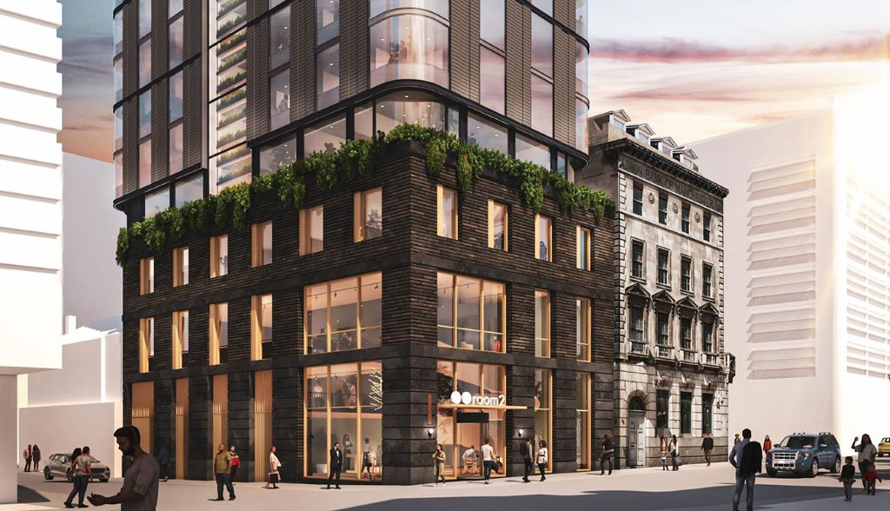
Date: 12 January 2026
Figure 1: Architectural visualisation of a proposed hotel in Manchester — used for illustrative purposes only (Source: Place Northwest).

Table of Contents
1 Executive Summary 3
2 Site Analysis 3
3 Structural Frame and Foundations 4
4 Building Envelope 7
5 Prefabricated and On-Site Construction 9
6 Fire Safety 9
7. Sustainability and Environmental Impact 10
8. Conclusion 11
9. References And Documents 12
10. Appendix 13

1 Executive Summary
1.1 This report outlines the proposed structural and construction strategy for a medium- to high-rise hotel development, justifying the choice of the structural frame, foundations, building envelope, and construction methods in response to site conditions, environmental factors, and regulatory requirements.
1.2 The site is found within a coastal environment and is underlain by variable ground conditions, including made ground over dense granular strata. A reinforced concrete structural frame with a central core is proposed to provide durability, fire resistance, and wind stability, with bored pile foundations selected to safely transfer loads while minimising vibration near Singleton Hospital.
1.3 The building envelope is designed to suit Swansea’s maritime climate using non-combustible rain-screen cladding, high-performance insulation, and effective moisture control, supporting regulatory compliance and long-term thermal performance.
1.4 A hybrid construction approach combining in-situ reinforced concrete construction with selective prefabrication is proposed to improve build quality, reduce programme duration, and support sustainability through material efficiency and reduced waste.

2 Site Analysis
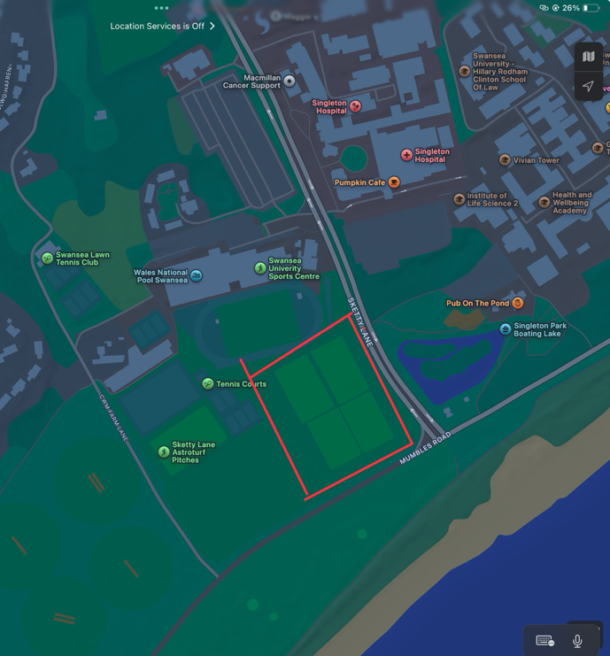
2.1 The site is an open sports field found on Swansea Singleton Campus between Sketty Lane and Mumbles Road.
2.2 To the north of the site lies Singleton Hospital, separated by Sketty Lane. Sports facilities, including Swansea University Sports Centre, found to the west, while the seafront promenade and beachfront are situated directly to the south.
2.3 Ground investigation data obtained from the British Geological Survey (BGS) for the nearby Swansea University Sports Centre show variable subsurface conditions typical of the area. Borehole records show made ground overlying soft to firm deposits, with dense granular strata present at greater depth.
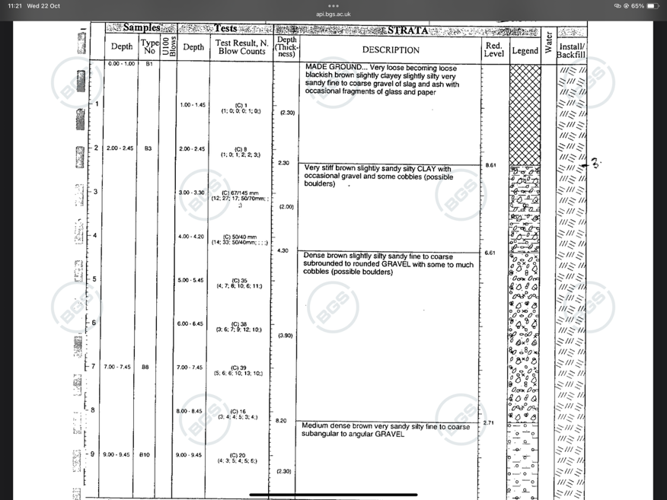
2.4 The borehole information shows the presence of made ground near the surface, underlying soft soils with limited bearing capacity, dense gravel strata at approximately 3 metres depth or greater, and a total recorded borehole depth of approximately 9.45 metres.
2.5 These conditions show that shallow foundations such as strip or pad footings would be unsuitable due to the risk of excessive settlement and inadequate load-bearing capacity within the upper soil layers. Excavations within the made ground and soft soils may also require temporary support due to instability and potential groundwater ingress.
2.6 A deep foundation solution is needed to transfer structural loads to competent bearing strata safely. Bored reinforced concrete piles are considered a suitable foundation solution for the proposed development, allowing loads from the multi-storey structure to bypass weaker soils and be transferred to stable strata at depth.
2.7 The use of bored piling is particularly advantageous on this site due to reduced vibration compared with driven piles, improved installation control, suitability for high vertical loads, and a reduced risk of differential settlement. These factors are especially important given the proximity of hospital facilities.
2.8 The site is accessed via Sketty Lane. Key constraints include hospital proximity, requiring low vibration and noise control; public pedestrian movement around the site; and a restricted staging and material storage area.
2.9 Swansea experiences a temperate maritime climate with mild temperatures throughout the year. However, the coastal environment increases exposure to wind, rainfall, and salt-laden air, which must be addressed through robust structural and envelope design.
2.10 Design implications arising from the local climate include enhanced waterproofing and drainage for foundations and the building envelope, choice of a structural frame with wind and moisture resistance, and the use of materials and detailing suited to a marine environment.

3 Structural Frame and Foundations
3.1 The proposed medium- to high-rise hotel development, forming 8–15 storeys, will utilise a reinforced concrete structural frame incorporating reinforced concrete columns, reinforced or post-tensioned floor slabs, and a central reinforced concrete core housing lifts and staircases.
3.2 Reinforced concrete framing systems are widely used in hotel developments due to their durability, inherent fire resistance, and adaptability to architectural layouts. This system is particularly suitable for urban coastal locations such as Swansea, where wind loading and environmental exposure are key considerations.
3.3 Reinforced concrete columns form the primary vertical load-bearing elements of the structure and transfer loads from upper floors to the foundations. Their high compressive strength allows them to support the vertical loads associated with a multi-storey building safely.
3.4 Concrete columns also provide inherent fire resistance, reducing the need for added applied fire protection, and offer good durability in coastal environments when concrete cover and mix design are specified.
3.5 The column grid can be arranged to maximise flexibility in hotel room layouts, allowing efficient repetition of bedroom modules while maintaining overall structural efficiency.
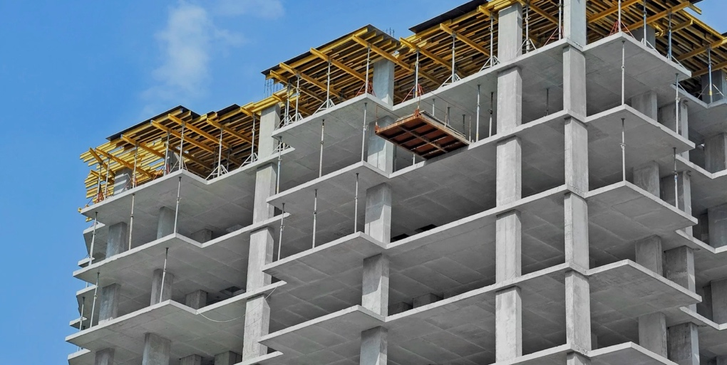
3.6 A post-tensioned reinforced concrete flat slab system is proposed for the floor construction. This system allows longer spans with reduced slab thickness compared to conventional reinforced concrete slabs, reducing the number of internal columns and increasing flexibility in bedroom and public space layouts.
Figure 1: Reinforced concrete (RC) frame under construction showing columns, flat slabs, and temporary formwork. Source: Loft-house Premier Construction Services (n.d.).
3.7 The reduction in slab thickness achieved through post-tensioning lowers the overall building weight, thereby reducing loads transferred to columns and foundations. This is beneficial given the variable ground conditions present at the site.
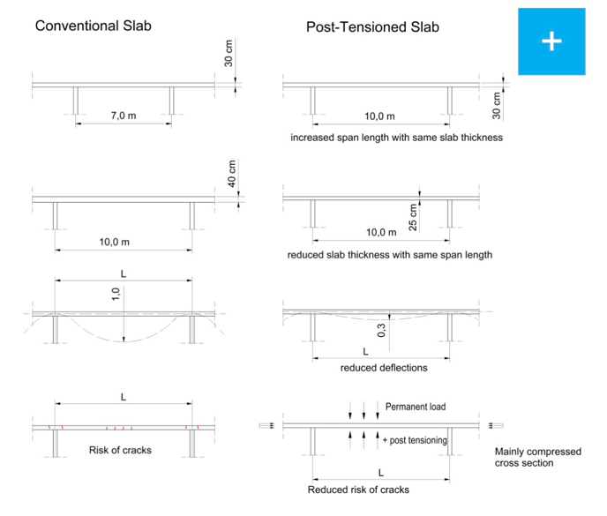
3.8 The post-tensioned slab system also provides inherent fire resistance and improved material efficiency, contributing to both safety and sustainability aims.
Figure 2: shows how post-tensioned flat slabs achieve longer spans with reduced slab thickness compared to conventional reinforced concrete construction.

3.9 A central reinforced concrete core is proposed to accommodate lift shafts, staircases, and service risers.
3.10 The core acts as the primary lateral load-resisting system, counteracting wind forces acting on the building. In a coastal location such as Swansea, this stiffness helps to limit building sway, improving structural safety and occupant comfort.
3.11 The core also enhances fire safety by providing protected escape routes and contributes to the overall robustness of the structure.
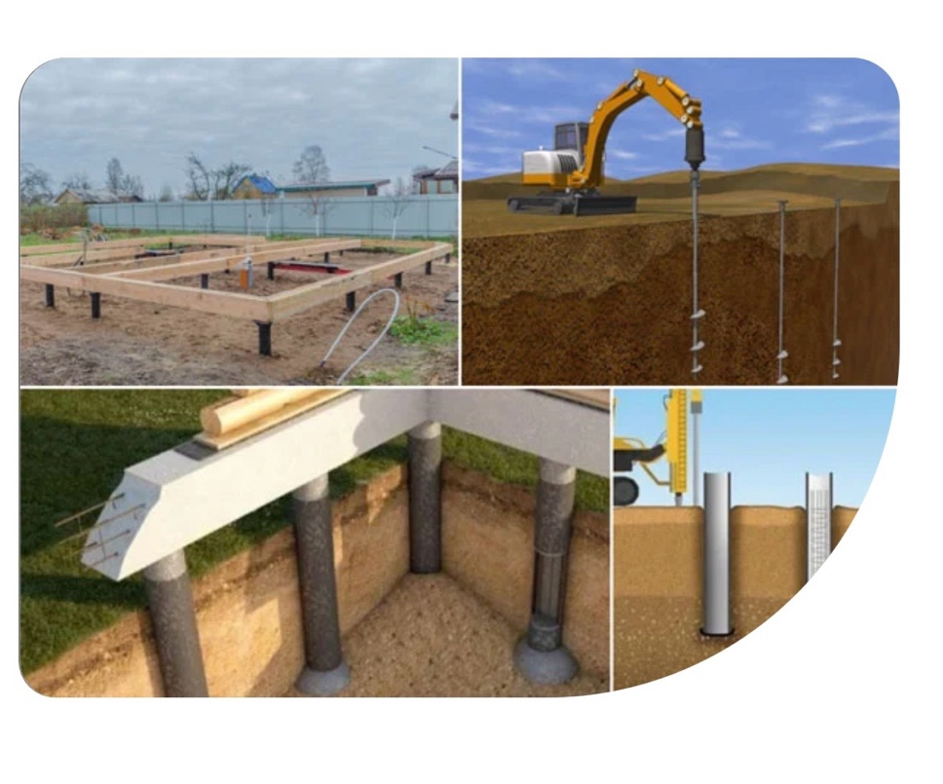
3.12 The foundation system has been selected to safely support the building loads while responding to variable ground conditions and site constraints. A piled foundation solution is considered the most suitable choice.
3.13 The proposed foundation system consists of bored reinforced concrete piles supporting reinforced concrete pile caps and ground beams.
Figure 4: Typical piled foundation systems illustrating bored piles and pile caps.
3.14 Bored piles are suitable for transferring loads to deeper competent strata, reducing differential settlement, supporting high vertical loads, and minimising vibration compared with driven pile systems.
3.15 Bored piling also allows greater control during installation, reducing the risk of damage to adjacent structures, including nearby hospital facilities.
3.16 Where a basement or underground parking level is incorporated, the substructure will form an integral part of the foundation system. Reinforced concrete retaining walls will resist lateral earth pressures, surcharge loads, and groundwater forces.
3.17 The basement slab will act as a structural raft, resisting uplift through self-weight and structural continuity with the pile system.
3.18 Given the coastal location and potential groundwater presence, waterproofing will be achieved using waterproof concrete (Type B protection), controlled drainage systems, and damp-proof membranes detailed following BS 8102.
3.19 These measures ensure long-term durability, prevent water ingress, and protect the internal environment of the building.

4 Building Envelope
4.1 The building envelope must provide adequate weather protection, thermal insulation, fire resistance, acoustic separation, and visual quality to ensure the safety, comfort, and performance of the proposed hotel.
4.2 The envelope design must limit heat loss and control moisture ingress under Approved Document L (Conservation of Fuel and Power) and Approved Document C (Resistance to Contaminants and Moisture).
4.3 Fire resistance and compartmentation must follow Approved Document B, while acoustic performance should meet the requirements of Approved Document E to reduce external noise transmission.
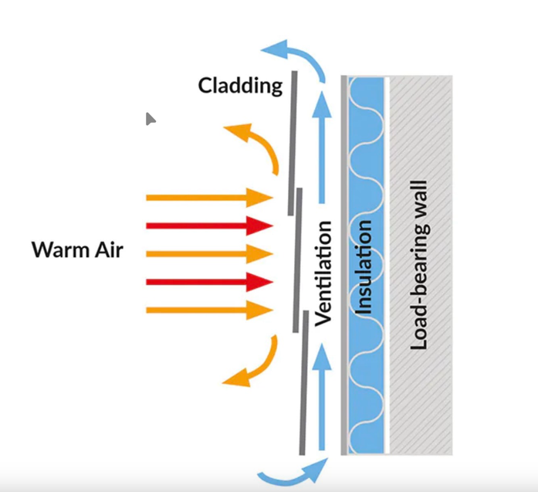
4.4 The proposed hotel will incorporate a ventilated rain-screen cladding system using lightweight stone-faced panels fixed back to the reinforced concrete structural frame. This construction method separates the load-bearing structure from the weather-resisting exterior layer, improving moisture control, durability, and façade performance.
Figure 3: Principle of a ventilated rain-screen cladding system showing external stone-faced panels, ventilated cavity, insulation layer, and reinforced concrete load-bearing wall (Source: 3B Training).
4.5 A continuous ventilated cavity is provided behind the external cladding panels, allowing wind-driven rain to drain away and evaporate naturally. This cavity significantly reduces the risk of water penetration and is particularly well-suited to Swansea’s maritime climate, where prolonged rainfall and high wind exposure are common.
4.6 The external façade will utilise lightweight stone rain-screen panels, consisting of a thin natural stone veneer bonded to a lightweight concrete or composite backing. These panels provide the visual quality of natural stone while being significantly lighter than traditional solid masonry, reducing imposed dead loads on the reinforced concrete frame and piled foundations.
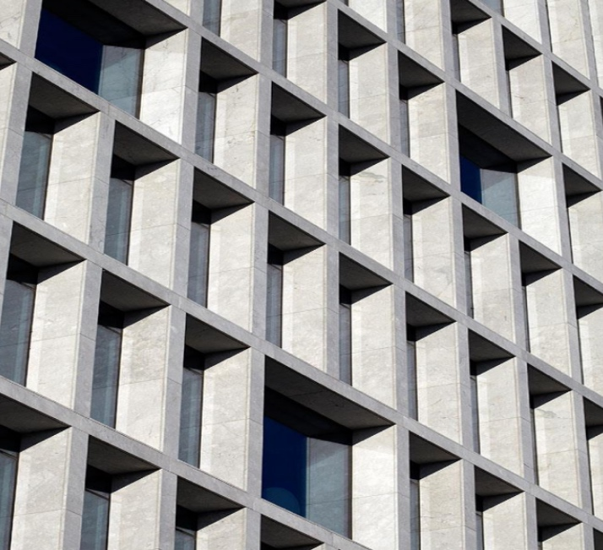
Figure 4: Example of lightweight stone rain-screen cladding applied to a modern multi-storey building, illustrating façade depth, panel articulation, and architectural quality (Source: Advanced Glass / Litho-Stone – image used for academic purposes).
4.7 The rain-screen system is supported on a non-combustible subframe and incorporates high-performance external insulation fixed to the structural wall behind the ventilated cavity. This arrangement enhances thermal efficiency, reduces cold bridging, and contributes to compliance with Approved Document L.
4.8 The stone rain-screen panels and supporting façade system are non-combustible, supporting compliance with Approved Document B and current guidance for relevant buildings with sleeping accommodation. The system also limits the risk of external fire spread while keeping façade durability and visual quality.
4.9 The use of rain-screen cladding is set up in Swansea through developments such as Urban Village Swansea, where rain-screen systems contribute to façade performance, thermal efficiency, and visual quality. (R&M Williams)
4.10 Windows and glazing systems will be selected to provide adequate daylighting, thermal performance, and acoustic insulation. High-performance double or triple glazing will reduce heat loss and external noise ingress.
4.11 The roof will include a warm flat roof system constructed over a reinforced concrete deck, incorporating rigid thermal insulation and a single-ply waterproof membrane such as PVC or TPO. This system is suitable for exposed coastal environments due to its resistance to wind uplift, UV exposure, and salt-laden air.
4.12 The warm roof configuration reduces condensation risk and allows compliance with Approved Document L. Roof falls will be formed using tapered insulation to direct rainfall to internal drainage outlets, minimising maintenance requirements.

5 Prefabricated and On-Site Construction
5.1 The proposed hotel development adopts a hybrid construction strategy, using on-site construction for primary structural elements and prefabrication for repetitive and non-primary components.
5.2 The reinforced concrete frame, central core, and piled foundations are constructed in situ to accommodate variable ground conditions, bespoke structural geometry, and the need for structural continuity and robustness.
5.3 In-situ construction also provides inherent fire resistance, high stiffness, and improved acoustic performance, which are essential for a medium- to high-rise hotel in an exposed coastal location.
5.4 Prefabrication is used for elements where standardisation and repetition are helpful, including bathroom pods, façade panels, stair flights, and selected service modules.
5.5 These components receive help from factory-controlled manufacture, which improves quality, reduces defects, and shortens the construction programme through parallel off-site production. The use of prefabricated elements also enhances health and safety by reducing working at height and minimising on-site labour.
5.6 Overall, the combination of on-site and prefabricated construction methods provides an efficient, safe, and sustainable approach, ensuring structural performance and design flexibility while improving build quality, reducing waste, and limiting disruption to surrounding sensitive uses.

6 Fire Safety
6.1 Fire safety is a key consideration due to the presence of sleeping occupants and the building height. The reinforced concrete structural frame provides inherent fire resistance and supports structural stability during a fire event.
6.2 Fire resistance periods will be designed following Approved Document B to allow sufficient time for safe evacuation and fire-fighting operations.
6.3 The building will be subdivided into fire compartments to limit the spread of fire and smoke between rooms and floors. A central reinforced concrete core accommodates protected staircases and lift shafts, providing safe means of escape and fire-fighter access.
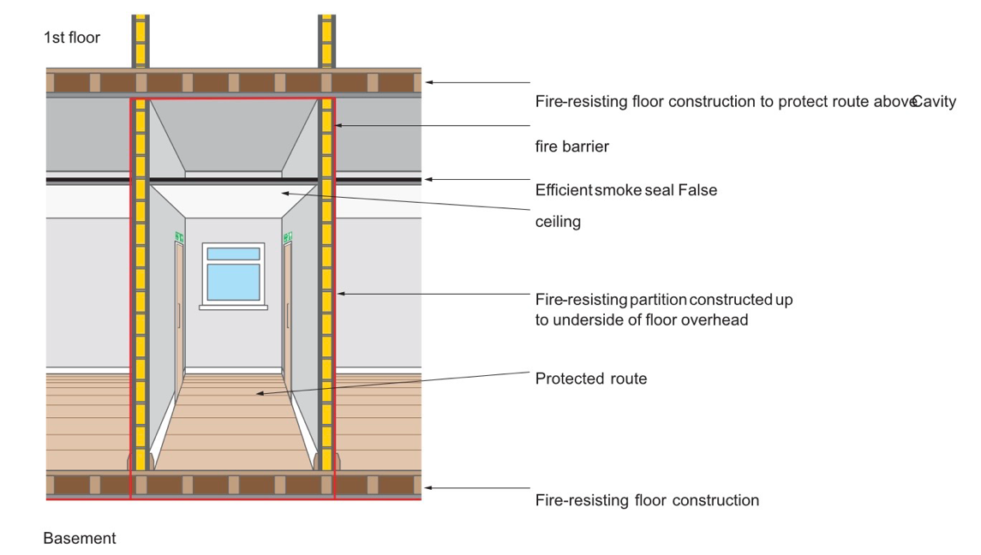
Figure 5: Example of fire-resisting construction and protected escape routes within a multi-storey building (Source: HM Government, Approved Document B – Fire Safety).
6.4 External wall construction incorporates non-combustible materials to reduce the risk of external fire spread. Active fire safety measures, including automatic fire detection and sprinkler systems, further enhance occupant safety and regulatory compliance. An example of external wall fire safety information is provided in Appendix C.

7. Sustainability and Environmental Impact
7.1 The proposed rain-screen façade system supports sustainability aims through material efficiency, durability, and improved operational energy performance. The lightweight nature of the stone panels reduces material use and embodied carbon when compared to traditional full-depth masonry construction.
7.2 The reinforced concrete structural frame can incorporate low-carbon concrete mixes having cement replacement materials such as GGBS or PFA, significantly reducing embodied carbon while supporting structural performance and durability.
7.3 A fabric-first approach is adopted through high-performance external insulation, airtight construction detailing, and energy-efficient glazing. These measures reduce heat loss, improve thermal comfort, and lower operational energy demand following Approved Document L.
7.4 The flat roof design provides opportunities for the future installation of photovoltaic panels, enabling on-site renewable energy generation and contributing to reduced carbon emissions during building operation.
7.5 Water efficiency measures, including low-flow sanitary fittings and dual-flush WCs, reduce potable water consumption and improve the environmental performance of the hotel during operation.
7.6 The use of prefabricated construction elements reduces material waste, improves construction efficiency, and minimises environmental impacts associated with on-site activities.

8. Conclusion
8.1 This report presents a justified structural and construction strategy for a medium- to high-rise hotel development in Swansea, responding to site constraints, ground conditions, environmental exposure, regulatory requirements, and hotel functional needs.
8.2 Variable ground conditions informed the selection of a bored piled foundation system, providing reliable load transfer to competent strata while minimising vibration, settlement, and impact on nearby sensitive uses.
8.3 A reinforced concrete structural frame with post-tensioned flat slabs and a central concrete core has been proposed to meet structural strength, stability, fire safety, and serviceability requirements. This system offers inherent fire resistance, durability in a coastal environment, and sufficient stiffness to resist wind loading while enabling flexible layouts.
8.4 The building envelope adopts a ventilated rain-screen façade using lightweight stone-faced panels, delivering effective weather protection, moisture control, and architectural quality. Non-combustible materials ensure compliance with Approved Document B, while high-performance insulation, glazing, and a warm flat roof enhance thermal efficiency and operational performance.
8.5 A hybrid construction approach combining in-situ concrete construction with selective prefabrication balances structural robustness and design flexibility with improved quality, reduced waste, and increased construction efficiency.
8.6 Steel framing was considered for speed and reduced self-weight but discounted due to lower inherent fire resistance and higher maintenance demands in a coastal environment.
8.7 Although reinforced concrete has higher embodied carbon, this impact is mitigated through low-carbon concrete mixes and post-tensioning to reduce material quantities.
8.8 Sustainability is embedded throughout the design through material efficiency, reduced embodied carbon, improved operational energy performance, and future renewable energy integration, resulting in a safe, durable, and environmentally responsible hotel development

9. References And Documents
  - Approved Document B
  - Approved Document E
  - Approved Document L
  - Fire Safety Regulations 2022

British Geological Survey (BGS) (no date) BGS ID: 370609: BGS Reference: SS69SW117 [PDF]. Available at: https://api.bgs.ac.uk/sobi-scans/v1/borehole/scans/items/370609 (Accessed 4th December 2025)
Loft-house Premier Construction Services Ltd (2025) Reinforced Concrete (RC) Frames. Available at: https://www.lofthousepcs.com/reinforced-concrete-rc-frames (Accessed 10th December)
BBV Systems GmbH (2026) Post-tensioned flat slabs. Available at: https://www.bbv-systems.com/en/services/post-tensioned-flat-slabs/ ( Accessed 10th December 2025)
3B Training Ltd (no date) What is rain-screen cladding and what are the benefits? https://www.3btraining.com/news-articles/what-is-rainscreen-cladding-and-what-are-the-benefits/ (Accessed 27th December 2025)
Advanced Glass Ltd (no date) Lithodecor Rainscreen Cladding Systems & Ceramic Systems. Available at: https://www.advanced-glass.co.uk/lithodecor-rainscreen-cladding-systems-ceramic-systems/ (Accessed 10th January 2026)
R&M Williams Ltd (no date) Urban Village Swansea – High Street, new build mixed-use project case study. Available at: https://rmwgroup.co.uk/case-studies/urban-village-swansea-the-strand-mixed-use/ ( Accessed 10th January 2026)

10. Appendix
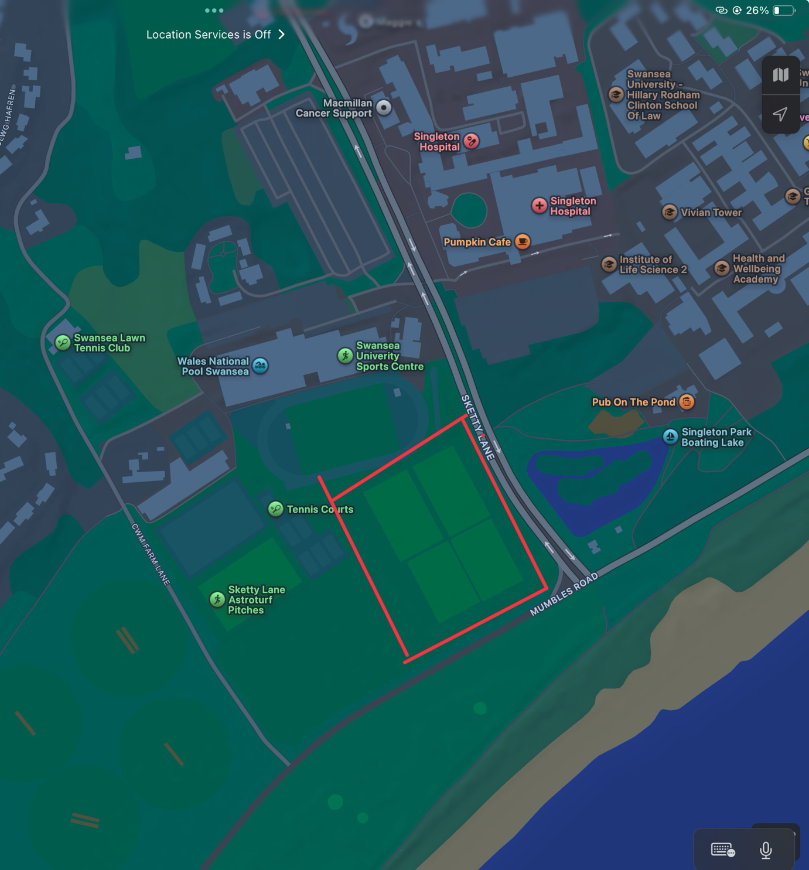
Appendices A: Site map

Appendices B: Borehole log
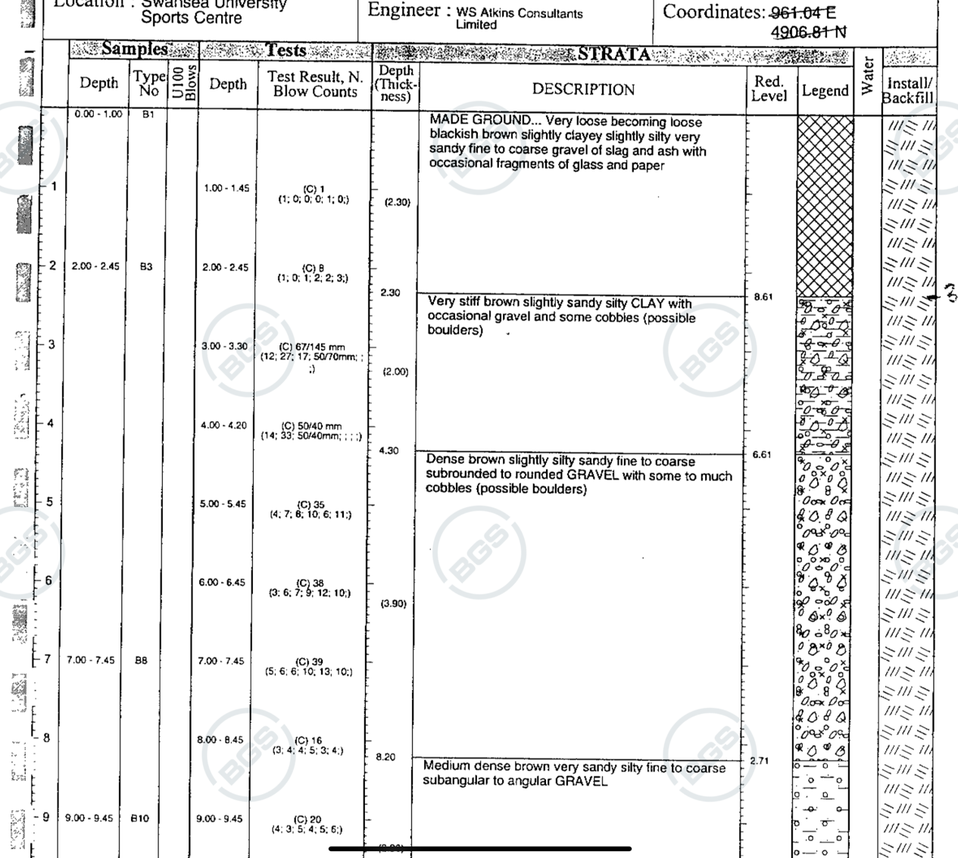

Appendices C: External Wall Fire Safety Information (FRS Template)


