

Postgraduate/Distance Learning
Assignment coversheet & feedback form

THIS SHEET MUST BE THE FIRST PAGE OF THE ASSIGNMENT YOU ARE SUBMITTING (DO NOT SEND AS A SEPARATE FILE)

For completion by the student:
Student Name: Helen Claire Astley

Student University Email: 2126960@student.uwtsd.ac.uk
Module code: HPCA7028  Module title: Sacred Skies | Student ID number: 2126960 |  |  | Educational support needs:  Yes/No
Assignment title: A Critical Examination of the Sky in Relation to Material Culture

Assignment due date: 05th May 2022
This assignment is for the 1st 2nd 3rd 4th 5th 6th module of the degree
I confirm that this is my original work and that I have adhered to the University policy on plagiarism.
Signed ……………………………………………………………
Email submission:if you are submitting this form via email, please tick this box R
(as a substitute for your signature) to confirm that you agree to the above declaration.
Assignment Mark
1st Marker’s Provisional mark
2nd Marker’s/Moderator’s provisional mark
External Examiner’s mark (if relevant)
Final Mark

NB. All marks are provisional until confirmed by the Final Examination Board.

ALL COMMENTS ARE ON THE PDF OF YOUR PAPER IN TURNITIN

For completion by Marker 1 :
Comments:

Marker’s signature: |  |  | Date:
For completion by Marker 2/Moderator:

Comments:

Marker’s Signature: |  | Date:
External Examiner’s comments (if relevant)

External Examiner’s Signature: |  | Date:

A critical examination of the sky in relation to material culture, an investigation of the orientation of the Great Temple and Small Temple at Amarna in relation to the skyscape

Introduction
On the east bank of the Nile, in Middle Egypt, the city of Amarna was founded by the pharaoh Akhenaten (c.1355-1338 B.C.E.). Figure 1 shows the relative position of Amarna in relation to the two main administrative centres of Memphis and Luxor. This 18th dynasty New Kingdom pharaoh, who was originally crowned Amenhotep IV was not, as Kemp points out, that the original heir to the throne, his elder brother Thutmose was the intended heir.
Katheryn A. Bard writes that this newly built city was designed to be the new cultic centre for the god Aten and was called Akhetaten, which translates as ‘Horizon of Aten’. The name of the new city and the deity it was focussed on would perhaps imply that the sun and the line between land and sky were important parts of the founding of the city in this particular area. Possibly the skyscape of the sweeping bay in the cliffs resonated with the new religious ideas of the pharaoh Akhenaten.
Fabio Silva defines the new word skyscape as a way of extending landscape and seascape into the sky, the creations of people past and present being connected to their philosophies, sense of time and place all overlooked by the sky, clouds, sun and other cosmic phenomena. Ruggles and Saunders, cited by Silva , ‘proposed three key processes in the formation of a skyscape: observation, perception and use’. Silva states that these three processes are interlinked by human activity, the observation of the sky and the movements of its components, the ability to understand and bestow a significance on those movements and finally to use those observations for religious, socio-economic or administrative purposes or power.
The sun as the only god and Akhenaten as his conduit to earth was a central focus of the religion and city of Amarna, although Barry Kemp sees this as being an ‘extreme manifestation of the cult of the ruler’. This essay will examine the orientation of the Great Temple and Small Temple in relation to the surrounding skyscape and material culture and the role of the sky in the life of Akhenaten.
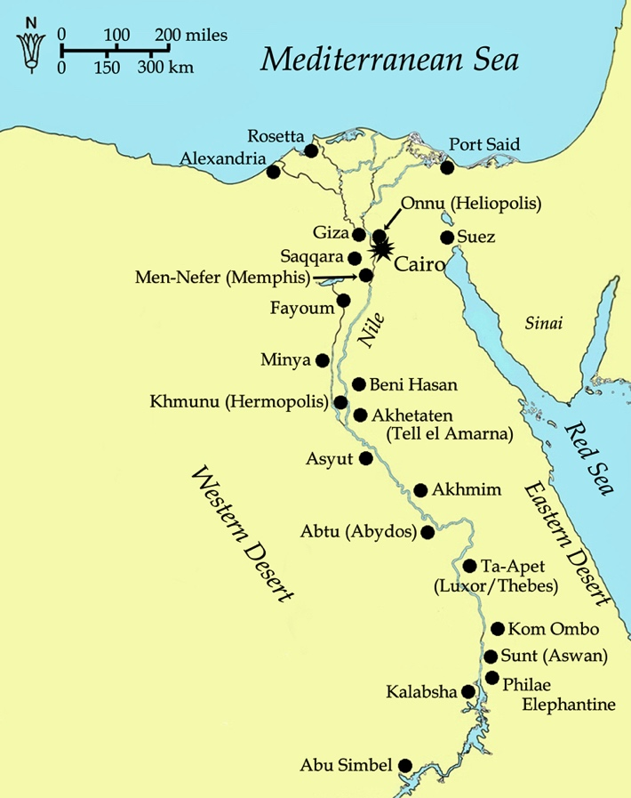
Figure 1: Map of Egypt
Methodology
To identify the orientation of the Great Temple and Small Temple at Amarna and the direction of the sunrise the programme Google Earth Pro was used in conjunction with the programme HeyWhatsThat.
The two coordinates necessary to define the position of a celestial body in the sky, viewed from a particular location and time, are azimuth and elevation. The azimuth is the angle in degrees measured clockwise around the horizon from due north to a celestial body, from a specific point of observation, the azimuth for an object which is due north is 0°, and due south 180°. The vertical angular distance between a celestial body and the viewer's local horizon is the elevation. The latitude and longitude of the temples are required to find the correct location to take the observations from.
The latitude and longitude of both the temples were noted from Google Earth Pro from a suitable central position in both the temples. Several azimuth bearings were measured using the ruler in Google Earth Pro and an average one was chosen. The figures were then transferred to HeyWhatsThat which pinpointed the area and the elevation was then calculated from the azimuth. The azimuth, elevation and latitude were transferred to the Sacred Skies Calculation Spreadsheet and the declination was calculated. Declination is the astronomical counterpart of latitude; it is measured in degrees, the celestial equator is at 0°, the celestial north pole is at + 90° and the celestial south pole is – 90°. The declination allows the observer to calculate the visibility of a celestial object at a given date.
The use of satellite imagery has become a useful tool in an archaeological and archaeoastronomical investigation as noted by Clive L. N. Ruggles giving the opportunity of studying the orientation of a structure before a site visit is planned. If a site visit is not feasible then Juan Antonio Belmonte has found that Google Earth images can supply very precise measurements, the average error being between ½° and 1°. As a site visit was not possible the use of Google Earth Pro and HeyWhatsThat were the only options for the statistical measurements in this essay. As addressed by both Belmont and Frank Prendergast the orientation of the temples should not be automatically interpreted as being specifically aligned with a currently recognised phenomenon. The surrounding skyscape and material culture must be taken into account when looking at the temple alignments.

Literature Review
The city of Amarna had been recorded by the expedition of Napoleon Bonaparte in 1798 -1799, who included accomplished savants with his military expedition and later had Description de l'Égypte published about their findings but at this time the origins of the city and the founding pharaoh were unknown . The religion of Akhenaten and its focus on the sun became a topic of interest, speculation and conjecture when the exploration of the city of Amarna began in the early eighteen hundreds.
Previously the theories of the orientation of the city were founded on the boundary stelae, physical observation and interpretation of the texts, more recently this has been expanded to include measurements and projections.
The city of Amarna is defined by fifteen known boundary stelae, twelve on the east bank of the Nile and three on the west bank . Figure 2 shows the relative positions of the stelae in relation to the city, the Nile and the surrounding hills. Ronald. A. Wells proposed a reinterpretation of the texts on stelae M, X and K, using them as ‘identifiable astronomical observation’. Combining these with the azimuth of the small temple and the calculation of the declination of the sun Wells proposes that the offering ceremony mentioned on the stelae coincided with the sun rising from the depression in the hills that is the Wadi Abu Hasah El-Bahri on February 20, 1351, B.C. Cyril Aldred noted that the gap formed in the hills by the aforementioned Wadi could be said to be a natural formation of the horizon sign. Figure 3 is an early cartouche of the Aten with the horizon sign on the lower right-hand side.
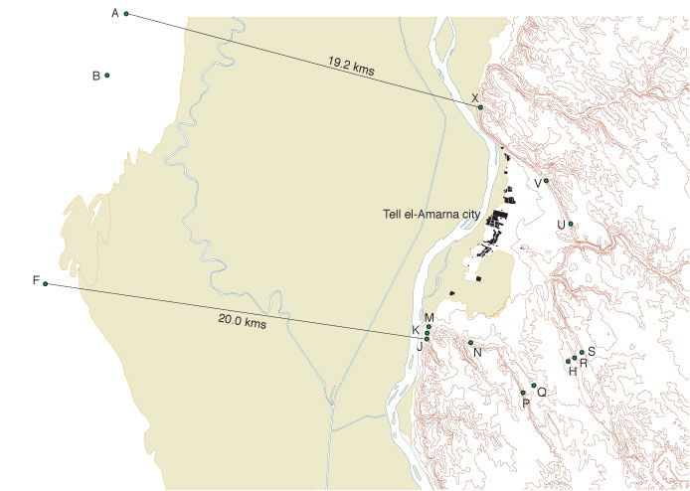
Figure 2: Map of Boundary Stelae
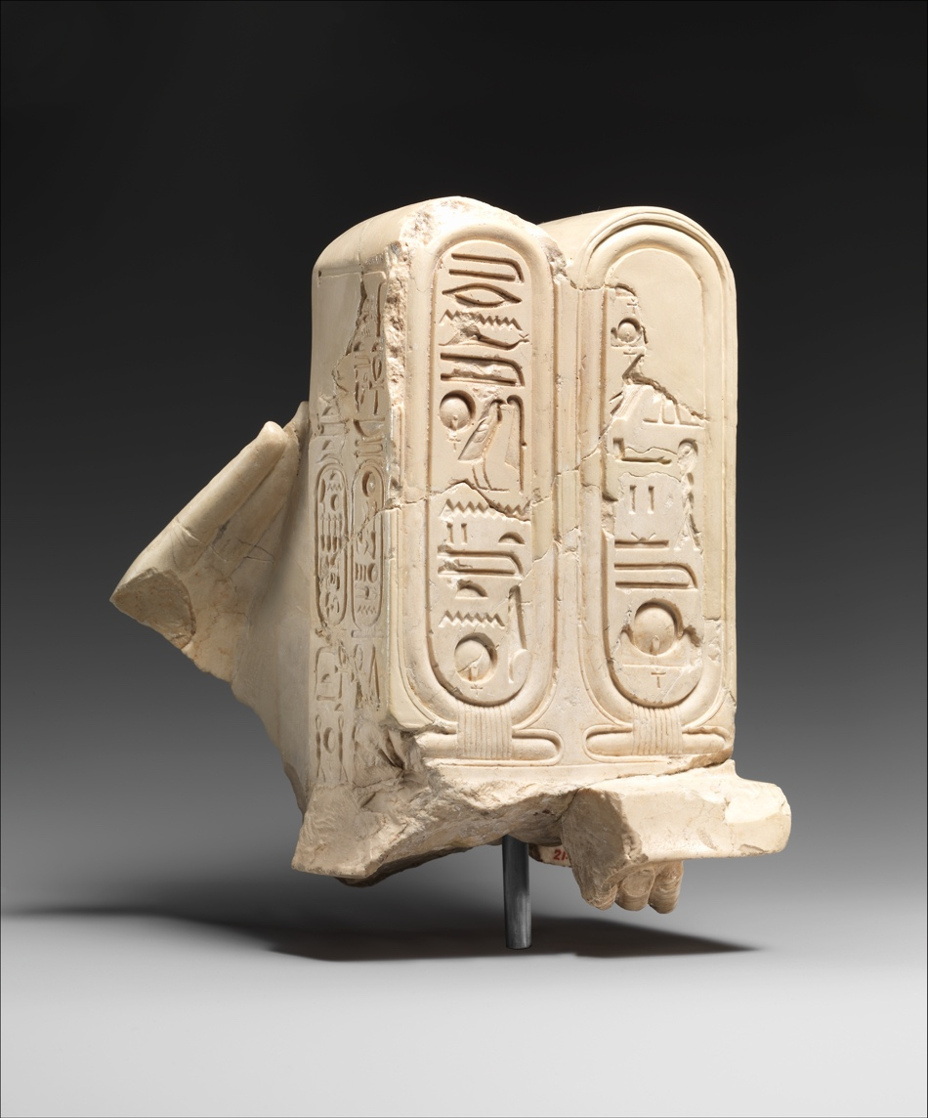
Figure 3: Early Aten cartouche. The Met Museum Accession Number: 21.9.431
Wilkinson states that most temples that were built along the Nile were aligned at 90° to the river and on an east-west axis. This orientation was affected by previous structures, the landscape and the river’s course therefore the temples were decorated with the correct symbols to give them an internal east-west orientation. Wilkinson claims that solar and stellar alignments can be seen to be a priority in some temples, for example, the Great Temple of Ramesses II at Abu Simbel, the temples of Akhenaten and the temple on the island of Elephantine at Aswan.
Belmonte has spent a considerable amount of time in the field measuring the alignment of Egyptian temples and has extended this study to Nubia, his team has measured alignments in nearly 400 shrines and temples. Belmonte and his team make their fieldwork measurements using a clinometer and a high precision compass, corrected for local magnetic declination. Theoretically, this should give a precision of ¼° but Belmonte believes that an error of ½° in both azimuth and elevation is more likely. Belmonte states that the temples were usually measured from the sanctuary to the main gate and occasionally this measurement was reversed to check for possible anomalies. Belmonte summarises his findings as follows ‘we might reach the conclusion that actually only three conventions of orientation were present in ancient Egypt throughout her land and her history: cardinal, solar, and stellar’. In Belmonte’s opinion the temples of Egypt were astronomically orientated on one of three points:

- The different combinations of the stars of the constellation of Meskhetyu
- A solar target is linked with the civil calendar or annual events, such as the inundation
- The stars Sirius or Canopus

Belmonte concluded that 'the ancient Egyptians undoubtedly scrutinized the sky seeking their correct orientation not only in time but also in space in their permanent search for cosmic order'.
After the work on the re-clearance of the Great Temple during the 2017 and 2018 seasons at Amarna and the identification of the foundation of a staircase Kemp explained it was decided to create a 3D model to test the theory of the temple alignment with significant astronomical events. The staircase would have been wide and would have risen at a shallow angle, from west to east between the front pylons of the temple. Paul Docherty used artistic sources and previous and current archaeological data to prepare models of the Long Temple using Autodesk 3D modelling software and a lighting rig by the same company. The lighting rig as explained by Kemp does not have the ability to run with the dates of the reign of Akhenaten but this could be addressed if the simulation was run again for a more in-depth study. As there is no surviving temple architecture the height of the temple walls and other features had to be extemporised. In Kemp’s opinion there did not appear to be any specific planned connection between the alignment of the temple and the astronomical events such as the solstice or the equinox. Kemp stated that although the dates in February/March and October were close to the equinox significant work would have to be done with the alignment of the lighting rig to recheck the current findings.

The Broader Landscape and the Stelae
The founding stelae discovered in the city area of Amarna are one of the reasons we know anything about the founding of the city and the religion of Akhenaten. The city was built in a short space of time and was lived in for approximately eleven years, the city is relatively well preserved as unlike other sites in Egypt it was not rebuilt after its abandonment. According to Bard after the initial demolishing of the stone temples and destruction of statues, the mud-brick structures were left to degenerate naturally.
The hills on the eastern bank of the Nile retreat and form a desert bay where Akhenaten chose to build his city of Amarna. Figure 4 is a map of the landscape with the Royal Wadi, city, modern habitation and some boundary stela marked. The landscape of the area, Murnane and van Siclen claimed, was to influence the pharaoh in the manner he demarcated his new city extent, the proclamations of stela M. and X being carved into the rocky headlands enclosing the bay at the southern and northern ends respectively. The bay is approximately ten kilometres long and six kilometres deep, this barren landscape is in contrast to the agricultural land on the west bank.

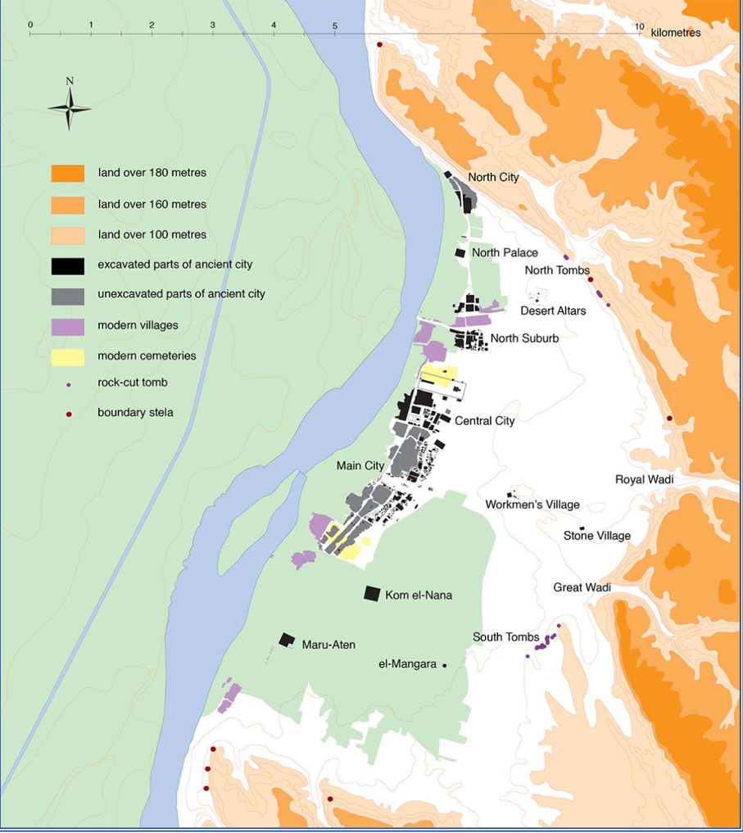
Figure 4: Map of Amarna, Stevens, Anna, Tell el-Amarna in UCLA Encyclopedia of Egyptology, ed. by Willeke Wendrich (Los Angeles 2016)
The stelae are identified by a discontinuous series of letters, this was begun by W. M. Flinders Petrie in 1892 when he first excavated the site and allowed for other stelae to be found and entered into the sequence. The stelae K, M and X, see Figure 2 for placement, named by Murnane and van Siclen as the ‘Earlier Proclamation’ are the group of stelae where the proposed city layout is described and Akhenaten tells of his discovery of the site and his reason for choosing it. Eleven of the other stelae which are called the ‘Later Proclamation’ are a confirmation of the previous text with an addition of a specification on stelae being set up on the northern, central and southern perimeters, Akhenaten also renews his oath about the borders of the city . The later stelae extend the boundaries of the original land area to include the agricultural land on the western bank of the Nile . Kemp describes these stelae as being bright white when they were initially carved, with the hieroglyphs and presumably the accompanying statues painted in bright colours, wide paths had been cleared to many of them, so they were meant to be seen and visited. Although only a limited number of people would have been able to read the inscriptions.

The text of the earlier stelae has many lacunas and the stelae themselves are badly damaged, but S, Q, U, A and R preserve enough of the text to make restitution of a full version, Murnane and van Siclen give translations and review previous translations and documentation of the stelae.
The following three excerpts are from the 'Earlier Proclamation', these are the arrival of Akhenaten and offerings made to the Aten, the discovery of the site and the setting out of the site area. ‘Horizon of the Orb’ is used instead of Akhetaten as the city name and the Orb instead of the Aten in most places in this translation, the date is given on the stelae as regnal year 5, day 13 of the 4th month of Peret (the growing season):

On this day, when One was in ‘Horizon of [the Orb], his Majesty [appeared] upon the great chariot of electrum…. Setting [off] on a good road [toward] 'Horizon of the Orb', His place of the primaeval occurrence which He made for Himself that He might set within it daily….
There was presented a great oblation to the Father, THE ATEN, consisting of bread, beer, long-and short-horned cattle, calves, fowl, wine, fruits, incense, all sorts of fresh green plants, and everythi[ng] good in f[ront of] the mountain of ‘Horizon of the Orb’….

As the orb is beheld! The Orb is desirous that there be ma[de] for Him […] as a monument with an etern[al] and everlasting name! Now, it is the Orb, my father, who advised me concerning it, (namely) ‘the Horizon of the Orb’. No official had ever advised me concerning it, not any of the people who are in the entire land had ever advised me concerning it, to tell unto me [a plan] for making ‘the Horizon of the Orb’ in this distant place. It was the Orb, my fath[er, who advised me] concerning it …. Behold, it is Pharaoh, Life, Prosperity, Health, who found it- -not being the property of a god, not being the property of a goddess, not being the property of a ruler, not being the property of a female ruler, not being the property of any people to do business of theirs with it….

I shall make ‘Horizon of the Orb’ for the Orb, my father, in this place. I shall not make ‘Horizon of the Orb’ for him in the south of it, in the nort[h] of it, in the west of it (or) in the east of it. I shall not go past the southern stela of ‘Horizon of the Orb’ towards the south, nor shall I go past the northern stela of ‘Horizon of the Orb’ towards the north, in order to make ‘Horizon of the Orb’ for him there. Nor shall I make (it) for him on the wester[n] side of ‘Horizon of the Orb’, but I shall make ‘Horizon of the Orb’ for the Orb, my father, on the orient (side) of ‘Horizon of the Orb’ - - the place which He Himself made to be enclosed for Him with the mountain ….

Akhenaten did not begin his reign by founding his new city of Amarna, as Kemp reveals there have been thousands of talatat blocks recovered at Karnak and Luxor temples where they were used as infill. Akhenaten designated a new smaller size of stone building block for his building projects now known as talatat they are about 52 centimetres long and Donald B. Redford confirms they can be carried by one person.

The Great Aten Temple
The Great Aten Temple enclosure was made of mudbrick and is 800 metres long and 300 metres wide, as can be seen in Figure 5 the outline of most of the wall is still visible. Kemp reports that most of the space appears to be empty, the Long Temple and the Sanctuary being the most notable buildings inside it, although they seem to be dwarfed by the space. The Long Temple is a series of courts, open to the sky, with offering tables inside and out, so far Kemp details more than 1,700 have been identified, the external ones are visible in Figure 5. Large quantities of offerings were to be given each day to the Aten as shown in some tomb scenes and listed on the stelae. Several of the Amarna tombs have pictures of the Aten temples in their wall decorations Kemp suggests that two of the men were probably priests of the temple, Meryre had the title ‘Chief of Seers of the Aten in the House of Aten in Akhetaten’ and Panehsy who was ‘Chief Servitor of the Aten in the House of Aten in Akhetaten’. The depictions are of subdivided spaces, doorways and many offering tables these spaces were mainly open to the sky with a few columns that supported open colonnades, Kemp notes that these depictions agree with the excavation plans.
To measure the orientation of the temple I noted the latitude and longitude in the last court of the Long Temple, this was latitude 27.650661 and longitude 30.898980 and the azimuth of 103°, was measured along the red line in Figure 5. These figures were transferred to HeyWhatsThat which produced an elevation of 1.48°, see Figure 6 for the profile of the area. The map produced from HeyWhatsThat, Figure 7, gives a line of sight from the Great Temple enclosure to the hills in the east. The figures were then entered into the Sacred Skies Calculation Spreadsheet which produced a declination of -10.79°, the dates of the sunrise in line with the temple are similar to those calculated by Kemp in the 3D model that is in late February and October.
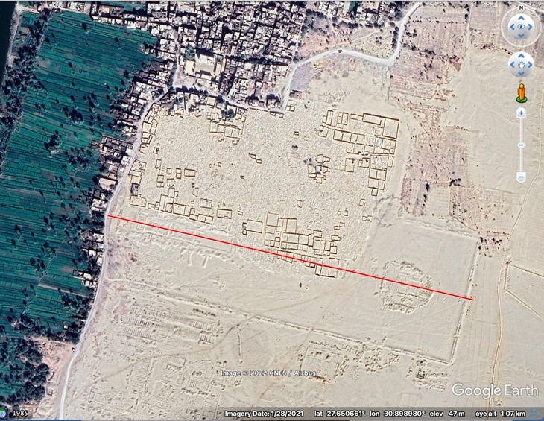
Figure 5: Map of the Great Aten Temple from Google Earth Pro
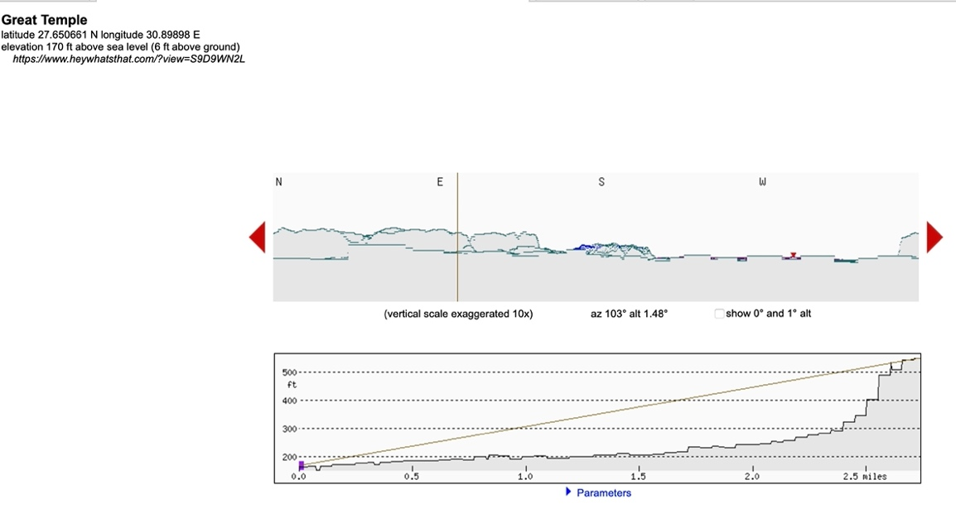
Figure 6: Great Temple Elevation from HeyWhatsThat

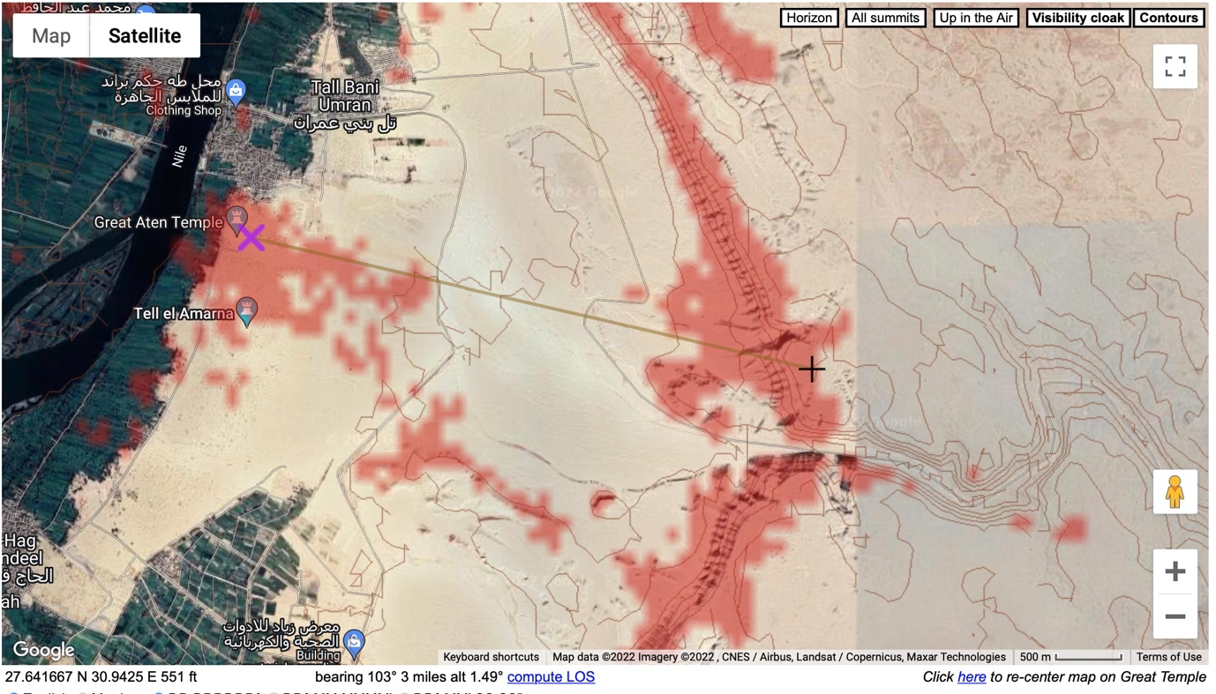
Figure 7: Great Temple Map from HeyWhatsThat

The Small Aten Temple
The Small Aten Temple has several sets of temple auxiliary buildings and royal buildings between it and the Great Aten Temple as shown on the recreated 3D plan Figure 8. The enclosure wall of the Small Aten Temple bordered an area of 192 by 111 metres and differed from the Great Aten Temple in having buttresses, these were not structurally necessary and Kemp suggests that this was an artistic ploy which endeavoured to portray the temple as the god’s fortress.
To measure the orientation of the temple I noted the latitude and longitude as shown in Figure 9 by the blue circle and where the red lines cross, this was latitude 27.645204 and longitude 30.896745 and the azimuth of 103°, was measured along the long red line on Figure 9. These figures were transferred to HeyWhatsThat which produced an elevation of 1.04°, see Figure 10 for the profile of the area. The map produced from HeyWhatsThat, Figure 11, gives a line of sight from the Great Temple enclosure to the Royal Wadi in the east. The figures were then entered into the Sacred Skies Calculation Spreadsheet which produced a declination of -11°. The calculation would indicate that the sunrise would appear in the cut produced by the Royal Wadi, see Figure 12, whereas the view from the Great Aten Temple would just see the sunrise over the hills.

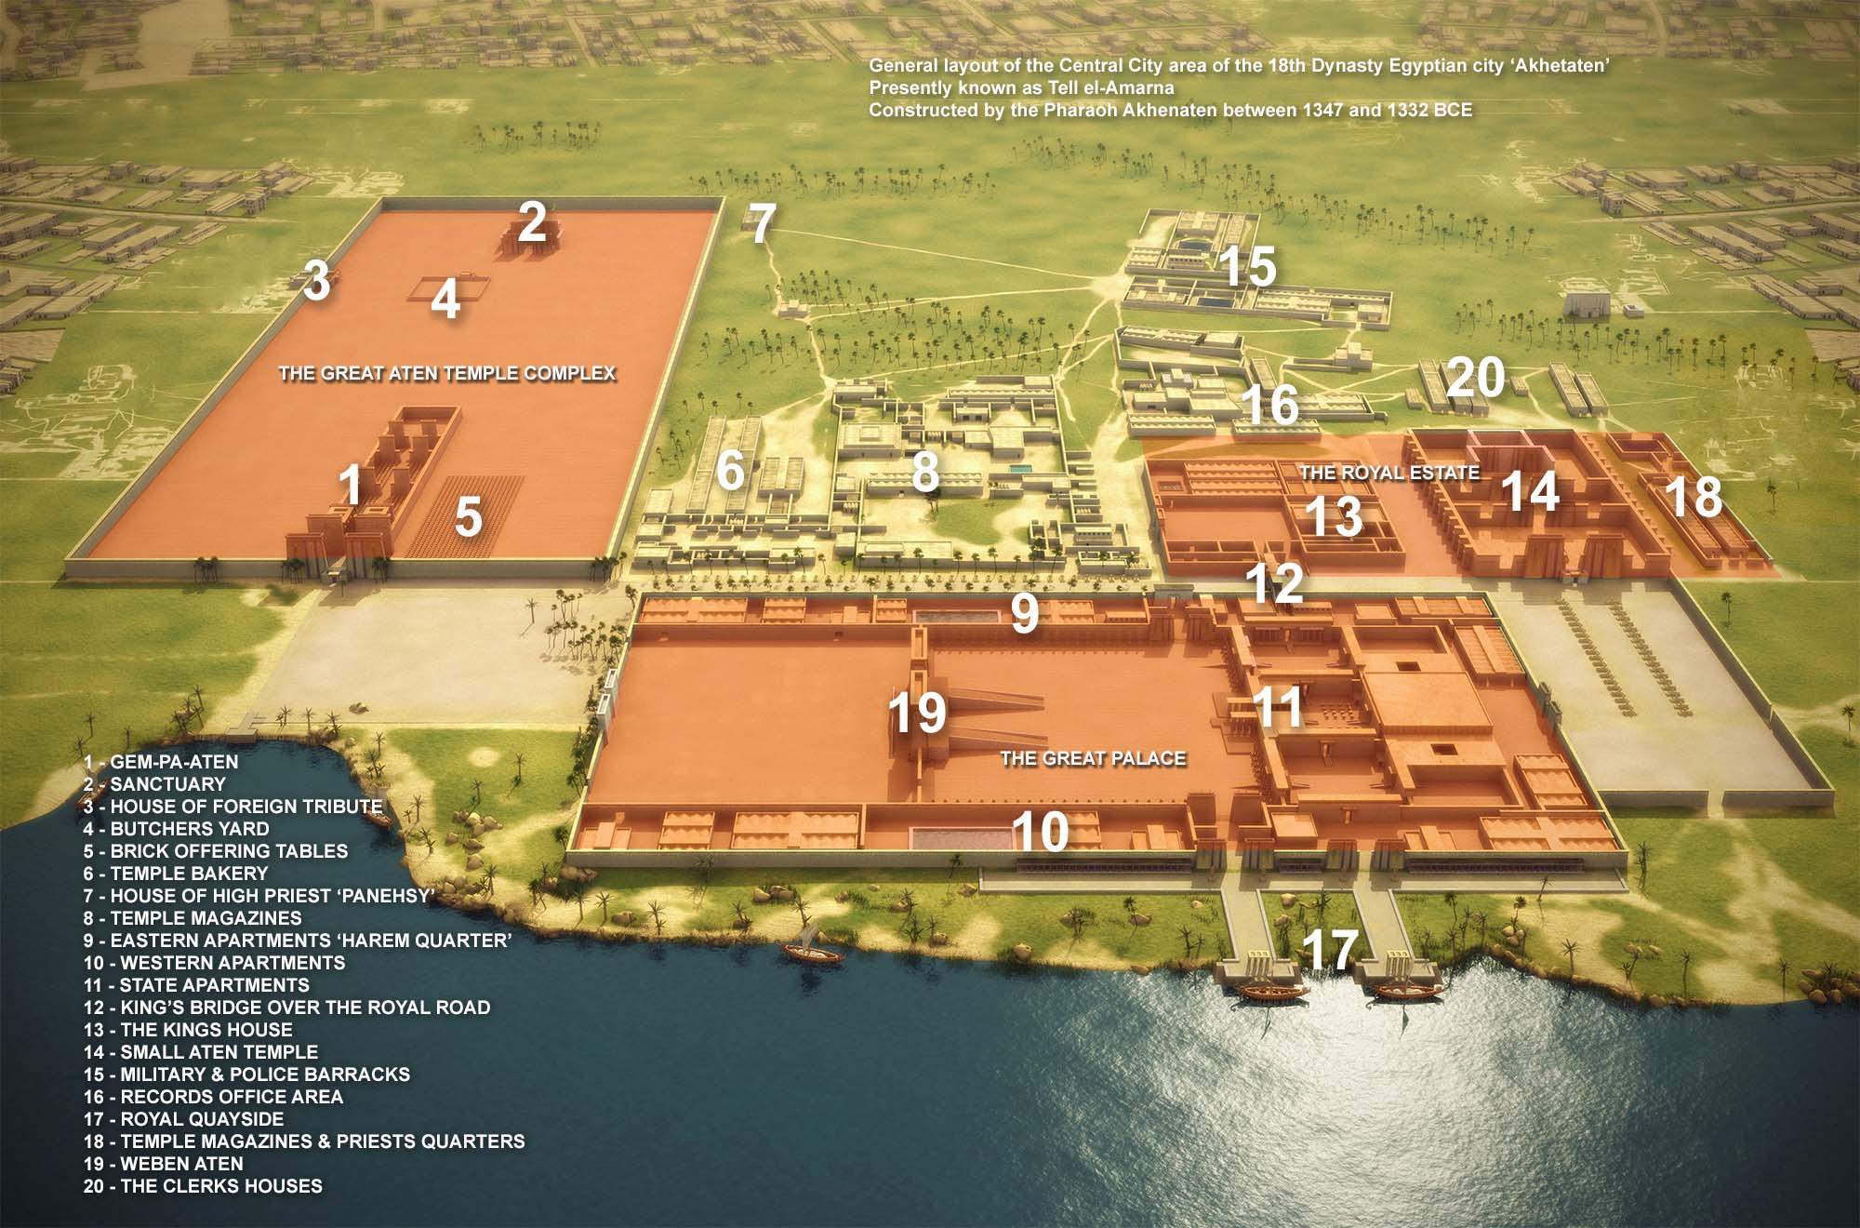
Figure 8: City of Amarna drawing 3D, Docherty, P. S. Amarna3D. "Map of Amarna, Egypt." World History Encyclopedia
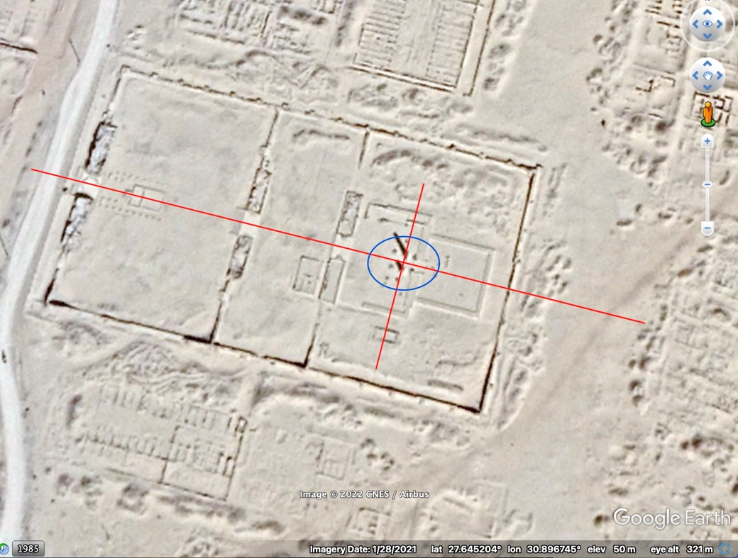
Figure 9: Small Aten Temple from Google earth Pro
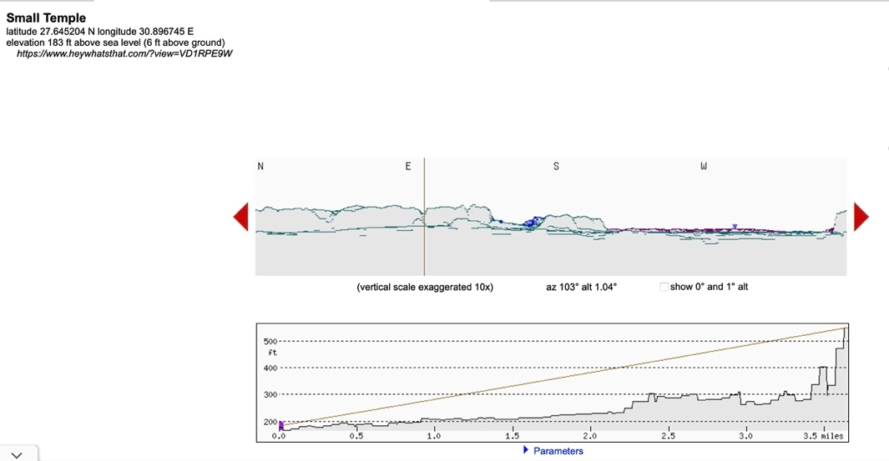
Figure 10: Small Aten Temple Elevation from HeyWhatsThat

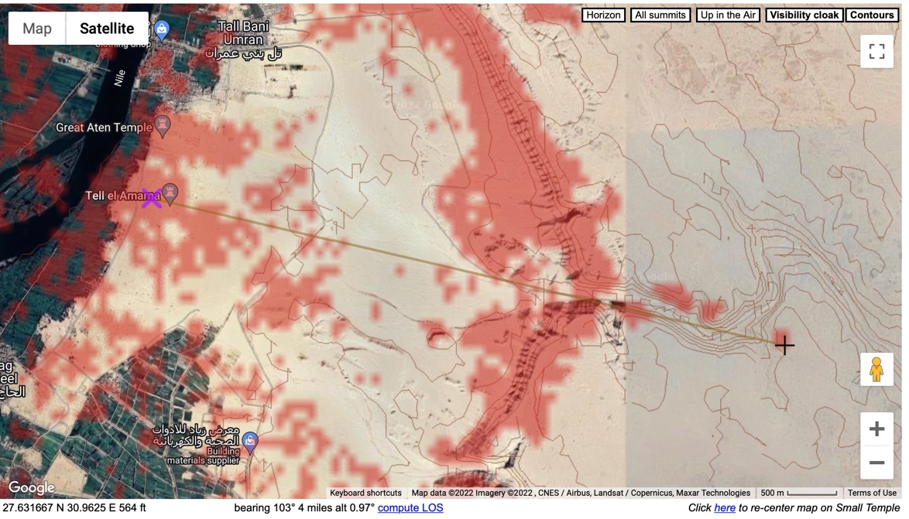
Figure 11: Small Aten Temple Map from HeyWhatsThat

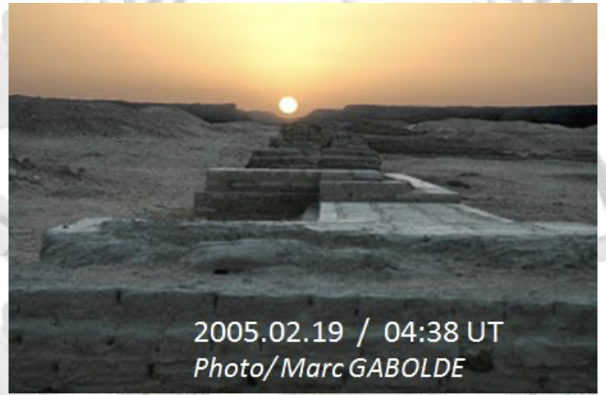
Figure 12: Small Aten Temple Sunrise photo by Marc Gabolde
Akhenaten and Akhetaten
Much has been written on the subject of Akhenaten his perceived monotheism, his sun worship, his strange statues, his family values and his new city of Akhetaten (Amarna). The views expressed cover a wide gamut of opinions from negative to positive. James Henry Breasted saw a ‘simple and beautiful realism’ in the art but finds Akhenaten’s body form an unresolved problem, the pharaoh’s family life ‘open and unconcealed before the people’ is seen as a positive note. With ‘effeminate counsellors’ such as his wife and mother in Breasted’s opinion Akhenaten failed to address the military needs of Egypt and immersed himself in the ‘philosophising theology of the priests’. Arthur E. P. Weigall compares the Great Hymn to the Aten to Psalm 104 and sees the religion of the Aten as akin to Christianity.
In the opinion of Eric Hornung the ‘Great Hymn to the Aten’ may perhaps have been written by Akhenaten. The text has survived through a copy being made by Urbain Bouriant, a French Egyptologist, the original in the tomb of Aya being partially destroyed in 1890 during a quarrel. Hornung contrasts the ‘Great Hymn to the Aten’ with previous solar songs, where the mythical imagery of the past has been replaced by the observation of nature. The primaeval creation of the cosmos has been replaced by the Aten who continually creates the world by means of his pure light, this light shines on all peoples, not just Egypt. There also appears to be a connection to rain and watering lands other than Egypt, while the true Nile is watering the land of Egypt. The Aten does not just supply the heat and rays of the sun it supplies life. The following stanza describes the growing of the crops and the different seasons. The following lines perhaps indicate that the passage of the sun over the seasons is being observed
You made the sky far in order to ascend to it
and gaze upon what you have created.

You are unique when you have risen
in all your manifestations as the living Aten
who shines and gleams,
distances himself and comes near .

Akhenaten had a vision of worshipping the Aten when he first ascended the throne, he spent some time building temples in Karnak, Luxor and as far afield as Nubia but this does not seem to have fulfilled his feelings on the worship of the Aten. Egypt had many gods and many temples, perhaps looking for an unused site was a necessary part of being able to focus on the worship of the Aten. Another important consideration of this worship was that Akhenaten and his wife appear to be the only interface between the god and the people. Akhenaten had a one-to-one relationship with the Aten his father, his arrival on a chariot of electrum would perhaps link the son with the father as the sun rose and the chariot gleamed in the sun’s rays.
The stelae confirm that it was Akhenaten who looked for the site of the new city under guidance from the Aten. The wording indicates that perhaps his advisers tried to dissuade him from founding a city in such an inhospitable area, that was a considerable distance away from the normal seats of power at Thebes and Memphis. Although the city margins were expanded on the west to encompass the agricultural land and the tombs in the Royal Wadi were slightly outside the boundary, was this the limit of the city itself or the limit of the sun’s travel as viewed from the Small Aten Temple. The city was not an important part of Amarna according to Kemp it was the land that was defined by the boundary stelae. Akhenaten did not proscribe himself and his family from travelling as the stelae have instructions that if any of them died ‘in any town downstream, to the south, to the west, to the east’ then they have to be brought back to be buried at Amarna. The previous importance of returning to Egypt to die and be buried appears to be restricted to being buried at Amarna. Jan Assmann considers that the new religion saw only one existence, the present and this was illuminated by the Aten, the afterlife and the netherworld disappeared. According to Hornung life after death for the populace was no longer the Netherworld but sleeping during the night and accompanying Akhenaten and his family to the temple during the day. The people were looked after by the pharaoh, as he looked after them in life, the Aten only looking after his son Akhenaten.
James K. Hoffmeier speculates that crepuscular rays may have been the inspiration for the shape of pyramids and the Benben stone but states that not until the Amarna period was the sun’s rays included in the iconography, this becoming the sun’s rays with hands as in Figure 13. In the opinion of Orly Goldwasser the image of the sun’s rays with hands is the image of ‘Energy of Light’, which is usually identified as the ‘Living Aten’, the hieroglyph represents not just a name or a phrase but a complex notion. The name of the Aten, according to Goldwasser, which is written with a sun disc determinative as in Figure 14, never needs a divine determinative, such as a small god figure, as there is only the Aten a divine determinative is unnecessary. The disc with rays and hand should not be interpreted according to Hornung as a depiction of the sun disc itself, it is the light that comes from the sun and keeps the world alive, the Aten as the god of the life-giving light.

Figure 13: Aten image illustration with sun’s rays terminating in hands
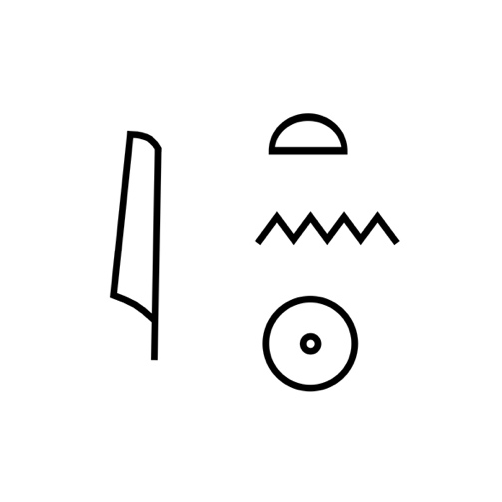
Figure 14: The name of the Aten

Conclusion
The initial upbringing of Akhenaten would have brought him into contact with the worship of multiple gods, some with sun connections but there has not been found a driving force that would have changed his religious ideas. The city of Amarna was built specifically to be in a new and isolated place. The pharaoh identified this place with the help of the Aten, it is likely that he saw the desert bay as he sailed down the Nile, perhaps at or near dawn and he may have seen the sunrise over what was to become the Royal Wadi. The stelae were large and would have stood out making a statement on the cliffs that this was a royal proclamation. The electrum chariot was another statement and connection to the sun, the pharaoh travelling in it being similar to the sun travelling through the sky. The temples had a great many offering tables, we do not know if they were all used at the same time or if the food was distributed amongst the ordinary people afterwards. The quality and quantity of offerings were mentioned on the stelae, so they obviously were important. The Small Aten Temple was connected to the Royal Apartments so it is a possibility that it was the personal temple of Akhenaten, he may have used it to greet each new day. From this temple, the sun would have risen in line with the Royal Wadi as the name of the city the 'Horizon of the Aten' twice a year. The connection with a particular calendar date is unlikely as the Egyptians did not use a solar calendar. The ’Greta hymn to the Aten’ shows the special connection that Akhenaten considered he had with the Aten and the different connection he had with his land. The worship of the Aten was very limited as all worship was conducted through Akhenaten and the royal family; it was as if the sun only rose in the one place. There was no continuation of the religion once Akhenaten died, although the sun still rose over the Royal Wadi.

Illustrations

Figure 1: Map of Egypt < https://egyptianwisdomcenter.org/map-of-egypt/ > [accessed 25/April/2022]

Figure 2: Map of Boundary Stelae < https://www.amarnaproject.com/pages/amarna_the_place/boundary_stelae/index.shtml > [accessed 25/April/2022]

Figure 3: Early Aten cartouche. The Met Museum Accession Number: 21.9.431 < https://www.metmuseum.org/art/collection/search/549821 > [accessed 25/April/2022]

Figure 4: Map of Amarna, Stevens, Anna, Tell el-Amarna in UCLA Encyclopedia of Egyptology, ed. by Willeke Wendrich (Los Angeles 2016) <http://digital2.library.ucla.edu/viewItem.do?ark=21198/zz002k6x4x > [accessed 25/April/2022]

Figure 5: Map of the Great Aten Temple from Google Earth Pro

Figure 6: Great Temple Elevation from HeyWhatsThat

Figure 7: Great Temple Map from HeyWhatsThat

Figure 8: City of Amarna drawing 3D, Docherty, P. S. Amarna3D. "Map of Amarna, Egypt." World History Encyclopedia. < https://www.worldhistory.org/image/12167/map-of-amarna-egypt/ > [accessed 30 April 2022]

Figure 9: Small Aten Temple from Google earth Pro

Figure 10: Small Aten Temple Elevation from HeyWhatsThat

Figure 11: Small Aten Temple Map from HeyWhatsThat

Figure 12: Small Aten Temple Sunrise photo by Marc Gabolde <https://www.archaeometry.org/nefertiti.htm >

Figure 13: Aten image illustration with sun’s rays terminating in hands < https://en.wikipedia.org/wiki/Aten >
Figure 14: The name of the Aten < https://commons.wikimedia.org/wiki/File:Aton.svg >

Bibliography

Aldred, Cyril, ‘The Horizon Of The Aten’, The Journal Of Egyptian Archaeology, 62 (1976), p. 184
Assmann, Jan, Death And Salvation In Ancient Egypt, trans. by David Lorton (Ithaca: Cornell University Press, 2005)
Bard, Kathryn A., ‘Royal Cities And Cult Centers, Administrative Towns, And Workmen’s Settlements In Ancient Egypt’, in The Ancient City: New Perspectives On Urbanism In The Old And New World, ed. by Joyce Marcus and Jeremy A. Sabloff (Santa Fe: School for Advanced Research Press, 2008), pp 165-182
Belmont, Juan Antonio and others, ‘On the Orientation of Ancient Egyptian Temples: (5) Testing the Theory in Middle Egypt and Sudan’, Journal For The History Of Astronomy, 41.1 (2010), 65-93
Belmont, Juan Antonio, ‘In Search Of Cosmic Order: Astronomy And Culture In Ancient Egypt’ in The Role Of Astronomy In Society And Culture: Proceedings Of The International Astronomical Union, IAU Symposium No. 260, ed. by David Valls-Gabaud and Alexander Boksenberg (2011), pp. 74-86
Belmont, Juan Antonio, ‘Orientation Of Egyptian Temples: An Overview’, in Handbook Of Archaeoastronomy And Ethnoastronomy, ed. by Clive L. N. Ruggles, (New York: Springer, 2015), pp. 1501-1518, <doi.org/10.1007/978-1-4614-6141-8_146>.
Breasted, James Henry, A History Of The Ancient Egyptians, (New York: Charles Scribner’s Sons, 1908)
Goldwasser, Orly ‘The Aten Is The Energy of Light: New Evidence From The Script’, Journal Of The American Research Center in Egypt, 46 (2010), pp. 159-165
Hoffmeier, James K., Akhenaten And The Origins Of Monotheism (Oxford: Oxford University Press, 2015)
Hornung, Eric, Akhenaten And The Religion Of Light, trans. by David Lorton (Ithaca: Cornell University Press, 1995)
Kemp, Barry Ancient Egypt: Anatomy Of A Civilization, 2nd edn. (London: Routledge, 2006)
Kemp, Barry, The City Of Akhenaten And Nefertiti: Amarna And Its People (London: Thames and Hudson Ltd., 2013)
Kemp Barry and Paul Docherty, ‘The Solar Observation And Offering Platform At The Front Of The Great Aten Temple’, The Amarna Project (2018), 1-7 <https://www.amarnaproject.com/documents/pdf/Solar-Observation-and-Offering-Platform.pdf> [accessed 25/April/2022]
Murnane, William J. and Charles C van Siclen III, The Boundary Stelae of Akhenaten (Abingdon: Routledge, 2011)
Petrie, W. M. Flinders, Tell El Amarna, (London: Methuen & Co., 1894)
Prendergast Frank, ‘Techniques Of Field Survey’, in Handbook Of Archaeoastronomy And Ethnoastronomy, ed. by Clive L. N. Ruggles, (New York: Springer, 2015), <DOI.org/10.1007/978-1-4614-6141-8_31>
Redford, Donald B., ‘Akhenaten: New Theories And Old Facts’, Bulletin Of The American Schools Of Oriental Research, 369 (2013), pp. 9- 34
Ridpath, Ian, ed. A Dictionary Of Astronomy: Online Version, 3rd edn. (Oxford: Oxford University Press, 2018), <DOI: 10.1093/acref/9780191851193.001.0001>
Ruggles, Clive L. N. and N. J Saunders, ‘The Study Of Cultural Astronomy’, in Astronomies And Cultures, ed. by Clive L. N. Ruggles and N. J. Saunders (Niwot: University Press of Colorado, 1993), pp. 1–31, cited in Silva, Fabio, ‘The Role And Importance Of The Sky In Archaeology: An Introduction’, in Skyscapes: The Role And Importance Of The Sky In Archaeology, ed. by Fabio Silva and Nicholas Campion (Oxford: Oxbow Books, 2015), pp. 1-7
Ruggles, Clive L. N., ‘Analyzing Orientations’, in Handbook Of Archaeoastronomy And Ethnoastronomy, ed. by Clive L. N. Ruggles, (New York: Springer, 2015), pp. 411-425 (pp. 413-417), <DOI.org/10.1007/978-1-4614-6141-8_26>
Silva, Fabio ‘The Role And Importance Of The Sky In Archaeology: An Introduction’, in Skyscapes: The Role And Importance Of The Sky In Archaeology, ed. by Fabio Silva and Nicholas Campion (Oxford: Oxbow Books, 2015), pp 1-7
Wells, Ronald A. ‘The Amarna M, X, K Boundary Stelae Date: A Modern Calendar Equivalent’, Studien zur Altägyptischen Kultur, 14 (1987), pp. 313-333
Wilkinson, Richard H., The Complete Temples Of Ancient Egypt, (London: Thames & Hudson Ltd., 2000)

Barry Kemp, The City Of Akhenaten And Nefertiti: Amarna And Its People (London: Thames and Hudson Ltd., 2013), p.14.
Kathryn A. Bard, ‘Royal Cities And Cult Centers, Administrative Towns, And Workmen’s Settlements In Ancient Egypt’, in The Ancient City: New Perspectives On Urbanism In The Old And New World, ed. by Joyce Marcus and Jeremy A. Sabloff (Santa Fe: School for Advanced Research Press, 2008), pp. 165-182 (p. 176).
Fabio Silva, ‘The Role And Importance Of The Sky In Archaeology: An Introduction’, in Skyscapes: The Role And Importance Of The Sky In Archaeology, ed. by Fabio Silva and Nicholas Campion (Oxford: Oxbow Books, 2015), pp. 1-7 (p. 3).
. Clive L. N Ruggles, and N. J. Saunders, ‘The Study Of Cultural Astronomy’, in Astronomies And Cultures, ed. by Clive L. N. Ruggles and N. J. Saunders (Niwot: University Press of Colorado, 1993), pp. 1–31 (p. 2-4), cited in Fabio Silva, ‘The Role And Importance Of The Sky In Archaeology: An Introduction’, in Skyscapes: The Role And Importance Of The Sky In Archaeology, ed. by Fabio Silva and Nicholas Campion (Oxford: Oxbow Books, 2015), pp. 1-7 (p. 2).
Silva, ‘The Role And Importance Of The Sky’, p. 2.
Barry Kemp, Ancient Egypt: Anatomy Of A Civilization, 2nd edn. (London: Routledge, 2006), p. 285.
Ian Ridpath, ed. A Dictionary Of Astronomy: Online Version, 3rd edn. (Oxford: Oxford University Press, 2018), p. 19, <DOI: 10.1093/acref/9780191851193.001.0001>.
Ridpath, ed. A Dictionary Of Astronomy, p. 49.
Clive L. N. Ruggles, ‘Analyzing Orientations’, in Handbook Of Archaeoastronomy And Ethnoastronomy, ed. by Clive L. N. Ruggles, (New York: Springer, 2015), pp. 411-425 (pp. 413-417), <DOI.org/10.1007/978-1-4614-6141-8_26>.
Juan Antonio Belmont and others, ‘On the Orientation of Ancient Egyptian Temples: (5) Testing the Theory in Middle Egypt and Sudan’, Journal For The History Of Astronomy, 41.1 (2010), 65-93 (p.66).
Juan Antonio Belmont, ‘Orientation Of Egyptian Temples: An Overview’, in Handbook Of Archaeoastronomy And Ethnoastronomy, ed. by Clive L. N. Ruggles, (New York: Springer, 2015), pp. 1501-1518 (p. 1512), <doi.org/10.1007/978-1-4614-6141-8_146>.
Frank Prendergast, ‘Techniques Of Field Survey’, in Handbook Of Archaeoastronomy And Ethnoastronomy, ed. by Clive L. N. Ruggles, (New York: Springer, 2015), pp. 389-409 (p. 391), <DOI.org/10.1007/978-1-4614-6141-8_31>.
Richard H. Wilkinson, The Complete Temples Of Ancient Egypt (London: Thames & Hudson Ltd., 2000), pp. 30-31.
William J. Murnane and Charles C van Siclen III, The Boundary Stelae of Akhenaten (Abingdon: Routledge, 2011), p. 1.
Ronald A. Wells, ‘The Amarna M, X, K Boundary Stelae Date: A Modern Calendar Equivalent’, Studien zur Altägyptischen Kultur, 14 (1987), pp. 313-333 (p.315).
Wells, ‘The Amarna M, X, K Boundary Stelae Date’ pp. 331-333.
Cyril Aldred, ‘The Horizon Of The Aten’, The Journal Of Egyptian Archaeology, 62 (1976), p. 184.
Wilkinson, The Complete Temples Of Ancient Egypt, pp. 36-37.
Wilkinson, The Complete Temples Of Ancient Egypt, p. 37.
Belmont, ‘Orientation Of Egyptian Temples: An Overview’, p.1510.
Belmont and others, ‘On the Orientation of Ancient Egyptian Temples: (5), pp. 65-66.
Belmont and others, ‘On the Orientation of Ancient Egyptian Temples: (5), p. 66.
Belmont and others, ‘On the Orientation of Ancient Egyptian Temples: (5), p. 89.
Belmont, ‘Orientation Of Egyptian Temples: An Overview’, p.1510.
Juan Antonio Belmont, ‘In Search Of Cosmic Order: Astronomy And Culture In Ancient Egypt’ in The Role Of Astronomy In Society And Culture: Proceedings Of The International Astronomical Union, IAU Symposium No. 260, ed. by David Valls-Gabaud and Alexander Boksenberg (2011), p. 74-86 (p. 84).
Belmont, ‘In Search Of Cosmic Order’, p. 85.
Barry Kemp and Paul Docherty, ‘The Solar Observation And Offering Platform At The Front Of The Great Aten Temple’, The Amarna Project (2018), 1-7 (p. 1) <https://www.amarnaproject.com/documents/pdf/Solar-Observation-and-Offering-Platform.pdf> [accessed 25/April/2022]
Kemp and Docherty, ‘The Solar Observation And Offering Platform’, p. 4.
Kemp and Docherty, ‘The Solar Observation And Offering Platform’, p. 5.
Kemp and Docherty, ‘The Solar Observation And Offering Platform’, p. 5.
Kemp and Docherty, ‘The Solar Observation And Offering Platform’, p. 6.
Bard, ‘Royal Cities And Cult Centers’, p. 177.
Murnane and van Siclen III, The Boundary Stelae of Akhenaten, p. 1.
W. M. Flinders Petrie, Tell El Amarna, (London: Methuen & Co., 1894), p. 5-6.
Murnane and van Siclen III, The Boundary Stelae of Akhenaten, p. 1.
Murnane and van Siclen III, The Boundary Stelae of Akhenaten, pp. 1-2.
Kemp, The City Of Akhenaten And Nefertiti, p. 40.
Kemp, The City Of Akhenaten And Nefertiti, p. 33.
Murnane and van Siclen III, The Boundary Stelae of Akhenaten, pp. 11-109.
Murnane and van Siclen III, The Boundary Stelae of Akhenaten, pp. 35-48.
Kemp, The City Of Akhenaten And Nefertiti, p. 35.
Donald B. Redford, ‘Akhenaten: New Theories And Old Facts’, Bulletin Of The American Schools Of Oriental Research, 369 (2013), pp. 9- 34 (p. 18).
Kemp, The City Of Akhenaten And Nefertiti, p. 87.
Kemp, The City Of Akhenaten And Nefertiti, p. 92.
Kemp, The City Of Akhenaten And Nefertiti, p. 95.
Kemp, The City Of Akhenaten And Nefertiti, p. 96.
Kemp and Docherty, ‘The Solar Observation And Offering Platform’, p. 5.
Kemp, The City Of Akhenaten And Nefertiti, pp. 86-87.
James Henry Breasted, A History Of The Ancient Egyptians, (New York: Charles Scribner’s Sons, 1908), pp. 277-278.
Breasted, A History Of The Ancient Egyptians, p. 264.
Arthur E. P. Weigall, The Life And Times Of Akhnaton: Pharaoh Of Egypt, (Edinburgh: William Blackwood and Sons, 1911), pp. 155-157.
Eric Hornung, Akhenaten And The Religion Of Light, trans. by David Lorton (Ithaca: Cornell University Press, 1995), p. 78.
Hornung, Akhenaten And The Religion Of Light, p.84.
Hornung, Akhenaten And The Religion Of Light, p. 82.
Kemp, The City Of Akhenaten And Nefertiti, p. 155.
Jan Assmann, Death And Salvation In Ancient Egypt, trans. by David Lorton (Ithaca: Cornell University Press, 2005), p. 15.
Hornung, Akhenaten And The Religion Of Light, p.102.
James K. Hoffmeier, Akhenaten And The Origins Of Monotheism, (Oxford: Oxford University Press, 2015), p. 11.
Orly Goldwasser, ‘The Aten Is The Energy of Light: New Evidence From The Script’, Journal Of The American Research Center in Egypt, 46 (2010), pp. 159-165, (p. 165).
Hornung, Akhenaten And The Religion Of Light, p.54.

