Harry Woollands
2214706
Abstract
This report designs, simulates, implements, analyses, and compares the performance of a Braun’s Multiplier and Wallace Multiplier designed using Vivado software, highlighting their similarities and differences. Both multipliers are also implemented onto a BASYS FPGA board. The results of the study reveal that the Wallace Multiplier has superior performance, in terms of both speed and power efficiency.

Critical evaluation of braun’s multiplier and wallace tree multiplier using vhdl
ACDA6001 – Electronics II
2719 Words
Contents
Table of Figures 2
Introduction 4
Multipliers 5
Braun’s Multiplier 5
Wallace Tree Multiplier 5
Development in Multiplier Techniques 6
Task 1 7
Flowchart 7
Testing 8
Register-transfer-level (RTL) Design 16
Implementation 16
Task 2 20
Flowchart 20
Testing 22
Register-transfer-level (RTL) Design 30
Implementation 30
Task 3 35
Longest delay 35
Power Consumption and Utilisation 39
Look-up Tables (LUT’s) 41
Speed and Power Efficiency 41
Conclusion 42
Bibliography 43
Appendices 45
Appendix A - Half-adder code 45
Appendix B - Full adder code 46
Appendix C - Braun’s Multiplier code 47
Appendix D - Wallace Multiplier code 65

Table of Figures
Figure 1. Half Adder and Full Adder circuit diagrams [2]. 4
Figure 2. Braun's 8x8 Reference Diagram [9]. 6
Figure 3. Flowchart showing operation of 8x8 Braun's Multiplier. 7
Figure 4. Braun's Multiplier simulation test 1. 8
Figure 5. Hexadecimal calculator for test 1. 9
Figure 6. Braun's Multiplier simulation test 2. 10
Figure 7. Hexadecimal calculator for test 2. 11
Figure 8. Braun's Multiplier simulation test 3. 12
Figure 9. Hexadecimal calculator for test 3. 13
Figure 10. Braun's Multiplier simulation test 4. 14
Figure 11. Hexadecimal calculator for test 4. 15
Figure 12. Braun's Multiplier RTL design. 15
Figure 13. Braun's Multiplier Implementation Schematic. 16
Figure 14. Braun's Multiplier device implementation. 17
Figure 15. Braun's Multiplier I/O Planning. 18
Figure 16. Braun's Multiplier Implemented on BASYS Board. 19
Figure 17. Binary Calculator for Braun’s FPGA test. 19
Figure 18. Wallace dot Diagram [12]. 20
Figure 19. Flowchart showing operation of Wallace Multiplier. 21
Figure 20. Wallace Multiplier simulation test 1. 22
Figure 21. Hexadecimal calculator for test 1. 23
Figure 22. Wallace Multiplier simulation test 2. 24
Figure 23. Hexadecimal calculator for test 2. 25
Figure 24. Wallace Multiplier simulation test 3. 26
Figure 25. Hexadecimal calculator for test 3. 27
Figure 26. Wallace Multiplier simulation test 4. 28
Figure 27. Hexadecimal calculator for test 4. 29
Figure 28. Wallace Multiplier RTL design. 29
Figure 29. Wallace Multiplier Implementation Schematic. 30
Figure 30. Wallace Multiplier device implementation. 31
Figure 31. Wallace Multiplier I/O Planning. 32
Figure 32. Wallace Multiplier Implemented on BASYS Board. 32
Figure 33. Binary Calculator for Wallace FPGA test. 33
Figure 34. Braun's Critical Path. 34
Figure 35. Wallace Critical Path. 34
Figure 36. Braun's Timing Summary. 35
Figure 37. Wallace Timing Summary. 35
Figure 38. Braun's delays. 36
Figure 39. Wallace's delays. 37
Figure 40. Braun's Multiplier Power summary. 38
Figure 41. Braun's Multiplier Power Utilisation. 38
Figure 42. Braun's Multiplier Power Utilisation. 39
Figure 43. Wallace Multiplier Power summary. 39
Figure 44. Wallace Multiplier Power Utilisation. 39
Figure 45. Wallace Multiplier Power Utilisation. 40
Figure 46. Braun's Multiplier LUT's. 40
Figure 47. Wallace Multiplier LUT's. 40

Introduction
In digital electronics, Multipliers are essential for applications such as Digital Signal Processing (DSP). Due to their importance, multipliers are continuing to be developed to increase and enhance their efficiency, with the goal of consuming less power and providing greater speeds.
This report will compare, contrast and critically evaluate two different types of binary multiplier techniques – Braun’s Multiplier, and Wallace Tree Multiplier. These multipliers performance will be compared using metrics such as longest delay and power consumption to conclude which is the better multiplier method. Both multipliers will be designed and compared using VHDL Vivado Software, before being implemented onto a Field-Programable Gate Array (FPGA).
In Task 1, an 8-bit Braun’s Multiplier will be designed in order to produce a 16-bit result. In task 2, a Wallace Tree Multiplier will be designed using a provided diagram for reference. Both multipliers will be simulated and synthesized for FPGA design. Finally, in Task 3, the performance of both multipliers will be evaluated.

Multipliers
Multipliers can be defined as circuits that are used to multiply two numbers together, producing an output [1]. In digital electronics, this multiplication is done through the use of AND gates, as well as the use of full adders and half adders. There are numerous different types of multipliers, all of which produce the same output, but have different speeds and different levels of complexity. For the purpose of this report, only Braun’s Multiplier and Wallace Tree Multiplier will be focused on.
Figure 1 below shows the logic circuit diagrams for half adders and full adders. The half adder is comprised of an XOR gate and an AND gate. The half adder has two inputs, A and B, and produces two outputs, a Sum and a carry. The full adder is comprised of two XOR gates, an OR gate, and two AND gates. The full adder has three inputs, A, B, and a carry (C-in) from a previous adder. It also produces two outputs, a sum and a carry.
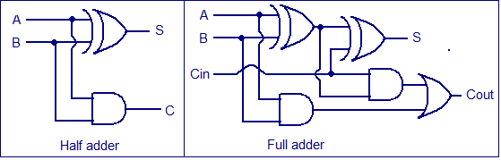
Figure 1. Half Adder and Full Adder circuit diagrams [2].

Braun’s Multiplier
Braun’s Multiplier is one type of binary multiplier, multiplying two binary numbers (A and B) to produce an output. The Braun’s Multiplier is built using AND gates, as well as the use of full adders and half adders. Braun’s Multiplier works by multiplying each bit of number ‘A’ by each bit of number ‘B’. This results in numerous partial products [3]. These partial products are then added together using full adders and half adders. Each adder produces two outputs, the sum output, and the carry output. This occurs for every adder, which results in a final binary output, the result of the multiplication of the binary numbers. Advantages of Braun’s multiplier is that is a simple design, and therefore can be easy to implement. However, due to its simplicity, it is slower than other types of multiplier, which can worsen with increasing the number of bits that are multiplied [4]. A real-world example of where are Braun’s Multiplier is used is in medical imaging [4].

Wallace Tree Multiplier
Wallace Tree Multiplier is another type of binary multiplier, albeit a more complex multiplier than Braun’s Multiplier. Just like in Braun’s multiplier, each bit of one number (A) is multiplied with each bit of the other number (B) using AND gates to form partial products. For the first line of adders, the partial products are added in groups of three. For the next lines of adders, the sum of the previous adders and a partial product are added together. This continues until the final line of adders, where the only inputs are sums and carries, which produces the final output [5]. The main advantage of Wallace Tree Multiplier is that it is much faster than Braun’s Multiplier. However, it is more complex and therefore harder to implement. A common example of where Wallace Tree Multiplier is used is in high performance image and video processors [6].

Development in Multiplier Techniques
As technology develops and knowledge increases, multipliers will continue to develop. This development will focus on areas such as reducing timing delays, such as shortening their critical path, and reducing power consumption. Reducing timing delays will result in a faster time for data to pass through the multiplier from input to output. One of the ways to reduce this is through reducing the critical path, which is defined as the longest path that data can take from input to output [7]. The critical path determines the maximum speed which the multiplier can operate, so by making the critical path shorter, the multiplier is faster. Reducing power consumption increases the efficiency of the multiplier, increasing overall performance of the multiplier [8].

Task 1
Task 1 was to design an 8-bit Braun’s Multiplier. The multiplier had to be designed such that two unsigned numbers created partial products when multiplying each bit of the first number with each bit of the second number, with these partial products producing a 16-bit result. After this, the logic circuit design will be provided, as well as a range of simulated results. Finally, the design will be synthesized, so that the multiplier can be integrated onto an FPGA. Figures will be provided as proof that the design functions correctly.

Flowchart
Before designing the 8x8 Braun’s Multiplier, a flowchart was necessary in order to code the multiplier accurately. Figure 2 below shows a diagram sourced from a paper [9], which was used as a reference when creating the flowchart.
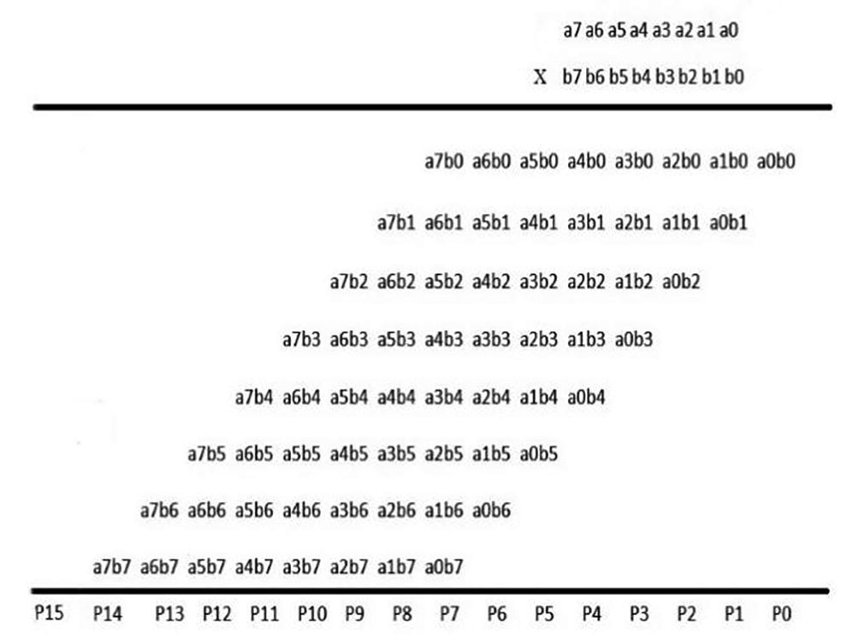
Figure 2. Braun's 8x8 Reference Diagram [9].
Figure 3 below shows the flowchart created for the 8x8 Braun’s Multiplier. The flowchart is made from AND gates, Half adders, and Full adders. The diagram contains 8 Half adders, and 48 Full adders.
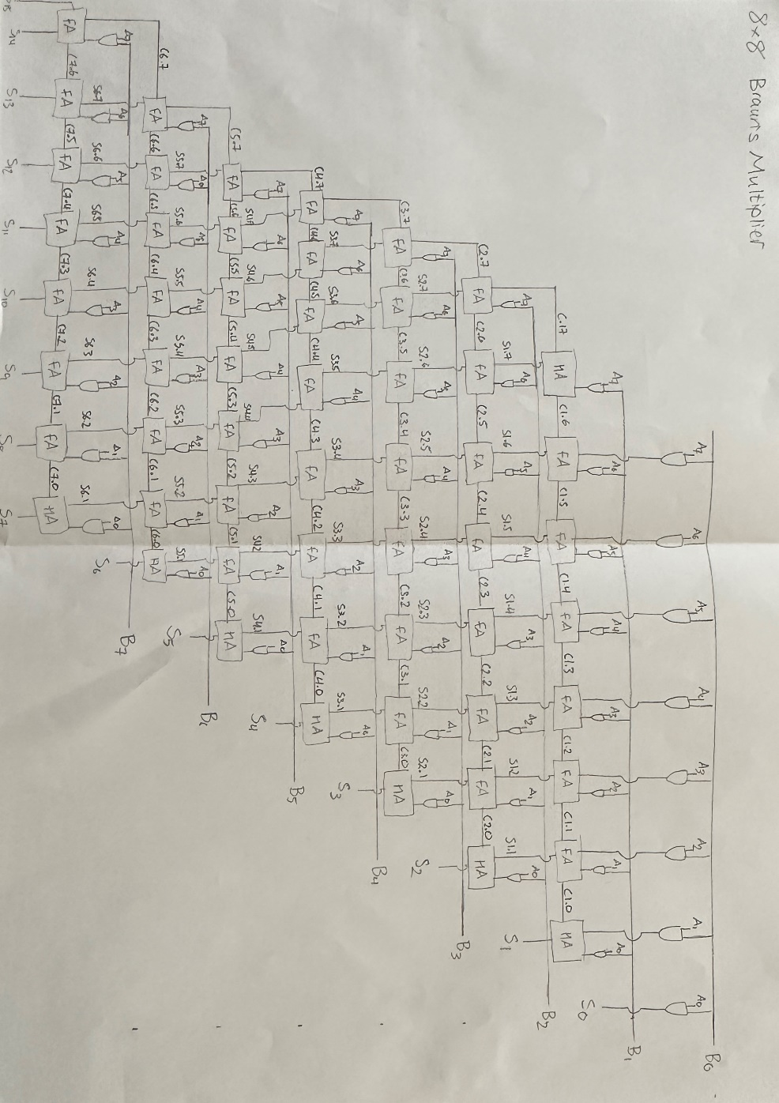
Figure 3. Flowchart showing operation of 8x8 Braun's Multiplier.
The Braun’s Multiplier works by first adding each bit of ‘A’ to each bit of ‘B’. These values are then inputted into the adders. Each half adder takes 2 ‘AB’ inputs, producing a product, and a carry. In the case of all bar one of the half adders, the product is one of the bits of the 16-bit overall output. The only exemption to this is the half adder at the left-hand side of the first row of adders, where one of its inputs is a carry input. In the case of the full adders, most take 3 inputs, 1 of which is an ‘AB’ input, the second being the product from the adder directly above it in the previous row, and the final one being a carry from the adders directly to the right of its position. The exemptions to this are the full adders on the left-hand side of each row, which have a secondary carry input, which comes from the far-left adder on the previous row. Finally, the products of all of the final row of adders are the bits used to make up the 16-bit value. The last point of note is that far left adder on the final row produces two of these outputs, with both the product and the carry bit taken into the final 16-bit value.

Testing
Next, using the flowchart, the Braun’s Multiplier was designed using Vivado. After designing it, a number of checks had to be conducted. The code for Braun’s Multiplier can be found in the appendix C. The first check was to run the simulation, inputting hexadecimal values. To do this on Vivado, first the clock, and then the constant had to be forced for both A and B values. To check that the calculated output value was correctly, an online hexadecimal calculator was used. Figures 4, 6 ,8 and 10 below show four tests using Vivado. Figures 5, 7, 9 and 11 show the tested values inputted into the online hexadecimal calculator. These figures match the Vivado screenshots, showing that the Braun’s Multiplier is functioning as intended.
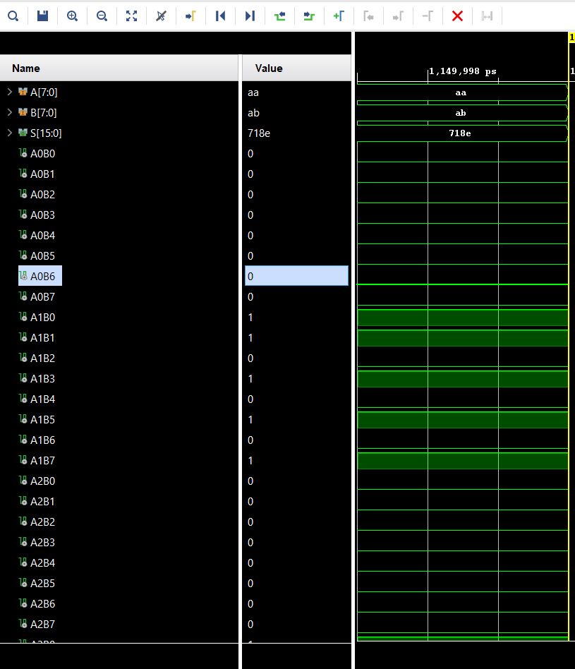
Figure 4. Braun's Multiplier simulation test 1.
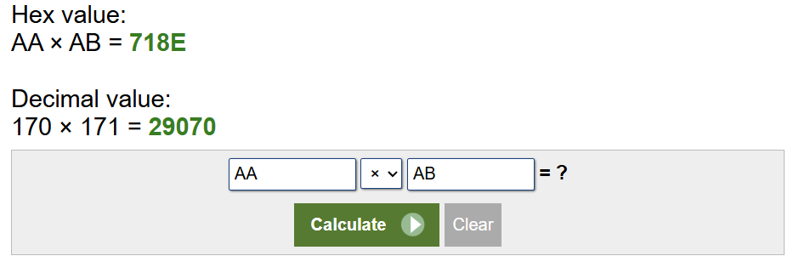
Figure 5. Hexadecimal calculator for test 1.
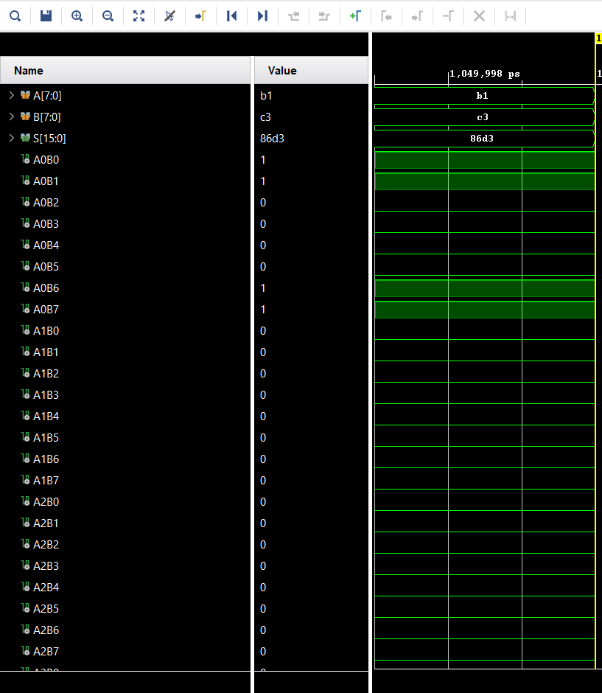
Figure 6. Braun's Multiplier simulation test 2.
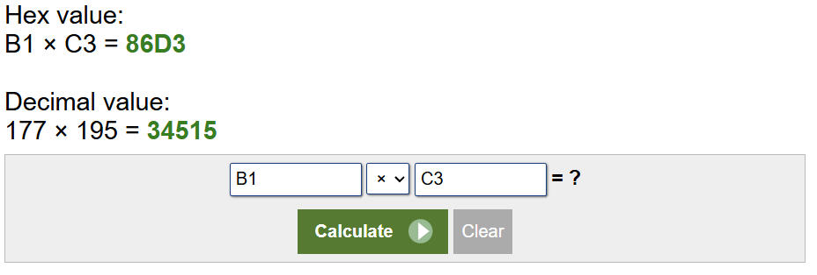
Figure 7. Hexadecimal calculator for test 2.
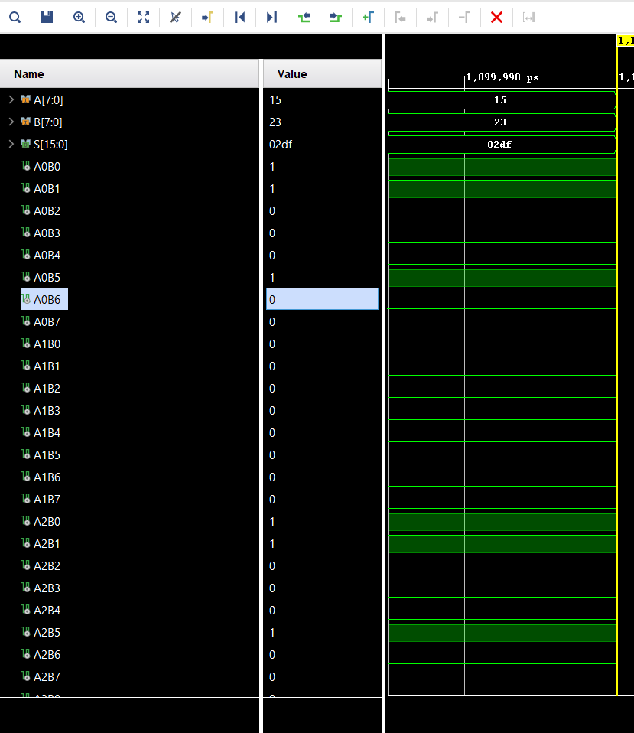
Figure 8. Braun's Multiplier simulation test 3.
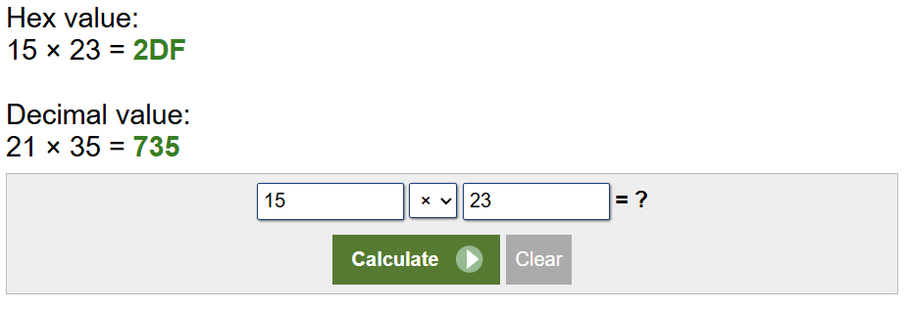
Figure 9. Hexadecimal calculator for test 3.
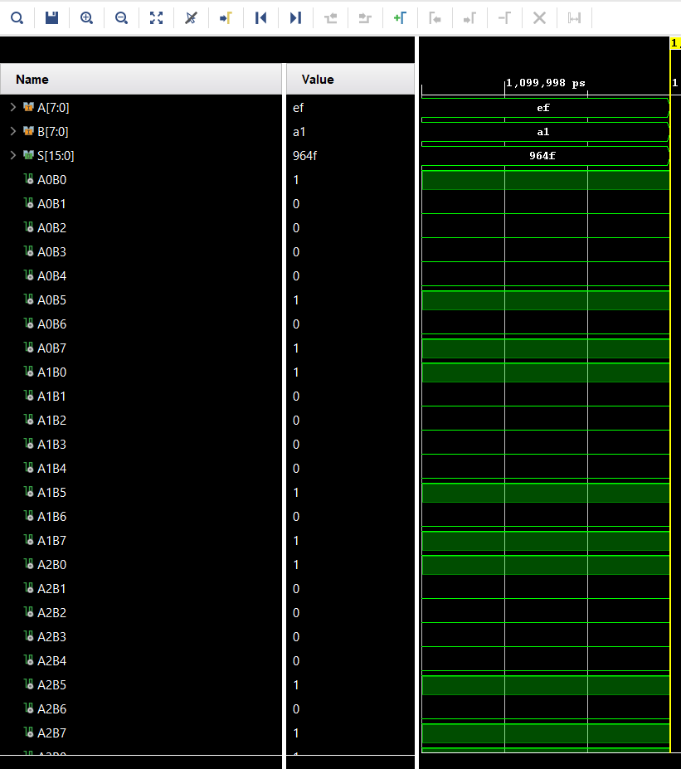
Figure 10. Braun's Multiplier simulation test 4.
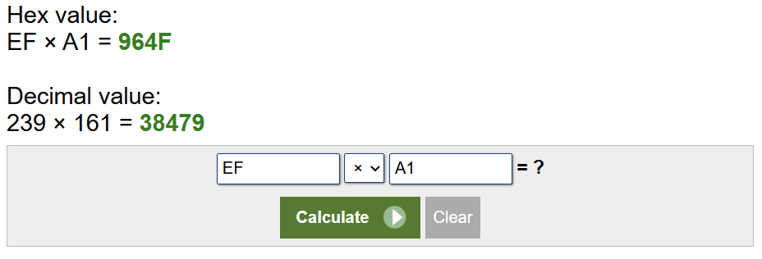
Figure 11. Hexadecimal calculator for test 4.

Register-transfer-level (RTL) Design
The next step was to generate a Register-transfer-level (RTL) design. An RTL design is a design that visualises the circuits functionality [10]. The RTL design is Vivado’s way of representing the flowchart drawn that was seen in Figure 2. Figure 12 below shows the RTL for the Braun’s Multiplier.
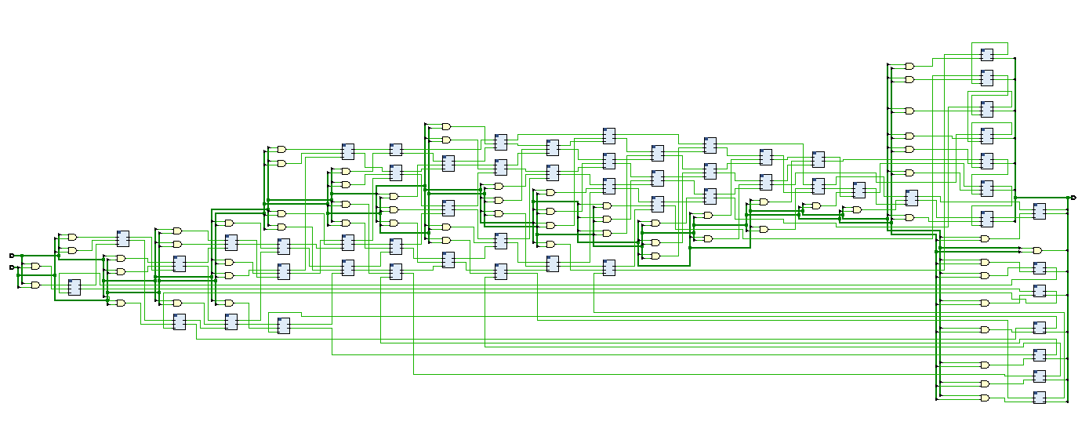
Figure 12. Braun's Multiplier RTL design.

Implementation
The next step was to generate the implementation schematic. The implementation schematic is another visual representation of the multiplier design [11]. However, it is more complex than the RTL design, showing how each input is being routed. Figure 13 below shows the Braun’s Multiplier implemented schematic.
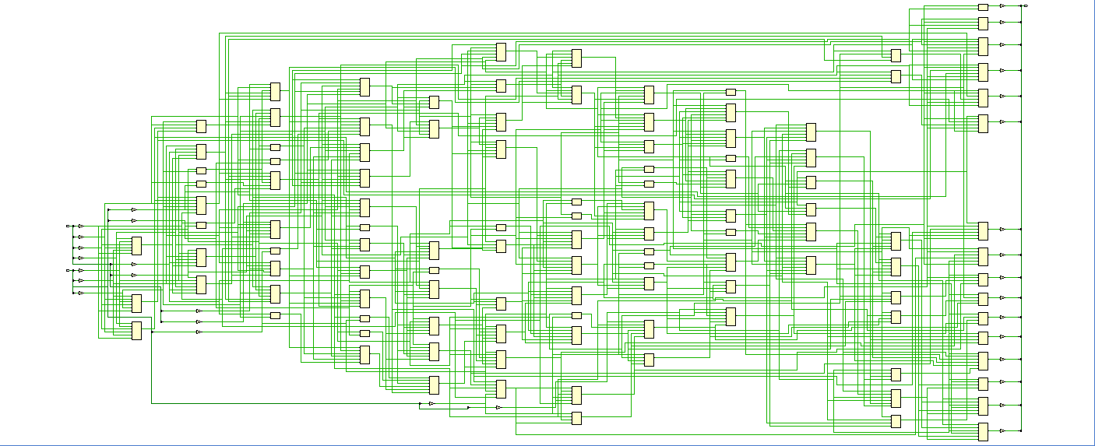
Figure 13. Braun's Multiplier Implementation Schematic.
The next screenshot shows how the Braun’s Multiplier is implemented onto an FPGA device. This shows how the multiplier is allocating its AND gates and adders across the FPGA. This can be visualised as the layer above the implementation schematic, i.e. each block on this diagram is a part of the schematic. Figure 14 below shows the Braun’s Multiplier implemented onto the device.
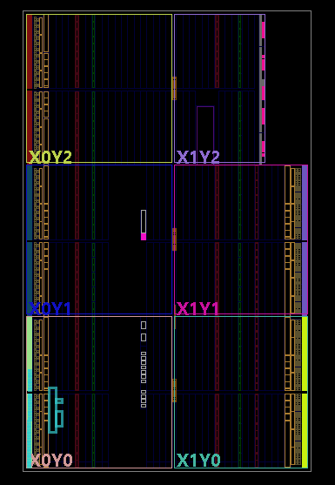
Figure 14. Braun's Multiplier device implementation.
Figure 15 below shows the I/O planning of the Braun’s Multiplier. The diagram shows how the I/O ports are assigned on the FPGA for the input and output signals. These can be seen on the design with the ‘C’s’ and the ‘S’’.
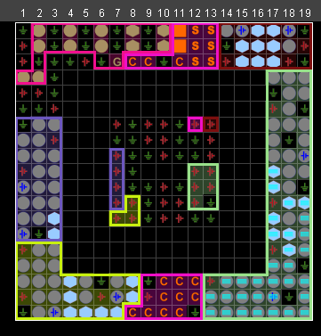
Figure 15. Braun's Multiplier I/O Planning.
The final task of task 1 was to implement the designed Braun’s Multiplier onto an FPGA. To do this, a BASYS 3 Artix-7 FPGA Trainer Board was used. To use the board, a binary bit stream was generated and implemented onto the FPGA. The board has 16 switches which can be set to high or low. The 16 switches are split in half, with the first 8 switches representing the binary value of one number, and the second 8 switches representing the value of the second number. The 16 LED’s above the switches represent the binary value of the two numbers multiplied together, with the on LED’s representing a ‘1’, and the off LED’s representing a ‘0’. Figure 16 below shows an example of this, where 01001010 is multiplied by 10101100, resulting in 0011000110111000.
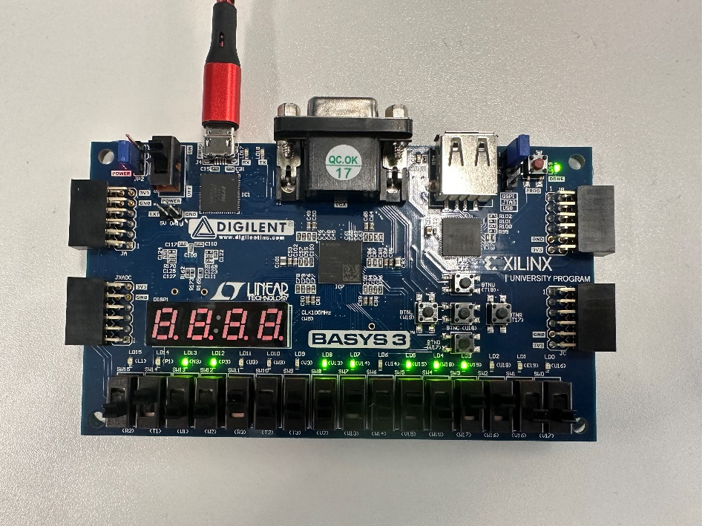
Figure 16. Braun's Multiplier Implemented on BASYS Board.
This result was then verified using an online binary multiplier, which can be seen below in Figure 17.
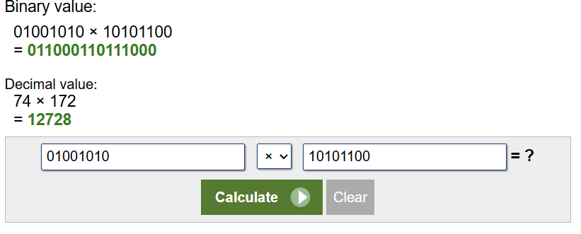
Figure 17. Binary Calculator for Braun’s FPGA test.

Task 2
Task 2 was to design an 8x8 Wallace Tree Multiplier. As with Task 1, the multiplier had to take two inputs, multiplying each bit of the first input with each bit of the second input, producing a 16-bit result. Similarly, the logic circuit design will be provided, alongside simulated results. The Wallace Tree Multiplier design will also be synthesized, so that this multiplier can also be integrated onto an FPGA. In addition to this, a flowchart and dot diagram of the multiplier will be provided, specifying the number of adders included in the design.

Flowchart
When designing the flowchart for Wallace Multiplier, the dot diagram seen in Figure 18 was used as a reference for how the multiplier is constructed.
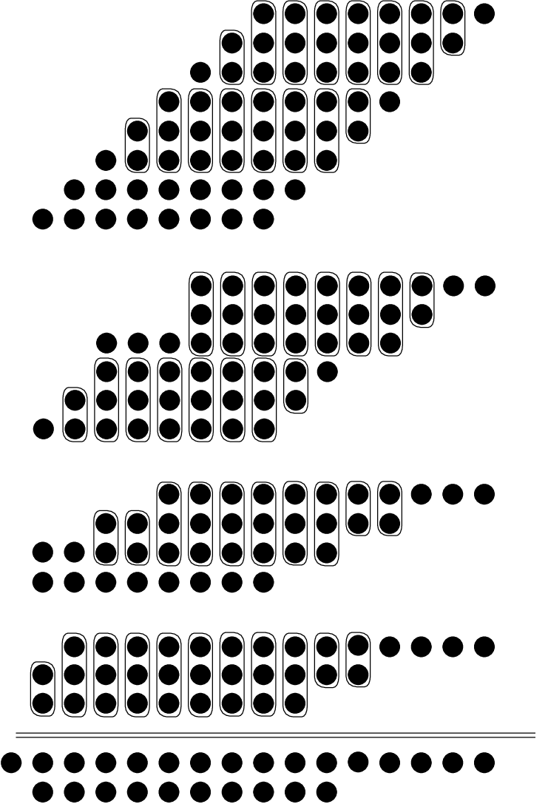
Figure 18. Wallace dot Diagram [12].
Figure 19 below shows the flowchart created for the Wallace Multiplier. Similarly to Braun’s Multiplier, the diagram contains 8 Half adders, and 48 Full adders.
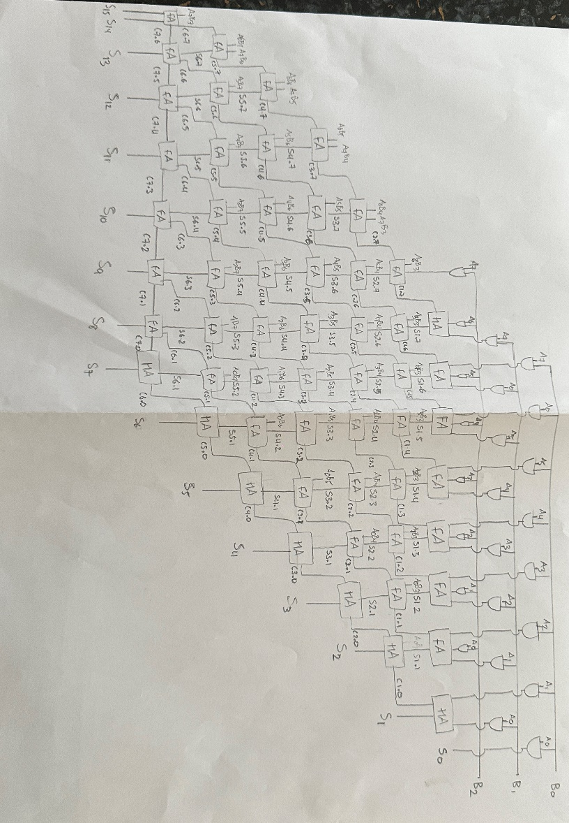
Figure 19. Flowchart showing operation of Wallace Multiplier.
The operation of Wallace Multiplier is somewhat similar to Braun’s multiplier, however there are some differences to note. The first of which are the carries where instead of the output carry being used as an input for the adder to the next of the adder, it is used as the input for an adder on the row below it. The exemption to this rule is the final row of adders, where the carries behave as they do in Braun’s, inputting to the adder to the left. The final output is generated in the same way as in Braun’s, from the half adders at the end of each row, and all of the adders in the bottom row.

Testing
The rest of task 2 will include the same screenshots as in task 1. Firstly, Figures 20, 22 ,24 and 26 below show four tests using Vivado. Figures 21, 23, 25 and 27 show the tested values inputted into an online hexadecimal calculator. These figures match the Vivado screenshots, showing that the Wallace Multiplier is functioning as intended. The code for Wallace Multiplier can be found in the appendix D.
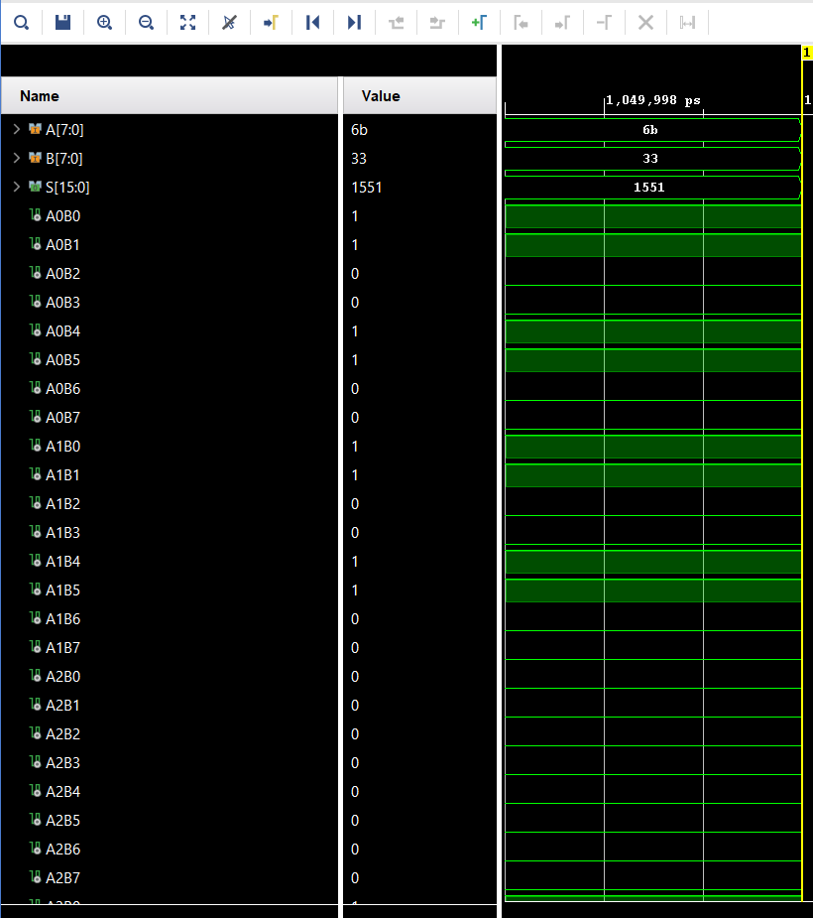
Figure 20. Wallace Multiplier simulation test 1.
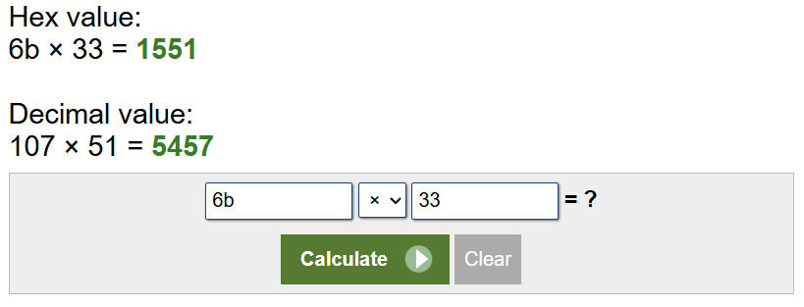
Figure 21. Hexadecimal calculator for test 1.
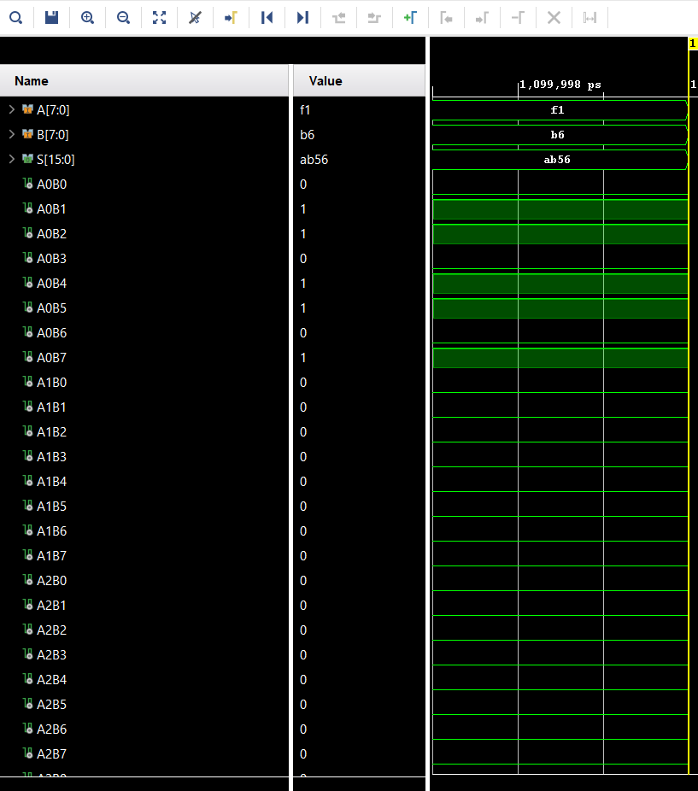
Figure 22. Wallace Multiplier simulation test 2.
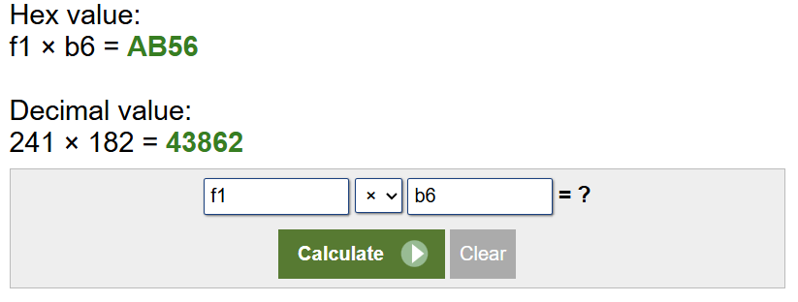
Figure 23. Hexadecimal calculator for test 2.
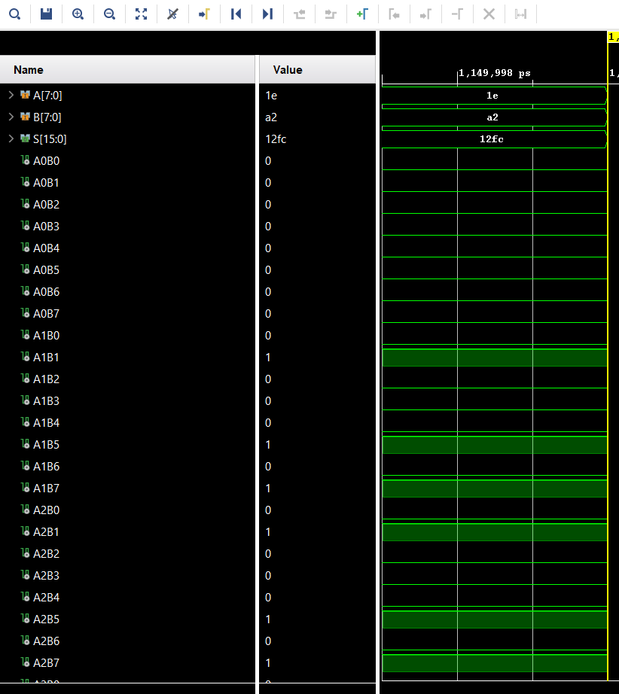
Figure 24. Wallace Multiplier simulation test 3.
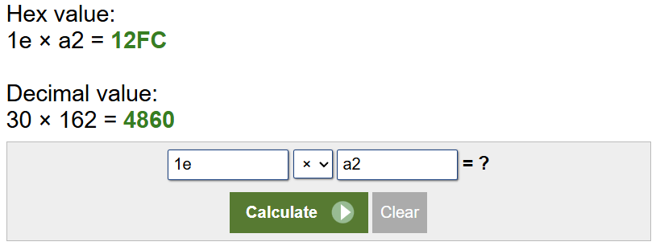
Figure 25. Hexadecimal calculator for test 3.
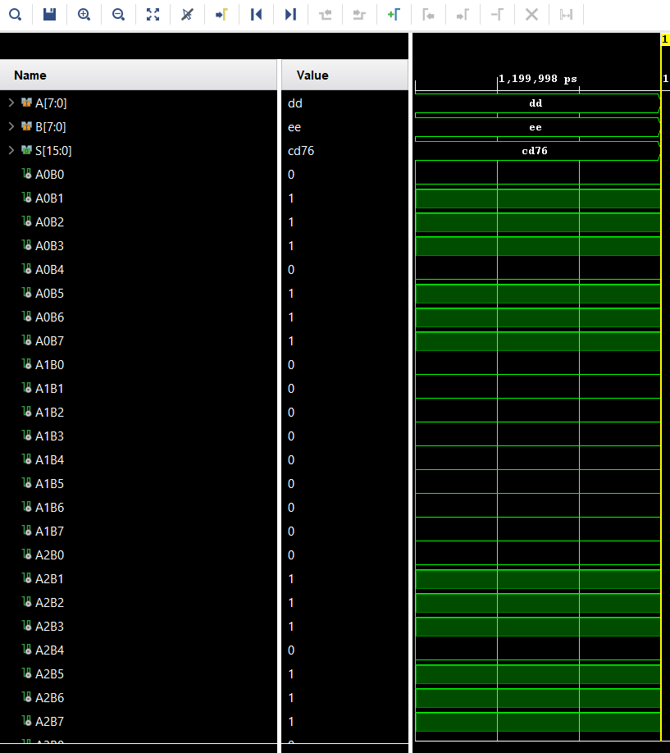
Figure 26. Wallace Multiplier simulation test 4.
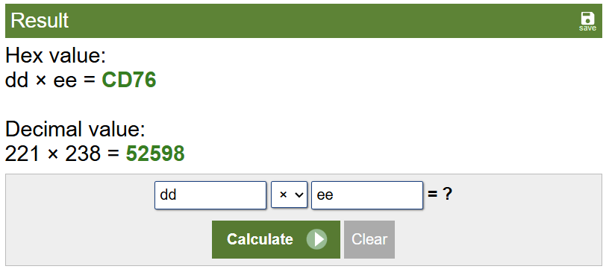
Figure 27. Hexadecimal calculator for test 4.

Register-transfer-level (RTL) Design
Next, Figure 28 below shows the Wallace Multiplier RTL design.
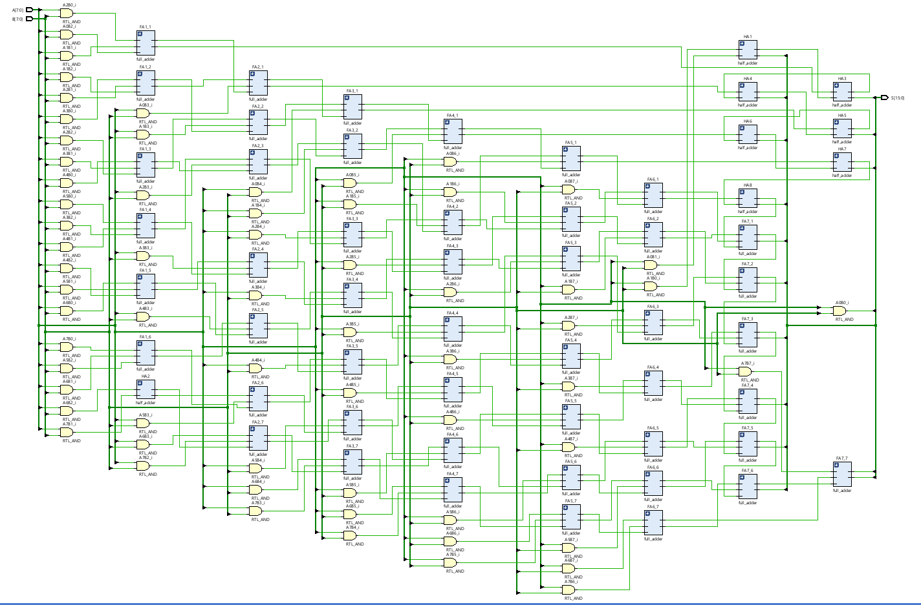
Figure 28. Wallace Multiplier RTL design.

Implementation
Figure 29 below shows the Wallace Multiplier Implementation Schematic.
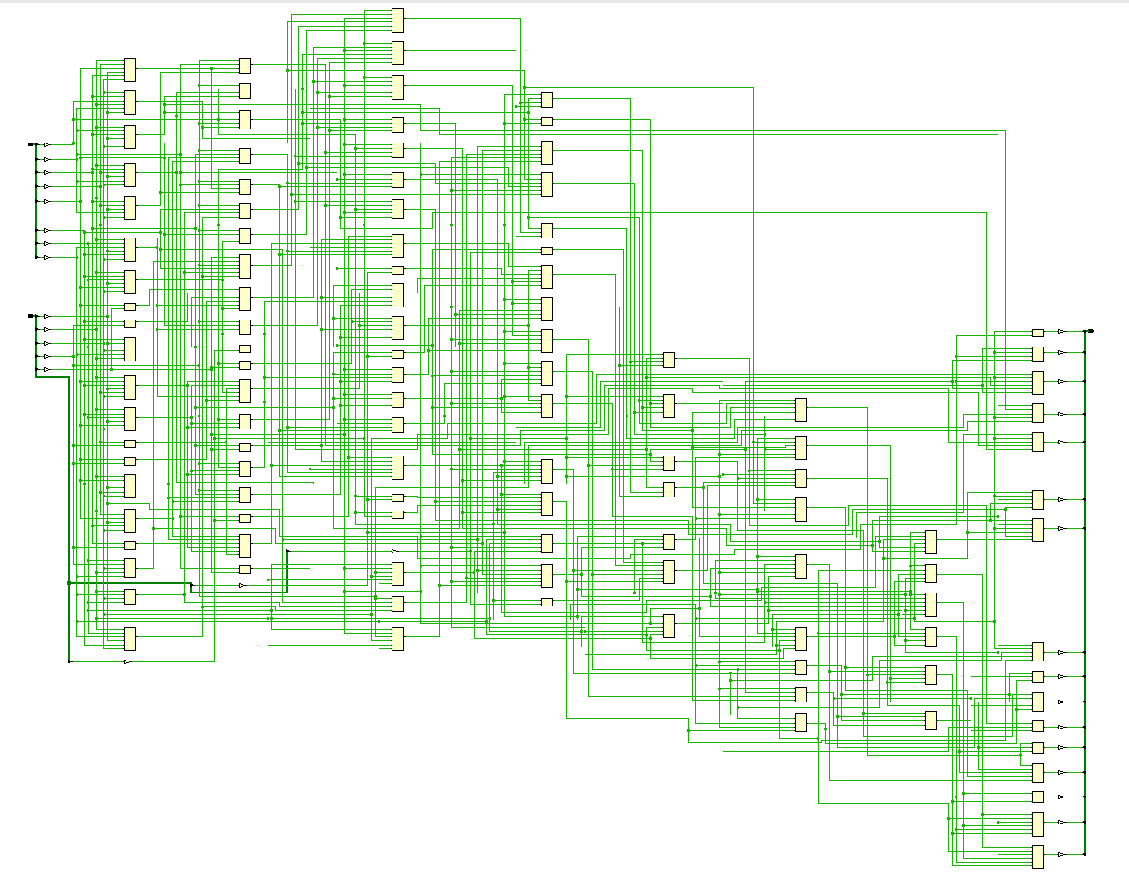
Figure 29. Wallace Multiplier Implementation Schematic.
Figure 30 below shows the Wallace Multiplier device implementation.
Figure 30. Wallace Multiplier device implementation.
Figure 31 below shows the Wallace Multiplier I/O planning.
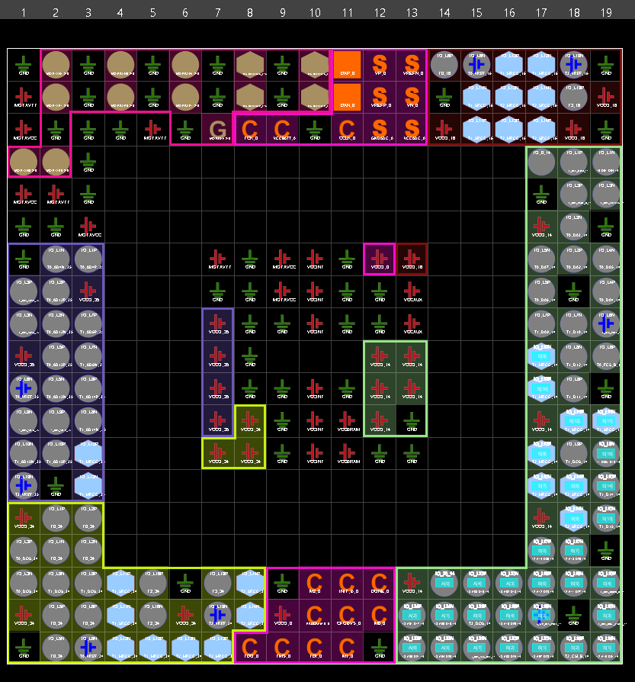
Figure 31. Wallace Multiplier I/O Planning.
Finally, the Wallace Multiplier was implemented on the BASYS board. Figure 32 below shows an example of testing the Wallace Multiplier, where 00101011 is multiplied by 10111001, resulting in 0001111100010011.
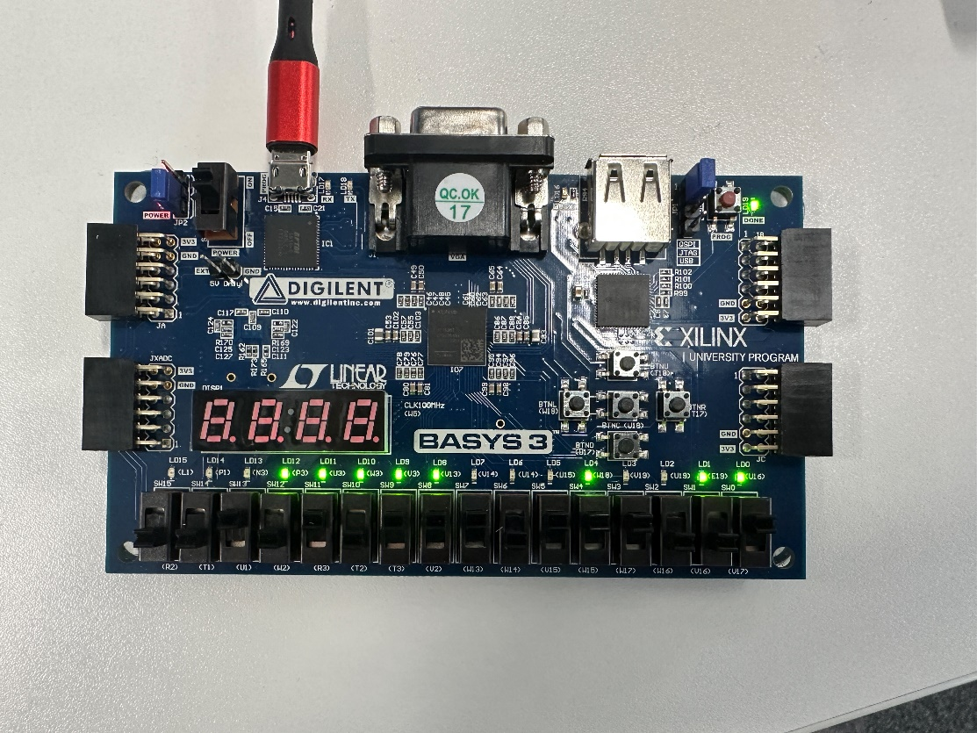
Figure 32. Wallace Multiplier Implemented on BASYS Board.
This result was then verified using an online binary multiplier, which can be seen below in Figure 33.
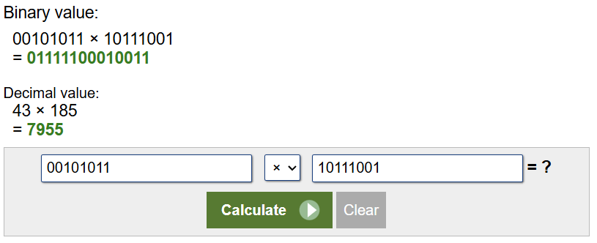
Figure 33. Binary Calculator for Wallace FPGA test.

Task 3
Task 3 was to critically evaluate the performance of both Braun’s and Wallace Multipliers. There will be a number of comparison points used to evaluate their performances, such as longest delay, power consumption, speed and power efficiency, and number of Look-up tables (LUT’s).

Longest delay
The first method of calculating the longest delay is by calculating it manually. This can be done using the flowcharts seen earlier in this report. To do this, the critical path of the multipliers must be found. The critical path can be defined as the longest path that a signal must pass through from input to output in a multiplier [13]. The signal will pass through adders, which have a delay of 2ns, and, AND gates, which have a delay of 1ns. The author calculates that the critical path passes through 20x adders and 1x AND gate, with a calculated critical path of 41ns. Figure 34 below shows the Braun’s critical path using the flowchart.
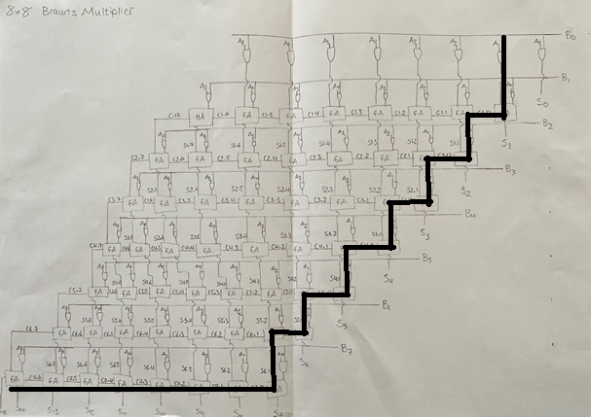
Figure 34. Braun's Critical Path.
The same can be applied to the Wallace Multiplier. The author calculates that the critical path passes through 14x adders and 1x AND gate, with a calculated critical path of 29ns. Figure 35 below shows the Wallace critical path using the flowchart.
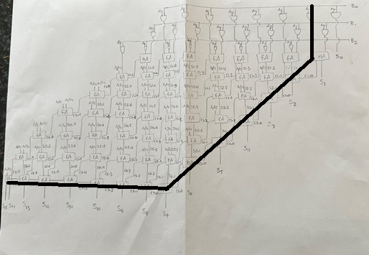
Figure 35. Wallace Critical Path.
The second method of determining maximum delay is using Vivado. Figure 36 shows the simulated delay for Braun’s Multiplier, and Figure 37 shows the simulated delay for Wallace Multiplier.

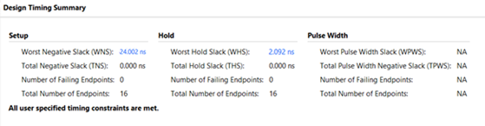
Figure 36. Braun's Timing Summary.
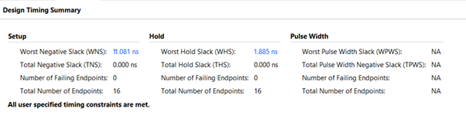
Figure 37. Wallace Timing Summary.
It can be seen that in Vivado simulations Wallace Multiplier has a shorter delay that Braun’s. This matches the flowchart calculations, as well as Multiplier theory.
Figure 38 and Figure 39 below also show a selection of simulated delays.
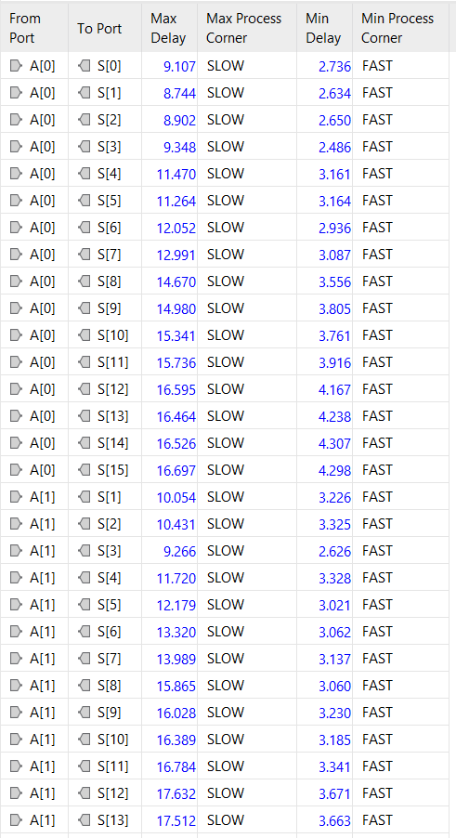
Figure 38. Braun's delays.
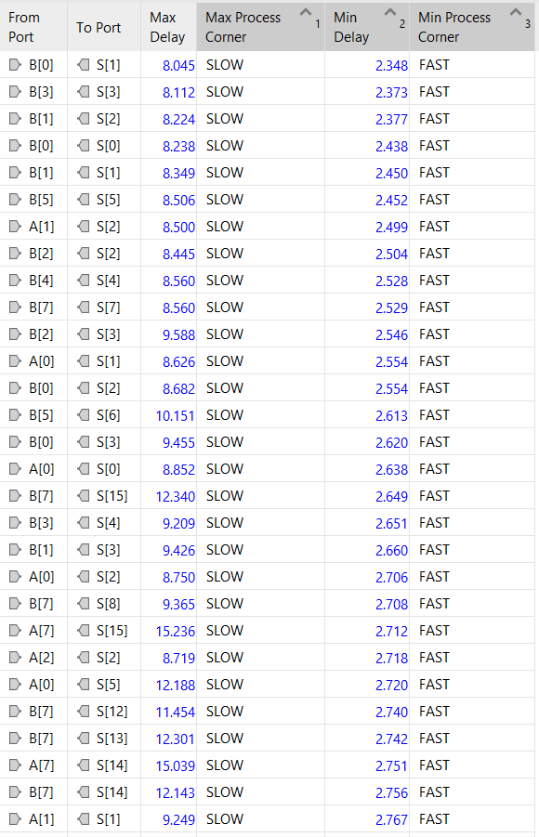
Figure 39. Wallace's delays.

Power Consumption and Utilisation
The next comparison point is power consumption and utilisation. Figures 40, 41 and 42 show Vivado’s simulated power summary and utilisation for Braun’s Multiplier, and figures 43, 44 and 45 show the same for Wallace Multiplier.
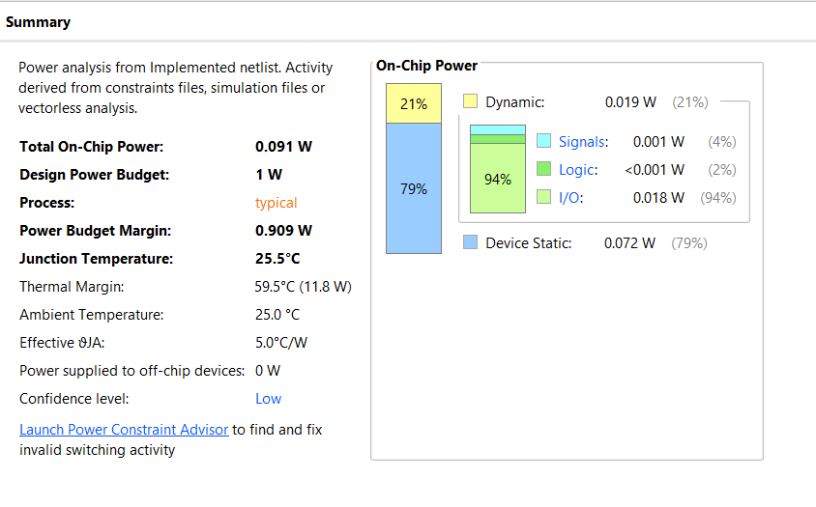
Figure 40. Braun's Multiplier Power summary.
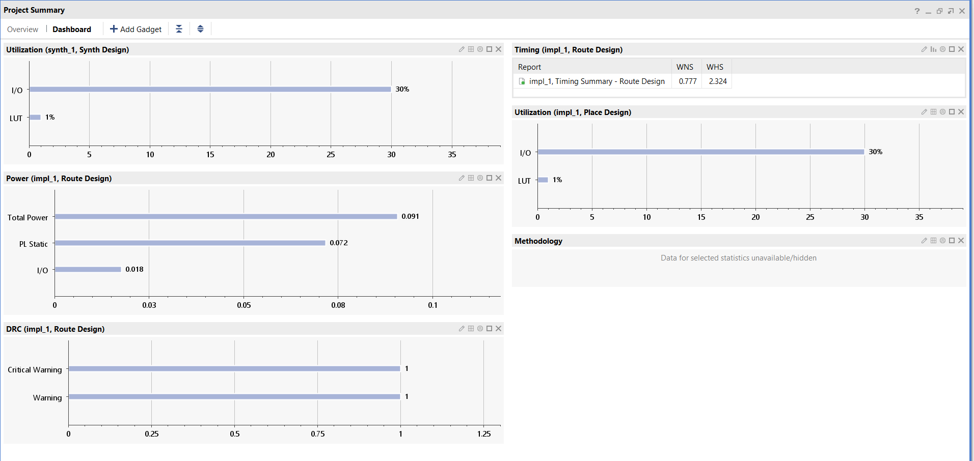
Figure 41. Braun's Multiplier Power Utilisation.
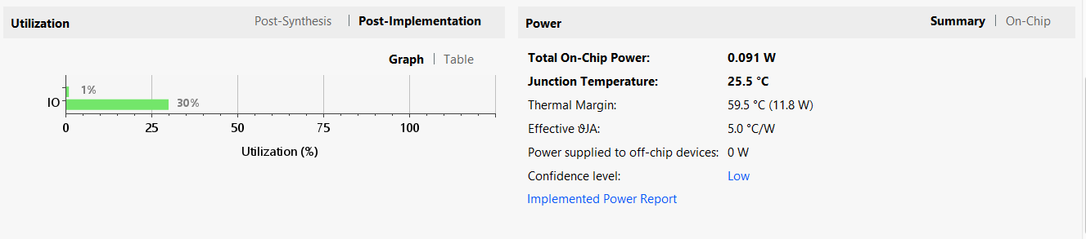
Figure 42. Braun's Multiplier Power Utilisation.
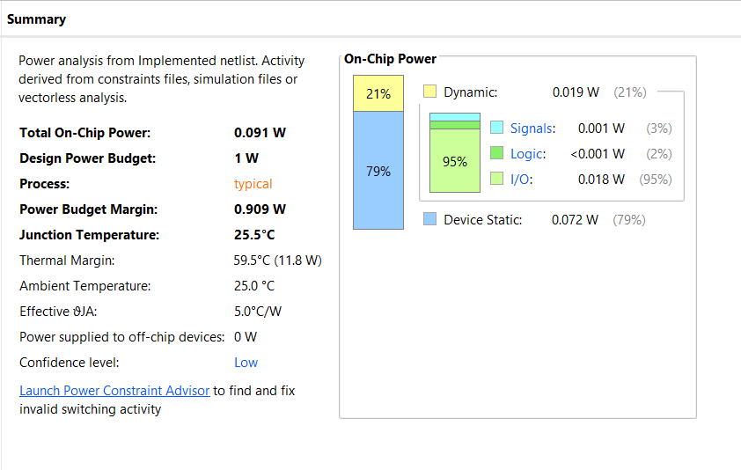
Figure 43. Wallace Multiplier Power summary.
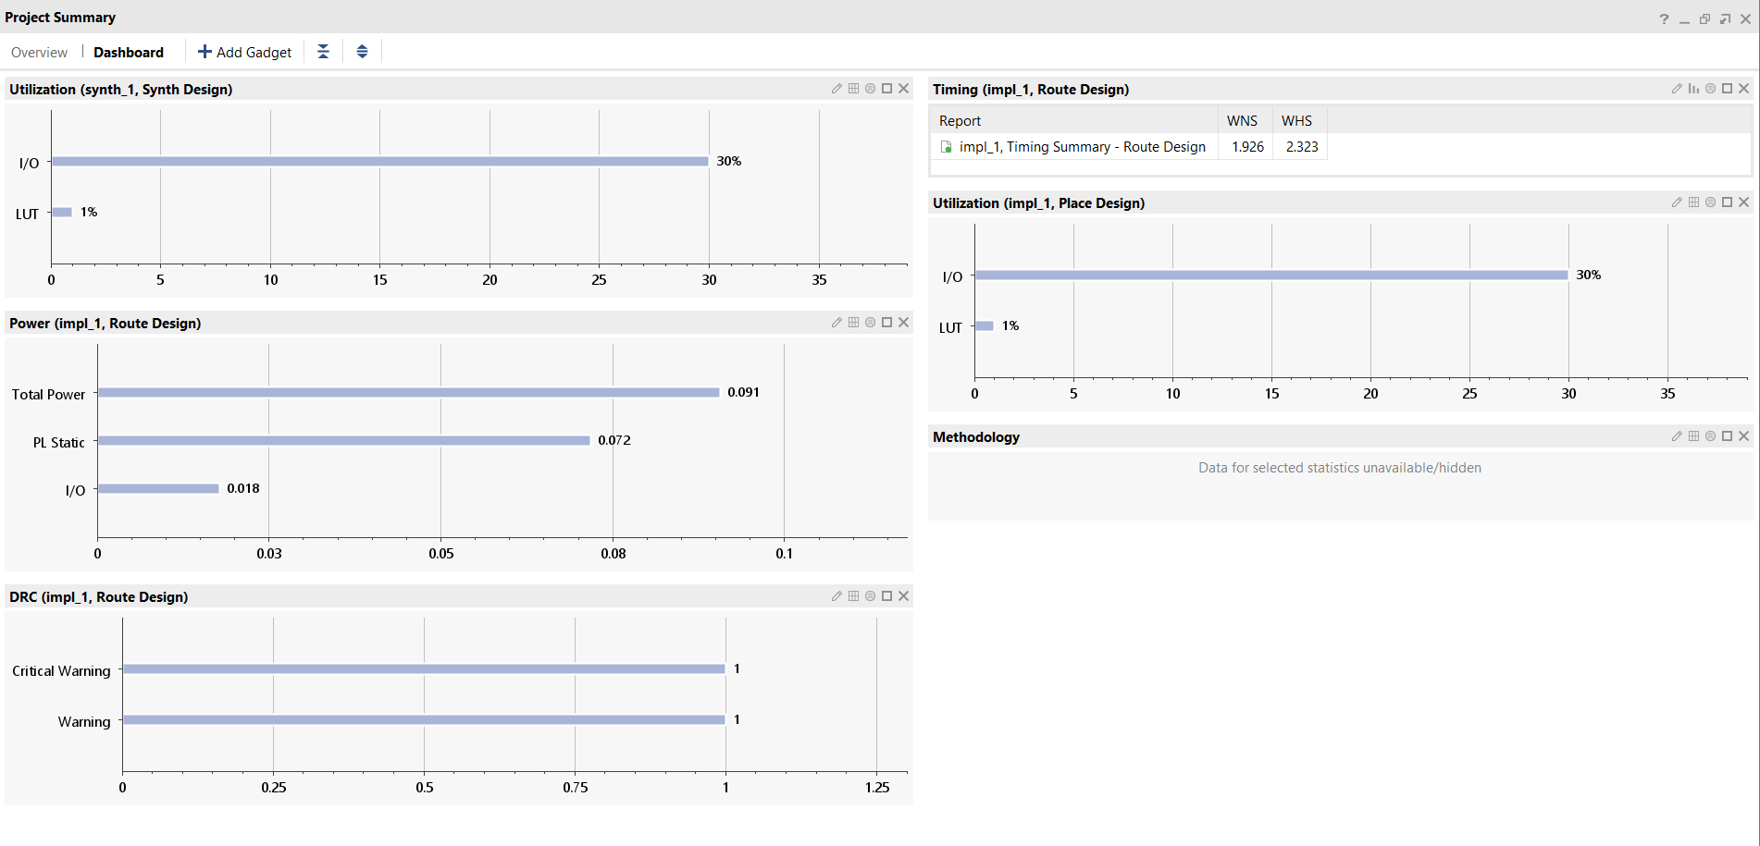
Figure 44. Wallace Multiplier Power Utilisation.
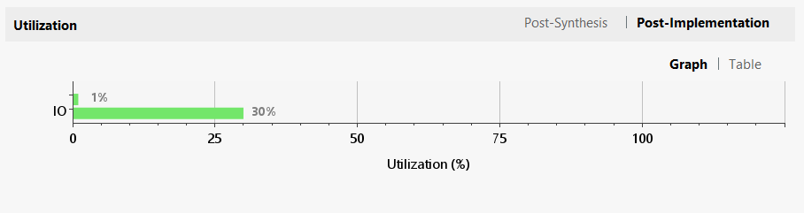
Figure 45. Wallace Multiplier Power Utilisation.
Both multipliers were given a power budget of 1W. Figures 40 and 43 show there is very little difference in the power, with the only noticeable difference being Wallace used 1% more I/O power. This is also true for the power utilisation, with no noticeable differences between the multipliers.

Look-up Tables (LUT’s)
The final comparison point used in this report is the number of LUT’s. LUT’s can be defined as a programmable way to perform digital logic [14]. Figures 46 and 47 below show the number of LUT’s used by Braun’s and Wallace Multipliers in Vivado simulations.
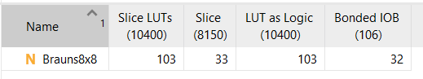
Figure 46. Braun's Multiplier LUT's.
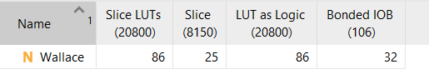
Figure 47. Wallace Multiplier LUT's.
Figures 46 and 47 show that Wallace Multiplier uses 17 less LUT’s than Braun’s Multiplier. This means that the Wallace Multiplier. This means that when implementing the multipliers onto an FPGA, less physical space is required. This would be particularly beneficial for larger multipliers, as the difference between the number of LUT’s in the multipliers would increase.

Speed and Power Efficiency
Using the comparison points above, it can be observed that Wallace Multiplier has superior speed compared to Braun’s Multiplier. This has been showcased in both Vivado simulations and flowchart calculations. Wallace Multiplier is also superior in power efficiency. Whilst the actual power simulations are very similar between the multipliers, the multiplier is more efficient in speed, as well as space used on an FPGA.

Conclusion
In conclusion, this report has demonstrated a comparison between Braun’s and Wallace Multipliers. The multipliers have been simulated, analysed and evaluated in order to determine which is the greater multiplier, using Vivado software and FPGA board implementation. The results show that Wallace Multiplier is the superior multiplier as it is superior in all performance aspects. It has been shown that it has greater speed, as well as greater efficiency compared to Braun’s. However, this study has shown that Braun’s Multiplier is a solid multiplier, especially when multiplying smaller binary numbers. Whilst it does not have as great overall performance as Wallace Multiplier, its simplicity to implement means that it remains a viable alternative.
For future work on this subject, simulating both smaller and larger Braun’s and Wallace Multipliers could be beneficial. This could reaffirm conclusions, as well as seeing greater performance differences, in particular with larger binary numbers. In addition to this, this study has only investigated two multipliers. Investigating the performance of different multipliers would be beneficial to perhaps discover a multiplier with even better performance.

Bibliography
[1] Electrical Technology, “Binary Multiplier - Types & Binary Multiplication Calculator,” ELECTRICAL TECHNOLOGY, May 25, 2018. https://www.electricaltechnology.org/2018/05/binary-multiplier-types-binary-multiplication-calculator.html

[2] L. Madushanka, “Quantum Half-adder and Full-adder,” Lahiru Madushanka, Feb. 04, 2020. https://lahirumadushankablog.wordpress.com/2020/02/04/quantum-half-adder-and-full-adder/

[3] S. C. Avinash. Bikkina and Nekkanti. Mouni, “Design and Implementation of Braun Multiplier using Parallel Prefix Adders,” International Journal of Engineering and Advanced Technology, vol. 9, no. 4, pp. 1251–1254, Apr. 2020, doi: https://doi.org/10.35940/ijeat.d8075.049420.

[4] R. Anitha, “Comparative Study of High performance Braun’s Multiplier using FPGAs,” IOSR Journal of Electronics and Communication Engineering, vol. 1, no. 4, pp. 33–37, Jan. 2012, doi: https://doi.org/10.9790/2834-0143337.

[5] P. Mishra and S. Nayak, “A study on Wallace tree multiplier,” Apr. 2018. Accessed: Apr. 12, 2025. [Online]. Available: https://www.ijarse.com/images/fullpdf/1523964041_IIMT19.pdf

[6] I. Qiqieh, R. Shafik, G. Tarawneh, D. Sokolov, S. Das, and A. Yakovlev, “Energy-Efficient Approximate Wallace-Tree Multiplier using Significance-Driven Logic Compression,” 2017. Accessed: Apr. 12, 2025. [Online]. Available: https://www.staff.ncl.ac.uk/rishad.shafik/files/2015/11/Paper_SiPS.pdf

[7] Y. Yu, W. Pan, C. Tang, N. Yin, and Z. Yu, “Design of a High-Speed, Low-Power PTL-CMOS Hybrid Multiplier Using Critical-Path Evaluation Model,” Electronics, vol. 13, no. 7, pp. 1284–1284, Mar. 2024, doi: https://doi.org/10.3390/electronics13071284.

[8] A. Rafiq and M. Jenihhin, “An optimized design of delay-and energy-efficient Booth multiplier,” e-Prime - Advances in Electrical Engineering, Electronics and Energy, vol. 9, no. 9, p. 100698, Jul. 2024, doi: https://doi.org/10.1016/j.prime.2024.100698.

[9] C. Shah, R. Shah, R. Dhavse, and R. Parekh, “Design and implementation of single electron transistor based 8X8 bit signed multipliers,” Materials Today: Proceedings, vol. 43, no. 6, pp. 3904–3910, 2021, doi: https://doi.org/10.1016/j.matpr.2020.12.1236.

[10] Ansys, “What is Register Transfer Level (RTL) Design? | Ansys,” Ansys.com, 2024. https://www.ansys.com/simulation-topics/what-is-register-transfer-level-design

[11] AMD, “AMD Technical Information Portal,” Amd.com, 2025. https://docs.amd.com/r/en-US/ug906-vivado-design-analysis/Using-the-Schematic-Window (accessed Apr. 17, 2025).

[12] A. Patra, T. Schneider, A. Suresh, and Hossein Yalame, “SynCirc: Efficient Synthesis of Depth-Optimized Circuits for Secure Computation,” Efficient Synthesis of Depth-Optimized Circuits for Secure Computation, pp. 147–157, Dec. 2021, doi: https://doi.org/10.1109/host49136.2021.9702293.

[13] L. Shannon, “Digital System Design,” 2009. Accessed: Apr. 19, 2025. [Online]. Available: https://www2.ensc.sfu.ca/~lshannon/courses/ensc350_09/Lecture_Set_8.pdf

[14] O. Westfall, “Using Lookup-Tables in Programmable Logic,” Aug. 2024. Accessed: Apr. 19, 2025. [Online]. Available: https://www.ti.com/lit/an/scla071/scla071.pdf?ts=1745035110392

Appendices

Appendix A - Half-adder code
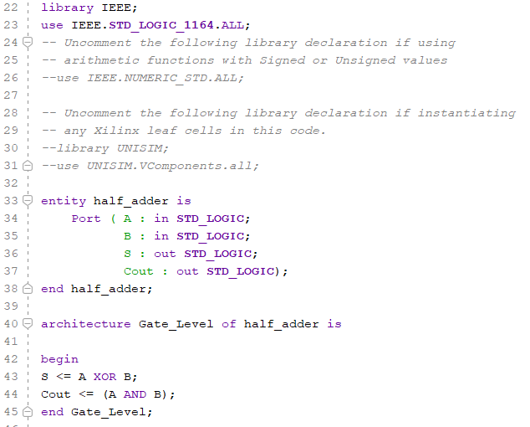

Appendix B - Full adder code
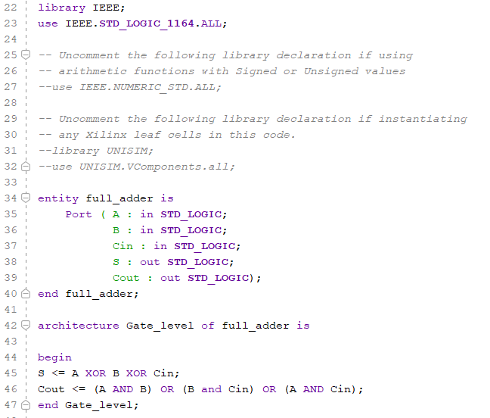

Appendix C - Braun’s Multiplier code
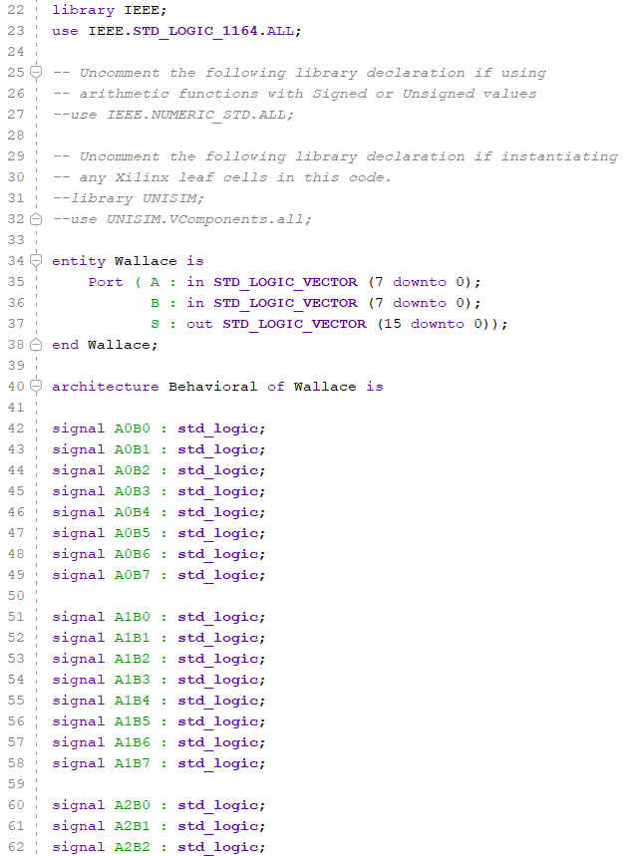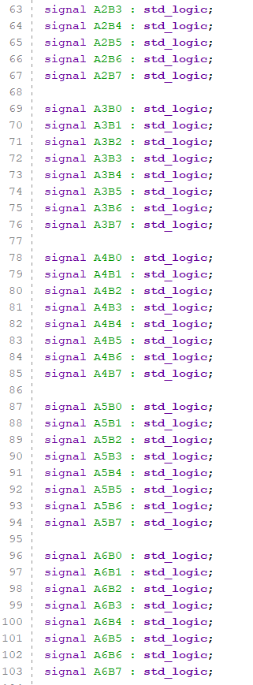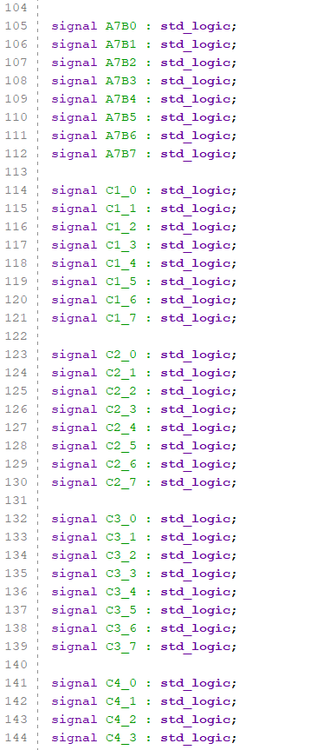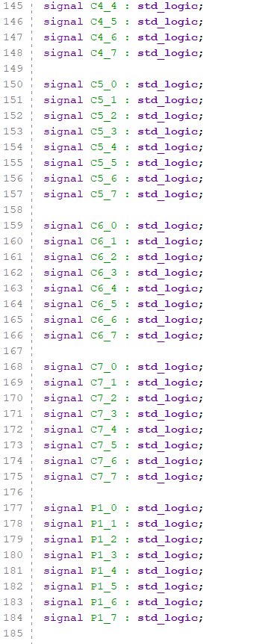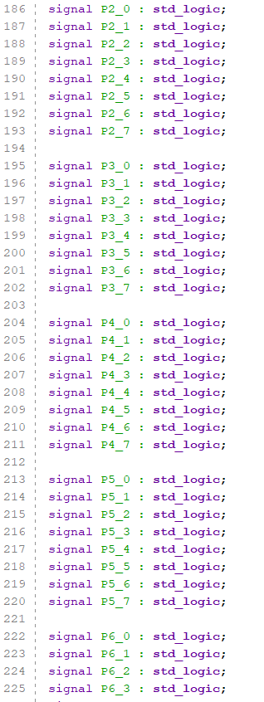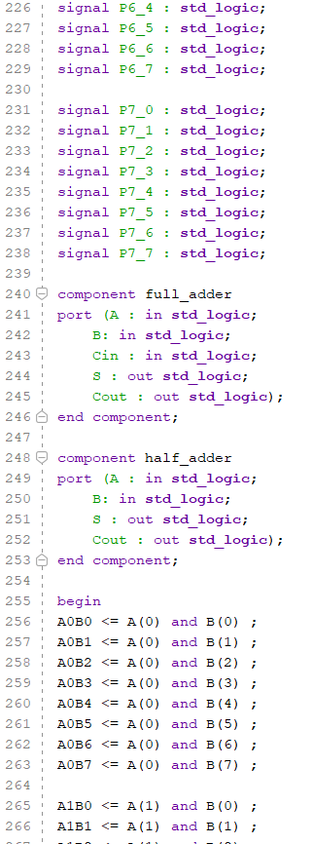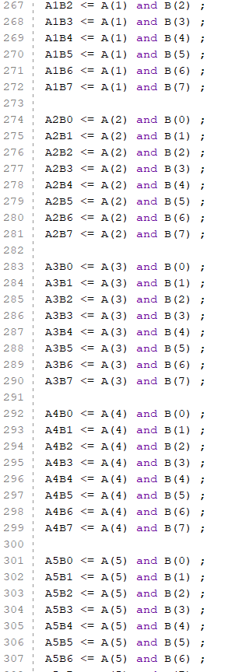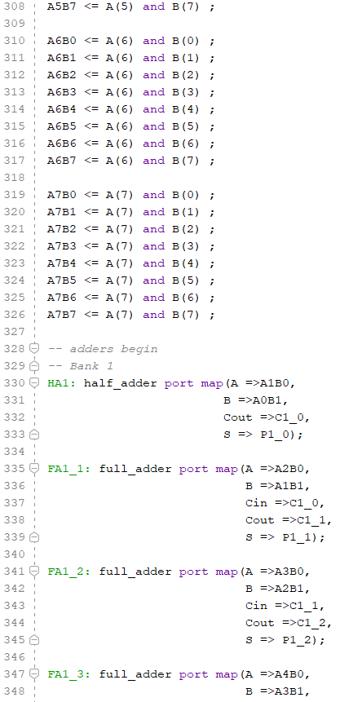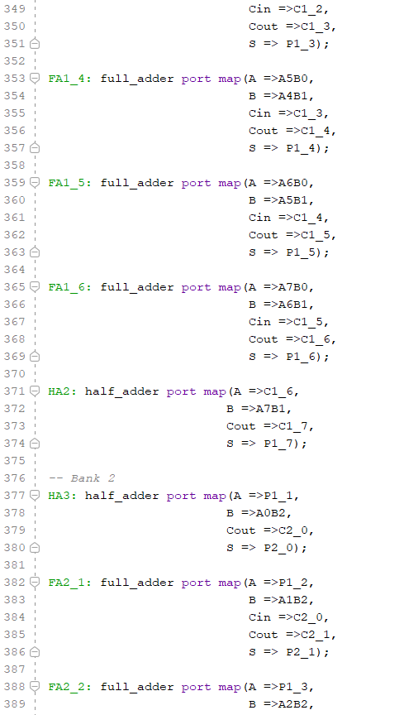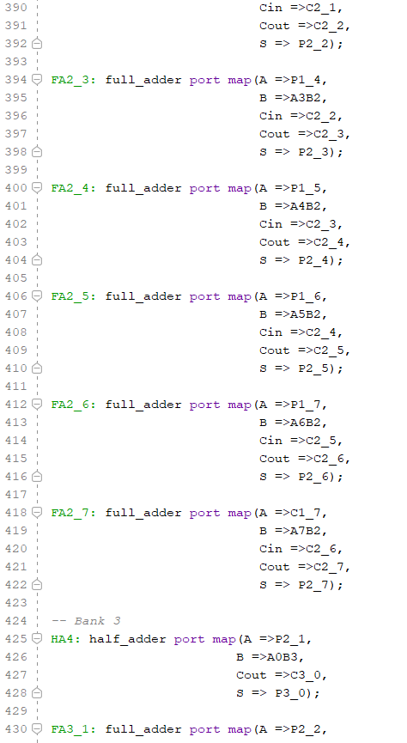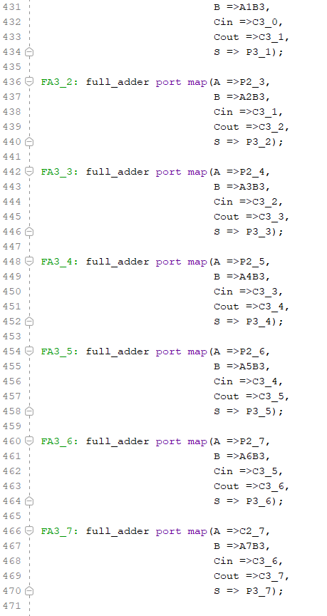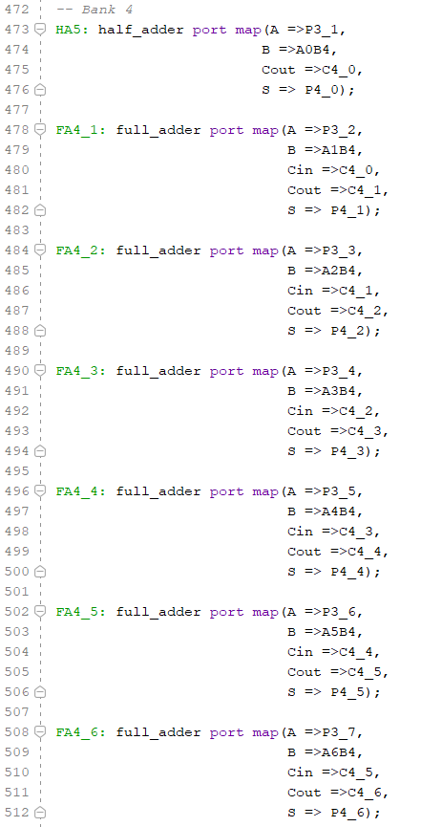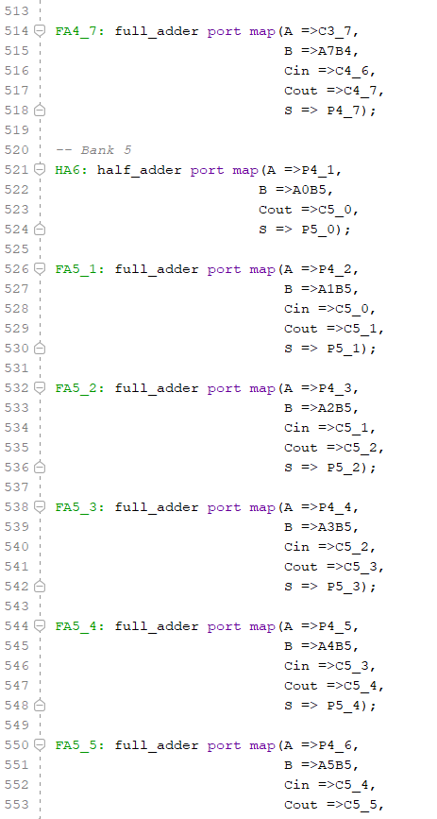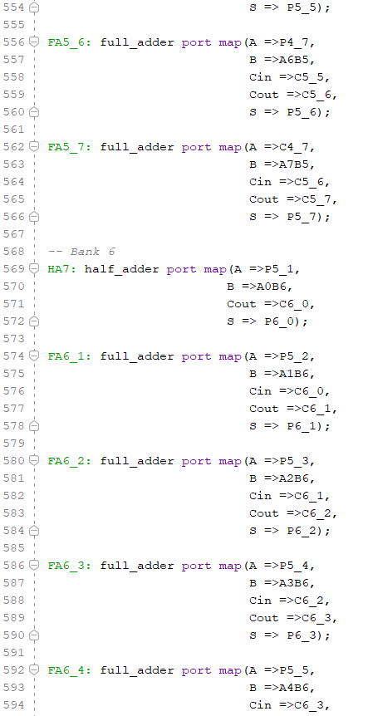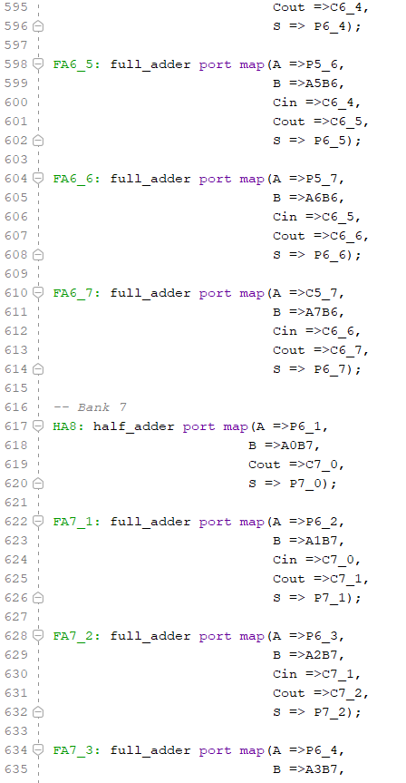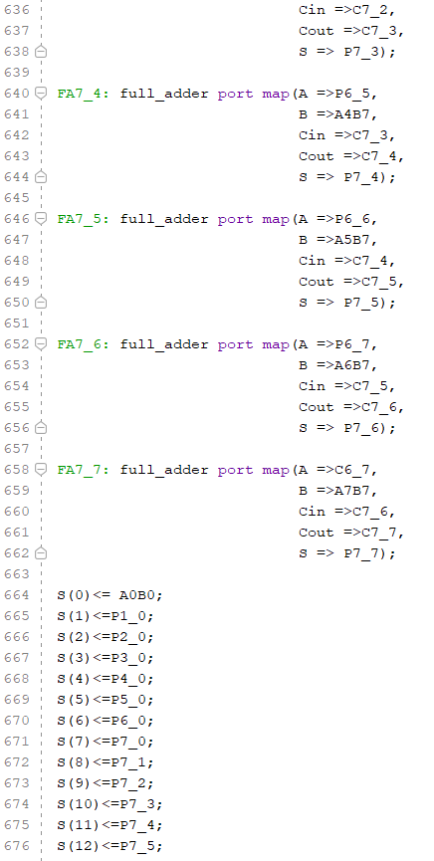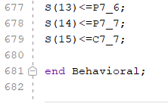

Appendix D - Wallace Multiplier code


