

Laura Jones | P084789 | Managing Employee Relations | Wordcount: 4850
Employee Voice at
E Cigarette Direct
Executive Summary
The following report critically analyses the issue of employee voice within the retail division at E Cigarette Direct. A range of academic literature and current research is reviewed and the current employee voice mechanisms at E Cigarette Direct is analysed against this. As well as mechanisms for voice, the role of management in supporting a culture of voice will also be reviewed. The report concludes by making recommendations to improve employee voice within the retail division at E Cigarette Direct.

Contents
- Introduction…………………………………………………………….………...….... p6
  - Defining Employee Relations ………………….………………………………...…. p6
  - Approaches to Employee Relations………….………………..….……………. p7
  - Defining Employee Voice………………………………….……….……......……. p8
  - The changing context of employee relations and voice in the UK….………p9
  - Trade Union Membership Decline……………………………………………. p9
  - Information and Consultation of Employees Regulations (ICE)…………… p9
  - Commercial Benefits of Supporting Employee Voice……………………....p10
  - Beyond Commercial Benefit…………………………………………………..p11
  - A Framework to Evaluate Employee Voice…………………………...…….p11

- Employee Voice in Practice ……………………………………………………..….p12
  - Communication and Briefing Systems …………………………………………….p12
    - Modern Communication and Briefing Systems…………………….…...p13
    - Employee Attitude Surveys ………………………………………...p14
    - Criticism of Communication as a Form of Voice …………………p14
    - Communication and Briefing Systems at ECD …………………..p15
  - Task and Work Group Involvement………………………………………p16
    - Criticism of Task and Work Group Involvement………………………….p16
    - Task and Work Group Involvement at ECD………………………...…….p16
  - Financial Participation ……………………………………………………....p17
    - Criticisms of Financial Participation…………………………………...…...p18
    - Financial Participation at ECD…………………………..………………….p18
  - Representative Involvement and Participation………………...………...p18
    - Trade Union Representation …………………………….…………p19
    - Non-Trade Union Representation …………………………………p19
    - Criticism of Representative Involvement and Participation……...p20
    - Representative Involvement and Participation at ECD…………..p20
  - The Role of Managers in Supporting Voice……………….……………..p21
    - Managers at ECD……………………………………….……...……p21

- Conclusion …………………………………………………...………………....p21
- Recommendations ……………………………………………………...……...p22
  - Training and Support for ECD Employee Representatives………….....p23
  - Research a Social Media Platform………………….………………….…….p23
  - Management Development …………………….....……………………….....p24
- Bibliography………………….....……………….................…………….…….p25

.

List of Tables and Charts
Figure 1: The Retail Structure at E Cigarette Direct……………………………………………. 6
Figure 2: The Benefits of Employee Voice …………………………………………………….10
Figure 3: Dimensions to Evaluate Voice …………………………………………………….…11
Figure 4: Written & Face to Face Communication ……………………………….……………13
Figure 5: Communication Methods ………………………………………………………….…15
Figure 6: Summary of Voice at ECD……………………………………………………………22
Figure 7: IPA Representative Training …………………………………………………………23

1. Introduction
E Cigarette Direct (ECD) is a privately-owned retail company founded in 2008. ECD sells a range of own brand and third-party e liquids and hardware through 20 retail stores across England and Wales, as well as through its wholesale division ‘Orderly Distro’ supplying resellers globally. ECD currently employees 90 full and part time members of staff across its 20 stores, warehouse and head office located in Gower. ECD does not recognise any trade union, either voluntarily or via statutory recognition and no request for union recognition has ever been made to date. For this reason, trade unions will be discussed only briefly in this report.

ECD takes great pride in being a ‘values driven employer’ and expects all managers to operate under the principle “All people should be valued and deserve to be treated with respect”.

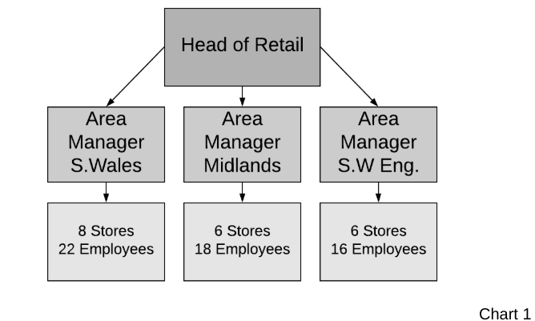
The focus of this report will be employee voice in the retail division at ECD. The retail division is made up of 20 stores across South Wales, The South West of England and the Midlands. The structure of the retail division can be seen in figure 1.
Figure 1

  - Defining Employee Relations
Before examining employee voice we must understand the umbrella under which the concept of voice falls. The term ‘employee relations’ replaced the traditional term ‘industrial relations’ in describing the relationship between employer and employee, addressing both collective and individual relationships (CIPD 2018a).

Employee relations is impacted by both internal and external factors and although there are common features in all employment relationships it must be considered that relationships are dynamic and relationships will change (Daniels 2006).

A key feature in any employee relationship is an organisations approach to employee relations.

1.2 Approaches to Employee Relations
Unitarism and pluralism, proposed by Fox 1966 are the two most commonly cited approached to employee relation’s (Daniels 2006).

Unitarism assumes employer and employee are working towards a common goal and therefore conflict is unnecessary, needing to be removed rather than resolved. Unitarism does not support the concept of employee voice as under this perspective there is only one voice, management and management retains all power (Daniels 2006). In Unitarist organisations HR’s role is to police the ‘appropriate’ use of employee voice, rather than enable it (Baczor, Zheltoukhova & Yarlagadda 2017)

In contrast, Pluralism recognises that parties in the employment relationship have varying interests making conflict inevitable. Organisations adopting a pluralist perspective are concerned with outcomes for people as well as the organisation (Daniels 2006, Baczor, Zheltoukhova & Yarlagadda 2017). Whilst pluralists may view trade unions as a way of giving employees a voice and readdressing the balance of power between employer and employee, the legitimacy of managerial authority is still accepted (Gennard et al. 2016).

The pluralist perspective is clearly more accepting of employee voice than a unitarist perspective, next we define what exactly employee voice is.

1.3 Defining Employee Voice
Employee voice is a broad term, covering a range of activities and practices. Essentially, voice is the way which employees communicate with their employer to influence decisions (CIPD 2017, Daniels 2006). The techniques used to support employee voice will vary depending on the level of influence given, scope of subject matter and the level at which voice operates (CIPD 2019, Dundon & Rollinson 2011, Dromey 2016 and Gennard et al. 2016).

Employee voice has taken many forms over the decades and seemingly similar terms are used when discussing voice in the literature. A commonly used term is involvement and participation (EIP). Although involvement and participation appear to describe similar processes, and are sometimes used interchangeably, notable differences exist between them (Dundon & Rollinson 2011, Wilkinson, Townsend and Burgess 2013).

Involvement is generally considered a weaker form of voice, it entails soliciting the views, ideas and opinions of employees but management retains overall power in the decision making process. Involvement is more commonly seen as directed at individual employees (Gennard et al. 2016).

In contrast, participation is regarded as a more powerful form of voice as refers to sharing power in decision making, usually through indirect collective representation via a trade union.

Power plays a significant part in employment relationships and the extent to which voice is considered by management. There is an argument that increased individual employee protection in recent years addresses the balance of employee/employer power. A counter argument is that decreasing union membership is shifting power in favour of the employer, inevitably affecting employee voice (CIPD 2017). To understand this further we need to understand the changing context for employee relations and how this effects voice.

1.4 The changing context of employee relations and voice in the UK
The context for employee voice in the UK has changed dramatically since the end of WW2. Many factors have influenced this change including labour market changes, more women in work, an increase in part time and flexible workers and increased regulation. However one of the most significant influences on employee voice in the UK is the presence of, or lack of, trade union representation (Gennard et al. 2016, Dundon & Rollinson 2011).

1.5 Trade Union Membership Decline
Trade union membership has declined almost annually since its peak of 13 million members in the late 1970’s, with only an estimated 6.2 million members in 2017 (BEIS 2018).

A Conservative government held power between 1979 and 1997. It is argued that this administration is responsible for breaking the power of the unions, passing Acts of Parliament intended to weaken unions and increase employer power (Millward, Bryson & Forth 2000). However, Gennard et al. (2016) points out that although it is easy to link trade union decline to the Conservative government’s policies, other factors such as deindustrialisation and globalisation combined to create a hostile environment for unions to operate.

Union recognition can have a significant impact on the depth, scope, level and form of employee voice, offering members the opportunity for representation through collective bargaining on issues such as pay and conditions.

Considering low union membership Stuff (2017) explains that the importance of offering workers the widest possible opportunities for information and consultation through alternative measures, leading on to the Information and Consultation of Employees Regulations (ICE).

1.6 Information and Consultation of Employees Regulations (ICE)
The ICE is a formal agreement which gives employees the legal right to be informed and consulted, offering a voice to employees where no union exists as well as complementary voice where there is union presence (ACAS n.d, Stuff 2017).

Since its introduction in 2005 ICE has had a low adoption rates leading Taylor (2017) to recommend reform of the regulations to reduce the threshold for implementation from 10% to 2% of the workforce making the request and include workers as well as employees in this number.

We can see that there are formal routes, such as trade union recognition or implementing the ICE regulations, employees can take in order to make their voices heard. However, we have also learnt that the number of employees taking up these routes are low. The question for the organisation then becomes, without a statutory obligation to listen to employee voice what is the benefit in doing so?

1.7 Commercial Benefits of Supporting Employee Voice
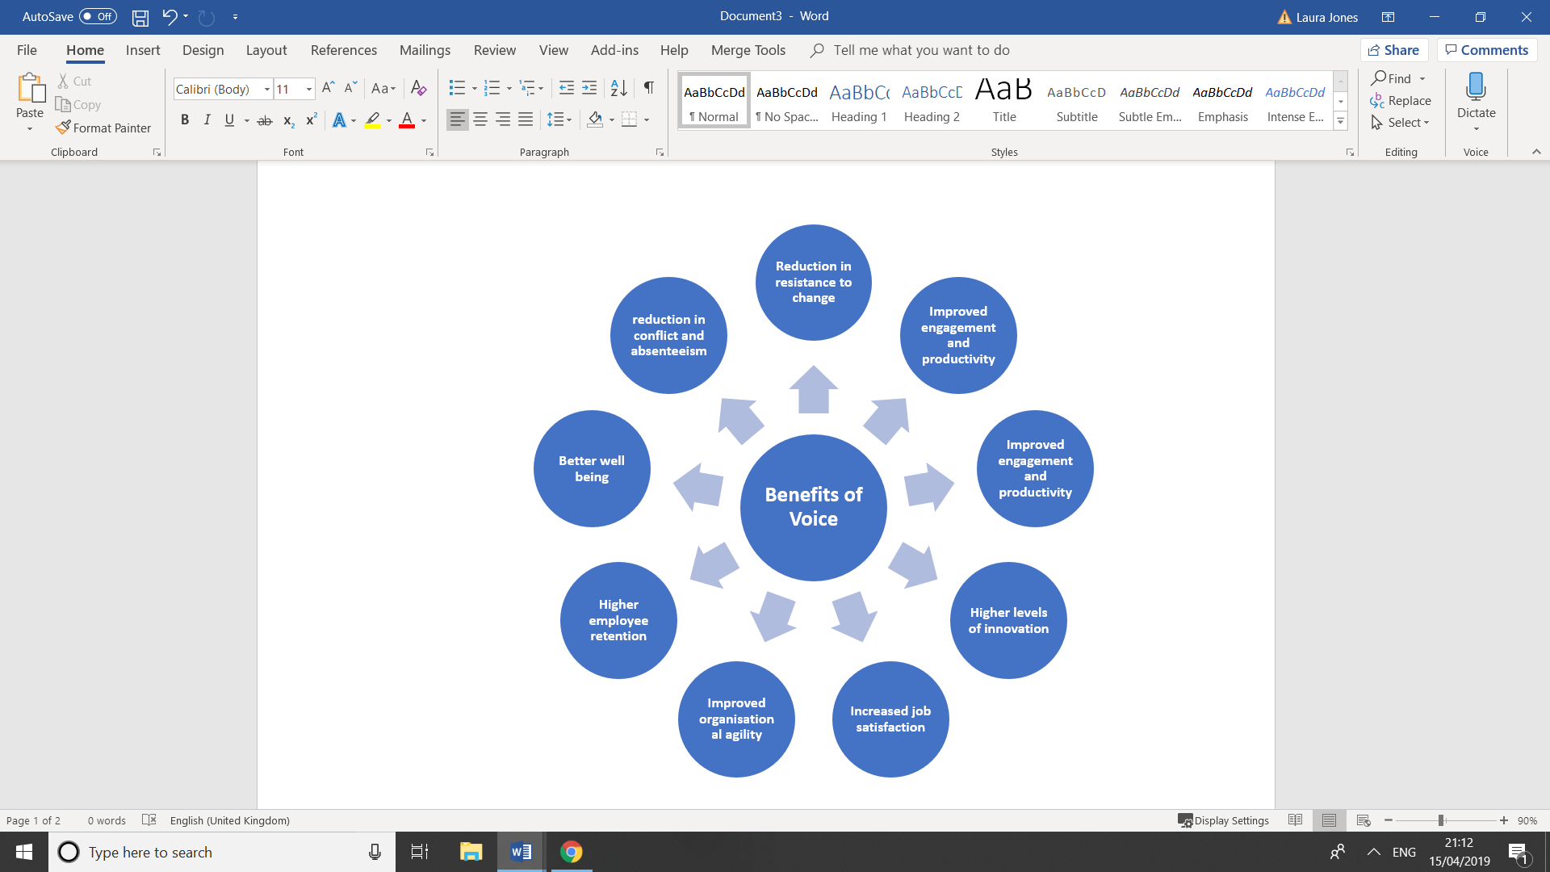
The commercial benefits of supporting and enabling employee voice are widely reported. Dromey (2015) concludes that in general, employers who involve employees in decision making and give them a say are more profitable and more productive. Other commonly reported commercial benefits of supporting employee voice can be seen in figure 2.
Figure 2

Adapted from Baczor, Zheltoukhova, & Yarlagadda 2017, CIPD 2019, Dromey 2015, Gennard et al. 2016, MacLeod & Clarke 2009

1.8 Beyond Commercial Benefit
It is clear from the literature that there are significant business benefits to supporting employee voice. However, it is reasoned that organisations should also recognise the human element of giving workers a voice. This reasoning suggests that voice is a human right rather than a privilege, comparing voice to an extension of democracy in the workplace. This viewpoint argue that if workers are to be treated as legitimate and valued stakeholders and work is to be fair and decent, they must have a say in the way they work (CIPD 2019, Dundon & Rollinson 2011, Taylor 2017). CIPD summarises this in saying;

If we fundamentally believe in humanity at work, we must recognise the importance of self-determination in the workplace, not in all matters, but where practicable. Thus, separate from any instrumental gain, employee influence has intrinsic value to us as humans (CIPD 2017).

1.9 A Framework to Evaluate Employee Voice
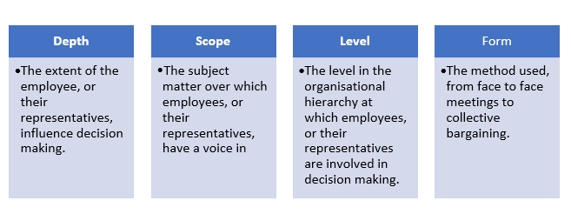
It is necessary to have a framework to evaluate the forms of voice within an organisation and the extent to which those forms facilitate employees having their say (Dundon & Rollinson 2011). Marchington and Wilkinson (2008) offers such a framework which evaluates four dimensions:
Figure 3

2. Employee Voice in Practice
There are a broad range of processes and mechanisms available to facilitate employee voice. ACAS (2012) reports the broader the mixture of channels an organisation uses the better results they will see. Ramsay (1996) proposes that all voice activities can be categorised under four headings; communication and briefing systems, task and work group involvement, financial participation and representative involvement and participation. However, it should also be noted that within these headings some mechanisms overlap (Dundon & Rollinson, 2011).

2.1 Communication and Briefing Systems
Communication and briefing systems support the essential flow of information needed to support the employment relationship.

Effective communication is described by IPA (2017a) as an essential characteristic of high performing teams. Other benefits are widely reported, including increased trust, engagement and employee wellbeing. (ACAS n.d.a, CIPD 2019a, Gennard et al. 2016)

Communication can either be one way, such as a communication from management to inform employees of a change, or two way, where management asks for feedback. Communication can be split into two main methods, face to face and written as summarised in figure 4.

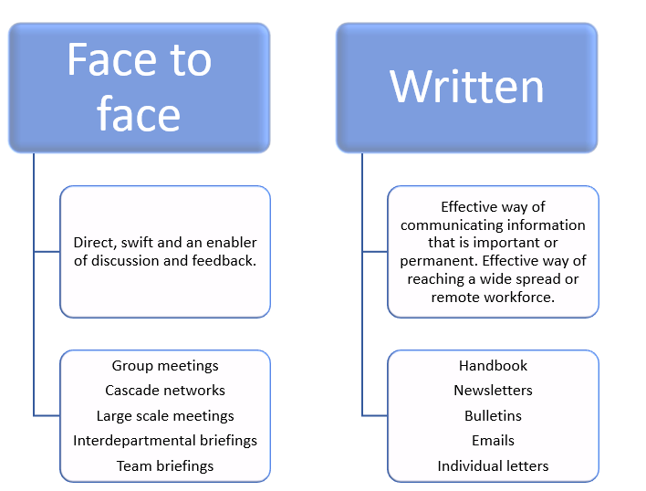
Figure 4
(Adapted from Gennard et al. 2016)

2.1.1 Modern Communication and Briefing Systems
In recent years technology has hugely influenced how organisations facilitate communion with employees. Social media provides an opportunity to facilitate voice, engaging employees and drawing them into discussion. It can also be used as an enabler, making traditional tools such as engagement surveys more engaging (CIPD 2014 & Dromey 2016).

The use of social communication tools such as Slack and Yammer is rising, a reported 72% of organisations are using such tools to facilitate employee communications (HBR 2017, McKinsey 2012).

Sharp (2018a) explains that apps with functions including chat, group networks and feedback facilities, can be an effective way of enabling dialogue for employees in non-desk-based environments such as retail. However, for these to be truly effective they must mirror the tools employees use in their personal lives. ACAS (2012) agrees, stating tools such as blogs, intranets and social media platforms can be used alongside traditional representation, allowing employee voice to flourish (ACAS 2012).

2.1.2 Employee Attitude Surveys
Employee attitude surveys are frequently used upward channel of communication (CIPD 2018, Gennard et al. 2016).Surveys can gather data on areas including perception of fairness, pay, opportunities for L&D, leadership & management or business strategy. Surveys can also be used to gather views on proposed changes, specific HRM policies or provide any data which could be used to assist management decision making (Gennard et al. 2016, Bersin 2015).

Judd, O'Rourke, and Grant 2018 explain the benefits of surveys include being an effective predictor of behaviour, giving employees the chance to feel heard and acting as a vehicle for changing behaviour.

2.1.3 Criticism of Communication as a form of Voice
Allen and Tuselmann (2009) argue that for a mechanism to truly be a mechanism for voice it must also allow influence over work place practices.

On this basis, we can separate communication mechanisms into; one way methods, that simply disseminate information from management to employees, and two way methods which allow the flow of information both up and down the chain (Dundon & Rollinson 2016). Under this assumption we can discount one way methods as being mechanisms for voice. Although one-way communication may not be considered voice under this definition IPA (nd) point out that in order to make voice worth listening too employees must be kept informed by allowing information to flow down the chain.

Whist there are obvious benefits to using technology for social communication, it is suggested that overreliance on its use can be damaging due to its imprecise and erratic nature. Therefore, organisations should select the most appropriate method for its purpose, not overlooking the specific advantages of formal communication (Tenhiala and Salvador 2018). Another criticism is that organisations are not capitalising on the potential of this technology, often using it as a communications tool to provide updates, as opposed to a tool to support voice, encourage conversation and collaboration (Dromey 2016, HBR 2017, McKinsey 2012).

De Wall (2014) points out that whilst surveys have the potential to act as an effective agent for voice there are common mistakes which organisations make when implementing these. Surveys with too narrow scope, questions implying action can be taken from the response (where this is not the case) and poor follow up of results can leave employees feeling frustrated and undervalued. Bersin (2015) believes the speed at which surveys are conducted and action is taken on the results is also too slow, suggesting tools such as pulse surveys can be a more real time method of collecting feedback.
2.1.4 Communication and Briefing Systems at ECD
Although under the definition given by Allen and Tuselmann (2009) communication can only be considered as a mechanism for voice we must also consider the viewpoint that in order to make voice worth listening to employees must also be kept informed via one way communication. Therefore we must consider both one way and two-way communication at ECD. Figure 4 shows the main methods of communication in the retail division.
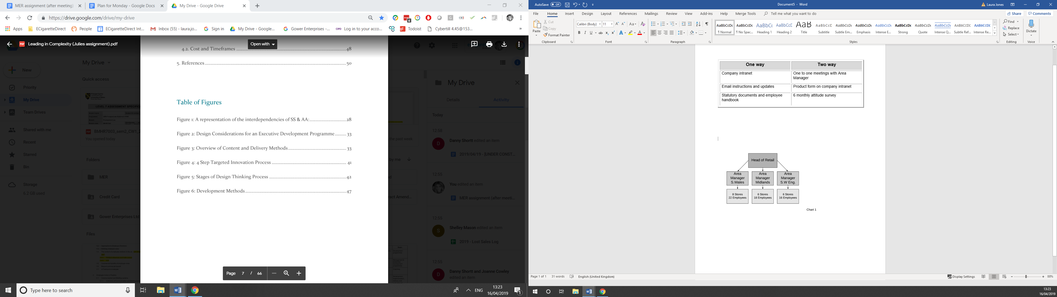
Figure 5
Logistics make regular face to face communication between management and employees difficult, and regular team meetings impossible in the retail division. Therefore, a great deal of communication is via emails or intranet communications and could be considered one-way information sharing rather than voice under Allen and Tuselmann’s definition.

The use of social media at ECD is limited, confined to forum discussions within the company’s intranet and only on the topic of product. The intranet interface is not particularly engaging. Sharp (2018a) points out that for these types of tools to be effective they must mirror what employees use in their personal lives. This may be why anecdotal evidence suggests the forums are not widely used.

ECD conducts an online, anonymous attitude survey twice annually. Genuine changes have been made as a result of the feedback from these surveys including an increase in holiday allowance and the introduction of an occupational sick pay scheme. Although the results of the survey are not split by retail/head office data shows the last survey only received a response rate of circa 50% of the total company. Typical engagement survey response rates are between 50-70% (Survey Lab 2016) indicating 50% is a low response rate. This poses the question, do colleagues believe completing the survey will illicit change and have the previous changes made as a result of the survey been sufficiently communicated? Both these points are identified by Waal (2014) as potential pitfalls of engagement surveys. ECD does not currently use any pulse surveys.

2.2 Task and Work Group Involvement
Described as a ‘problem solving voice’ task and work group involvement is a method direct involvement which typically involves small groups of employees (Dundon & Rollinson 2011).

Employees partaking in such schemes are not usually representatives but are chosen because of their knowledge of the task at hand. Groups work together to identify work-based problems, sometimes with the autonomy to roll out solutions but usually to feed back to management with proposed solutions. Methods of task and work group involvement include team-working, quality circles and total quality management (Dundon & Rollinson 2011, Gennard et al. 2016).

Task and work group involvement can be viewed as a form of voice as it is an upward form of communication to management (Dundon & Rollinson, 2011, Gennard et al. 2016).

2.2.1 Criticism of Task and Work Group Involvement
Gennard et al. (2016) explain that drawbacks of using these methods include participants reporting peer pressure and stress from the added responsibility, particularly as managers may not listen to employee contributions.

Daniels (2006) also points out that there can be a time implication before results are seen due to teams needing to go through the process of forming, storming and norming before they perform.

2.2.2 Task and Work Group Involvement at ECD
Task and work group involvement is a concept which ECD have recently trialled but have minimal experience in. In line with the definition of task and work group involvement by Dundon & Rollinson (2011) the project involves a small group of employees who are working on a solution to a problem and feeding back to management with solutions. The group has not been elected, rather chosen for their specific knowledge in this area. The trial is in its early stages but positive steps have already been taken to address the issue they were tasked to work on, with the group also highlighting issues that management would not have otherwise considered.
This strongly indicates there is scope to roll this out further.

2.3 Financial Participation
Financial participation (FP) is a mechanism that allows employees to share in the financial success of the organisation and is said to be one of the most direct and tangible forms of EIP (Dundon & Rollinson, 2011 & Gennard et. al 2016).

FP takes many forms, Dundon & Rollinson (2011) say that these can be split into three basic forms; profit sharing, employee share ownership schemes and profit related pay schemes. FP models have experienced a revival in the last decade, driven by EU initiatives as well as being used as an instrument to overcome the financial crisis of 2008 and 2009 (Matiaske, Pendleton and Poutsma, 2016).

Literature suggests that financially involving employees in the success of the business holds many commercial benefits. Employees are said to develop a greater sense of the business needs and better attitudes to problem solving (Blaszczyk 2014) as well as having increased motivation and productivity (Gennard et al. 2016, Kozlowski 2014). It has also been said that generally businesses adopting some means of FP for employees outperform their peers (Campbell, Case and Fotsch 2018). FP schemes also allow the organisation to better reward and compensate employees without adding to its fixed cost (ibid).

2.3.1 Criticisms of Financial Participation
As previously discussed, Allen and Tuselmann, 2009, argued that a mechanism for voice must allow influence over work place practices. Using this definition, it could be argued that FP does not facilitate employees to have influence and is therefore not a mechanism for voice. Dundon & Rollinson, 2011 explain that it would be very unlikely that employees benefitting from a FP scheme would be able to influence an organisation based on their position of holding stocks or shares as these would be minimal.

2.3.2 Financial Participation at ECD
ECD does not currently employ any methods of financial participation. Retail employees currently partake in a discretionary, non-contractual bonus scheme, system based on a number of KPIs. Feedback on the scheme, from those partaking in it, is that KPI’s are not a fair or liked way of calculating bonus. With this in mind, there is scope to replace this with a form of profit-sharing scheme.

2.4 Representative Involvement and Participation
Representative EIP is an indirect form of voice through which management inform, consult and or negotiate with employee representatives. Although commonly associated with union representation, there are an increasing number of non-union representation mechanisms (Dundon & Rollinson, 2011).

2.4.1 Trade Union Representation
As previously discussed, union representation provides a definite voice mechanism for its members. Union representation is commonly associated with collective bargaining and joint consultation, although trends indicate these are decreasing in popularity (Dundon & Rollinson 2011). Although the main purpose of a union is to protect and enhance living standards for members, the presence of a trade union is also said to be beneficial to the employer by reducing labour turnover, encouraging investment in capital and skills and improving managerial decision making (Gennard et al. 2016).

2.4.2 Non Union Representation
Aside from trade union representation, joint consultation (JCC) is the next main form of representative participation. This involves management and employees, or their representatives, discussing issues and seeking solutions through an exchange of views and information (Gennard et al 2016).

Sometimes known as ‘works councils’ or ‘employee forums’, commonly discussed issues include employment issues, future plans, financial issues and health and safety (Adam, D., Purcell, J. and Hall, M. 2014).

Gennard et al. (2016) point out that for JCC’s to be effective, a well-prepared agenda should be sent out in advance allowing representatives to consult with constituents prior to the meeting. The deliberations of the committee should be relayed to constituents as soon as possible.

For representatives to confidently and effectively undertake their roles training and support should also be provided (IPA nd., ACAS 2014).

Examples of organisations who claim to see a benefit from engaging in non-union representative EIP include Virgin Media, Prudential, Sainsbury's and John Lewis Partnership (Sharp, 2018., IPA, a., IPA, b. And EOA, 2018).

2.4.3 Criticism of Representative Involvement and Participation
Whilst union recognition provides employees with a definite voice mechanism it does not automatically guarantee effective or extensive voice. In some situations, union representation has been described as a ‘hollow shell’, ineffective and marginal to other direct voice arrangements (Dundon & Rollinson 2011)

Using the previously discussed definition by Gennard et al (2016) that employee involvement entails soliciting the views, ideas and opinions of employees but management retaining overall power in the decision making process, it could be argued that representative involvement is not a true voice mechanism and there is no requirement for managers to actually listen.

2.4.4 Representative Involvement and Participation at ECD
ECD set up the “ECD Employee Forum” in June 2018. This would be considered a form of JCC. One representative from each area attends a meeting with Senior Management each quarter to give constituent feedback, ask questions and offer suggestions. Discussions are a mix of topics chosen by both management and the representatives. The representatives then produce report to circulate a report to the retail division to inform them of outcomes. The forum has been successful in affecting changes in communication and helped to develop a new retail job role.

However, criticisms that the feedback employees receive from their representatives is not adequate or timely enough have been raised. The representatives have also raised that they find it difficult to gather feedback from their areas, particularly as they are required to gather feedback from colleagues, they may never have met face to face.

ACAS (2014) and IPA (nd) recommend representatives receive training in order to be effective in this role. ECD representatives have not had any training which may be why these issues have been raised.

ECD has not received any request to recognise a union or requests under the ICE regulations to date.

2.5 The Role of Managers in Supporting Voice
There is a strong argument that without a culture which supports voice, mechanisms to support voice will not be effective. Dundon & Wilkinson (2004) conclude that where voice mechanisms exist but the culture does not support them there is little point in those mechanisms at all. In contrast, the right culture can create organic feedback and voice without the need for formal structure (Dundon & Wilkinson 2004, Sharp, 2018a).

Managers play a critical role in creating a culture which engages employees and facilitates voice. Aside from supporting formal mechanisms for voice, Sharp (2018a) points out that if managers are tuned in to the voice of employees on the ground it can help organisations “catch things early”, there is also evidence that some employees find informal discussions more useful than more formal voice mechanisms (Townsend, Wilkinson, and Burgess 2012).

Managers can either be a barrier or facilitator voice and managers with strong people management skills are better placed to listen to their subordinates (Heffernan, M., Dundon, T. 2015, IPA nd,a, Townsend et al., 2012). CIPD (2018) point out the importance of equipping managers with strong people management skills, particularly the skill to manage conflict, highlighting it is common for managers to find this difficult.

In summary “Voice is about both culture and structures; first you need to get the culture right, then you need to provide the processes and channels through which voice can be expressed” (Newcome, 2012).

2.5.1 Managers at ECD
Currently there is no formal management development at ECD to support managers to enable and encourage voice.

3. Conclusion
Employee voice is a topic which falls under the umbrella ‘employee relations’. There are many internal and external factors affecting employee relations in the UK, including political influences and the organisations own approach. This report has identified that employee voice is a broad term, covering a range of activities and practices (CIPD 2017) which, if used effectively, can bring a range of commercial benefits to the organisation (Dromey 2015). It has also been identified that separate from any instrumental gain, employee influence has intrinsic value to us as humans (CIPD 2017).A variety of employee voice mechanisms have been identified analysed using a range of literature and employee voice at ECD has been evaluated against these. Figure 6 below shows a summary of the evaluation using a framework proposed by Marchington and Wilkinson (2008).
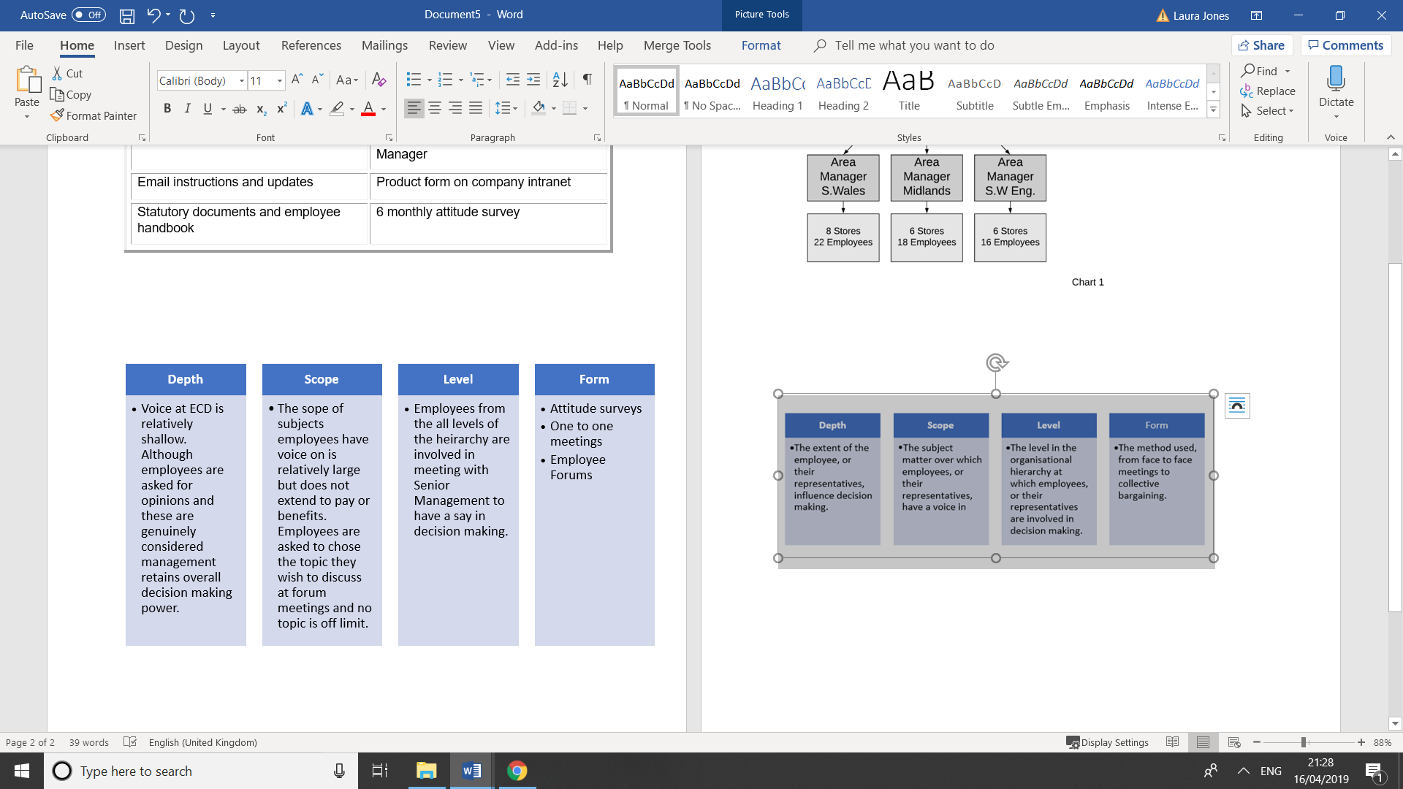
Figure 6

It has also been identified that there is a strong argument that culture can be far more crucial in enabling and utilising employee voice than the mechanisms. Concluding that “Voice is about both culture and structures; first you need to get the culture right, then you need to provide the processes and channels through which voice can be expressed” (Newcome, 2012).

4. Recommendations
The scope of this report does not allow for an extensive list of recommendations to be made. Therefore, three recommendations have been chosen as actions believed to have the biggest potential for impact on improving employee voice in the retail division at ECD.
- Training and support for ECD Employee Representatives
- Research a social media platform to allow for two-way conversation
- Invest in Management Development

4.1 Training and Support for ECD Employee Representatives
Of the mechanisms reviewed, the ECD forum has the most depth, scope and level of voice making it the most powerful. There is obvious value in the forum, but investment is needed to ensure we are capitalising on its potential.

Criticisms of the forum have been the difficulty representatives face in collecting feedback and the lack of timely feedback to constituents. However, the representatives have not had any training in how to perform their roles effectively. Support and training for representatives is recognised by IPA (nd) and CIPD (2014) as essential to ensure effectiveness.

IPA offers such training in as seen in figure 7. 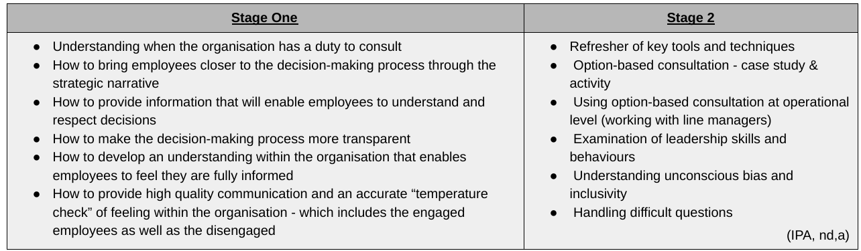
Figure 7

It should be identified what support representatives require to communicate forum information appropriately and in a timely manner. Timely feedback was cited by Gennard et al. (2016) as being a critical component in making such schemes successful. Representatives must also be given enough support to ensure information is provided to constituents as soon as possible. This may include time off the shop floor to write reports or out of store visiting constituents

4.2 Research a Social Media Platform
Social technology has been identified as a particularly effective way of engaging those in non-desk based work environments such as retail (ACAS 2012., CIPD 2014., Sharp, 2018).

ECD are not currently capitalising on this potential, using an unengaging interface, to discuss a very limited set of topics.

A range of social communication platforms are available for businesses including facebook workplace, Slack and Yammer. The scope of this report does not allow for researching the most appropriate platform. As such, the recommendation is that further research be conducted into the most appropriate social media platform to adopt. Research should address the following;
- The platform should be app based, allowing easy access by those who are not in desk-based roles.
- The platform should mirror platforms employees use in their personal lives (Sharp 2018).
- The platform should allow for two-way flow of information. Content should not be narrowly limited as this may render the platform simply a corporate communications tool (Dromey 2016).

4.3 Management Development
Currently there is no management development program at ECD. The role of managers in enabling voice has been identified as crucial. Without managers to support a culture which enables voice, mechanisms are worthless. CIPD (2019) recommend that people managers understand the value of employee voice, and are trained to facilitate open conversations and demonstrate empathic listening. Therefore, the final recommendation is the creation of a retail management development program to develop managers with the capability to encourage an enable employee voice at all levels.

5. Bibliography

- ACAS (n.d. a) Why are communications and consultation important? Available at http://www.acas.org.uk/index.aspx?articleid=665 (Accessed 7 April 2019)
- ACAS (n.d.) Information and consultation of employees (ICE). Available at http://www.acas.org.uk/index.aspx?articleid=1598 (Accessed 2 April 2019)
- ACAS. (2012) Employee voice is benefiting from the changing nature of communication in the workplace, Available at http://www.acas.org.uk/index.aspx?articleid=3942 (Accessed 7 April 2019)
- ACAS. (2015) Building Productivity in the UK. Available at http://www.acas.org.uk/media/pdf/7/9/Building-productivity-in-the-uk.pdf (Accessed 30 March 2019)
- Allen, M. and H.J. Tuselmann. (2009) ‘All powerful voice? The need to include "exit", "loyalty" and "neglect" in empirical studies too’. Employee Relations, 31(5), pp. 538-552. Available at https://search-proquest-com.ezproxy.uwtsd.ac.uk/docview/235186717/fulltextPDF/E66F9FBF22444D68PQ/1?accountid=130472 (Accessed 7 April 2019)
- Baczor, L., Zheltoukhova, K., & Yarlagadda, R. (2017) Have your say: alternative forms of employee voice. Available at https://www.cipd.co.uk/Images/voice-positioning-report_tcm18-27507.pdf (Accessed 26 March 2019)
- Bersin, J. (2015) Becoming irresistible: A new model for employee engagement, Available at https://www2.deloitte.com/insights/us/en/deloitte-review/issue-16/employee-engagement-strategies.html (Accessed 7 April 2019)
- CIPD. (2018) Employee engagement and motivation, Available at https://www.cipd.co.uk/knowledge/fundamentals/relations/engagement/factsheet#6235 (Accessed 7 April 2019)
- CIPD. (2019) Employee voice. Available at https://www.cipd.co.uk/knowledge/fundamentals/relations/communication/voice-factsheet#53775 (Accessed 26 March 2019)
- CIPD. (2019a) Employee communication. Availavble at https://www.cipd.co.uk/knowledge/fundamentals/relations/communication/factsheet (Accessed 7 April 2019)
- Daniels, K. (2006) Employee Relations in an Organisational Context,London; CIPD
- De Waal, A. (2014) ‘The employee survey: benefits, problems in practice, and the relation with the high performance organization’. Strategic HR Review, 13(6), pp. 227-232. Available at https://search-proquest-com.ezproxy.uwtsd.ac.uk/docview/1645849520/fulltextPDF/F65DAFA2417B4752PQ/1?accountid=130472 (Accessed 7 April 2019)
- Department for Business Energy and Industrial Strategy. (2018) TRADE UNION MEMBERSHIP 2017. Available at https://assets.publishing.service.gov.uk/government/uploads/system/uploads/attachment_data/file/712543/TU_membership_bulletin.pdf (Accessed 2 April 2019)
- Dromey, J. (2015). ICE and Voice 10 years on. Available at https://www.ipa-involve.com/Handlers/Download.ashx?IDMF=d9ca5fed-5b63-4834-b25f-ffd92ea27716 (Accessed 26 March 2019)
- Dromey, J. (2016) Going Digital? Harnessing Social Media for Employee Voice. Available at https://www.ipa-involve.com/Handlers/Download.ashx?IDMF=92017733-5f9f-4dc3-80b4-5244a872d4c4 (Accessed 26 March 2019)
- Dundon, T. and Rollinson, D. (2011) Understanding Employment Relations. Berkshire: McGraw-Hill.
- Gov.uk (n.d.) Informing and consulting employees. Available at https://www.gov.uk/informing-consulting-employees-law (Accessed 2 April 2019)
- Harvard Business Review. (2017) What Managers Need to Know About Social Tools. Available at https://hbr.org/2017/11/what-managers-need-to-know-about-social-tools (Accessed 7 April 2019)
- Investors in People (2017) Employee voice: 6 ways employers can activate it. Available at https://www.investorsinpeople.com/employee-voice-6-ways-employers-can-activate-it/ (Accessed 30 March 2019)
- Investors in People. (2017) Employee voice: why is it important to sustainable success? Available at https://www.investorsinpeople.com/employee-voice-why-is-it-important-to-sustainable-success/ (Accessed 30 March 2019)
- Investors in People. (2017a) Virtual teams: 5 ways to ensure communication works well. Available at https://www.investorsinpeople.com/virtual-teams-5-ways-to-ensure-communication-works-well/le at (Accessed 7 April 2019)
- Judd, S., O'Rourke, E. and Grant, A. (2018) Employee Surveys Are Still One of the Best Ways to Measure Engagement, Available at https://hbr.org/2018/03/employee-surveys-are-still-one-of-the-best-ways-to-measure-engagement (Accessed 7 April 2019)
- MacLeod, D. and Clarke , N. (2009) Engaging for success. Available at https://engageforsuccess.org/wp-content/uploads/2015/08/file52215.pdf (Accessed 26 March 2019)
- McKinsey. (2102) The Social Economy, Available at https://www.mckinsey.com/industries/high-tech/our-insights/the-social-econom y (Accessed 7 April 2019)
- Ramsay, H. (1996) Involvement, empowerment and commitment. In Towers, B. The handbook of Human Resource Management. 2nd ed. Oxford; Blackwell
- Stuff, R. (2017) The Taylor review: time to enhance employee voice. Available at https://www.cipd.co.uk/news-views/cipd-voice/issue-12/enhance-employee-voice (Accessed 2 April 2019)
- Taylor, M. (2017) Good Work. Available at https://assets.publishing.service.gov.uk/government/uploads/system/uploads/attachment_data/file/627671/good-work-taylor-review-modern-working-practices-rg.pdf (Accessed 30 March 2019)
- Tenhiala, A and Salvador, F., (2018) ‘When Communication Should Be Formal’. MIT Sloan Management Review, 60(1), pp. 1-6. Available at https://search-proquest-com.ezproxy.uwtsd.ac.uk/docview/2131141708/fulltextPDF/3F9AF416C0994926PQ/1?accountid=130472 (Accessed 7 April 2019)
- Wilkinson, A., Townsend, K., Burgess, J. and Markey, R. (2013) ‘Reassessing Employee Involvement and Participation: Atrophy, Reinvigoration and Patchwork in Australian Workplaces.’ Journal of Industrial Relations, 55(4) pp. 583-600. Available at https://whel-primo.hosted.exlibrisgroup.com/primo-explore/fulldisplay?docid=TN_sage_s10_1177_0022185613489419&context=PC&vid=44WHELF_UWTSD_VU1&lang=en_US&search_scope=CSCOP_EVERYTHING&adaptor=primo_central_multiple_fe&tab=tab1&query=any,contains,Reassessing%20employee%20involvement%20and%20participation:%20Atrophy,%20reinvigoration%20and%20patchwork%20in%20Australian%20workplaces&sortby=rank&offset=0 (Accessed 7 April 2019)
- CIPD. (2018a) Employee relations: an introduction. Available at https://www.cipd.co.uk/knowledge/fundamentals/relations/employees/factsheet (Accessed 8 April 2019)
- CIPD. (2017) Power dynamics in work and employment relationships: the capacity for employee influence. Available at https://www.cipd.co.uk/Images/power-dynamics-in-work-and-employment-relationships_2017-the-capacity-for-employee-influence_tcm18-33089.pdf (Accessed 9 April 2019)
- Millward, N. Bryson, A. Forth, J. (2000) All Change at Work? London; Routledge
- CIPD. (2014) Putting Social Media to Work. Available at https://www.cipd.co.uk/Images/putting-social-media-to-work-lessons-from-employers_tcm18-10319.pdf (Accessed 12 April 2019)
- Adam, D., Purcell, J. and Hall, M. (2014) Joint consultative committees under the Information and Consultation of Employees Regulations: A WERS analysis. Available at http://www.acas.org.uk/media/pdf/3/c/0414-Joint-consultative-committees-under-the-Information-and-Consultation-of-Employees-Regulations-A.pdf (Accessed 13 April 2019)
- Campbell, D., Case, J., Fotsch, B. (2018) More than a paycheck. Available at https://hbr.org/2018/01/more-than-a-paycheck (Accessed 12 April 2019)
- Survey Lab. (2016) What is a good response rate for an employee survey? Available at http://www.surveylab.co.uk/2016/what-is-a-good-response-rate-for-an-employee-survey/ (Accessed 13 April 2019)
- Matiaske, W., Pendleton, A. and Poutsma, E. (2016) ‘Financial Participation’, Introduction. Management Revue, 27(4), pp.217-218, available at https://search-proquest-com.ezproxy.uwtsd.ac.uk/docview/1853303378/fulltextPDF/630FB80D165448D7PQ/1?accountid=130472 (accessed 12 April 2019)
- Blaszczyk, B. (2014) Employee financial participation in businesses: Is it worth discussing? Available at http://www.case-research.eu/sites/default/files/publications/S%26A%20472.pdf (Accessed 12 April 2019)
- Kozlowski, M. (2014) ‘The Relationship Between Workers' Financial Participation in Companies and Economic Results’, Comparative Economic Research, 17(1), pp. 167-191Available at https://search-proquest-com.ezproxy.uwtsd.ac.uk/docview/1853303378/fulltextPDF/C20ED677A7CA4A91PQ/1?accountid=130472 (Accessed 12 April 2019)
- Dundon, T., Wilkinson, A. (2004) ‘Changing Patterns of Employee Voice: Case Studies from the UK and Republic of Ireland’, Journal of Industrial Relations, 46(3) Available at file:///home/chronos/u-39b85c6a42eb124acb17c82529aab481f95447a5/Downloads/Changing_Patterns_of_Employee_Voice_Case_Studies_f%20(1).pdf (Accessed 13 April 2019)
- IPA. (nd) Employee voice exists, whether you recognise it or not. The only question is – "are you listening?". Available at https://www.ipa-involve.com/employee-voice (Accessed 12 April 2019)
- Newcombe, T. (2012) "Employee voice" is a key to a successful business, says Nita Clarke. Available at https://www.hrmagazine.co.uk/article-details/employee-voice-is-a-key-to-a-successful-business-says-nita-clarke (Accessed 13 April 2019)
- IPA. (2012, a) Rethinking Employee Voice: Prudential. Available at https://www.tomorrowscompany.com/wp-content/uploads/2016/05/Voice_at_the_Prudential_final_50c20c59645d2.pdf (Accessed 13 April 2019)
- ACAS. (2014) Non-Union Representation in the Workplace. Available at http://m.acas.org.uk/media/pdf/9/o/Non-union-representation-in-the-workplace-advisory-booklet.pdf (Accessed 13 April 2019)
- Sharp, R. (2018) Case study: Virgin Media’s employee voice structure. Available at https://www.hrmagazine.co.uk/article-details/case-study-virgin-medias-employee-voice-structure-1 (Accessed 12 April 2019)
- IPA. (2012, b) Rethinking Employee Voice: Sainsburys. Available at http://www.tomorrowscompany.com/wp-content/uploads/2016/05/Employee_voice_IPA_TC_case_study_Sainsburys_50c20c9770c64.pdf (Accessed 13 April 2019)
- EOA. (2018) John Lewis Partnership. Available at https://employeeownership.co.uk/case-studies/john-lewis-partnership/ (Accessed 12 April 2019)
- IPA. (nd, a) Training for representatives. Available at https://www.ipa-involve.com/Pages/Category/training-for-representatives (Accessed 13 April 2019)
- Sharp, R. (2018a) Breaking the silence: Employee voice. Available at https://www.hrmagazine.co.uk/article-details/breaking-the-silence-employee-voice (Accessed 13 April 2019)
- Townsend, K., Wilkinson, A. and Burgess, J. (2012) ‘Filling the gaps: Patterns of formal and informal voice’. Economic and industrial Democracy, 34(2) 337–354, Available at https://journals-sagepub-com.ezproxy.uwtsd.ac.uk/doi/pdf/10.1177/0143831X12448442 (Accessed 13 April 2019)
- Heffernan, M., Dundon, T. (2015) The role of front line managers in employee voice: a social exchange perspective. Available at https://www.ilera2015.com/dynamic/full/IL52.pdf (Accessed 13 April 2019)

