Chronic obstructive pulmonary disease

Name: Vidhi Prajapati

Student number: 2506527

Module: Community Care and Management of Longer-term Conditions

Module Code: LCHS7003

Lecturer’s Name: Dr Aishat Bakre

Assignment Title: Information Booklet of Long-term Condition Management

Chronic obstructive pulmonary disease (COPD)

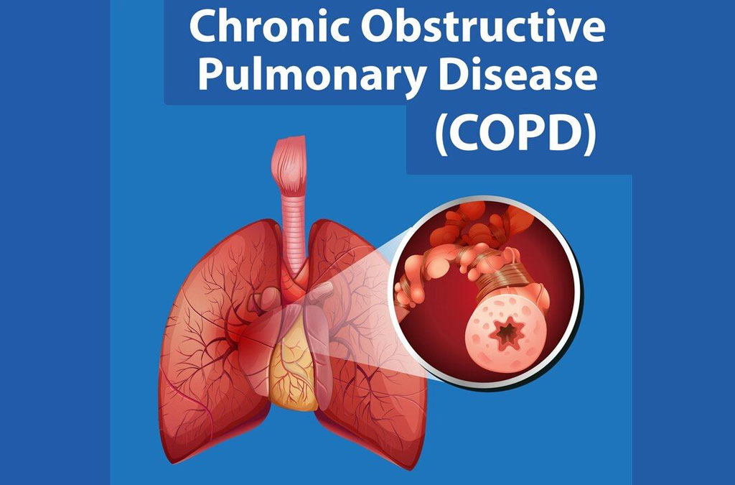
(CHH 2024)

Chronic obstructive pulmonary disease
Introduction
Chronic Obstructive Pulmonary Disease (COPD) is a global health issue that affects millions of people and places a significant burden on healthcare systems worldwide. As the condition is accompanied mainly by continuous difficulty in breathing, it is a debilitating one that is associated with extreme limitations on the quality of life. Long-term exposure to cigarette smoke, environmental toxins, and occupational human factors affecting the air and genetic factors are the leading causes of COPD (Barnes, 2020, p. 101544; Silverman, 2020, p. 418). The age group mainly impacted by the disease is over 40, and the prevalence of the disease is very high among individuals over 65 (Szalontai et al., 2021, p. 2890). The disease is underdiagnosed, although it can be prevented and treated, both of which influence the mortality and morbidity rates positively. The pathophysiology, risk factors, and social impact of COPD are discussed in the paper, and the approach to management and the new health care systems are also considered with the aim of reducing the burden of the chronic condition and enhancing patient outcomes.
Definition, COPD Prevalence and Aetiology.
Definition
COPD is a progressive lung disease, which is accompanied by inexhaustible airflow blockage associated with chronic inflammation as a response to damaging substances and particles (Carmona, Aurrecoechea & Garcias de Yebenes, 2023, p. 55). It has chronic bronchitis, causing an inflammation of the airways and emphysema, which is characterized by the destruction of alveoli (Rodrigues et al., 2021, p. 981). The symptoms, such as dyspnoea, cough, and sputum secretion, become increasingly severe and most often lead to respiratory and cardiac complications. However, the further the diagnosis and treatment are performed, the slower the disease development and the better the life quality (Mein & Ferrera, 2024, p. 100107; Arnold, 2021, p. 103).
Prevalence
On the global scale, COPD is the third most common cause of death; its prevalence has been observed in more than 250 million patients, and annual mortality rates have been reported to be over 3 million people (Dong et al., 2025, p. e002768; Khan et al., 2023, p. 15). In the UK alone, the diagnosis has been made in 1.2 million people; however, it is probable to be twice due to the underdiagnosis (Kaplan et al., 2024, p. 13). COPD has immense disability and productivity and may have in terms of healthcare expenditures up to 1.9 billion annually (Gronhaug et al., 2024, p. 18; Orozco et al., 2024, p. 739).

Risks factors
Non-Modifiable Risk Factors
Genetics: Family/genetic (as inherited in information) history of COPD, e.g., the deficiency of alpha-1 antitrypsin (Rodrigues et al., 2021, p. 981).
Age: Age is also a complication in which COPD is more evident among young smokers below 40 years (Khan et al., 2023, p. 15).
Modifiable Risk Factors
Smoking: Smoking cigarettes is considered to be the most common cause of COPD as the habit is known to kill most of the disease, airways, and alveoli (Carmona, Aurrecoechea & Garcias de Yebenes, 2023, p. 55).
Environmental pollution: COPD can be caused or even exacerbated by exposure to dust, chemicals, and occupational odors (Carmona, Aurrecoechea & Garcias de Yebenes, 2023, p. 55).
Exercise: It may exacerbate the COPD condition and decrease the patient's tolerance (Arnold, 2021, p. 103).

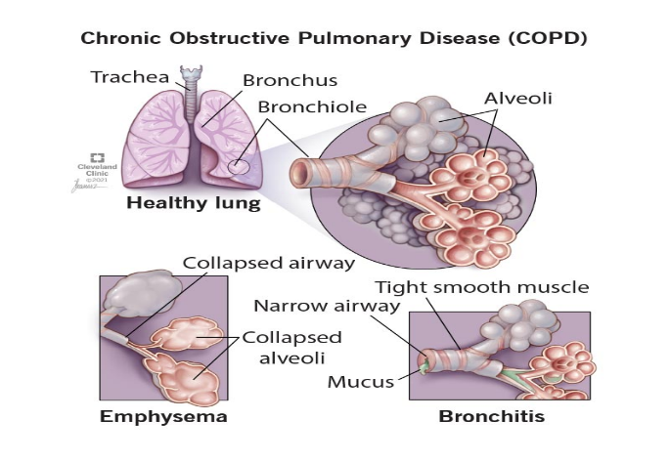
Figure 1 Comparison between health lung and lung affected by COPD (COPD 2023)
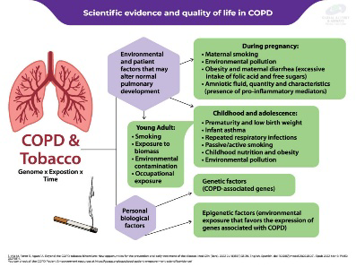
Figure 2 Scientific evidence and quality of life in COPD (Patient Empowerment Scientific Evidence - Global Allergy & Airways Patient Platform 2024)
Impact of COPD
The physical, psychological, and social impacts of COPD on the patients and families are overwhelming, and this triggers both negative experiences for the patient as well as the relatives.
Physical Implications
The respiratory tract affected by COPD is the cause of the increased dyspnoea (breathlessness), which progresses over time (Lange et al., 2021, p. 303). One can first practice it through physical exercise. However, it does not reach a specific threshold, as it impacts patients even during rest, limiting their mobility and autonomy (Rodrigues et al., 2021, p. 981). Among the factors contributing to the growth of respiratory failure and hypoxia are infections and pollution, which cause pulmonary hypertension and right-sided heart failure (Khan et al., 2023, p. 18; Mein et al., 2024, p. 100107). Also, issues such as anxiety and depression can progress due to COPD and can increase the severity of the symptoms and limit the observation of the treatment process (Yawn, 2024, p. 12; Gronhaug et al., 2024, p. 15).
Social Implications
The consequence of social isolation, along with unemployment and disengagement within the community, is that COPD causes physical challenges, making people more physically challenged (Gronhaug et al., 2024, p. 13). Such stigma of the disease, in particular, the inferior socioeconomic levels, will contribute to mental torture (Fazleen and Wilkinson, 2020, p. 4). The probability of patients leading an economically stable life is low due to the absence of productivity and the high cost of healthcare services that patients with COPD experience (Kahnert et al., 2023, p. 14; Agusti, Vogelmeier, and Faner, 2020). Additionally, poor living conditions expose low-income earners to a disadvantaged position in terms of health inequities (Sandelowsky et al., 2021, p. 5; Czarnecka-Chrebelska et al., 2023, p. 448).
The quantity of information that the family will receive is considerably lower compared to the information that healthcare providers and other stakeholders will accept.
The facility also has a significant impact on the COPD family since caregivers are exposed to immense emotional, physical, and financial stress. It may cause the development of anxiety and fear, the existence of one of the loved ones with breathing issues (Gronhaug et al., 2024, p. 10; Narjes Heshmatifar et al., 2025, p. 24). The caregivers are overwhelmed with work that was previously handled by the patient, leading to the emergence of stress, exhaustion, and burnout (Orozco et al., 2024, p. 737). The other possible consequence of long-term care giving is sleeping deprivation and depression, which lower the capability of such a caregiver to deliver care (Gronhaug et al., 2024, p. 8). There are ways in which support groups and counseling can help caregivers improve their well-being (Xu, Jin, & Xia, 2025, p. 3258). It has also been revealed that family involvement in the care planning process enhances communication, adherence, and well-being of family members (Ragusa et al., 2025, p. 2571; Yawn, 2024, p. 12).
The comorbidity effect of COPD highlights the need for interdisciplinary care to consider not only the physiological and psychological aspects of human needs, but also the social aspects.
Diagnosis of COPD
The diagnosis of COPD should be prompt and adequate to reduce the incidence of the disease and improve the quality of life (Fazleen and Wilkinson, 2020, p. 4). They are to be composed of clinical examination, lung function tests, and X-ray (Cagle, Landrum, and Kennedy, 2023, p. 606).
Spirometry
One of the diagnostic criteria for COPD is spirometry (Kahnert et al., 2023, p. 437). It identifies the amount of air that has been forced out, their expelled air rate, and it is measured with the aid of FEV1 and FVC (Yawn, 2024, p. 12). A value of less than 0.70 of the ratio FEV1 / FVC of the bronchodilator proves the diagnosis of COPD (Arnold, 2021, p. 103). It may also be done with the assistance of a spirometer to distinguish between COPD and asthma, which is a reversible hindrance of airflow (Dong et al., 2025, p. e002768). However, it cannot be interpreted correctly without the necessary training, and non-adherence to the principles of spirometry can also be identified as another factor that leads to underdiagnosis (Kaplan et al., 2024, p. 13).

Chest X-ray and CT scans
Chest X-rays help determine whether the structures are damaged or rule out other possibilities (Rodrigues et al., 2021, p. 982). CT aids in clarifying the image of the picture and determining their respective comorbidities, such as lung cancer and emphysema (Szalontai et al., 2021, p. 2892).
Other Diagnostic Tests
Blood gas and pulse oximetry measurements evaluate the level of oxygenation, whereas alpha-1 antitrypsin tests rule out the presence of genetic causes (Silverman, 2020, p. 420). Hypoxaemia also has a significant influence on both hospitalization and infection; therefore, it is essential to note that it should be detected early (Guecamburu et al., 2023, p. 5).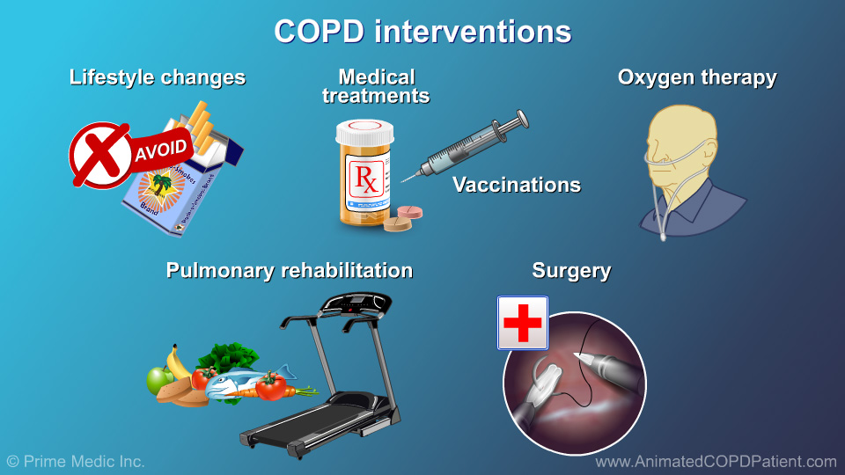
Figure 7 Management and treatment of COPD (Medicine 2025)
The pharmacotherapy of COPD has been reported to alleviate airway blockages, bronchial spasm, and airway exacerbations (Stevermer et al., 2021, p. 13). They are prescribed as bronchodilators, with salbutamol (Ventolin) in the short term and salmeterol (Serevent) in the long term (Arnold, 2021, p. 103). Tiotropium is an antimuscarinic agent that prevents bronchoconstriction (Kaplan et al., 2024, p. 15). Fluticasone (Flovent), used in the treatment of airways, is an example of an ICS, as are mucolytic drugs such as acetylcysteine (Mucomyst) and medicines that help remove mucus (Barnes, 2020, p. 101544). A division into them is based on the symptoms, exacerbation rate, and spirometry (Dong et al., 2025, p. e002768).
COPD Non-pharmacological Therapy and Surgical Therapy.
Non-pharmacological COPD interventions are essential. The so-called Pulmonary Rehabilitation (PR), which involves pulmonary offloading and dyspnoea reduction, potentially involving education and counseling, aims to improve the quality of life (Rochester et al., 2023, p. e8). It also has an inhibitory effect on anxiety and enhances self-efficacy (Gronhaug et al., 2024, p. 7). Oxygen therapy is administered to achieve an oxygen saturation of 90 percent or above in the blood of patients with chronic heart Failure and dyspnea (Mein et al., 25, p. 100107). Very high importance is given to smoking cessation, which can reduce the incidence of the disease (Arnold, 2021, p. 103). Moreover, the implementation of the nicotine replacement therapy may be more successful in the process (Sandelowsky et al., 2021, p. 4). Vaccination against the influenza virus and pneumococcus is also recommended annually to prevent infections and exacerbations (Khanert et al., 2023, p. 438). The benefits of self-management plans lie in their ability to facilitate earlier symptom detection and enhance long-term outcomes (Schrijver et al., 2024, p. e39070). In severe cases, such as Lung Volume Reduction Surgery (LVRS) and lung transplants (Rodrigues et al., 2021, p. 983; Khan et al., 2023, p. 23), surgery is considered.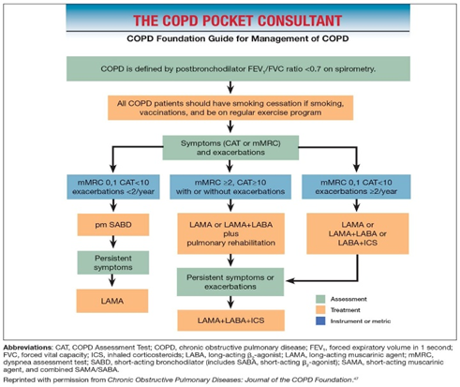
Figure 8 COPD Pocket Consultant: COPD Foundation Guide for Management of COPD (Thomashow et al. 2019)
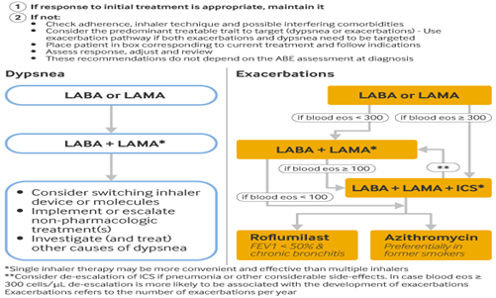
Figure 9 COPD Treatment Recommendations for Dyspnea and Exacerbations (Chronic obstructive pulmonary disease (COPD) - Management Approach | BMJ Best Practice US 2025)
COPD: Chronic Care models and house of care.
COPD is a respiratory complication that cannot be eradicated; however, it should be manageable in a way that addresses all three biological, psychological, and social levels adequately. Therapy of COPD is linked to both medical and self-managed and psychosocial treatments. To improve the process of care delivery to patients with COPD, two models that can be employed are the House of Care model and the Chronic Care Model (CCM).
House of Care Model in the NHS Long-term Plan (UK).
This model is referred to as the House of Care Model, which represents the progress the NHS has undertaken. The model will be founded upon multidisciplinary care, and in this model, the interaction between physiotherapists, pharmacists, and general practitioners will provide the linkage between patient care and self-care. The model has six crucial components, and they encompass:
Informed and Collected: Nurses Educating COPD patients and their families, the knowledge and skills that might help manage the condition (Dong et al., 2025, p. e002768).
Person-Centred Coordinated Care: The care plan is developed according to the individual's needs, and the patient becomes a professional in the industry from which they receive treatment (Celli et al., 2025, p. 106424).
Organisational and Supporting Processes: These types of systems have the role of ensuring that the process of delivering care is evidence-based and ensuring that the patients actively participate in the decision-making process.
Loyal Healthcare Professionals Who are loyal to Partnership working: It assists Partnership between healthcare providers in the aspect of long-term care.
The commission is committed to improving the healthcare system and ensuring that the results of healthcare implementation drive additional use of healthcare services (Rochester et al., 2023, p. e8).
Whole-System Approach: This refers to the integration of primary care and secondary care, providing an opportunity to treat patients comprehensively (Rochester et al., 2023, p. e8).
Early intervention, stress management, and patient empowerment are the primary foundations of this model, as they cater to the high needs related to improved COPD management. The discussion of these aspects as part of the House of Care model will contribute to enhancing the physical and mental well-being of COPD patients and offer them practical solutions (Rochester et al., 2023, p. e8).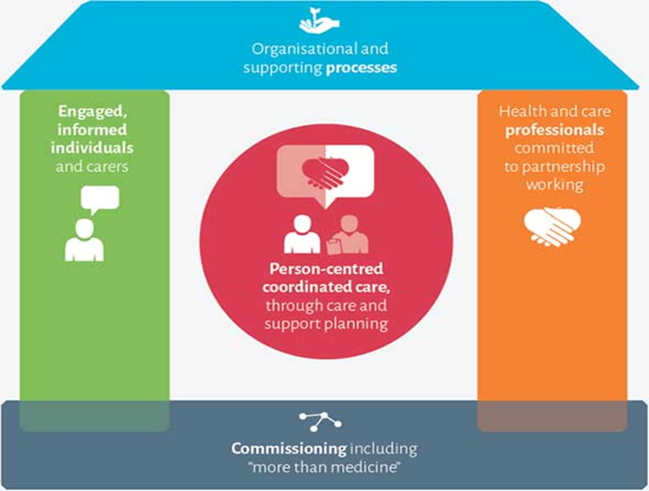
Figure 10 House of Care Model (UK NHS Long-term Plan). (NHS,2022)

Chronic Care Model (CCM): International model
The Chronic Care Model (CCM) is a globally recognized model for treating chronic illnesses, such as COPD. The model includes patient-centered preventive therapy, which implies that patients are trained to initiate actions in self-determination and self-regulation of their treatment. The model involves patient-centred preventive therapy, implying that patients are educated on actions for self-determination and self-activity in their treatment. The CCM has six major points:
Community Resources and Policies: Community Resources and Policies Community Resources Implementation to aid COPD Patients (Dong et al., 2025, p. e002768).
Health System Organization: This corresponds to the fact that healthcare systems are designed to offer patient-cantered care, and such systems require well-coordinated operations (Dong et al., 2025, p. e002768).
Self-In-Person Support: Patients can be educated to become self-managed in their health management, which is an essential issue in chronic diseases, including COPD (Orsolini et al., 2022).
Design of the Delivery System: The combination of the primary care and a specialty-based service in which the continuity care of the COPD patients will be initiated (Rochester et al., 2023, p. e8).
Decision Support: Monitoring evidence-based solutions to assist healthcare professionals in making necessary treatment decisions (Celli et al., 2025, p. 106424).
Clinical Information Systems: In this field, the team has been tasked with providing clinical professionals with evidence-based information on patients, enabling them to make informed decisions regarding treatment promptly (Rochester et al., 2023, p. e8).
The CCM is in support of integrative therapies that combine therapies that utilize exclusively biological (universally pharmacological) and those therapies that use psychosocial (cognitive behavioral therapy or family therapy). It is a biological and social system of content that comprises both biological and social aspects associated with COPD, aiming to achieve a better quality of life and fewer symptoms (Orozco et al., 2024, p. 737).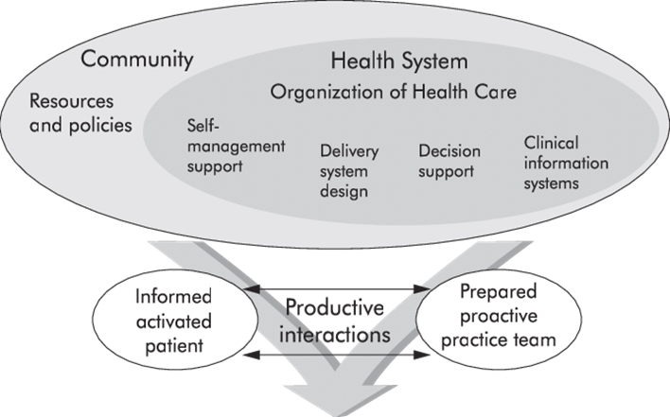
Figure 11 Chronic Care Model (CCM) (Wagner et al., 2020)

The Models of COPD Care were incorporated.
The Chronic Care Model and the House of Care are two potential efficient approaches to dealing with COPD. The models are geared towards multidisciplinary, early intervention, and patient-centered care that is pertinent to the management of COPD. The House of Care model, characterized by stress reduction, self-management, and empowerment, resembles the proactive care, community resources, and education that define the patient-centered model of the CCM (Barnes, 2020, p.101544; Celli et al., 2025, p. 106424). The two models emphasize the importance of prevention and personalized treatment, which involves early and specialized help to the general populace and even those who already possess the illness but are at risk of contracting COPD.
The healthcare system, integrating a collaborative approach such as the House of Care model, effective management interventions, and the synthesis of the CCM system-wide, will be sufficiently positioned to deliver holistic care, which is followed by patient-centered care, ultimately contributing to the quality of life for patients with a COPD condition.
Politics and Health Care Agendas.
In the UK, COPD prevention and early-intervention priorities for care are still at the forefront of COPD management in the NHS. The COPD Pathway encourages screening of people at high risk, smoking cessation programs, and vaccination against exacerbations (Sandelowsky et al., 2021, p. 4). Outreach respiratory care prevents care interruptions and increases accessibility through the community-shifting of respiratory services (Fazleen & Wilkinson, 2020, p. 5). These initiatives that accompany pulmonary rehabilitation are a pointer that the UK is interested in comprehensive, patient-cantered, respiratory care (Xu, Jin, & Xia 2025, p.3258). The disease COPD is included in the Global Action Plan in Non-Communicable Diseases (2013-2030) issued by the World Health Organization. The WHO supports the oppression of tobacco, the improvement of air quality, and the healthcare infrastructure, particularly in the low- and middle-income states (Agusti, Vogelmeier,& Faner, 2020). The Framework Convention on Tobacco Control (FCTC) is in favour of tobacco control in the form of taxation, smoking prohibition, and social awareness promotion (Silverman, 2020, p. 422). In addition, the WHO advances the environmental and work-related health campaigns to reduce the exposure to pollutants to eradicate the COPD epidemiology on the international level (Szalontai et al., 2021, p. 2893).
Recommendations for improving COPD Care.
There is a need to shift towards patient-centred care in an effort to improve the COPD outcome. An individual approach to care using lifestyle and preferences would enhance compliance and understanding of the disease (Yawn, 2024, p.12; Celli et al., 2025, p. 106424). Inequality in the geographical area can be reduced by increasing the provision of pulmonary rehabilitation, including the use of telehealth (Guecamburu et al., 2023, p.5; Kaplan et al., 2024, p.13). The involvement and the psychological health are also improved due to the inclusion of psychological support in the rehabilitation process (Narjes Heshmatifar et al., 2025, p.33). Palliative care should be added at the very beginning, and it should be in the form of comfort, symptom control, and emotional support. Advance care planning contributes to ensuring that the will of the patients will not be violated, but rather, the family members will not suffer due to it (Celli et al., 2025, p. 106425). Governments ought to put COPD on par with other policies at the policy level, implement research and fund it, introduce spirometry in primary care, and enact environmental policies to reduce air pollution (Barnes, 2020, p.101544; Dong et al., 2025, p. e002768). Preventive measures still require the use of anti-smoking campaigns and clean air campaigns (Agusti, Vogelmeier & Faner, 2020). The collaboration between the health and social systems, in the form of integrated, multidisciplinary, and preventative collaboration, will eventually result in improved outcomes in the population and economic pressure (Celli et al., 2025, p.106424).
Conclusion
In conclusion, COPD is a progressive and debilitating disease that continues to present a significant challenge to the world's health. Its effects are both physical, psychological, and social, thus making management difficult. The existing evidence implies that prompt diagnosis with the assistance of spirometry and imaging may be the key to the compression and elimination of complications (Kahnert et al., 2023, p.14). It can be treated with the help of pharmacological therapy, namely bronchodilators and corticosteroids, non-pharmacological activities, i.e., pulmonary rehabilitation, oxygen therapy, and smoking cessation (Papaporfyriou et al., 2023, p.1299; Rochester et al., 2023, p.6). The introduction of the principle of person-centred care into these measures, as the NHS Long-Term Plan or the GOLD guidelines depict, shows how interventions of collaboration and evidence-based practices may favourably influence patient outcomes (Celli et al., 2025, p. 106424; Orozco et al., 2024, p.738). Lastly, the burden of COPD in the world will only be diminished through long-term investment into prevention, policy on the matter of the health of the populations, and research innovation. Early recognition of this will make it possible to use a model of multidisciplinary care and enable patients to deal with the issue of COPD on their own, and reduce its advancement and the hospitalization of millions of patients worldwide, which will significantly improve the quality of life of millions of patients.

Reference list
Alvar Agustí, Claus Vogelmeier & Faner, R 2020, ‘COPD 2020: changes and challenges’, AJP Lung Cellular and Molecular Physiology, vol. 319, American Physical Society, no. 5, pp. L879–L883, viewed 18 October 2025, https://journals.physiology.org/doi/full/10.1152/ajplung.00429.2020.
Arnold, MJ 2021, ‘Treatment of Chronic Obstructive Pulmonary Disease: Guidelines from the American Thoracic Society’, American Family Physician, vol. 104, American Academy of Family Physicians, no. 1, pp. 102–103, viewed 18 October 2025, https://www.aafp.org/pubs/afp/issues/2021/0700/p102.html.
Barnes, PJ 2020, ‘Oxidative stress-based therapeutics in COPD’, Redox Biology, vol. 33, Elsevier BV, p. 101544, viewed 18 October 2025, https://www.sciencedirect.com/science/article/pii/S2213231720301610.
Papaporfyriou, A, Konstantinos Bartziokas, Gompelmann, D, Idzko, M, Evangelia Fouka, Stavrina Zaneli, Petros Bakakos, Stelios Loukides & Papaioannou, AI 2023, ‘Cardiovascular Diseases in COPD: From Diagnosis and Prevalence to Therapy’, Life, vol. 13, Multidisciplinary Digital Publishing Institute, no. 6, pp. 1299–1299, viewed 18 October 2025, https://www.mdpi.com/2075-1729/13/6/1299.
Cagle, SD, Landrum, LS & Kennedy, AM 2023, ‘Chronic Obstructive Pulmonary Disease: Diagnosis and Management’, American Family Physician, vol. 107, American Academy of Family Physicians, no. 6, pp. 604–612, viewed 18 October 2025, https://www.aafp.org/pubs/afp/issues/2023/0600/chronic-obstructive-pulmonary-disease.html.
Celli, BR, Fabbri, LM, Yohannes, AM, Hawkins, NM, Criner, GJ, Bon, J, Humbert, M, Jenkins, CR, Pantoni, L, Papi, A, Quint, JK, Sethi, S, Stolz, D, Agusti, A & Sin, DD 2025, ‘A person-centred clinical approach to the multimorbid patient with COPD’, European Journal of Internal Medicine, vol. 140, Elsevier BV, p. 106424, viewed 18 October 2025, https://www.sciencedirect.com/science/article/pii/S0953620525003024.
Chambers, P, Dameron, K & Kiefer, C n.d., Implementation of Chronic Obstructive Pulmonary Disease Action Implementation of Chronic Obstructive Pulmonary Disease Action Plan on the Step Down Critical Care Unit: A Pilot Study Plan on the Step Down Critical Care Unit: A Pilot Study, viewed 18 October 2025, https://digitalcommons.unmc.edu/cgi/viewcontent.cgi?article=1015&context=con_dn.
Dong, F, Su, R, Ren, Y, Huang, K, Li, W, Yang, L, Li, X, Hu, X, Ye, T, Jin, D, Yang, T, Jones, PW & Wang, C 2025, ‘Real-world effectiveness study of guideline-directed COPD standardized management in patients with chronic obstructive pulmonary disease: a cluster randomised trial design’, BMJ Open Respiratory Research, vol. 12, BMJ, no. 1, p. e002768, viewed 17 October 2025, https://pmc.ncbi.nlm.nih.gov/articles/PMC12232468/.
Fazleen, A & Wilkinson, T 2020, ‘Early COPD: current evidence for diagnosis and management’, Therapeutic Advances in Respiratory Disease, vol. 14, SAGE Publications, viewed 18 October 2025, https://journals.sagepub.com/doi/full/10.1177/1753466620942128.

Gronhaug, LM, Farver-Vestergaard, I, Frølund, JC, Lindström Egholm, C & Ottesen, AL 2024, ‘Unveiling the burden of COPD: perspectives on a patient-reported outcome measure to support communication in outpatient consultations—an interview study among patients’, Frontiers in Rehabilitation Sciences, vol. 5, Frontiers Media SA, viewed 18 October 2025, https://www.frontiersin.org/journals/rehabilitation-sciences/articles/10.3389/fresc.2024.1434298/full.
Guecamburu, M, Anaëlle Coquelin, Rapin, A, Guen, NL, Agnès Solomiac, Henrot, P, Erbault, M, Morin, S & Zysman, M 2023, ‘Pulmonary rehabilitation after severe exacerbation of COPD: a nationwide population study’, Respiratory Research, vol. 24, BioMed Central, no. 1, viewed 18 October 2025, https://respiratory-research.biomedcentral.com/articles/10.1186/s12931-023-02393-7.
Kahnert, K, Jörres, RA, Behr, J & Welte, T 2023, ‘The Diagnosis and Treatment of COPD and Its Comorbidities.’, PubMed, vol. 120, National Institutes of Health, no. 25, pp. 434–444, viewed 18 October 2025, https://pmc.ncbi.nlm.nih.gov/articles/PMC10478768/.
Kaplan, A, Babineau, A, Hauptman, R, Levitz, S, Lin, P & Yang, M 2024, ‘Breaking down barriers to COPD management in primary care: applying the updated 2023 Canadian Thoracic Society guideline for pharmacotherapy’, Frontiers in Medicine, vol. 11, Frontiers Media, viewed 18 October 2025, https://www.frontiersin.org/journals/medicine/articles/10.3389/fmed.2024.1416163/full.
Khan, KS, Jawaid, S, Memon, UA, Perera, T, Khan, U, Farwa, UE, Jindal, U, Afzal, MS, Razzaq, W, Abdin, ZU & Khawaja, UA 2023, ‘Management of Chronic Obstructive Pulmonary Disease (COPD) Exacerbations in Hospitalized Patients From Admission to Discharge: A Comprehensive Review of Therapeutic Interventions’, Cureus, Springer Science and Business Media LLC, viewed 17 October 2025, https://pmc.ncbi.nlm.nih.gov/articles/PMC10505355/.
Lange, P, Ahmed, E, Zakaria Mohamed Lahmar, Martinez, FJ & Arnaud Bourdin 2021, ‘Natural history and mechanisms of COPD’, Respirology, vol. 26, Wiley, no. 4, pp. 298–321, viewed 18 October 2025, https://onlinelibrary.wiley.com/doi/full/10.1111/resp.14007.
Ragusa, R, Bufano, P, Tognetti, A, Laurino, M & Caselli, C 2025, ‘Recent Evidences of Epigenetic Alterations in Chronic Obstructive Pulmonary Disease (COPD): A Systematic Review’, International Journal of Molecular Sciences, vol. 26, Multidisciplinary Digital Publishing Institute, no. 6, pp. 2571–2571, viewed 18 October 2025, https://www.mdpi.com/1422-0067/26/6/2571.
Mein, SA & Ferrera, MC 2025, ‘Management of Asthma and COPD Exacerbations in Adults in the ICU’, CHEST Critical Care, vol. 3, Elsevier BV, no. 1, p. 100107, viewed 18 October 2025, https://www.sciencedirect.com/science/article/pii/S2949788424000613.
Narjes Heshmatifar, Amini, M, Hamid & Manzari, ZS 2025, ‘Empowering nurses to provide palliative care for COPD patients in a pulmonary department: participatory action research’, BMC Palliative Care, vol. 24, BioMed Central, no. 1, viewed 18 October 2025, https://bmcpalliatcare.biomedcentral.com/articles/10.1186/s12904-025-01743-0.
Orozco, RJ, Rodriguez, D, Hunter, K & Roy, S 2024, ‘The 2021 Global Initiative for Chronic Obstructive Pulmonary Disease (GOLD) guidelines and the outpatient management: Examining physician adherence and its effects on patient outcome’, Journal of Family Medicine and Primary Care, vol. 13, Medknow, no. 2, pp. 736–742, viewed 18 October 2025, https://pmc.ncbi.nlm.nih.gov/articles/PMC11006038/.
Czarnecka-Chrebelska, KH, Mukherjee, D, Maryanchik, SV & Rudzinska-Radecka, M 2023, ‘Biological and Genetic Mechanisms of COPD, Its Diagnosis, Treatment, and Relationship with Lung Cancer’, Biomedicines, vol. 11, Multidisciplinary Digital Publishing Institute, no. 2, pp. 448–448, viewed 18 October 2025, https://www.mdpi.com/2227-9059/11/2/448.

‌
Rochester, CL, Alison, JA, Carlin, B, Jenkins, AR, Cox, NS, Gerene Bauldoff, Bhatt, SP, Bourbeau, J, Burtin, C, Camp, PG, Cascino, TM, Anne, G, Garvey, C, Goldstein, R, Harris, D, Linzy Houchen-Wolloff, Limberg, T, Lindenauer, PK, Moy, ML & Ryerson, CJ 2023, ‘Pulmonary Rehabilitation for Adults with Chronic Respiratory Disease: An Official American Thoracic Society Clinical Practice Guideline’, American Journal of Respiratory and Critical Care Medicine, vol. 208, American Thoracic Society, no. 4, pp. e7–e26, viewed 18 October 2025, https://pubmed.ncbi.nlm.nih.gov/37581410/.
Rodrigues, S de O, Cunha, CMC da, Soares, GMV, Silva, PL, Silva, AR & Gonçalves-de-Albuquerque, CF 2021, ‘Mechanisms, Pathophysiology and Currently Proposed Treatments of Chronic Obstructive Pulmonary Disease’, Pharmaceuticals, vol. 14, p. 979, viewed 18 October 2025, https://www.mdpi.com/1424-8247/14/10/979.
Sandelowsky, H, Weinreich, UM, Aarli, BB, Josefin Sundh, Høines, K, Georgios Stratelis, Anders Løkke, Janson, C, Jensen, C & Larsson, K 2021, ‘COPD – do the right thing’, BMC Family Practice, vol. 22, Springer Science+Business Media, no. 1, viewed 18 October 2025, https://link.springer.com/article/10.1186/s12875-021-01583-w.
Schrijver, J, Anke Lenferink, Marjolein Brusse-Keizer, Marlies Zwerink, DLPM, P, van & Effing, TW 2022, ‘Self-management interventions for people with chronic obstructive pulmonary disease’, Cochrane library, vol. 2023, Elsevier BV, no. 3, viewed 18 October 2025, https://pmc.ncbi.nlm.nih.gov/articles/PMC8743569/.
Mariniello, DF, D’Agnano, V, Cennamo, D, Conte, S, Gianluca Quarcio, Luca Notizia, Pagliaro, R, Schiattarella, A, Salvi, R, Bianco, A & Perrotta, F 2024, ‘Comorbidities in COPD: Current and Future Treatment Challenges’, Journal of Clinical Medicine, vol. 13, Multidisciplinary Digital Publishing Institute, no. 3, pp. 743–743, viewed 18 October 2025, https://www.mdpi.com/2077-0383/13/3/743.
‌
Schrijver, J, Effing, T, van Helden, J, van der Palen, J, van der Valk, P, Brusse-Keizer, M & Lenferink, A 2024, ‘Does adherence to exacerbation action plans matter? Insights from two COPD self-management studies’, Heliyon, vol. 10, Elsevier BV, no. 20, p. e39070, viewed 18 October 2025, https://www.sciencedirect.com/science/article/pii/S2405844024151018.
Stevermer, JJ, Fisher, L, Lin, KW, Liu, R, Goodenberger, D, Schellhase, K, Vaughan, B & Bird, MD 2021, ‘Pharmacologic Management of COPD Exacerbations: A Clinical Practice Guideline from the AAFP’, American Family Physician, vol. 104, American Academy of Family Physicians, no. 1, p. online-online, viewed 18 October 2025, https://www.aafp.org/pubs/afp/issues/2021/0700/od1.html.

‌ Silverman, EK 2020, ‘Genetics of COPD’, Annual Review of Physiology, vol. 82, Annual Reviews, no. 1, pp. 413–431, viewed 18 October 2025, https://www.annualreviews.org/content/journals/10.1146/annurev-physiol-021317-121224.

Szalontai, K, Gémes, N, Furák, J, Varga, T, Neuperger, P, Balog, JÁ, Puskás, LG & Szebeni, GJ 2021, ‘Chronic Obstructive Pulmonary Disease: Epidemiology, Biomarkers, and Paving the Way to Lung Cancer’, Journal of Clinical Medicine, vol. 10, MDPI AG, no. 13, p. 2889, viewed 18 October 2025, https://www.mdpi.com/2077-0383/10/13/2889.

Xu, S, Jin, Q & Xia, J 2025, ‘Bibliometric Analysis of the Current Landscape of Chronic Obstructive Pulmonary Disease (COPD) Nursing Interventions and Research’, International Journal of Chronic Obstructive Pulmonary Disease, vol. Volume 20, Informa UK Limited, pp. 3255–3268, viewed 18 October 2025, https://pmc.ncbi.nlm.nih.gov/articles/PMC12456438/.
Yawn, B 2024, ‘Improving Patient-Centric COPD Management’, Federal Practitioner, vol. 41, Frontline Medical Communications, Inc., no. Supplemental 6, viewed 18 October 2025, https://pmc.ncbi.nlm.nih.gov/articles/PMC11745468/.

