

MODULE:
Changemakers: Building your Personal Brand for Sustainable Employment (Code: BMHP5015)

STUDENT: Manuela Mihaila
STUDENT NUMBER: 2223871
LECTURER:Tsiwani Khumalo

Component 2. Report – Developing Employability for a HealthCare Assistant Role in the UK

Developing Employability for a HealthCare Assistant Role in the UK
- Introduction
This report explores the requirements for a Healthcare Assistant (HCA) role within the UK health and social care sector and evaluates my current skills, experience and future development in relation to this career pathway. Healthcare Assistants play a crucial role in supporting individuals with daily living activities, promoting wellbeing and assisting qualified professionals in delivering safe, effective and person-centred care (NHS, 2023). They are often the frontline staff who spend the most time with patients, making their contribution essential to the overall quality of care.
Employability within health and social care is not solely dependent on academic qualifications but also on the development of interpersonal skills, professional values and reflective practice (Yorke, 2006). These elements are essential in ensuring high-quality care, maintaining professional standards and responding effectively to the complex needs of service users. As a result, individuals entering this field must demonstrate both competence and the appropriate attitudes expected within caring professions.
This report will analyse the key employability skills required for the Healthcare Assistant role, evaluate my own skills in relation to these expectations and identify areas for further development. It will also examine how I can build and communicate my personal brand and professional identity in order to strengthen my employability. In addition, the report will present a structured action plan and timeline outlining the steps required to achieve this role. Finally, it will explore the importance of networking and effective communication strategies in securing employment within the health and social care sector.
Overall, this report demonstrates a proactive and reflective approach to career planning, highlighting how continuous development, self-awareness and engagement with professional standards are essential in achieving sustainable employment in health and social care.
- Job Description and Person Specifications
A Healthcare Assistant typically works within a range of settings, including hospitals, community healthcare services and residential or nursing homes. The role involves supporting individuals with personal care tasks such as washing, dressing and eating, as well as assisting with mobility and monitoring general wellbeing. According to NHS job profiles, Healthcare Assistants are also responsible for observing patients, recording information and reporting concerns to qualified staff, ensuring that care is delivered safely and effectively (NHS, 2023).
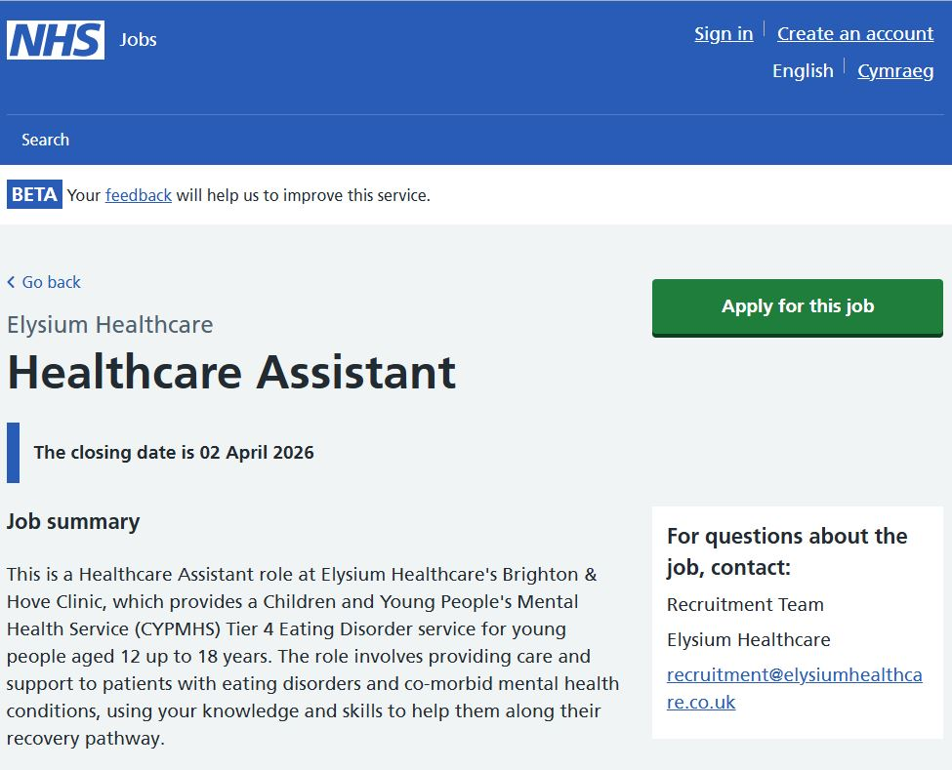
Figure1. Healthcare Assistant job vacancy (NHS Jobs, 2026)

These responsibilities are reflected in current Healthcare Assistant vacancies advertised on NHS Jobs, where duties commonly include supporting daily living activities, assisting with patient comfort, observing physical and emotional changes and working as part of a multidisciplinary team (NHS Jobs, 2026). This highlights the practical and relational nature of the role, requiring both technical competence and strong interpersonal skills.
The person specification for this role emphasises essential skills such as communication, empathy, teamwork and reliability. In recent years, there has been a growing focus on values-based recruitment within the NHS, meaning that personal qualities such as compassion, dignity and respect are considered as important as formal qualifications (Health Education England, 2020). This reflects the wider shift towards person-centred care, which prioritises the individual needs, preferences and dignity of service users (NICE, 2022).
In addition, job adverts often highlight the importance of flexibility, resilience and the ability to work under pressure, as Healthcare Assistants frequently operate in demanding environments. While formal qualifications may vary, many employers prefer candidates with a Level 2 or Level 3 qualification in health and social care, alongside relevant experience or a willingness to undertake training. The inclusion of “desirable” rather than “essential” experience requirements also indicates that the role is accessible to individuals entering the sector, provided they demonstrate the right values and commitment.
This makes the Healthcare Assistant role an appropriate and realistic entry point for developing practical skills and gaining experience within the health and social care sector.
- Analysis of Employability Skills
Healthcare Assistants require a diverse range of employability skills that support both effective care delivery and professional behaviour. One of the most important skills is communication, as HCAs must interact with patients, families and multidisciplinary teams. Effective communication ensures that patient needs are understood, reduces the risk of errors and contributes to safe and coordinated care (Skills for Care, 2022). It also helps build trust and rapport, which are essential in supporting individuals who may feel vulnerable or anxious.
Empathy and compassion are central to the role, particularly when supporting individuals who may be experiencing illness, distress or reduced independence. These qualities underpin person-centred care, which is a key principle within UK health and social care practice (NICE, 2022). Demonstrating empathy enables practitioners to respond sensitively to individual needs and provide care that respects dignity and individuality.
Emotional intelligence further enhances these abilities by enabling individuals to recognise, understand and manage emotions in themselves and others (Goleman, 1995). This is especially important in emotionally demanding situations, where Healthcare Assistants must remain calm, supportive and professional. In addition, resilience is required to cope with the physical and emotional demands of the role, including dealing with stress, workload pressures and exposure to challenging situations (Cottrell, 2019).
Teamwork is another essential skill, as Healthcare Assistants work closely with nurses, doctors and other healthcare professionals. Effective collaboration ensures continuity of care and supports holistic approaches to patient wellbeing. Furthermore, professionalism, including reliability, time management and adherence to safeguarding procedures, is critical in maintaining high standards of care and ensuring patient safety.
These employability skills are interconnected and must be developed collectively. For example, strong communication enhances teamwork, while emotional intelligence supports both empathy and resilience. Developing these skills holistically is essential for becoming an effective Healthcare Assistant.
- Self-Evaluation of Skills
Reflecting on my current skills and abilities, I recognise several strengths that align with the requirements of the Healthcare Assistant role. I have developed strong communication skills through both academic study and life experience, enabling me to interact effectively with individuals from diverse backgrounds. I am also able to listen actively and respond appropriately, which is important when supporting individuals with different needs.
I also demonstrate empathy and cultural awareness, which are essential for delivering inclusive and respectful care. As someone who has experienced adapting to a new environment, I am able to understand the challenges faced by others and respond with patience and sensitivity.
As a mature student, I bring resilience, adaptability and a strong work ethic. Completing my degree has required commitment, organisation and perseverance, all of which are transferable to professional practice. My studies have also strengthened my understanding of safeguarding, ethical principles and the importance of maintaining dignity in care.
However, I also recognise areas where I need to improve. My main limitation is the lack of direct practical experience within a healthcare setting. While I have gained theoretical knowledge, I need to develop practical skills and confidence in real-life care situations. In addition, I need to become more familiar with healthcare environments, routines and expectations.
To address these areas, I plan to seek volunteering opportunities and entry-level roles within care settings. I will also engage in reflective practice, regularly reviewing my experiences and identifying areas for improvement. This will help me develop both professionally and personally as I prepare for a career in health and social care.
- Relevant Qualifications and Experience
I am currently completing a BSc in Health and Social Care (Level 5 – Level 6 following this year), having successfully completed Level 4 with strong academic results. This qualification has provided me with a comprehensive understanding of key concepts such as person-centred care, communication, safeguarding and health promotion.
Through my studies, I have developed critical thinking skills, the ability to analyse information and an understanding of how theory can be applied to practice. These skills are important in health and social care, where professionals must make informed decisions and respond to individual needs.
Although I do not yet have formal employment experience within the healthcare sector, I have developed a range of transferable skills from my personal and professional background. These include organisation, responsibility, communication and the ability to work with diverse individuals. These skills are particularly valuable in care roles, where reliability and interpersonal interaction are essential.
In addition, my academic work has required time management, independent learning and the ability to meet deadlines, all of which are important in professional environments. My commitment to completing my degree also demonstrates motivation and dedication, which are important qualities for working in health and social care.
While practical experience is still needed, my current qualifications and skills provide a strong foundation for entering the Healthcare Assistant role and continuing to develop through practice.
- Personal Brand and Professional Identity
My personal brand, Manuela Mihaila, is based on values of compassion, respect, cultural awareness and commitment to continuous learning. Personal branding involves presenting a clear and consistent professional identity that communicates strengths, values and career goals (Montoya and Vandehey, 2009).
In health and social care, professional identity is closely linked to ethical behaviour, empathy and accountability. I aim to develop a professional identity that reflects reliability, professionalism and a commitment to delivering person-centred care. This includes maintaining appropriate attitudes, behaviours and communication when working with service users and colleagues.
Developing my professional identity also involves understanding the expectations of the sector and aligning my behaviour with professional standards (HCPC, 2023). This includes respecting confidentiality, promoting equality and diversity, and maintaining professional boundaries.
To strengthen my personal brand, I will develop a professional online presence, such as a LinkedIn profile, where I can present my qualifications, skills and career aspirations. I will also ensure that my CV reflects my values and strengths clearly. By presenting myself consistently across different platforms, I can demonstrate my commitment to the profession and increase my visibility to potential employers.

- Unique Value (Personal Contribution)
My unique value lies in my maturity, life experience and cultural awareness. As a mature learner, I bring a strong sense of responsibility, resilience and commitment to my professional development. My experience of adapting to a new country and environment has strengthened my ability to understand and support individuals from diverse backgrounds.
I am able to demonstrate empathy, patience and understanding, which are essential qualities in care roles. My motivation to work in health and social care is driven by a genuine desire to support others and improve their quality of life. This intrinsic motivation is important in maintaining commitment and providing high-quality care.
In addition, my academic journey demonstrates determination and dedication, which are important for ongoing professional development. I am willing to learn, adapt and continuously improve my skills. These combined strengths position me as a compassionate and reliable Healthcare Assistant who can contribute positively to patient care and team environments.
- Action Plan and Timeline
To achieve my goal of becoming a Healthcare Assistant, I have developed a structured action plan over the next three to five years. In the short term, I will focus on completing my degree and gaining practical experience through volunteering or part-time roles in care settings. This will allow me to apply theoretical knowledge in practice and develop confidence in real-life situations.
Within the next one to two years, I plan to apply for entry-level Healthcare Assistant positions. During this time, I will also complete relevant training, such as safeguarding, first aid and dementia awareness. These qualifications will strengthen my employability and ensure that I am prepared to deliver safe and effective care.
In the longer term, I aim to continue my professional development through additional training and workplace learning. Continuous professional development is essential in maintaining high standards of care and adapting to changes within the sector. I will also seek opportunities for progression within the role, such as gaining additional responsibilities or specialising in specific areas of care.
This structured approach allows me to set realistic and achievable goals, ensuring gradual and sustainable career progression.

- Networking and Communication Strategy
Building a professional network is an important aspect of developing a career in health and social care. I plan to connect with professionals through university contacts, LinkedIn and local care organisations. Networking can provide access to information, support and potential job opportunities, as well as helping me understand the expectations of the sector.
Volunteering will also allow me to build relationships with experienced practitioners and gain practical insights into the role. These connections can support my development and provide guidance as I progress in my career.
To communicate my skills effectively, I will develop a professional CV and maintain an up-to-date LinkedIn profile. These tools will allow me to present my qualifications, experience and personal brand clearly to potential employers. I will also ensure that I am able to communicate confidently in interviews, demonstrating both my skills and my commitment to the role.
Effective communication of my skills and values will increase my employability and support my transition into the health and social care workforce.

- Conclusion
In conclusion, the Healthcare Assistant role represents a realistic and valuable entry point into the health and social care sector. This report has demonstrated that while I already possess many relevant skills and personal qualities, further development is required, particularly in gaining practical experience.
By building my personal brand, strengthening my professional identity and following a structured action plan, I will be able to achieve my career goals. Through continued learning, networking and practical experience, I am confident in my ability to become a competent, compassionate and effective Healthcare Assistant.

Reference List
Cottrell, S. (2019) Skills for Success: Personal Development and Employability. 4th ed. London: Red Globe Press.
Goleman, D. (1995) Emotional Intelligence. New York: Bantam Books.
Health Education England (2020) The NHS Workforce Strategy. London: HEE.
HCPC (2023) Standards of proficiency. London: Health and Care Professions Council.
Montoya, P. and Vandehey, T. (2009) The Brand Called You. 2nd ed. New York: McGraw-Hill.
NHS (2023) Healthcare Assistant Job Profile. London: NHS.
NHS Jobs (2026) Healthcare Assistant – Job Vacancy. Available at: https://www.jobs.nhs.uk/candidate/search/results?keyword=healthcare%20assistant Accessed: 8 March 2026.
NICE (2022) Person-centred care. London: National Institute for Health and Care Excellence.
Skills for Care (2022) Care Certificate Standards. Leeds: Skills for Care.
Yorke, M. (2006) Employability in higher education. York: Higher Education Academy.

