

Name: Lorell Boyce
Student Number: 1814347
Module Code: BMSW4005
Module: Professional and Career Development
Module Leader: Buddhi Pathak
Assignment Title: Reflective Portfolio

Introduction
In this report you will understand the meaning of Career Development based on elements and steps taken when choosing career paths. Results obtained from self-awareness test and tools learnt in class including the history of my past events will provide a clear indication on How I make the chooses I did, Why I made the chooses I did, The effects it causes Mentally and Emotionally and The position I currently face in 2020.
We looked at the Jahrio Windows this was particular interesting for me as when looking at your Blind Self it did not occur to me to ask anyone How they viewed me, What they saw in, First impression etc. The MBTI test revealed my personality to more or less 100% match when reflecting on my character, this one more is more essential to my development. When completing the test it highlighted the relevance and insights to my career aspirations, how I process decisions and progress.
Finally you will identify through reading a part of my history and the journey I have travelled the type of career choices I have made by understanding the importance of short- term goals which has successfully give me results on being a % off a hired position in my mock interview, the detailed approached I took with the tasks provided will show my confidence and determination will unquestionably see me through to my long term goals.

Introduce
This report will display previous career aspiration and progress based on two self-awareness test taken in class. It will reflect the choices I have made during the course of my life:
- How I reached to that point,
- How I picked myself up
- Why I made the decisions I made.

- Johari Windows,
The Johari Window model is a simple and useful tool for illustrating and improving self-awareness, and mutual understanding between individuals within a group. This model can also be used to assess and improve a group's relationship with other groups. It was devised by American psychologists Joseph Luft and Harry Ingham in 1955, while researching group dynamics at the University of California Los Angeles. The model was first published in the Proceedings of the Western Training Laboratory in Group Development by UCLA Extension Office in 1955, and was later expanded by Joseph Luft. Today the Johari Window model is especially relevant due to modern emphasis on, and influence of, 'soft' skills, behaviour, empathy, cooperation, inter-group development and interpersonal development.The Johari Window concept is particularly helpful in understanding employee/employer relationships within the Psychological Contract.
Over the years, alternative terminology has been developed and adapted by different people - particularly leading to different descriptions of the four regions, hence the use of different terms in this explanation. Don't let it all confuse you - the Johari Window model is really very simple indeed.
Businessballs.com. (2020). Johari Window: Model and Free Diagrams - BusinessBalls.com. [online] Available at: https://www.businessballs.com/self-awareness/johari-window-model-and-free-diagrams/ [Accessed 28 Jan. 2020].

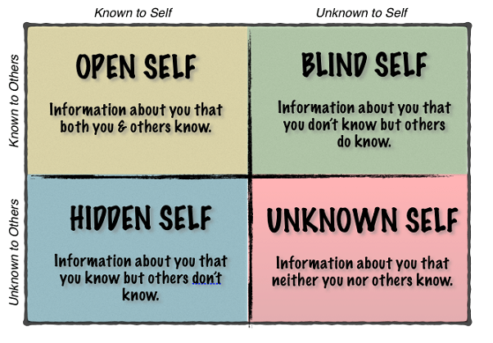

Only using the Open and Blind self methods, asking friends, family and university colleagues in class I was able to compare areas I knew about myself to what others thought or knew about me.

OPEN SELF:
- Confident
- Ambitious
- Passionate
- No loud noises when concentrating
- Can work under pressure
- Organised
- Humorous
- Stubborn
- Bossy
- Impatient

BLIND SELF:
- Confident
- Honest
- Approachable
- Diligent
- Good Leadership
- Determination
- Humorous but can be serious at the same time

This test shows only a few similarities between my Open and Blind self, throughout the years I have evaluate my OPEN SELF and have become more self-reliant within. At times I was told “You wear your heart on your sleeve, you never hold anything back” making me quite venerable in some situations yet strong in others, contemplating work relating affairs finding the balance between he two became somewhat of a challenge giving me the drive to assess the BLIND SELF Lorell and no the Open SELF.
- Approachable, - I had asked (Mr Tate) a previous manager who had hired me for the role of Student Advisor and Head Receptionist in a private university institute and his answer was approachable, being told I look feisty throughout my teenage years I assumed I looked unapproachable however, during this role I owned living with approachable as I registered the highest amount of students each month. I found students who were not assigned to my caseload would enquire and be asked to be seen by myself.

- Determination – my Mother said this, its amazing the words you associate you own self with not understanding the full meanings to most of them, as you read in my OPEN SELF I wrote the word Stubborn, always believing it was a negativity attribute to hold however, when my Mother said determination I searched it up in the dictionary and online and found 40 synonyms with one of the words being stubborn.
To be determined is the process of establishing something exactly by calculation or research.

- Leadership – my colleagues at university voted me class rep second week into our first module which to me was quite shocking, I know (OPEN SELF) I am bossy, like order, don’t take no prisoners so for the whole class to be unified in the decision after knowing me two weeks to trust me with such a position was warming. I received comments: “you just look serious” “you look like you can get things done” “I noticed something about you when you first worked in the room”

Many of my fellow colleagues knew I had a passion for dance however, what they did not know is that I Teach dance to young people every Saturday. Leadership is something they see in me just from stepping into a room however, this is skill I project everyday as a Mother, big sister, aunty and teacher. I may not have the qualifications that qualifies my skills but hopefully with the steps I have finally taken after years of beginning a course and quitting for varies reasons, this Level 4 will encourage me to upgrade onto a Bachelors in Science for Health and Social care course, following a successful two years of determination, not quitting and in control, the qualification can open doors to a brighter future for my children, my education, my business and most importantly myself.

As I focus on my short-term goals my long-term goals become more assessable to reach, I was focused too much for too long on the bigger picture instead of reality, which surely knocked me in the face a few times. It is important to understand the concept of strategizing short-term goals: in an article written by BENNY LEWIS I discovered online he writes “When we think of goals, we may think of something to work towards over a long period of time that you can reach and feel that immense sense of achievement when you do. I'm way too impatient to wait for such validation. I want to feel a sense of achievement NOW! 🙂 On top of this, a long-term goal can lead to an inefficient structure in trying to reach it.

Lewis, B. and Lewis, V. (2020). Mini-goals are the path to achieving fluency - Fluent in 3 months - Language Hacking and Travel Tips. [online] Fluent in 3 months - Language Hacking and Travel Tips

I found this profound as the impatient behaviour I displayed (such as being):
- Irritated
- Annoyed
- Angry and restless soon became an overwhelming feeling which then developed into emotions of:
- Worry
- Fearfulness
- Apprehensive against making the wrong choices in future decisions
- Tense and highly concerned about my next steps.

This way of thinking (which I did 80% of the time without a MBTI test) put me into a state of depression at one stage creating doubts on my personal and career goals. Lack of support from family, friends and employment advisors affected my state of mind causing a case of sudden laziness and disregard toward my future. Developing an unhealthy emotional condition I found myself reading all varieties of books and frequently search the Internet foe anything that would help me out this dark place I was in. Gradually after reading, the quote below, my belief system and purpose for life began building.
“If you can’t fly, then run.
If you cant run, then walk.
If you cant walk, then craw,
But by all means, keep moving forward.” -Martin Luthe King Jr

Goalcast. (2020). The Top 10 Quotes to Jumpstart the Journey to Your Dreams | Goalcast. [online] Available at: https://www.goalcast.com/2017/05/31/top-10-quotes-jumpstart-journey-dreams/ [Accessed 31 Jan. 2020].

Everything about this quote made sense, there were many things I could not do but instead of pity give and myself me I had to keep going. I began looking at the positive areas in my life and decided how I could improve them, the negatives were also a big part but nothing that could not be turned around with some short term goals in place. Writing a huge list of short terms goals I finally rich my long term goal of becoming a Student Advisor and Head Receptionist in a private University helping those whose desire was too attend a full time course studying a HND in Business and Finance, this position gave me all the skills and experience I used today as a:
- Woman
- Mother to a larger family
- Business owner of a Dance Academy
- University Student who was nominated Student Rep
- Youth Leader in my Church and on the journey to become a Private Foster Carer

Without understanding baby steps are better than sprinting I discovered a whole new person I never realised was there before, my whole attitude on life changed for the better. In comparison to my Open and Blind self assessment it clearly shows what I could see about myself could only be revealed by having a strong mind-set and determination that giving up was not an option. It also shows what I did know about myself took control of stability as I aloud stubbornness to override my situation. Everyday I am learning and there will always be areas in my life I do not see, making it my priority to ask who ever I come into contact with “what do you see in me?”

2. MBTI personality Teat

The purpose of the Myers-Briggs Type Indicator® (MBTI®) personality inventory is to make the theory of psychological types described by C. G. Jung understandable and useful in people's lives. The essence of the theory is that much seemingly random variation in the behaviour is actually quite orderly and consistent, being due to basic differences in the ways individuals prefer to use their perception and judgment.

Myersbriggs.org. (2020). [online] Available at: https://www.myersbriggs.org/my-mbti-personality-type/mbti-basics/ [Accessed 28 Jan. 2020].

At a younger age I was very easily distracted, after my GCSE’s I gained good results but not great my foot was through the door at college and looking back, I always started a thing with the best intention of completing it but as previously stated becoming distracted was a weakness of mine. (at this point I would now say extravert)/
I began two separated courses in two different colleges and unfortunately completed none, walking away with nothing, wasting two years of what should of set me up for university, it never occurred to me the impact it would have on my life. When your young you thing you know it all, “no need for qualifications I have life skills, a piece of paper wont prove anything, it wont provide finances” just plain immaturity, however reflecting on education at school the importance of education was never installed to me, I rarely remember a teacher drilling it into my head like how I drill it into my children now, but as I said I was easily distracted so maybe they just I just didn’t pay attention regardless a situation arose itself during my journey which would change the course of my walk for ever, instead of thinking which shows I do 21% I went with my feelings which I do 71% of the time, made the decision and choose to give birth and play happy families. At this time I studied a YMTB course (Youngs Mums To Be), here I gained qualifications in Life Skills Level 1, First aid infant and child, Equal Opportunities along with 19 additional qualifications, I left this course with knowledge on:
- Motherhood
- How to look after a baby
- How to physical prepare myself
- What to do if my baby chokes etc
However, all the certificate I gained proudly did not prepare me for:
- My emotional state when faced with loneliness in the hospital
- The pain of giving birth
- The complications you can face afterwards
- The loss of friends because now your mother and their not
- Breakdown of relationships
- Finances etc
The decision of choosing family life over education came to an end shortly after my first child was born, I found myself a single mother at eighteen in a home I no longer desired to live in and on benefits, not only did I feel ashamed of this life choose, not my baby but my decision because I knew how my family now viewed me but I did not want to be another statistic in this judgmental society. I soon took the steps to find a job not knowing caring about my career path I made steps with my work coach at the Job Centre and began employment at Jaguar Cars as a Part- time receptionist.
I enjoyed this role working in this field it became natural to me:
- Being first point of contact greeting clients
- Always dressing in appreciate attire
- Answering incoming calls to internal and external customers
- Making outbound calls to clients ensuring payments are made
Booking conference rooms
- Emailing staff
- Faxing and filing confidential records
I began to learn many new skills in this prestigious company and decided to try again with education and enrolled on a course: BTEC in Business, Administration and Retail.
I knew that by studying this course it would:
- Give me academic knowledge and understanding within these sectors
- Serve me with a qualification that could possibly strengthen my CV and a stronger job position.
Unfortunately, an interruption surfaced causing me to quit my chosen path and focus on a different route, upsetting, as it was Motherhood was harder than I imagined it would be. I realized the sacrifice meant more positive than negative and that is what I understood she needed in order to have the brightest future she possibly could in this world, I analyzed my choices and was just mom.
For six years I felt depressed, read books, searched the Internet for just a sign that motherhood was not the purpose of my existence and before you know it I was:
- Working full time earning £1,300 monthly after tax (more money than I ever used to see in my bank account)
- Using my previous work skills and experience to help other study full time at university
- Signed off benefits
- Lived in a beautiful private rented apartment (with a garden)
- Paying my own rent (which I loved)
- Taking vacations
- Providing my daughter with everything and more than she deserved and I was more than happy to give
- Treating ourselves to a life we saw others enjoying
- Planning our future

Just my little girl and I until the company went buss and we was made redundant, how life turns out no back up plan, back to job searching, contemplating the government funds or just work. Wow, I was pregnant again I told my partner who was more excited than I was, I had no job, could I depend on him to step up and support us? Could I trust him? Could I bare the thought of getting rid of child just because of fear? NO, I couldn’t so there I was enjoying pregnancy, partner supporting us, hearing congratulations, family supporting me life was great until it wasn’t. There’s this thing called ‘intuition’
intuition or your intuitions are unexplained feelings you have that something is true even when you have no evidence or proof of it.

‘Her intuition was telling her that something was wrong’.

“You can't make a case on your intuitions, Phil”.

Collinsdictionary.com. (2020). Intuition definition and meaning | Collins English Dictionary. [online] Available at: https://www.collinsdictionary.com/dictionary/english/intuition [Accessed 31 Jan. 2020].

As women, if we do not follow that feeling we are hit with more problems than we bargained for. Now faced with two children, single again because I believed what he said later down the line finding evidence of an affair and another child he had Postnatal Depression struck me hard.
The symptoms of postnatal depression are similar to the symptoms of depression. New mums may experience low mood, loss of interest, fatigue or low energy for most days over the course of two weeks. Additionally, they may experience other symptoms such as: self-critical thinking and rumination (increased worrying); reduced concentration and attention; reduced self-esteem and self-confidence; disturbed sleep and changes in appetite.
Some new mums may feel they are detached from their babies. Furthermore, some new mums experience repetitive thoughts about harming themselves and/or their babies. However, it is very rare for women to act on these thoughts
Mental Health Foundation. (2020). Postnatal depression. [online] Available at: https://www.mentalhealth.org.uk/a-to-z/p/postnatal-depression [Accessed 31 Jan. 2020].

Here you will notice they mention being a new mom at this point I had been a mother for eight, I may have been a new mother to my second born however, the depression hit me without warning, I descending rapidly into a place mental distress, I had no thoughts, I was numb all over everyday. My mother was my greatest support during the time and after I snapped out of it without her voice in my ears constantly, the noise of my new born and my eldest “mom its going to be ok” I wouldn’t be were I am today.

Fast-forward five years of:
- Moving home
- Starting a business
- Understanding the real importance of education and the many doors it will open for you
- Achieving a success in completing a full year of education with no distractions, no interruptions of study, no set back that caused me to walk away
- Constant support from family
- Giving birth to my precious son (finally) who’s father is no longer with us
- A sense of true happiness
- Girls in full time education performing outstanding results in their academics without reports of distractions or misbehaviour
A single mother of three and by all means keeping it moving forward with the understanding on how I think and who I am. In class we were ask to do a personality test on ourselves, the MBTI personality test as explained above, appendix in I will show the results to my test:

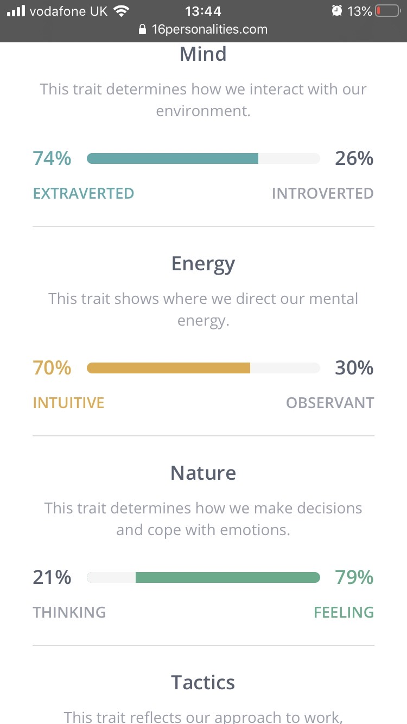
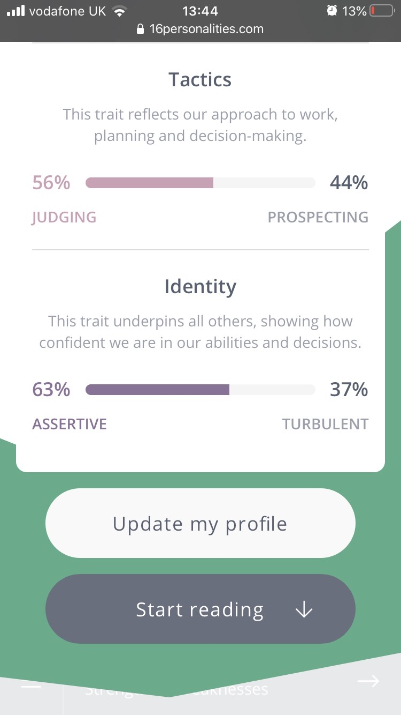
After 16 question on yourself the results revealed my personality type to be: Protagonist.
Protagonists are natural-born leaders, full of passion and charisma. Forming around two percent of the population, they are oftentimes our politicians, our coaches and our teachers, reaching out and inspiring others to achieve and to do good in the world. With a natural confidence that begets influence, Protagonists take a great deal of pride and joy in guiding others to work together to improve themselves and their community.
16Personalities. (2020). Introduction | Protagonist (ENFJ) Personality | 16Personalities. [online] Available at: https://www.16personalities.com/enfj-personality [Accessed 31 Jan. 2020].

This is just one definition however, based on the way my personality is divided the choices I have made or not made all make sense.
I am more of an:
- Extravert character, I am interested in other people and the world around them than my thoughts and feeling, hence he distraction description I previously gave myself in the text when speaking about school life as a child and college life as teenager.
- Intutive, I have the ability to understand or know something without direct evidence (I knew my partner was being unfaithful to me I just couldn’t prove it)
- I Feel more than I Think I move of emotion when I feel something it is my general attitude toward it or thoughts about it. (I felt like a children at the ages I did were best decisions for me, I knew the feeling of termination would mentally destroy my mind).
- Judging character personally I thought the results were wrong here, I never pictured myself the judging however, I judged education a waste of my time, pointless now in the grand scheme of things without education your lost, you have no foundation, without expanding your knowledge each day how could I pour into my children and better their future, my future.
- Assertive I do speak and behave in a confident and direct manner, people do pay attention to me, without my assertiveness the job positions I have held would not have been a possibility if I was more Turbulent less certain about my choices.
These area will only develop me into a stronger character being more observant will be short term goal of mine in order to make wiser decisions in the future.

Career Development
Career development is the series of activities or the on-going/lifelong process of developing one’s career. Career development usually refers to managing one’s career in an intra-organizational or inter-organizational scenario. It involves training on new skills, moving to higher job responsibilities, making a career change within the same organization, moving to a different organization or starting one’s own business.
Career development is directly linked to the goals and objectives set by an individual. It starts with self-actualization and self-assessment of one’s interests and capabilities. The interests are then matched with the available options.
The individual needs to train himself to acquire the skills needed for the option or career path chosen by him. Finally, after acquiring the desired competency, he has to perform to achieve the goals and targets set by him.

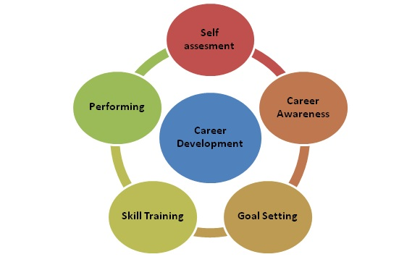

MBA Skool-Study.Learn.Share. (2020). Career Development Definition, Importance & Overview | Human Resources (HR) Dictionary | MBA Skool-Study.Learn.Share.. [online] Available at: https://www.mbaskool.com/business-concepts/human-resources-hr-terms/1779-career-development.html [Accessed 31 Jan. 2020].

The use of short term is certainly one of the many steps in choosing your career path, as shown the diagram (above) Goal Settings. In part B of this report I will reflect on the steps taken during the class exercise for:
- Seeking a job
- Writing a cover letter and CV
- Preparing for an interview
Providing insight on my thought process taken from previous examples when finding work you will be see how the development reveals it chosen career path.
- Self Assessment – by studying the in class activities with the outcome of the Johiro Windows and the MBTI personality test I began with writing a SWOT analysis focusing on Strength and Weakness, by doing this I would determine the best outcome on the job type I was looking for.
- Career Awareness – most positions/companies require qualifications in order to depicted the knowledge of a person, some will offer training on the job with zero experience (more than likely a sales position with commission wages) and others will simply just like to see the face behind the application form.
Having basic GCSE’s with no further higher education knowledge, although I gained some experience from previous course there was no evidence. Over a total of 7years of experiences and skills in the administration field not to mention managing my own small business I was exactly an eye catcher however, I looked for roles I knew with my experience, knowledge and confidence would flourish in if offered the positions.
- Goal setting – my long term goal was to successful gain a job role or have the potential to be considered, the results at the end of this activity would reflect the elements I took in order to receive my long term outcome. In addition to this the short term goals gave me the appropriate assistance to achieve the result I aimed for.
- Registering to different job agency sites
- Searching for positions/saving them in a ‘save for later’ box
- Looking at the skills require to ensure they matched with the skills I already had
- Reading over my CV (which brings us to point 4).
- Skill training – when looking back on my CV I decided to enter a copy to a Professional CV maker service (unfortunately, the results were a shock to my system) it showed results that caused me to revamped my whole CV in order for it to possess the creativity, interest and skills my employment count suggests.
- Performing – confidence and good listening skills will always be my strengths, during my performance I ensured:
- Appropriate clothing was set from the night before,
- cover letter and cv in a clear plastic wallet,
- hygiene was on point,
- arrived early for my interview,
- shook the hands of my interviewees,
- kept regular eye contact with both,
- Well mannered and answered all questions
- Asked one question
- Gave examples as asked

Appendix in you see Cover letter and C.V provided unfortunately, although I gained the highest marks of the class achieving my long term goal of being considered my organization departed from me, I did not securely keep my results from interviewees, when asking if copies were made that was unfortunately in searching for them I have yet to find providing no evidence of my results showing 80-89%.

Cover Letter:

Mildendhall Road
Greatbarr
Birmingham
B42 2PF

11TH December 2019

Hollyfield Personnel LTD
3 Midland Drive
Sutton Coldfield
B72 1TU

Dear Sir/Madam

I am writing to you wit regards to the recent position for Trainee Administrator
that I saw advertised on Totaljobs.

I am currently a full time student studying Level 4 in Skills in the Workplace at University of Wales and work as a Dance Choreographer in my own business BTNG (Birthing the next Generation) but keen to make a career change into the administration industry.

When I saw the position at Hollyfield Personnel advertised, I immediately felt I should apply. My background includes a variety of roles, which combined make a strong knowledge and skill-set for a role in administration.

I am motivated, ambitious and enthusiastic individual looking to make a change both personally and for those in work with. I feel I have the skills and experience to competently take on and flourish in this role.

Please find attached my current CV, which details my experience along with my technical skills.

I believe I have the right qualities and attributes for the Trainee Administrator vacancy.

I very much look forward to hearing from you.

Your Sincerely,

Lorell Boyce

CV:

Miss Lorell Boyce
Email: lorell.boyce@yahoo.com
Contact: 07437570432

Personal Profile
Motivated and professional administrator with 4+years experience, in my last role as a Student Advisor/Administrator I achieved promotion and created changes, which allowed me to increased students educational and staff environment. I am a hard working team player who also has the ability to lead, which is my current role as the owner of an Academy teaching students Etiquette and Deportment through the creative Arts of Dance and Vocals. I would be the perfect candidate to employ in any position as I learn fast and put 100% into everything I do.

● Enthusiastic, ambitious and persistent individual.
● Confident in dealing with difficult and sometimes unexpected situations, able to think quickly and come up with solutions.
● Well-organised and able to cope with all the administration in reception work.
● Good MS office system knowledge able to use word, excel and PowerPoint.
● Team worker and able to use my own initiative, calm and professional under pressure and can multitask.
● Experienced in customer service, able to inspire others.

Experience
Owner/Dance Tutor
BTNG ACADEMY (Birthing the next Generation)
August 2019 – present
BTNG Academy is an upcoming Social Enterprise family owned business training youth in Etiquette and Deportment through the creative arts of Vocals and Dance. We created and began this organisation in August 2019 and together we have structured a one-year course consisting of a 12 week per term program. We have three age groups who attend 2 and half hour sessions, which are broken down into one hour each discipline each week. My duty as the Owner/Dance tutor and Admin Officer is to create all dance routines, teach different styles, arrange events, shows, competitions and performances for all students, chase up emails, file payments for tuition fees, book free trail sessions for potential students and liaise with parents weekly. We currently hire a youth center; my duty is to ensure all payments are made on time and that our academy students follow the rules and guidelines set. Our aim is to travel the world spreading the positivity and Knowledge, Understanding and Wisdom through academic and life skills.

Student Advisor and Head Receptionist
Finance Business Training
July 2013 – May 2014
At this prestigious organisation we helped those who had found it hard to get back into work or higher education by giving them the opportunity to study a full time HND course with a choice of: Business and Finance, Health and Social Care, Travel and Tourism or Fashion and Textiles. Finance Business Training (FBT) is one of the branches set by London School of Business and Finance who have been running these courses and others for many years. My role here at FBT was to assist all applicants who then become students. I as their advisor would go through the registration process stage by stage, speak to them about the personal assessment, go through all application forms provided by the University and then photocopy all proofs of I.D, address, CV, qualifications and references. I also performed admin skills with the Head Reception position I held, answering inbound calls, making bookings for open day presentations that we held explaining the courses details following a short presentation about Student Finance.

Customer Service Advisor
Teleperfomance House
June/July 2008 – March 2010
Here I began working for the new sports campaign Setanta Sports. My role was based in a call centre with a team of 50 staff members all trained in the same position. My role involved answering inbound calls dealing with customer quires, signal problems, payments producers requiring me to set up direct debits, transferring internal calls to the cancellation department and complaints. With every conversation I had to log the conversation into the in-house Maytas system as a case study. I enjoyed my time here, built good professional relationships and gained a lot of experience.

Receptionist and Trainee Advisor
Pertemps People Development Group
February 2008 – June 2008
This role involved me working within the community; I was first point of contact a role I was comfortable with. I answered incoming calls, making and cancelling appointments for career advisors and ensuring all clients felt respected and welcomed. I provided a high level of customer service always being polite, respectful and making them feel valued. Other duties required me to send important emails to different companies, faxing, filling documents for clients and liaising internally to ensure clients were seen promptly satisfying their needs and expectations. The manager saw potential in my abilities and encouraged me to apply for an advisors position as I was learning a lot about their roles. I began training on that role however; due to lack experience within the company I did not get the position. Overall my experience working for this company was the incredible, I left this position to study.

Receptionist
Jaguar Cars
March 2007 – November 2007
At this prestigious company I was first point of contact my role as a receptionist involved me to answer incoming calls, making and cancelling appointments and ensuring all clients felt respected and welcomed. I provided a high level of customer service always being polite, respectful and making them feel valued by asking them for tea/coffee. I also became very involved taking minutes in meetings with managers, staff and clients keeping reports on each client’s case, sending internal and external emails to different departments and companies, faxing and filing. Above all I always adhered to the health and safety policies.

Cobra
December 2005-April 2006
Door to door sales agent
In this role I worked in the community knocking door-to-door persuading the public to donate to a charity called the ‘Dogs Trust’. I gained some excellent experience in how to meet team and individual targets, completed forms with classified information, gained intelligence on how to speak comfortably and confidently and log information accurately on to the in house computer. I thoroughly enjoyed my experience and above all I utilised my team working skills and I enjoyed meeting strict targets and deadlines.

Glass collector and Bar Assistant
Bar Maya
Nov 2004- June 2005
I worked collecting the glasses from table to table, making sure I cleaned the customer area at all times, I then carried the glass wear to the kitchen to be washed and put back behind the bar. My role involved multitasking and working under pressure, as a bar assistant I would have ten customers to serve and ask me enquires. Working in a team was an absolute must as I learnt supporting and respecting my colleagues earned me respect as well. I handled stock in the cellar area in a safe manner and I then refilled the shelves and the fridges as well as keeping the area clean and tidy. I always worked in the line with the health and safety directive and have valued my excellent customer service experience.

Receptionist, Cashier and Trainee Hairdresser
Crimper International
November 2003 – August 2004
My role as a receptionist involved answer-incoming calls, making and cancelling appointments. I provided a high level of customer service always being polite, respectful and making them feel valued by asking them for tea/coffee. My role was also to handle cheque, cash and credit card payments so I became very efficient in this area. Due to my hard work I was asked by my manager to gain some training in hairdressing so I learned the skills washing, conditioning and styling hair, how to use different products making sure I asked customers of any allergies. I always maintained an immaculately presented store and staff area, as the salon could look untidy very quickly cleanliness was important image. Above all I followed the health and safety at work act and gained lots of job satisfaction working in this line of business as I found I could easily build a good rapport with the customers and I had a variety in my job.

Education
University of Wales, Birmingham
March 2019- present
Level 4 Skills in The Workplace

LSBF – London School of Business and Finance
April 2013- August 2013
HND in Business Finance

South Birmingham College
September 2006 – December 2006
Achieved Certificates in Starting Your Own Business

JHP Training
May 2006 – August 2006
Achieved Certificates from Young Mums To Be
(YMTB) NCFE Skills for Life level 1, 19 certificates in First aid Infant and Child and Equal Opportunities (Voice-it)

Matthew Bolton College
September 2005 – May 2006
BTEC in National Certificates in Dance

In closing the concept when looking into your chosen career path can be based on the elements taken during the process, how serious you fulfill you short tem goals, planning ahead and if thinking process.
Everything starts on a small to help you deviser the choice you make in the long run.

Reference

Businessballs.com. (2020). Johari Window: Model and Free Diagrams - BusinessBalls.com. [online] Available at: https://www.businessballs.com/self-awareness/johari-window-model-and-free-diagrams/ [Accessed 28 Jan. 2020].

Lewis, B. and Lewis, V. (2020). Mini-goals are the path to achieving fluency - Fluent in 3 months - Language Hacking and Travel Tips. [online] Fluent in 3 months - Language Hacking and Travel Tips

Myersbriggs.org. (2020). [online] Available at: https://www.myersbriggs.org/my-mbti-personality-type/mbti-basics/ [Accessed 28 Jan. 2020].

Goalcast. (2020). The Top 10 Quotes to Jumpstart the Journey to Your Dreams | Goalcast. [online] Available at: https://www.goalcast.com/2017/05/31/top-10-quotes-jumpstart-journey-dreams/ [Accessed 31 Jan. 2020

Myersbriggs.org. (2020). [online] Available at: https://www.myersbriggs.org/my-mbti-personality-type/mbti-basics/ [Accessed 28 Jan. 2020

Collinsdictionary.com. (2020). Intuition definition and meaning | Collins English Dictionary. [online] Available at: https://www.collinsdictionary.com/dictionary/english/intuition [Accessed 31 Jan. 2020].

Mental Health Foundation. (2020). Postnatal depression. [online] Available at: https://www.mentalhealth.org.uk/a-to-z/p/postnatal-depression [Accessed 31 Jan. 2020].

16Personalities. (2020). Introduction | Protagonist (ENFJ) Personality | 16Personalities. [online] Available at: https://www.16personalities.com/enfj-personality [Accessed 31 Jan. 2020].

MBA Skool-Study.Learn.Share. (2020). Career Development Definition, Importance & Overview | Human Resources (HR) Dictionary | MBA Skool-Study.Learn.Share.. [online] Available at: https://www.mbaskool.com/business-concepts/human-resources-hr-terms/1779-career-development.html [Accessed 31 Jan. 2020].

