LCHS7009
Population Health and Digital Health Promotion
Component 1
Blog - 2 entries

Student Name: Nadia Jabeen
ID: 2234873

Blog 1: Can Digital Self-Help Improve Mental Health?
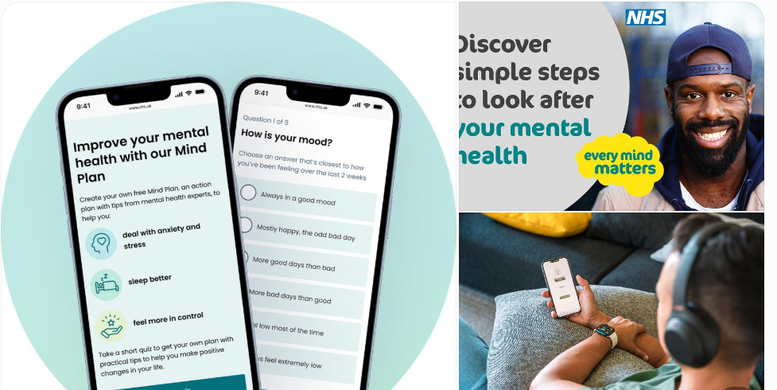
Why does this matter?
Relationships, education, employment and physical health may all be impacted by anxiety and depression. The World Health Organization (WHO, 2022) has recognised mental health as a key public health issue and reports on the need for better access to mental health care. Digital health promotion is one potential solution, as it can deliver information and practical help without forcing all users to come in for a face-to-face appointment.
How does the technology work?
The NHS Every Mind Matters website offers mental wellbeing advice online, a personalised Mind Plan and self-help techniques using cognitive behavioural therapy (CBT). These techniques will help to identify negative thinking, respond to concerns, solve problems and build better habits (NHS, 2026). The resource is available online and accessible via a Web browser, so that people can view guidance at the time of need.
Does digital support promote health?
However, there are some positive signs supporting digital mental health interventions. Kim et al. (2023) reviewed 80 studies with 12,070 study participants. They found that those who had received digital interventions had better depression/anxiety symptoms than those in control groups in their meta-analysis. The studies vary, however, in their interventions and outcomes, so it is not possible to draw any generalisations about whether every website or app will achieve similar outcomes. Similarly, Goldberg et al. (2022) indicate that there are benefits to some digital interventions, but this differs by intervention and outcome measured. So, the evidence base for digital mental health interventions should not be taken as definitive evidence of the effectiveness of Every Mind Matters.
Benefits and limitations
One of the significant benefits is that the materials are easily accessible. Individuals can learn self-help techniques in isolation, at their own speed, and without having to go to an appointment. Digital resources can also help people to identify problems at an earlier stage and request additional help, if needed. CBT techniques can help individuals to understand the relationships between thoughts, feelings, and behaviour (NHS, 2026). However, there is no guarantee of engagement and recovery just by being on a website. Limited internet access, low digital confidence, and visual and language barriers may make it difficult to benefit. Self-guided information might also not be adequate for serious and complicated mental health issues. The study by Philippe et al. (2022) highlights ongoing issues with the effectiveness and appropriateness of digital interventions for marginalised groups. There is also a value to privacy and the quality of information on the Internet. Users must be assured that their data is managed properly and that advice given is clinically relevant. It is important to note, however, that a self-help Web site should be used in conjunction with, and not as a substitute for, professional assessment when symptoms are persistent or serious.
How could the shortcomings be addressed?
Digital mental health promotion should be inclusive. Resources should be provided in accessible formats, in clear language and with links to professional support. Public health services may provide online self-help, with a choice of practitioner support, and measure engagement, change in symptoms and differences between population groups.
The central message:
Digital self-help has the potential to increase opportunities for mental health promotion but only if it is accessible, has good evidence and a clear pathway to further care.

References
Goldberg, S.B. et al. (2022) ‘Mobile phone-based interventions for mental health: A systematic meta-review of 14 meta-analyses of randomised controlled trials’, PLOS Digital Health, 1(1), e0000002. Available at: https://journals.plos.org/digitalhealth/article?id=10.1371/journal.pdig.0000002 (Accessed: 18 October 2026).
Kim, J. et al. (2023) ‘Effectiveness of digital mental health tools to reduce depressive and anxiety symptoms in low- and middle-income countries: Systematic review and meta-analysis’, JMIR Mental Health, 10, e43066. Available at: https://pubmed.ncbi.nlm.nih.gov/36939820/ (Accessed: 18 October 2026).
NHS (2026) Self-help CBT techniques. Available at: https://www.nhs.uk/every-mind-matters/mental-wellbeing-tips/self-help-cbt-techniques/ (Accessed: 18 October 2026).
Philippe, T.J. et al. (2022) ‘Digital health interventions for delivery of mental health care: Systematic and comprehensive meta-review’, JMIR Mental Health, 9(5), e35159. Available at: https://mental.jmir.org/2022/5/e35159 (Accessed: 18 October 2026).
World Health Organization (WHO) (2022) World mental health report: Transforming mental health for all. Geneva: WHO. Available at: https://www.who.int/publications/i/item/9789240049338 (Accessed: 18 October 2026).

Blog 2: MindSteps – A Digital Approach to Preventing Anxiety and Low Mood
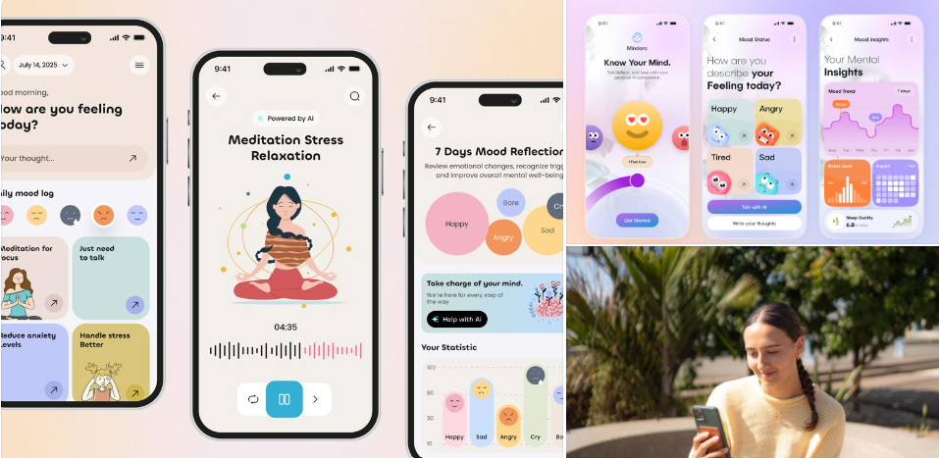
The public health challenge
Low mood and anxiety may impact everyday functioning, relationships, and quality of life. While digital mental health interventions are a way to extend mental health services, they are not necessarily effective for everyone. A meta-analysis by Kim et al. (2023) showed that digital interventions were effective at reducing depression and anxiety symptoms; however, there was significant variation between studies, with design, delivery and user needs.
Introducing MindSteps
The proposed MindSteps smartphone app is intended for use by adults who are having mild anxiety symptoms or low mood. It is a concept that has not yet been clinically validated in the market. Its purpose is to teach users some lifelong coping strategies and to recognise when professional assistance is needed.
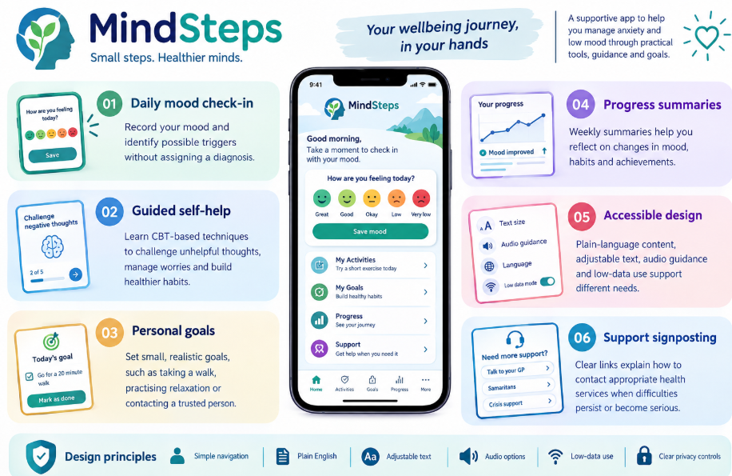
How could it promote health?
The combination of mental health education and opportunities to practise healthier behaviours would be accomplished by MindSteps. It is designed to help users set goals and track their progress, with a goal of getting them to come back, and perhaps CBT activities might help users identify the relationship between thoughts, feelings and actions. CBT is a method of understanding and changing unhelpful thought and behaviour patterns (NHS, 2026).
Digital delivery can also be a great first step for those who might not want to get immediate help. But the app should not be used for diagnosis of mental health issues or for the prevention of all anxiety and depression. It would require pilot studies to be conducted comparing outcomes before and after it is used, preferably with a suitable comparison group and a follow-up study.
Advantages and potential shortfalls
One of its biggest assets is the self-monitoring, hands-on activities and referral information all within one location. MindSteps would allow for techniques to be applied and reflection of progress, unlike a web page that contains information. Karyotaki et al. (2023) conducted a study which suggests that digital interventions have potential for common mental disorders, but also noted some variation in effects and a need for more research.
However, for some users, this frequent mood monitoring may prove burdensome. There may be some people with a low level of digital literacy, poor internet connection, or disabilities that may cause barriers. Mood Data is also sensitive and presents privacy concerns. Moreover, an automated application cannot offer the therapeutic relationship and the fine judgment of a trained individual. Philippe and colleagues (2022) also emphasise the need for more evidence and focus on marginalised groups in digital mental health care.
Making the intervention safer and more effective
MindSteps should be designed by potential users and mental health professionals, tested for usability, and have clear data-protection policies. Notification and data sharing should be under the control of the user. It is integral that there is clear guidance and pathways to professional assessment on how to manage a crisis. Outcomes of a pilot evaluation should include usability, sustained interest, changes in validated anxiety and depression scores, and differences between population groups.
The key message:
MindSteps has the potential to ensure evidence-informed self-help is more practical, but in order to be effective for public health, it will require careful evaluation, broader design, privacy protections and integration with professional services.

References
Goldberg, S.B. et al. (2022) ‘Mobile phone-based interventions for mental health: A systematic meta-review of 14 meta-analyses of randomised controlled trials’, PLOS Digital Health, 1(1), e0000002. Available at: https://journals.plos.org/digitalhealth/article?id=10.1371/journal.pdig.0000002 (Accessed: 20 October 2026).
Karyotaki, E. et al. (2023) ‘Digital interventions for common mental disorders in low- and middle-income countries: A systematic review and meta-analysis’, Cambridge Prisms: Global Mental Health, 10, e68. Available at: https://pubmed.ncbi.nlm.nih.gov/38024798/ (Accessed: 20 October 2026).
Kim, J. et al. (2023) ‘Effectiveness of digital mental health tools to reduce depressive and anxiety symptoms in low- and middle-income countries: Systematic review and meta-analysis’, JMIR Mental Health, 10, e43066. Available at: https://pubmed.ncbi.nlm.nih.gov/36939820/ (Accessed: 20 October 2026).
NHS (2026) Cognitive behavioural therapy (CBT). Available at: https://www.nhs.uk/tests-and-treatments/cognitive-behavioural-therapy-cbt/ (Accessed: 20 October 2026).
Philippe, T.J. et al. (2022) ‘Digital health interventions for delivery of mental health care: Systematic and comprehensive meta-review’, JMIR Mental Health, 9(5), e35159. Available at: https://mental.jmir.org/2022/5/e35159 (Accessed: 20 October 2026).

