Ellie Armytage - Principles of Analytics – 3C002
CIPD Level 3 Foundation in People Practice
Q1. Explain what evidence-based practice is and provide two examples of how Company X could apply it. (AC 1.1)

Evidence based practice is the process where evidence is gathered from a range of reliable sources, used to develop knowledge and understanding. This is used to inform professional practices with a systematic approach to decision making (Waite, et al., 2021, p. 47). Implementing EBP in HR delivers comprehensive advantages that elevate both individual and organisational performance, enhancing credibility and promoting critical thinking. This eliminates bias, personal reactions, gut feelings and irrational decisions. Barends, Rousseau and Briner (2014) believe that using the best available evidence from multiple sources will enhance EBP.
The 6 A’s are a framework for evidence-based decision making in HR, leading a step by step approach helps professionals use the best available data from sources like research, organisational data, stakeholders and expertise to make effective decisions based on fact adding value to the organisation. Adapting to the six steps will increase the decision outcome to be more favourable.
Using performance management data could be beneficial to Company X. In my current workplace this data allows us to track employee performance in line with strategic goals and objectives. Benefits from data driven systems promote the use of the SMART framework, supporting goal-setting research, effective feedback and analysis of performance.
You could also use exit interview data to gain insights into employee experiences and reasons for leaving. Acquiring and appraising the data will enable you to make an informed judgement on the validity. Once data is valid this can be used to apply to inform decisions when looking at factors affecting staff turnover rates and inform retention strategies.

Q2. Explain the importance of using data at Company X to accurately determine problems and issues. (AC 1.2)

Using data effectively is highly important to enable us to make informed decisions. When determining problems and issues within the business, accuracy is key through the use of different types of data. Accurate data drives brand credibility and productivity. Building a valued brand is key for customers and stakeholders to feel trusted in the product saving Company X time and money (Safegraph, 2024). Using accurate data will reduce unnecessary expenses, avoiding compliance penalties, for example GDPR fines.
An accuracy driven organisational culture values data by creating an environment that helps employees. Ensuring all data in our HR systems is reliable and valid is a key point to enable an effective workplace. Having the wrong information could be detrimental to the business, impacting business culture, creating negative morale and reduction on performance within Company X. One example of this is dealing with conflict. Conflict must be dealt with in a fair and consistent approach avoiding bias and personal feelings.
Data accuracy and collection are essential as it has a direct influence on the organisational performance and success. Bad data could lead to poor decisions, loss of revenue and inefficient operation of the business. As stated in (Leadership, 2018) accurate data will ‘stop the guessing game’ and inform the strategies and decisions with the outcome that is best. Examining the appraisal of data is vital to assess if you have gathered the best available evidence and whether it is sufficient enough to reach a conclusion.
By aligning strategic goals with the evaluation of data sources, you can ensure that your methods of collection support fair and reliable outcomes. Proactive problem-solving, combined with accurate reporting, strengthens decision-making and helps minimize bias.

Q3. Explain the different types of data measurements that people professionals at Company X could use. (AC 1.3)

There are various types of data measurements that professionals can use to aid in decision making. Identified by Barends, Rousseau and Briner (Waite, et al., 2021, p. 48) there are four sources to consider when combining evidence to inform a decision, utilizing these factors will benefit your organisation and employees (CIPD 2025). Relying on four primary sources, these being scientific literature, organisational data, expertise and stakeholders, provides a strong foundation for decision-making. Each contributes value, enabling a balanced and comprehensive perspective that supports credible and effective outcomes. In addition to these sources, two key forms of data measurement can be applied: quantitative and qualitative.
Quantitative refers to statistical or numerical data that is useful when measuring trends and patterns over a period of time. You could use quantitative data in Company X when comparing and reviewing labor turnover data patterns and absence rates throughout a duration of time. As well as engagement or job satisfaction surveys to show statistics on working environment.
Qualitative refers to non-statistical data and is based on narrative meaning and perceptions. You could gather this data through exit interviews and written evidence from performance reviews. Both are effective data measurements controls and go hand in hand when looking at evidence-based decision making. Ensuring that both forms are used in unison will deliver results in different formats, providing a more comprehensive and balanced outcome. You must consider that to determine what the data is telling us we will need to analyse four main types of analytics: descriptive, diagnostic, predictive and prescriptive. Analysing these will add an important question as to whether the data is credible.

Q4. Explain how the application of policies and procedures can inform Company X’s decisions. (AC 1.6)
Policies and procedures are a considerable part of any organisation and structure the way HR help to run the business. They are in place to ensure fairness and to guide company decisions, for example, through the disciplinary process. Certain steps will need to be taken to allow the system to remain unbiased along with an ethical approach. Deviating from process can potentially breach protocol and lead to legal implications. As shown in the CIPD Profession Map in Figure 1, the values are set out as the core and all attributes are combined around. Keeping the purpose and core values at heart will benefit the surrounding factors.
Figure 1: CIPD Profession Map (CIPD, 2025)
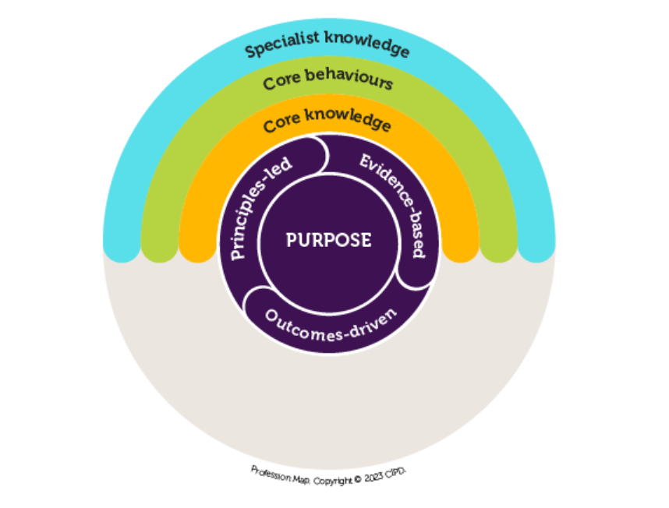
Establishing clear guidelines for employees whilst outlining the expected behaviour is essential when following process. The philosophy sets the overarching vision and values that inform choices, while policies and procedures translate that vision into concrete steps to deliver results. Having clear policies set out in your company will enable all employees to feel trusted and equally treated, boosting engagement and creating a clear line of expectation.
Dealing with matters in a consistent way can impact on decisions although failure could lead to dissatisfaction and legal implications. It is essential to adhere to established policies and procedures throughout the recruitment process, as any deviation by hiring managers can lead to inconsistency and result in unfair treatment of candidates. Adhering to Equality Act 2010 (Gov.UK, 2024) is significant to reduce the risk of discrimination claims in employment tribunals. Having an equal opportunity policy sets out that all candidates will be assessed fairly and a recruitment procedure will aid in steps to conduct standardised interviews and questions, background checks preventing bias and ensuring compliance. Ensuring that the process is fair and the right applicants are being put forward will help the trajectory of the business.

Q5. Explain how the people professionals at Company X can create value for their people, their organisation and their wider stakeholders. (AC 2.1)

Creating value in the workplace is an integral part of any organisation. With people the core of our approach, guiding and building a sense of shared purpose is meaningful to support the organisation in day to day working practice. David Ulrich’s (1995) HR Model emphasises the importance of HR as a strategic partner. Tthrough emphasis on the necessity for HR professionals to function as true business partners, the evolution of the model has created value by setting targets and goals offering multiple-perspective thinking (Indeed, 2024).
People professionals create value for wider stakeholders and customers through the development of structural capital or human capital. Analysing and reporting on data provides valuable information and insight into how value can be added through people management and strategic investment by supporting and optimising strategic goals. Both are used autonomously to create value within.
HR practices can serve as a strategic lever for value creation within Company X, fostering employee growth and development, supporting and maintaining robust selection and hiring processes. Offering fairness and consistency will add value and earn credibility acting with an ethical approach. Developing employees through performance management and L&D systems will increase skills and knowledge of the workforce with employee capability. Creating harmonious employment relations increases wellbeing and engagement whilst ensuring ethical principles are maintained. Integrating business strategy, culture and other capabilities contribute to the long term success of both the organisation and the stakeholders, ensuring sustainable growth increasing the attractiveness of the business.

Q6. Imagine that you have been successful in your application for the role at Company X. Summarise the ways that you could be customer focused and standards driven in your new role, drawing on your previous experience, as necessary. (AC 2.2)

As a people professional, I can demonstrate a strong customer-focused approach in achieving and maintaining a high level of reliability as well as ensuring integrity when dealing with employees and key stakeholders. This enables me to understand the requirements and concerns of employees, tailoring policies and strategies to address specific needs. Having a good depth of knowledge to draw on will contribute to the team enabling customer satisfaction to be maintained. In my previous role, customer satisfaction was the top priority, allowing me to carry the ethos of the company with everything that I do. Adapting to new strategies and values is vital to sustain a successful business built to grow. HR is a service-oriented team, given my flexibility and approach to always do the right thing, I would use feedback internally and externally to improve organisational practices. I can be standards driven by adhering to policies and procedures in all aspects of my role, acting with professionalism and taking accountability when required. This embodies fairness and reinforces ethical practice.
According to David Ulrich (The RBL Group, 2019), the business conditions are what shape and drive who we are and what we do when looking at HR from the ‘outside in’. Understanding this theory will enhance the company and shift towards success.
Optimising the customer focus within the company will assist in loyalty, achieve sustained growth and increase retention. This can be incorporated through value and culture alignment. Creating a strong ethos will preserve and grow the customer base through high satisfaction, meeting needs and expectations for employees and stakeholders. To achieve greatness every member of the company needs to align with the values and actions to support the overall goals (Team, 2025). I’m confident I can contribute to a positive environment and drive success in Company X with my commitment to high standards.

Q7. The excel table inserted below shows the overtime worked over a four-week period for one of Company X’s clients, Blue Mountain Patisserie.
- Analyse the results and provide written comments on any issues that the data has revealed suggesting potential problems and solutions. (AC 1.4)
The table illustrates the overtime hours worked at Blue Mountain Patisserie across a four-week period. The data reveals that most employees consistently work more overtime than their contracted hours. For instance, B. Sykes, is employed on a 20-hour contract, but has recorded overtime of 63% of their standard hours. Meaning that more than half of their total working time was spent on overtime. This trend is consistent across multiple departments, underscoring a widespread reliance on staff exceeding contractual commitments. Evaluating H. John from the Barista Department, despite having relatively low contracted hours, he has averaged 59% overtime compared to his standard workload.
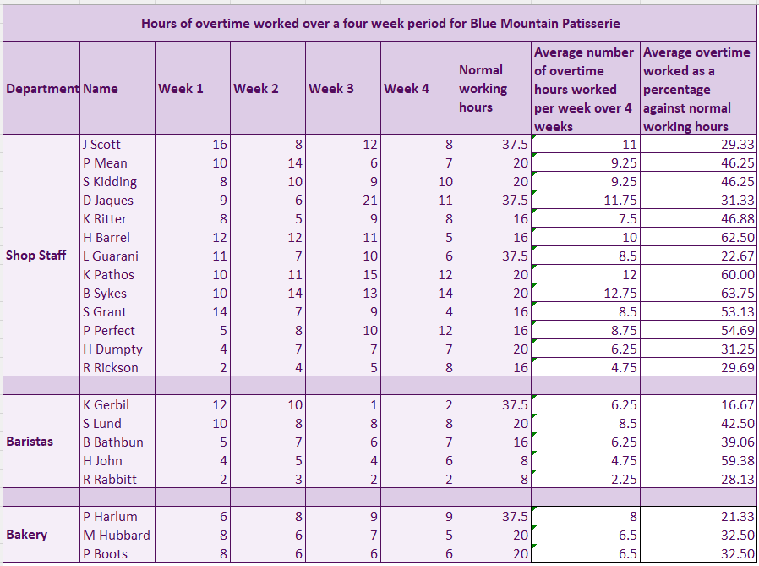

The bar graph provides a clear representation of overtime hours worked across departments, highlighting significant variation in workload distribution. The highest percentage of overtime in the bakery is 32.5%, though this remains lower than that of shop staff and baristas. This contrast may be linked to the unsociable hours in bakery roles, which often require night shifts to prepare products for sale the following day.
The line graphs below illustrate overtime worked per employee within each department, revealing notable differences in contractual hours. Of the thirteen shop employees, only three hold full-time contracts of 37.5 hours, while the remainder are contracted for considerably fewer hours. Across the business, just five of twenty-one employees are full-time, underscoring the reliance on part-time staff to absorb overtime. Examples such as P. Mean, P. Perfect, and B. Bathbun suggest that insufficient staffing levels may be driving the high overtime burden. This imbalance in contractual hours could also create tension, as part-time staff often receive more overtime opportunities at premium rates compared to their full-time colleagues.
The data points to a consistent reliance on overtime across the business. Under the Working Time Regulations 1998 (GOV.UK, 2025), employees undertaking significant overtime must be afforded adequate rest periods to avoid legal and health risks. Failure to comply could result in both regulatory consequences and workforce fatigue.
Extended working hours increase the risk of burnout, stress, and sickness absence. A practical solution would be to increase contractual hours for part-time employees, thereby reducing overtime costs while promoting a healthier work-life balance. This approach would enhance job satisfaction, foster a sense of value and support among staff, and contribute to a more sustainable workforce. Additionally, increasing contractual hours would entitle employees to greater vacation allowances, further strengthening employee wellbeing and retention.

Additionally, you could look to increase headcount by one or two. By increasing headcount it may relieve stress levels of staff, improving culture of Blue Mountain Patisserie. By having an additional member of the team, it could elevate stress taken on from sickness absence and vacation. As shown above the shop staff take on much more overtime across the four week period.
Implementing small changes could create a significant impact on Blue Mountain Patisserie’s work life balance and overall spend on overtime premiums creating a more positive working environment.

References
CIPD (2025). Evidence-based practice for effective decision-making. [Online]
Available at: https://www.cipd.org/uk/knowledge/factsheets/evidence-based-practice-factsheet/
[Accessed: 6 December 2025].
Gov.UK (2024). Equality Act 2010. [Online]
Available at: https://www.legislation.gov.uk/ukpga/2010/15/contents
[Accessed 12 December 2025].
GOV.UK (2025). The Working Time Regulations 1998. [Online]
Available at: https://www.legislation.gov.uk/uksi/1998/1833/contents
[Accessed 15 December 2025].
The RBL Group (2019). YouTube. [Online]
Available at: https://www.youtube.com/watch?v=RGxpU1UuRX8
[Accessed 13 December 2025].
Indeed (2024). The Ulrich model and how it applies to the HR role. [Online]
Available at: https://uk.indeed.com/career-advice/career-development/ulrich-model
[Accessed 13 December 2025].
The Council on Quality and Leadership (2018). 12 Reasons Why Data Is Important. [Online]
Available at: https://www.c-q-l.org/resources/guides/12-reasons-why-data-is-important/
[Accessed 11 December 2025].
Safegraph (2024). Why accurate data is important for business operations. [Online]
Available at: https://www.safegraph.com/guides/why-accurate-data-is-important
[Accessed 11 December 2025].
Indeed Editorial Team (2025). Indeed Career Guide: 8 Strategies To Improve Customer Focus. [Online]
Available at: https://www.indeed.com/career-advice/career-development/customer-focus-examples
[Accessed 15 December 2025].
Waite, K., Beevers, K., Small, N., Tomlinson, K. and Hussain, S. (2021). People Practice: A Complete Guide. 1st ed. London, United Kingdom: Kogan Page.

