

MODULE:
Changemakers: Building your Personal Brand for Sustainable Employment (Code: BMHP5015)

STUDENT: Manuela Mihaila
STUDENT NUMBER: 2223871
LECTURER: Tsiwani Khumalo

Task 1 – Personal Brand
Write about your own person brand and how you could develop this to enable you to reach your employment goals (200 words- 2 referenced sources)

My professional brand, Manuela Mihaila, represents compassion, maturity, cultural awareness and commitment to ethical practice within health and social care. As a Level5 BSc Health and Social Care student with consistently strong academic performance, I am developing a professional identity centred on person-centred values, dignity and evidence-informed practice. Personal branding involves clearly communicating one’s values, strengths and professional purpose to create a distinct and credible identity (Montoya and Vandehey, 2009).
My target group for future employment is older adults and vulnerable individuals requiring holistic, person-centred support. I am particularly interested in roles within community care or residential settings where I can contribute to promoting independence, wellbeing and social inclusion. My professional profile is built around supporting individuals not only with their physical needs but also with emotional wellbeing, cultural sensitivity and advocacy. By integrating theory from my degree with practical experience, I aim to deliver safe, respectful and empowering care.
To further strengthen my brand, I will focus on continuous professional development, gaining practical experience and building professional networks within the sector. Employability in health and social care requires reflection, adaptability and lifelong learning (Cottrell, 2019). By consistently demonstrating professionalism, empathy and competence, I aim to establish Manuela Mihaila as a trusted and capable practitioner committed to sustainable and ethical care practice.

Task 2 - Network Map and Rationale
Create a map of your own network considering career, support, social and community dimensions. Additionally, you should provide a supporting rationale explaining and critically assessing this (200 words- 2 referenced sources).
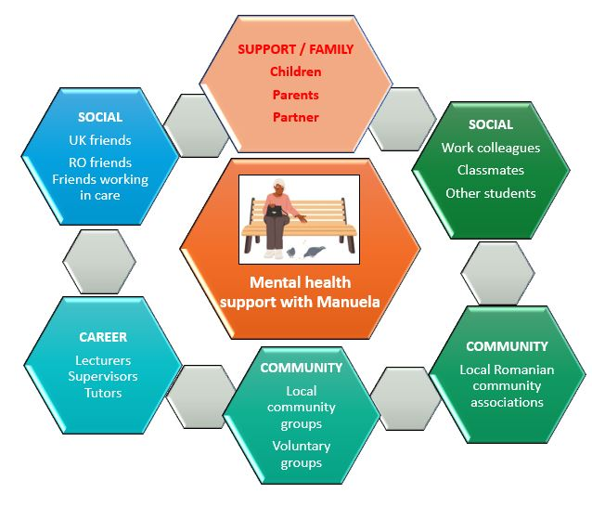

My current network can best be described as a hybrid network, as it combines strong close relationships with some developing professional connections. I have strong bonding capital, particularly through family, close friends and members of the Romanian community in the UK. Bonding capital refers to relationships with people who are similar to us and who provide emotional and practical support (Putnam, 2000). These connections provide stability and encouragement during my studies.

However, my bridging and linking capital are less developed. Bridging capital involves connections with people from different professional or social backgrounds, while linking capital refers to relationships with individuals in positions of authority or influence (Woolcock, 2001). Although I have some contact with lecturers and friends working in health and social care, I currently lack strong connections with employers, managers or organisations in the sector.
To strengthen my network, I need to expand my professional contacts through volunteering, LinkedIn engagement and attendance at health and social care events. Developing stronger linking relationships will increase my access to opportunities, placements and future employment, supporting my long-term goal of becoming a competent practitioner in the sector.

Task 3- Blog
Write a blog exploring a current topic or issue of your choice within the health and social care sector in the UK. The purpose of this is to inform a specific target audience of your choosing (300 words)
Loneliness in Older Adults
If you care for an older family member, you may already know that loneliness is more than just a feeling — it can significantly affect health and wellbeing. According to Age UK, nearly 1 million older people in the UK frequently experience loneliness, making it a widespread issue among older adults (Age UK, 2024). Research shows that social isolation is linked to increased risks of depression, cognitive decline and even heart disease (Holt-Lunstad et al., 2015). As family carers, understanding this risk can help you take practical steps to protect your loved one’s health.
Older adults are particularly vulnerable to isolation due to retirement, bereavement, mobility challenges or long-term conditions. In England, Age UK (2023) reports that millions of older people experience persistent loneliness. This makes social connection a major public health concern.
So, what can you do?
Small, consistent actions matter. Encouraging participation in community groups, local day centres or faith groups can strengthen social engagement. Digital inclusion is also important. Supporting older relatives to use video calls or messaging apps can help maintain connections with distant family members. Where mobility is limited, community transport services and befriending schemes can reduce barriers.
From a health and social care perspective, person-centred care means recognising social needs alongside physical ones (NICE, 2022). When professionals and families work together, outcomes improve.
If you are worried about someone, speak to your GP, local authority adult social care team or voluntary organisations in your area. Social wellbeing is not a luxury — it is a key part of healthy ageing.
Together, we can help older adults remain connected, valued and supported.

Task 4- NHS Equality, Diversity and Inclusion Quiz (250 words equivalent)
- What is the primary goal of the NHS Equality, Diversity, and Inclusion Improvement Plan?
(Answer in one or two sentences.)

The primary goal of the NHS Equality, Diversity and Inclusion (EDI) Improvement Plan is to create a fairer, more inclusive NHS workforce by addressing inequalities in recruitment, progression, experience and pay, while improving patient care outcomes (NHS England, 2023).

- How does the NHS EDI Improvement Plan propose to tackle the gender pay gap?
(Answer in one to two sentences.)

The Plan proposes tackling the gender pay gap through transparent pay reporting, fair recruitment and promotion practices, and improved access to flexible working and leadership development opportunities for underrepresented groups (NHS England, 2023).

- What is meant by the term ‘intersectionality’ as used in the NHS EDI Improvement Plan?
(Answer in one to two sentences.)

Intersectionality refers to how different protected characteristics, such as race, gender and disability, can overlap and compound disadvantage or discrimination within the workforce (NHS England, 2023).

- Why is it important for the NHS to create a psychologically safe work environment?
(Answer in one to two sentences.)

A psychologically safe work environment allows staff to speak up about concerns, share ideas and report discrimination without fear of blame or retaliation, which supports staff wellbeing and patient safety (Edmondson, 2018).

- How does the NHS EDI Improvement Plan suggest improving the experience of internationally recruited staff?
(Answer in one to two sentences.)

The Plan recommends better induction, pastoral support, fair career progression pathways and tackling discrimination to improve the experience of internationally recruited staff (NHS England, 2023).

- What role does leadership play in advancing EDI objectives according to the NHS Improvement Plan?
(Answer in one to two sentences.)

Leadership is central to advancing EDI objectives, as leaders set organisational culture, model inclusive behaviour and are accountable for measurable progress (NHS England, 2023).

- Identify one way the NHS EDI Improvement Plan aims to reduce health inequalities within the workforce.
(Answer in one to two sentences.)

One strategy to reduce health inequalities within the workforce is addressing disparities in recruitment and disciplinary processes identified in Workforce Race Equality Standard (WRES) data (NHS England, 2023).

- Why does the NHS EDI Improvement Plan emphasise the importance of collecting and analysing data on protected characteristics?
(Answer in one to two sentences.)

Collecting and analysing data on protected characteristics enables the NHS to identify inequalities, monitor progress and design targeted interventions (NHS England, 2023).

- Explain how flexible working policies can contribute to equality and inclusion in the NHS workforce.
(Answer in one to two sentences.)

Flexible working policies promote inclusion by enabling staff with caring responsibilities, disabilities or health conditions to remain in employment and progress fairly.

- What is one strategy mentioned in the NHS EDI Improvement Plan to combat bullying and harassment in the workplace?
(Answer in one to two sentences.)
One strategy to combat bullying and harassment is strengthening reporting mechanisms and promoting a zero-tolerance culture supported by leadership accountability.

Task 5- A Letter to Yourself
Think of a time in the past when you may have been experiencing issues or difficulties, and after considering what you have learned in this module about emotional intelligence and resilience write a letter to your younger self explaining how these attributes were important at that time and perhaps how developing these areas could have been useful (250 words)

Dear Younger Manuela, Manuela Mihaila
58 Middleborough Rd, CV14DE,Coventry
I remember a time in my life when everything felt uncertain and overwhelming. I was trying to adapt to a new country, new expectations and new responsibilities, while quietly carrying the pressure of proving myself. My wellbeing was not at its best then, I felt anxious, tired and sometimes doubted about my own abilities.
What I understand now, through learning about emotional intelligence, is that recognising and naming those emotions would have helped me manage them more effectively. Instead of pushing my feelings aside, I could have acknowledged them with self-compassion. Emotional intelligence is not about suppressing emotions; it is about understanding them and responding thoughtfully. If I had paused to reflect rather than react, I might have felt more in control and less self-critical
Resilience is another lesson I have learned. At the time, I believed strength meant coping alone. Now I know that resilience also means asking for support, building connections and accepting that setbacks are part of growth. Difficult moments were not signs of failure but opportunities to develop inner strength.
If I could advise myself, I would say: Trust your experience, speak kindly to yourself and allow others to support you. The challenges you face are shaping your empathy, maturity and determination. They are preparing you to support others with understanding and compassion. You are stronger than you realise and the version of you writing this letter is proud of how far you have come.

With care and understanding,
Manuela

Task 6- GANTT Chart (200 words equivalent)
Compile a Gantt chart which illustrates the tasks you have to complete to achieve your future employment goals
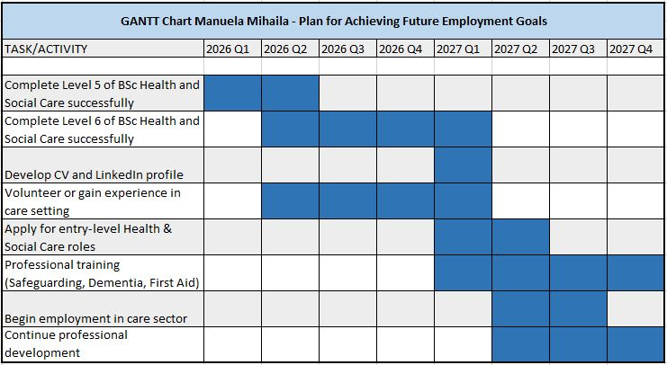
Explanation
This Gantt chart outlines the steps I plan to take to achieve my future employment goals within the health and social care sector. The first stage focuses on completing my Level 5 and Level 6 studies and successfully graduating with a BSc in Health and Social Care. During this time, I will also begin preparing for employment by developing a professional CV and creating a LinkedIn profile to present my skills, qualifications and interests to potential employers.
Alongside my studies, I plan to gain practical experience through volunteering or part-time work within a care setting. This will allow me to apply the theoretical knowledge gained during my degree and develop important professional skills such as communication, empathy and teamwork.
Following graduation, my next goal is to apply for entry-level positions within community or residential care services. At the same time, I plan to complete additional professional training, including safeguarding, dementia awareness and first aid. These qualifications are highly valued within the health and social care sector and will strengthen my employability.

Once employed, I intend to continue developing my professional knowledge through ongoing training and workplace learning. Continuous professional development will help me become a competent and confident practitioner who can provide high-quality, person-centred care.

Task 7- Making Changes- Report
You are the manager of a care home and want to make changes your workplace. Identify one specific change that you want to implement and write a brief report on how this is going to be achieved considering the necessary skills needed and addressing possible barriers to success. Relevant change models can be highlighted (250 words- 2 referenced sources).

Proposed Change: Introducing a structured programme of social activities to reduce loneliness among residents.
As the manager of a care home, I would like to introduce a structured programme of social and wellbeing activities aimed at reducing loneliness and improving residents’ quality of life. Social isolation is a significant issue for many older adults in residential care settings and can negatively affect mental and physical health. Implementing regular group activities, such as music sessions, gentle exercise classes, storytelling groups and community visits, could help residents feel more engaged and connected with others.
To successfully introduce this change, effective leadership and communication skills will be essential. Staff members will need to understand the purpose of the new activities and how they contribute to residents’ wellbeing. Training may be required to ensure staff feel confident facilitating activities and encouraging participation among residents. According to Kotter’s (1996) change model, successful organisational change begins with creating a clear vision and communicating it effectively to staff. Therefore, I would involve staff in planning the programme so they feel motivated and responsible for its success.
However, there may be barriers to implementing this change. These could include limited staffing levels, lack of time, or resistance from staff who may feel the change increases their workload. Lewin’s (1951) change management model suggests that organisations must first “unfreeze” existing practices by helping staff understand why change is necessary. By explaining the benefits for residents and involving staff in decision-making, it may be easier to overcome resistance and successfully implement the programme.
Overall, introducing structured social activities could improve residents’ wellbeing while creating a more positive and supportive care environment.

Task 8- Self-Reflection
Using one of the highlighted models of reflection, reflect on what you have learned about yourself during this module, as well as the knowledge you have gained, and explain how this has developed your skills and informed your future practice (250 words- you must reference the model you use)

Self-Reflection using Gibbs’ Reflective Cycle
During this module, I have developed a deeper understanding of my personal and professional identity and how it relates to my future career in health and social care. Using Gibbs’ Reflective Cycle (Gibbs, 1988), I can reflect on what I have learned and how it has influenced my development.
Description: Throughout the module, I completed several activities related to personal branding, networking, communication and career planning. These tasks encouraged me to think about my strengths, values and long-term professional goals.
Feelings: At the beginning of the module, I felt uncertain about how to define my personal brand and how my previous experiences could contribute to my future career in health and social care. However, as the module progressed, I became more confident in recognising the transferable skills and personal qualities that I can bring to the sector.
Evaluation: One of the most valuable aspects of the module was learning about networking, emotional intelligence and resilience. These topics helped me understand the importance of building professional relationships and managing challenges in a positive way.
Analysis: Reflecting on these experiences has helped me realise that developing a strong personal brand requires self-awareness, continuous learning and clear career planning. Understanding these concepts will help me communicate my skills and values more effectively to potential employers.
Conclusion and Action Plan: In the future, I plan to continue developing my professional skills by gaining practical experience, strengthening my professional network and engaging in continuous professional development. This reflective process has helped me understand how I can grow both personally and professionally as I prepare for a career in health and social care.

Reference List
Age UK (2023) Loneliness in Later Life. London: Age UK.
Age UK (2024) Loneliness research and resources. Age UK. Available at: https://www.ageuk.org.uk/our-impact/policy-research/loneliness-research-and-resources/
Cottrell, S. (2019) Skills for Success: Personal Development and Employability. 4th ed. London: Red Globe Press.
Edmondson, A. (2018) The Fearless Organization. Hoboken: Wiley.
Gibbs, G. (1988) Learning by Doing: A Guide to Teaching and Learning Methods. Oxford: Oxford Polytechnic.
Holt-Lunstad, J., Smith, T.B., Baker, M., Harris, T. and Stephenson, D. (2015) ‘Loneliness and social isolation as risk factors for mortality’, Perspectives on Psychological Science, 10(2), pp. 227–237.
Kotter, J.P. (1996) Leading Change. Boston: Harvard Business School Press.
Lewin, K. (1951) Field Theory in Social Science. New York: Harper & Row.
Montoya, P. and Vandehey, T. (2009) The Brand Called You: Make Your Business Stand Out in a Crowded Marketplace. 2nd ed. New York: McGraw-Hill.
NHS England (2023) NHS Equality, Diversity and Inclusion Improvement Plan. London: NHS England
NICE (2022) Older people: independence and mental wellbeing. London: National Institute for Health and Care Excellence.
Putnam, R.D. (2000) Bowling Alone: The Collapse and Revival of American Community. New York: Simon & Schuster.
Woolcock, M. (2001) ‘The place of social capital in understanding social and economic outcomes’, Canadian Journal of Policy Research, 2(1), pp. 11–17.

