

Module Title: Foreign Language and Cultural Awareness
Module Code: BMIH5003
Student Name: Alexandru Badea
Student Id: 2208275
Lecturer: Heidi Prosser

Executive Summary
This paper shows the necessity of understanding a location's culture when running a business. The Inclusivity Hotel & Spa is a German hotel with headquarters in Berlin and other outlets in London, England. The analysis identified two significant components, social and cultural, in determining cultural differences between the two countries. Cultural differences have been understood using global project theory. As a result, some of the obstacles described in this paper are intellectual in nature. Although several solutions have been proposed to address these concerns.

Table of Contents
Introduction 4
Key differences among the countries (England and Germany) 5
Analysing and comparing England and Germany using the GLOBE Project's culture and leadership study 6
Challenges of Intercultural Leadership 7
Recommendation to mitigate the challenges 8
Conclusion 9
References 10

Introduction
Exploring new cultures and languages is critical for hospitality organisations seeking to grow their business. Every country has its own distinct culture, and England and Germany are no exception. The following report will evaluate the difference in culture for the The Inclusivity Hotel & Spa. Some key differences among both countries will be highlighted in this report context. Alongside a brief analysis will be provided using global projects and leadership study along with intercultural challenges of leadership. Moreover, some recommendations will also be illustrated in the following context of the report.

Key differences among the countries (England and Germany)
Language
Both countries are located in Europe and communicate in different languages. One country's language is English and the other one is German. The main cultural differences for the Inclusivity Hotel & Spa team will be a language barrier. Thus the Inclusivity Hotel & Spa team needs an expert person in both languages (BBC, 2019).
Communication style and pronunciation
Another cultural gap between German and British people is their communication style. The British people are considered to be softly spoken and polite whereas the German people are very direct. The German language has more letters than English and has different pronunciations. The pronunciations between them are another gap between the cultures (Evason, 2019). For example, most German people pronounce the Camera as Kamera.
Punctuality
Most German people are very punctual with their time and love to stick to their schedule. On the other hand, the British people are very different from them. Since in German a punctual person is highly praised and can be in a workplace for a long time. Thus being too late for important work has a poor impact on Germans. According to Hofstede's cultural dimensions theory, Germany has a high value of uncertainty avoidance that can lead to a preference for clarity of the rules and structured time management (Germany Hofstede, 2010). The respect for time characteristic of this culture impacts the way punctuality is perceived and valued at work.

Analysing England and Germany using the GLOBE Project's culture and leadership study
Performance orientation
Performance orientation is part of the GLOBE project's culture and leadership that denotes a community that encourages and gives praise for innovation and reflects on High Standards, along with performance development. Similarly, both countries give praise to their employees for innovations on a high or low scale. Moreover, for some reason, Germany tends to give their employees high-performance orientation and rewards whereas England gives less performance orientation to their employees (Abramson and Moran, 2018). Germany's competitive market and emphasis on individual achievement drive high-performance orientation and rewards for employees compared to Britain.
Human orientation
Countries that value high human orientation tend to promote social and economic support by individual people of the country, not by the state. Since some aspects of human orientation are fairness, friendliness, and support, both countries follow these aspects very well. Due to language and communication barriers, the communication style of the German people may seem rude. Though both countries have good Human orientation reputations across the world.
Future orientation
Future orientation indicates an individual's plan and mindset about the future and their development. According to research about the Future Oriented Index in 2015 by UCL Germany is considered to be the most future-oriented county than London. Since London or England trends are very much attached to their old concept. Thus, to improve business in Germany UK-based hotels need to think about the future. Although later, Covid-19 the rate dropped, Germany continued to grow afterward (GCB, 2024).

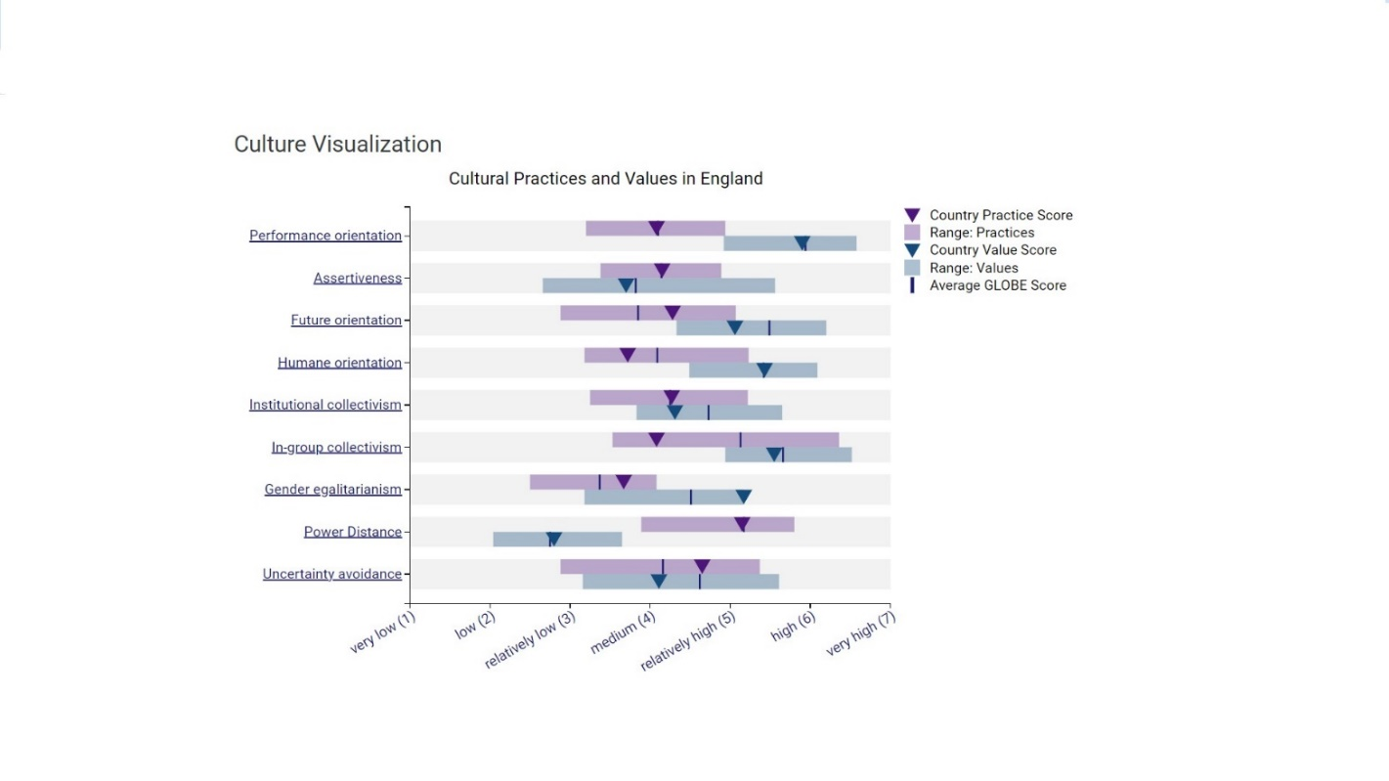
(Culture visualisation England)
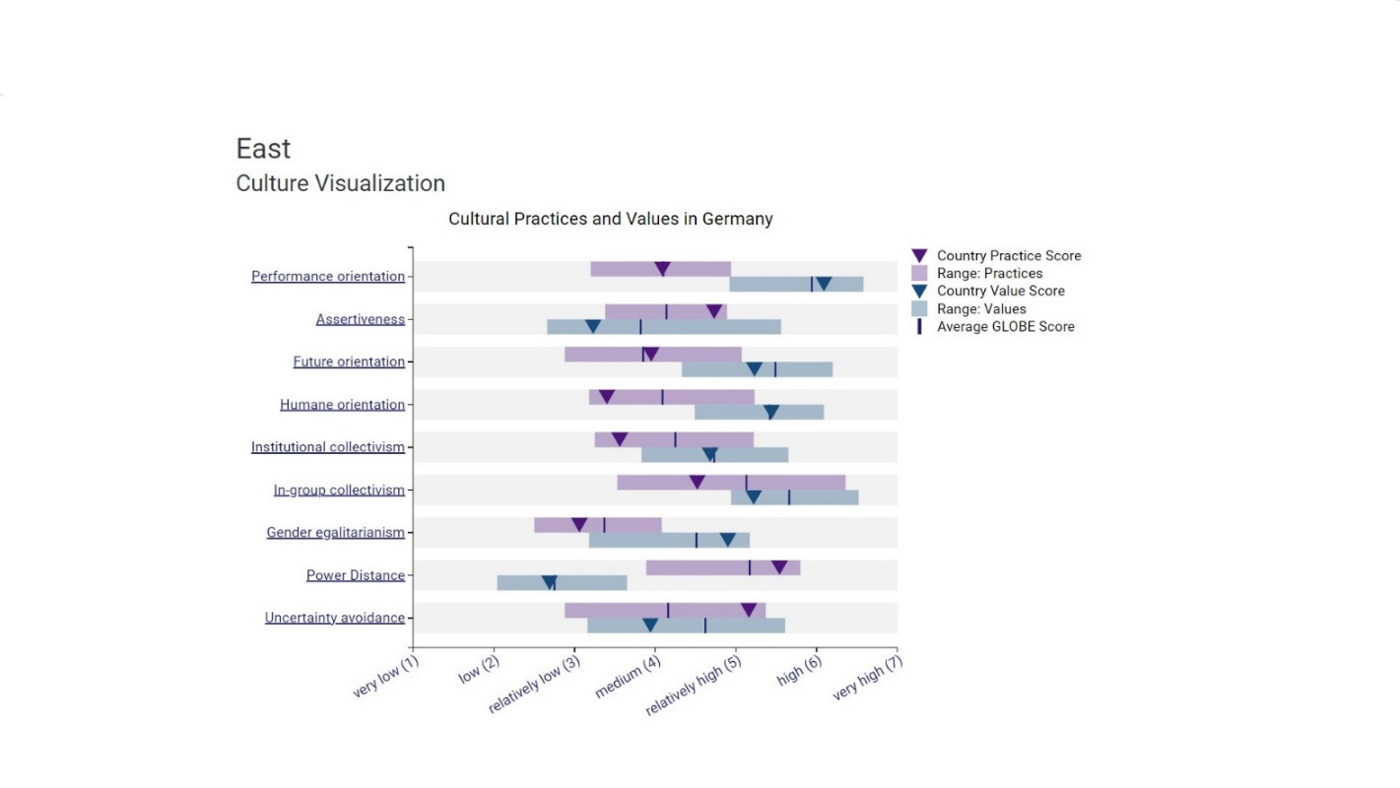
(Culture visualisation East Germany)
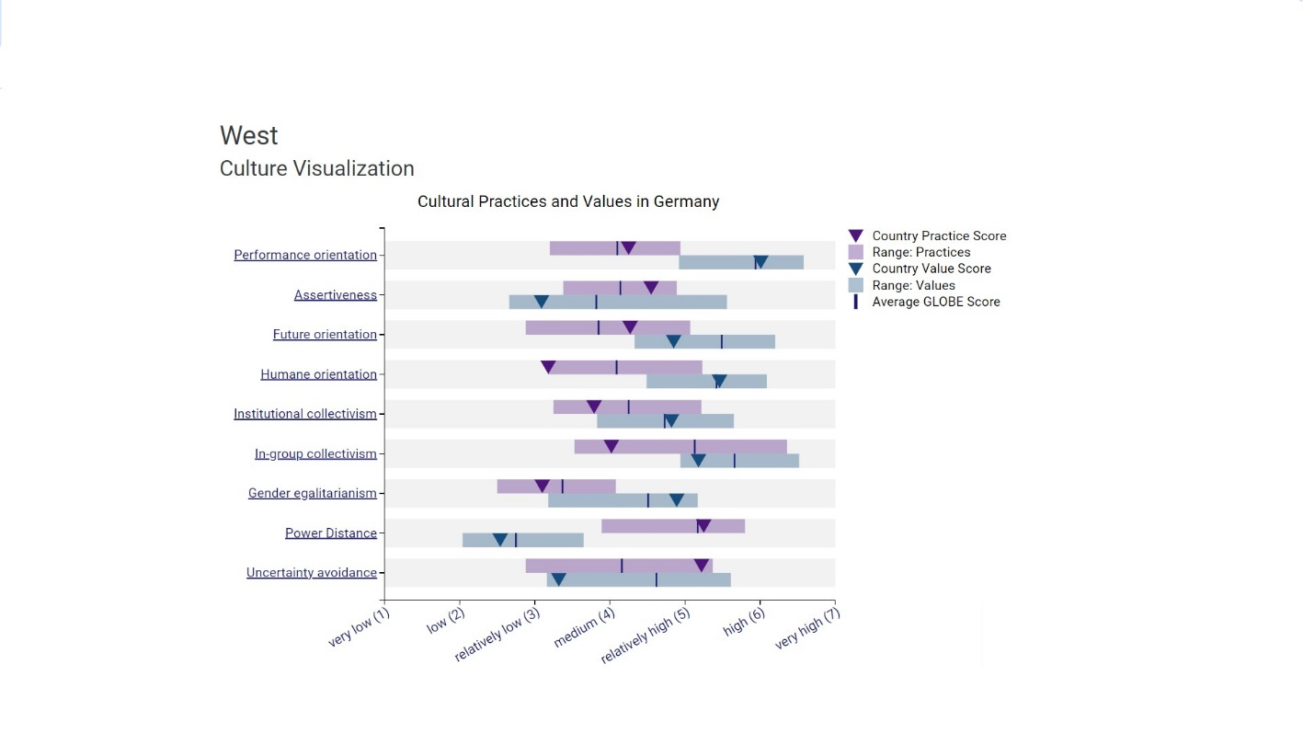
(Culture visualisation West Germany)

Leadership Scores
When comparing the leadership visualisation scores for outstanding leadership between England and Germany, we find some interesting similarities. According to the Globe Project’s diagrams below, in both countries, outstanding leaders are perceived to possess strong charisma, a focus on teamwork, and a willingness to involve others in decision-making. The leaders are expected to display a degree of autonomy while also being mindful of self-protection. However, there might be slight differences when it comes to humane-oriented leadership. While both countries value leaders who demonstrate empathy and compassion, England seems to emphasize this quality slightly more compared to Germany. Overall, both England and Germany prioritise leadership qualities that promote engagement, collaboration, and independence, reflecting a balanced approach to effective leadership.
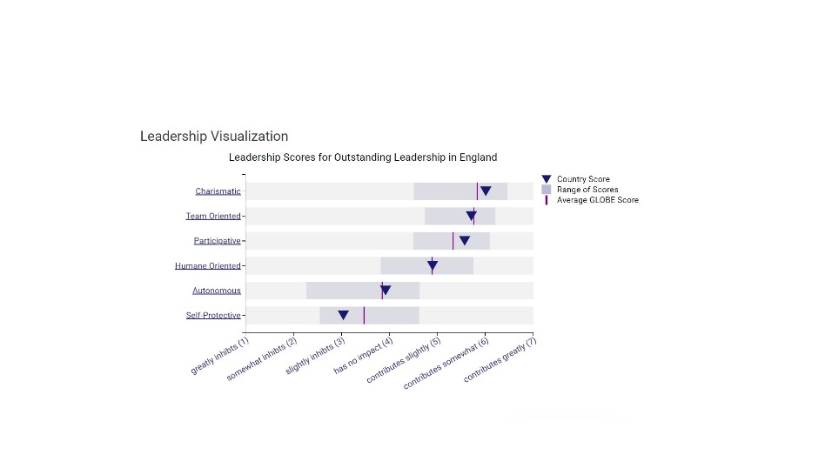
(Leadership Visualization England)
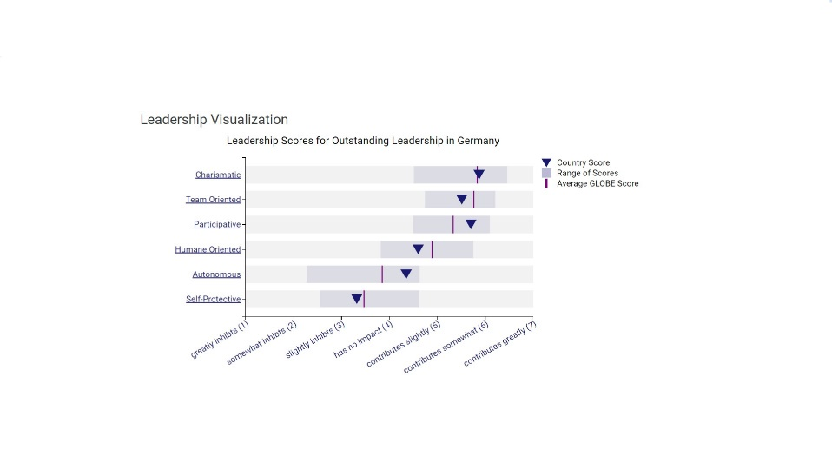
(Leadership Visualization East Germany)
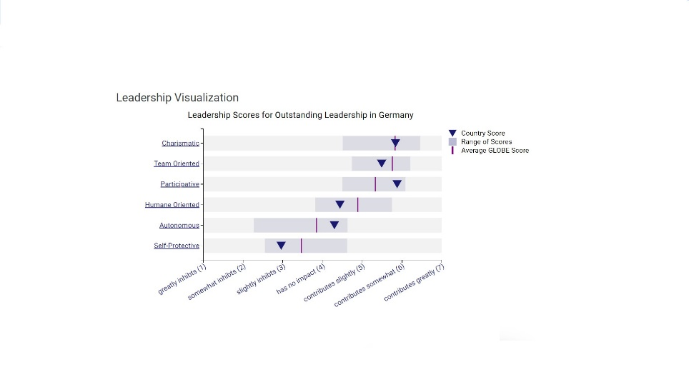
(Leadership Visualization West Germany)

Challenges of Intercultural Leadership
Communication barriers
Cross-cultural interaction often leads to communication barriers between the parties. Communication barriers are the obstacles that create misunderstandings and misinterpretations among the diverse team. This may make the employees feel less confident and unwelcome as for the communication barrier. Thats why, the team leader must excel in understanding cultural norms and effectively communicate messages to avoid potential errors. (Wacharamanotham, 2021).
Managing conflict resolution
One of the most important roles of team leaders is to navigate and understand other people's perspectives. Leaders are required to better manage their teams, but this gets more difficult when employees originate from diverse cultures. Furthermore, team leaders should address any conflicts that arise in order to ensure future success. When mediating conflict, the leader should not depend on emotional intelligence and negotiation techniques (Deresky, 2019).
Overcoming Stereotypes and Biases

When there's a cultural barrier, it can lead to misunderstandings among employees. So, it's important for team leaders to treat everyone with respect and fairness. This helps break stereotypes and biases, making the workplace safer and better for everyone.

Recommendation to mitigate the challenges
Learning the language
All the associated leaders of the diverse team should obtain knowledge about the language to convey the message properly. This will eventually help the team leader and the employees to prevent misinterpretation and misleading and be able to provide better understanding. Although through communication employees can participate in decision-making skills. Moreover, the team leaders will obtain knowledge about other cultures.
Prevent conflict
Conflict management is the biggest issue for intercultural as the team leader may be unable to manage the rising conflict between the employees. A team leader can manage their team by arranging training sessions for the employees. Through this session all the problems can be solved or a solution that will be neutral. Thus through this chances of having conflict in the future will be reduced.
Proper leading
Proper leading or guidance is essential for team development to maintain the ethics of the team. Leaders can remedy this by establishing guidelines that all members must obey. The proper leading by the guidelines will lead a team in a proper path and the team will eventually be on the right track.

Conclusion
When we compare these two countries, England and Germany, we see differences in how people communicate and work. Understanding these differences is key for teamwork and success. The GLOBE Project's study on culture shows us that leadership is seen differently in England and Germany. Also, dealing with problems like language barriers and conflicts is tough but necessary for achiving success.

References
Abramson, N.R. and Moran, R. (2018) Managing CulturalDifferences: Global Leadership for the 21st Century. 10thEd. Abingdon: Routledge.
BBC, (2019). Language Geramany. [Online] Available at: https://www.bbc.co.uk/languages/german/ [Accessed 26 January 2024].
Culture visualisation England. [Online] Available at: https://globeproject.com/results/countries/GBR%3Fmenu=list.html#list [Accessed 27 January 2024].
Culture visualisation East Germany. [Online] Available at: https://globeproject.com/results/countries/DEU%3Fmenu=list.html#list [Accessed 27 January 2024].
Culture visualisation West Germany. [Online] Available at: https://globeproject.com/results/countries/DEU%3Fmenu=list.html#list [Accessed 27 January 2024].
Deresky, H. (2019) International Management: ManagingAcross Borders and Cultures: Text and Cases. 9th Ed.Harlow: Pearson Education Ltd.
Evason, N., (2019). German Culture (Communication). [Online] Available at: https://culturalatlas.sbs.com.au/german-culture/german-culture-communication [Accessed 24 January 2024].
Germany Hofstede, (2010). Germany Hofstede, Available at: https://alingavreliuc.files.wordpress.com/2010/10/germany-hofstede.pdf (Accessed: 14 February 2024).
GCB, (2024). A Joint Post by Petra Hedorfer (GNTB) and Matthias Schultze (GCB). [Online] Available at: https://www.gcb.de/en/germany-meetings-magazin/mice-think-tank/business-travel-2023/ [Accessed 26 January 2024].
Hofstede, G., & Bond, M. H. (1984). Hofstede’s Culture Dimensions: An Independent Validation Using Rokeach’s Value Survey. Journal of Cross-Cultural Psychology, 15(4), 417-433. https://doi.org/10.1177/0022002184015004003
Leadership Visualisation England. [Online] Available at: https://globeproject.com/results/countries/DEU%3Fmenu=list.html#list [Accessed 27 January 2024].
Leadership Visualisation East Germany. [Online] Available at: https://globeproject.com/results/countries/DEU%3Fmenu=list.html#list [Accessed 27 January 2024].
Leadership Visualisation West Germany. [Online] Available at: https://globeproject.com/results/countries/DEU%3Fmenu=list.html#list [Accessed 27 January 2024].
Wacharamanotham, C., (2021). Two Sides to Every Story: Mitigating Intercultural Conflict through Automated Feedback and Shared Self-Reflections in Global Virtual Teams. [Online] Available at: https://dl.acm.org/doi/abs/10.1145/3134686 [Accessed 26 January 2024].

