

Managing Projects in the Organization
BMSW5104


Lecturer: Paul Jenkins
Student: Irina Merlan
Student number: 1818268

24.08.2020
Table of Contents

Executive Summary 3
Introduction 3
- Project Management (PM). 4
  - Project Management Tools and Techniques 4
2. Project Plan and Project Implementation 7
3. Critically Evaluate My Ability to Manage a Project 15
4. Conclusion 17
5. References 18
6. Appendices 1-5 19

Executive Summary
The main focus of this report is for the PM which stands aut for Project Manegement. PM has a variety of tools and techniques which can be defined and applied in the assignement. For a better understanding of the management of the project in this assignement they can be analysed along with appendices 1-5. Another important thing is that this report was written according with many authors and experts in MP, giving alternative examples. Irene Barbers shop is the project which will be implemented and we have everything analysed in project, especially in appendices. In order to investigate the PM for Irene Barbers shop I have applied: charts, critical charts, schedule in the calendar, Gantt, costs, planning of human resources, salaries, costs, risks, benefits. Along with all this, I have made a self-developmenet plan which can be implemented in order to plan the PM succesfully and I added conclusions based on the report.
Introduction
The European Management Journal, states, “Project Management has become a core business process for most organisations”. (Maylor, H., 2001). Project management begins with a definition of a project, in this assignment it is about a opening for kids barbers. Project Management permits managers to rapidly comprehend information for example: Who is working on project tasks? When will the tasks be accomplished? How the tasks relate to the general project?
Throughout this assignment its will be looking at the different stages, responsibilities/ risks and budgets.The main purpose of this assignement is to show a good understanding of what exactly means a project and how to manage it. The tools and methods which are used to develop projects are the main key to success “Project management is the application of knowledge skills and tools.” (Wiley, J., 2017). The International Journal of Project Management applied a survey which shows the project’s success rates, and they descover a remarkably high proportion of 41% were reported to be completely successfully.(White D., 2002). This is due to the right tools and techniques being utilized. International journals claim, “Tools and techniques are one of the key elements in project process, numerous tools are available to support the various phases of the project.” (Raz, T., 2001).

1.Project Management (P.M.)
1.1.Project Management Tools and Techniques
The methodology of project management is a scheme which is organized, scientifically proven and disciplined and uses all logical and practical processes with the purpose of creating a correct planning and to manage it until it is finished. They have been identified methodologies as follows: APF, CCPM, CPM, ECM, XP, KANBAN, PRINCE2, PRiSM, Process-Based Project Management, Six Sigma, Waterfall, V-model and many more. An example for better understanding the methodology for the project management is to compare it with a meal recipe as the following figure 1.1.a.
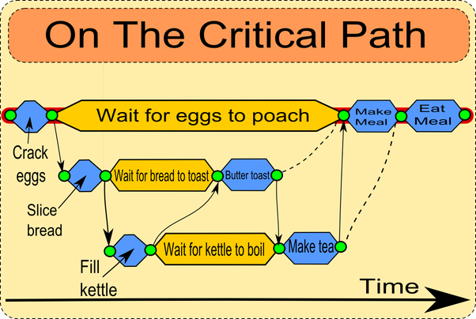
Figure 1.1.a, Acqnotes(2018).
The ingredients can be the same or a bit different. Same with the temperature which can be lower or higher. You will get a meal recipe which needs to go through some stages which can be selected depending on how do you like the meal. This is also a tool named CPM (Critical Path Method) usually made for a short period of time. Another representation of this method is shoed in figure 1.1.b.
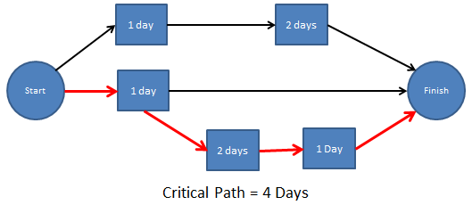
Figure 1.1.b, Acqnotes(2018).
Project Libre tool- PL is a globalPM software system with both a free open source work area and forthcoming Cloud adaptation. ProjectLibre work area is a free and open-source venture the board programming framework planned at last as an independent swap for Microsoft Project.
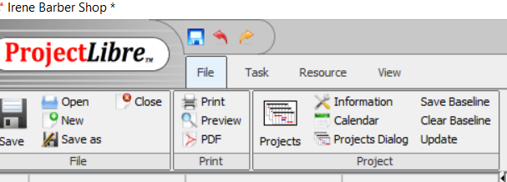
Figure 1.1.c, Project Libre Tool
Another project management tool is a chart named Gantt Chart which is simple and effective to use. Gantt Charts are even bars diagrams that show the conditions between the assignments and evaluated time which the will be finished. It permits arranging time and asset the executives and gives sign with respect to how long the undertaking will take from beginning to end. Research found out that “Gantt Charts are the favourite project plan representation because it’s really easy to view.” (Smith, T., 2016).
There are blended audits on this announcement as one Journal proposes Gantt Charts are losing their ubiquity, it contends that Gantt Charts pull an undertaking supervisor's concentrate away from the venture and onto going before lovely diagrams that don't generally coordinate reality. (Asoravala, 2006). Others guarantee that the outlines are made distinctly to satisfy higher associations and subsequently an interruption to the real tasks.
The Gantt Chart itself would not give detail costing or back up plans, and would then need to return to and amended in like manner, the even bars don't really mean more assets required. For instance, a bar may seem shorter in contrast with another errand it might require a larger number of assets than the more drawn out bar which may just require one individual to complete the tasks. (See figure 1.1.d).
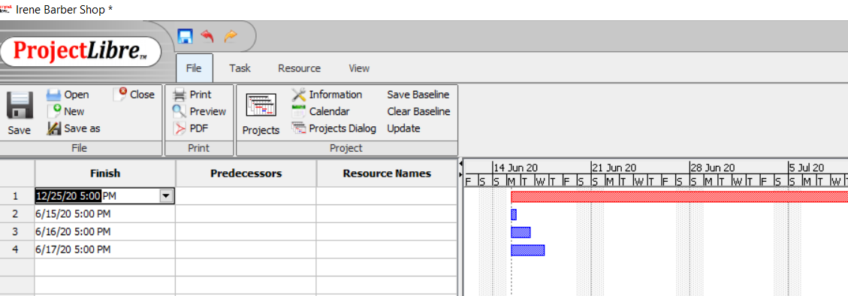
Figure 1.1.d, Gantt Chart
According to Project Management Journal Kumar stated, “Gantt Charts are a powerful and the most preferred visual tool”. (Kumar, 2005). It is one of the most preferred tools by most of the project managers, along with the Pert Chart with a critical pathway to back it up. A critical path “effectively copes with a number of activities, data, and dependencies between activities involved.” (Milosevic, N. & Martinell, D., 2016). The Pert Chartinvestigation midpoints three distinctive timescales, the briefest, sensible, and most pessimistic scenario to anticipate due dates. The Pert graph is revolved around significant achievements, the most significant achievement is the last due date. Not all errands in a task are reliant and can run equal, be that as it may, to decide the basic way of an undertaking the conditions should be resolved. (See informative supplement 2).
The Pert Chart is well known for venture supervisors, advantages of Pert Charts incorporate creation dubious cutoff times more unsurprising which shows an unmistakable request to finish assignments. It improves correspondence during the undertaking and permits the association to focus on the task that are pertinent to its key situating. Be that as it may, there is one significant drawback, if the figurings are mistaken any defer will make a bottleneck and influence the last conveyance date. That is the place a Gantt Chart may step in for more straightforward and visual manner.After all there are just three factors in a venture and shuffling three things is generally a basic assignment. These are time, cost and quality, their interrelationships are frequently delineated as a triangle.Another instrument utilized is a spending plan, this shows each applicable thing, its expenses against the day week or month in which it is caused. For some activities it might be vital just to plan and record for outer costs, for example, merchandise and enterprises bought outside the project. “Many organisations are perfectly happy with this type of budget, where as some go a little further wanting to see the internal staff costs of project.” (Watson, M., 2002) See appendix 3.
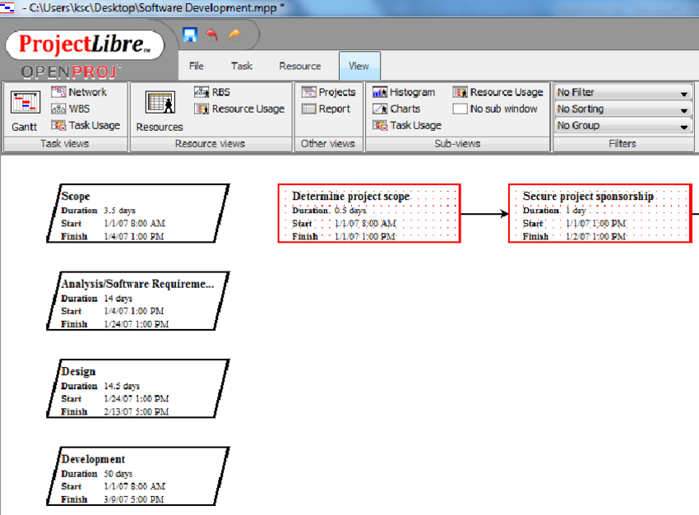
Figure 1.1.e, Pert Chart
The international Journal of Project Management contends the issue with a spending plan is the compromise issue with the risks. In the event that the dangers are higher and happen more than anticipated it might push the venture financial plan towards a negative side. "Cost decrease endeavors then again are now and then connected with high dangers. Venture directors face the issue adjust spending plans and dangers in the arranging stage." (Sato, T., 2013).
An alternative to a budget plan would be a cost benefit analysis (CBA). This examination takes a gander at both quantitative and subjective elements to decide the money related reasonability of an undertaking. "In money saving advantage examination the choice standard is on a basic level and clear." (Gray, A., 2000). As indicated by research "money saving advantage can be applied in two different ways, the human capital methodology, the standards commitments is connected to what they are paid or the methodology on people." (Robinson, R., 1993). Every strategy has its disadvantage's, the best that has been found so far is the eagerness to pay approach.
There are still issuess with the money saving advantage examination application and isn't all around fit to all tasks and ought to be utilized where suitable. For this task a spending plan will be be provided instead.
2.Project Plan and Project Implementation
2.1. Plan and project Definition
A project management life cycle is the management process and projects that can be broken up into well-defined phases to form a life cycle. Artlo the author states “the reported life cycle is typically illustrated by project processes that range from project initiation to project closure.” (Karlos, A., 1999). According to management theorist Henry Fayol (1841-1925) the main responsibilities of management are: planning, organising, command, co-ordination and control. These responsibilities will be used throughout this project plan. First there is the initiation phase. This is where Project Manager can start defining the project objectives, scope, and purpose.
All kids dislike having their hair style especially cut, we have every accomplished kid shouting, kicking and crying declining to let the beautician/hairdresser close to them. There are a lot of salons and hair stylists around us providing food for females and guys however not for kids. This open door has emerged to open a hair stylist as an effective 'Irene Barbers Shop'. This will be kid themed highlighting a kid well disposed condition being given by extraordinarily prepared workers, a sitter to engage the kids, brilliantly shaded furnishings, kid drawing in fittings, play place, uncommon scissors and hardware. The styling seats will include kid's shows, privateers and princess designs. The mirrors before the seats will have tablets fitted with the goal that the children can be involved while having their hair style. The holding up region is known as the play place, a completely qualified proficient sitter with a total DBS check will be in control who will give incredible entrainment and loads of fun. It will be a restricted organization, it will have a secretary, a director, four hair stylists and IT individual, sitter, assistant and a lesser cleaner, they will be payed an essential pay with focuses to hit to pick up commission and lift their compensation. All risk and benefit will swear by the proprietor, Irene Barbers Shop will be situated at 29 Bridge Street, Cardiff, SA 20 RFT. It is a bustling piece of the city with heaps of attractions around, for example, galleries and drive-through eateries which are famous with families, for example McDonalds, and that's just the beginning. The premises is a leased property of 500 ft squared with the month to month lease costing £500. An independent company credit of £10,000 has been allowed by the bank to get this business fully operational, alongside close to home reserve funds of £5,000. The task support is the L'Oréal team.The vital monetary accomplice is the bookkeeper whose design is to screen the progression of business cash and think of new answers for increment the sum accessible to the business. Vital promoting will enable the business to develop easily and vital provider who will flexibly everything the business needs. There is no immediate rivalry as there is an enormous hole in the market for this sort of business in the zone, on the flipside of this there are little stylists opening new shops up down the littler avenues anyway there is no motivation behind why this business shouldn't be succesful.The target market will include the parents living in the area and on the outskirts of the location, with kids age from 2 months to 13 years old girls and boys. The total for this project is £15,000, and a timescale of 7 months to be up and running. The closing of this project will be done when the first day of ‘Irene Barbers Shop will start giving their services to the customers the children.
Figure 1.1.f, StudiS
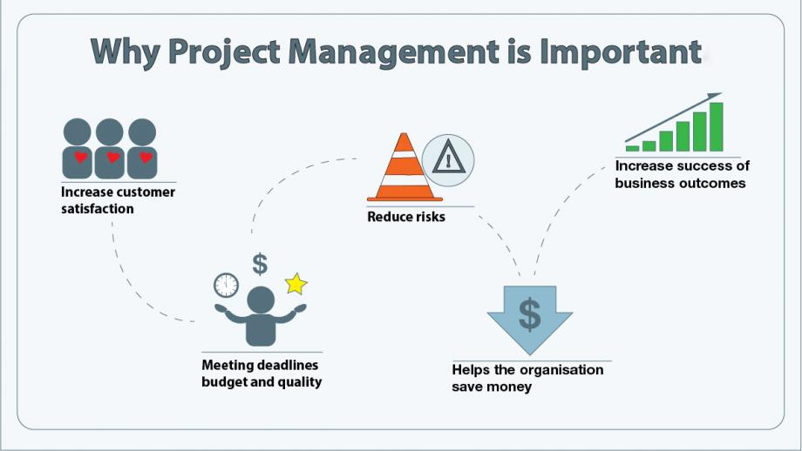
Planning phase:To show what the project aims to achieve, a project initiation document is shown below to outline and plan the project, along with a cost budget plan to show the cost effectiveness of the project.
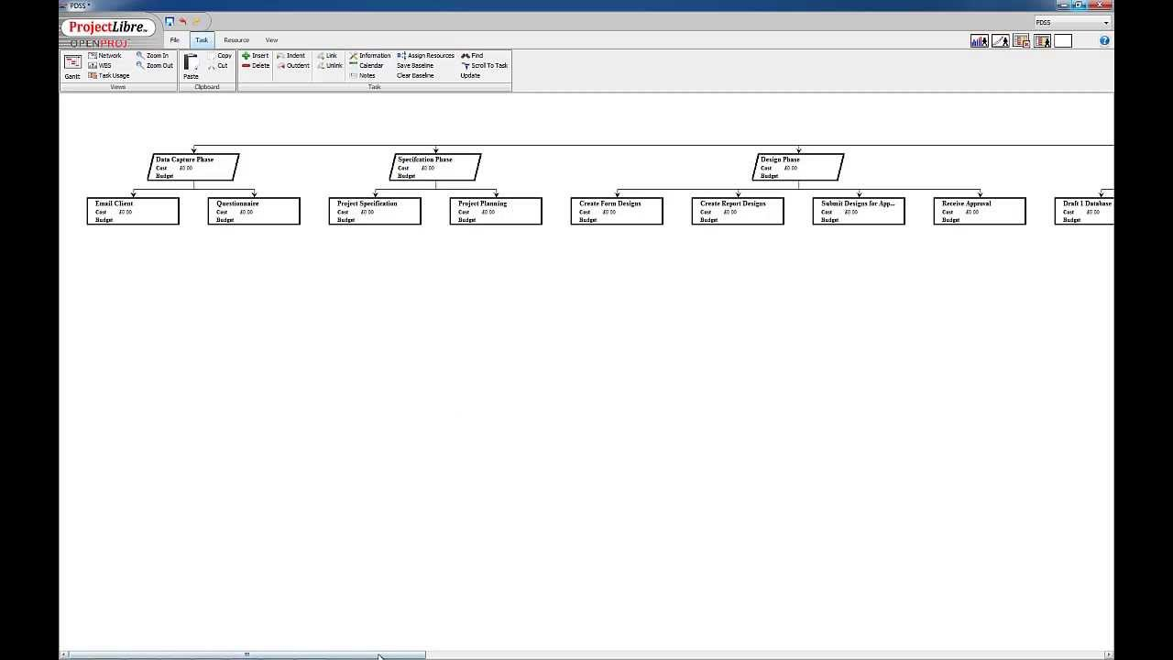
Figure 2.a. Project Work Breakdown Structure.
Project initiation document (PID)
Section 1 – What is the project all about?
Project Title: Opening a barber’s shop. The name is ‘Irene Barbers Shop’.
Foundation
There are a lot of salons for women and gentlemen, yet not for youngsters, on the off chance that you do go over a salon to trim kids' hair, the businesses don't run over expert or patient. Peaceful Kidz cutz will be the first of its sort in Carmarthenshire, in this manner it will be trailblazer. Youngsters disdain having their hair style and can be a difficult errand for all.
Reason
The reason for existing is to bring a kid agreeable condition, to be effective and gain faithfulness and responsibility from customers, and in the long run for the business to extend and turn out to be notable.
Figure 2.b, The design of Irene Barbers Shop
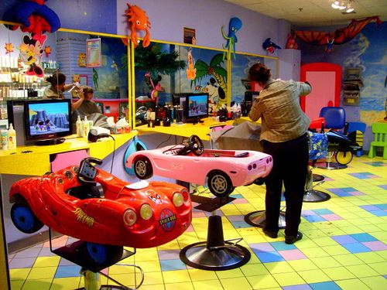
Targets (and how they will be estimated)
•To achieve total consumer loyalty, with moderate and sensible value hair styles.
Will b – this will estimated by asking criticism from customers as a poll.
•To accomplish a glad domain for the representatives to work in.
This will be estimated by month to month audits, balanced with the executives and have the chance
•To be as present day as could be expected under the circumstances.
State-of-the-art preparing and courses to go to at regular intervals to a year.
Venture scope
All businesses will be remembered for the venture.
Avoidance from scope:None
Expectations (counting dates of fulfillment)
• Weekly calls and messages updates to be held between venture chief and the partners that is appropriate to, at each phase of the undertaking.
Requirements and presumptions
•High level undertaking dangers and limitations include:
• Gain a terrible notoriety
• Funding accessibility, or if venture goes overbudget.
• The correct area to open hairdressers.
• Products probably won't get conveyed on schedule.
• The tablets and gear get harmed.
• Project must meet necessities of the venture
Section 2: Why should this project go ahead?
Business case: Project Benefits By re opening a shop as a child's hairdressers, it expects to give the best nature of hair styles and experience for youngsters. Make a sensible benefit. A sitter who will engage all ages is special while having the choice to complete your nails a similar time. Birthday bundles accessible too. Enormous measure of Media and publicizing to be shared and followed.
Choices
- Acquisition of hardware
- Renting of hardware
- Presenting game consoles later on
Cost and Timescale : Expected timescale to be 7 months for the usage at an expected expense of £15000. Cost-See spending plan in Appendix 3
Hazard Analysis: Risk Identification
• Accidents or wounds.
• Loss of clients, terrible climate and client care. Will at that point lead clients to new salons
• Disruption with the executives, could bring about workers leaving which would influence the business.
• Finical misfortune, insufficient clients.
• Marketing misfortune, free supporters.
• Operational hazard, items not being conveyed
Hazard avoidance
• Health and wellbeing preparing and COSHH test each year
• Always guarantee a cheerful situation.
• Rewards and acknowledgment, positive input, the more extended the representatives work for Stress free Kidz cuts more noteworthy the pay.
• consistently Promote hair stylists, have a reinforcement crisis ledger with certain reserve funds.
• Confusing commercials must be maintained a strategic distance from so the situating of the administrations is accuratein the brains of the clients.
• The lead time for the request handling and conveyance of, stock, items and toys refreshmentsmust be appropriately figured out how to guarantee consumer loyalty consistently.
Hazard Management
Guarantee distant observing on clients and representatives and normal security reports on
tablets and gear.
Hazard Monitoring
Distant observing by venture the executives and workers to report dangers when they show up
(see appendix 4)
Section3: Who will work on the project?
Jobs and Responsibilities
• The director to arrange stock, check protections and licenses
• Electricians to ensure everything is sheltered.
• Plumbers to fit all the right funnels, and check everything is working right.
• Carpenters to enrich.
• Baby sitter to engage all the youngsters in the play place with capabilities and DBA check
• Receptionist with capabilities and experience.
• Junior cleaner has the obligation to keep hair stylists tidy and clean up after the hairdressers.
Names of: Project Sponsor
L' Orel Team
Project Manager (PM)
Section 4: How and when will the project be delivered?
Beginning Project Plan
Tasks/Milestones apply for bank credit start venture 16/04/2018
Lease a property 02/05/2018
Reregister the business/protections 16/05/2018
Wellbeing and security/construction\electricians and handymen 10/09/2018
Promote business and staff/meets and recruiting 05/09/2018
Capabilities checked/garbs requested and conveyed 04/10/2018
Opening day 05/11/2020
Calendar (Gantt Chart)
Human Resource Requirements: Project Team
Talented specialists
Material and administrations assets
Hardware.
Budgetary assets.
I.T support
Care Staff- Not required
Extra staff- Not required
Undertaking Control: Monitoring instruments
Checking to occur on week after week telephone call/week after week email update between supervisors also, representatives.
Correspondence channels and timetables
Plan correspondences is the way toward deciding venture partner data needs and characterizing correspondence approach. This piece of the arrangement incorporates the procedure required to guarantee ideal and fitting assortment, appropriation, stockpiling and extreme aura of undertaking data. Following is the correspondence plan table.(see appendix 5)
Quality Control
There is no trade off on quality. It is made to sure that every client gets the best quality from our representatives and the hair stylists. Guaranteeing quality is likewise enrolled part of the expected set of responsibilities of every one of representatives. The administrator and representatives will dispose of any obstacle that will come in the method of conveying quality administrations and guaranteeing the best quality is conveyed.
The adequacy of the undertaking will be appeared in reports from client criticism A Post-execution Review is to be finished a half year after the re-opening of the hairdressers. The figure bellow represents the quality control made for the openning day of the barbershop. It is guaranteed that this is a friendly way to practice haircuts on kids.
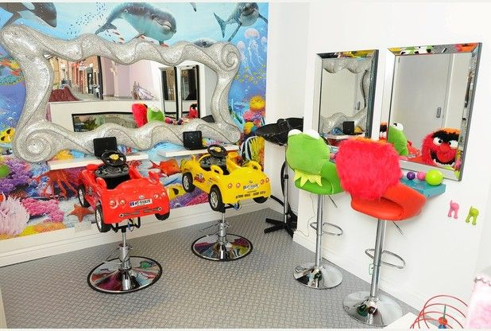
Figure 2.c, Quality control for Irene Barbers Shop
Correspondence
A correspondence plan should be made before the execution stage can be entered. This shows how partners in the task will be educated regarding the advancement in the undertaking. Partner are; the hairdressers partners incorporate undertaking director, stylists, junior cleaner, sitter, assistant, clients, L'Oréal the provider, I.T worker, nail professional, promoting representative and bookkeeper. This piece of the arrangement incorporates the procedures required to guarantee convenient and fitting assortment, conveyance, stockpiling, recovery and extreme manner of managing data. In the Journal of Change Management (2004) Goodman and Tuss underscore that representatives need correspondence during seasons of progress, by keeping them educated will lessen vulnerability. Following the correspondence plan table, this methodology will be utilized in the task. (Appendix 5)
Change the executives
All change solicitations will be recorded, submitted to, and passed by the managingadministrator and group pioneers for effect and undertaking need preceding task the executives endorsement. On the off chance that the change is affirmed the venture timetable, extension, and spending will be refreshed in like manner and imparted to proper partners as per the interchanges plan. The venture the board and group will impart the endorsed change and refreshed timetable to the staff answerable for executing the change.
Execution stage
This is the place the task execution is done, while obtaining assets and overseeing partners. Controlling/observing occurs in this stage.The quality is checked just as a degree creep, and cost/time distributions are watched to keep things in the spending plan. By following the undertaking plan from the arranging stage, this will permit the project administrator to contrast the advancement with the project achievements and Gantt Chart/Pert to guarantee that errands are being finished in opportune way and quality norms. The utilization of a Pert graph is exceptionally abstract and subject to the executives experience. Week after week calls and messages updates to be held between venture chief and the partners, at each phase of the task. This will permit the Project Manager to air any worries and address issues without setting aside some effort to genuinely meet, when execution stage is finished, a stage audit will happen to guarantee that the task has met every arranged target before entering the conclusion stage.
Shutting stage
This stage is the place the venture is concluded and where the deliverable help is given to the clients and the partners are recounted the fruition of the undertaking. Sage diary states "Fruitful undertaking culmination is dependent upon individuals cooperating successfully as a venture group." (Kloppenburg, T., 1999). In any case, if the group is useless practices win, plans slip, costs overwhelm, yield quality decreases and in outrageous cases the venture will fizzle. To pick up input, the undertaking supervisor will lead a post usage survey to gage the viability of the venture from partners and all the targets set have been met. The survey will happen 3 months from the initial day of Irene Barbers Shop this is sufficient time for useful input on the hairdressers. To accumulate the input a multi decision study will be conveyed to clients and workers, if any protests the clients will get an opportunity to communicate these. All input will assist the business with making changes to turn into the best proficient hairdressers with consumer loyalty as a principle need.
3. Critically Evaluation of My Managing Project Ability
In this project I assumed the role as a project manager, this was a new experience to me. This role added to the bits of knowledge and thoughts on the most proficient method to re-open the hair stylists and how it would profit the hole in the market, to develop inside what's to come. I chose to utilize the Smaller Projects strategy (SP). This is composed by Mike Watson (2002), it is a down to earth manual for fusing standards of task the executives to littler ventures straightforward and simple. Watson asserts that his strategy is straightforward and use and anybody absent a lot of task the executives experience can profit by this experience. All my insight and outlines originated from following this book. Watson states "Numerous strategies and procedures utilized in customary undertaking the executives look like heavy hammers when coordinated at littler ventures, so this framework can be utilized effectively to make a method of controlling littler activities in any condition." (Watson, M., 2002).
A large number of articles allude Watson as an 'administration master'. The Journal of the executives study contends this, "Watson characterizes administrators as passing progressions of thoughts is one way that he depends onan scholastic collaboration of information". (Clark, T., 2002). Different articles state, "Watson demonstrates ideal for the framework approach which with its painstakingly made establishments, appears to offer significantly more to chiefs". (Jackson, M., 1995).
The PRINCE2 technique is by all accounts the most well known methodology. When dealing with a task again relying upon what the venture was nevertheless I would utilize this strategy as it's an extremely useful asset to help venture administrators in arranging and dealing with an undertaking. Harris states "PRINCE2 is likely the most broadly utilized undertaking booking instrument being used today." (Harris. P., 2008). This is on the grounds that it is itemized and unmistakably distinguishes territories of shortcoming and consistently proposes an approach to work around any issues that happen. (Hughes. L. D., 2017). My venture the board style was supported by Harold Kerzner key making arrangements for venture the board development model. This was a valuable model to assist me with arranging this undertaking.
My strenghts all through this task was the utilization of the Gantt outline and the Pert graph. The utilization of the Gantt Chart guaranteed that the task kept to plan which implies the undertaking was a ton simpler to oversee. The Gantt could have been separated into littler classes to ease factors and have a more definite arrangement. The Pert outline upheld up the Gantt graph with the basic way. The Journal of Multidisciplinary recommended, "The basic way is the way of exercises, which speaks to the longest all out time required to finish the task." (Naveenchandra, N., 2017).
A deferral in any movement in the basic way causes a postponement in the finishing of the undertaking. In any case, this was a decent method of detecting an issue; "It is a splendid procedure to decide how much time a task needs before its finished, a distinctive component of Pert is its capacity to manage vulnerability in movement fruition time." (Cay, Et.al, 2004).
In spite of the fact that the venture was a triumph it featured a few shortcomings, the utilization of the spending plan was one as I followed the technique for SP. It prescribed to utilize a spending plan, this prompted a couple of confusions. A spending plan is an announcement of the measure of cash accessible to spend over a period." Budget plan incorporates a delineated arrangement for how the cash will be spent, with a breakdown of things, it will be spent on. It would have been more successful by utilizing a money saving advantage investigation". (Wen, W. and Wong, K.W., 2005).
The money saving advantage examination would have been more viable as it's a straight foreword device to utilize. When utilizing the money saving advantage apparatus, it incorporates the expense to present the venture, perform it and bolster the progressions coming about because of it. Money saving advantage advances through the term of the venture, creating in detail and exactness. This would have been more appropriate.
Inside this venture, coast was not thought of, fortunately everything went to design with no genuine hiccups. This is down to a littler undertaking, anyway in light of the elements and vulnerabilities that emerge inside the activities the normal deferrals do happen, and unfavorably influence the arranged timetable.
Contactors regularly need to change the assets, or the term of exercises or start dates, this would be conceivable if the buoy was thought of. As indicated by the Journal of development "Postponements to exercises that are not on basic ways may not influence the last culmination date of the venture, anyway impromptu utilization of buoy diminishes the capacity to retain plan changes and can bring about additional expense." (Kim, K., and Garza, J., 2013). "Debates can be kept away from by utilizing a technique to quantify the expense of buoy utilization dispassionately to distribute the buoy on a sensible premise." (Abingdon, M., 2013.)
Input Input is a significant key inside undertaking the board. To hear a fair point of view to survey my capacity to extend mange, I will make a secret poll sent to the undertaking group through email. "It emerges from a wide range of headings and measurements, for an effect on be made these issues should be recognized and handled together to improve." (Brod, D., 2013).
Here are a few inquiries I will ask:
Did you feel that the task was effective in general? Did you feel the venture chief tuned in to you? Was the undertaking supervisor agreeable? Did you feel bolstered all through byproject administrator? Some other extra input you'd prefer to include?
For future activities I would consider utilizing Bruce Tuckman's Model of 'Phases of Group Development' to draw in the entire group all the while.
The fifth phase of this model is named the 'suspending stage', which takes a gander at the group from a prosperity perspective and may propose changes in approach in future ventures.
Self-improvement plan:
Advancement objectives. Information/abilities. Activities to create. Cutoff time. Backing. Present moment. Think about all results. Picked up information and experience Knowledge/research skills.More research addresses venture troughs Ongoing. Preparing, courses, gatherings with managers,Gained experience through dealing with a littler undertaking Management, correspondence, information. Next task bigger venture,Work on 2 out of year and a half Meetings, perceptions, take notes. Long haul. Relational abilities and certainty Listening, receptive, the executives. Work close by venture chief, instructing and shadowing venture administrators. Progressing. Criticism, listening taking notes, support from venture directors et a genuine model/show others how its done Delegate, tuning in, quiet, positive, Feedback from colleagues,Ongoing,Attending courses.
Figure 3.a. The importange of a PM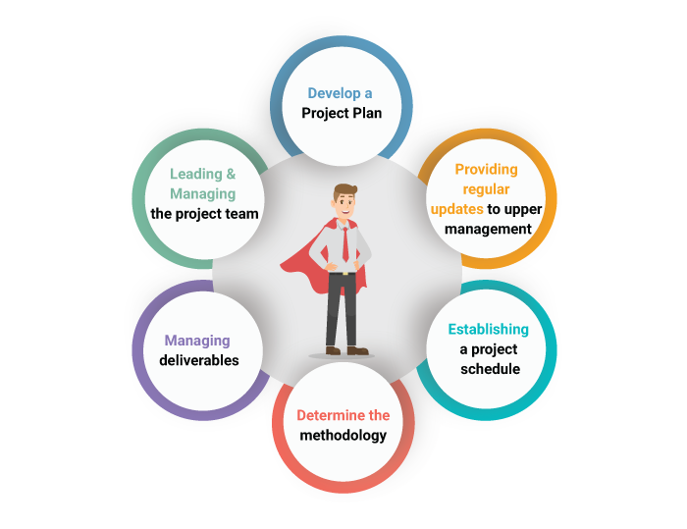
Conclusion
This report canvassed everything really taking shape of a task. The SP strategy was the guide all through. Dealing with the change procedure all through an undertaking life cycle is mind boggling and ought to be comprehended, made arrangements for, embedded and estimated by the task administrator. The object was to build up an evaluation device to gauge to change elements over the 4 phases. The negatives have been perceived and can gain from them, anyway the positives were found as well. Later on greater complex activities will be accomplished.

4.References
Books
- Boad. D (2013) Feedback in higher profession education. 2 Pork Square, Milton Park, Abington, Oxon, OX14 4RN. Pp 8-10
- Karlos. A (1999) Project management. Helsinki University of technology, Finland, PO box 9500 02015 pp. 4-10.
- Kerzner.H (2017) project management a system approach to planning, scheduling and controlling, twelfth edition. JohnWiley & sons, 111 River Street, Hoboken, NJ07030 pp. 63- 160.
- McGrath. J & Bates.B (2017). The little book of big management theories. Edinburgh Gate,Harlow CM20 2JE pp. 58-117.
- Mike.W (2002) Managing smaller projects. Multi-Media publications Inc, Lakefield, Ontario, Canada, K0L 2H0 pp. 1- 119.
- Milton. R (2005) Successful Project management- A step by step approach with practical examples. 222 Rosewood Drive, Danvers, MA 01923 pp. 18-24.
- Journals Abington. M (2013) Cost impact of float loss on project with adjustable activity deration. Journal of the operational. Vol 64 issue 8 pp 1147-1156
- Asoravala. A (2006) Defending the Gantt chart.) Software development: San Francisco. Vol 47 issue 7 pp. 14- 21.
- Boer, F (2000) Valuation of technology using real option. Research Technology Management Vol.43 issue 4, pp. 26-30.
- Fan et al (2005) Choosing in a project risk handling strategy an analytical model. International Journal of production economics. Vol 112 issue 2 pp. 700-713.
- Gray. A (2000) Using cost effectiveness information. British medical Journal Vol 320 issue 7229 pp. 246-249
- Kempfer.L (1994) Systems are required to manage, schedule and monitor tasks resources and costs. Computer-Aided engineering CAE, Cleveland. Vol 13 issue 4 pp 18
- Kim.K & Garza. J (2013). Phantom Float. Journal of construction engineering and management Vol 1129 issue 5 pp 507-510
- Maylor. H (2001). Beyond the Gantt chart project manager moving on. European management journal. Vol 19 issue 1 pp. 92-102.
- Naveenchandra. N (2017) Triple A research critical path analysis. Journal of multiciliary. Vol. 1 issue 1 pp 37-64
- Raz. T (2001). Use and benefits of tools for project risk management. International Journal. Vol 19 issue 1 pp9-17.
- Suto. T (2013). Optimum budget allocation methods for projects with critical risks. International Journal of project management. Vol 31 issue 1 pp. 126-135.
- Tuckman. B (1977) Stages of small group development revisited. Sage journal. Vol 2 issue 4 pp 19-77.
- Wen. W & Wong. K. W (2005) A knowledge based intelligent decision support system for natural defence budgeting. Science direct. Vol 28 issue 1 pp 55-5



