NAME: EDUARDO POLANCO ADOKA
ID: 2132108
MODULE: INTERNATIONAL MEETINGS MANAGEMENT FOR THE HOTEL INDUSTRY
MODULE CODE: BMIH6007
LECTURE: KATHRYN FLYNN
TITLE: EVENT FOR THE CROESO 2025

Speaker Notes
Slide 1
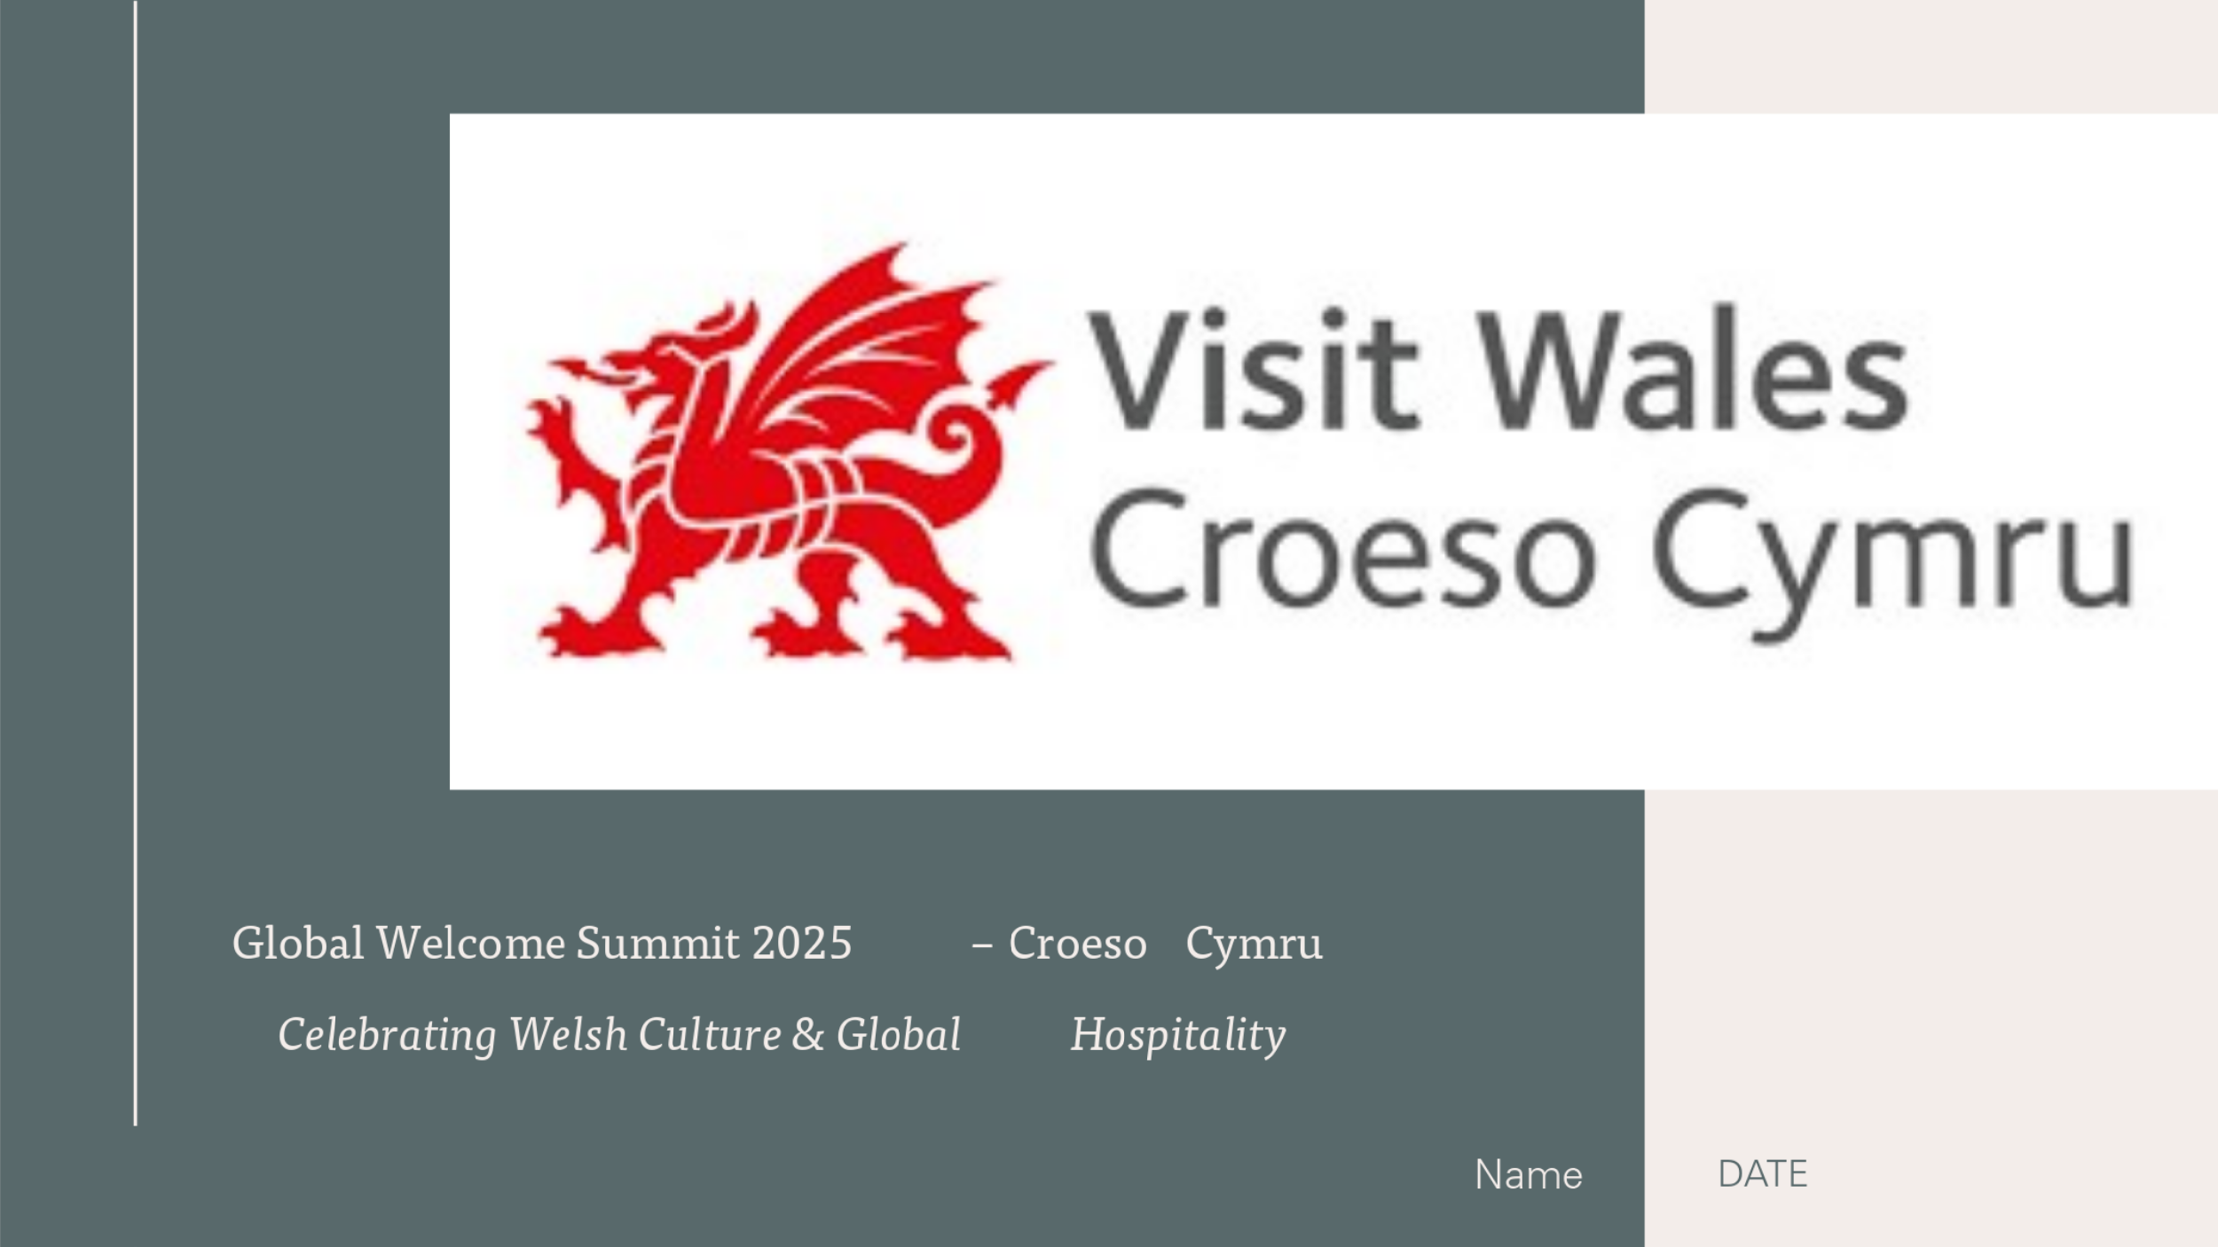
Slide 2
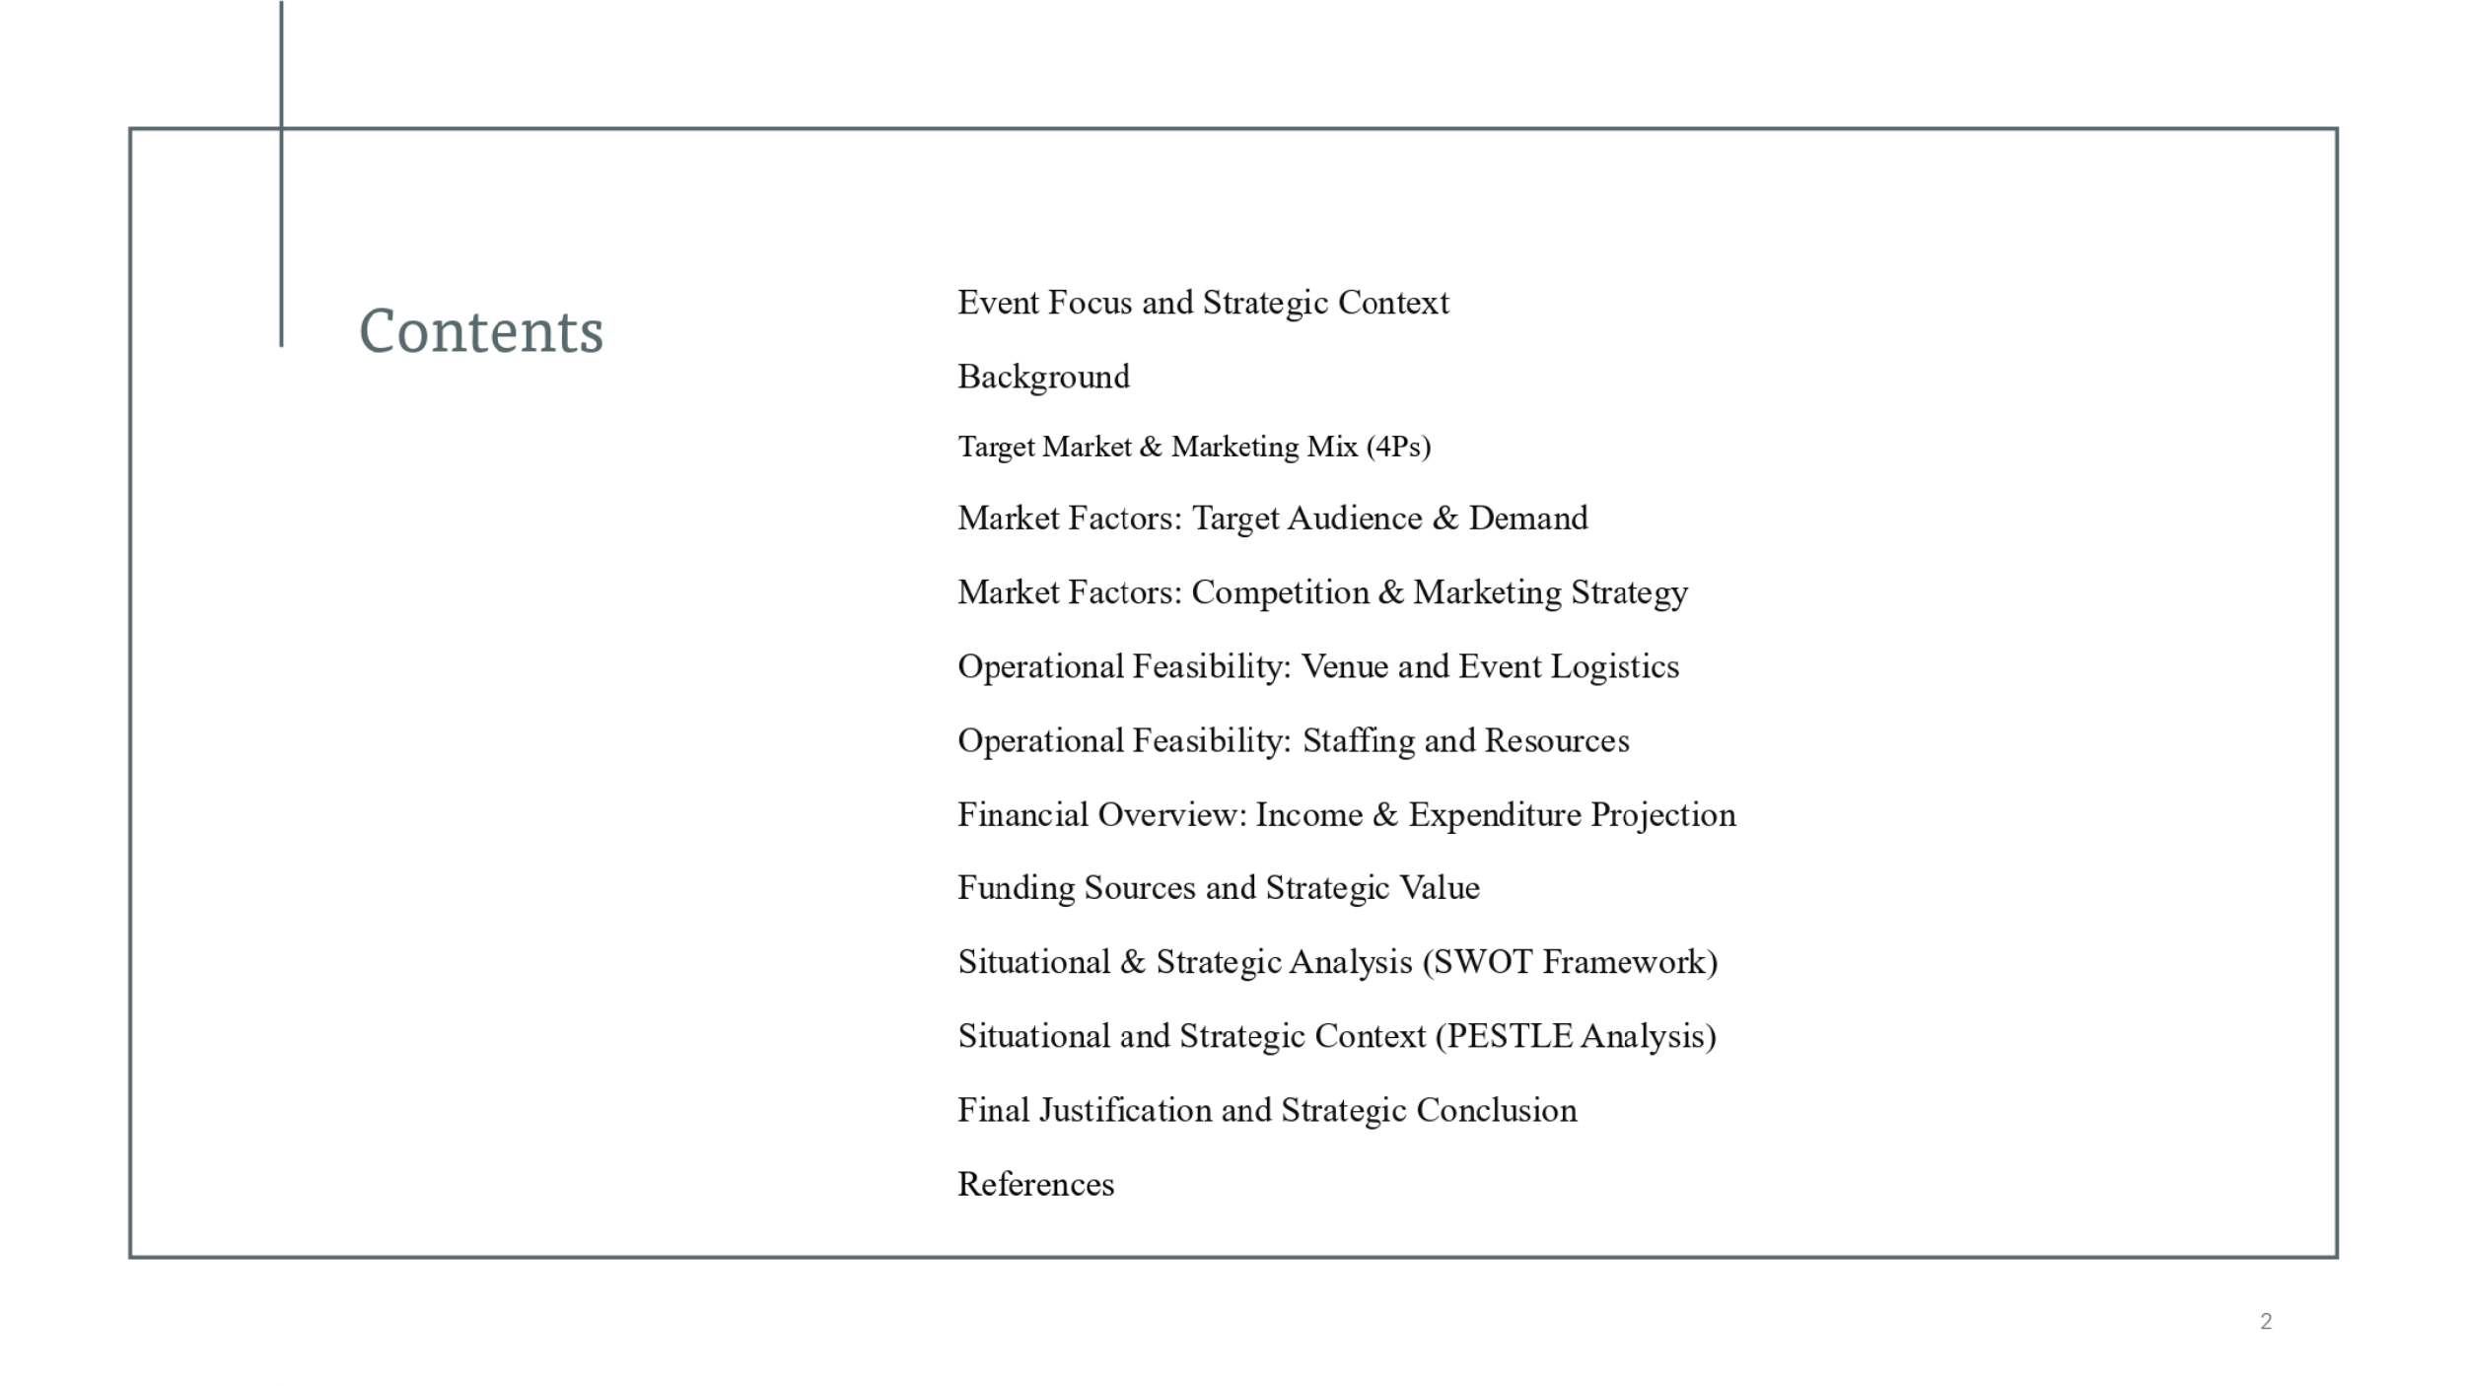
Slide 3
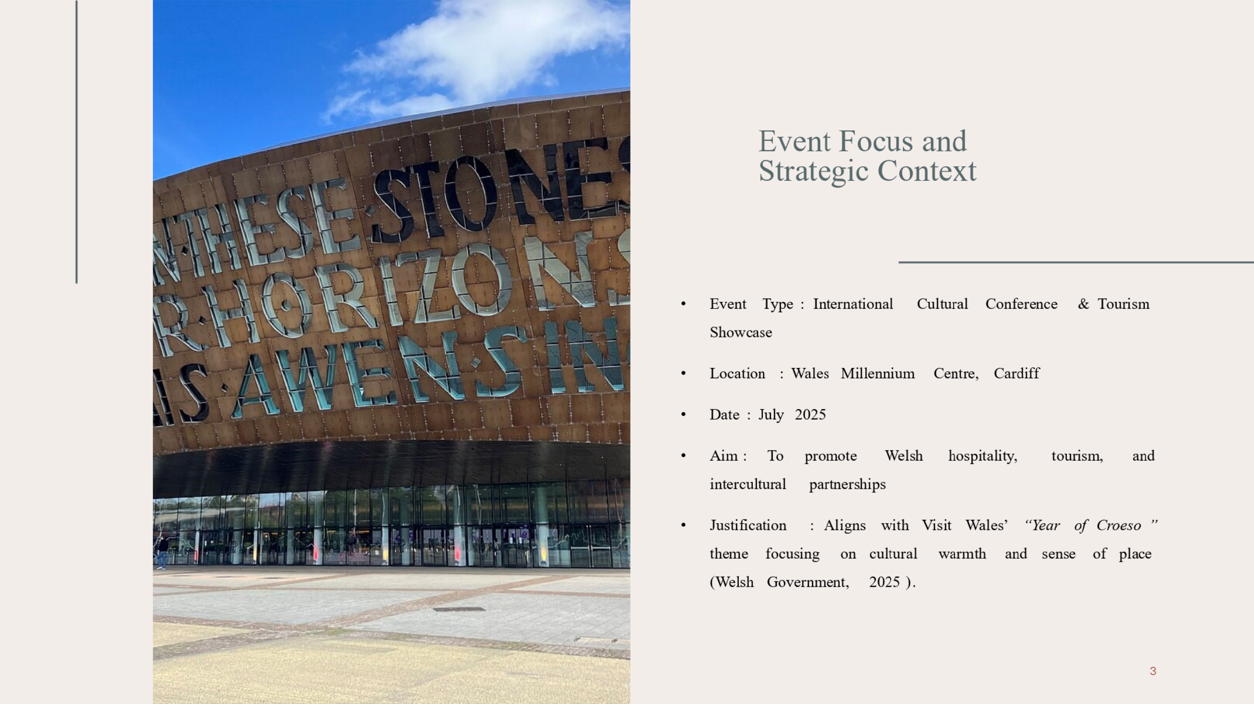
Global Welcome Summit is a unique MICE event with incorporated cultural exhibitions, hospitality forums, as well as tourism showcases. The venue of the event will be iconic Wales Millennium Centre in Cardiff; it will happen in July 2025. It will facilitate Welsh identity to the international delegates at the same time promote global tourism and business collaborations. This complements the “Year of Croeso” strategy of Visit Wales that characterizes warmth, welcome, and rich culture of Wales.
Slide 4
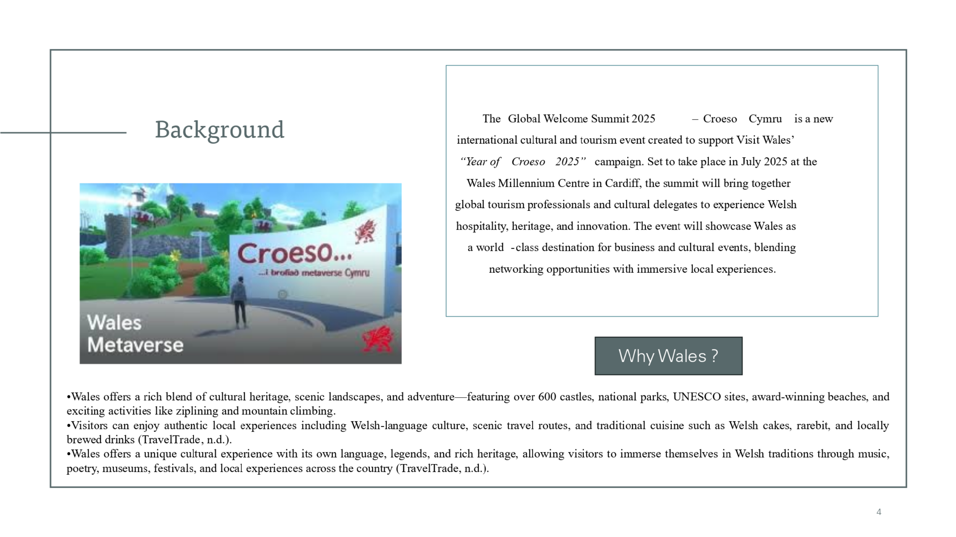
The Global Welcome Summit 2025 – Croeso Cymru is a novel, innovative event for assisting Visit Wales’ “Year of Croeso” campaign. It will be hosted at the Wales Millennium Centre in Cardiff between July 2025 and aims at uniting the global tourism experts, the leaders of culture, and the hospitality investors. The event joins cultural celebration and business opportunity to establish a medium for introducing Welsh identity, hospitality, and innovation at the international stage. It’s not only aimed at attracting visitors, but at putting Wales on the world map of MICE destinations, combining immersive experience with a professional networking environment (Visit Wales, 2024).
Slide 5
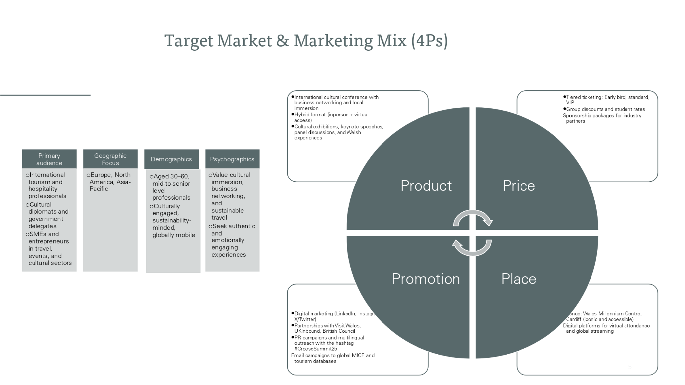
“On this slide, we examine the event’s target market and its marketing mix strategy using the 4Ps framework.
Our primary target audience consists of international professionals from the tourism and hospitality sectors, cultural delegates, and small business owners looking to expand their global networks. We’ve identified specific regions such as Europe, North America, and Asia-Pacific as high-potential zones, due to strong outbound tourism and interest in cultural exchanges.
Demographically, we’re targeting professionals aged 30 to 60 who are well-established in their fields and interested in sustainable, immersive travel. Psychographically, this audience values unique cultural experiences and is likely to share their engagement via professional and social networks.
Moving into the 4Ps:
- Product: The summit offers a hybrid model, combining a cultural conference with networking and local immersion, making it both informative and emotionally resonant.
- Price: We've introduced flexible pricing strategies to make the event accessible while also offering premium experiences for high-level delegates.
- Place: The Wales Millennium Centre provides world-class infrastructure and a central location, while digital platforms extend our global reach.
- Promotion: Our strategy includes partnerships with trusted institutions, targeted social media campaigns, and the use of a memorable, brand-aligned hashtag: #CroesoSummit25. We’re also engaging in email marketing and international PR to ensure maximum visibility.
This integrated approach ensures that the event is not only well-attended but also strategically positioned to build long-term value for Wales as a cultural and MICE destination.”
Slide 6
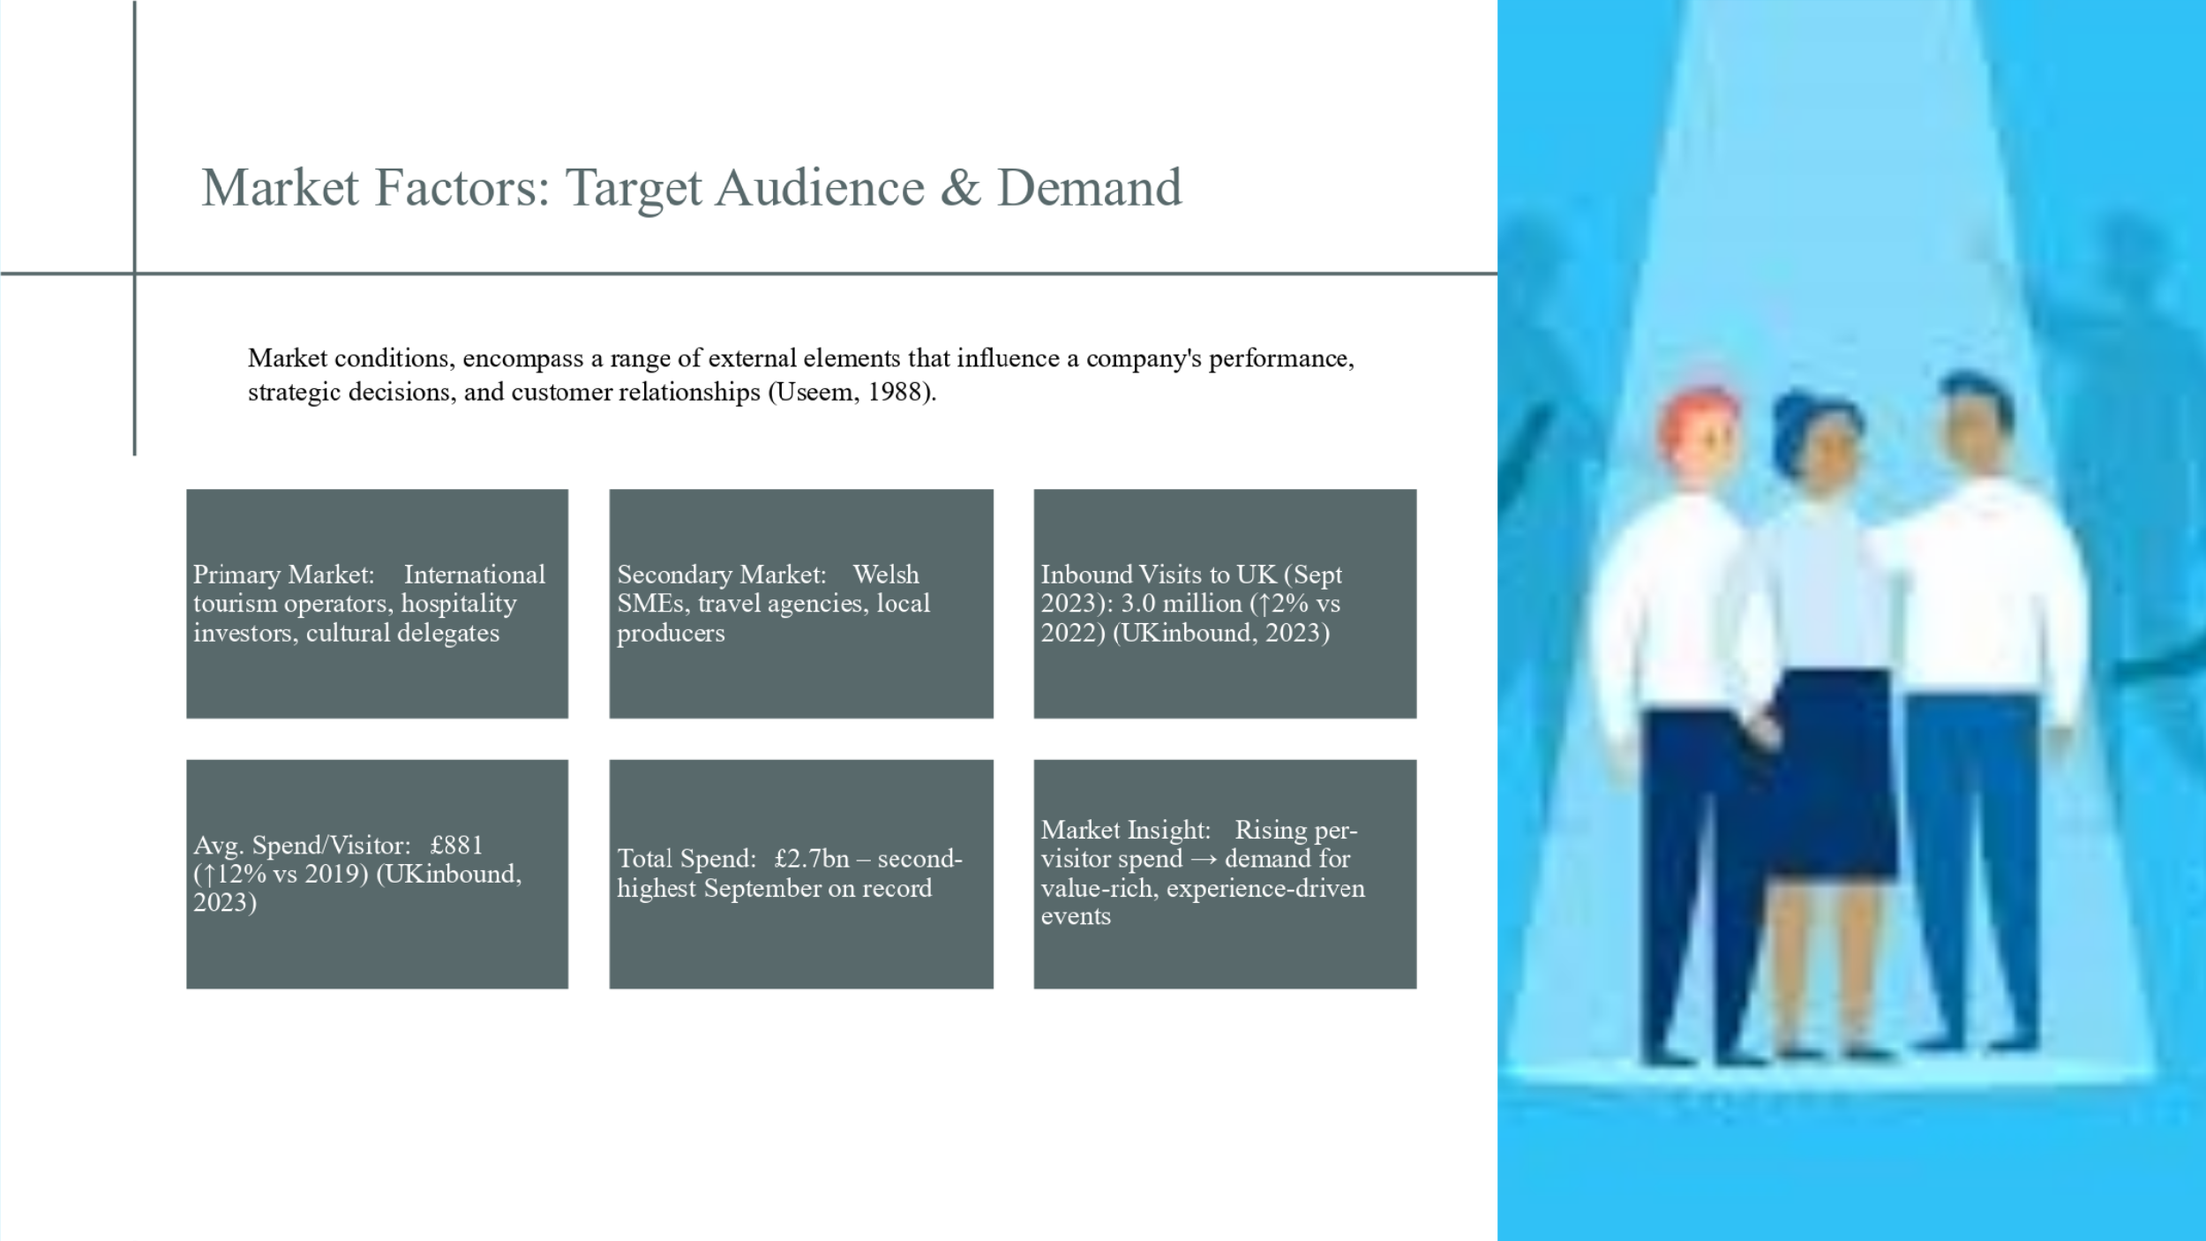
For our event, the detection of a viable market would need to be of utmost significance in achieving feasibility. The primary market consists of visiting international delegates these are, professionals in the field of tourism, event planners and cultural institutions mostly from Europe, North America and Asia. These people are looking for genuine and experience-based places for cooperation and future business.
VisitBritain (2023) indicates that a total of 3.0 million inbound visits were made in September 2023, compared to 2022 – a 2% increase. Although small, that’s a stabilising post-COVID recovery trend. It is more important that the average spend per visitor increased to £881 which is 12% more than the 2019 level. It ties in with a “fewer visitors, higher value” tourism trend – perfect for premium cultural venues such as the Global Welcome Summit.
This further pushes the notion that the modern international crowds are happy to pay more for carefully curated and culturally in-depth entertainment experiences. Our event that combines tourism, hospitality, and the cultural diplomacy reaches the very heart of this demand.
In addition, the network markets and market exposure benefit the secondary market-Welsh businesses and tourism agencies. This double-targeting strengthens the economical effect of the event and justifies it as viable in the sphere of the MICE.
Slide 7
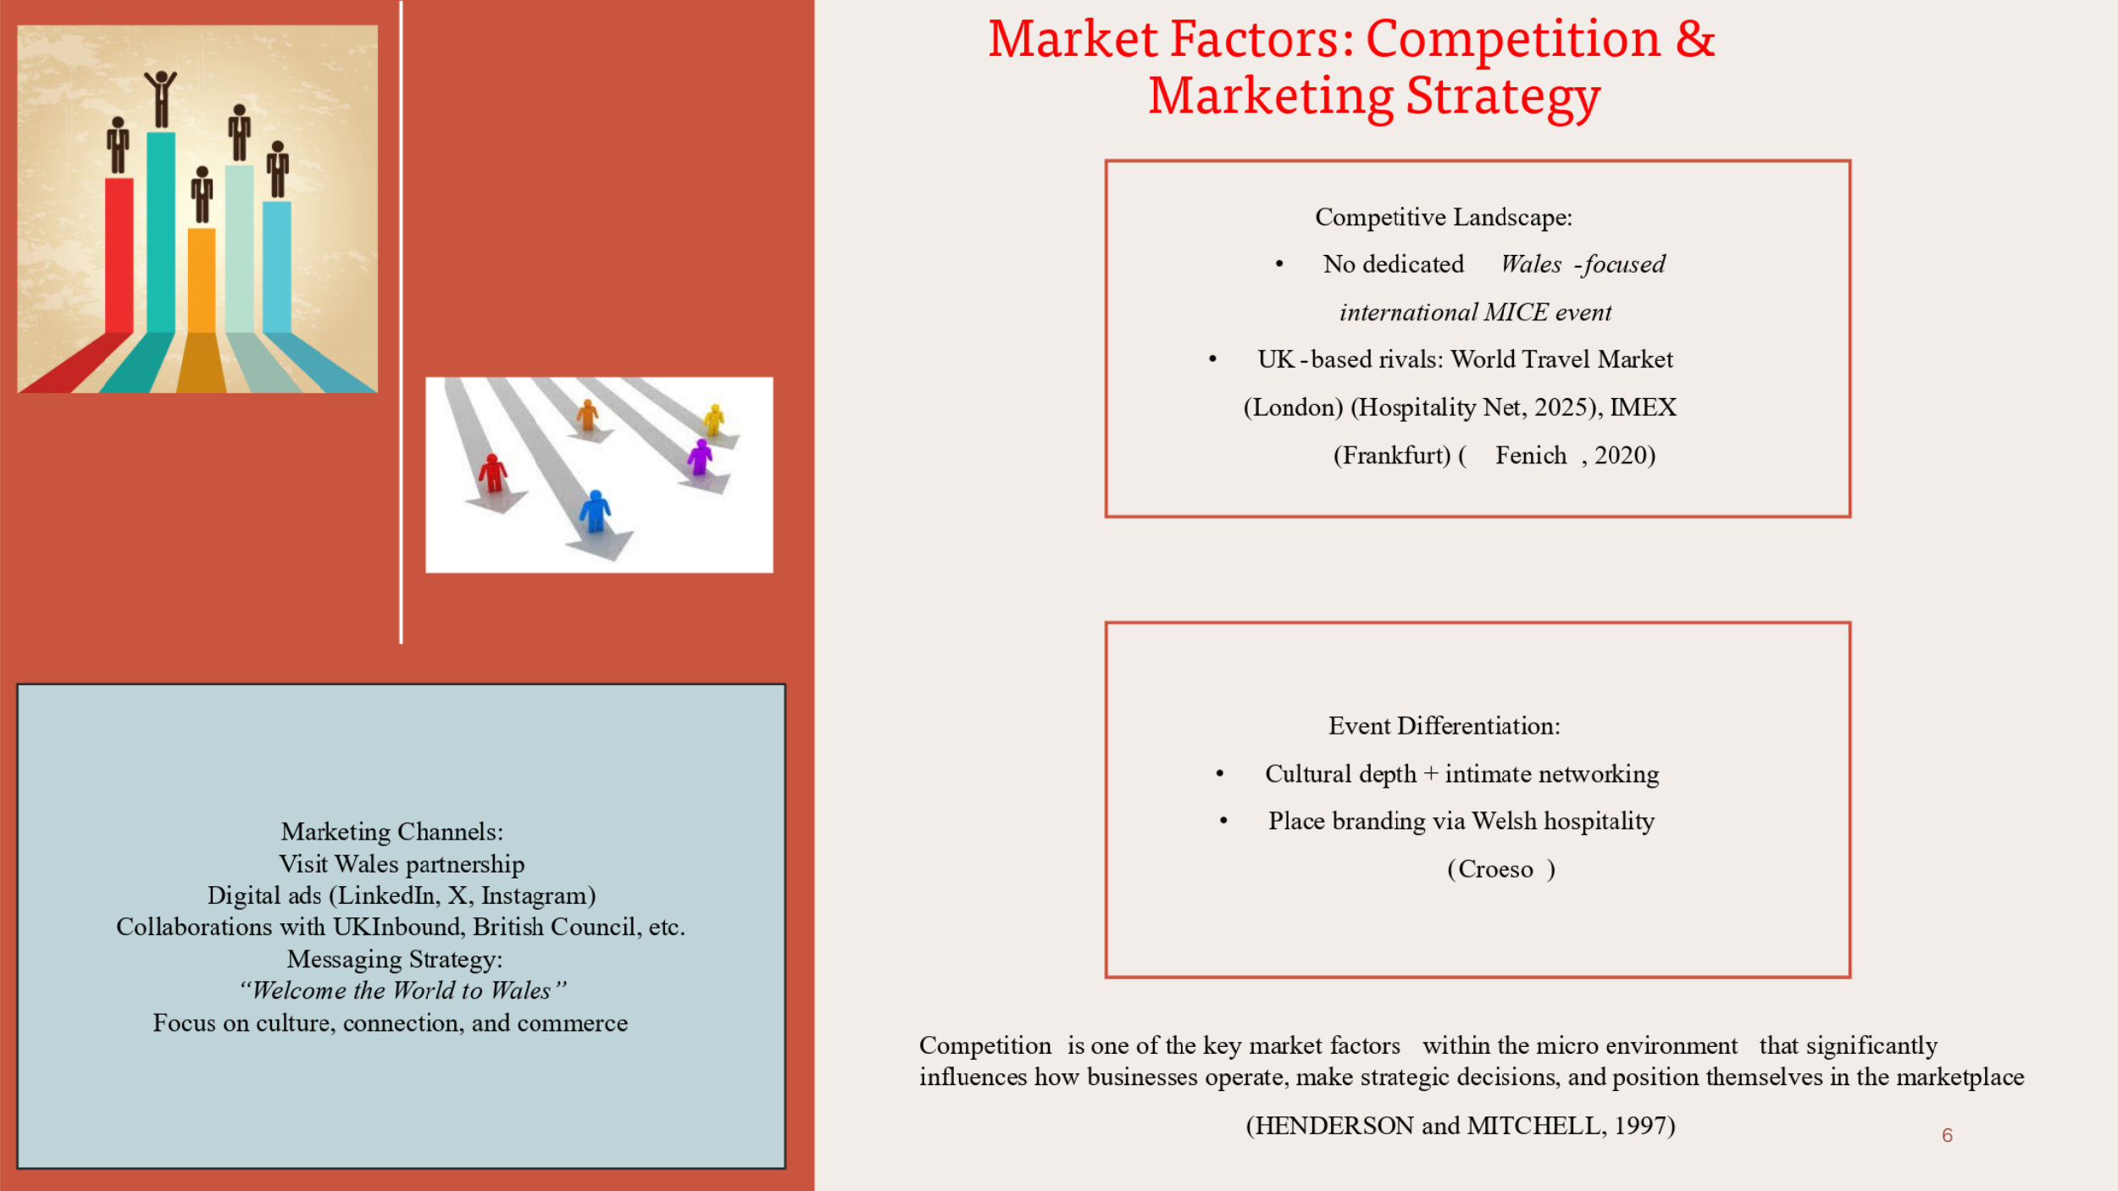
In terms of strategic feasibility, the competition analysis and the definition of the marketing approach that would characterise our event are important. There are such global MICE events such as World Travel Market in London; IMEX in Frankfurt that saturate the global tourism and events industry. However, none of the mentioned are Wales-specific, nor could any of them integrate cultural identity to business meetings the way our event does.
Our competitive advantage resides in Place Branding – providing a ‘distinctly Welsh’ sense of welcome, or “Croeso” in cahoots with professional networking and cultural experience. This combines the experiential and commercial aspects of tourism – this is an offer which is not present in UK event calendar.
The marketing strategy will be focused on the digital-first tactics. Paid ads and focused campaigns on LinkedIn and on Instagram will target the global B2B and cultural audiences. We are also going to use co-branding with the Visit Wales, UKInbound, and the British Council to build trust and relevancy with international markets.
Our messaging (“Welcome the World to Wales “,) casts the summit as a meeting of culture, connection and commerce. This unique selling proposition (USP) consolidates the relevance of the event in a competitive market environment.
Slide 8
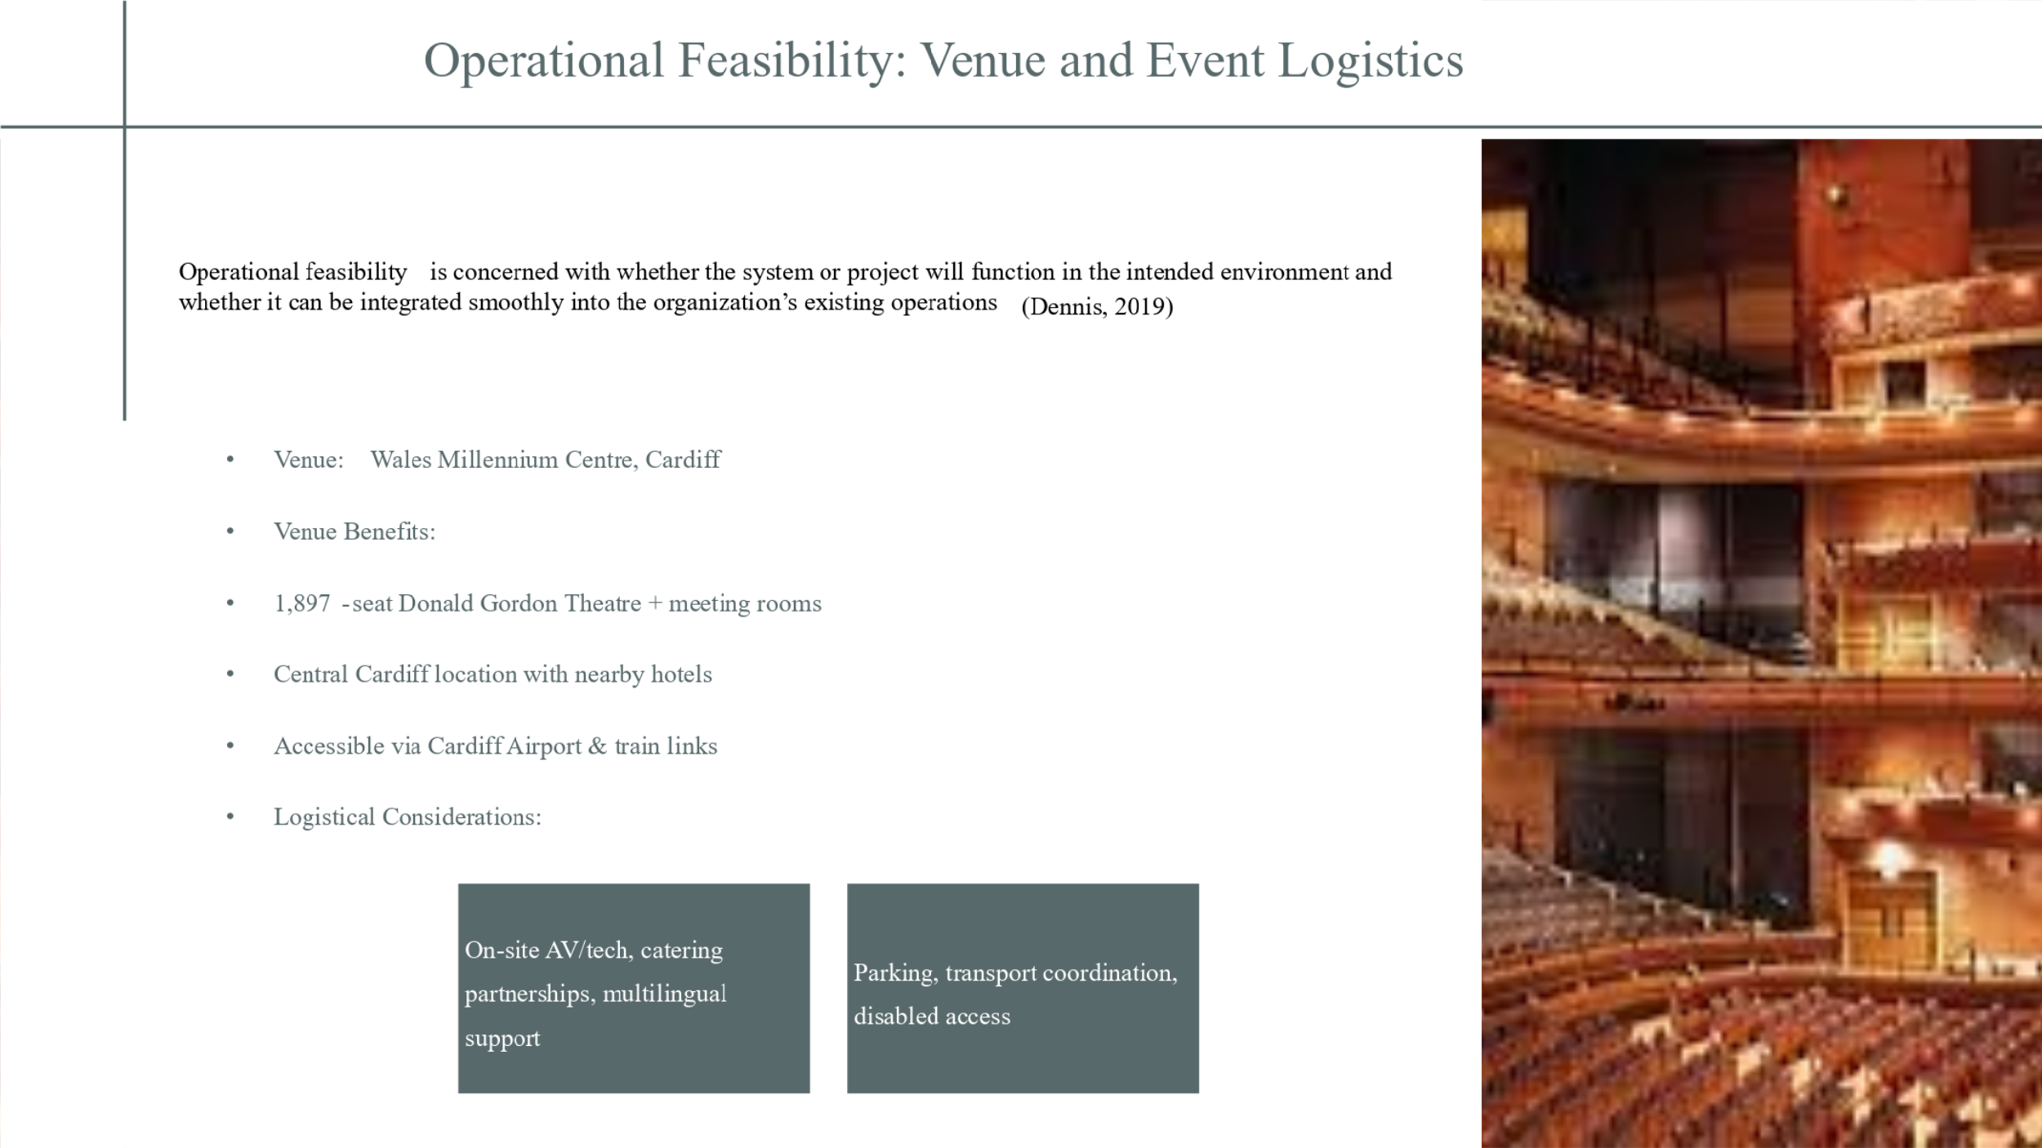
Operational feasibility requires the choice of an appropriate venue. The Wales Millennium Centre in Cardiff is a state-of-the-art cultural centre that incorporates modern technical equipment, several breakout rooms, and high capacity. Its location near Cardiff Central Station and international access through Cardiff Airport guarantees ease of access for the international delegates.
The venue is already providing a home for cultural and business events and its facilities such as integrated AV systems, a high-end catering solution, and accessibility support eliminate the need for external infrastructure. What is important, it supports multilingual hosting, which is a necessity for the international audience.
The complementary hospitality network including the high-end hotels down to the boutique stays accommodates overnight lodgings for all the budgets. Liaison with local transport and taxi services will guarantee hassle free movements and accessibility standards will be achieved to make it inclusive, as expected by visit Wales and equality act 2010.
Slide 9
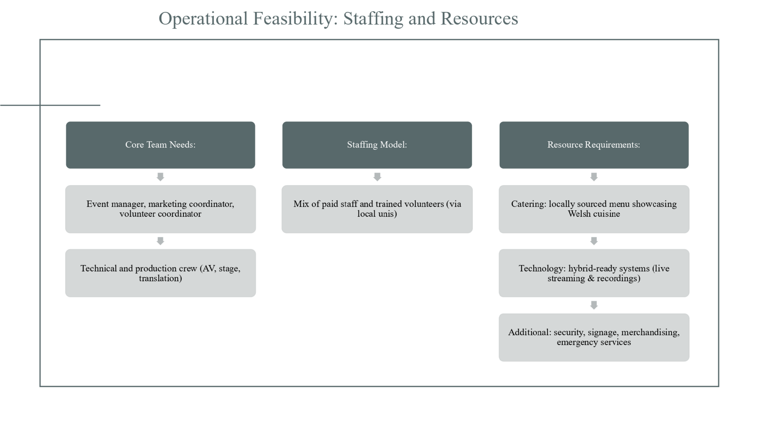
Human and technical resource is a key constant of event feasibility. For this summit, we require a lean team of experienced hands and which will be headed by an experienced event manager, and working directly with him, a marketing and volunteer coordinator. Technical workforce will manage lighting, translation services, as well as a live-streaming to facilitate hybrid attendances.
A hybrid staffing model will use professionals who are paid for their services and student volunteers who are armed with the right tourism and event management skills – working in partnership with establishments like Cardiff Metropolitan University for sourcing tourism and event management interns. This is cost-effective as it develops local engagement.
We intend to promote Welsh gastronomy, cooperating with the native caterers to provide sustainable culturally authentic food. I will outsource technological needs (stage design and digital streaming) to trusted vendors. More provisions such as security, accessibility signage, and emergency services will guarantee quality as well as safety.
Slide 10
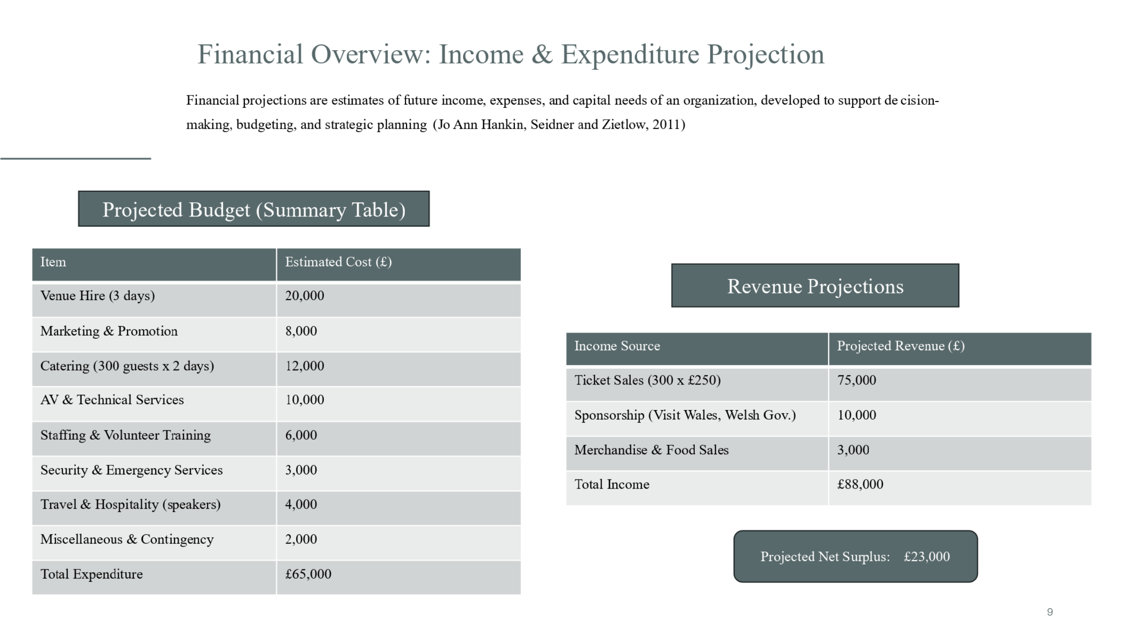
Financial projection is pivotal in the feasibility analysis and has to be elaborate. As shown, the approximate expense of organizing the Global Welcome Summit is about 65000 pounds which includes hire of venue, marketing, catering services, staff, and contingency.
We have opted for a conservative and realistic ticket pricing strategy with 300 delegates buying tickets at £250, meaning that we would receive £75,000 in terms of ticket revenues. This is the price range, a good indication of the high value of the event though affordable to international business and cultural delegates. Supplementary revenue comes from government partnerships-most notably, Visit Wales and Welsh Government cultural funding and other smaller revenue through merchandise and food sales. Costing £88,000 for revenue we estimate a £23,000 surplus which will make us profitable and sustainable with reference to public sector value for money rules.
Slide 11
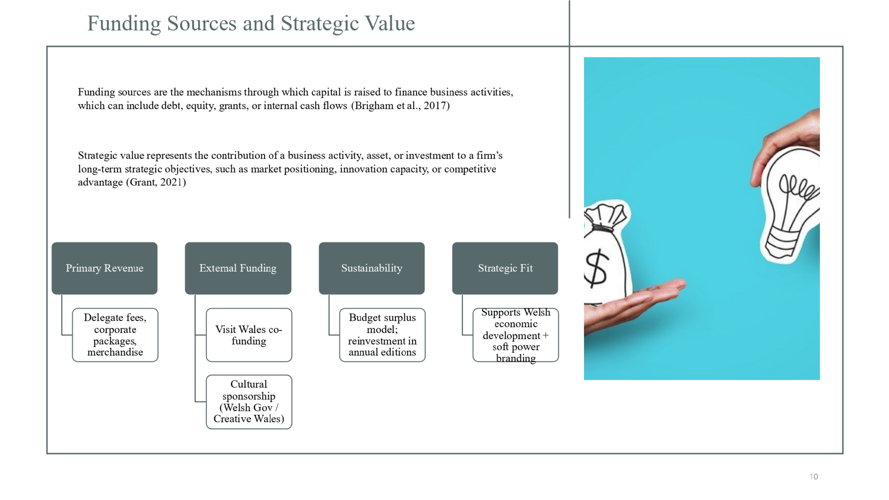
In order to be financially viable; the event, has diverse funding pattern. Most of the income is derived from delegate fees and includes; standard, early-bird and premium networking passes payments. This is supplemented with public sponsorships from Visit Wales and Creative Wales, which are in accordance with “Year of Croeso” promotion aims.
This two-flow source facilitates budget surplus, financial stability and ability to capitalize on future editions – promising to make it an annual or biennial international event.
Strategically, the event promotes the Welsh tourism, cultural diplomacy and economic growth. By flying in global delegates to Wales, we enhance off-season visitation, enhance brand awareness, and position Wales as a leading MICE destination.
Slide 12
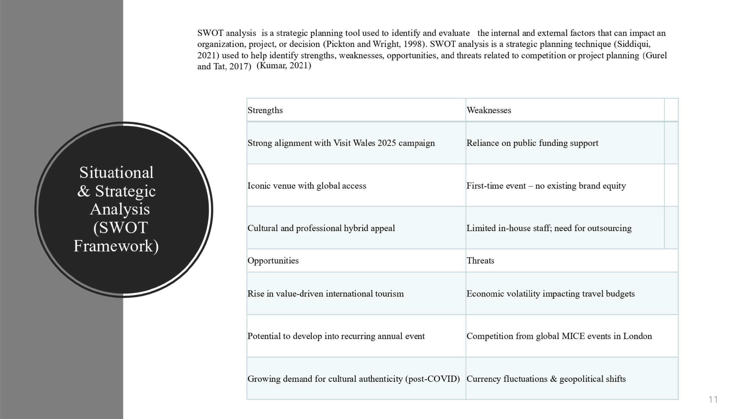
By using SWOT analysis it will be possible to determine internal and external factors that can affect the viability of our event. Let’s begin with strengths: the annual theme of the event is simply perfect for such campaigns since they gain policy-based and cultural status. The Wales Millennium Centre, a centre of international fame, embellishes our brand perception. Also, the event combines networking, that is, business with cultural immersion, making use of post-pandemic trends of value-driven travel.
Weaknesses are that it is a first event in time and, hence, will suffer from limited recognition of existing brands, as well as risk of heightened marketing. We are also dependent upon the external sponsorships and public grants that are subjective and unreliable.
Finally, threats: The foreign event organizer companies in London or Edinburgh exert competitive pressure. Other macroeconomic issues such as inflation or shift in the currency may also have an impact on the international delegate attendance. These threats focus on the need for contingency planning and flexible pricing determinants.
Slide 13
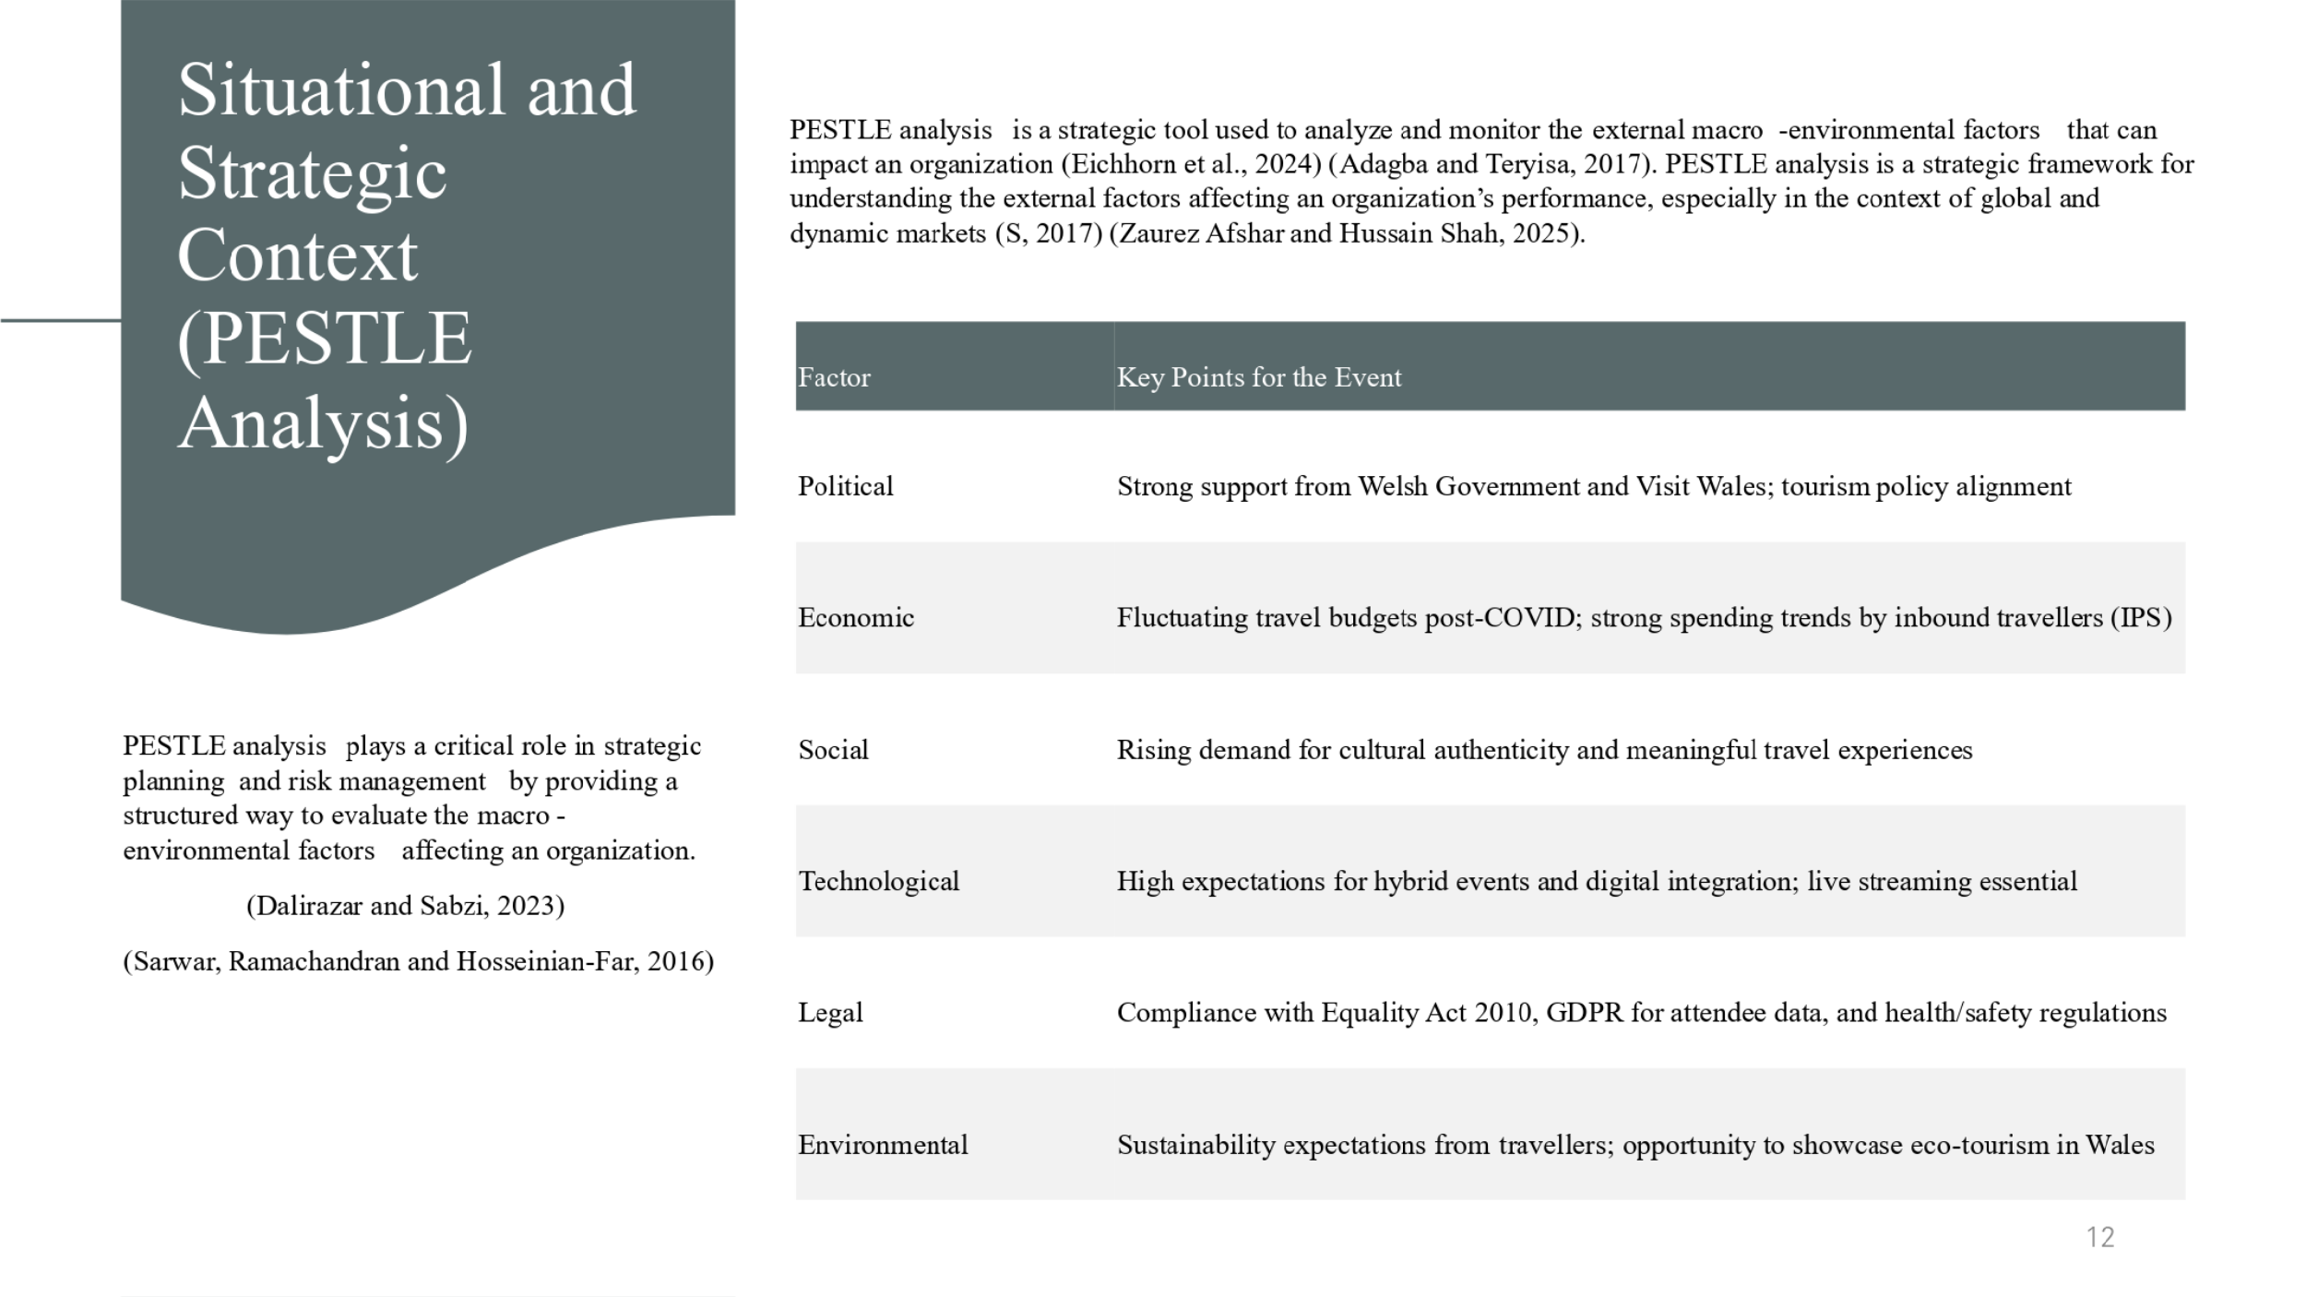
A PESTLE analysis is an important tool to evaluate the external macro-environmental factors of feasibility of our event. We begin with Political dimension. The event directly promotes Welsh Government cultural policy and Visit Wales Year of Croeso 2025 campaign. This integration increases development opportunities and support from the public sector.
In terms of an Economical viewpoint, although global travel budgets are taking a cautious stance after COVID, the enthusiasm for high-value experiences with per-visitor spend at average of £881 per trip, presumably pointing to a healthy market for these experiences.
Socially, there is an obvious trend to meaningful and immersive travel, particularly for Gen Z and millennial travellers who seek emphasis on local culture and sustainability. Our event satisfies this expectation directly in providing a rich cultural experience in Welsh.
Technology is another key driver. Now, delegates anticipate hybrid choices that include live-streaming, multi-language aid, and record of sessions after the event. This also extends our reach to non-travelling delegate ensures revenue and increases inclusivity.
Legal compliance is also vital. The event will comply with the Equality Act 2010 in relation to access and inclusivity, GDPR with regards to data protection and full health and safety regulations especially after the COVID.
Finally, the Environmental factor: today’s travellers expect eco-conscious events. Our intention to promote sustainable catering, public transport, and little printed material demonstrates our orientation to green practices – reflecting the spiral of the world trends.
Slide 14
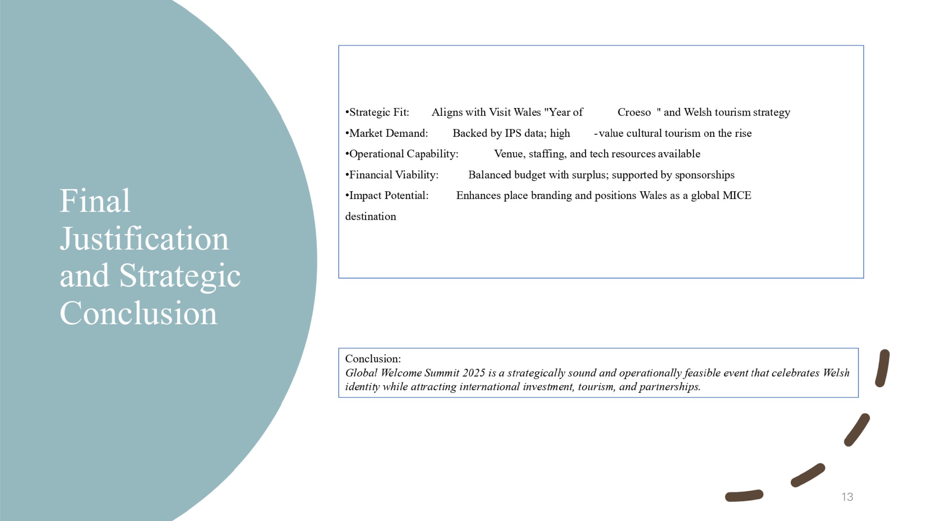
To conclude, the Global Welcome Summit 2025 is the event which does not only aim to attract visitors, but place Wales as competitive MICE destination. Let’s recollect why it is viable and significant that this event takes place.
First, it is in perfect line with Visit Wales Year of Croeso 2025 – supporting the national warmth, culture, and welcome message. It also contributes to broader objectives in the Welsh tourism and soft power strategy, contributing to a development in cultural diplomacy via events.
Secondly, the event is based on the real market demand. From part of the VisitBritain IPS 2023 data, the number of international visitors may be stabilising, but their spending and expectations are still growing – meaning there is golden opportunity for high-value, immersive, culturally oriented events like this one.
In terms of operation, we have a state-of-the-art venue, local partnership for staffing purposes, and a hybrid-ready infrastructure. Fundwise, our conservative budget is effective and we are in surplus, profitable and with long potential.
In other words, this is not only possible but even necessary to bring Wales to the international MICE terrain. It will deliver a real economic, cultural, and reputational value, and it is scalable enough to grow into an annual signature event.
Slide 15


