

University of Wales Trinity Saint David
School of Engineering
BEng Mechanical Manufacturing
Mike Lewis
1909144
Group Project M5X00400

Abstract
This assignment is a reflective essay on how a team was created from a group of people, all with different backgrounds and experiences. The team was responsible for running a shift within Zimmer Biomet Bridgend after the company went through great change. The shift “B shift” was one of the most militant and union driven shifts within the company and required determination, resilience, drive and discipline to turn the shift around and make it the most productive high achieving shift within the company. This essay will look back at what issues the group of people, “shift management” faced, how they became a team and what they did to achieve this. I was the shift manager of B shift and throughout my time as the shift manager I was also studying Leadership and Management via ION with Swansea University.
By studying the ION leadership course I was able to use a methodical approach to building my team which will be reflected within this assignment.

Contents
Abstract 2
Table of Figures 5
Introduction 6
Creating a team 7
Shaper 7
Completer 7
Implementer 7
Resource Investigator 7
Co-ordinator 7
Team Worker 7
Plant 7
Monitor Evaluator 7
Specialist 7
2017 Zimmer Biomet Shift Structure 8
Centralised management structure 8
2018 – present Zimmer Biomet Shift Structure 9
Flat management structure 9
B-Shift Management 9
Tuckman’s model – Forming, Storming, Norming, Performing 10
Forming 10
Storming 10
Norming 10
Performing 10
Individual needs 11
Physiological needs 11
Safety needs 11
Social needs 11
Esteem needs 11
Self-actualisation needs 12
Motivation 12
McClelland’s Needs Theory 13
Achievement 13
Affiliation 13
Power 13
Delegation. 14
Job enlargement 14
Job enrichment 14
Empowerment 14
Leadership 14
SMART 15
Emotional Intelligence 15
Bibliography 17

Table of Figures
Figure 1- Belbin's team roles 7
Figure 2 - ZB shift management structure 2017 8
Figure 3- ZB shift management structure 2018 - present 9
Figure 4 - Tuckman's model 10
Figure 5 - Maslow's Hierarchy of Needs 11
Figure 6 - McClelland motivation theory 13
Figure 7 - Leadership styles 14
Figure 8 - SMART objective 15
Figure 9 - Goleman emotional intelligence 15

Introduction
Zimmer Biomet was established in April 2014 when Zimmer purchased Biomet Inc for $13.4 Billion. Zimmer Biomet is the world’s third largest medical device company, employing 18,200 people in more than 40 countries across the world and selling products in more than 100 countries. In 2019 Zimmer Biomet had a revenue exceeding $8 Billion dollars. Zimmer Biomet designs, develops and manufactures orthopaedic products including, Hips, Knees both partial and full, ankles, wrists, elbows and dental prostheses. In Bridgend, the UK’s only manufacturing plant, Zimmer Biomet employs approximately 700 people with a range of skills and specialties including engineering, NPD, quality, manufacturing, validation, biology, facilities and maintenance. Bridgend currently adopts a 24/7 shift working patters consisting of 4 12 hour shifts on and four days off. The 12 hour shifts are split in to two days and two nights with the majority of Bridgend’s manufacturing personnel, around 500, working this rotation. There are 4 shifts, A, B, C and D that all have a management team consisting of a shift manager, three MAL’s (Manufacturing Area Leaders), 2 QA (Quality technicians) techs and a shift engineer. MAL’s are under managers who have responsibility for sections of the plant and manage the teams of people working within those sections. The shift engineer is responsible for all technical issues on shift. The QA techs are responsible for QA issues, measurements and calibration. The shift manager has overall responsibility for the whole plant on a shift by shift basis.

Creating a team
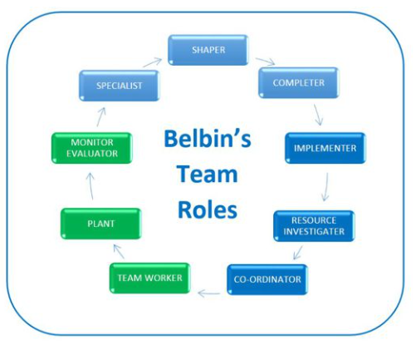
Figure 1- Belbin's team roles
(D., 2016)
“All too often, teams don’t always perform to that perfect blue print, even if they do have clear roles and responsibilities”.
(D., 2016)
Shaper – Thrives on pressure, has great drive to overcome challenges (Myself)
Completer – Searches out errors, polishes and perfects (QA techs)
Implementer – Reliable and efficient, turns ideas in to actions (MAL A)
Resource Investigator – Explores all opportunities and develops contacts (Shift engineer)
Co-ordinator – Clarifies goals and delegates effectively (Myself)
Team Worker – Co-operative and listens well (All)
Plant – Creative and imaginative (MAL C)
Monitor Evaluator – Can see all options and makes correct judgement (Myself & MAL A)
Specialist – Dedicated and provides knowledge and skills in rare supply (Shift engineer)

2017 Zimmer Biomet Shift Structure
In December 2017, Zimmer Biomet Bridgend restructured the business and changed the structure of shift management within manufacturing.
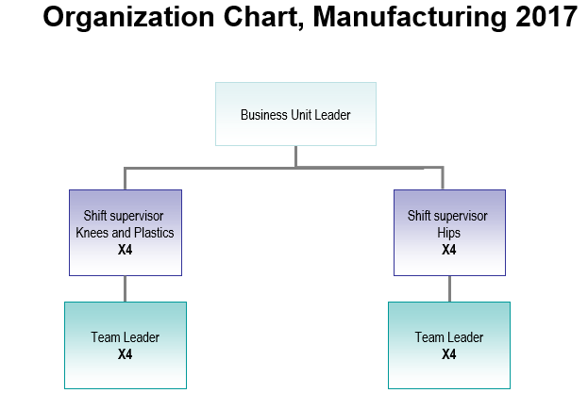
Figure 2 - ZB shift management structure 2017
In 2017, the organisational manufacturing shift management structure consisted of 8 supervisors and 8 team leaders split between two cells, Knees and Hips. This proved to be inefficient as there were too many “managers” involved who all had a difference of opinion and who didn’t work as effectively as they could in a team. The structure was quite centralised and required information to be passed down the layers of responsibility.

Centralised management structure
According to Osmond Vitez - Centralised organisations can have too many layers and systems in place. This can cause ineffective communication from the top down and bottom up.
(Vitez, 2019)

2018 – present Zimmer Biomet Shift Structure

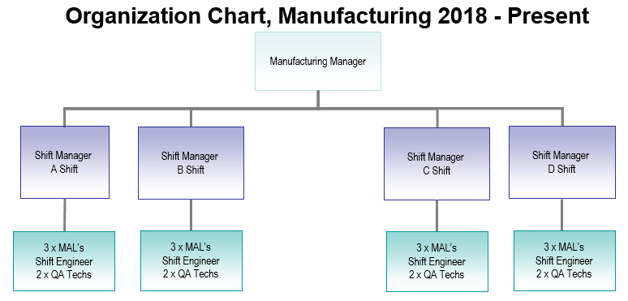
Figure 3- ZB shift management structure 2018 - present
The new organisational shift management structure came in to effect from January 2018. A flatter structure allowing for decision making to be shared amongst all stake holders. This consisted of 4 shift managers, 12 MAL’s, 2 QA techs and a shift engineer.

Flat management structure
According to Chris Rakoczy – Flat organisations allow for all employees to become involved in decision making. It encourages all levels of seniority within a business to get involved therefore increasing morale and inevitably productivity.
(Rakoczy, 2006-2020)
A structure within an organisation dictates how decisions and activities are carried out to help achieve the goals set out. The decisions can include anything from different rules to responsibilities. The organistaions structure also directly impacts how information is passed between the different layers within the company.
(Kenton, 2020)

B-Shift Management
I was shift manager of B shift. For the purpose of this essay the MAL’s will be referred to as MAL-A, MAL-B and MAL-C.

Tuckman’s model – Forming, Storming, Norming, Performing
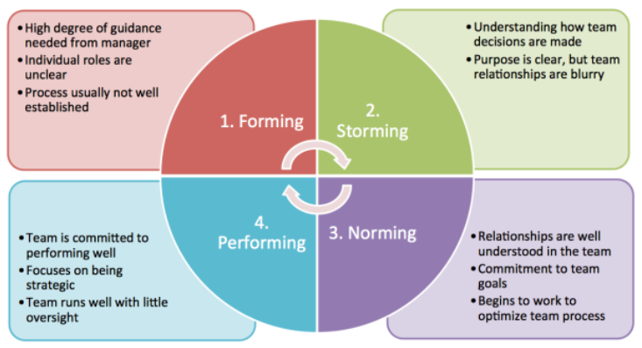
Figure 4 - Tuckman's model
(Carter, 2014)
To start building my team I used Tuckman’s model.

Forming
This was when the B shift management team first got together and the expectations were laid out by myself. I also explained how I expected them to work together and what the reporting lines would look like.

Storming
All members of my management team began to understand their peers and the individual expectations of each other. The different members were also beginning to understand how each of them make decisions and how they will form relationships with one another. This clearly put pressure on the team as they were all trying to become dominant as they were new to the roles and wanted to impress at an early stage.

Norming
The team began to work as one, they all understood the goal and believed in my vision. They began to buy in to the idea and were able to commit to it. Even when they found themselves in challenging situations they were able to work as a team and only ask me for advice when it was absolutely necessary.

Performing
“Performing teams get the job done with minimal supervision and conflict. People are motivated and competently get the job done. Conflicts are no longer threatening and different perspectives are seen as valuable. When a team fully meets this stage, it is a high-performing team”.
(Elsey, 2014)

As I now had a group of people in place I started to get to know and understand them individually and to know exactly what individual needs each person had. As all the team had different backgrounds inherently they would all have different needs.

Individual needs
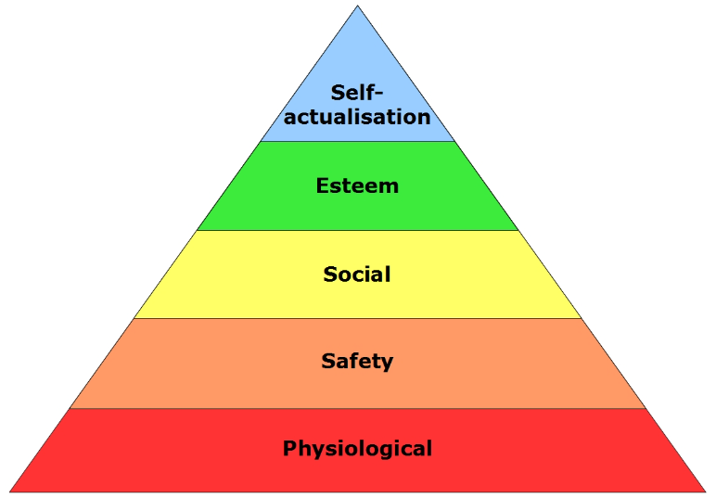
Figure 5 - Maslow's Hierarchy of Needs
(career satisfaction, classic theories, 2010)
Physiological needs – Has competitive salary, offers flexible benefits such as child care vouchers, is able to allow flexible working. Applicable to MAL-C as is new to the role and has young family. The most important requirement for MAL-C is salary and flexible benefits.
Safety needs – Offers great job security, a very stable employer within the market, allows a range of different working patterns. Applicable to the QA techs as they both preferred working shifts rather than days.
Social needs – Encourages personnel to be part of a group, will hold weekly coffee mornings and breakfast clubs, offers out of work activities such as gym membership. To me this was applicable to all the team as I still wanted to “catch up” with them over a coffee in the week as this enforces our relationship as a team.
Esteem needs – Has regular catch up or one to one’s with managers and coworkers, recognises the contribution of workers to achieve Key Performance Indicators and rewards staff for achievements. Applicable to MAL-B, oldest team member, is single and all children have grown up and left home. MAL-B requires recognition and wants to use experience to help influence this. This also applied to the shift engineer as his role was new within the plant. It was also important for him to have regular one to one’s so he understood how to best prioritise any technical breakdowns or work loads.
Self-actualisation needs – Allows opportunities for challenging and stimulating responsibilities, to allow workers the chance to take ownership of projects and to be allowed time off for higher education studies. Applicable to MAL-A, has worked within Zimmer Biomet for long time and has steadily worked way up with increasing responsibility.
According to Kendra Cherry – The hierarchy implies that individuals are motivated to carry out the basic needs before needing more advanced needs. So, people will start at the bottom of the pyramid and as they progress throughout their career and seniority within the company the less basic needs are replaced by the more advanced needs.
(Cherry, 2019)
The MAL’s were fast becoming more confident with the approach to work and with dealing with the running shift teams. They still needed to become more of a solid unit and still needed to become a complete team by working closely with the QA techs and shift engineer. To explore further needs and to understand what motivational requirements they needed I looked at McClelland’s motivational needs theory and Herzberg’s two factor theory.

Motivation
It became more important to me to understand how the team was motivated, by using McClelland’s theory on motivation I could further understand the individual needs and cater my decision making to individuals.

McClelland’s Needs Theory
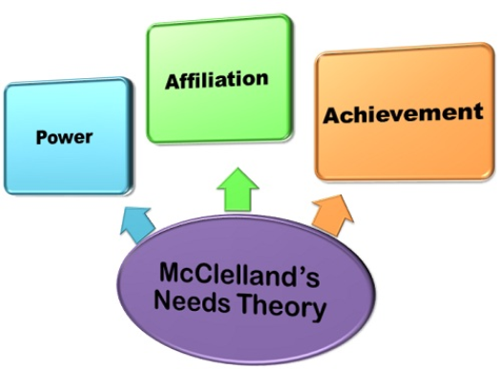
Figure 6 - McClelland motivation theory
(D., 2020)
Achievement – The individual has an urge to plan and achieve demanding goals. They will take deliberate risks to achieve goals. The individual likes to have regular one to one’s on their progress and achievements. The individual is also very independent. Applicable to MAL-A and shift engineer
Affiliation – The individual wants to be part of a team, wants to be thought well of and will agree with the rest of the group so not to upset any one. They always want to work together and avoid competition where possible and will not take high risk. Applicable to MAL-B, MAL-c and the QA techs
Power – The MAL wants to dominate and impose on others. Will always try anything to succeed. MAL thrives on competitiveness and results and relishes the status and recognition. MAL-C
Business Jargon writes – “David McClelland believed that the specific needs of the individual are acquired over a period of time and gets molded with one’s experience of the life”.
(Business jargon, 2018)

Delegation.
As I began to understand the different needs my team required I was able to delegate to them. I understood what each person’s motivational needs were and this greatly helped in delegating to the individual. Each member of my management team had their own area of responsibility and they then, under my direction, tried to achieve the task set out. I always took into consideration who in my team was be best suited for each task and whenever possible I used that individual. Delegation is an opportunity for extra responsibility, recognition and promotion.
According to James Young – “Herzberg first discussed his influential theory in 1959’s Motivation to Work. It’s also known as the ‘Hygiene-motivation theory’ because it groups motivators into these two categories, hygiene and growth”.
(Young, 2017)
Some of the methods I used to achieve this were:

Job enlargement
Giving my team a greater range of tasks to perform, which aren’t more difficult but will make the work more engrossing.

Job enrichment
Giving my team a broader range of more thought-provoking and testing work which will give them a greater sense of achievement.

Empowerment
Means delegating more power to my team to use when they need it and to become more accountable and responsible in their areas of work.

Leadership
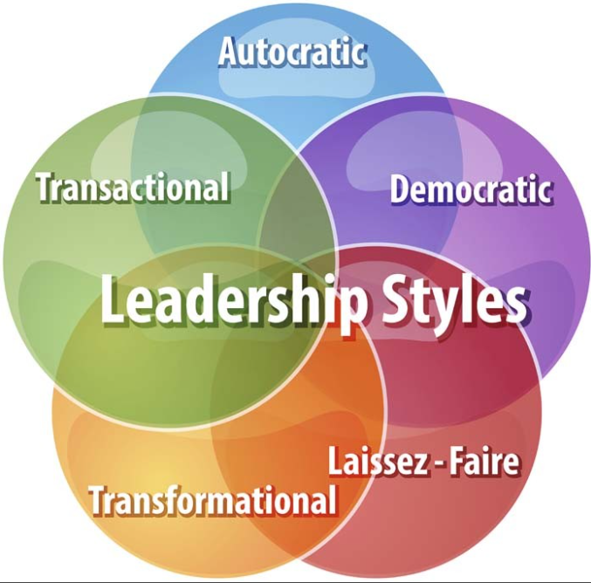
Figure 7 - Leadership styles
(Schneider, 2015)
To lead my team I used Transactional Leadership where possible. I focused on supervision I liked to reward the team for outstanding performance.

SMART
When setting the goals and objectives I used the SMART formula to ensure understanding and to ensure we achieve the goals.
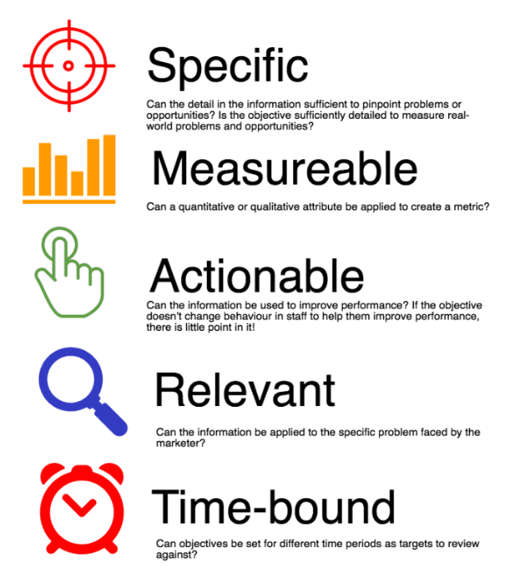
Figure 8 - SMART objective
(Chaffey, 2019)

Emotional Intelligence
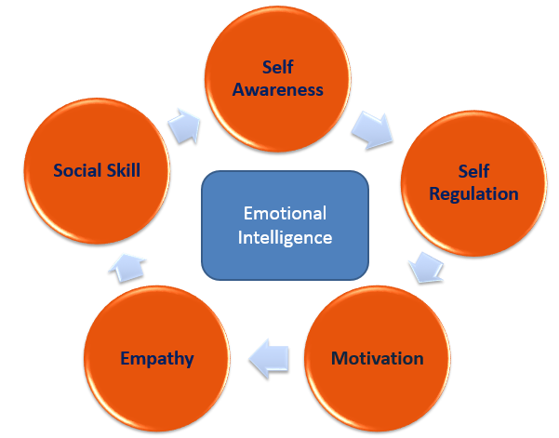
Figure 9 - Goleman emotional intelligence
Emotional intelligence enables you to understand and control your own emotions.
(Morin, 2020)
By understanding individual emotion helps me to make better decisions for both the individual and the whole shift ultimately helping the business. Understanding basic needs such as the person’s social skill, how they interact with others, how they express themselves and how they perform in teams and on their own. A person’s motivation, what motivates them to do the work, what they take encouragement from and how I can get the best out of the individual by praising them or even by changing their job to keep it interesting. A person’s empathy, their sensitivity towards others, towards the business and their own work.
If you have emotional intelligence, it enables you to understand and control your own emotions. It also allows you to be able to read and interpret other people’s emotions. “People with a high degree of emotional intelligence know what they're feeling, what their emotions mean, and how these emotions can affect other people”.
(Mind Tools, 2015)

Conclusion
Having used all my experience with management and by using the understanding and education gained from the ION leadership course I was able to create a strong, very capable close knit team who understood their individual positions within the team and were able to work together to achieve our goals. The team was built over a period of approximately 12 months and continues to work together without me as I have moved on within the business. MAL-A has since been promoted to shift manager and is currently recruiting a new MAL. The shift engineer and QA techs till work on shift B.

Bibliography
Abudi, G., 2010. THE FIVE STAGES OF TEAM DEVELOPMENT: A CASE STUDY. [Online]
Available at: https://www.projectsmart.co.uk/the-five-stages-of-team-development-a-case-study.php
[Accessed 08 April 2020].
Business jargon, 2018. McClelland’s Needs Theory. [Online]
Available at: https://businessjargons.com/mcclellands-needs-theory.html
[Accessed 08 May 2020].
career satisfaction, classic theories, 2010. Careers in theory. [Online]
Available at: https://careersintheory.wordpress.com/2010/01/20/classics-maslows-hierarchy-of-needs/
[Accessed 05 April 2020].
Carter, J., 2014. teambuildingactivity.com. [Online]
Available at: https://www.teambuildingactivity.com/tuckmans-model/
[Accessed 05 April 2020].
Chaffey, D., 2019. From SMART to SMARTER marketing objectives. [Online]
Available at: https://www.smartinsights.com/goal-setting-evaluation/goals-kpis/define-smart-marketing-objectives/
[Accessed 08 May 2020].
Cherry, K., 2019. The 5 Levels of Maslow's Hierarchy of Needs. [Online]
Available at: https://www.verywellmind.com/what-is-maslows-hierarchy-of-needs-4136760
[Accessed 08 May 2020].
D., A. N., 2016. Belbin Team Roles: Building Effective and Balanced Teams for Success. [Online]
Available at: https://www.educational-business-articles.com/belbin-team-roles/
[Accessed 05 April 2020].
D., A. N., 2020. McClelland’s Needs Theory. [Online]
Available at: https://businessjargons.com/mcclellands-needs-theory.html
[Accessed 05 April 2020].
Elsey, E.-L., 2014. Tuckman's Team and Group Development Model. [Online]
Available at: https://www.thecoachingtoolscompany.com/get-your-team-performing-beautifully-with-this-powerful-group-development-model/
[Accessed 07 May 2020].
emerald works, 2019. Belbin's Team Roles. [Online]
Available at: https://www.mindtools.com/pages/article/newLDR_83.htm
[Accessed 06 April 2020].
Janzen, M. E., 2018. TRANSFORMATIONAL Theory Page. [Online]
Available at: https://wikispaces.psu.edu/display/P5PFLD/TRANSFORMATIONAL+Theory+Page#
[Accessed 05 April 2020].
Kenton, W., 2020. Organizational Structure. [Online]
Available at: https://www.investopedia.com/terms/o/organizational-structure.asp
[Accessed 05 April 2020].
Mind Tools, 2015. Emotional Intelligence in Leadership. [Online]
Available at: https://www.mindtools.com/pages/article/newLDR_45.htm
[Accessed 08 May 2020].
Morin, A., 2020. 5 Components of Emotional Intelligence. [Online]
Available at: https://www.verywellmind.com/components-of-emotional-intelligence-2795438
[Accessed 05 April 2020].
Rakoczy, C., 2006-2020. business.lovetoknow.com. [Online]
Available at: https://business.lovetoknow.com/business-operations-corporate-management/advantages-flat-organizational-structure
[Accessed 17 April 2020].
Schneider, G., 2015. WHAT IS YOUR LEADERSHIP STYLE?. [Online]
Available at: https://www.pdstrategies.com/index.php/easyblog/entry/what-is-your-leadership-style
[Accessed 08 May 2020].
Vitez, O., 2019. smallbusiness.chron.com. [Online]
Available at: https://smallbusiness.chron.com/centralized-vs-decentralized-organizational-structure-2785.html
[Accessed 17 April 2020].
Young, J., 2017. Heroes of Employee Engagement: No.3 Frederick Herzberg's Two Factor Theory. [Online]
Available at: https://peakon.com/blog/future-work/frederick-herzberg-two-factor-theory/
[Accessed 25 April 2020].
Zhou, Z., 2017. Jordan Belfort: Herzberg’s Two-Factor theory. [Online]
Available at: https://blogs.ubc.ca/comm292ziqingzhou/author/ziqingzhou/
[Accessed 05 April 2020].

