CERTIFICATE IN SKILLS FOR THE WORKPLACE

MODULE NAME: Problem Solving and Decision Making
Student Name: Angelica Costache
ID Student: 1818635
Term3 (BMSW4004) G5
Lecturer: Yasejh Kumar

Table of Contents

Introduction 3
1. Defining the problem at workplace 3
1.1 Impact and scope 3
2. Analysing information regarding the problem 4
2.1 Mind mapping 4
3. Proposing alternative solutions to resolve the problem 5
3.1 Brainstorming 5
4. Using a decision-making technique to identify the most appropriate solution 6
4.1 Porter’s five forces 6
5. Developing a plan to implement the right solution 7
6. Communicating the plan to different stakeholders 8
7. Applying suitable monitoring techniques to assess the effectiveness of the implemented solution 8
Conclusion 9
Recommendation 9
References 10

Introduction
While working at any organisation, employees may often face certain workplace issues. Thus, the company need to work on coming up with suitable solutions and implement them for resolving these work-based issues to ensure the smooth functioning of the firms. The report will be analysing the case study of UK-based multinational food corporation, Unilever Food Solutions UK (UFS), a subsidiary of Unilever UK, and identify a recent work-based problem that the company has been facing. The report will aim to come up with probable solutions and implement them for resolving the work-based problem at the company. It is essential to implement necessary models and techniques to identify the problem and generate effective solutions.

Defining the problem at workplace
The “food and drinks” industry in the UK is the largest manufacturing sector and employs around 430,000 people across the country. The industry contributes over 28 billion GBP to the country’s economy (Fdf.org.uk, 2020). UFS is considered as one of the biggest food firms in the UK. The company’s team of more than 300 chefs constantly work to come up with high-quality food items for their customers. The chefs at UFS are trained to develop quality food products, innovative and trending menus that can satisfy the customer needs (Unileverfoodsolutions.co.uk, 2020). However, with the recent pandemic outbreak of COVID-19 and the economic turmoil of Brexit, the company, along with the entire food industry, has been greatly affected.

1.1 Impact and scope
UFS has faced significant staff shortage amidst this global pandemic as well as Brexit. As per the views of Adnan et al. (2018), with significant staff shortage, work pressure also increases considerably for existing employees. Thus, it can adversely affect the service as well as product quality. Similarly, under these uncertain times, UFS has been facing serious issues with its services due to shortage of skilled staff. With the ongoing pandemic, the food and beverages industry of the UK has been hugely affected, as customers are forced to stay indoors amidst lockdowns. Thus, “at-home consumption” has increased, as compared to “out-of-home consumption” (Deloitte.com, 2020).
Moreover, incidents associated with Brexit have particularly affected the food industry in the UK. This has created an uncertain future for the food firms of the country. Almost 47% of the food-manufacturing firms have confirmed that a majority of their workforce belong to other EU countries. As a result, they are leaving the UK due to their uncertain future (Natwestbusinesshub.com, 2020). Therefore, the scope of the study is to improve the workplace of UFS and bring an effective analysis regarding employees succeeding in reducing their work pressure. This will, moreover, enable UFS to overcome complex challenges regarding staff shortage.

Analysing information regarding the problem
It is essential for companies to critically analyse their business and work-based problems to come up with necessary solutions for the issues (Frye et al. 2020). The authorities at UFS must closely assess the problems that the company has been facing due to staff shortage. The company needs to understand how staff shortage can affect various processes and operations of the firm and affect its service quality. UFS can adopt the technique of mind mapping to well-organise all the information related to this specific problem of staff shortage.

2.1 Mind mapping
Developing a mind map is a strategic technique to create diagrams that can organise information in a hierarchical structure and establish its relationship with various organisational processes. Thus, mind maps provide a visual representation of the relationship of an information with different organisational operations (Fauzi and Degeng, 2018). In this case, UFS can utilise mind mapping to analyse relevant information regarding its work-based issue and determine how staff shortage issue is affecting its daily operations. By using mind mapping software, like Miro, the company can develop suitable mind maps for assessing the current issue and determine reasons behind staff turnover. Through mind mapping, UFS can assess how workload is leading to staff shortage. This will then help the company to come up with effective preventive measures to solve shortage of staff members and mitigate its negative impact on the company’s business.
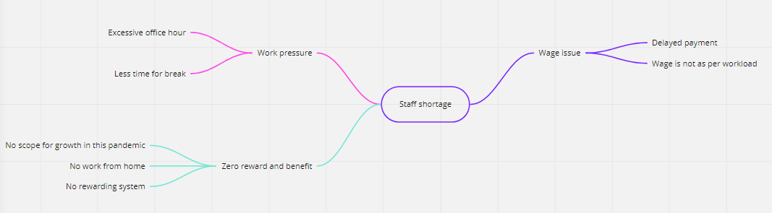
Figure 1: Mind mapping on reasons of staff shortage
(Source: Inspired by Fauzi and Degeng, 2018)

Proposing alternative solutions to resolve the problem
As stated earlier, staff shortage or a gap in the workforce can have a massive impact on the service quality as well as work pressure of an organisation. Thus, companies must develop effective strategies to retain their skilled employees (Kossivi et al. 2016). In the case of UFS, the company has conducted various interviews with professional head chefs to understand how they work to retain their employees. By interviewing these chefs, the company aims to find probable solutions to the issue of staff shortage and stopping its employees from leaving their jobs (Unileverfoodsolutions.ie, 2020). The process of brainstorming can be greatly effective in coming up with probable solutions to this work-based issue of UFS.

3.1 Brainstorming
Through brainstorming, it is possible for individuals to generate ideas and strategies for solving a problem. Thus, it is an effective problem-solving tool (Besant, 2016). In an organisational setup, brainstorming encourages individuals to share their ideas and opinions for coming up with alternative solutions during problem-solving. Similarly, UFS can implement this technique to encourage its employees to share their ideas regarding solving the issue of staff shortage and motivate them. For instance, the company can come up with the idea of implementing an effective reward system for retaining its employees. As stated by Frye et al. (2020), for reducing employee turnover rates, companies must make their employees feel valued. Thus, UFS can focus on developing interactive HR policies, which will encourage the employees to share their grievances regarding the company’s management without facing the risk of losing their jobs.
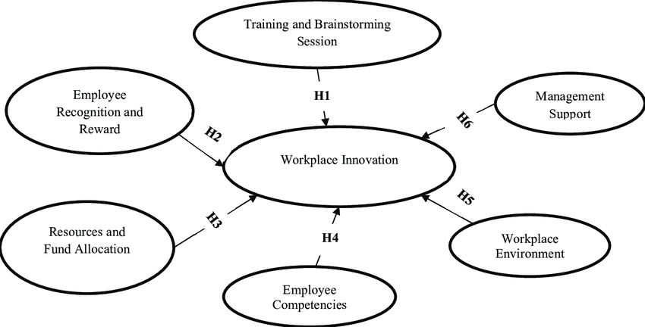
Figure 2: Brainstorming on employee reward
(Source: Frye et al. 2020)

Using a decision-making technique to identify the most appropriate solution

4.1 Porter’s five forces
Competitive Rivalry
Unilever is one of the giant consumer good firms with high aggressiveness and have wider diligence in the market. As Raj and Aithal (2018), stated that high aggressiveness and high number of firms lead to sustainable diligence to the system. This can be potentially founded in the module of the system where Unilever food solution has developed creative and plat potential product that can meet the present demand of the market (Unilever.com, 2020). Unilever has to face wider competition in the market due to its low switching cost and hence, the company has strong competitive rivalry.
Bargaining Power of Customers
Consumer response in the Unilever food solution department is high as low switching cost and high quality of information small size of individual buyers have lead strong forces of bargaining power of the consumer to be high. This has lead wider diligence in market provision and has countered a sustainable approach within the system. Hence, it can be stated that the customers buying power is high in case of Unilever.
Bargaining power of Suppliers
Supply chain of Unilever food solution is positive and has wider market provision as their perspective alignment is effective to bring strategic understanding of the forces. As stated by Grekova et al. (2016), effective suppliers with reliable supply process have led Unilever to gain wider market provision. It has been so stated that the moderate size of individual suppliers and population of suppliers as well as overall supply system is moderate that make the bargaining power of the suppliers to be moderate in nature.
Threat of Substituents
Substituents have provision to reduce the revenue and strength of the firm. As the switching cost is low, it enables the customer to avoid any form of substituents and the market of Unilever food solution is unique. This is because it has no such substituents due to its effective strategy and team of chefs, who are known to be creative. This tends to bring overall analysis that the threat to substituent in Unilever food solution is low.
Threats of New Entrants
Unilever is known to have competed with both the new firm as well as the old firm. As mentioned previously low switching cost against Unilever leads to development of strategic base, which has lowered its threat from the new entrants. On the other hand, it is hard to compete with brands like Unilever, and for that, it needs to solidify its base with utmost proficiency. Hence, the threats of new entrants are low for Unilever.

Developing a plan to implement the right solution
Tasks | Action to be taken | Tools to be used | Responsible person | Time required
Addressing employee grievances | Developing a platform where employees can anonymously submit their complaints | Software tools to develop an online portal for publishing grievances | HR and R&D teams | 3 to 6 months
Providing job security | Creating policies to prevent unfair job termination | Financial tools | HR team | 2 to 3 months
Fulfilling employee needs with reward facility | Providing satisfactory pay check, medical and travel benefits. | Financial resources, gifts and vouchers | HR team | 6 months

Table 1: Plan for solving the issue of staff shortage at UFS
(Source: Inspired by Watson et al. 2018)
In order to successfully implement the strategies to solve their work-based issues, companies need to carefully plan the implementation process (Watson et al. 2018). UFS must carefully assess its list of alternative solutions to determine the solution that can be most effective in dealing with its issue of staff shortage. The company then needs to develop a plan to properly implement the right solution. In the case of staff shortage, UFS must consider developing better employee relations by addressing the grievances and fulfilling the needs of the employees.
According to the views of Lee et al. (2018), employees are less likely to leave a company that implements employee-friendly organisational policies. Similarly, UFS also needs to develop a system that will help the employees to publish their needs and grievances while staying anonymous so that their jobs are not affected. The company must work on fulfilling these employee demands and providing them with necessary job security so that the employees feel valued at the workplace. Thus, by developing a relation-oriented plan, UFS can work to resolve its problem of staff shortage.

Communicating the plan to different stakeholders
It is essential for UFS to discuss its plan for resolving the staff shortage problems with its stakeholders so that they are well-aware of the company's strategies. As per the views of Watson et al. (2018), stakeholders play a significant part in the business success and functioning of an organisation. Thus, it is essential for companies to maintain good stakeholder relationships by discussing their strategies and organisational policies with the stakeholders. Similarly, if UFS aims to implement its new plan for retaining more employees, it needs to communicate with all its stakeholders to ask for their feedback regarding this context and make them aware of the new company policies.

Applying suitable monitoring techniques to assess the effectiveness of the implemented solution
A strategy is only useful when it is successful in producing satisfactory results. Thus, companies need to closely monitor the effectiveness of their implemented strategies and pans in enhancing organisational operations by solving the work-based problems (Neumann et al. 2018). UFS can implement monitoring techniques observation, estimating staff turnover as well as conducting surveys among employees to evaluate the effectiveness of its plan in resolving the issue of staff shortage. By conducting surveys among its staff, the company can determine whether the employees are satisfied with the new company policies or not. On the other hand, by calculating the staff turnover rates, UFS can evaluate the effectiveness of its plan in retaining more employees and preventing staff shortage.

Conclusion
From the report, it can be concluded that companies must develop effective strategies to handle work-based problems. The recent events of Brexit and the global pandemic outbreak have resulted in the issue of shortage of staff in the UK-based renowned food corporation Unilever Food Solutions. The company must focus on analysing the information related to its issue through mind mapping. It needs to focus on developing solutions to deal with this problem of staff shortage through brainstorming. The company must implement an effective plan to solve this issue. It also needs to discuss this plan with the stakeholders and closely monitor its effectiveness in retaining employees.

Recommendation
Shortage of staff has not only marked Unilever Food solution to detect it as a problem but other firms from different industry face such issues. In this aspect, the company need to manifest its own prospectus through providing the effective safety measures that can provide protection to the staffs. In addition to that, provision of incentives can also be effective for bringing sustainability in drawing employee to serve the company in such pandemic situation. Also, providing sustainable motivation and medical facilities such as insurance can bring effective drawing provision of employees.

References
Adnan, A.M., Rahman, A.E.A. and Ahmad, R. (2018). Factors influencing turnover intention among fast food restaurant managers. International Journal of Academic Research in Business and Social Sciences, 8(17), pp.195-210.
Besant, H. (2016). The journey of brainstorming. Journal of Transformational Innovation, 2(1), pp.1-7.
Deloitte.com (2020). COVID-19: Impact on food & beverage consumer products companies. Available at: https://www2.deloitte.com/global/en/pages/about-deloitte/articles/covid-19/covid-19--impact-on-food---beverage-consumer-products-companies.html#:~:text=Consumer%20Products%20food%20%26%20beverage%20companies,come%20to%20nearly%20a%20standstill. [Accessed on: 29.08.2020]
Fauzi, Z.A. and Degeng, I.N.S. (2018). Implementation of Mind Mapping Learning Model to Improve Learning Outcomes of Civil Education Subject. Journal of K6, Education and Management, 1(3), pp.9-14.
Fdf.org.uk (2020). Representing the UK's biggest manufacturing sector. Available at: https://www.fdf.org.uk/statsataglance.aspx [Accessed on: 29.08.2020]
Frye, W.D., Kang, S., Huh, C. and Lee, M.J.M. (2020). What factors influence Generation Y’s employee retention in the hospitality industry? An internal marketing approach. International Journal of Hospitality Management, 85, p.102352.
Grekova, K., Calantone, R.J., Bremmers, H.J., Trienekens, J.H. and Omta, S.W.F., (2016). How environmental collaboration with suppliers and customers influences firm performance: evidence from Dutch food and beverage processors. Journal of cleaner production, 11(2), pp.1861-1871.
Kossivi, B., Xu, M. and Kalgora, B. (2016). Study on determining factors of employee retention. Open Journal of Social Sciences, 4(05), p.261.
Lee, T.W., Hom, P., Eberly, M. and Li, J. (2018). Managing employee retention and turnover with 21st century ideas. Organizational dynamics, 47(2), pp.88-98.
Natwestbusinesshub.com (2020). Food sector faces skills and labour shortage. Available at: https://natwestbusinesshub.com/articles/food-and-drink-sector-faces-labour-shortage [Accessed on: 29.08.2020]
Neumann, J., Robson, A. and Sloan, D. (2018). Monitoring and evaluation of strategic change programme implementation—Lessons from a case analysis. Evaluation and Program Planning, 66, pp.120-132.
Raj, K. and Aithal, P.S., (2018). A ‘Desi’Multinational–A Case Study of Hindustan Unilever Limited. International Journal of Case Studies in Business, IT and Education (IJCSBE), 2(1), pp.1-12.
Unilever.com. (2020), Seven ways we are creating an appetite for change, Available at: https://www.unilever.com/news/news-and-features/Feature-article/2020/seven-ways-we-are-creating-an-appetite-for-change.html [Accessed on: 29/08/2020]
Unileverfoodsolutions.co.uk (2020). We are Chefs supporting Chefs. Available at: https://www.unileverfoodsolutions.co.uk/we-are-chefs-supporting-chefs.html [Accessed on: 29.08.2020]
Unileverfoodsolutions.ie (2020). How do Chefs keep their staff from leaving? Available at: https://www.unileverfoodsolutions.ie/chef-inspiration/from-chefs-for-chefs/work-smart/how-to-keep-staff.html [Accessed on: 29.08.2020]
Watson, R., Wilson, H.N., Smart, P. and Macdonald, E.K. (2018). Harnessing difference: A capability‐based framework for stakeholder engagement in environmental innovation. Journal of Product Innovation Management, 35(2), pp.254-279.

