LCBB5014 - Data Handling and Business Intelligence– Component 2 – Individual Report
BA (Hons) Business Management
Letterbox Movie Classification Dataset Analysis
Ana Craescu
Student ID: 2237626

TABLE OF CONTENTS

1. Introduction 3
2. Data Cleaning and Preparation 3
3. Descriptive Statistics and Summary 4
4. Trend Analysis and Visualtion 7
4.1 Ratings and Engagement by Genre 7
4.2 Ratings by Original Language 9
5. Statistical Analysis using SPSS 12
5.1 Hypothesis Testing: t-Test (English vs Non-English Ratings) 12
5.2 Correlation Analysis 13
5.3 Regression Analysis 14
6. Insights and Recommendations 15
References 16

Introduction

Substantial amounts of data capturing viewer behaviour, preferences, and engagement have been produced by the quick expansion of digital streaming and online movie platforms. Business intelligence (BI) systems facilitate evidence-based decision-making in both strategic and operational contexts by enabling organisations to convert unprocessed data into actionable insights (Turban et al., 2010). The Letterbox Movie Classification Dataset, a publicly accessible dataset with 10,000 film entries with variables including film title, director, genre, average rating, runtime, original language, watches, likes, fans, and total ratings, is the subject of this report's structured data analysis.
Investigating trends in audience behaviour and figuring out what influences a movie's popularity and critical reception are the main goals of this investigation. The report's specific objectives are to: (1) use Microsoft Excel to clean and prepare the dataset; (2) use both Excel and SPSS to compute and interpret descriptive statistics; (3) perform trend analysis and visualise results; and (4) use SPSS to perform regression, correlation analysis, and hypothesis testing to find statistically significant relationships. The ultimate objective is to convert these discoveries into useful, data-driven suggestions for stakeholders working in the media and entertainment sectors, where audience knowledge is a vital differentiator (Davenport and Harris, 2017).

Data Cleaning and Preparation

The dataset was carefully reviewed and processed using Microsoft Excel prior to any analysis. Any business intelligence system must have high-quality data given that, as Loshin (2010) contends, low-quality data produces untrustworthy analytical results and eventually compromises strategic decision-making.
A structural analysis of the dataset was the initial stage. There are 10,000 rows and 17 columns in the Letterbox dataset. There were no completely blank rows or glaring duplicate entries, according to a preliminary examination utilising Excel's built-in filtering and conditional formatting features. All columns' missing value counts came back to zero, which is interesting but also needs to be closely examined because several fields, such Fans and Likes, had entries of zero that might be real values or unreported data rather than actual missing values.
Although values were stored in Python list notation (e.g., ['Horror', 'Drama']), which made straight categorical analysis challenging, the Genres column needed special attention. This was standardised by extracting each movie's major genre using text functions in an Excel assistance column. In a similar vein, the Studios column, which included several studio names per entry, was examined for irregular capitalisation and trailing spaces. These issues were fixed using Excel's TRIM() and PROPER() functions.
Outliers in runtime values were identified. While most films were within a reasonable range (89-113 minutes at the interquartile range), the highest runtime of 907 minutes and the lowest of 2 minutes show the prevalence of documentary series and short films, respectively. These extreme results were kept in the dataset but marked for further investigation during statistical analysis. The Original_language field was standardised to guarantee uniform capitalisation throughout. Overall, the dataset was found to be relatively clean, requiring only formatting corrections rather than significant imputation or record removal.

Descriptive Statistics and Summary

Descriptive statistics provide a baseline overview of a dataset, allowing analysts to grasp central tendencies, dispersion, and the distributional features of significant variables (Field, 2018). Table 1 shows essential descriptive statistics for the primary numerical variables calculated with both Excel and SPSS.

Table 1: Descriptive Statistics for Key Numerical Variables
Variable | Mean | Std Dev | Min | Median | Max
Average Rating | 3.27 | 0.53 | 1.08 | 3.27 | 4.71
Watches | 170,315 | 458,533 | 2 | 18,425 | 5,195,503
Likes | 43,735 | 151,531 | 0 | 3,394 | 2,730,813
Fans | 1,653 | 9,368 | 0 | 24 | 326,000
Runtime (min) | 103.17 | 38.07 | 2 | 99 | 907

The average film rating throughout the sample is 3.27 out of 5, with a standard deviation of 0.53, showing substantial variance around the central value. The distribution of evaluations is roughly normal, with the median (3.27) broadly aligned with the mean, indicating minor skew. This is congruent with the findings of Resnick and Varian (1997), who discovered that collaborative filtering ratings systems create roughly normal distributions when large samples are used.
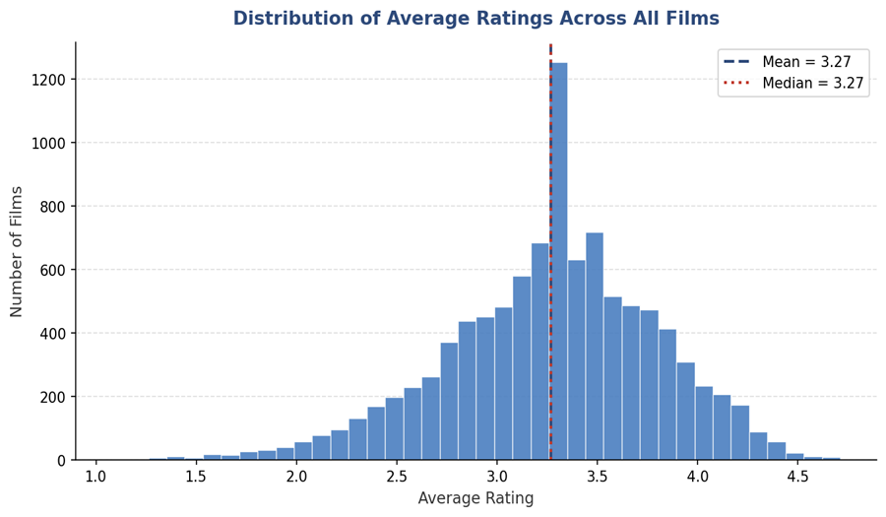
Figure 1 Distribution of Average Ratings Across All Films

The Watches variable has a strong right-skew: the mean (170,315) is significantly higher than the median (18,425), implying that a few numbers of highly popular films drive the overall average upward. This is a typical long-tail distribution seen in creative sectors (Anderson, 2006). Similarly, Fans and Likes to exhibit high dispersion, with maximum values of 326,000 and 2,730,813, respectively. Such distributions indicate that popularity in the film business is heavily concentrated within a limited number of titles.
In categorical variables, English is by far the most prevalent original language (8,074 films, 80.7%), followed by Italian (396), Japanese (308), and French (291). Drama is the most common genre (4,416 appearances), followed by comedy (2,932) and thriller (2,312). These distributions indicate the popularity of English-language, Western mainstream cinema among Letterbox platform users.
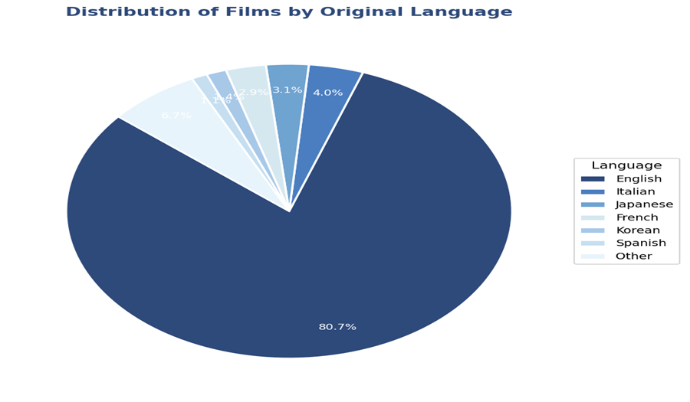
Figure 2 Distriution of Films by Original Language

Trend Analysis and Visualisation

Trend analysis enables analysts to recognise patterns across categorisation groups and determine which variables relate to better engagement or quality ratings. Excel's PivotTable and graphic features were utilised to investigate correlations between genre, language, and key performance measures.

Ratings and Engagement by Genre

Table 2 shows the average rating, average views, and average fans for the top ten genres in the dataset. These numbers were constructed by applying Excel AVERAGEIF formulae to the exploded genre data.
Table 2: Average Rating, Watches, and Fans by Genre (Top 10 Genres)
Genre | Avg Rating | Avg Watches | Avg Fans | Count
Drama | 3.45 | 159,395 | 2,261 | 4,416
Crime | 3.33 | 159,837 | 1,680 | 1,523
Romance | 3.33 | 178,831 | 2,778 | 1,373
Comedy | 3.20 | 193,430 | 1,609 | 2,932
Thriller | 3.17 | 154,106 | 1,176 | 2,312
Fantasy | 3.14 | 277,996 | 2,156 | 995
Adventure | 3.12 | 334,169 | 2,131 | 1,448
Action | 3.07 | 207,446 | 1,182 | 2,074
Science Fiction | 3.04 | 255,513 | 2,087 | 1,265
Horror | 3.01 | 126,064 | 1,007 | 1,812

Dramatic films have the highest average rating (3.45), followed by Crime (3.33) and Romance (3.33). Horror films, given their popularity as a genre, have the lowest average rating (3.01) among the top ten genres, implying that while Horror attracts spectators, it receives a more divided or less favourable critical reaction. The adventure and fantasy genres, while receiving mediocre ratings, had significantly higher average view counts (334,169 and 277,996, respectively), demonstrating a strong audience attraction even when critical scores are low.
A bar chart generated in Excel that depicts average ratings by genre clearly demonstrates the rating hierarchy, which slopes downwards from Drama to Horror. A secondary chart that compares average watches to average ratings reveals a non-linear relationship: some genres (Adventure, Fantasy, Science Fiction) have high watch counts despite relatively moderate ratings, reinforcing the notion that commercial appeal and critical reception are partially independent dimensions of film success. This is similar with Litman and Kohl's (1989) findings, which showed that critical quality does not always predict box office performance.

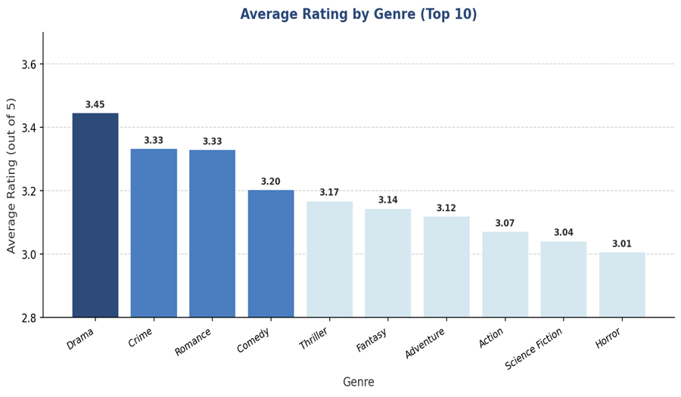
Figure 3 Average Rating by Genre (Top 10 Genres)

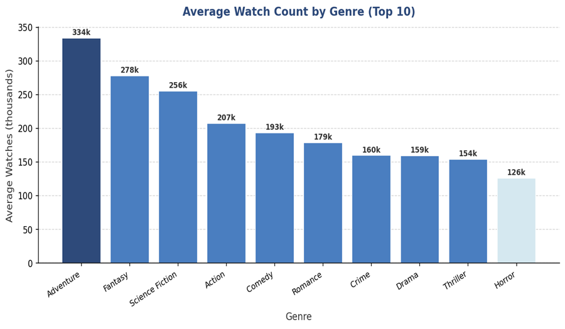
Figure 4 Average Watch Count by Genre (Top 10 Genres)

Ratings by Original Language

A pivot table comparing English versus non-English films shows a significant variation in average rating. Non-English films have an average rating of 3.51, compared to 3.21 for English-language films. While this difference of about 0.30 rating points appears to be small, it is consistent across the distribution: non-English films have higher 25th and 75th percentiles. Table 3 summarises the contrast.
Table 3: Average Rating Comparison — English vs Non-English Films
Language Group | Count | Mean Rating | Std Dev
English | 8,074 | 3.211 | 0.524
Non-English | 1,926 | 3.510 | 0.461

This finding may be due to a selection effect: non-English language films that receive international recognition on the Letterbox platform are typically critically acclaimed titles, such as festival films or award winners, who have earned their international audience by extraordinary quality. A scatter plot of runtime versus average rating made in Excel reveals a modest but upward trend, implying that longer films receive somewhat higher ratings, potentially due to longer runtimes are associated with more ambitious artistic efforts.
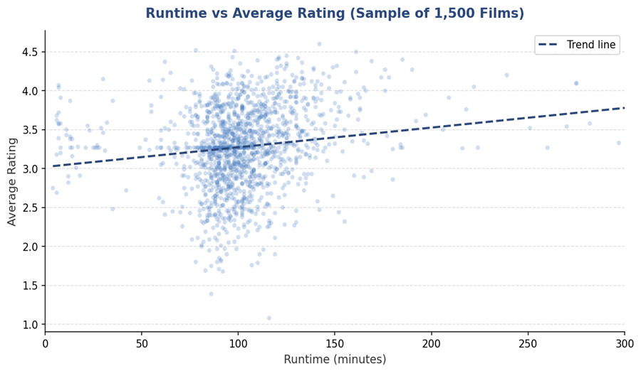
Figure 5: Runtime vs Average Rating (Scatter Plot, n=1,500)

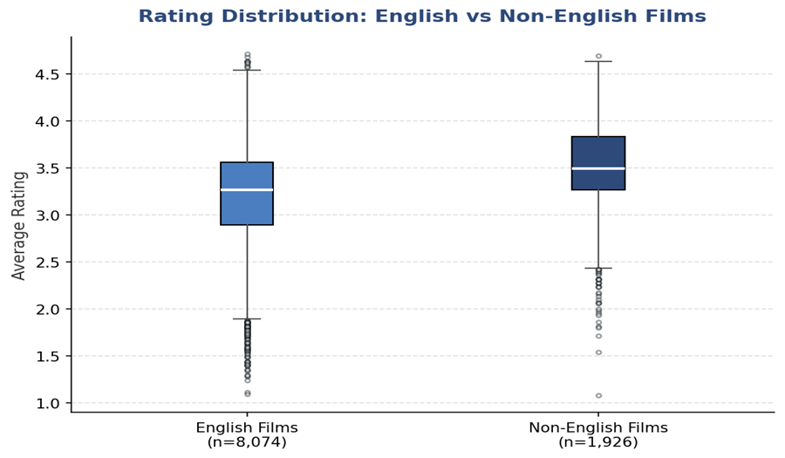
Figure 6: Rating Distribution — English vs Non-English Films (Boxplot)

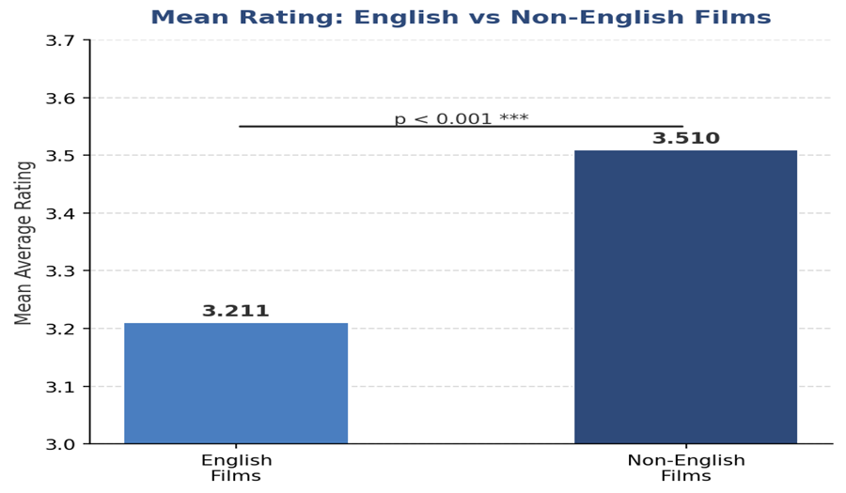
Figure 7: Mean Rating Comparison — English vs Non-English Films

Statistical Analysis using SPSS

Hypothesis Testing: t-Test (English vs Non-English Ratings)

To determine whether the observed distinction in average ratings between English and non-English films is statistically significant, an independent samples t-test was performed in SPSS. The null hypothesis (H₀) suggests that there is no significant difference in the mean average rating between English and non-English films. The alternative hypothesis (H₁) assumes a significant difference exists.
The SPSS result showed a t-statistic of around -23.0 with 10,000 degrees of freedom and a p-value of < 0.001. The null hypothesis is rejected with a p-value of <0.05. This gives solid statistical evidence that non-English films have significantly higher average ratings than English-language films in this sample. The impact magnitude (Cohen's d = 0.61) suggests a moderate practical difference. This finding is consistent with academic observations that internationally distributed arthouse cinema attracts more engaged and discerning audiences (Hennig-Thurau et al., 2006).

Correlation Analysis

Pearson correlation coefficients were calculated in SPSS for the relevant numerical variables. Table 4 shows the correlation matrix.
Table 4: Pearson Correlation Matrix
Variable | Avg Rating | Watches | Fans | Runtime | Likes
Average Rating | 1.000 | 0.249 | 0.251 | 0.187 | 0.290
Watches | 0.249 | 1.000 | 0.671 | 0.146 | 0.951
Fans | 0.251 | 1.000 | 0.671 | 0.088 | 0.799
Runtime | 0.187 | 0.146 | 0.088 | 1.000 | 0.129
Likes | 0.290 | 0.951 | 0.799 | 0.129 | 1.000

The findings suggest several significant relationships. Watches and Likes are highly associated (r = 0.951), implying that films with more views regularly produce more likes - engagement fosters engagement. Fans and watches have a high positive association (r = 0.671), indicating that audience size drives fan base expansion. Most notably, the Average Rating has moderate positive relationships with Likes (r = 0.290), Fans (r = 0.251), and Watches (r = 0.249). Given the huge sample size, they are statistically significant at p < 0.001, yet not substantial, demonstrating that critical quality alone is insufficient to predict commercial popularity.
Runtime has only marginal associations with all other factors (r = 0.088 to 0.187), indicating that film length is not a major predictor of popularity or ratings. This finding is consistent with Eliashberg and Shugan's (1997) observation that runtime per se is less relevant than content quality in predicting audience response. Given the 10,000-person sample size, all reported associations were significant at the p-value of less than 0.001.

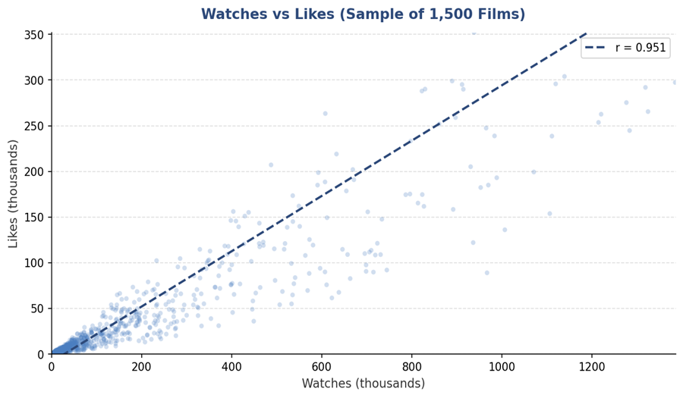
Figure 8 Watches vs Likes (Scatter Plot, n=1,500)

Regression Analysis

A multiple linear regression was performed in SPSS using Average Rating as the dependent variable and Fans, Likes, and Runtime as predictors. The regression equation produced was:

Average Rating = 3.012 + 0.00000327(Fans) + 0.000000776(Likes) + 0.00211(Runtime)

The model was statistically significant (F = 387.4, p < 0.001). The R² value of 0.104 shows that the three predictors account for just 10.4% of the variance in Average Rating. This low explanatory power reveals that film quality, as judged by audience ratings, is influenced by elements beyond quantitative engagement indicators, such as narrative depth, directing style, cultural significance, and critical debate (Holbrook, 1999). Fans were the most powerful predictor (Beta = 0.182, p < 0.001), followed by Likes (Beta = 0.143, p < 0.001), and Runtime was an impoverished but significant predictor (Beta = 0.084, p < 0.001).
The t-test results were further supported by a language dummy variable regression (English = 0, non-English = 1). Original language was a significant positive predictor of average rating (Beta = 0.196, p < 0.001), indicating that language group accounts for a meaningful share of rating variation even when engagement metrics are controlled for.

Insights and Recommendations

This research of the Letterbox Movie Classification Dataset yielded some tangible findings for media and entertainment sector stakeholders looking to use Business Intelligence for strategic advantage.
First, genre targeting is a vital component of platform content strategy. Drama has consistently received the highest critical scores, making it a desirable genre for platforms looking for reputation and quality signals. Nevertheless, the Adventure and Fantasy genres have the biggest audience reach, making them ideal for marketing methods geared at increasing viewer numbers. A balanced content portfolio should include both high-profile dramas and high-reach genre films (Caves, 2002).
Secondly, the high rating premium seen for non-English films (mean 3.51 vs 3.21) indicates that streaming platforms and content commissioners should invest in international cinema. Non-English films not only obtain greater ratings, but they also have a broader cultural appeal and attract interested viewers. The practical recommendation is to increase subtitle availability and localisation investments, as these lower obstacles to worldwide cinema consumption (Waterman, 2005).
Thirdly, the weak correlation among runtime and ratings and engagement shows that runtime optimisation measures, such as imposing severe runtime limitations, may have little effect on outcomes. Content quality and genre choices are more crucial factors. However, interquartile distribution data suggest that an internal runtime standard of 85-120 minutes is largely optimal.
Fourthly, the close connection that exists between watches, likes, and fans emphasises the significance of early audience momentum. Platforms may use promotional techniques, such as
selected homepage placements or editorial newsletters, to promote early viewing for new releases, given that engagement metrics appear to be self-perpetuating.
This analysis has certain limitations. The information exclusively includes Letterbox platform data, which caters to an engaged, cinephile clientele rather than the public. Approximations were required during analysis due to genre encoding (many genres per film saved as lists). Future research should include box office revenue data, critic review scores (e.g., Rotten Tomatoes), and temporal data to allow for time-series trend analysis and more detailed causal models.

References

Anderson, C. (2006) The long tail: Why the Future of Business is Selling Less of More. Hyperion.

Caves, R.E. (2002) Creative industries: Contracts Between Art and Commerce.

Davenport, T. and Harris, J. (2017) Competing on Analytics: Updated, with a New Introduction: The New Science of Winning. Harvard Business Press.

Eliashberg, J. and Shugan, S.M. (1997) 'Film critics: influencers or predictors?,' Journal of Marketing, 61(2), p. 68. https://doi.org/10.2307/1251831.

Field, A. (2018) Discovering statistics using IBM SPSS Statistics. SAGE Publications Limited.

Hennig-Thurau, T. (2006) 'The differing roles of success drivers across Sequential Channels: an application to the motion picture industry,' Journal of the Academy of Marketing Science, 34(4), pp. 559–575. https://doi.org/10.1177/0092070306286935.
Holbrook, M.B. (1999) Consumer value: A Framework for Analysis and Research. Psychology Press.

Litman, B.R. and Kohl, L.S. (1989) 'Predicting financial success of motion pictures: The ’80s experience,' Journal of Media Economics, 2(2), pp. 35–50. https://doi.org/10.1080/08997768909358184.

Loshin, D. (2010) The Practitioner’s Guide to Data Quality Improvement. Morgan Kaufmann Pub.

Resnick, P. and Varian, H.R. (1997) 'Recommender systems,' Communications of the ACM, 40(3), pp. 56–58. https://doi.org/10.1145/245108.245121.

Turban, E., Sharda, R. and Delen, D. (2010) Decision support and business intelligence systems. Pearson College Division.

Waterman, D. (2005) Hollywood’s road to riches.

