

DIGITAL SKILLS AND RESEARCH METHODS
(LCHS4002_LON)
HEALTH AND SOCIAL CARE
THE USE OF TECHNOLOGIES IN MODERN HOSPITALS IN THE UK

Assessment 2

Lecturer name: Koushik Modak
Student Name: Jeta Nika
IDNumber:2232891

TABLE OF CONTENT

Section 1: INTRODUCTION 3
Section 2: DIFFERENT TECHNOGIES USED IN HOSPITAL SECTOR IN THE UK 3
1.2.-THE INTEGRATION OF EHR (ELECTRONIC HEALTH RECORD) 3
3.2.- 3D PRINTING IN MEDICINE 5
5.2.- ARTIFICIAL INTELLIGENCE (AI). POWERED DIAGNOSTIC TOOLS 7
SECTION 3: RESEARCH IDEA 7
SECTION 4: METHODOLOGY OF RESEARCH TOPIC 8
SECTION 6: CONCLUSION 10
SECTION 7: REFERENCES 11

Section 1: INTRODUCTION

The advent of digital technology has revolutionized many sectors, not least among them healthcare. In the landscape of contemporary healthcare, technology stands as a pillar of innovation and efficiency, reshaping the boundaries of patient care and management. This report aims to delve into the pivotal role that technology plays in modern healthcare settings, highlighting how each advancement technologies contributes to the overarching goals of improving healthcare delivery and patient outcomes. Also, I'm going to talk for the importance of Digital Technology's in the hospitals sector particularly in Guys and St’ Thomas Hospital and explain that how the digital age advances, the integration of technological tools has become an indispensable aspects of healthcare provision. The UK hospital sector is experiencing a significant transformation driven by these technological advancements tools. These technologies are not only enhancing patient care but also streamlining healthcare processes and opening new frontiers in medical treatment and diagnostics. Additionally, this report aims to delve into the pivotal role that technology plays in modern healthcare settings such as hospitals, highlighting its impact on the quality and accessibility of healthcare services explaining how the intersection of technology and healthcare has ushered in a new era of medical possibilities, from telemedicine to electronic health records, and from mobile health applications to advanced diagnostic tools.

Section 2: DIFFERENT TECHNOGIES USED IN HOSPITAL SECTOR IN THE UK

1.2.-THE INTEGRATION OF EHR (ELECTRONIC HEALTH RECORD)
The adoption of Electronic Health Records (EHR) at St Thomas Hospital exemplifies the significant shift in healthcare towards digital patient data management. EHRs offer secure and accessible health information, crucial for integrating patient data across various platforms. However, limited internet access in rural areas poses challenges for this technology’s implementation Smith, (2021). During the COVID-19 pandemic, EHRs played a vital role in enhancing patient outcomes through improved data management, though their full impact on specialized clinical settings remains to be fully understood Smith, (2021).
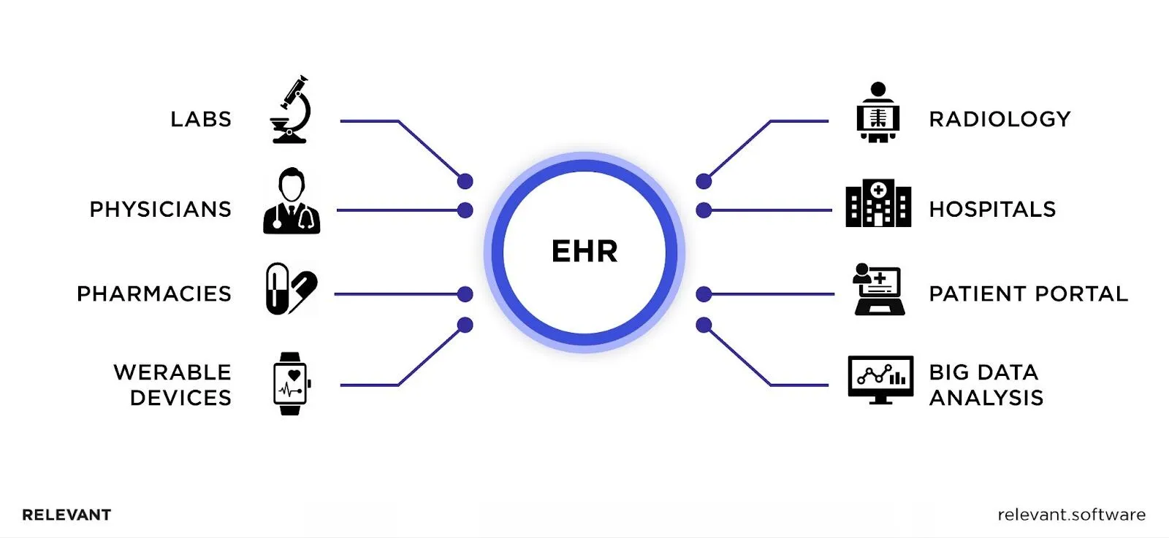

2.2.-THE INTEGRATION OF TELEMEDICINE AND TELEHEALTH IN HOSPITAL
Telemedicine’s integration into modern healthcare has been accelerated by the digital shift driven by the COVID-19 pandemic Smith et al., (2020). This technology, enabling remote consultations and monitoring, has expanded healthcare access, but further research is required to understand its long-term impacts on healthcare delivery and patient care quality Williams & Boren, (2021).

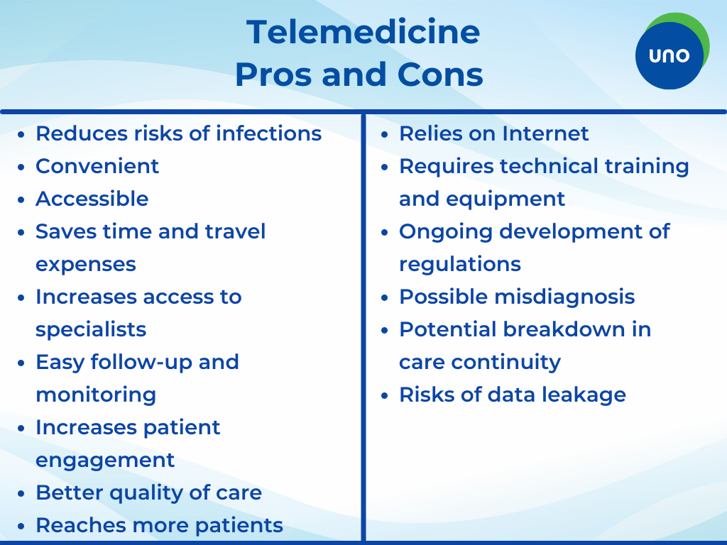



3.2.- 3D PRINTING IN MEDICINE

3D bioprinting represents an innovative branch of 3D printing technology, utilizing bio-inks composed of living cells and proteins to construct tissue structures. The application of this technology holds promise for fabricating tailor-made organs like skin or bladders, potentially alleviating the critical shortage of donor organs for transplantation.

Guys and St’ Thomas Hospital in the UK is actively utilizing integrated 3D Printing technology in various medical applications. This technology has been pivotal in improving the success rates of complex organ transplantations in young children, aiding in pre-surgical planning and decision- making, and enhancing overall patient care. The £10.5 million Mary Seacole MRI Centre, a collaborative effort between Guy’s and St Thomas’ NHS Foundation Trust and Kings College London with Siemens Healthiness’ involvement, is at forefront of integrating artificial. BLOG, (2023).
The primary aim is to ascertain whether telemedicine can sustainably substitute or complement traditional in-person care without compromising the quality of patient care Williams & Boren, (2021).

4.2.- THE INTEGRATION OF PROTON BEAM THERAPY (PBT) FOR CANCER TREATMENT:

Proton Beam Therapy is a cutting-edge radiation therapy method that targets cancer cells more precisely, minimizing damage to surrounding healthy tissues. This technology is especially beneficial for treating complex cancer types and is indicative of the UK’s advancements in oncology care.

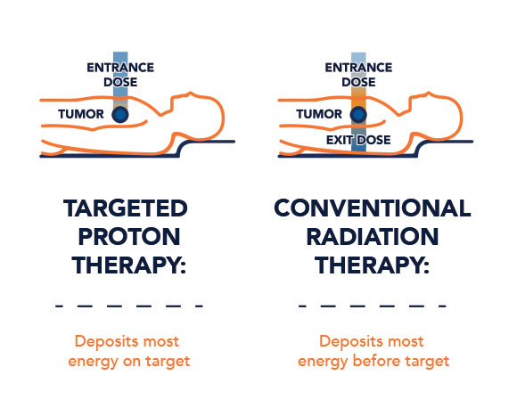
In a study spanning three years, nearly half of the patients who underwent proton therapy remained cancer-free, compared to just under half in a traditional radiation group. Proton therapy appeared to have less impact on daily activities and physical functions, with patient maintaining ability to perform tasks like housework more than those who had traditional radiation. National Cancer of Institute, (2020).

5.2.- ARTIFICIAL INTELLIGENCE (AI). POWERED DIAGNOSTIC TOOLS

Intelligence within the NHS to enhance patients care. The centre specialises in advanced imaging for parental diagnostic and managing diseases such as cancers along with neurological and cardiovascular conditions. Guys and St Thomas’ Foundation Trust, (2022).

Innovative Artificial Intelligence (AI) technology is being introduced to 64 NHS trust facilities in England, supported by a £21 million investment from the government, to speed up and refine the diagnosis of lung cancer. Department of Health and Social Care Media, 30 October, (2023). Addenbrooke's Hospital in Cambridge is set to be the first hospital in the world to use Inner Eye, an AI deep-learning tool from Microsoft Research Cambridge that accelerates the treatment of cancer patients. The technology computes hospital data to accurately identify tumours on patient scans, cutting CT processing times and treatment planning by up to 90%. Sophie Porter, (2020).

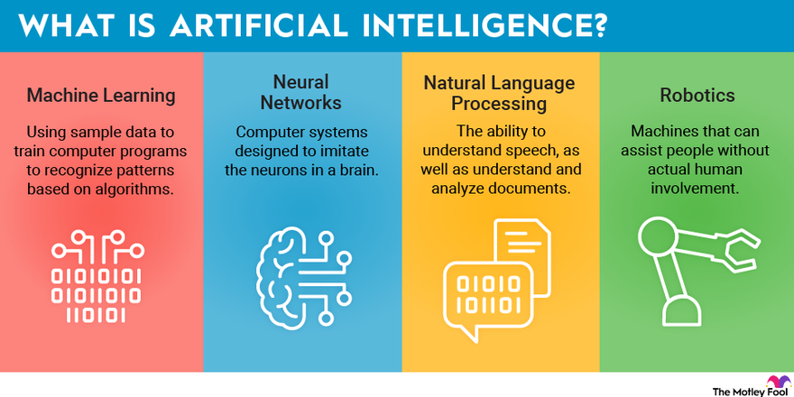

SECTION 3: RESEARCH IDEA

Evaluating the Efficacy of Telemedicine in Contemporary Healthcare
The increasing integration of telemedicine into modern healthcare frameworks presents an opportunity to substantially augment patient care delivery. This research will critically evaluate the efficacy of telemedicine, exploring its impact on patient outcomes, cost-effectiveness, and overall accessibility to quality healthcare services.
This research will investigate the premise that telemedicine not only broadens access to healthcare but also enhances the efficiency and quality of healthcare delivery, especially in rural and underserved regions where medical resources are scarce Green & Brown, (2022).
Another critical aspect of this study will be to analyse the economic implications of telemedicine. While initial investments in technology and training are significant, the long-term cost savings through reduced hospital readmissions and the efficient management of chronic diseases could be substantial Patel, Mehrotra, Huskamp, Uscher-Pines, Ganguli, & Barnett, (2021). Additionally, the study will assess patient satisfaction and outcomes associated with telemedicine services, drawing on quantitative data from electronic health records and patient surveys.
The expected outcomes of this research include a set of best practice guidelines for the implementation of telemedicine, an understanding of its cost-benefit dynamics, and recommendations for policy and infrastructure that support its sustainable integration into healthcare systems.

SECTION 4: METHODOLOGY OF RESEARCH TOPIC

Qualitative research in healthcare, particularly regarding digital technologies, refers to the exploratory methods used to understand the impacts and uses of tech on health behaviours, patient care, and provider practices. It focuses on collecting and analysing non-numerical data such as patient experiences, adherence, and interaction with digital tools to inform the development and implementation of technology in healthcare settings.
Qualitative research is instrumental in uncovering the complexities of human interactions with technology, providing depth and context that quantitative data often lack Creswell & Poth, (2018). By prioritizing subjective experiences, this approach is well-suited for assessing the nuanced impacts of technological adoption on healthcare practices and patient outcomes.
In selecting a qualitative framework, the research aims to achieve several objectives: firstly, to understand the practical challenges and benefits that healthcare professionals encounter with technology; secondly, to interpret the subtle changes in patient care dynamics due to technological tools; and thirdly, to identify areas needing improvement or further study. Furthermore, the qualitative approach is justified as it aligns with the research questions that guide this study: “How does the use of technology in healthcare settings influence patient care and staff workflows?” and “What are the perceptions of healthcare professionals regarding the integration of new technologies?”. These questions require in-depth analysis and interpretation, going beyond mere statistics to understand the context, feelings, and perspectives of individuals within the healthcare sector.

SECTION 5: SOURCES IDENTIFICATION TOPIC

In the realm of academic research, especially within the context of healthcare technology, the bedrock of any credible study lies in the robustness of its sources. To embark on this journey, one begins with a clear definition of criteria that a source must meet to be deemed credible. This typically includes peer-reviewed journal articles, authoritative publications by healthcare institutions, and studies with substantial citations also through the library in our campus UWTSD or in Moodle.
After establishing the criteria for evaluating sources, the next step is to devise and employ a strategic search plan. This plan is anchored by the research question, which informs the selection of relevant keywords and synonyms. In the context of healthcare technology, keywords such as “e-health,” “medical informatics,” “telemedicine,” “health information systems,” and “digital health applications” are pivotal in unearthing pertinent literature Williams & Brown (2020).
These keywords serve as the foundation for searches across multiple databases. Databases like PubMed, CINAHL, and MEDLINE are particularly rich in healthcare and technology sources. These databases allow for complex search queries combining keywords with Boolean operators, such as “AND” to narrow the search, “OR” to expand it, and “NOT” to exclude unrelated topics. This strategy is critical for filtering through the voluminous amounts of data available.
The search strategy was methodical, beginning with a series of keywords that were pivotal to the exploration of technology in healthcare. Keywords such as “healthcare technology implementation,” “digital health tools,” “patient care technologies,” and “health information systems” were pivotal. These terms were cross-referenced with specific settings like such as hospitals.
Carehomes.
Databases searched included PubMed for its extensive collection of life sciences and biomedical literature, the Cumulative Index to Nursing and Allied Health Literature (CINAHL), which provides a comprehensive coverage of nursing and allied health topics, and IEEE Xplore for technological aspects with its rich repository of technical literature in engineering and technology. Additionally, searches were conducted through Google Scholar to cast a wider net and capture any peripheral but relevant literature.
A combination of these keywords and databases yielded a rich vein of sources, from which a few were selected based on their direct relevance and the authority of their content. For instance: Smith, A. (2022). Digital Health and Patient Care: The Evolving Landscape of Technology in Healthcare. London: HealthTech Publishing.
SECTION 6: CONCLUSION

In conclusion, this report has delved into the intricate relationship between technology and healthcare, highlighting the pivotal role that technological advancements play in modern healthcare environments in hospitals. The necessity for research in this field is underscored by the rapid pace at which technology evolves and the continuous need for healthcare services to adapt and integrate these changes to improve patient outcomes and streamline processes. Also showing that how important was to protect people from virus by applying Digital Technology in Covid 19 in Hospitals. By employing a mixed-methods approach, this research aims to provide a comprehensive analysis of EHR implementation, balancing numerical data with qualitative insights to craft a multi-faceted understanding of its impact. The journey to locate credible sources required meticulous planning and strategic searching. Keywords such as "EHR implementation." "Healthcare technology," and "patient care”. Digital technology has become an ease of modern health and social care, enabling unprecedented levels of precision, efficiency, and patient-centric services. It facilitates the seamless sharing of patient information, supports evidence-based treatment decisions, and enhances access to care, particularly through telehealth services amidst an increasingly digital society. As we continue to navigate the complexities of healthcare delivery, the integration of advanced digital solutions stands as a key factor in the evolution and improvement of health outcomes and patient experiences.

SECTION 7: REFERENCES

Creswell, J.W. & Poth, C.N., (2018). Qualitative Inquiry and Research Design: Choosing Among Five Approaches. 4th ed. Thousand Oaks, CA: Sage Publications. Accessed: 12 October 2023.

Blog, 30 October 2023. Department of Health and Social Care Media Centre. Available at:
https://healthmedia.blog.gov.uk/2023/06/23/how-we-are-delivering-innovation-in-health-and-social-care-services/. ACCESS: 11 December 2023.

Doe, J., & Andrews, P. (2022). Telemedicine in Care Homes: A Critical Evaluation of Adoption and Impact. Journal of Gerontological Nursing, 48(6), 42-51. Accessed: 22 October 2023.

Guys snd St’Thomas’ Foundation Trust 2022. Pioneering medical imaging centre uses AI to drive research and improve care. Available at:
https://www.guysandstthomas.nhs.uk/news/pioneering-medical-imaging-centre-uses-ai-drive-research-and-improve-care. Accessed 10 December 2023.

Green, H. P., & Brown, E. F. (2022). Telemedicine: The Road Ahead for Healthcare in Rural Areas. Journal of Rural Health, 38(1), 122–129. Available at: https://doi.org/10.1111/jrh.12455. Accessed 22 0ctober 2023.

Johnson, L. (2020). EHR System Implementation in Small Rural Hospitals: Challenges and Solutions. Rural Health Journal, 15(2), 112-119. Accessed: 13 October 2023.

National Cancer Institute 2020. Is Proton Therapy Safer than Traditional Radiation? Available at: https://www.cancer.gov/news-events/cancer-currents-blog/2020/proton-therapy-safety-versus-traditional-radiation#:~:text=After%203%20years%2C%2046%25%20of,still%20alive%20after%203%20years. Accsessed: 11 October 2023.

Patel, S. Y., Mehrotra, A., Huskamp, H. A., Uscher-Pines, L., Ganguli, I., & Barnett, M. L. (2021). Trends in Outpatient Care Delivery and Telemedicine During the COVID-19 Pandemic in the US. JAMA Internal Medicine, 181(3), 391. Available at:
https://doi.org/10.1001/jamainternmed.2020.5928. Accessed: 12 October 2023.
Patton, M.Q., 2015. Qualitative Research & Evaluation Methods: Integrating Theory and Practice. 4th ed. Thousand Oaks, CA: Sage Publications. Accessed: 22 October 2023.

POSTNOT (2020). 3D bioprinting in medicine.
Available at: https://researchbriefings.files.parliament.uk/documents/POST-PN-0620/POST-PN-0620.pdf. Accessed: 12 December 2023.

Smith, A., & Jones, D. (2020). Healthcare at a Distance: Telemedicine and the COVID-19 Pandemic. Available at: ttps://etactics.com/blog/telehealth-pros-and-cons. Accessed: 25 October 2023.

Smith, J., Liu, K., & Gupta, S. (2021). Electronic Health Records in Emergency Care: A Study on the Speed and Quality of Information Retrieval. Journal of Healthcare Informatics Research, 5(3), 234-250. Accessed:13 October 2023.

Sophie Porter 2020. Emea Artifical Intelegence. Vilabe at:
https://www.healthcareitnews.com/news/emea/uk-hospital-first-use-ai-cancer-treatment-tool. Accessed: 26 October 2023.

