Daniel Rotheram Dissertation
P140999
Digital Film and Television Production
School of Film and Digital Media
University of Wales Trinity saint David

Analysis of reflective editing and how it is used in film and television industry
What is the importance in reflective editing, why do we use it?

Introduction

Editors, Reflection, Idea, Revolution. Why do editors need to be reflective, what is the meaning of it? This dissertation will look into why editors need to be reflective in their work and how it is important to be reflective. Research into the role and into case studies of other editors and will attempt to understand the meaning. This dissertation will also incorporate findings of research into my own editing practice and will decide on how I will edit my work differently in the future. Editing is a gift, a pleasure, they are the last point between cutting room and the audience, without reflection everything will be the same, same techniques, same structure, no difference. The main question this dissertation will ask is, why do we have to be reflective?

Being a keen editor learning about reflection is very important for a role in the film and television world. Getting to know my past techniques that was used, and learning how to develop new ones. Using the research this dissertation gains the plan is to decipher the information and transform it to better understanding, learn about other editors and how they prepare work and what they have to say about it.

Chapter 1
Editing as a reflective practice

An editor is defined as ‘someone who edits especially as an occupation; a device is used in Editing motion-picture film or magnetic tape” (Merriam-Webster, 1828). The term editing was brought into being in the 1640s, and comes from Latin meaning “one who puts forth… to bring forth, produce (Harper, 2001). Within the genre of film an editor, a person who assembles a sequence of video clips to produce a short narrative piece of art. The film editor who works as a head of department in a film production, responsible for the final edit of a film. An editor could be considered as the final point between the cutting room and the audience. Most people an understanding of what it takes to create a professional film, it involves many people at a given time to produce it. But aside from this rarely we pay attention to names at the beginning and the end of a film e.g. directed by, film by. Stop and think on how an actor's performance can differ from theatre to screen. There is a medium for acting, that is called theatre, but there is also a medium for a film editor and that is called film (Reed, 2012)
At its most basic form, reflection is the mental process fundamental to learning, which requires the application of either an outcome or purpose; sometimes both (Ayas & Zeniuk, 2004; Moon, 1999). Research around reflection and reflective practice is vast and in some ways varied, but all adhere to similar underpinning principles such as understanding and development of skills. Raelin argues that reflection as a process provides an action plan for future development, that we are unable to learn unless we are consciously aware of the consequences (Ayas & Zeniuk, 2004).
Leading theorists in the field of reflective practice have identified five key areas which determine the purpose. Firstly….
”Reflection in the context of learning is a generic term for those intellectual and affective activities in which individuals engage to explore their experiences in order to lead to new understandings and appreciation” It may take place in isolation or association with others (Boud, Keoh & Walker, 1985, 19).

Understanding how reflection works is noticing the changes in methods from time to time, reflection in a way is a key aspect to life. Giving people and workers a keen understanding of how life evolves, without reflection life would not be able to evolve as people would not be able to develop new technologies. Reflection is the reason that we as humans can travel to space, dive under the sea, dig into the ground. Reflection is the starting point of life; without it we would be nothing. “Reflective action is bound up with persistent and careful consideration of practice in the light of knowledge and beliefs, showing attitudes of open-mindedness, responsibility, and whole-heartedness”(Hatton & Smith, 1995, 35) Showing viewers a new way of editing is key for a successful film, working on film using reflective practice is fundamental for emotion in a film, editors would use the skills they have developed from past films to improve the next, watching films these days have a vast emotional side of it, an example of this would be in a sad scene in a film, the editor may have edited this by using a sad memory, being reflective from this memory would make a good scene, as it uses true emotion rather than a technique. Sometimes reflective editing is key when editors use silence to edit the film, rather than normal. Editing may be a job, but it is one of the most important jobs in the industry.

Editing in general is important but editing as a reflective practice is most important. Understanding how people develop ideas, techniques is very important. Most people do not understand how editors work; they don't know how long they work and what their thoughts are while they are editing. Getting to know an editor may be quite difficult as they like to keep themselves to themselves, but a few editors have published their own stories about how they work online, editors like Joe Walker, and Sally Joanne Menke. These editors worked on films like ‘12 Years a Slave’ 2013, ‘Arrival’ 2016 and ‘Pulp Fiction’ 1994. Walker continues to work on films while sadly Menke passed away in September 2010. Bur her ideas and techniques still go on to this day, people have been working on films that have the same look and feel that Menke edited, thus showing that her work continues to encourage others to follow in her footsteps, her ambition continues.

What is the role of a film editor?

In film and television, an editor is defined as one of the key heads of department responsible for assembling and grading a film piece using specialised software or hardware. “Editors are one of the key Heads of Department on feature films, responsible for First Assistant Editors, and on bigger productions, Second Assistants and Trainees.” (Creative Skillset, 2017)

A film editor is the last point between the cutting room and the audience. Editors work long hours in a dark cutting room trying to gain the best possible outcome for an edited piece of work. By working very closely with Directors to gain the feedback to their reflective piece of work, the role of an editor requires a good amount of reflection. The use of reflection in the editing process allows the editor to accomplish self-emotion to the edited piece of work, this would help bring the audience closer to the story within the film.

“Reflective practice is “a process, incorporating a range of different techniques, through which one can acquire a deeper understanding of oneself and one’s interconnections with others and one’s working environment.” (Bolton, 2005)
The older way of editing used a device called a moviola a device used in the early 1900s to cut up and edit individual clips into a narrative edit.

Editing in the past

In the 1920s a moviola A device which reproduces the picture and sound of a film on a small scale, to allow checking and editing (Oxford Dictionaries, n.d.). This device cuts a 35mm film reel at specific points to allow them to be cut up into a narrative piece.

At this point of time methods like, computers and editing software was non-existent. Physical cutting of film reel was the only way the editor can piece together a film. Editors would have to work very long hours and handle miles’ worth of film reel, the job was very demanding and editors worked for a long time physically cutting the film at specific point to ensure the edit is seamless. Development of new editing methods shows how reflecting upon the methods in the past has an effect on modern editing techniques. This shows on how development has revolutionised the way that editors work. With the invention of computers and editing software. They all had to come from somewhere. Without reflection, there won't be any editing software as nobody would have the idea of creating it.

Editors need to be reflective in how we think and how we produce work, film editors use reflective editing to provide their emotional input of the final film. Without this, edited narrative pieces will become bland and boring, the use of reflective editing helps make the films more interesting to watch. Thus, being said editing has been around for a very long time and also has reflective work. Editors are one of the key points in film-making being the final point between the cutting room and the audience.

There are two key theories or reflective cycles which come to mind when considering reflective practice; Kolb’s experiential learning cycle and Gibbs’ Reflective Cycle. Kolb states that learning involves the acquisition of abstract concepts that can be applied flexibly in a range of situations. In Kolb’s theory, the impetus for the development of new concepts is provided by new experiences. (McLeod, 2010)

(Mcleod, 2010)

Experimentation (planning/trying out what have you learned)
Experience (doing/having an experience)
Observation (reviewing/reflecting on the experience)
Conceptualisation (concluding/learning from the experience

Gibbs reflective cycle

The Gibbs reflective cycle wants people to think about the stages of an experiment or activity, through using his cycle to put together your reflection. The clever way that the cycle can be used on your work is by making the practitioner think at the parts of the work that he has done and makes him/he think of what could be change or what can be added. (Gibbs, 1988)

(Oxford Univeristy, n.d.)

How could these be used by editors to encourage reflective practice?

Editing using these theories can help editors may help them be reflective in way that helps them see how their work has progresses and how they can develop them. An example of this would be Joe Walker with his editing in reverse experiment. In a way, he is using Kolb’s learning theory to develop this. With the creation of these cycles editing in itself has changed, allowing editors to be more reflective and help them develop editing skills by using different methods, learning from the development of techniques editors can also encourage others to use the techniques derived from other editors by allowing them to work from developed techniques. The future of development relies on reflection this would help other editors follow the same footsteps of their peers, allowing them to develop their own techniques in editing. (English, 2005)

To be reflective an editor must adhere him/herself to the idea of self-development, changing the way they work in terms of what techniques they use and how they use them. Most editors use software to edit their work but there are many software’s out there, e.g. Adobe Premiere Pro, Avid, Final Cut Pro etc. Editors chose their platform on how they feel about it.

Learning from being reflective

Reflective practice is a way that people learn from their own activities and experiments, and how improvements can be made for a better outcome, film editors must be reflective to tackle the issue of repetitiveness, this would help them be original in the work that they do, let them be open minded. As a reflective practitioner, the editor has one of the most demanding role in the film industry. They are the creative mind that will bring a film to life.

If an editor was not to be reflective films and television shows would be bland, as they would all use the same editing style. Editors use their own personal experiences to make the edit more interesting, as being a reflective practitioner, it would help them be more confident, proactive. Following a process of six steps would help provide a better understanding on being reflective.

Gibbs’ reflective cycle

Description - What happened?
Feelings - What did you think and feel about it?
Evaluation - What were the positives and negatives?
Analysis - What sense can you make of it?
Conclusion - What else could you have done?
Action Plan - What will you do next time?

Reflection is arguably one of the most important parts of life and how we can improve on our work as well as our personal life. There are numerous ways to reflect on life and work, reflection is an essential part of everyday life in many aspects as illustrated below by William.P. Quigley in the DePaul Journal for Social Justice, in order to do social justice for life, reflection is an important aspect of it, regular reflection is vital for a person’s quest for justice in terms of physical and mental health. For some people, it is prayer and for others it is meditation (Quigley, 2007)

This explains how reflection has a positive effect on social life, reflection is used in many different forms. It is used as meditation as well as a reflection of work following the careful and considering thinking of the work that was undertaken.

“Reflective practice is “a process, incorporating a range of different techniques, through which one can acquire a deeper understanding of oneself and one’s interconnections with others and one’s working environment.” (Bolton, 2005)
The older way of editing used a device called a moviola a device used in the early 1900s to cut up and edit individual clips into a narrative edit.

Chapter 2
What is reflective editing? Why do you need to be reflective? What purpose does it serve?

Joe Walker

Joe Walker, is a well-known British Film Editor currently working in Los Angeles, California known for his work on ‘Arrival 2016’, ‘Sicario 2015’ and ‘12 Years a Slave’ 2013, Walker is a well accomplished editor with over fifty credits to his name. (Walker, 2016)

Walker describes that if something does not work in your edit and says that it could be down to a few things, invention lies in finding the problems, truly seeing and analysing them. Walker describes the best way to get out of this mess is to view the film on a regular basis, this shows how regular reflection of work is vital for development. At first Walker views the film himself to help find any flaws and to do any adjustments in the film before showing it to his peers to for further feedback. (Walker, 2016)

In an interview Walker mentions that he has been developing a new technique that he has tried using, which entails that he will be editing in reverse. By this Walker will be assembling a scene from a film and attempts to edit it in reverse. Walker uses this method because of past experiences in his days working with the ‘BBC’ hand-cutting film- being a meticulous process this taught Walker that attention to detail is absolutely necessary. (Elwyn, 2017)

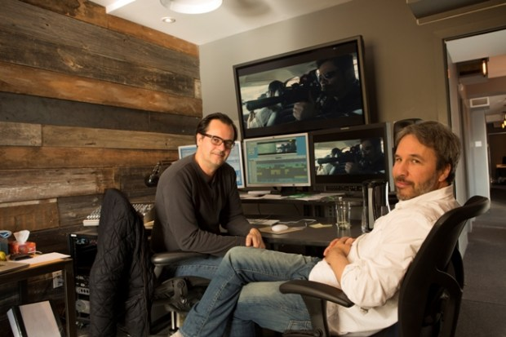
(Walker, n.d.)
Walker explains that he separates himself from the editing software and uses a physical wall to create a somewhat mood board structure to his films. Even though this method would us a considerable amount of time, but it would also be more effective in terms of the organization of scenes. Walker explains that he had to go through over 4500 hours of footage and shaping them into a clear structure before jumping onto the editing software. (Walker, 2016)

Walker suggests that editing without sound lets you discover the rhythm of the films. He mentions that he edited parts of the film Sicario with the sound muted, and he tries to keep the edit music free for as long as he possibly can. This suggests that editing without sound lets the editor better discover the style of the film, makes it simpler to put together.
Editing sometimes works better without a meaning as mentioned by Walker “Occasionally, let the film take a break from logic” (Walker, 2016).

Walker suggests to all editors that they must buy themselves a set of playing cards printed with “thought-provoking aphorisms” (Walker, 2016). Walker mentions that he has two favourites in particular, they are, ‘Emphasize differences’ and ‘What wouldn’t you do’. Walker had learned when he was working as a composer that sitting in front of speakers listening to the same beat is useless, he suggests that you will get a better idea when you hear the music through a different method e.g. Outside, in a large hall. This shows how Walker worked in terms of sound, using headphones has a different effect on how the sounds are heard rather than listening through a set of monitor speakers. (Walker, 2016)

By placing speakers in different locations, the sound will give off a different feel. (Walker, 2016) Walker describes that using different sound methods in different locations would change the feel of the sounds, this would change because of the different acoustics in the room and it depends on the room size and other variables. Walker likes to make sure that his work is precise in regards to where the cuts are placed and to ensure that the work is produced to a professional standard, ensuring that all the work is flawless.

Sally JoAnne Menke

Sally JoAnne Menke, Was the film editor that edited all the Quentin Tarantino films, up until her death in 2010. Menke graduated from the New York University Tisch School of the Arts.

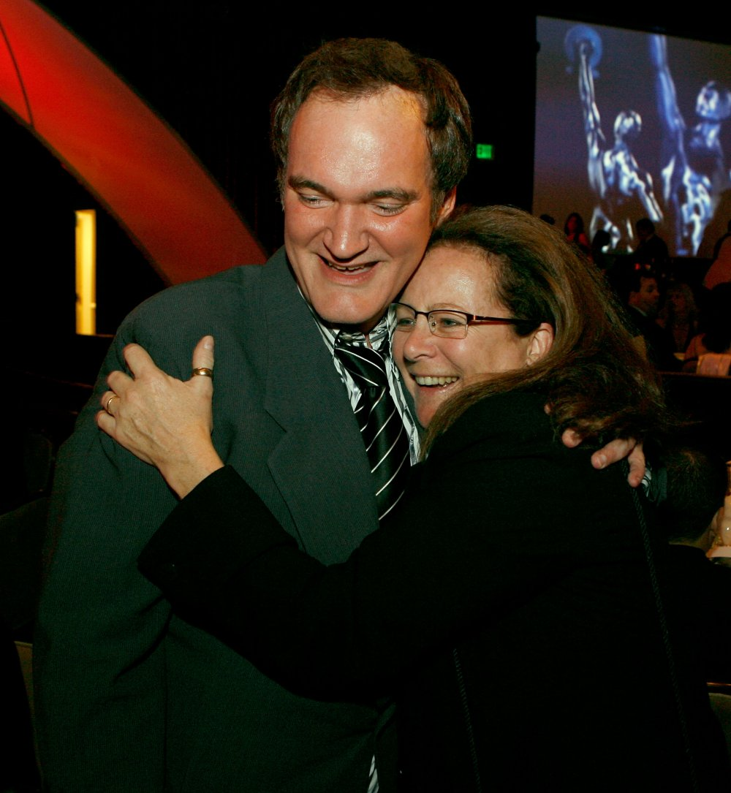
(Gilbey, 2015)

Working on films by Quentin Tarantino she uses similar techniques as of Joe Walker. In a statement, she said that she edits the films in mute and refers to the visuals to guild her through the editing process. Even though Tarantino’s films are very much music based, she added the music at the late stages of post-production alongside Tarantino, this shows that ideas developed from being reflective can be passed on from editor to editor, even though this is not always the case where editors can create ideas that are similar but not identical to each other. ‘Sally worked on other films with other people as well as Tarantino, she worked on films like All the Pretty Horses and Daddy and them and many more. Menke tried to make all of the films she worked on look professional’ (Gilbey, 2010).

Chapter 3
My own Work as a reflective editor

Being Reflective in my work

Learning from research, it has come to my attention that using different editing techniques is paramount to the success of a film. As suggested by Julian Webb “Experience is valuable in helping us to reflect on how we learn- particularly on how, as learners, we experience the interplay between cognition and metacognition” (Webb, 2006, 151) Using some of the techniques mentioned by Joe walker it would become simple to edit using emotion rather than the norm. David Boud mentions that ‘the effects of reflection can help change the way of doing something developing a set of skills of a skill’ (Boud, 1985:34). Editing using this method would put the editor in the shoes of the viewer. I believe that developing my future editing projects will help me understand and develop my knowledge and experiences. Reflecting upon the works of other editors would help me discover a fundamental way of editing, using different software, weather to edit in the dark or in silence. “Reflective practice begins “where practitioners are problematizing their practice and learning afresh about knowledge and skills and attitudes that their practice demands” (Schӧn, 1983,31) Using these techniques I can build a better understanding of the technological change editors go through every time they go to work. I have learned that difference is important. Editing in my own personal way would be beneficial to my own experiences and development. As Mentioned by Donald A, Schon “Reflective Practice is “a dialogue of thinking and doing through which I become skilful” (Schӧn, 1983:31). this shows how being reflective can help a person be more skilful in what they do, reflection is the key part of success.

Reflecting on my own work would help me gain more knowledge on the skill of editing. Learning net techniques will help discover hidden talents and have a better understanding of technology and how things work. “...Reflective practice as its best is neither just a set of operational techniques nor only a clarify identifiable group of academic skills, but is rather a critical stance” (Johnston & Bradley, 1996, 66). Being reflective in a way would help change my perception of how things work and how I use them. “Willingness and desire to subject their own taken for granted and their own activities to serious scrutiny” (Johnston & Bradley, 1996, 10).

What was done differently?

Re-editing a piece of work, I have reviewed over my past reflection and have attempted to re-work a piece of film that was created in 2017. By analysing my work thoroughly, it has come to my attention that alterations to the music specifically in terms of the music to movement relationship, keeping the audio and video in same sync to each other, and possibly add some new shots of the area that was being filmed to have a better establishing clip I believe would be beneficial to the overall feel of the film. Had this been done sooner the final product could be more effective in terms of marketing and reaching the audiences, and also help give emotion to the viewers. By re-editing this piece of work, I have gained knowledge of different techniques that I could use on future projects, I have learned that a true understanding of your goals is key to a perfect film.

By saying this my lack of encouragement on projects similar to this had me thinking that prior preparation prevents poor performance, preparation for the project e.g. research, would have been beneficial to myself as a thorough understanding of the topic would help me have a better understanding of the topic in question. Therefore, with better understanding will mean better performance.

On this piece of work that way that it has been edited differently is better consideration on where the shots will go, better placement of the shots meant that it will help the audience feel the rhythm of the edit. Prior to this change, the edit was bland and boring. Receiving feedback from the first attempt of editing my work proved useful as the opinion of outside sources are a vital part as they would see the product through the eyes of the audience. Alongside each other development to my edit has helped me gain more knowledge in the area and will assist me in progressing in my next film. Even though I’m reflecting on an edited piece of work, this may help on any future practical work.

Conclusion

This dissertation conducted an investigation into how the role of an editor is a reflective practitioner, the goal was to discover and get a keen understand of why an editor should be reflective in their work. This dissertation only partially met that goal and no full understanding was accomplished, this dissertation lacked in the research and time. If this dissertation was to be completed again, more time and effort would be put into place to discover the reason why editors must be reflective in their work. This dissertation has learned that reflection is not only used in editing, but is used in everyday life, life would be very broad without it. There will be no development and no accomplishment to life. Reflection is vital for a smooth running of lives.

Reflection is how we as people have developed our technologies, built our homes, grown our communities, got to know each other. Reflection is the main reason that the world is what it is like today. Without it, we would be nothing, humans have evolved from the stone age to today. From creating the wheel, to creating a bike, from using a brick to an iPhone, from Post Cards to ‘Facebook’ being reflective plays a big part in the development of life. It is important, it is life changing. It has come to light that editors in the 21st centenary don’t only reflect on their own work but may also reflect on the work of others. Editors sometimes work closely with each other and will reflect on the work of one another, editors gain more experience this way. This dissertation has also shed a light on who and what editors are.

Through the research findings on editors and who they worked with have come to light. Knowing that Sally Menke worked on all the Quintin Tarantino films was unknown before this dissertation had begun, the same with Joe Walker with editing backwards as a technique in film editing. Getting to know these editors shined a light on how my work as an editor will change over the next coming years. By using the techniques that they have developed, new techniques may rise from them, showing reflection and how development in ideas can make a difference

Bibliography

Books

David Boud, Rosemary Keoh and David Walker, eds., Reflection Turning Experience into Learning (New York: Kogan Page Ltd., 1985) at 19

Leona English, ed., International Encyclopaedia of Adult Education (New York: Palgrave, 2005)

Neville Hatton and David Smith, “Reflection in Teacher Education: Towards Definition and Implementation” (1995) 11:1 Teaching & Teacher Education 33 at 34

G, Gibbs., 1988, A Guide to teaching and learning Methods. Further Education Unit. Oxford Polytechnic: Oxford.

Oldham, G., 1992. First Cut: Conversations with Film Editors. Los Angeles: University of California.
Pepperman, R. D., 2004. The Eye is Quicker. Studio City, CA: Michael Wiese Productions.

Quigley, W. P., 2007. Letter to a Law Student Interested in Social Justice. DePaul Journal for Social Justice, pp. 23-24.
Reed, C. L., 2012. Film Editing Theory and Practice. Dullas, VA: Mercurey Learning and Information LLC.

K.Ayas & N Zeniuk, “Project-based learning: Building Communities of Reflective Practitioners” in Christopher john Gray & Elena Antonacopolulu, eds., Essential Readings in Management Learning (Thousand Oaks, CA: Sage, 2004) 271 at 272

Jukian Webb, “ The Ambitions Modesty” of Harry Arthurs’ Humane Professionalism” (2006) 44 Osgoode Hall L.J. 119 at 151

Donald A. Schon, The Reflective Practitioner, How Professionals Think in Action (New York: Basic Books Inc., 1983) at 31.

Ron Johnston & Graham Bradley, “The Commitment Reflective Practitioner: Innovation and Learning in Education” (1996) 2 int J. Reflective practitioner 4 at 10

Online

Elwyn, J., 2017. Video Editing Tips and Tricks from Oscar-Nominated Editor Joe Walker. [Online]
Available at: https://www.premiumbeat.com/blog/arrival-editor-joe-walker-editing-tips/
[Accessed 20 December 2017].
Gilbey, R., 2015. Sally Menk, 1953-2010. [Online]
Available at: http://www.bfi.org.uk/news-opinion/sight-sound-magazine/comment/obituary-sally-menke
[Accessed 20 December 2017].
McLeod, S., 2010. Kolb - Learning Styles. [Online]
Available at: https://www.simplypsychology.org/learning-kolb.html

Walker, J., 2016. Moviemaking. [Online]
Available at: https://www.moviemaker.com/archives/mm_guide_2017/getting-unstuck-arrival-editor-joe-walker-objectivity/
[Accessed 13th December 2017].

Bolton, G., 2005. Reflective Practice: Writing & professional development. 2nd ed. thousand Oaks, California: Sage.
Creative Skillset, 2017. Editor. [Online]
Available at: http://creativeskillset.org/job_roles/2940_editor

Oxford Dictionaries, n.d. Definition of Movieola in English. [Online]
Available at: https://en.oxforddictionaries.com/definition/moviola

Images

Oxford Univeristy, n.d. Gibbs Reflective Cycle. [Online]
Available at: https://www.brookes.ac.uk/assets/0/1425/1426/2147485178/2147490135/96de2a2f-36ab-4816-835f-7bcfd9202abc.gif

Mcleod, S., 2010. Kolb - Learning Styles. [Online]
Available at: https://www.simplypsychology.org/learning-kolb.jpg
McLeod, S., 2010. Kolb - Learning Styles. [Online]

Walker, J., n.d. Edited Yourself into a Hole? Use Arrival Editor Joe Walkers Tricks for Getting Unstuck. [Online]
Available at: https://www.moviemaker.com/archives/mm_guide_2017/getting-unstuck-arrival-editor-joe-walker-objectivity/

Gilbey, R., 2015. Sally Menke, 1953 - 2010. [Online]
Available at: http://www.bfi.org.uk/sites/bfi.org.uk/files/styles/full/public/image/sally-menke-001-with-quentin-tarantino.jpg?itok=Esbj6HKn

