

Name: Charles Uzor
Student Number: 1809185
Course Title: Managing Projects in the Organisation
Course Code: BMSK 5104
Tutor Name: Dr Kenny Tang

Statement of Confirmation of Authenticity
By the act of making this submission, the student declares that this is the work of the student named above. The work has not, in whole or in part, been knowingly presented elsewhere for assessment, or where assessment has been built on a previous assessment, this has been identified. Where materials have been used from other sources it has been properly acknowledged. If this statement is untrue, the student acknowledges that an assessment offence has been committed.
Attention is drawn to the plagiarism and unfair practice policies of both the University and of ILM.

Contents
Introduction: 3
Section 1: 3
Project management Tool and Techniques 3
Project management Techniques: 4
Traditional Project Management: 4
Agile project management: 5
Lean Project Management: 5
Six- Sigma Project management method: 5
Project Management Tools: 6
Planning: 6
Project Risk management: 7
Project Time management Plan: 8
Section 2: 9
The BBC Worldwide Structural and Organisational Change Project Implementation: 9
Kotter’s Eight Steps Change Model Applied to BBC Worldwide Change project 9
Greiner Lifecycle Model: 10
Stakeholder identification: 12
Organisational Stakeholder: 13
Stakeholder Mapping: 13
Section 3. 15
Project Implementation Reflection and Action Plans: 15
Gibbs Reflective Cycle 15
Belbin Team Work Skill: 17
Personal Development Plan: 18
Conclusion: 18
References 19
Appendix 21
Appendix 1 21
Project Management Approach Comparison and Usage 21
Appendix 2 22
Kotter’s Eight Steps Change Model Applied to BBC Worldwide Change project 22
Appendix 3 24
Personal Development Plan. 24

Introduction:

Every individual or organisation have undertaken some sort of a project in other to accomplish a purpose or objective. Regardless of the size, all projects have a purpose or a mission, which is to solve some problem or create an opportunity for a client (Maund, 2018). Project owners play a key part in determining how successful a project is, more so project purpose is built around the owners and other important stakeholders. Project managers need to follow a structured approach in other to achieve the project mission in the most effective and efficient way.
This is where project management methods and techniques come in. These methodologies have been developed over time and provided organisations frameworks used today to execute projects known today as project management tools and techniques.
British Broadcasting corporation (BBC) are looking to restructure the organisation, changing from a divisional to geographical lines of management, with main purpose of increasing overall revenue, whilst making the organisations more dynamic and in a better position to capture future growth opportunities around the world (CIPD, 2015). This report will seek to evaluate the processes adopted by the BBC during the project implementation, to determine if the project scope and mission as set by the management reorganising committee were achieved.
This report will further evaluate the usefulness of project management tools and key considerations organisation should make when applying these tools and techniques for the purposes of making decisions.

Section 1:

Project management Tool and Techniques

Several literatures defined a project as being a temporary, unique and progressively elaborated work, undertaken to create a unique product or service (Rosenau, 2005). Every project has a definite start point and must end at a point. At the inception of a project, the owners will usually communicate the project mission, which is what the project is trying to achieve, the project general direction and overall aims. This is known as the project mission statement (Maund, 2018). All projects begin with some sort of a mission statement or intent from the project owners. The project leaders or managers develop the project around the mission statement and use this statement to identify needs, opportunities, interests and overall direction the project is to take.
Before a project can commence, certain important considerations must be made. These considerations are based on key attributes within the mission statement centred on efficient delivery of a project. These are project scope, risks, cost controls and stakeholders concerned. Applying these considerations within a structured approach is what is known today as project management method and techniques.
A project is considered successful if these aspects are efficiently managed during a project, ensuring they remain low and flexible enough to cope with any changes that occur during the life span of a project (koskela, 2000). It is based on the consistent failures around these key factors that new project management methods emerged, which now have in built capabilities to track and monitor a project and led to operational excellence techniques such as Lean and Agile (Vittorio, 2019).

Project management Techniques:

There are several ways in which projects are managed, but very few of these methods have made it to internationally recognised standards. The more well established project management techniques are the traditional, Lean, Agile and Six-Sigma. These techniques were developed to manage specific type of projects were more traditional project management techniques are considered inefficient but can also be applied in conjunction with other Project management methods. The Project management institute, which is the recognised body responsible for project management standards, defines project management methods as a set of techniques, procedures, rules, template and best practices used on a project (Project Managment Insitute, 2009).
A project management technique can be said to have a perspective or iterative approach and depending on which is applied with determine how in depth the various tools are applied (Vittorio Cesarotti, 2019). A perspective approach style of Project management will be traditional project management techniques, where the approach involves the sequential definition of task, detailing the life cycle of a project, structured as a sequence of phases, allowing for no changes to the project and deliverables once established. In this instance, the planning of cost and time are determined from the specification of the deliverables.
An iterative approach to a project, requires for quick assembly of the deliverables and further finishing them through repeated cycle of improvements. This requires extensive team work and collaboration with stakeholders and is controlled by contractual times and costs. It is a highly flexible approach, allowing for changes and revision of the project and characterises Agile and Lean methods of project management.

Traditional Project Management:

Traditional project management is a methodology applied where a project is deemed to have predictable, linear and clearly defined boundaries. It is the most common method of project management around and offers an easy to follow steps from inception to finish. The main concern of this method is optimization of cost, time and delivering the project within planned time, budget and scope (Vittorio Cesarotti, 2019). Traditional project management takes into consideration all processes, mechanisms and guidelines as identified and set out by the project management book of knowledge (PMBOK), (Project Managment Insitute, 2009). The processes include, defining and authorising, planning, executing, controlling and monitoring, while integrating the tools required which are, project scope, schedule, cost, quality, resources, communication, risk management stakeholder management, and procurement (Mirzaei, 2012).
Traditional project management can be said to be document driven and most at use where formal documentation is used to manage large complex processes, which occur in a predictable way and the outputs are easy to be verified. An example will be, many sales organisations use traditional projects management methods in managing new sales contract implementations, where there are multiple sales, delivery and supply points. This is because the process is expected to have a definitive outcome and the organisations uses all the tools to monitor progress made at various stages of the sale process, ensuring the sales process cycles are completed and desired objectives are met.
A sale exec pitches to a new customer about a new product or service, within this is the project mission which is the sale of the product or service and conversion of the prospect to a customer. The key processes involved in the sale are already predetermined and authorised by organisations, providing the allowed scope in which the sale is conducted, and the tools allow for easy implementation of the agreed sales term, providing control, monitoring and review of the entire process.

Agile project management:

Agile project management techniques is a techniques developed specifically for managing software and similar technically related projects (Highsmith, 2001). Like similar software related project management techniques, its adaptive characteristics allows for short lifecycle, frequent relations with customers and constant learning. This method of Project management is used with complex projects requiring quick agile responses, with organic self- organised teams with simple rules, open information sharing and adaptive leadership (Agustine, 2005).
Agile project management method is characterised by steps such as Guiding vision; recognises shared project vision amongst team member; small team sizes, simple operational rules; free flowing of information within team members, with collaboration and communication key to quick project turn around; and supervision only necessary to balance risk and maintain project boundaries. This method of project management will be appropriate IT departments designing short programmes to support operational activities within organisation.

Lean Project Management:

Lean project management method focuses on increasing value to a project. The method is concerned with minimising waste and maximising value. It is used in conjunction to other project management methods and its often considered the engine of innovation in project management due to its nature of reorganising the common structure of knowledge sharing in PM, relationships in knowledge sharing, with an ultimate view to improving project time and resources (Reusch, 2013). Lean method is commonly used in manufacturing industries where production processes require to be constantly improved and managed in other to achieve the highest possible efficiency
The main difference being in the definition of phases, the relationships between the phases and participants in each phase. A project like managing a production process, is viewed from aspects of design, operation and improvement of production systems, where operation is about planning, controls and correction. The correction may entail changes to the means or objectives pursued (Koskela, 2002).

Six- Sigma Project management method:

Six-sigma project management technique is method driven by data for improving products, processes, and is geared towards eliminating defects. Like other project management methods, six-sigma is a systematic data driven method that incorporates all project management concepts, and uses PMBOK planning, organising, managing, and controlling methods (Jainendrakumar, 2008, Vittorio Cesarotti, 2019).
The six-sigma project management method is implemented to fix a defect on an existing product, where the product does not meet the client’s specification. It can also be used in the design of new products or services and applied to projects in phases. An example of where six-sigma will be used may be in a manufacturing process where the production out-put cost is higher that the originally forecasted, this method will be applied to define, measure, analyse and implement controls in other to rectify the error (Jainendrakumar, 2008).
See Appendix 1 Project Management Approach Comparison and Usage

Project Management Tools:

Regardless of what technique is applied, project management tools are fundamental, as they provide a structure on which projects are completed. These tools cover the key parts to project management which are Planning, implementation, monitor and controls.

Planning:

Project planning is an important stage of a project. This stage starts from when the project objectives being established. It involves detailing all deliverables, identifying resources required and allocating time and costs to all resources required for successful delivery of a project. Within these processes are:
- Forming a Team: Create a team with adequate experience in all areas of the project, ensuring the chosen team members are compatible and have the right experience and will be available for the entire duration of the project.
- Statement of Work: Details, reason for the project, what work needs to be completed for the project to be successfully delivered. The customer, stakeholders, costs and budget, deliverables, measurables, risk and communication plan.
- Work Breakdown Structures: Details the activities and tasks of the project, in order of completion, responsibilities, highlighting all dependent levels and allocating time frames and monitors to each level.
- Project Schedule: Provides schedules for completing various stages of the project. Detailing the order, the project work is to follow in the most cost efficient way and minimal risks.
- Resource Plan: Identify all the resources required for the project, ensuring that the resources will be available for the project at the required time and detailing communication and alternate arrangement plan should the primary options fail.
- Budgets/ Costs: Allocates costs to all aspect of the plan, ensuring the cost stays within the budget scope. This is then used to monitor expenditure during the project ensuring the project stays within budget.
- Risk Plan: Details all risk factors considerations throughout the life of the project and identifies how to mitigate any risk to the project.
- Communications plan: Details the channels of information flow within the project, highlighting strategies and important communication points such as stakeholder’s communication, and other project updates.
- Quality Plan: Details minimum standards to be achieved at every level of the project as required by the Statement of work
- Verification and Validation plan: used by project managers to verify the project outcomes ensuring they meet all aspects of the requirements of the project.
(Project Management Institute, Inc., 2017).

Project Risk management:

Risk is an unwanted event that has a negative consequence in any process (university of wales trinity st davids, 2020). Project risk management is critical to project sustainability. It is the art of identifying, analysing and responding to risk factors throughout the life of the project and is in the best interest of the project (Project Management Institute, Inc., 2017). Risk management plan should include different levels of communication responses in an event of a risk occurring.
Project risk management involves:
Risk Plan:
- Identifying the risks; these are things that can go wrong and affect outcomes at various stages of the project. E.g. personnel shortages, Unrealistic Schedule and budgets, wrong time estimates
- Risk Register; Details of all identified risk with assumptions, potential impact to the project and priority response levels and methods.
- Risk analysis; Details all dynamics, performance modes and levels, cost modes, communication networks, decision analysis, quality risk factors.
- Risk response; details alternative measures to avoid risks, risk transfers and order leverage options
- Risk Mitigation; details fall back events where risks cannot be avoided, e.g. adequate insurances and back up plans. Monitoring, reporting and reassessing all identified risk factors.

Project Risk Prioritising & Planning
100%
Priority 2 Risks  (High Probability)  (Low Impact)  Response: Reactive measures | Priority 1 Risk  (High probability)  (High Impact)  Responses: proactive and Reactive measures
Priority 3 Risks  (Low Probability)  (Low Impact)  Responses: Monitor Only | Priority 2 Risks  (Low Probability)  (High Impact)  Response: Reactive measures
0% Low Medium High

Project Time management Plan:

Project time management is important for cost and risk controls in a project. It provides a schedule of activities and resources needed for a project and allocates time controls related framework for each activity, ensuring the project is delivered within the time frame allowed. Project time management involves estimating activity resources, ensuring this is equal to what is required to deliver the project. E.g. personnel, equipment and materials.
- Scheduling: This process is used to determine the viability of the expected project completion date, identifying start and completion dates of all works, determine work sequencing and controls, provide data for resource allocations and track progress of stages of the project against set baselines. Project scheduling is the main cause of conflicts in most project, this is because of the inflexibility time allows for an activity and the impact this has on smooth delivery of a project. According to Meyer-Briggs (1995) Type indicator, people have different attitude and react differently when faced with similar situation (Meyers, 1995). Some people may prefer to follow schedules while others may not, differences in culture can affect attitudes to work schedules. E.g. A Muslim supplier may opt to pray at specific times of the day even if this mean altering a scheduled time for an activity. Therefore, it is important that appropriate considerations are made to mitigate this when developing project time schedules.
- Plan activity: identify the specific activities that stakeholders and project team members must perform to realise the project deliverables. E.g. communication between suppliers and other stake holders. Any changes to work plans such as holidays and pre-set appointments.
- Sequence Activities: Involves reviewing activities and determining dependencies, this process must be carried out in order to use critical path analysis. A critical part of a project is the series of activities that determine the earliest time by which a project can be completed (university of wales trinity st davids, 2020).
- Milestones: Milestones are significant events that normally has no duration in a project (university of wales trinity st davids, 2020). It involves the completion of several activities and work processes to achieve a milestone. Milestones are used to set progress goals and highlight key activities in progress made in a project. E.g. quality control sign-off.
- Monitoring: This involves controlling and managing changes to the project schedule. Identifying and creating series of documents, charts and diagrams detailing the relationships between activities, in order to highlight activities duration, dependencies and milestones. E.g. Gant charts, critical paths and PERT.

Section 2:

The BBC Worldwide Structural and Organisational Change Project Implementation:

BBC worldwide is the main commercial arm of the BBC, and a wholly owned subsidiary of the BBC. BBC worldwide exists to build the brand around the world, support public service mission and maximise returns on its behalf, ensuring business activities are conducted in a way that is consistent with the standards and values. BBC worldwide was set an ambitious task to of increasing revenue to BBC public service over five years. BBC world wide employs around 1800 staff across 18 offices around the globe. The executive team are known as the WEx (Worldwide Executive committee) and are also members of the GLT (Global Leadership team) a group of 100 senior managers in BBC worldwide. The executive board are responsible for overall supervision of the BBC worldwide (CIPD, 2015).
Due to changes to the way contents is consumed in the media world and new entrants into the market, the organisation needed to change its approach and work culture, in order to achieve its revenue objectives of becoming the most successful content provider. It needed to change its structural layout to geographical regions, to provide its member the autonomy required to achieve the objective, while changing the organisational work culture to support the change vision.
In order to successfully achieve the objectives set by BBC and to effectively manage the change process, a recognised change model should be applied to ensure that all stakeholders concerned with the change are properly carried along to minimise the risk of losing knowledge assets and ultimately the change plan. Change management is a process of transitioning people, processes and resources using methods to achieve better results (Toolshero, 2020).

Kotter’s Eight Steps Change Model Applied to BBC Worldwide Change project
According to Ray, M. Breland (2011), change model are effective tools to bring about organisational transformation (Breland, 2011, Auguste, 2013). Kotter model represents one such model used to successfully implement the BBC worldwide structural and organisational change project. Kotter’s model expressed in eight step process addresses organisational, individual and environmental barriers to change (Kotter, 2007, Auguste, 2013). Kotter (1995), defined a model for understanding and managing change based on his experience following consultations with many organisations. He identified numerous difficulties associated with change effort and aligned the common themes, targeting strategic level of change, creating an eight step framework referred to as “vision of change” (Tang, 2019).
Similar change management such as Jeff Hiatt (2003), ADKAR model, also lends itself to the BBC world word change project. ADKAR stands for Awareness, Desire, Knowledge, Ability and Reinforcement. ADARK change model, portends that change occurs in two dimensions, the organisation and the employee, and the two must be in sync for change to successfully occur (Toolshero, 2020).
Organisation and employees must be fully aligned in all five aspects of the model and any area of stagnation is identified and resolved. The main difference between the ADKAR model and Kotter eight steps is, while Kotter models provide a stepwise process, offering an opportunity to address motivational issues that may assist in change, ADKAR model does not but rather focuses on element that has the highest chances of success.
See Appendix 2 Kotter Eight Steps Change Model to BBC Worldwide Change Project.

Kotter model provides a framework to address organisational change in step wise fashion and at the same time offers an opportunity to enhance change process by addressing motivational factors such as those relevant to the Global Leadership teams, (Auguste, 2013). Urgency is addressed by the need to create a world class business within five years and substantially increase revenue for BBC. This was achieved as BBC worldwide returned a turnover of £1, 044.01M in 2018 for sales compared to £314M made in 2013, (BBC worldwide LTD, 2018).
The use of self-management teams has been shown to lead to rapid process in change (Schermerhorn, 2011), Kotter model represents a tool that can be self- administered through group process of self-management and therefore can lend itself to (Schermerhorn, 2011) concept of faster response to a change process (Auguste, 2013). Kotter eight steps is therefore an effective model to us in implementing organisational transformational change.

Greiner Lifecycle Model:

Greiner organisational growth model theory is centred around terminating evolutionary problems in organisational growth’s different phases, by using revolutionary solution approaches (Greinier, 1998), Greiner proposes that dissolution of every revolution time interval will determines whether organisation will arrive to the next evolution phase or not and at the same time, finalisation of a growth phase will most certainly cause to rise of a new management crisis belonging to every phase (Hotamisli, 2009). Greiner analysed organisational life cycle in five stages of growth phase.
- Organisation Age: The concept of decentralization, for example, can have meaning for describing corporate practices at one time period, but loses its descriptive power at another (Mainiero, 1994), Also, the passage of time can lead to institutionalisation of managerial behaviour and further make employee behaviour harder to manage. This creates opportunity for growth, creativity and entrepreneurial innovation. New strong leadership is required to manage the process. BBC engaged its management team in the conversation for change and recruited a dedicated change director to manage the change process.

- Organisational Size: An organisations problems and solutions change over time as their number of employees and business grows. Thus, time is not the only determinant of structure. This growth phase require direction with structured functional systems. BBC embarked on restructuring programme, moving from a central to regional management system to help drive growth.

- Evolution Phase: As organisations increase in age and size, most growing organisations do not expand for two years and then retreat for one year; rather, those that survive a crisis usually enjoy four to eight years of continuous growth. Organisation must look to take advantage of the growth period and prepare for the next stage of the growth cycle through sharing of work load. BBC built on the achievement it made in the initial part of the change process and introduced development plan for staffs to manage the new expect growth.

- Revolution Phase: it cannot be assumed that organisational growth is linear and without problems. Over time traditional management practices considered appropriate become a source for dissolution and conflict. Management should find the next set of management practices to manage the next evolution growth. BBC developed a 360degree feedback process to provide support towards changing managerial behaviour.

- Sector Growth: The speed at which an organization experiences phases of evolution and revolution is closely related to the market environment of its industry, an organisation in a rapidly expanding market will need to employ more people to mitigate the growth. Organisation should look to at restructuring in order to accommodate the growth. BBC sort to encourage team work by introducing hotdesking policy to forge collaboration.

Greiner life cycle theory and organisational growth highlights the need for organisation to pay attention to their history and be more proactive in understanding their behaviour and stages of growth. This will help organisations better manage the evolution versus the revolution stages of their growth phases.

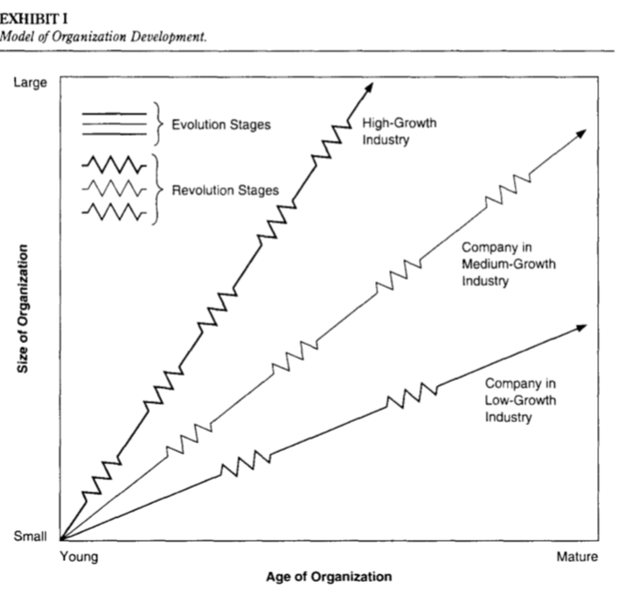
Source: (Hotamisli, 2009) Fig. 3. Greiner organisational Growth Model

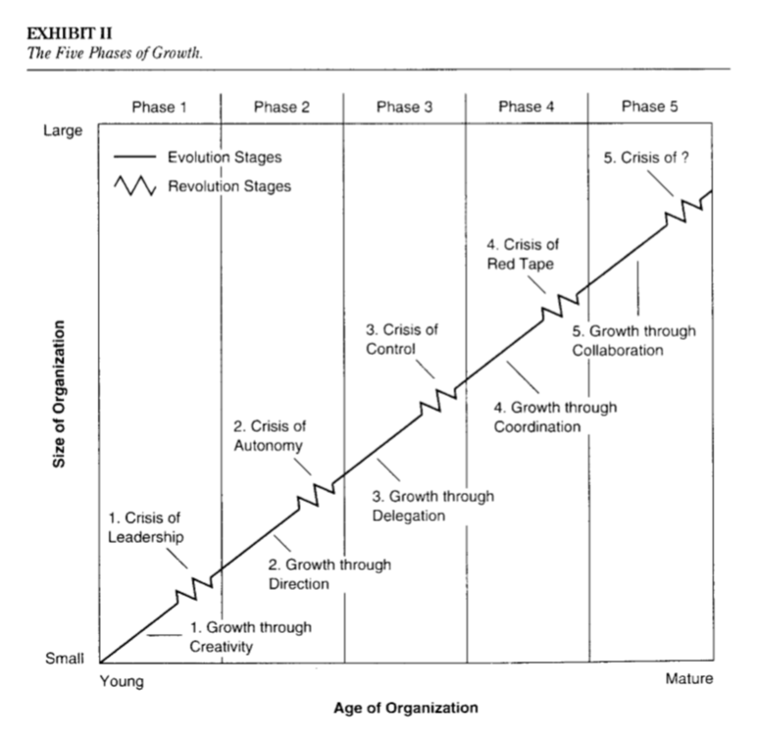
Source: (Hotamisli, 2009). Fig 4; Greiner five Phase growth Model.

Stakeholder identification:

A stakeholder is any individual, community, group, or organisation with an interest in the outcome of a programme, or a project, either as a result of being affected by it positively or negatively, or by being able to influence the activity in a positive or negative way (university of wales trinity st davids, 2020). A stake holder in an organisation is any group or individual who can affect or is affected by the achievement of the organisation (Freeman, E., 1994, university of wales trinity st davids, 2020).
Stakeholder theory begins with the assumption that values are necessarily and explicitly a part of doing business and rejects the separation thesis (Freeman, 2004). It asks managers to articulate the shared sense of the value they create, and what brings its core stakeholders together. It also pushes managers to be clear about how they want to do business, speciﬁcally what kinds of relationships they want and need to create with their stakeholders to deliver on their purpose.
Freeman (1994), theory argues that stakeholders are important towards the success of any organisation and should be high on the consideration list when developing business policies. Internal stakeholders have a role to play in an organisation functionality, while organisations need the external stakeholders for business sustainability, therefore stakeholder management is critical and about purpose and human relationships.

Organisational Stakeholder:
Internal Stakeholders are anyone who is directly connected with the day to day affairs of the organisation. BBC worldwide internal stakeholders are, WEx management team, Global leadership team, Employees. This group of stakeholders rely on the business for financial rewards, such as pay, profits, pensions, to support their livelihood, job security and ultimately career development.
External stakeholders are anyone who is indirectly connected or concerned with the activities of an organisations. e.g. BBC worldwide external stakeholders are, suppliers, society, government, creditors, shareholders, customers, media, unions, employee families. These group of stakeholders have varied interests ranging from consumption of good and services produced by BBC, to creating employment for the local community, to tax contributions to the government.

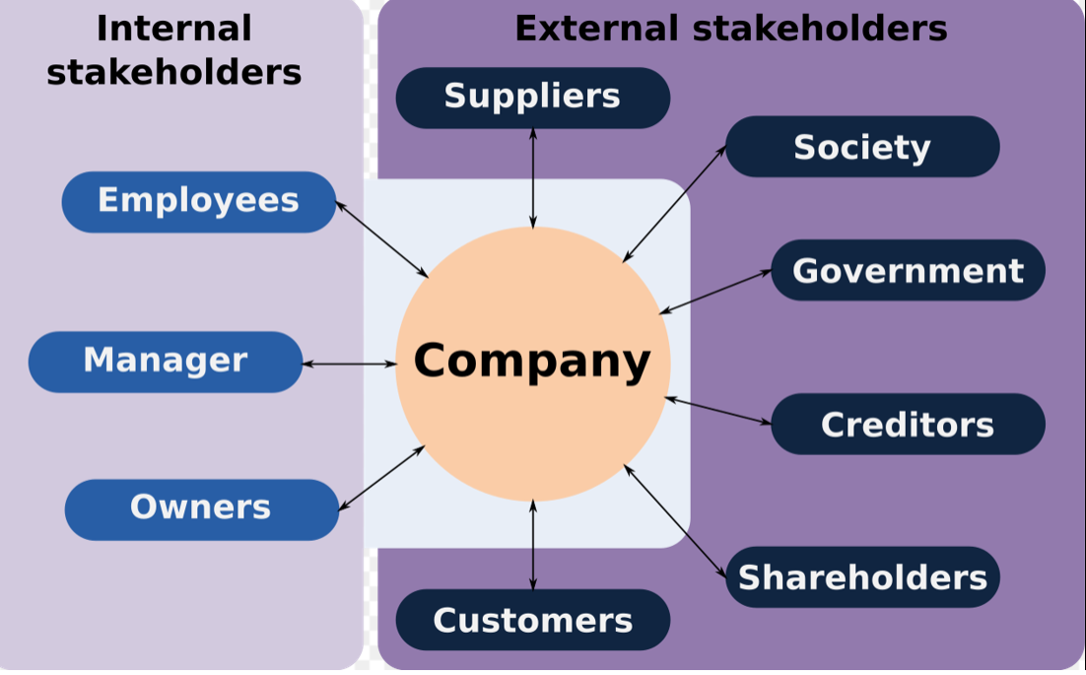
Fig. 5 Stakeholder Framework Source (Freeman 1994).

Stakeholder Mapping:
Stakeholder mapping is a way of establishing who among stakeholders can have the most positive or negative influence on an effort or who is likely to be most affected by the effort so that appropriate engagement strategies can be identified for future interventions. This theory portends that stakeholders have different levels of power and interest in affairs of organisations, therefore appropriate levels of consideration must be given when communicating with them (Mendelow,1991), (Ginige, 2018). There are two main dimensions suggested by (Mendelow, 1991), to use determining the level of importance to associate to these stakeholders.
Power and Influence: these are stakeholders who can severely impact the live of a project or hold the authority to make important decisions. E.g. owners, sponsors, senior managements.
Interest Dimension: these are stakeholders that interest but minimal power to impact the outcome of project activity or whose interest are not the target for the activity.

BBC worldwide Stakeholder mapping Matrix

High Importance/ Low Influence High Importance/ High Influence
POWER
A)  Media  Government  Regulatory bodies  shareholders | B)  Director  Worldwide executive committee  Global Leadership teams  Staff Team  Sponsors  Contractors
Trade and industry associations  Local community  competitors  C) | Consumers  Suppliers  Social & political action groups  D)
Low Importance/ Low Influence Low Importance / High Influence
INTEREST

Fig. 5 Mendelow Model stakeholder mapping Matrix

Stakeholder Communication Matrix
Stakeholder | Quadrant | How to Manage
Sponsors | High-high | Manage Closely
Global Leadership teams | High-high | Manage Closely
Suppliers | Low-high | Keep Informed
Media | High-low | Keep satisfied
Shareholders | High-low | Keep satisfied
competitors | Low-Low | monitor
Fig; 6 Stakeholder Mapping & communication Matrix

Section 3.

Project Implementation Reflection and Action Plans:

Following completion of a construction project 2014, which consisted of the remodelling of five bedroom duplex, it has become important to reflect on key aspect of this project, to help identify what was good about the project, what I learnt from the experience and what I could manage better in future projects.

Gibbs Reflective Cycle

A reflective framework has been found to be an effective method to critically evaluate experience whilst providing opportunities to analyse and set objectives to improve on the experience. Graham Gibbs, 1988), reflective framework for examining experience lends itself well to repeated experience and will be applied in this reflective analysis. Gibbs reflective model encourage learners to think systematically about the different stages of an activity or an experience (Heyer, 2015), and incorporates six steps in the process, Description, feelings, evaluation, Analysis, conclusion and action plan.
Description: In this step Gibb requires that we describe the experience, drawing from power of observation to identify key events from the activity. The property was purchased in the first quarter of 2014, from an auction using funds borrowed from the bank. The overall idea of the purchase was to redevelop and resale the property for a profit. There was a twelve months interest free period on the loan, after which interest will be calculated at 5% per month. There was a clear urgency to complete this project, including the sale within this period, as failure to achieve this will seriously impact any opportunity to make a profit. The project plan was developed with a contractor who was responsible for fulfilling the construction work for the project. All designs and approvals required to commence work, was obtained in the first month of purchase, and a project completion and hand over date was set for six months, having taken into accounts all possible factors such as weather disruptions. This will allow at least four months to sell the property post completion.
My role in the project was that of sponsor- manager, with main task area of overseeing the quality of work and responsible for the sale of the property after the remodelling work. The project commenced and was on schedule, two months to completion date, there was a machinery accident on site which required the hospitalisation of two key workers. This led to suspension of work, pending a review of health and safety procedure from the local authority. The suspension on work would seriously impact the project cost and overall objective. I maintained communication with the relevant local authority departments, as well as the contractor and suppliers, providing weekly update on my efforts to secure a new inspection date, and possible dates work could commence. The Health and safety review eventually completed after an eight week wait, which now put the project behind schedule. The project was eventually completed three months behind schedule, leaving two months for sales to be completed.
Feeling: Gibbs suggests we describe how the experience made us feel to help etch the learning into memory.
Ability to purchase this property left me feeling excited and proud on the prospect of completing my first remodelling project. The thought of earning a sizeable income from it project, motivated me more into wanting to see the project completed without any issues. The accident on site though unforeseen, provided course for concern, as I was worried about the welfare of the injured workers. This worry later changed to anxiety and frustration, at the prospect of incurring further costs and missing out on potential earnings. I did my best to remain focused on what I was trying to achieve and used the down time to reflect on what I could do to mitigate similar risk in future project.
Evaluation: Gibbs suggests identifying the positives and negatives aspects of experience.
The entire project was challenging, especially at the point of trying to secure a new inspection date with the health and safety board. I felt frustrated because I did not realise it could take that long to get an appointment. Following communication with the contractor and others in the construction industry, I realised it was normal and, in some cases, could have been longer. However, I could have mitigated the risk for the potential loss of earnings, by including this eventuality in the project insurance. I was able to renegotiate and extend key essential deliverables and resources, that was impacted due the delay, such as the site security, equipment hires, sub-contractor engagements, e.g. gas and electricity engineers.
Analysis: Gibbs suggests analysing the entire experience, highlight and compare experience with established processes to help identify gaps.
Accidents in construction sites have been one of the major causes of project delays (royal borough of Kensington, 2020), efforts must be made to minimise accidents on all construction sites. Good housekeeping plans as well as fire and emergency procedures must be included as part of the health and safety plan and project management planning process. Project managers must enforce housekeeping procedure to minimise the risk of accidents. I should have been more proactive in enforcing the house keeping rules in the project, rather I allowed the contractor the flexibility of managing the actions of his workers, which eventually was the cause of accident.
Conclusion: Gibbs suggests a summary of the experience and how you would respond in future.
In retrospect, I would do several things differently. I would have been more thorough when developing the project risk plan ensuring that I had fully mitigated for all eventualities. I would have more assertive with the workers on site with regards to maintaining housekeeping rules. I could develop a professional relationship with the workers as this would have helped me better manage the process.
Action plan: Gibb suggests a method to formalise the outcome of reflection experience (McMillan, 2013). In future I plan to develop professional relationship with every worker on site rather than just the contractors. This will provide the opportunity to develop appropriate communication levels required to maintain full control of a project site. I intend to work closely with experienced project managers in bigger projects site, to gain better experience on how to mitigate against unforeseen event.

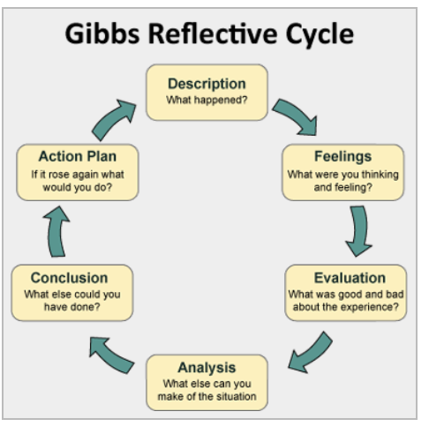
Fig; 6 Gibbs Reflective Cycle.

Belbin Team Work Skill:

Team work occurs were a small number of individuals with complementary skills and common purpose, working together in a common approach, to achieve a specific goal or objective, while sharing mutually agreed accountability (Mishra, 2014). Team working skills is a highly desirable skill to have in today’s employment market, and is further supported by Belin team work theory.
Belbin Theory portends that there are nine roles which need to be occupied within any team. These are, Shaper, Coordinator, Plant, Resource Investigator, Monitor Evaluator, Specialist, Team-worker, Implementer, Completer Finisher. These group of people are further placed into a bigger group (thought focused, Action focused, people focused) based on their personality threats and orientation. Belbin found from his research that whilst teams do not need to have all nine personalities, it must maintain a right balance of personalities within the team to be effective (Belbin, M. 1981).
“What is needed is not well balanced individuals, but individuals who balance well with each other.”! — Dr Meredith Belbin
Thought Focused Team roles: These group of is known as the thinking group made up of the Planter (Creative minder and free thinking), Monitor Evaluator (Serious, strategic and discerning), Specialist (Single-minded, self-starting and dedicated)
Action Focused Team Roles: Shaper (Challenging, dynamic, thrives on pressure) Implementer (Practical, reliable, efficient), complete-finisher (Painstaking, conscientious).
People Focused Team Roles: Co-ordinator (Mature, confident, identifies talent), Team worker (Co-operative, perceptive and diplomatic), Resource Investigator (Outgoing, enthusiastic, explores opportunities and develops contacts), (Imperail colleage of Sience London, 2020).
I fall into the action focused team roles as this depicts my learning style. I enjoy getting things done quickly and implementing processes. I will need to work more on my people focused team skills to broaden my resource development skills and team work skills.

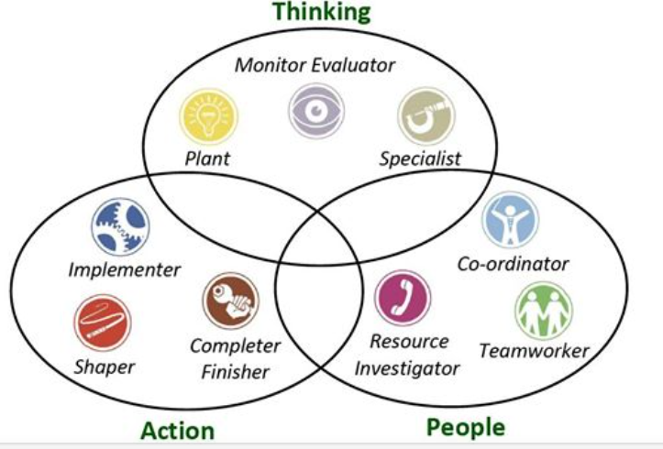
Fig; 7 Belbin team Roles Source Google Images

Personal Development Plan:

Personal development plan is a process of establishing smart goals and identifying strategies in which to achieve them. It involves setting time related aims and objectives, periodically reviewed geared towards achieving sets of personal goals. Personal development plans are created using a constructive approach, and takes into consideration, current situation, where they want to get to and how they intend to get there. It also accesses individual skills sets, highlights skills gaps and set timeline by when these gaps are to be filled. Personal development plan helps individual development of transferable skills as it’s based on schedule of continuous learning and achievement. Primary purpose of a personal development plan is identifying, nurturing, shaping of important employability skills needed to foster lifelong goals and ambitions (Chartered Management Institute, 2013).

See Appendix 2 Personal Development Plan.

Conclusion:

Project management involves applying important methodologies and tools when implementing or executing any project. it is important to have a good understanding of the project before choosing a method to use, this will help determine the most efficient technique to adopt to guarantee achieving the required deliverable. A projects success is judge in terms cost, time and deliverables, appropriate considerations must be given when planning a project, ensuring all factors such as (risk, time and stakeholder management), that could affect these key aspects are carefully managed.

References
Agustine, S., Payne, B., &. Sencindiver, F., 2005. Agile Project Management: Steering from the edges. commincation of the ACM, 48(12), pp. 85-90.
Auguste, J., 2013. Applying Kotter 8 Steps process of leading change to the digital transformation of an orthopedic surgical group in toronto canada. Health & Medical informatics, 4(3), pp. 2-4.
BBC worldwide LTD, 2018. BBC Worldwide Ltd Annual Reporst and Financial statements, London: BBC worldwide.
Breland, R., 2011. Methods of fostering change in the practice model of at the pharmacy department levels. In: health systems pharmarcy. s.l.:s.n., pp. 1138-1145.
CIPD, 2015. www.cipd.co.uk. [Online]
Available at: https://www.cipd.co.uk/Images/landing-transformation-change_2015-case-study-bbc-worldwide_tcm18-9055.pdf
[Accessed 4th MAy 2020].
Freeman, R., Andrew, C., W., Bidhan, P., 2004. “Stakeholder Theory and The Corporate Objective Revisited. Organization Science, 15(3), p. 364–369.
Ginige, K. Amaratunga, D., Haigh, R., 2018. Mapping stakeholders associated with societal challenges: A Methodological Framework. Reseachgate .
Greinier, L., 1998. Evolution And Revolution as Organisations Grow, s.l.: Havard Business School Reviews.
Heyer, R., 2015. Learning through reflection, The critical role of reflection in work-based learning.. Journal of work-Applied Management, 7(1), pp. 15-27.
Highsmith, F., 2001. Manifesto for Agile software development. Retrived from agilemanifesto.org:, s.l.: s.n.
Hotamisli, M., Ibicioglu, H., Karayel, M., 2009. Larry Greiner Growth Model in the Organisation Life and a Case study. International Symposium of sustainable development, 9(10), pp. 259-264.
Imperail colleage of Sience London, 2020. Imperail colleage of Sience London. [Online]
Available at: https://www.imperial.ac.uk/media/imperial-college/administration-and-support-services/st
[Accessed 5th May 2020].
Jainendrakumar, T., 2008. six-sigma vs PMBOK complementary and mutually supporting methodologies for handling projects. [Online]
Available at: https://pmworldlibrary.net/wp-content/uploads/2015/01/jainendrakumar-six-sigma-vs-pmbok-featured-paper-april2008.pdf
koskela, G., 2000. Reforming project management: the roal of lean construction, 8th annual conference of the international group of lean construction.
Koskela, L., Ballard, G, M., Howell, G. &. Tommelein, I., 2002. The Foundation of Lean Construction. Design & Constructions; Building, Volume 2, pp. 211-226.
Kotter, J., 2007. leading change, why transformation efforts fail. Harvard business review, pp. 1-10.
Mainiero, L., Tromley, C., 1994. Developing Managerail Skill in Organisational Behaviour. Excercises, cases, and readings, Volume 2, pp. 322-392.
Maund, A., 2018. Leadership and management skills for the work place. 2 ed. london: sage.
McMillan, K. W. J., 2013. How to improve your critical thinking and reflective skill. Harlow: Pearsons.
Meyers, I. B. M. P., 1995. Gift differing ; Understanding personality types. Moutain View CA: davies Black publishing.
MindTools , 2020. Mind Tools Essential Skill. [Online]
Available at: https://www.mindtools.com/pages/article/newPPM_82.htm
[Accessed 2020].
Mirzaei, M. M., 2012. Project Managment A comparison of three popular Approaches,. 46th Anuual conference of the operation research society New Zealand, s.n.
Mishra, K., 2014. Emplyability skills recruters demand. Soft Skills, september.
Project Management Institute, Inc., 2017. Project Managment Book of Knowlegde Guide. s.l.:Project managment institute , 6th Edition.
Project Managment Insitute, 2009. A suggested harmonization of DMAIC with PMBOK project life cycle, s.l.: PMBOK 4th Edition.
Reusch, P., 2013. how to develop lean Projetc managment;. intellengent Data Acquisition and advanced computing systems (IDAACS) IEEE 7TH international Conference Berlin, Germany , Volume 02, pp. 547-550.
Rosenau, M. D., &. Gitens, G.D., 2005. succesfull project management, A step by stepaaproach with practical examples, widley: s.n.
royal borough of Kensington, 2020. www.rbkc.gov.uk. [Online]
Available at: https://www.rbkc.gov.uk/idoxWAM/doc/Other-1863823.pdf?extension=.pdf&id=1863823&l
[Accessed 5th May 2020].
Schermerhorn, J., 2011. Organisational behaviour. 12th ed. s.l.:John Wiley & Son.
Toolshero,2020. www.toolshero.com[online] Available at: https://www.toolshero.com/change-management/ [Accessed 11th May 2020].
university of wales trinity st davids, 2020. Moodle. Uwtsd. [Online]
Available at: https://moodle.uwtsd.ac.uk/mod/folder/view.php?id=197329
[Accessed 20 April 2020].
Vittorio Cesarotti, Silvia, G., Introna, V., 2019. The Evolution of Project management; How Agile,Lean, and Six-Sigma are changing project management. journal mordern PM, 7(3), pp. 3-29.

Appendix

Appendix 1

Project Management Approach Comparison and Usage

Topic of Analysis | Traditional | Agile | Lean | Six- Sigma
Lifecycle Approach | Perspective | Timeboxing | Timeboxing | Perspective
Team Dimension | Varies depending on project | Small and dynamic | Small and Dynamic | Small team
Internal Communication | Fragmented information | Free open access to information | Free open access to information | Free open access to information
Leadership style | PM as Coordinator, issues usually escalated | Adaptive leadership | Adaptive leadership | Conductive Leadership
Roles of Customers and Stakeholders Policies | Customers defines project goal, budget and time in early stages of the project | Continuous feedback from the customer stakeholder interest aligned | Customer involved in project development | Customer is involved in define and control stages. Stakeholders contribute to solution creation.
Risk | Estimated in the early stages. | Reduced through Multiple iterations and continuous feedbacks | Managed using buffers to absorb variations. Activities are done at the last responsible moments | Estimated in the early stages
Cost | Consistent at early stages but heavily dependent on predictions made and context variability | Sustained during project development | Target costing method | Consistent at early stages but heavily dependent on predictions made and context variability
Main Applications | Constructions and engineering | Software | Construction, software development and healthcare | Manufacturing, Finance healthcare
(Source journal of modernPM.com)

Appendix 2

Kotter’s Eight Steps Change Model Applied to BBC Worldwide Change project

Create Urgency: | Kotter suggests that for change to happen, it helps if the whole organisations want it, thereby creating a sense of urgency around the need for change, will help create the initial motivation required to get thing going. Achieving this process require open and honest communications between all stakeholders, identifying threats, creating opportunities and gaining support from all concerned. Kotter Suggest that 77% of company management needs to buy into the change for it to happen successfully (MindTools , 2020). Directors at BBC announced the structural reorganisation in 2012, setting a five year plan in which to begin delivering increased revenue through implementation of change in work base practices and culture. This formed the organisation vision and created the urgency required to deliver the set objectives. The Director sort to communicate this vision to every level of the organisations starting with the management team, world executive committee and Global leadership team
Form Powerful Coalition: | Convincing people that change is necessary, often takes strong leadership and visible support from key people within an organisation. Identify key leaders and stakeholders in your organisation, gain their support and work on team building. The New BBC CEO took office in 2013 and set about creating a coalition with WEx and GLT management teams, he appointed a new Director of People in 2014 to help with the culture change. He empowered the management team through various workshops where he shared his vison and got them to take ownership of the drive for change. He further solicited for the advice and experience of long experienced staff, to get them on side.
Create Vision for Change: | In this step Kotter suggest you create a Clear vision and link to an overall message people can easily grasp. Determine what value that is central to the change, create strategy and drive message through repeated communication and leadership. The CEO created the vision of change by establishing three fundamental values, to build the reputation and brand of BBC, deliver sustained financial returns, build a world class media company.
Communicate the Vision: | In this step Kotter suggests that we communicate the vision frequently and powerfully, ensuring we address people’s concerns, anxieties, openly and honestly.  The HR department created workshops to open dialogue with the General leadership management teams, with the overall aim of agreeing the best approach to deliver the vision to the organisation. The vision and culture message were agreed and made compulsory and everyone was to live by it. WEx facilitated a virtual worldwide conference where international staff can dial in. The approach was to explain exactly what the business was seeking to achieve and suggest resources available to address any concerns. Two way communication was established between the management teams and corporate levels, set questions were used to gauge the mood of the staffs and personal stories were shared, demonstrating the passion and desire of management team to support the change.
Remove Obstacle and Empower Action: | In this step Kotter suggest e put in place structures for change and continually check for barriers to it. Identify and hire change leaders, recognise and reward people making change and remove people opposed to change. BBC further developed a workshop with the GLT team, to address the issue of SILO working and encourage team working and new ways introduced by the change culture. They came up with and agreed a phrase “Be part of Making history”. GLT was then tasked with delivering the message to their teams through similar workshops. This demonstrated the ambitions and GLT’s motivation toward delivering change
Create Short Wins: | In this step Kotter suggests that nothing motivates than success, creating early wins in change projects will only go a long way to motivate participants of change. This is further supported by McClelland’s motivation acquired needs theory, “appeal to individuals needs for affiliation, achievement and power” (Schermerhorn, 2011).  Emphasis was placed on value of personal stories; this was shared across the organisation through videos and pictures. The Directors did a good job of feeding back the global success picture to the GLT and WEx teams.
Build on the Change: | Kotter suggests that many changes fail because success is declared too early. Success provide an opportunity to build on what went right.  The various workshops helped BBC consolidate the achievements made into a smaller messages and themes used to further drive the change message. Culture change such as more recognition and saying “thank you” more was encouraged, clearer direction on working culture was promoted, through improved vision messages of building better relationships through innovations, business successes and creative environments, and global award scheme was created to reward committed employees. Development programs was encouraged and resources such as intranet system, packed with development information was made available to all staff, in house work placements were encouraged across the organisations and it was mandatory for every staff to have a personal development plan. Following a move to New Head office in 2015, hot- desking was introduced to encourage team working and schedule keeping.
Make It Stick Anchor the changes in corporate culture: | In the step Kotter suggests a continuous effort to ensure the change is seen at every aspect of your organisation. Maintaining the momentum of the change message and rewarding the people from the centre.  BBC created an international annual result day; Award was announced offering business and opportunities to reward teams and businesses that have shown commitment to the change process. This was an initiative from corporate aimed at further motivating staff. A quasi-contract was created between leaders and staffs setting out expectations, to further strengthen the commitment and finally a 360 degree feedback was introduced to support the GLT team in leadership behaviours.

Appendix 3

Personal Development Plan.
PERSONAL DEVELOPMENT PLAN
 | SKILL | CURRENT ABILITY | TARGET  ABILITY | DEVELOPMENT OPPORTUNITY | CRITERIA TO JUDGE SUCCESS | TIME FRAME | EVIDENCE
1st Priority | People focused | Implementer, finishers, organised | Team working skills | Attend more project team working exercises  workshops | Complete minimum of six workshops | Six months | Certificate
2nd Priority | Thought focused | Creativity | Strategic,  Communication skills | Enrol in a project management skills development programme | Gain qualification on Project Management | One year | Certificate
3rd Priority | People focused | Resource Investigator | Co-ordinator  Communication skills | Attend more project team working exercises  workshops | Complete minimum of six workshops | Six months | Certificate
Fig: 8 Personal Development plan

