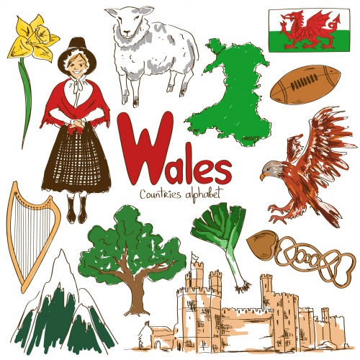
(Kids Press Magazine, 2017)
Portfolio of Activities that are delivered that promotes Welsh language, cultural, historical, and geographical features
Module SJIE5004: Celebrating Language
and Culture Belonging to Wales


Contents

Rationale 3
Overview of Activities 4 - 6
Evaluation 6 - 7
Appendices 8 - 16
References 17 - 19

This portfolio will discuss and critically analyse how Welsh language and culture can be celebrated within educational settings, and how this celebration is important for the future of the Welsh population. The Welsh language is one of the oldest languages of the British Isles and can be traced back to the 8th century (Greene, 2014) and pertains to why in my own opinion it is important to appreciate the traditions of the Welsh culture.
Howe, the Future Generations Commissioner for Wales, stated in the Future Generations Act Report (2020, page 343) that
“culture is part of the DNA of Wales … it is an identity, a language we speak, an industry, something that is experienced and something we engage in”.
After the language became threatened historically, there has since been a revival in the efforts to encourage appreciation and use of the language and culture. In the 16th century, when Henry VIII was King of England, in 1536 his Act of Union between England and Wales stripped the Welsh language of its status within the labour market and administratively through the justice system, and essentially ‘banned’ the use of the Welsh language within education (Brain, 2020). In the following centuries the level of Welsh speakers continued to fall, with a large amount of migration in the 18th and 19th century, due to the industrial revolution, with a population increase of over a million between 1750 and 1901, many of these being English speaking (Smith et al, 2020).
In the 20th and 21st centuries, many acts were created to help facilitate and promote the use of the language, of which seemed to attempt to reverse some of the effects of the previous centuries. These include the 1967 Welsh Language Act which gave the commitment that Welsh could be used in the courts and provided rights for the prescription of forms through the medium of Welsh (Reinks et al, 2014). In 1993 this was revised under the same name, mainly stating that the Welsh language should be promoted and facilitated and treated equally to the English language (NafW, 1993). To do this, the Welsh Language Board was established to ensure public bodies followed language schemes in order to facilitate Welsh language use within public services such as Police and Crime Bodies, Fire and Rescue, Health Services, as well as the Administration of Justice (Reinks et al, 2014). The Welsh language was only given official status and recognised as such, in the 21st century in 2011 within the Welsh Language Measure (NafW, 2011).
The first census to show increase in the number of those able to speak Welsh was in the first census of the 21st century, in 2001 (Jones, 2012). The main result showed that there was a rise in Welsh speakers of 2.1% for those over 3 years. It also showed us that the main rise was in the youngest generations, both the 5-9 years bracket and 10-14 showed an increase of around 14% [see appendix 1]. This rise can be attributed to the release of the Education Reform Act of 1988 in which Welsh was recognised as a core subject within schools which taught at least one foundation subject and Religious Education wholly or partly through the medium of Welsh, named ‘Welsh-speaking’ schools (Reinks et al, 2014) and in 1990 Welsh became compulsory at all schools for key stage 1, 2 and 3 (Statutory Instruments, 1990) and key stage 4 in 1999 (Statutory Instruments, 1998).
The Curriculum Cymreig was established to ensure that individuals in Wales would receive education in curriculum subjects to ‘develop and apply their knowledge and environmental, historical, and linguistic characteristics of Wales’ (WG, 2013), by establishing that some subjects are delivered using different programmes of study to the combined National Curriculum with England, such as Geography, History, Art and Music (ACCAC, 2003). The Qualifications, Curriculum and Assessment Authority (ACCAC) released guidance on developing a Curriculum Cymreig. This guidance states that cultural aspects of the Curriculum can be exercised by celebrating distinctive cultures, languages and traditions of Wales and exploring the expressive and creative arts in Wales in schools such as literature and dancing (ACCAC, 2003). The Eisteddfod is a fun and engaging way to ensure individuals can celebrate and appreciate their own culture, especially through literature and dancing.
The Eisteddfod is a form of festival that has historically celebrated Welsh culture, literature, and music, and continues to be the oldest and largest celebration of Welsh Culture (Johnson, 2020). Although according to Edwards (2016) there is a story of the eisteddfod dating back to as far as the 6th century, the main belief and association with the first eisteddfod is the National Eisteddfod which took place in Cardigan Castle on Christmas day in 1176 (Johnson, 2020) [see appendix 2]. It is said that Lord Rhys of Deheubarth (Edwards, 2016) invited Welsh poets, musicians and bards (Celtic Breizh, 2019) to compete from all over Wales, with a chair at the Lord’s table awarded to the winning poet and musician (Johnson, 2020), which is thought to have relevancy to how a wooden, hand-carved armchair became the traditional prize for the winner of the best long poem (Celtic Breizh, 2019). There was a decline in celebrations and festivals during the 16th century which is mainly thought to be because of the loss of patronage in Welsh culture (Johnson, 2020) during Henry VIII’s reign, as previously mentioned. There was also a further decline in the 18th century (Johnson, 2020) which may have been as a result of the industrial revolution of which brought on the rise of migration into Wales from other areas, resulting in the decrease in Welsh speakers (Greene, 2017). Festivities were revived in the 19th century, specifically in 1880 when the National Eisteddfod Association was formed (Johnson, 2020). Since their conception the festivals have occurred every year, with the only exceptions in 1914 in which the Bangor eisteddfod was postponed to the following year due to the conflict of the First World War, and in 1940 during the Second World War the National Eisteddfod was not permitted to hold the festival as areas intended for use were in ‘danger zones’, as a result the first and only radio Eisteddfod was held (National Museum Wales, 2010).
While there are National eisteddfods which can be entered by any individual across Wales, and Urdd eisteddfods which are specifically for those under the age of 25 (Urdd Gobaith Cymru, 2020) held every year, schools across Wales also hold their own celebration. At School A an eisteddfod is held in March as a Saint David’s Day celebration for key stage 3 and 4, with key stage 5 allowed to take part but are also encouraged to help with organising events and carrying out practice sessions. It is a way to celebrate Welsh language and culture through enjoyment and fun for all ages and abilities, with competitions concentrating on cultural themes. There are traditional competitions held, such as a Welsh literary competition for key stage 4 of which awards the chair, a Welsh literary competition for key stage 3 which award a trophy, an English literary competition of which rewards a crown, and solo instrumental performances [see appendix 3], and reciting competitions for first and second language speakers – these are part of the traditional ‘Coroni’r Bardd’ ceremony (Johnson, 2020). A poem about a local castle to the school was used for the second language competition, of which helps the individuals taking part to associate with their geographical and local environment [see appendix 4]. In 2020, history competitions were held for key stage 3 including creating a shield for those in Year 7, creating a dating profile for Henry VIII for those in Year 8 and creating an effective propaganda poster for World War One for those in Year 9 [see appendix 5]. Leading up to the eisteddfod individuals learn about Henry VIII and his impact on Wales in their history lessons, and have the opportunity to use props and artefacts to re-enact battles such as the Battle of Bosworth, to encourage participation in the shield-building competition. The guidance for the development of the Curriculum Cymreig in 2003 states that gaining knowledge about the religious and political past of Wales helps individuals acquire a sense of belonging (ACCAC, 2003). The art department encourages pupils to take part in their competition with a sea and mountain theme, where any media can be entered, and individuals study local mountains and areas associated with Welsh history in lessons prior to the Eisteddfod [see appendix 6]. There was also a ‘Dawnsio Gwerin’ competition which encourages pupils to learn a range of traditional folk dances [see appendix 7] associated with Welsh culture such as formation dancing which includes specific steps and clog dancing designed to create a rhythmic sound, some of which date back to 1188 (James, 2002). There are a few other competitions and activities leading up to the Eisteddfod; catering and food technology classes usually bake and cook traditional Welsh foods to sell on the day, there are other more relaxed competitions such as ‘Stori a Sain’ [see appendix 8] where a Welsh story is read to another contestant for the first time and they must create funny actions to portray the story, creating a music video [see appendix 9] and the ‘ice-bucket challenge’ where the heads of each house along with one younger member of the house are drenched in ice and water [see appendix 10] and compete to win the best video created to portray this, and a more modern dancing competition – ‘disco dancing’ [see appendix 11]. These less formal events create a relaxed atmosphere and allows individuals to hear and speak the Welsh language in an environment where it is promoted and in a social environment with peers. Vygotsky’s Sociocultural Theory stresses the importance of social interaction in the development of cognition and language development. Vygotsky also places emphasis on culture and how this, with social interaction improves cognitive development and this ultimately results from an internalization of language (McLeod, 2020).
Since at least 2016, Disney Land Paris have held an annual ‘Saint David’s Day Welsh Weekend’ on the closest weekend to March the 1st. This celebration includes a Disney fanfare and meet and greet with Mickey and Minnie Mouse dressed in traditional Welsh costume [see appendix 12] (Salon Mickey, 2016). There is usually a choir performance, with performances by Ysgol Gyfun Glantaf and ‘Only Men Aloud’ in 2020 (Thedlpgeek, 2020). There are booths for face painting that are Welsh themed, craft and food stalls, and in 2020 there was a new light projection show displaying the colours of St David’s Day (green white and red) [see appendix 13] before the fireworks display which also has a Welsh colour theme [see appendix 14] (Salon Mickey, 2016). Schools around Wales take the trip to Paris, France to promote the Welsh culture and language in an inclusive and enticing way.
The school Eisteddfod is a positive activity to encourage Welsh language and culture, but also has some areas for improvement. For individuals with Additional Learning Needs (ALN), specifically sensory based conditions or disorders such as Autistic Spectrum disorder and those with sensory processing issues can find the Eisteddfod as a very distressing place as some individuals with Autism experience hyper-sensitivity to a range of stimuli (Autism Speaks, 2020); the setting is usually concert based, with an audience and stage, with bright, flashing lights, microphones and speakers to ensure all attendees can hear the events and loud music. At School A, individuals who do not wish to attend due to these issues are permitted to spend most of the day at the ALN base and participate in Welsh themed crafts such as creating paper daffodils and drawing/painting portraits. At the 2020 eisteddfod at School A, for the first time, in 2020, an ALN competition was included as a way to encourage pupils who experience an Additional Need can design a poster to raise awareness of an aspect of ALN such as dyslexia, ADHD, Autism, hearing impairment, speech and language difficulties and Down’s Syndrome [see appendix 15]. Attendance competitions can have negative affects on those who do not speak Welsh as, from experience at a Bilingual ‘Type B’ school, meaning there are both English and Welsh medium streams, many individuals that learn Second Language Welsh feel it is a ‘Welsh only’ event, and would rather stay at home as it is a mandatory event. The intention of the competition may be to positively reinforce, by offering points to each house of which is awarded 150 extra points if 95% of the house attends on that day, and 100 extra points for 90% [see appendix 16], but one’s fear is that this may, in fact, negatively reinforce this behaviour causing more pupils to refuse to attend school on that day if their parents or guardians do not allow them to. Marcin (2017) states that negative reinforcement actually increases the unfavourable behaviours. This therefore causes the loss of encouragement in the Welsh language and culture that those who attend the event have.
The Disneyland Paris activity trip for St David’s day also has a positive impact as there are no formal or written tasks for pupils to complete, this is intended to help pupils understand that learning Welsh and speaking the language can be an enjoyable experience, and that Welsh culture is something of value and should be, and is being represented. Pupils are encouraged to speak Welsh at the event. As Piaget states, children acquire and develop language through interaction with the environment (McLeod, 2018) [1], at the Disney event the individuals can develop their language without realising, in a relaxed and welcoming environment with positive reinforcements for speaking the language, of which Skinner characterises as Operant Conditioning – when positive reinforcement occurs when a desirable behaviour is shown (McLeod, 2018) [2].
UNESCO recommends the use of bilingual teaching:
“the public and private sectors and the civil society at local, national, regional and international levels should work to provide the necessary resources and take the necessary measures to alleviate language barriers and promote human interaction” (UNESCO, 2010, page 2)
The Wellbeing of Future Generations Act ensures that the decisions taken today are not at the expense of future generations, and states that it is vital for the culture of Wales to be integrated into education, and envisions that by 2050, in the hopes that there are 1 million speakers by then, ‘bilingualism will be beneficial to both the economy and individuals through cognitive and social benefits’ (Howe, 2020). Both activities encourage bilingualism as many competitions in the Eisteddfod use both English and Welsh songs and the English story competition [see appendix 17] and Welsh poem competitions allow pupils to create a range of media in two languages. The Disneyland Paris trip encourages bilingualism in a relaxed environment which can alleviate the barrier for many individuals who are not fluent in the language who feel a lack of confidence due to feeling their understanding is not proficient enough to engage in conversation (Davies, 2020).
Personally, I am hopeful for the future of the Welsh language as Donaldson states in the Successful Futures Independent Review (2015) of the Curriculum 2022, languages are seen as a key to social cohesion and key to how individuals are able to understand their own culture and gain a sense of identity, as this helps to not only develop their own identity as Welsh citizens, but to empathetically understand the relationship between their own cultures and those of other people (WG, 2020). It is advised that schools to continue to follow recommendations made by Donaldson, to have a greater focus on “individuals’ ability to communicate confidently in everyday settings, with an emphasis on its increasing role in the workplace” (Donaldson, 2015, page 108).

Appendices
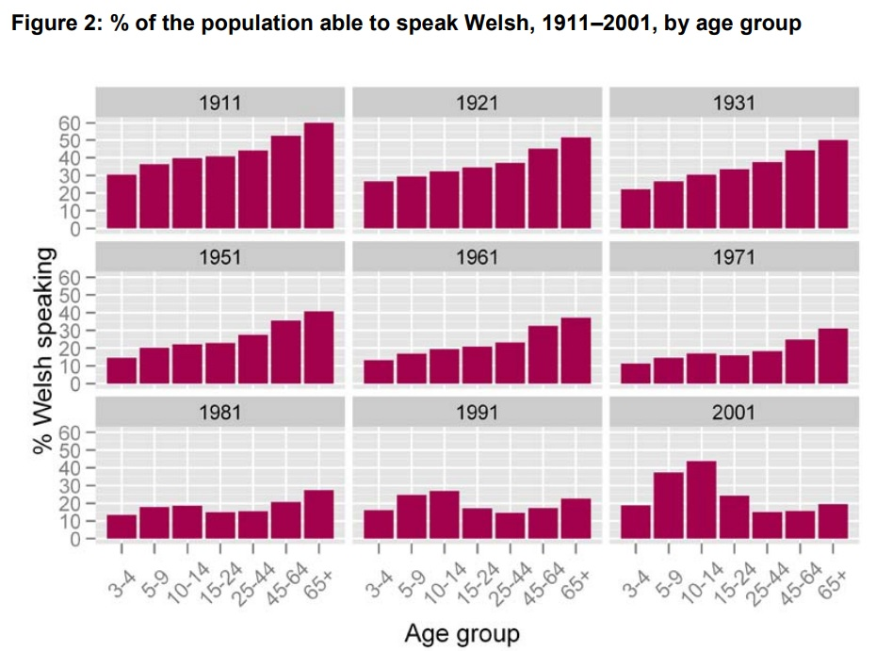
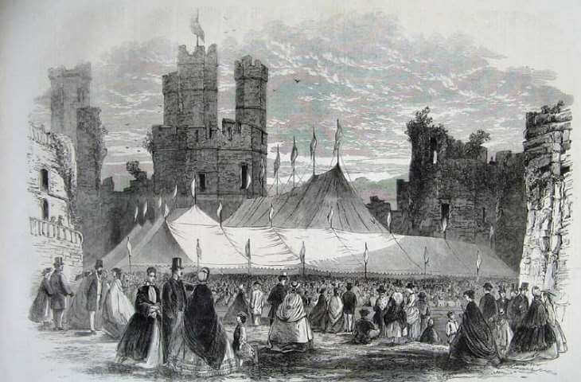
Appendix 1: (Jones, 2012, page 12)
Appendix 2: (Johnson, 2020) ‘Carnarvon Castle 1862’
Appendix 3: (School A, 2020) Chairing and Crowning of the Bard Ceremony Competitions
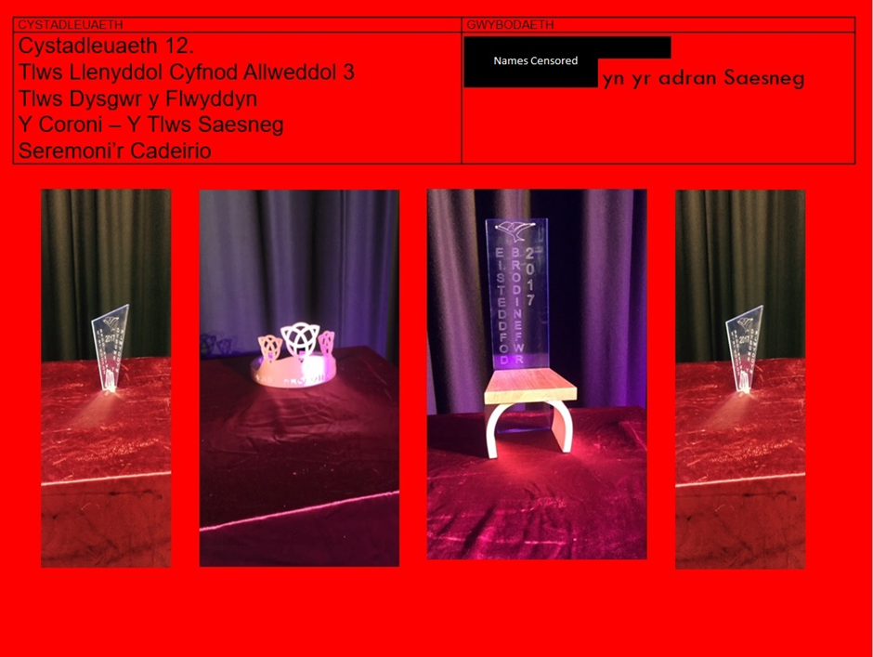
Appendix 4: (School A, 2020) Eisteddfod reciting group second language competition poster shown to all pupils
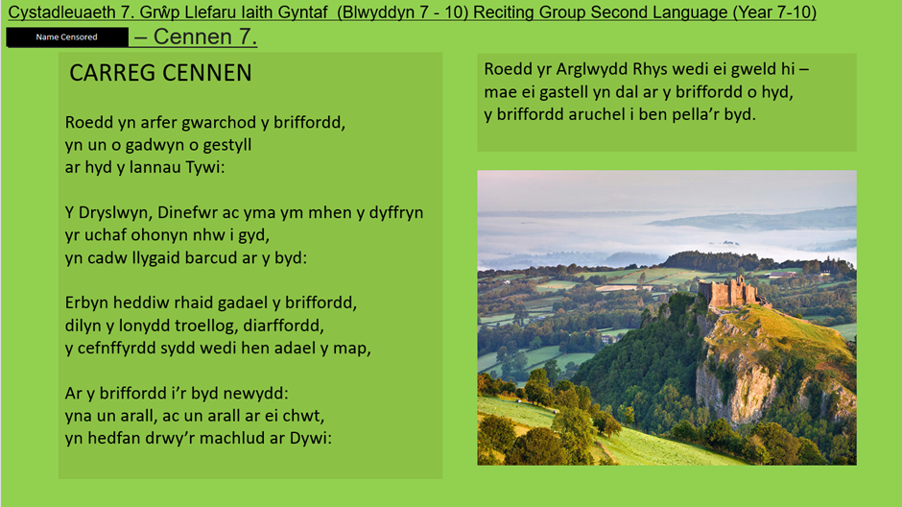
Appendix 5: (School A, 2020) Eisteddfod History competition Poster shown to pupils
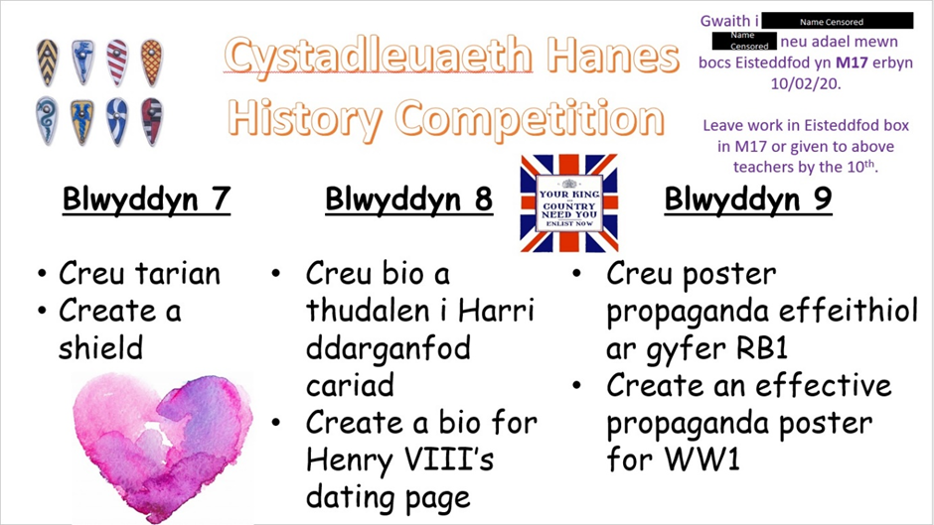

Appendix 6: (School A, 2020) Eisteddfod Art competition poster shown to pupils
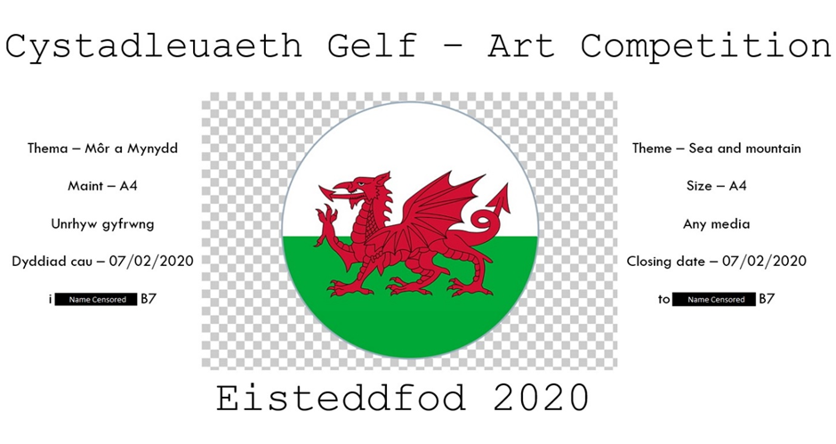
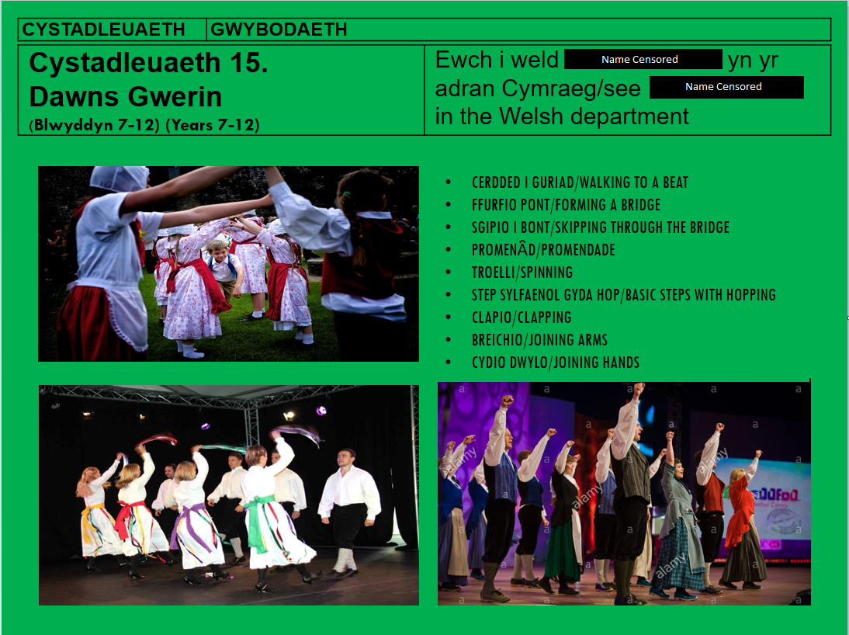
Appendix 7: (School A, 2020) Eisteddfod folk dancing poster shown to pupils

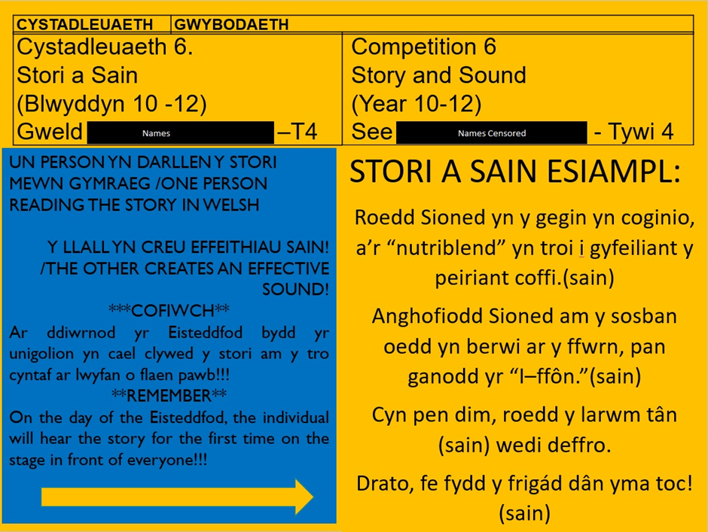
Appendix 8: (School A, 2020) Eisteddfod Story and Sound competition poster shown to pupils
Appendix 9: (School A, 2020) Eisteddfod music video competition shown to all pupils
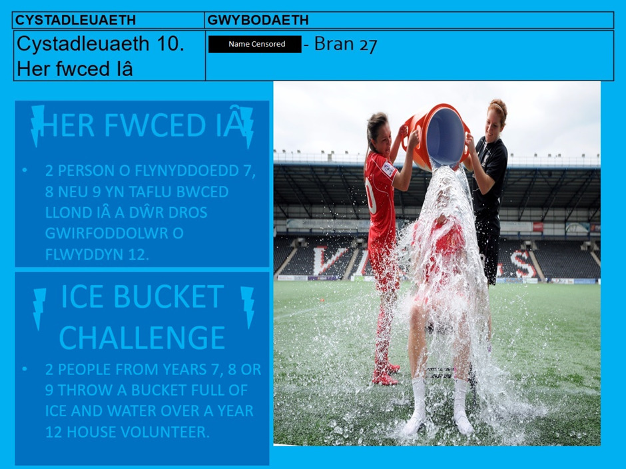
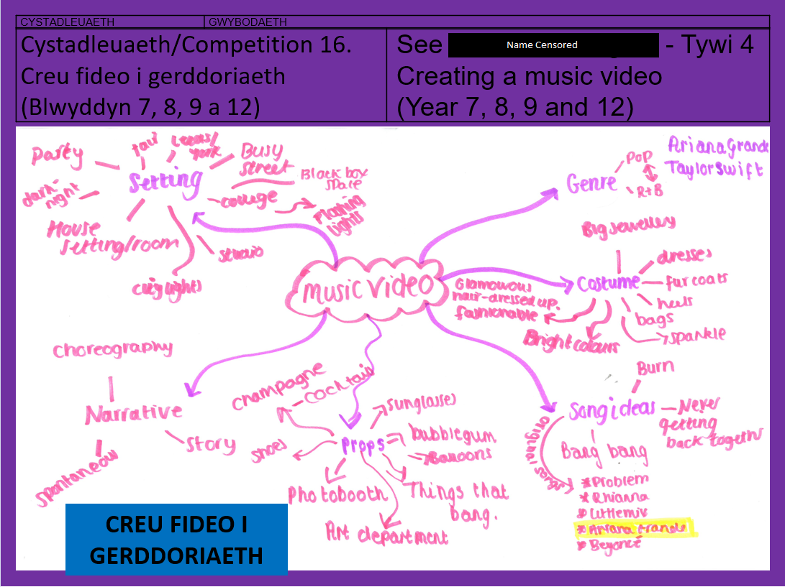
Appendix 10: (School A, 2020) Eisteddfod ice bucket challenge competition shown to all pupils

Appendix 11: (School A, 2020) Disco dancing competition poster shown to all pupils
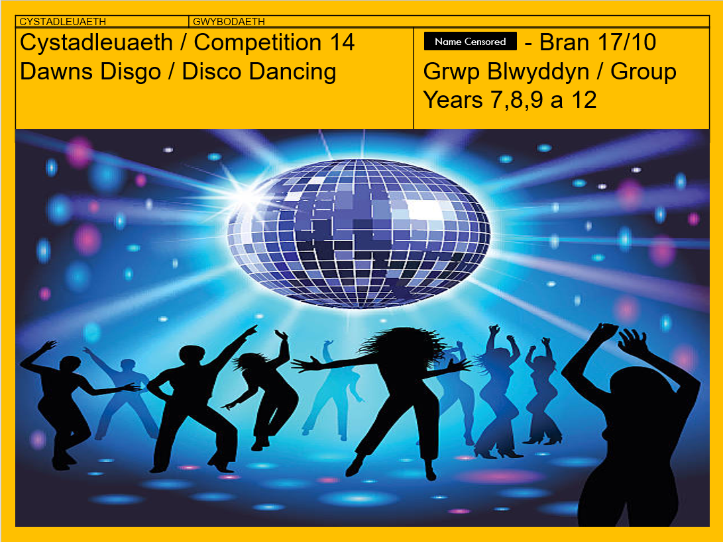
Appendix 12: (Salon Mickey, 2016) Mickey and Minnie in traditional Welsh costumes
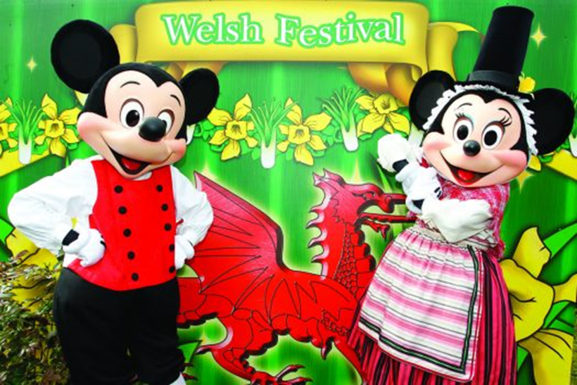

Appendix 13: (Salon Mickey, 2016) Disneyland Paris St. David’s Day weekend lights show
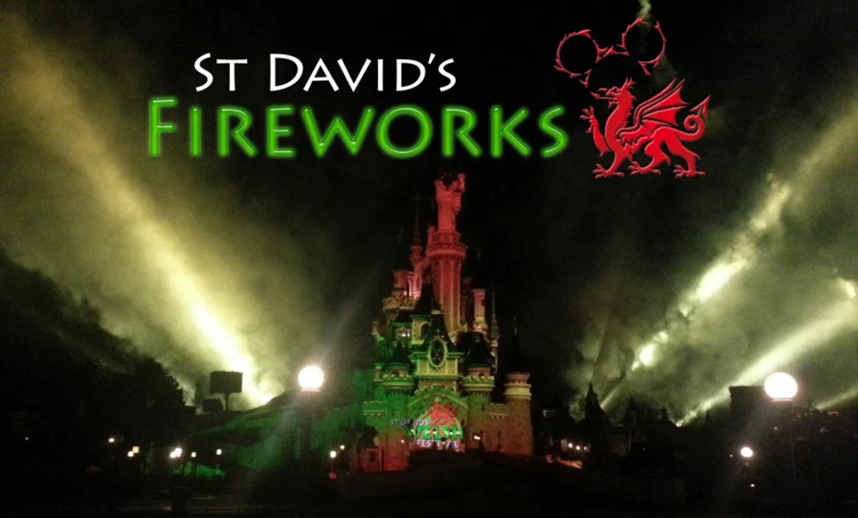
Appendix 14: (Thedlpgeek, 2020) Disneyland Paris St. David’s Day weekend Fireworks display


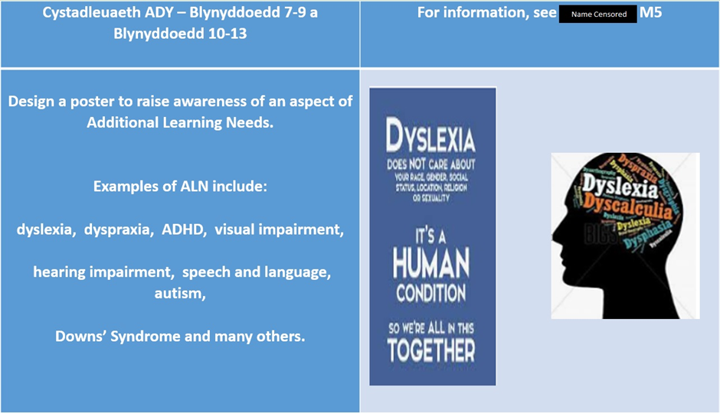
Appendix 15: (School A, 2020) Eisteddfod Additional Learning Needs (ALN) competition poster shown to all pupils
(English Version)
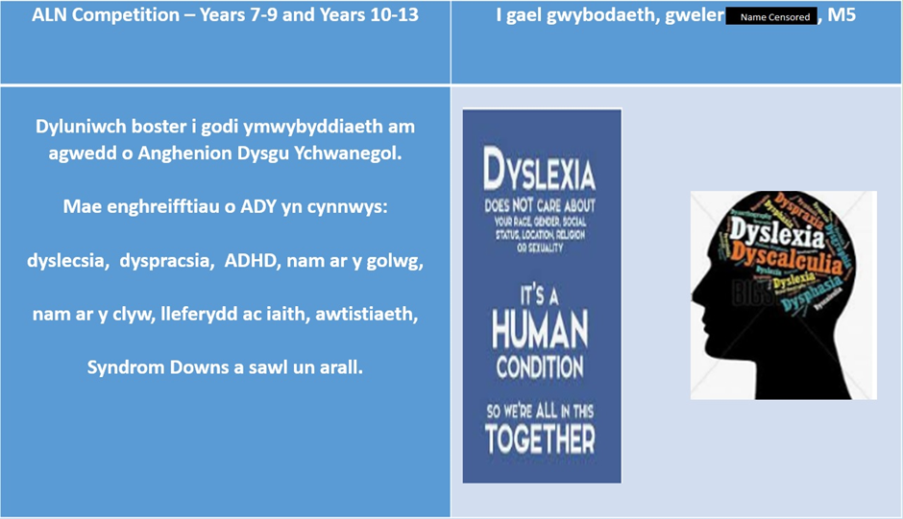
(Welsh Version)

Appendix 16: (School A, 2020) Eisteddfod attendance competition poster shown to all pupils
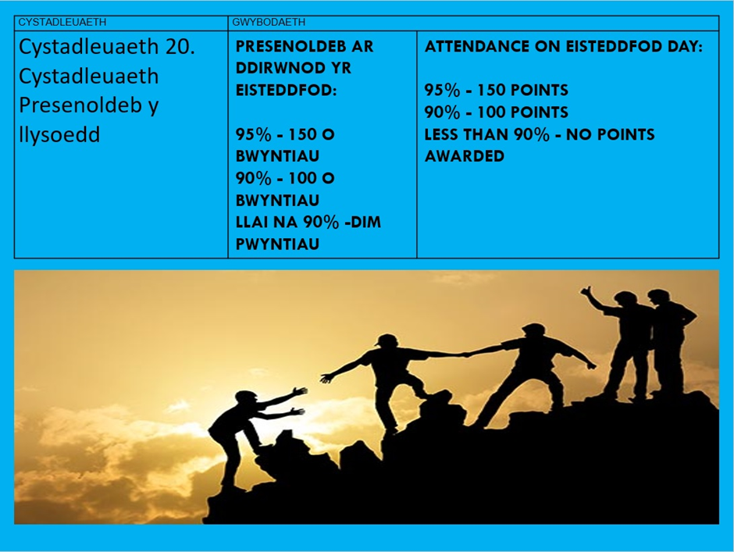
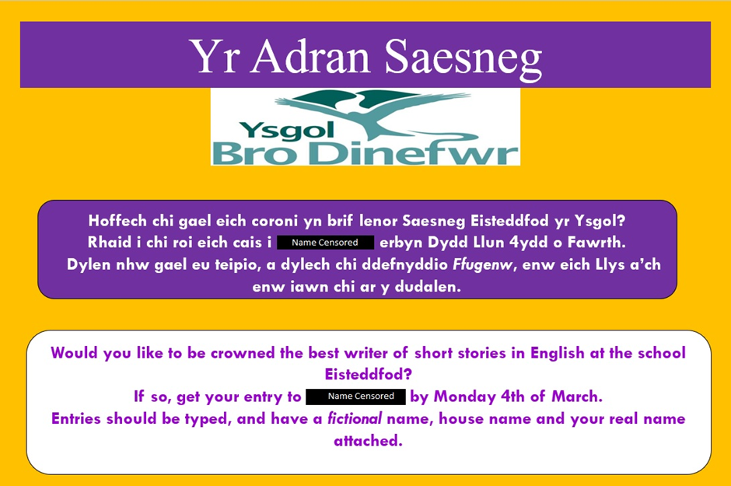
Appendix 17: (School A, 2020) Eisteddfod English story competition poster shown to all pupils

References
- Autism Speaks (2020) Sensory Issues. Available at : https://www.autismspeaks.org/sensory-issues (Accessed 04/11/2020)
- Brain, J (2020) The Welsh Language: History Magazine. Historic UK Copyright. Available at : https://www.historic-uk.com/HistoryUK/HistoryofWales/Welsh-Language/ (Accessed 17/10/2020)
- Celtic Breizh (2019) The Eisteddfod: welcome to the land of bards and poets! Available at : https://celticbreizh.com/the-eisteddfod-welcome-to-the-land-of-bards-and-poets (Accessed 27/10/2020)
- Davies, E. (2020) Barriers to Communication. Available at : https://ethandaviesq.weebly.com/barriers-to-communication.html# (Accessed 05/11/2020)
- Donaldson, G. (2015) Successful Futures: Independent Review of Curriculum and Assessment Arrangements in Wales. Crown Copyright. Available at : https://gov.wales/sites/default/files/publications/2018-03/successful-futures.pdf (Accessed 01/11/2020)
- Edwards, H. (2016) The Eisteddfod. University of Wales Press
- Greene, D. (2017) Celtic Languages: Encyclopædia Britannica. Available at : https://www.britannica.com/topic/Celtic-languages/ (Accessed on 02/10/2020)
- Howe, S. (2020) The Future Generations Report 2020. Future Generations Commissioner For Wales Copyright. Available at : https://www.futuregenerations.wales/wp-content/uploads/2020/05/FGC-Report-English.pdf (Accessed 28/10/2020)
- James, A. (2002) A Short History of Welsh dancing: 16th International Congress on Dance research. Corfu: Greece. Available at : http://writings.orchesis-portal.org/index.php/en/articlesen/articles-by-others/91-english/articlesen/306-james-angharad-a-short-history-of-welsh-dancing-16th-international-congress-on-dance-research-corfu-greece-30-10-3-11-2002 (Accessed 27/10/2020)
- Johnson, B. (2020) The National Eisteddfod of Wales. History of Wales: History magazine. Historic UK Ltd Copyright. Available at : https://www.historic-uk.com/HistoryUK/HistoryofWales/The-National-Eisteddfod-of-Wales/ (Accessed 05/10/2020)
- Jones, H. (2012) A statistical overview of the Welsh language. Cardiff: Welsh Language Board http://www.comisiynyddygymraeg.cymru/English/Publications%20List/A%20statistical%20overview%20of%20the%20Welsh%20language.pdf (Accessed 02/10/2020)
- Kids Press Magazine (2017) Wales Culture Map [Digital Artwork] Available at : https://kidspressmagazine.com/science-for-kids/images-clip-art/european-countries-flags-capitals/wales-culture-map.html (Accessed 01/10/2020)
- Marcin, A. (2017) Understanding Negative Reinforcement. Available at : https://www.healthline.com/health/negative-reinforcement (Accessed 05/11/2020)
- McLeod, S. (2018) [1] Jean Piaget’s Theory and Stages of Cognitive Development. Available at : https://www.simplypsychology.org/piaget.html (Accessed 01/11/2020)
- McLeod, S. (2018) [2] Skinner – Operant Conditioning. Available at : https://www.simplypsychology.org/operant-conditioning.html (Accessed 01/11/2020)
- McLeod, S. (2020) Lev Vygotsky’s Sociocultural Theory. Available at : https://www.simplypsychology.org/vygotsky.html (Accessed 02/11/2020)
- National Museum of Wales (2010) Historically Interesting Eisteddfodau. Available at : https://museum.wales/blog/2010-07-25/Historically-interesting-eisteddfodau/ (Accessed 25/10/2020)
- National Museum of Wales (2020) History of the Welsh Eisteddfodau. Available at : https://museum.wales/collections/eisteddfodau/ (Accessed 26/10/2020)
- National Assembly for Wales (NAfW) (1993) Welsh Language Act. Crown Copyright. Available at : https://www.legislation.gov.uk/ukpga/1993/38/pdfs/ukpga_19930038_en.pdf (Accessed 15/10/2020)
- National Assembly for Wales (NAfW) (2011) Welsh Language (Wales) Measure. Crown Copyright. Available at : https://www.legislation.gov.uk/mwa/2011/1/pdfs/mwa_20110001_en.pdf?lang=en (Accessed 15/10/2020)
- Qualifications, Curriculum and Assessment Authority for Wales (ACAC) (2003). Developing the Curriculum Cymreig: Guidance. Qualifications, Curriculum and Assessment Authority for Wales Copyright: Cardiff. Available at: https://hwb.gov.wales/api/storage/8e68e2f5-851f-43b8-af24-9eb38cf62482/developing-the-curriculum-cymreig.pdf (Accessed 04/10/2020)
- Reinks, I., Benedictus-Van Den, S. (2014) Welsh: The Welsh language in education in the UK; 2nd Edition. Mercator European Research Centre on Multilingualism and Language Learning, 2014. Available at : https://www.mercator-research.eu/fileadmin/mercator/documents/regional_dossiers/welsh_in_the_uk_2nd.pdf (Accessed 20/10/2020)
- Salon Mickey (2016) St David’s Welsh Festival 2016 Programme. Available at : https://salonmickey.wordpress.com/tag/st-davids-welsh-festival/ (Accessed 16/10/2020)
- School A (2020) 2020 Eisteddfod Leaflet. Information withheld to protect anonymity
- Smith, J.B., Carter, H. and Gruffudd, P. (2020) Wales: Encyclopædia Britannica. Available at : https://www.britannica.com/place/Wales (Accessed 03/10/2020)
- Statutory Instruments (1990) The Education (National Curriculum) (Attainment Targets and Programmes of Study in Welsh) Order 1990. Crown Copyright. Available at : https://www.legislation.gov.uk/uksi/1990/1082/made/data.pdf (Accessed 05/10/2020)
- Statutory Instruments (1998) The Education (National Curriculum) (Attainment Targets and Programmes of Study in Welsh (Amendment) Order 1998. Crown Copyright. Available at : https://www.legislation.gov.uk/uksi/1998/2576/made/data.pdf (Accessed 10/10/2020)
- Thedlpgeek (2020) Disneyland Paris celebrates St David’s Day 2020. Available at : http://thedlpgeek.com/disneyland-paris-celebrates-st-davids-day-2020/ (Accessed 15/10/2020)
- UNESCO (2010) Recommendation Concerning The Promotion and Use of Multilingualism and Universal Access to Cyberspace. UNESCO: Paris. Available at : https://en.unesco.org/sites/default/files/eng_-_recommendation_concerning_the_promotion_and_use_of_multilingualism_and_universal_access_to_cyberspace.pdf (Accessed 02/11/2020)
- Urdd Gobaith Cymru (2020) What is the Urdd Eisteddfod? Urdd Gobaith Cymru Copyright. Available at : https://www.urdd.cymru/en/eisteddfod/what-eisteddfod/ (Accessed 10/10/2020)
- Welsh Government (WG) (2020) Curriculum For Wales: Languages, Literacy and Communication Guidance. Available at : https://hwb.gov.wales/curriculum-for-wales/languages-literacy-and-communication/ (Accessed 27/10/2020)
- Welsh Government (WG)(2013) The Cwricwlwm Cymreig, history and the story of Wales: Final report. Crown Copyright. Available at : https://gov.wales/sites/default/files/publications/2018-11/the-cwricwlwm-cymreig-history-and-the-story-of-wales-final-report.pdf (Accessed 20/10/2020)

