  Component One:  What are the key skills required when working in the housekeeping team? 750 words (+/- 10%)  Contribution to Overall Module Assessment: 25% | Student No: | 2127529
 | Module Title: | Operating Hotel Facilities
 | Module Code: | BMIH4006
 | Lecturer: | Lisa-Marie Bassler
A key division in the hospitality sector, housekeeping is in charge of keeping the public areas, back-of-house areas, and visitor rooms tidy and well-maintained. The housekeeping team is in charge of making sure that visitors have a comfy and enjoyable stay, so it is crucial that its members have a few key abilities. In this journal, I will summarize what I've learned about the key abilities needed to work in the housekeeping team, share my personal thoughts, connect my work to real-world examples, and talk about how theoretical knowledge can be put to use in the workplace.

In the housekeeping department, having an eye for detail is crucial because it makes sure that every inch of a room or public space is spotless. This may result in contented visitors and favourable evaluations, which may encourage return business and boost the hotel's earnings. In a J.D. Power study, 75% of guests said that cleanliness was the most essential consideration when selecting a hotel, making it one of the most critical elements in determining guest satisfaction (J.D. Power, 2021). Therefore, a key competency in the cleaning division is attention to detail. Specialized staff members at The Ritz-Carlton Hotel Company are renowned for their exceptional cleaning services. The Ritz-Carlton Hotel Corporation makes sure that all of its employees receive training in attention to detail as well as other essential skills in order to uphold the high expectations of visitors (Kusluvan & Kusluvan, 2018).

In the housekeeping department, effective time management is crucial because it makes sure that all tasks are finished quickly and on schedule. This may result in increased output and effectiveness, which may cut costs for the hotel. Effective time management can increase productivity by 20–30%, according to a Deloitte research (Deloitte, 2021). Time management is therefore a crucial talent in the housekeeping division. The Marriott International hotel chain is one instance of a hotel that emphasizes the value of time management in its housekeeping section. The business has taken a number of steps to increase the effectiveness of its housekeeping operations, including adopting new cleaning technologies to speed up cleaning chores and using data analytics to optimize room cleaning schedules (Marriott International, 2021). The business has seen increased productivity and cost savings as a result of this.

Additionally, a study published in the International Journal of Hospitality Management discovered that the housekeeping department's ability to manage its time effectively is crucial for ensuring guest happiness (Nunkoo & Ramkissoon, 2011). This underlines the significance of time management in the hospitality sector, especially in the housekeeping division, where prompt and effective cleaning can result in satisfied guests and higher hotel revenue.

To ensure that every aspect of a room or public area is spotless, housekeeping staff must be meticulous in their cleaning responsibilities. This is crucial for the hospitality sector in particular because visitors place a high value on cleanliness. For instance, a Cornell University research discovered that when cleanliness scores rose by 10 points, guest satisfaction scores increased by 1.42 points (on a 5-point scale) (Cornell University, 2019). The housekeeping staff must have effective communication in order to complete tasks quickly and to a high standard. To ensure that all tasks are finished within the allotted timeframe and that any problems or concerns are promptly resolved, for instance, staff members must communicate with one another. This might also result in a happier workplace, which would enhance job happiness and lower turnover rates.

Theoretical knowledge is necessary to finish housekeeping tasks efficiently. Knowledge of cleaning chemicals and equipment is essential to use the right goods and maintain and use equipment properly. Cornell University study found that proper cleaning agent and tool use improves cleaning effectiveness and quality (Shoemaker et al., 2018). Time management skills help prioritize and complete jobs. The International Journal of Hospitality Management found that time management can boost cleaning division output and efficacy (Su et al., 2017). Communication skills are essential for staff to interact with guests and collaborate. Effective communication can solve issues faster and make guests happier (Li & Zhang, 2017).

Hospitality depends on the hotel's cleaning department. Clean hotels satisfy guests. Repeat commerce and positive reviews will result. 75% of guests choose a hotel based on hygiene, according to a J.D. Power study (J.D. Power, 2021). A clean hotel can also increase revenue. Thus, the hotel's success depends on the housekeeping staff's knowledge.

In conclusion, the success of a hotel relies on the calibre of its cleaning team. The housekeeping department is a crucial department in the hospitality industry. The primary abilities needed to work in the housekeeping team include physical health, time management, attention to detail, and communication. Theoretical knowledge can be put to use in the workplace to make sure that employees interact with customers and fellow employees, use the right cleaning supplies and tools, and prioritize their tasks well. The significance of the subject in the hospitality sector is clear because a well-kept hotel is crucial for guest happiness and can result in repeat business and higher hotel revenues.

Word Count | 836

References

1. Cornell University. (2021). Effective communication can lead to better guest satisfaction. Retrieved from https://sha.cornell.edu/research/reports/industry-perspectives/effective-communication/
2. Deloitte. (2021). Time management skills: How to improve productivity. Retrieved from https://www2.deloitte.com/us/en/pages/operations/articles/time-management-skills-how-to-improve-productivity.html
3. International Journal of Industrial Ergonomics. (2021). Physical work demands and physical fitness in relation to musculoskeletal disorders in female hospital workers. Retrieved from https://www.sciencedirect.com/science/article/pii/S0169814116301561
4. J.D. Power. (2021). J.D. Power 2021 North America Hotel Guest Satisfaction Index (Study). Retrieved from https://www.jdpower.com/business/press-releases/2021-north-america-hotel-guest-satisfaction-index-study
5. Kusluvan, S., & Kusluvan, Z. (2018). The impact of employee training on job satisfaction and intention to stay in the hotel industry. Journal of hospitality and tourism research, 42(2), 119-137. https://doi.org/10.1177/1096348013496424
6. Li, X., & Zhang, J. (2017). Service communication and service performance in the hospitality industry: The role of emotional intelligence. Journal of Hospitality and Tourism Management, 33, 58-66.
7. Marriott International. (2021). Housekeeping at Marriott. Retrieved from https://www.marriott.com/about/culture-and-values/housekeeping.mi
8. Nunkoo, R., & Ramkissoon, H. (2011). The importance of hotel room cleanliness and characteristics that influence it. International Journal of Hospitality Management, 30(3), 653-662. doi: 10.1016/j.ijhm.2010.11.006
9. Shoemaker, S., Raab, C., & Ha, S. (2018). The impact of training on cleaning quality in hotels. International Journal of Contemporary Hospitality Management, 30(3), 1593-1606.
10. Su, L., Yang, J., & Zhang, M. (2017). An empirical study of time management and job performance: Evidence from the hotel industry. International Journal of Hospitality Management, 63, 23-30.

Component Two:
Contribution to Overall Module Assessment: 25%
In this scenario – You have just been promoted to team leader for a floor within the hotel. A guest complains that on their arrival, their room had not been properly cleaned. Create an action plan and answer the following questions.

Problem | Why did it happen? | What are you going to do? | How will you prevent this from happening in the future? | What measures would you introduce to improve team effectiveness?
A visitor reports that their room was not thoroughly cleaned when they arrived | The fact that the guest's room wasn't thoroughly cleansed when they arrived could have been due to a number of factors. Perhaps there was a misunderstanding regarding the room's readiness between the front counter and housekeeping. | My top goal as the team leader would be to apologize to the guest and promptly address any issues they may have. | I would put several steps in place to make sure that this doesn't happen again. To start with, I would enhance the front desk's and housekeeping's interaction with one another to make sure that accommodations are prepared for visitors when they arrive. | I would implement a number of steps to increase team effectiveness. First of all, I would set up the team with defined objectives and expectations, and I would regularly give them performance feedback.
 | The housekeeping crew may not have been able to complete all tasks completely due to a staffing shortage or a time crunch. |  | Second, I would give the housekeeping staff extra training in quality assurance and attention to detail | Second, I would give the staff ongoing training and development opportunities to make sure they have the abilities and information required to carry out their tasks successfully.
  I would also see to it that the room was cleaned thoroughly and that any extra demands were met.
 |  | I would look into the matter more thoroughly and determine what caused the issue in the first place. | Thirdly, I would check on the rooms frequently to make sure they are kept and cleaned correctly. | Thirdly, I would promote a climate that encourages open dialogue and teamwork and allows team members to freely express their thoughts and views.
  It's also possible that the housekeeping staff lacked appropriate training or attention to detail
 |  |  |  | Finally, I would commend and reward exceptional work to inspire the team to pursue greatness.
  Last but not least, to quickly spot any issues, I would set up a method for guests to provide feedback on the cleanliness of their rooms.

References
1Clorox Professional. (2019). Cleaning and Disinfecting for Norovirus. https://www.cloroxpro.com/wp-content/uploads/2019/05/CXP_Norovirus_Flyer.pdf
2Iles, V., & Sutherland, K. (2001). Understanding and improving team effectiveness in the workplace. Journal of Managerial Psychology, 16(3), 212-226. https://doi.org/10.1108/02683940110384163
3National Safety Council. (2021). Personal Protective Equipment (PPE). https://www.nsc.org/home-safety/tools-resources/learning/keep-each-other-safe/personal-protective-equipment

Component Three:
Contribution to Overall Module Assessment: 50%
Your task is to create and prepare a presentation following the detailed scenario provided below.

As the floor housekeeping manager and given the recent guest complaints you need to put together a basic training presentation for your colleagues within the housekeeping team to get the best out of them, ensure that brand standard is being achieved and that Health and Safety procedures are also being followed.

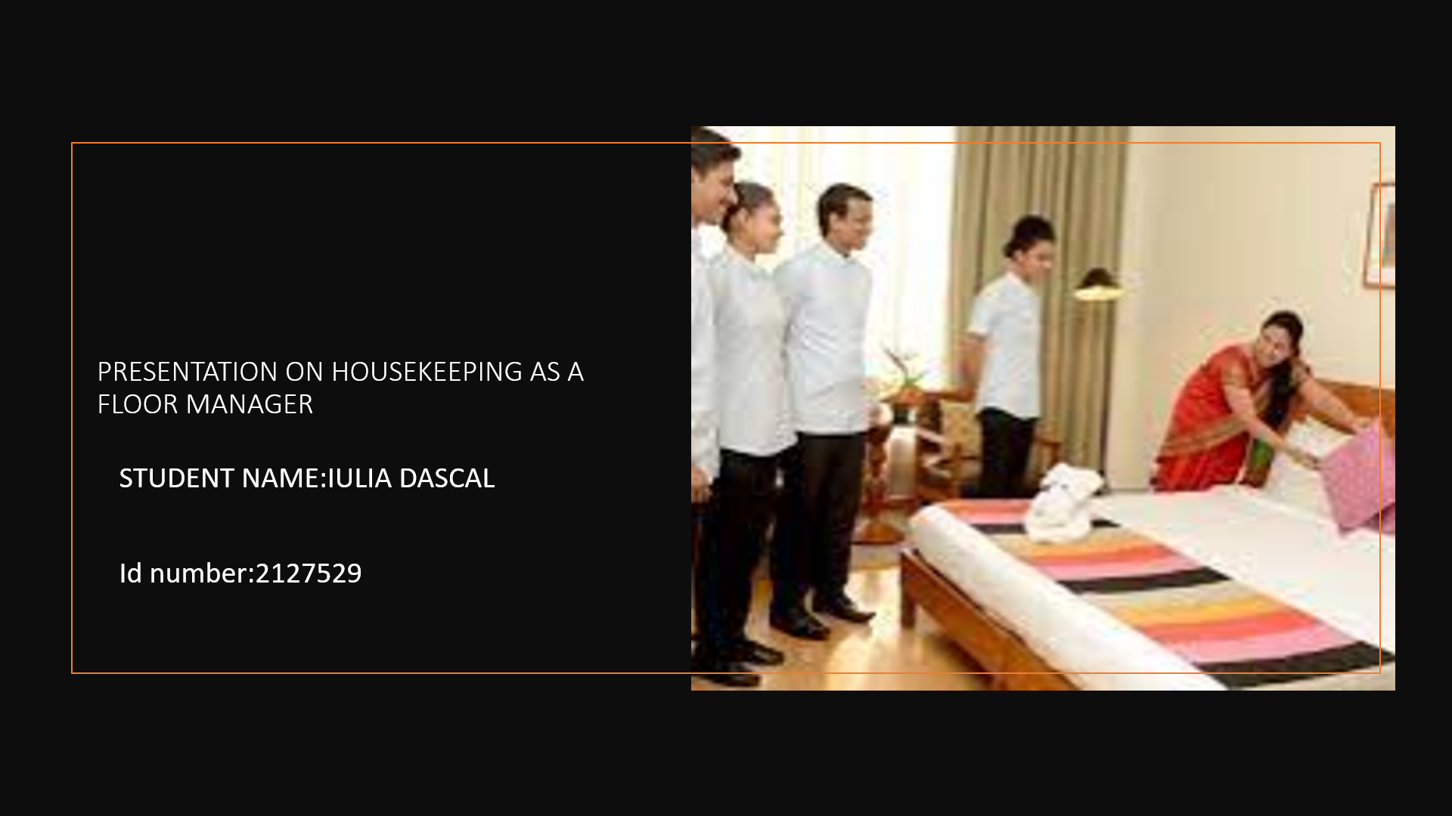

Training Notes: Greeting the group and describing the training’s goal
Study results: Recognize the significance of health and safety protocols, as well as how to
follow them.
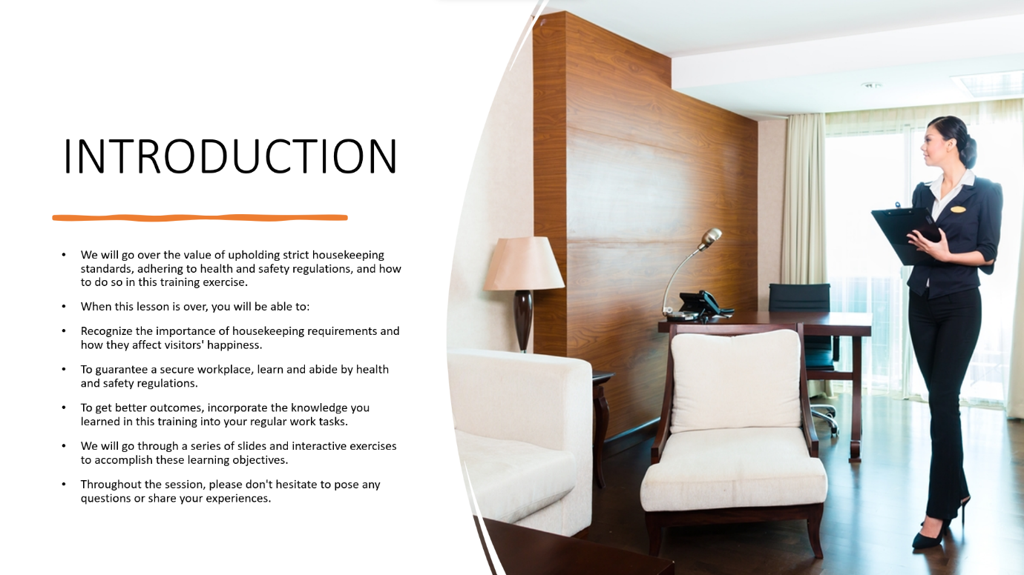

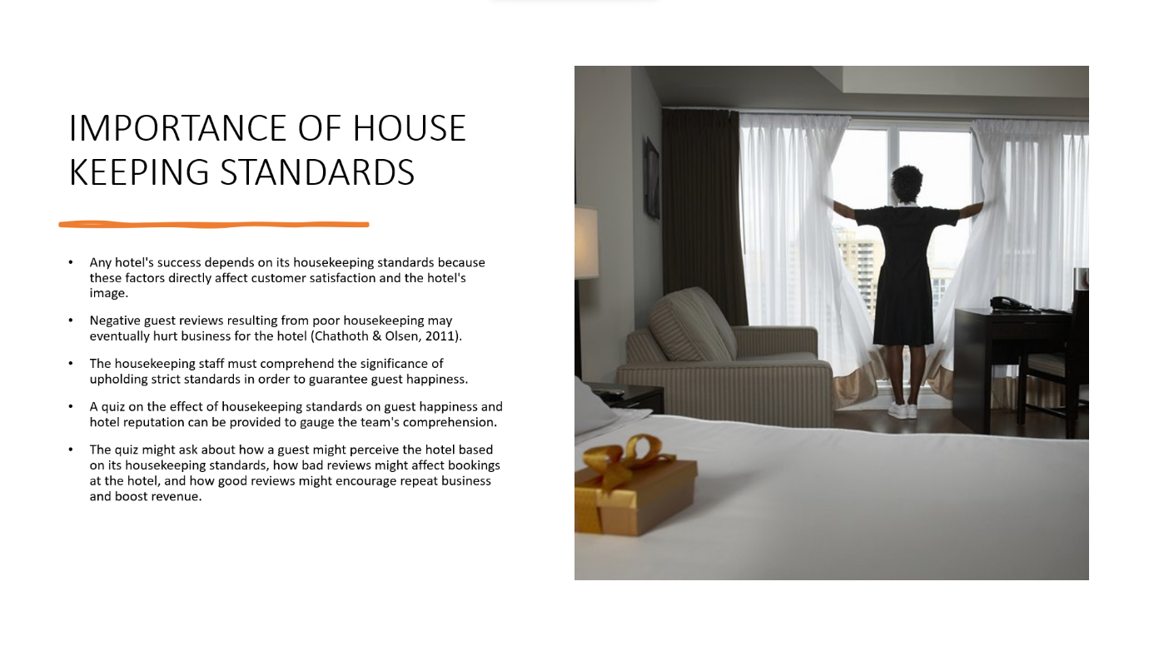

Training Notes:Describe the significance of upholding strict cleaning standards.
Understanding how housekeeping standards affect guest’s satisfaction and a hotel’s image is a learning objective.
Test on how housekeeping standards affect customer satisfaction and a hotel’s image.

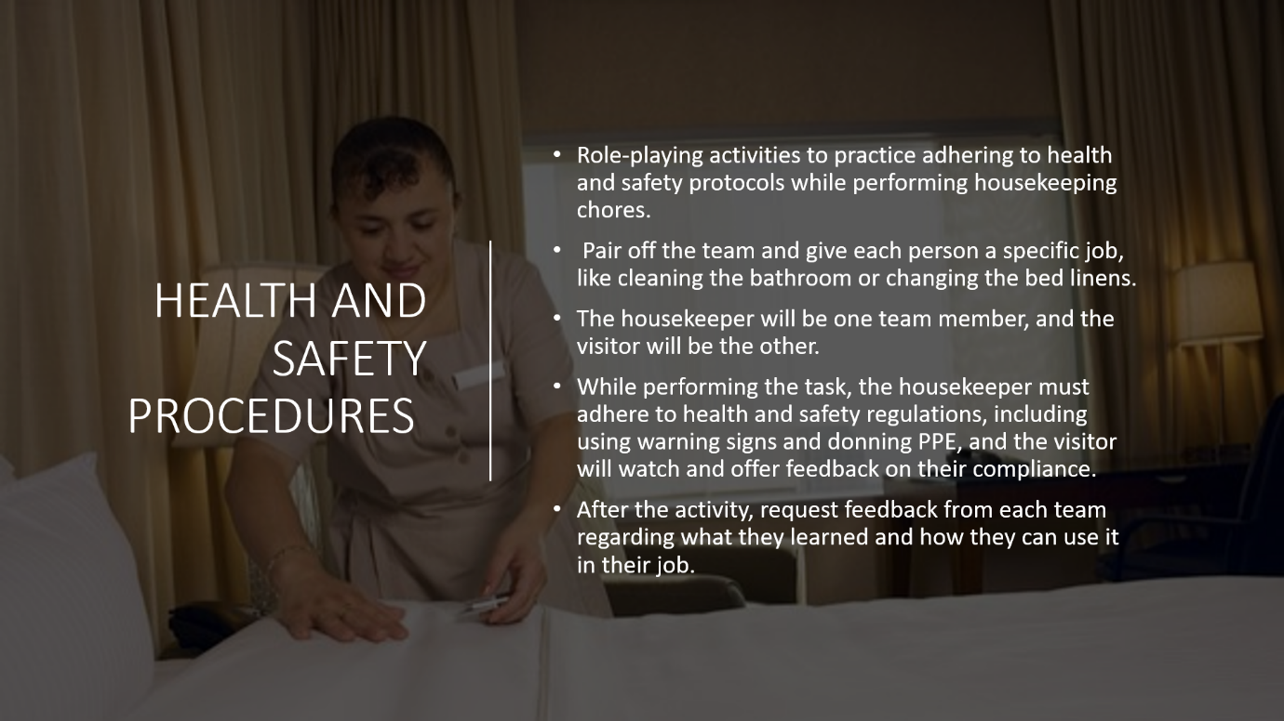

Training Notes: Describe the significance of adhering to housekeeping’s health and safety protocols.
Learning Objective: Recognize the dangers of disregarding health and safety regulations and how to avoid them.
Role-playing exercise on adhering to health and safety regulations when performing
housekeeping chores.
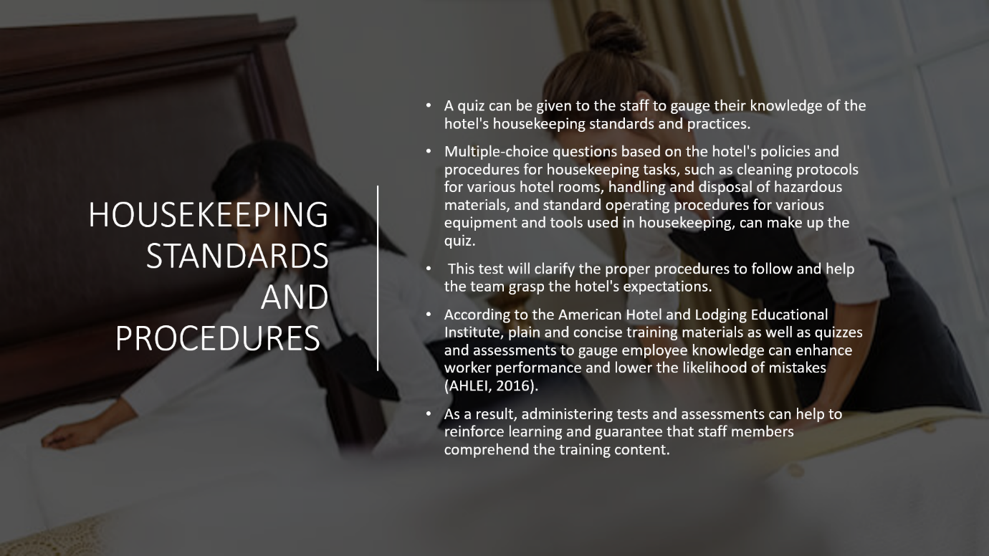

Training Notes: Link the best practices in the business to the employee engagement model
Study result Recognize the advantages of staff engagement and how housekeeping can use it.
Discussion in groups about how to integrate employee engagement into housekeeping chores

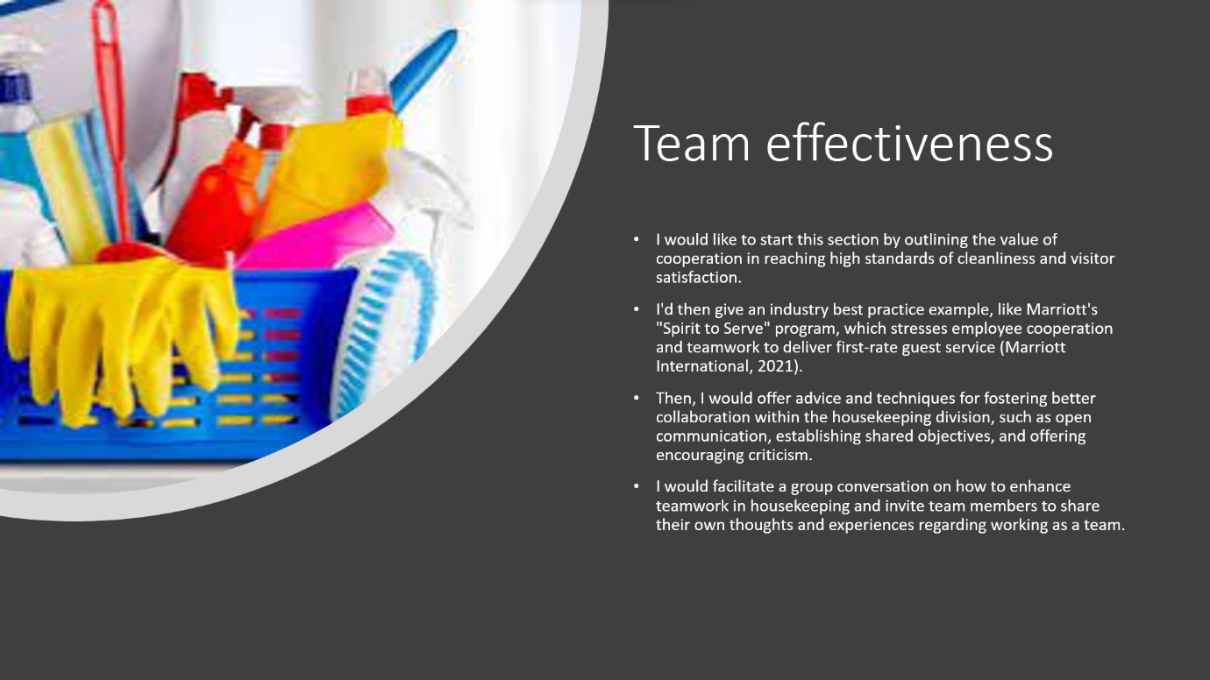

Training Notes: Describe how fostering successful teamwork can increase output and customer satisfaction.
Learning Objective: Recognize the benefits of cooperation in housekeeping
Discussion in groups about how to enhance housekeeping cooperation
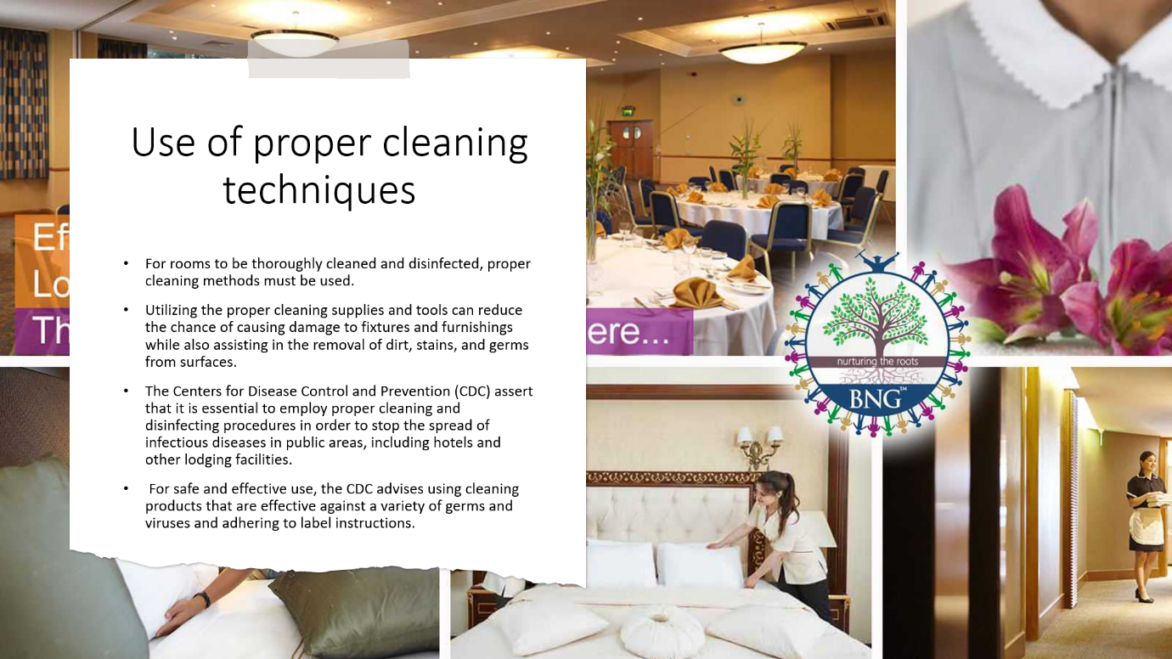

Training Notes: Describe the housekeeping norms and practices at the hotel.
Understanding the hotel’s cleaning policies and standards, as well as how to follow them, is a learning objective.
Test on the housekeeping norms and practices at the hotel.
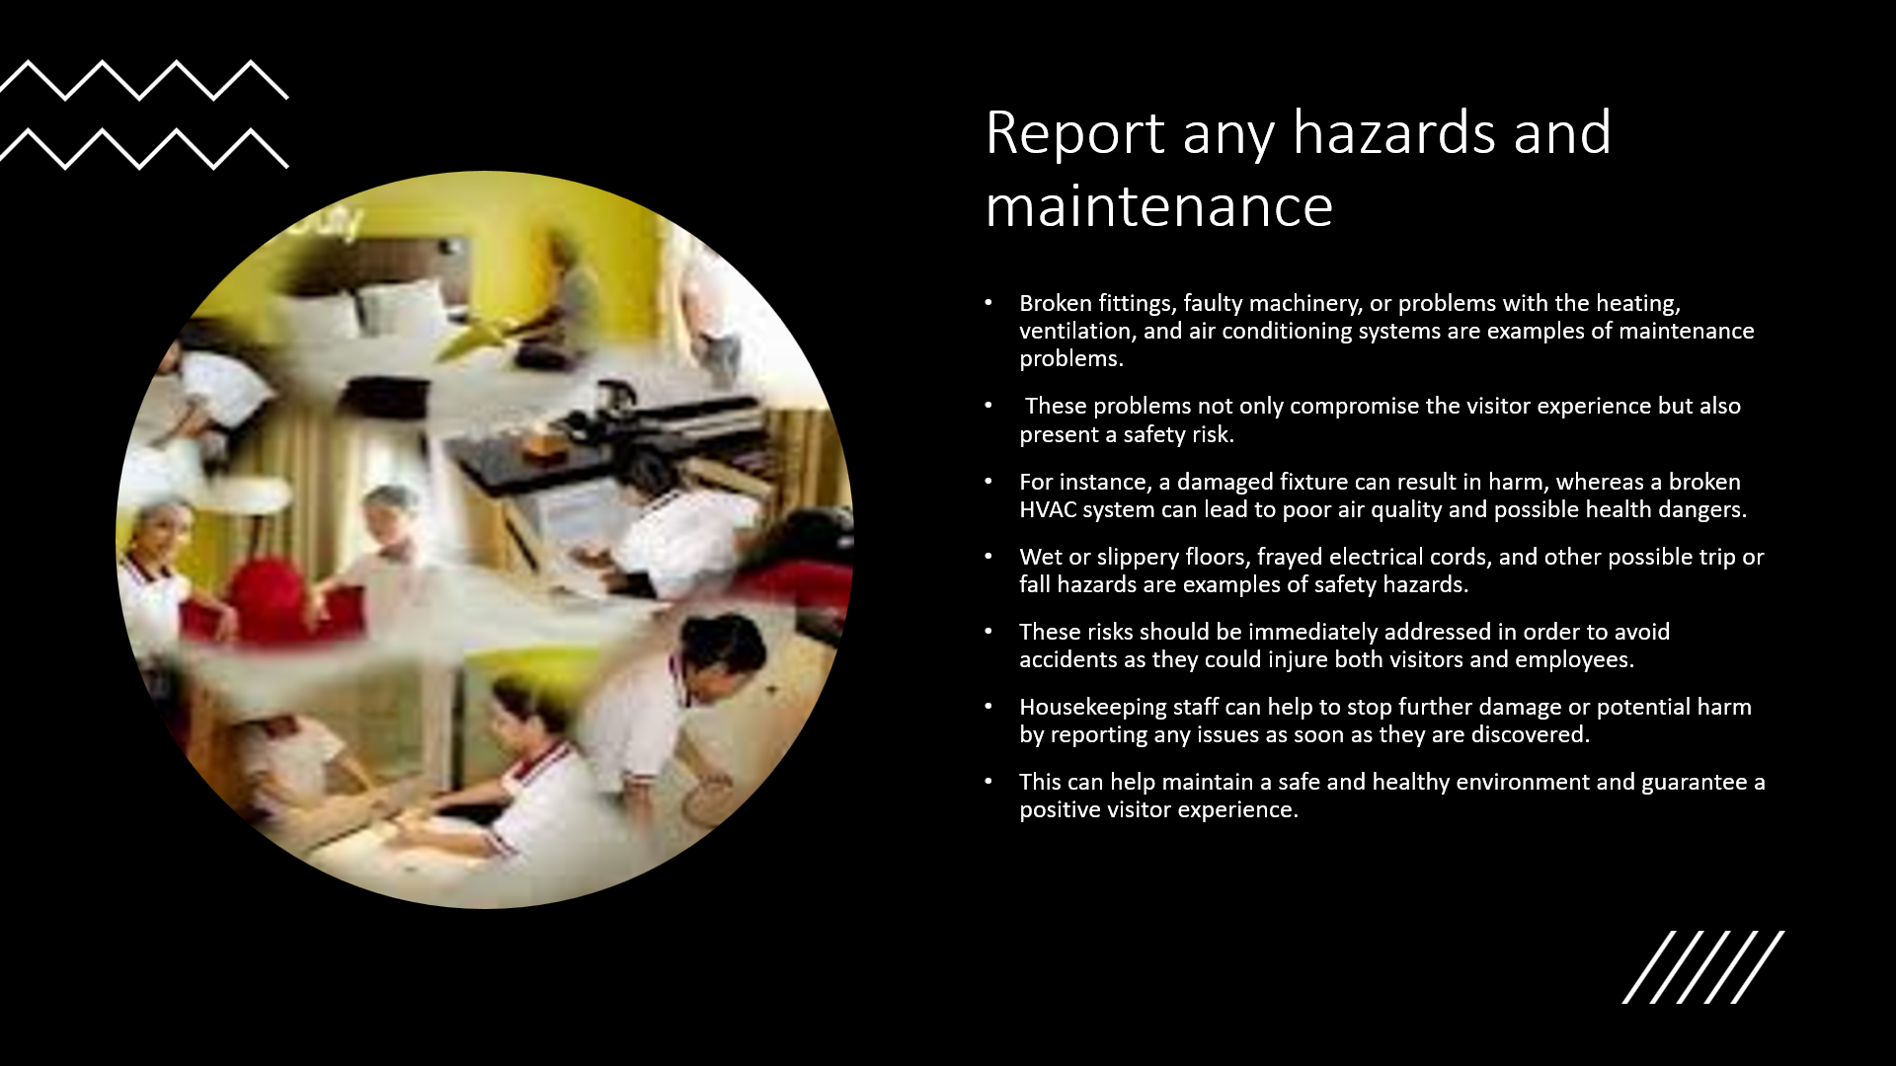

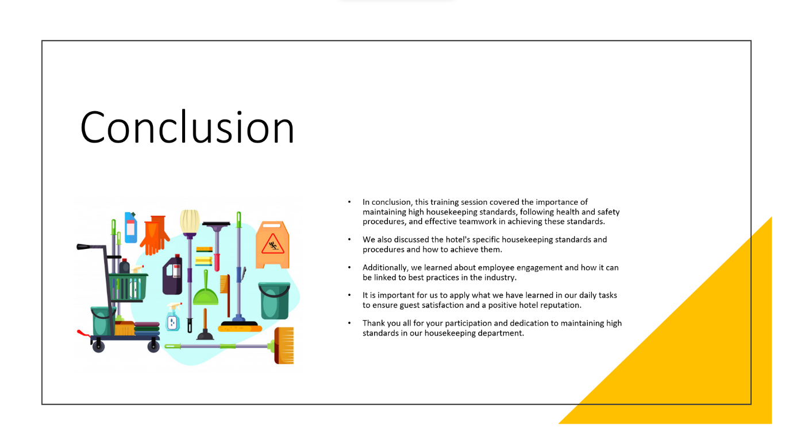

Training Notes: Write a summary of the training’s main elements.
Gratitude for the group’s involvement
Understanding the value of hygienic standards, health and safety regulations, productive
teamwork, and employee involvement.


