Prepared for: Terry Walcott
ACUA6002 – BIG DATA
WaLmart: A case study
Michele Chiarello - 1805745

Table of Contents

Table of Contents 1
Abstract 2
Introduction 2
1. Methodology 4
A) Cross-Industry Standard Process for Data Mining CRISP-DM 4
Business understanding 5
Data understanding 5
Data preparation 5
Modelling 5
Evaluation 5
Deployement 5
1.1 Machine Learning Types 6
1) Supervised Learning 6
2) Unsupervised Learning 6
3) Reinforced Learning 6
Walmart case study 6
Conclusions 13
Bibliography 13

Abstract

It is a common thing to hear somebody speaking of Big Data and AI nowadays. We live indeed in an era in which is really difficult to don’t use or be affected by Big Data effects. Big firms such as Apple, Google, Microsoft, Netflix use it to predict new trends, helping their businesses to create products that can have a positive impact on their revenue.
The rapid growth of Cloud Computing Technologies, Internet of Thing (IoT) and Social media during the last decade [1], contributed to the collection of big amounts of data useful to predict future trends.
The term Big Data, in fact, can be referred to situations in which, due to high volume and variety data, it is difficult to process it in a small time period, especially without the use of machines with high computational power. With this paper, the author aims to introduce the reader to basic Big Data and Machine Learning (ML) concepts to explain the choices behind the analysis and implementation of the proposed solution for the Walmart case study reviewed in the Assignment brief.

Introduction

We live in an era in which the use of social networks and digital services such as Facebook, Netflix etc. is common among users of every age and digital background. The amount of data we produce daily is increasing exponentially and it will continue to grow during the next years. According to [2], internet users generate 2.5 Quintillion bytes every day and this trend is destined to a continuous growth by the next few years.
All the digital footprints we produce by surfing the web and using apps and socials help Big Tech firms but even enterprises that operate in other fields (i.e. finance and sales) to study, predict trends and do business intelligence, by creating algorithms based on ML that continuously analyse this massive amount of data on a daily basis.
With the term Big Data in fact, it is possible to referred to a set of data which shows one or more of the following characteristics [3]:

- Volume
- Speed
- Variety

With volume is meant a really high data amount (10 Terabytes and more), automatically produced by devices that can be represented by computers, sensors, scientific tools etc.
Accordingly, speed is referred to the high velocity this data is produced. In fact, IoT sensors and other internet connected devices, continuously send data to manufacturers and enterprises that collect it to continuously create data sets that will be later analysed. More on this is explained in the next chapters.
Finally, variety, that is referred to the sources and structural diversity which collected data is made of.

When talking of Big Data, it is always possible to find references to Machine Learning and Artificial Intelligence (AI), that are used the used tools to analyse this data. Wanting to introduce the concepts of AI and ML, it is better to make a clarification. ML and AI are not the same thing. Machine Learning is a subset of Artificial Intelligence.

As visible in Figure 1, AI and ML are subset themselves of the Data Science field.

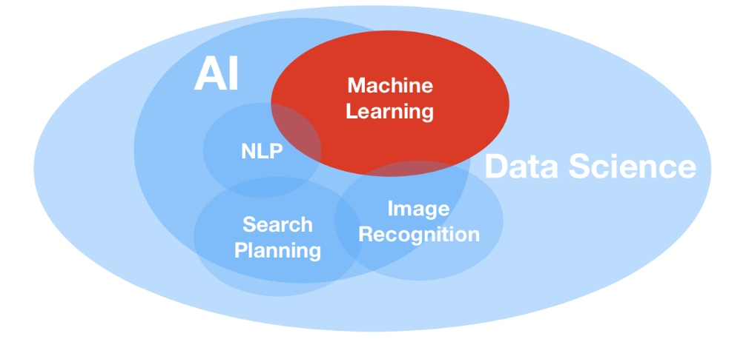
Figure 1. Data Science including AI and ML subsets. Source: [4]

Machine Learning is represented by the set of methodologies used to analyse and find common patterns into a data set, in order to Predict or Classify the analysed data.
It takes advantage of mathematical algorithms and models able to analyse the characteristics of the data set, technically called features.

Many research papers on Big Data and ML have focused their attention on the study and development of prediction models, aimed to solve sales forecasting problems, proposing extensive explanations on the reason why some models are more precise on this task.
Based on the contribution that these papers have done into the field of Big Data and ML, the author decided to write this paper that introduce some important aspects taken into consideration during the selection of the most appropriate Prediction model proposed for the Walmart case study of the assignment.

This report is organised in 3 main parts.

The first part is used to continue the explanation of the main concepts introduced in this chapter, focusing on the different phases that the Cross-Industry Standard Process for Data Mining methodology, more commonly known as CRISP-DM, suggests for approach and development of solution to Data Mining related problems.
Successively, are introduced some more ML concepts, particularly related to the three different Machine Learning types:

- Supervised Learning
- Unsupervised Learning
- Reinforced Learning

In the second part of the document is shown how the author approached the Assignment problem and successively developed a solution making use of the KNIME framework for the specified tasks.

Finally, the third and last chapter, where it is possible to find a discussion related to the results found with the use of the implemented solution.

1. Methodology

The literature review used during the study of the subject, allowed to understand that the most appropriate ML algorithms to implement during sales forecasting are those based on the Regression. According to [4] [5, 6, 7, 8, 9, 10], when a problem is related to forecasts (i.e. stock markets or sales), it is required to make use of a supervised ML model type. The author tested the various Regression algorithms in an empirical way. In Chapter 2 is shown how, using the KNIME analytic platform to create a workflow to test and collect all the needed results to determine the efficiency of every Regression based model, the author found the most accurate one.

A) Cross-Industry Standard Process for Data Mining CRISP-DM

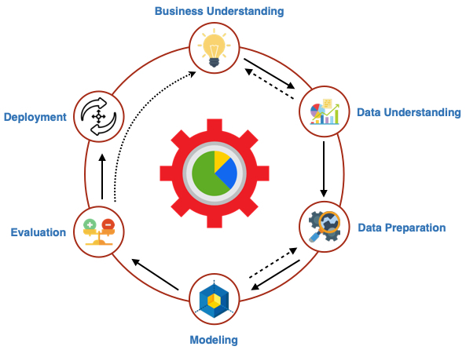
Figure 2. CRISP-DM model representation. Source: [4]

According to [4], CRISP-DM is the industry business standard for the approach and development of solution to Data mining Problems based on ML. The model is represented by six different phases:

- Business understanding
- Data understanding
- Data preparation
- Modelling
- Evaluation
- Deployment

Although the CRISIP-DM process is fairly simple, it is important to take into consideration its most important phases represented by Business understanding and Deployment. These two phases are the key to a successful solution to the set goal.

Business understanding

In this first phase, the goal and the different objectives that want to be achieved by the business are set. It is important in fact to understand if to find the solution to their needs is achievable just using DM and ML rather than a simpler solution, already implemented by others under the shape of a less complex, more traditional and cost-effective solution.
It is important to note that, even if ML is nowadays not too complicated to implement though many available opensource solutions are available on the market, is not a good idea to invest a huge amount of time that could compromise the business, if not really required.

Data understanding

This phase involves the study of the available data, to find out if it can be used to achieve the goal.

Data preparation

This step requires the preparation of the data to be used within the ML model that is chosen in the next phase. Although even this might seem nonsense, it is important to note that, if data is not properly cleaned and organised to be ingested by the model, this will result in a less precise prediction. Moreover, in this phase, the data set is split in two to create a Training and a Test Data Set. These two data sets are used by the algorithm to create a model by applying a set of rules on the first one and, successively, apply the model to the second part of the data set to test the accuracy of the model.

Modelling

Reached this point means finding out which ML model is the most appropriate to their needs. In this phase, the prepared data is given in input to the algorithm that generates a model to be applied to the Test data set.

Evaluation

If the model has achieved the required standards to be used by the business, it is possible to proceed to the next step. Otherwise, it is necessary to go back to the Modelling phase to find another model or settings for the model.

Deployement

This is the final phase in which the model can be deployed and in which it is possible to find some more problem. As said in [4], it is important to continue the training of the model with new data. This because, having created the right model doesn’t always mean that can accomplish the duty. Business dynamics changes and therefore important having an up-to-date model to work with, to make sure it can always be accurate enough.

1.1 Machine Learning Types

This chapter ends with the explanation of some ML learning types. Here below it is possible to find their name with a brief explanation of their characteristics.

1) Supervised Learning

Supervised learning (SV) is characterised by the need of two separate data sets to work. In particular test and training dataset. As previously explained in the “Data preparation Process” phase explanation of the CRISP-DM model, the main data set is split in two, to give the possibility to create a model with the first part (Training Set). This is successively applied to the second set (Test set) to test its accuracy.
SV learning algorithms are used to address two problem types: Regression and Classification. A regression problem regards the need to find a common pattern between numerical value, while a Classification one is used to solve problem such as the recognition of objects.

2) Unsupervised Learning

In brief, Unsupervised Learning is a type of ML based on Clustering. Clustering is a set of techniques that uses Statistical analysis to find common patterns after having grouped the analysed data in homogeneous groups (clusters). This learning type makes use of just one data set and is used when historical data is not available.

3) Reinforced Learning

According to [4], reinforced learning is a type pf ML that involves the use of three different types of logic, in which the algorithm does the following:

- Receives data in input and gives back an output
- Evaluates outputs based on some objectives (model testing)
- Reprograms the model itself on the base of the previous predictions

Walmart case study

As explained previously in Chapter 1, the right model for the Walmart case study has been found empirically testing the available KNIME regression models and comparing them after having determined their precision making use of a “Numerical Scorer” node.
Figure 3 shows how the full workflow has been implemented for the. Testing purpose of each model, as well as the calculation of the Annual impact that holidays have on sales during sorted by year (2010, 2011, 2012).

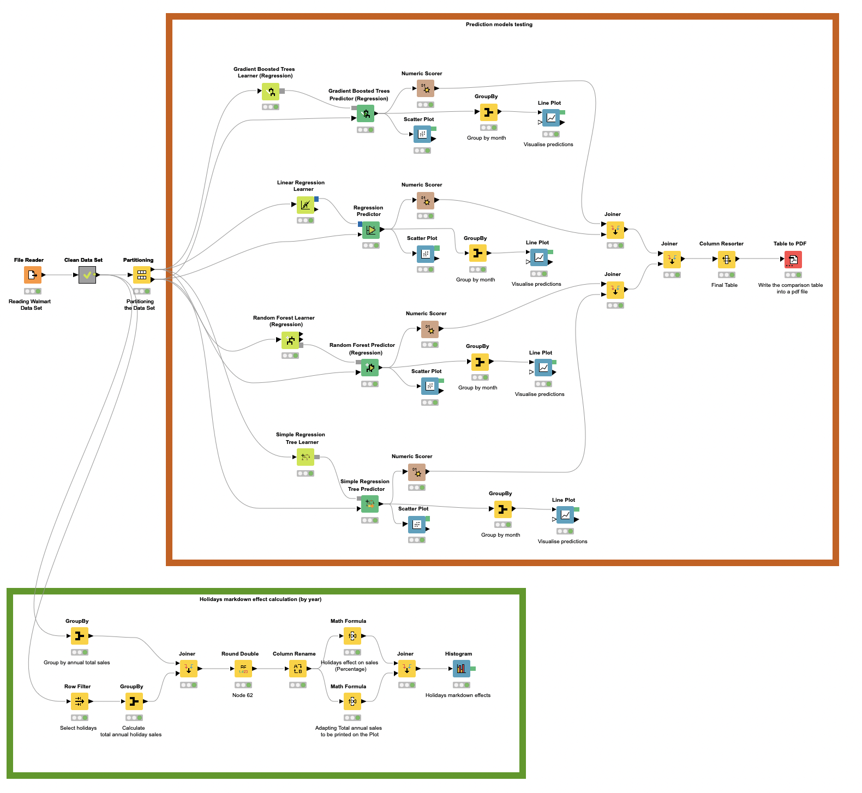
Figure 3. Full Workflow. Source: Author
As visible in the workflow, before proceeding to the test of each model, the used Data Set has been cleaned and split in Training and Testing Sets. The next two figures show the content of the “Clean Data Set” meta node, in which the different columns have been converted into the right data type and rounded to have a clearer readability. Also, the fields day, month and year have been extracted to successively be used as a parameter for the learning nodes.

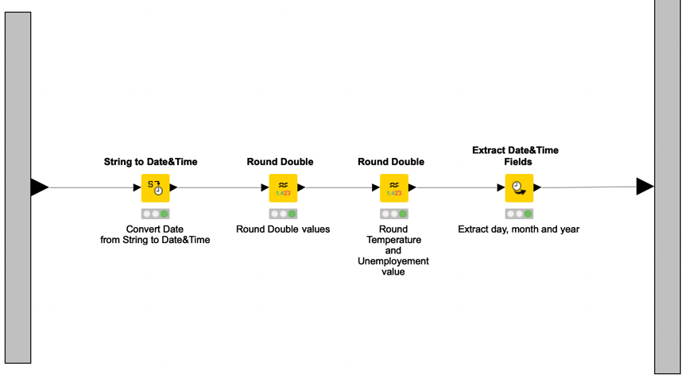
Figure 4. Clean Data Set meta node. Source: Author
In the following pictures is possible to see how the different Regression models have been compared first visually, by creating a Scatter and a Linear Plot for each model.

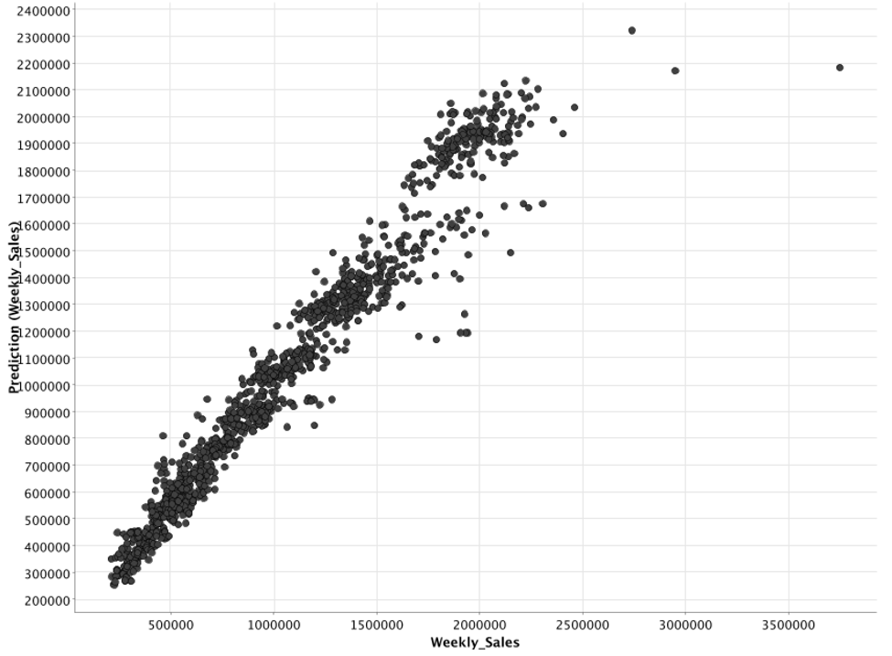
Figure 5. Gradient Boosted Tree Scatter Plot. Source: Author

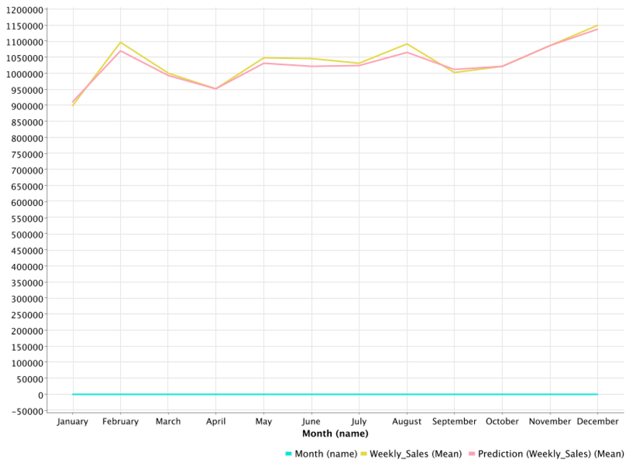
Figure 6. Gradient Boosted Tree Linear Plot. Source: Author
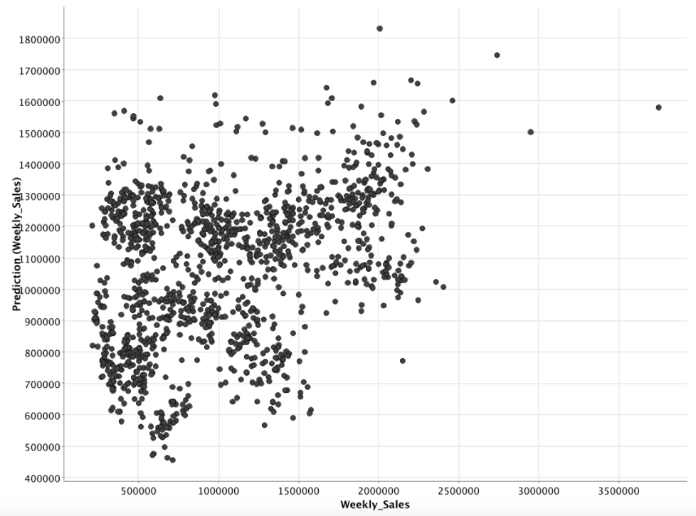
Figure 7. Linear Regression Scatter Plot. Source: Author

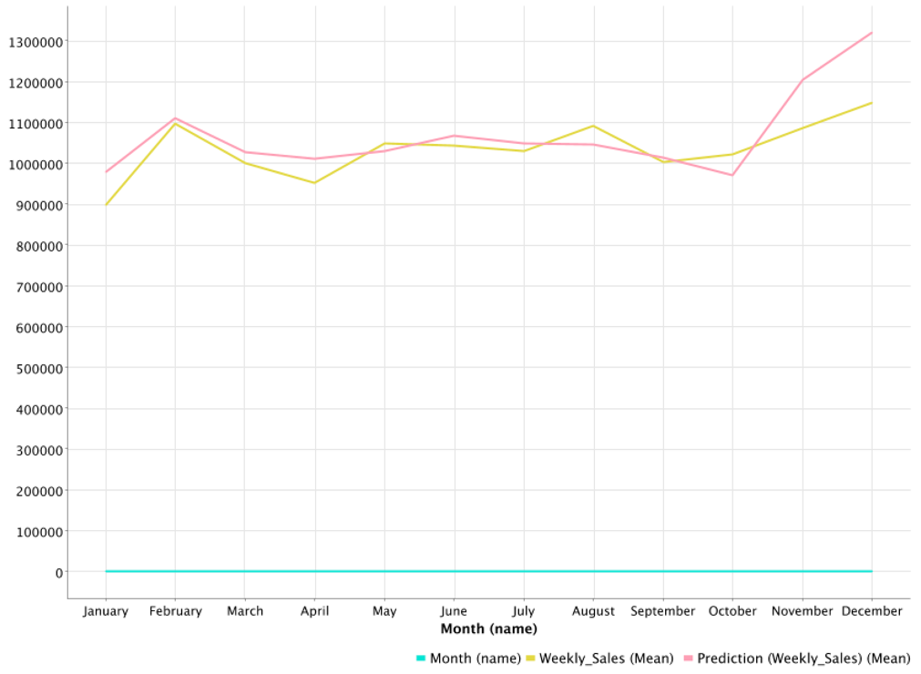
Figure 8. Linear Regression Linear Plot. Source: Author
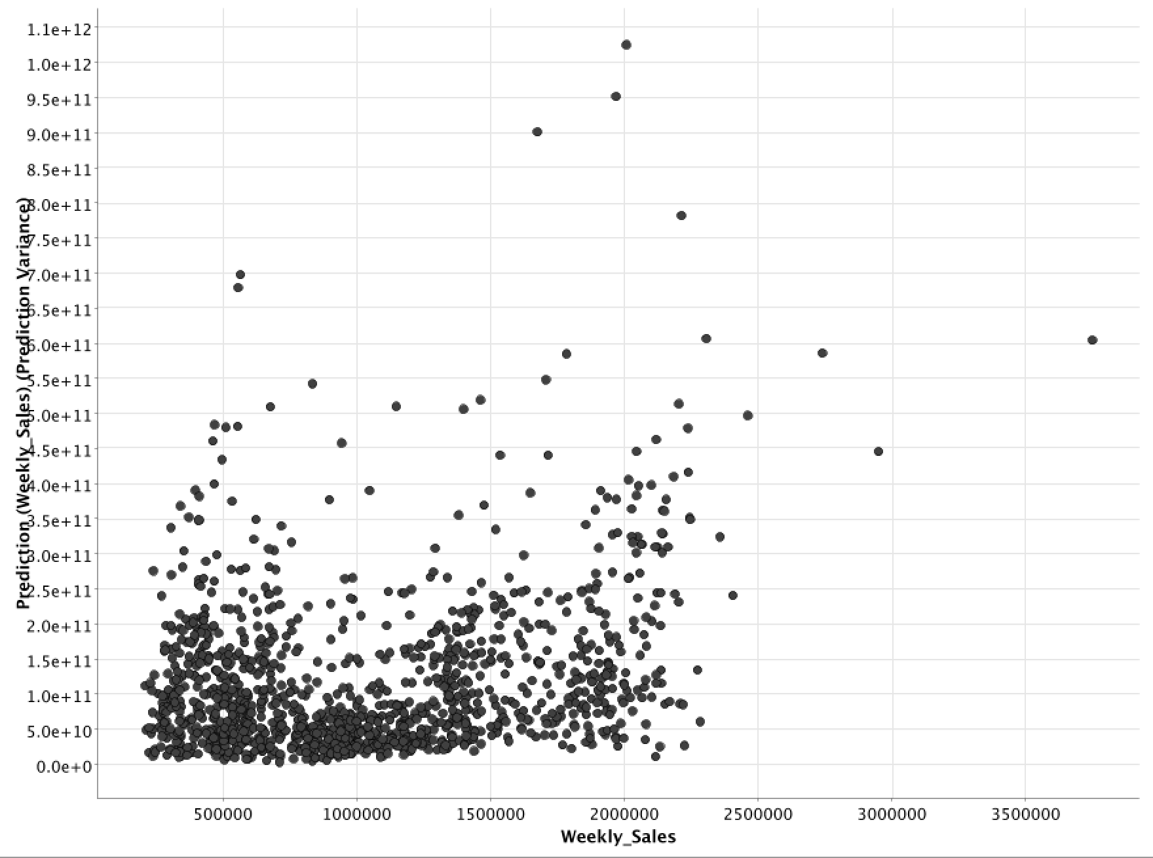
Figure 9. Random Forest Scatter Plot. Source: Author

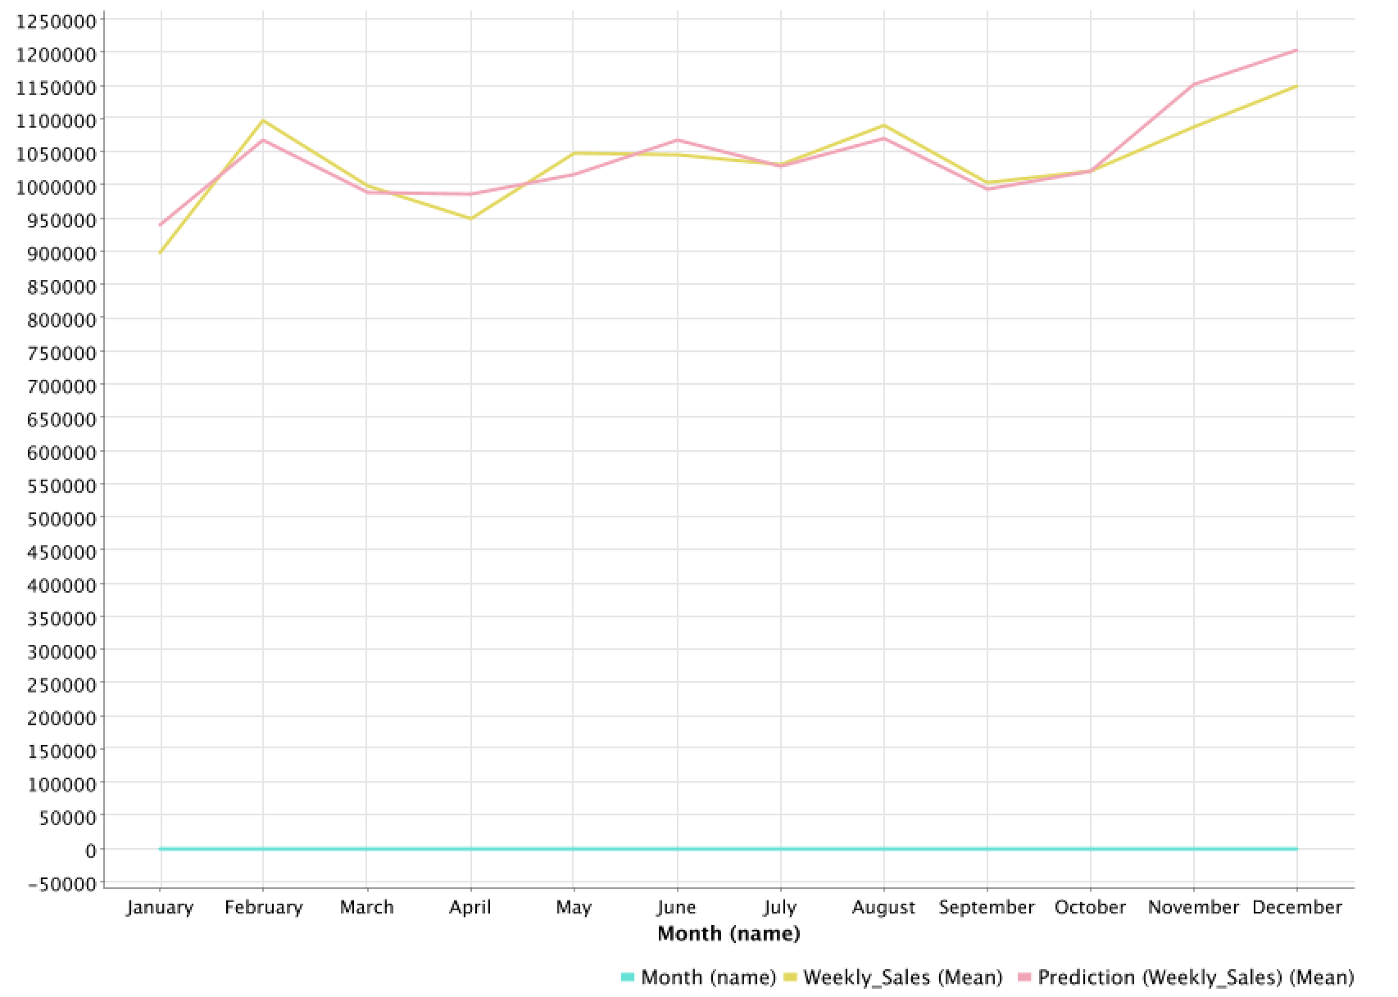
Figure 10. Random Forest Linear Plot. Source: Author
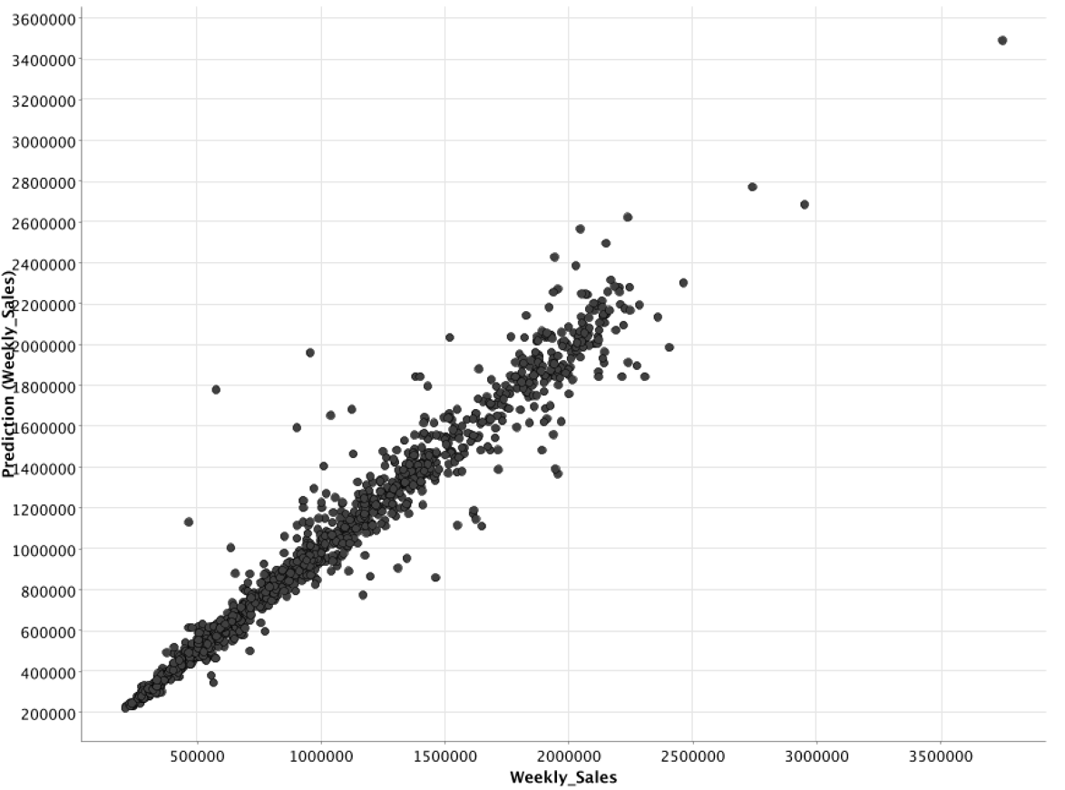
Figure 11. Regression Tree Scatter Plot. Source: Author

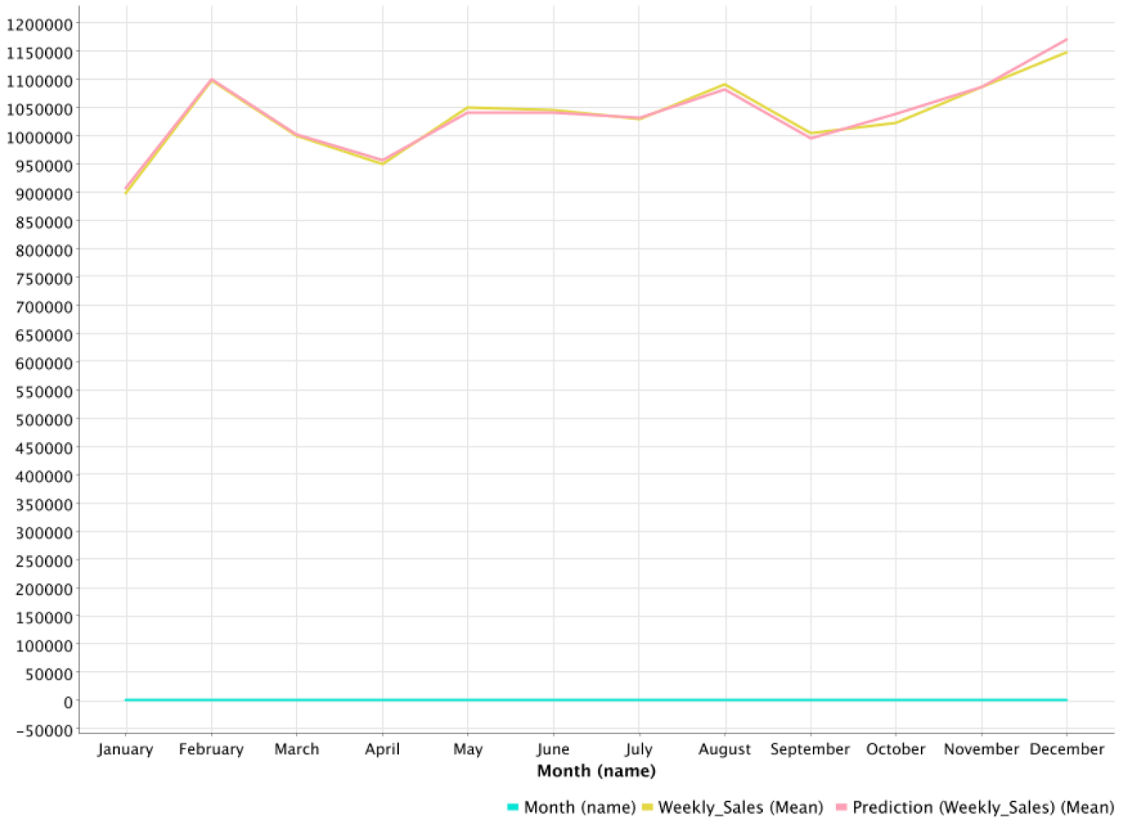
Figure 12. Regression Tree Linear Plot. Source: Author
Successively, all the statistics received in output by the numeric scorer of every model have been joined in a table, to have a clearer visual of the R^2 factor as well as Mean absolute percentage error etc.

R^2 is in ML is a statistical measure that shows how a model is closer to the Regression Line.
It belongs to the [0,1] and the closer to 1 it is the better it is.

The next figure shows the table with the above-mentioned statistics. As clearly visible the best model is represented by the Regression Tree (that is an adaptation of the XGBoost algorithm).

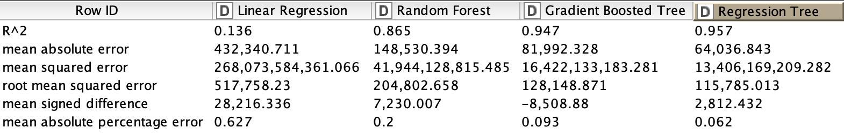
Figure 13. Models comparison table. Source: Author

The final two screenshots represent part of the workflow that has been used to calculate the impact of holidays’ sales on the total sales of the years 2010, 2011, 2012 using the data present in data set. To show the results, an histogram that overlaps the two calculated values has been used.

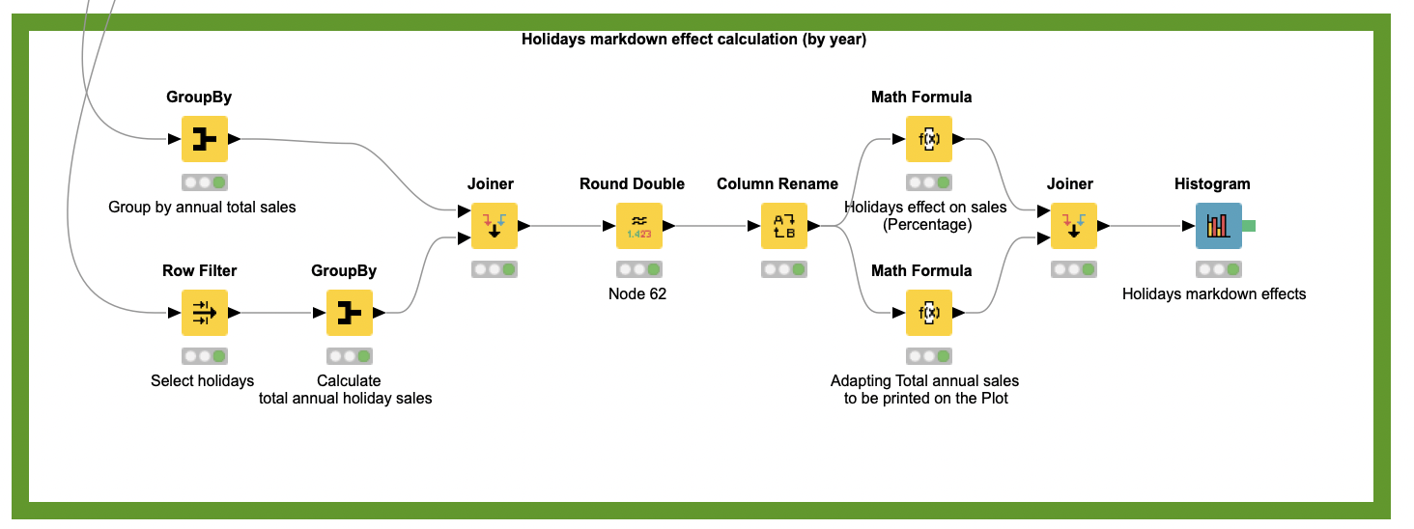
Figure 14. Holidays annual impact calculation. Source: Author

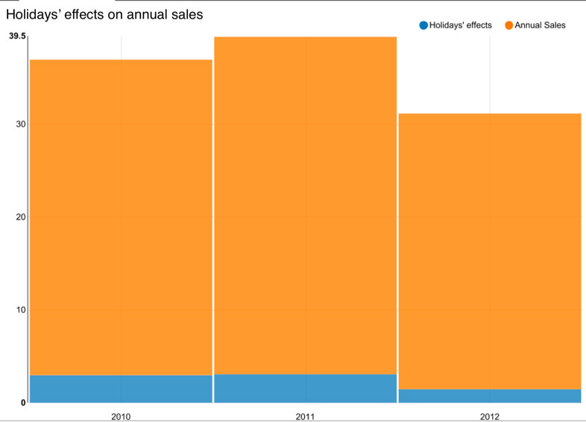
Figure 15. Holidays annual impact results. Source: Author

Conclusions

The topics examined in this report had the goal to give the author the knowledge to analyse and choose the right prediction model for the Walmart case study proposed in the Assignment brief. As seen in Chapter 1, one of the possible solutions while approaching a Data Mining problem is to follow the CRISP-DM model as it represents a valid methodology in the DM field. Although in 2015 IBM released a new methodology that takes the name of Analytics Solutions Unified Method (ASUM-DM), CRISP-DM is still the most widely used among data mining experts.
The proposed solution wants to represent a basic (rudimental) implementation of what learnt during the Big Data course, therefore it may not be precise as required. It offers anyway a starting point from where to start from in the Big Data and ML fields.

Bibliography

[1] | S. W. W. Y. W. Tsan-Ming Choi, “Big Data Analytics in Operation Management,” Production and operation management, vol. 27, pp. 1868-1883, 10 October 2018.
[2] | C. Petrov, “25+ Impressive Big Data Statistics for 2020,” techjury, 10 September 2020. [Online]. Available: https://techjury.net/blog/big-data-statistics/#gref. [Accessed December 2020].
[3] | R. Alessandro, Big Data Analytics: Il manuale del data scientist, Santarcangelo di Romagna (RN), italy: Maggioli Editore, 2017.
[4] | D. Gosmar, MACHINE LEARNING - The sixth chakra of artificial intelligence, Independently published (August 21, 2020), 2020.
[5] | M. K. B. M. R.-S. Marko Bohanec, “Explaining machine learning models in sales predictions,” Expert Systems With Applications, vol. 71, no. 2017, pp. 416-428, 2016.
[6] | M. W. G. a. S. R. DORLING, “ARTIFICIAL NEURAL NETWORKS (THE MULTILAYER PERCEPTRON)—A REVIEW OF APPLICATIONS IN THE ATMOSPHERIC SCIENCES,” Atmospheric Environment, vol. 32, no. 14/15, pp. 2627-2636, 1998.
[7] | J. L. C. X. L. Jin Huang, “Comparing Naive Bayes, Decision Trees, and SVM with AUC and Accuracy,” in Third IEEE International Conference on Data Mining (ICDM’03), London, Ontario, Canada, 2003.
[8] | J. Z. H. S. S. T. Z. E. a. K. S. Mohammad Sultan Mahmud, “A Survey of Data Partitioning and Sampling Methods to Support Big Data Analysis,” BIG DATA MINING AND ANALYTICS, vol. 3, no. 2, pp. 85-101, 2020.
[9] | B. M. Pavlyshenko, “Machine-Learning Models for Sales Time Series Forecasting,” in Using Stacking Approaches for Machine Learning Models, Lviv, Ukraine, 2019.
[10] | W. Z. W. X. Raymond Yiu Keung Lau, “Parallel Aspect-Oriented Sentiment Analysis for Sales Forecasting with Big Data,” POMS Production and operations management, vol. 27, no. 10, pp. 1775-1794, 10 October 2018.

