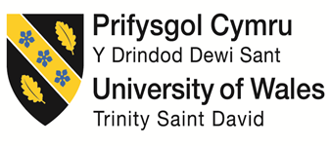

Marketing Plan Written for
Myconian Korali

  - Student’s Name: Anna Todos
  - Student’s Number:2108418

Marketing Essentials BMIH4005
  - Lecturer’s name:Deborah Lloyd

Table of Contents
Introduction 3
Marketing Mix 3
The Marketing Environment - Micro 4
SWOT Analysis 4
The Marketing Environment - Macro 4
PESTLE Analysis 4
Creating Customer Value and Engagement 5
Effective Use of Digital Marketing 5
Conclusion 6
References 6

Introduction
Myconian Korali Relais & Chateaux is a hotel situated in the Greek island Mykonos and it is in the top moat exclusive hotels on the island, having an excellent position, seafront. (Daktylides, 2021) Mykonos is one of the most exclusive islands from Greece and at the same time, is one of the most visited among Greek islands. (Greeka, 2020)
This Marketing Plan is having the purpose of attracting new customers after the hotel reopened after the lock-down during Covid-19 Pandemic. There will be followed aspects as the strengths, the opportunities, the location along with its challenges and advantages in order to make a clear image about what Myconian Korali Hotel.

Marketing Mix
Product: Mykonos Island is a top luxury travel destination especially the nightlife is very intense. Beaches near Myconian Korali are very popular and usually they are private and visitors can also enjoy different water activities such as scuba diving, flyboarding or parasailing but also, there are many attractions such as The Windmills (Kato Mily or Paraportiani Church. (U.S News, 2021)

Place: It is important to mention the fact that Mykonos is a safe place to walk, the rate being 64,29%, so travelers should not be concerned while going for a walk or visiting around the island. (All Luxury Apartments, 2020). From the Covid-19 Pandemic, Greece is a safe place as it is taking all the safety requirements in order to prevent spreading the virus by asking the travelers to be vaccinated or proof of recovery while entering in the country. (CNN, 2021)

Price: Mykonos is the most expensive island and for this reason, the price point is very high. Usually, a trip in Mykonos for a single person is £2,000, for couples is around £3,000 and for a family £8,000. (Reece, 2021). Myconian Korali is having a price point of an average £3000 per room in the summer season for 7 days, including breakfast, pool on the room terrace and an amazing view. (Booking, 2021)

Promotion: The main promotion strategy pf Myconian Korali is influencers promotion, Google Pages and Adverts that can target and personalize the ad’s for the certain group of people that are targeted. Moreover, Facebook, Instagram and Twitter will be social media channels used in order to promote Myconian Korali. (Set Up My Hotel, 2020)

The Marketing Environment - Micro

SWOT Analysis
Strengths: one if the biggest strengths of Myconian Korali is the excellent location due to the fact that it is situated on the seaside, offering to their guests the best views. The infinity pool is a luxury asset for a hotel and it is making guests attracted to it, as well as being open to pay a bigger price per night. (Baden Pools, 2019). The excellent reputation of a hotel is also a booster when guests are looking to stay at the best quality hotel on Mykonos. (Trip Advisor, 2021)

Weaknesses: Myconian Korali will be working on the official website in order not aboid the outdate factor and keeping is updated. Upgrading the rooms with more technology will be a boost for Myconian Korali due to the fact that it will improve the experience of their guests. (Attala, 2019)

Opportunities: Reaching new markets is a target for Myconian Korali such as targeting other groups of people than 20-40 aged would be a great thing in increasing the level of bookings. (Yield Planet, 2018). Automatic check-in and Check-in are an opportunity to take into account due tot he fact that it will reduce the lines at the front office. (Protel, 2020).

Weaknesses: The main threats of Myconian Korali are the Airbnb properties such as apartments and penthouses as well as local hosting businesses that often offer lower prices for their guests so it is a very strong competition. (Harvard Real Estate Review, 2019)

The Marketing Environment - Macro

PESTLE Analysis
Political: Usually political decisions of the Greek Government are leading to the success or failure of Myconian Korali. Opening the borders after the Covid-19 lock-down has been leading tot the success of the hotel while during the lock-down the hotel was closed for 5 months. (Farooq, 2019)
Economical: Financial crisis are often leading to a decrease in matter of traveling. For this reason, the crisis after Covid-19 lock down is decreasing the well-being of Myconian Korali because of the fact that traveling is harder due to special regulations. (Behsudi, 2020)
Social: Mainly socio-cultural factors are sustaining or not the hotels, so for this reason Myconian Korali is needing a strong brand image via social media platforms. (Lim, 2010). For example, any discrimination action will decrease the rates for the hotel as social media news are spreading within minutes and this can cause loses for Myconian Karoli.
Technological: Things such as security cameras in hallways and also around the hotel cab make the Myconian Karoli’s guests feel safe. It is important to use technology in a smart way in hotels, such as having a high speed internet network in order to be able to work and organize virtual conferences for the guests that travel in business purposes. (Robinson, 2021)
Legal: Once there exists a restaurant in Myconian Karoli hotel, one of the laws is to provide fresh food for their customers and also handling it should follow certain regulations. Moreover, for the safety of their guests, the hotel should assure that no external people can have access in the hotel unless is a guest. (Razak & Leng, 2021)
Environment: Myconian Korali should be aware of the seasons and weather in order to adjust the prices as the travelers have cheaper options to stay while there is not full season. (Farooq, 2019).

Creating Customer Value and Engagement
Customer value represents what Myconian Korali is bringing for their guests in matter of services and credibility, which actually at this hotel are 5 star ranked and offers a great experience. Customer value also brings satisfaction and engagement of customers. (Mahajan, 2020). The Customer engagement is the process of interacting with the customers via different kind of channels. For a high-quality customer engagement process, the reviews of the Myconian Korali’s guests should be taken into consideration. (Coleman, 2021). In order to create customer value and engagement, the potential customers of Myconian Korali should get involved in the process or at least get to know better the hotel and what services are they offering. In order to create customer value and engagement, the customers will be targeted and advertise will appear for them on the social media platforms: Facebook, Twitter, Instagram and also, there will be adverts on the television and via Radio. (Mahajan, 2020)

Effective Use of Digital Marketing
Digital Marketing is a tool used by companies in order to sell their services and products via electronic devices using different channels of promoting their brands and it can be done offline but also online due to the fact that it has a great impact on the performances of the company. (Patel, no date).
Due to the fact that digitalization is a process that overwhelmed most of the global population, the digital marketing process is more successful. Myconian Korali will be using affiliate marketing, that involves influencers that visit the hotel, to post pictures, videos and speak to their followers how they felt during their stay at the hotel but also, how was the food at the restaurant, how they have felt by the infinity pool or even in their personal pool on the terrace of their rooms. (Patel, 2020)
Content marketing will also be used as a digital marketing tool by Myconian Korali and a story will be created via video where will be captured the beautiful sunsets, guests enjoying the infinity pool, the food and also things around Mykonos island. The videos will be shared and promoted via social media channels. (Patel, 2021)

Conclusion
All in all, I consider that the Myconian Korali hotel is situated in one of the best spots around Mykonos Island which makes things easier while promoting the amazing location and it’s spectacular views. Moreover, even if there are challenges such as weather, laws and regulations implemented after Covid-19 lock-down, the hotel will eb able to successfully create a stronger brand image and attract more customers as it is following all the laws and make guests feel safe.

References
- Daktylides M., (2021), Myconian Korali, Accessed on 7th of November 2021.
- U.S. News, (2021), 16 Best Things To in Mykonos, Published on February 11th, Accessed on November 7th 2021.
- All Luxury Apartments, (2020), What to Know About Mykonos Crime Rate, Published on November 6th, Accessed on November 7th 2021.
- CNN, (2021), Traveling to Greece during Covid-19, What you need to know before you go, Updated on October 18th, Accessed on November 7th 2021.
- Reece, (2021), Is Mykonos Expensive to Visit? Average Travel Costs, Published on May 3rd, Accessed on November 7th 2021
- Set Up My Hotel, (2020), The Hotel Marketing Mix, Accessed on November 7th 2021.
- Baden Pools, (2019), Benefits of Installing an Infinity Pool, Published on November 29th, Accessed on November 7th 2921.
- Attala J., (2019), 10 ways smart technology is reshaping the hotel industry, Published on March 25th, Accessed on November 7th 2021.
- Yield Planet, (2018), How to win new markets in the hotel industry?, Published on September 15th, Accessed on November 7th 2021.
- Protel, (2020), Five Key Benefits of Self-Service Check-In/ Out, Published on March 3rd, accessed on November 7th 2021.
- Harvard Real Estate Review, (2019), A New Era of Lodging: Airbnb’s Impact on Hotels, Travelers and Cities, Published on January 25th, Accessed on November 7th 2021.
- Farooq U., (2019), PESTLE Analysis of the Hotel Industry, Published on December 12th, Accessed on November 7th 2021.
- Behsudi A., (2020), Tourism-dependent economies are among those harmed the most by the pandemic, Accessed on November 7th 2021.
- Lim W., (2010), The Effects of social media networks in the hospitality industry, Published on September, Accessed on November 7th 2021.
- Robinson J., (2021), Technology in the hospitality industry - exploring the very late trends, Accessed on November 7th 2021.
- Razak M., Leng C. W., (2921), Introduction to Tourism & Hospitality Law, Accessed on November 7th 2021.
- Mahajann G., (2020), What Is Customer Value and How Can You Create It?, Published on May 29th, Accessed on November 7th 2021.
- Coleman B., (2021), The Ultimate Guide to Customer Engagement in 2021, Published on October 21st, Accessed on November 7th 2021.
- Greeka, (2020), Mykonos, Accessed on November 7th 2021.
- Booking, (2921), Myconian Korali, Accessed on November 7th 2021.
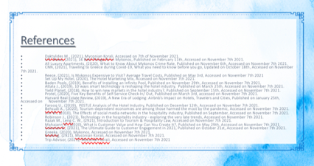
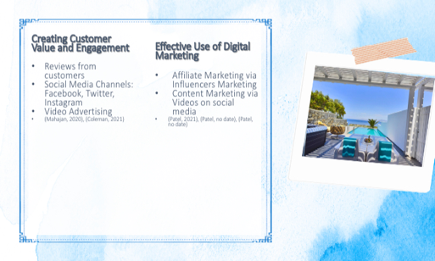
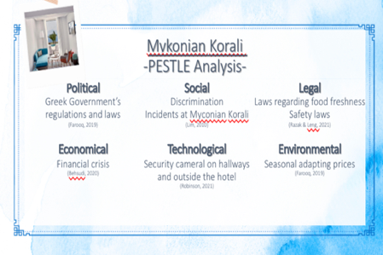
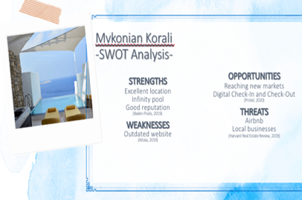
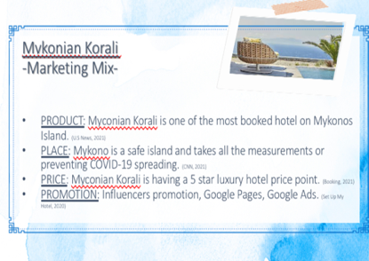
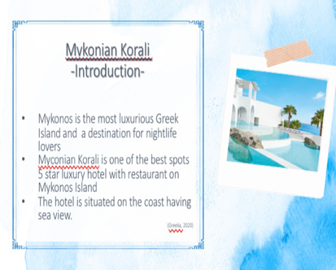
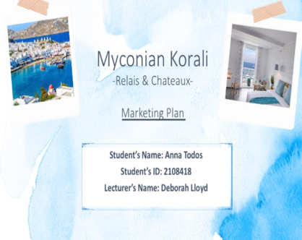
- Trip Advisor, (2021), Myconian Korali, Accessed on November 7th 2021

