
CAREER DEVELOPMENT
REPORT AND PRESENTATION

November 15, 2019
UNIVERSITY OF WALES TRINITY SAINT DAVID

ALBA DEL ROCIO TORRES CORDERO

STUDENT NUMBER 1904926

TABLE OF CONTENTS…………………………………………………1

- INTRODUCTION………………………………………………………………………………………………….2

- FINDINGS…………………………………………………………………………………………………………..3

- CONCLUSION……………………………………………………………………………………………………..11

- REFFERENCES……………………………………………………………………………………………………..12

INTRODCUTION

This is my first assignment and in this report I am going to talk about SMART career goal, SWOT analysis, a few theories like Johari’s, Maslow’s or Kolb… Go MAD Thinking Framework, Learning Styles and Personnel Development.

I’ll apply the Smart career goal to my self. SWOT analysis based on my current situation. I’ll do the same with the GO MAD setting up from my SMART and SWOT as a reference.

To finish with the report I have done a personal development plan again basing on my self and the questionnaires I did not only during my report, in the class as well.

FINDINGS

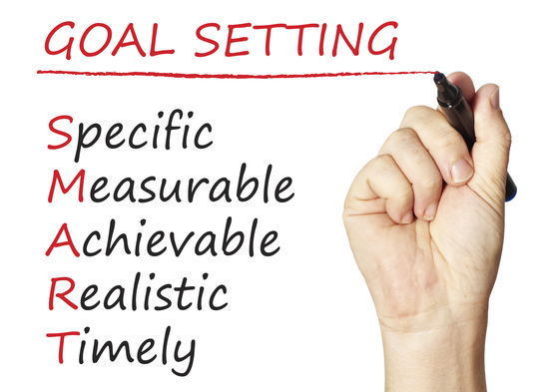
The way to achieve personals goals is to have them very clear, sometimes is not enough having understandable targets to get them. To define the goals is good to use a methodology using it as a standard form, it will guarantee huge possibilities of success. That is the objective of SMART method and shows how to determine all your goals (Ramsey, n.d.).
I’m going to apply the SMART method to myself based on my own goals. One of my dreams and my goals is absolutely to travel around the world at the same time of work. My target is very specific, I want to be my own boss with my online business and make possible the work in any place on the world. After I chosen the right kind of business that can make more simple to achieve my goals and planning everything to see the progress and get it better if it’s needed. If I know what I want, when I want and how I can get it and I plan a process to achieve my goals, following the right and reasonable steps I’m sure to get it. I totally believe in my targets because my goals are realistic and if I follow all the points and if I pursue the right way, I will achieve it. To achieve my target I need at least 3 more years because I need to finish my studies and 1 more year to focus on the future plan, meanwhile I’ m saving money and getting random information about that kind of business.

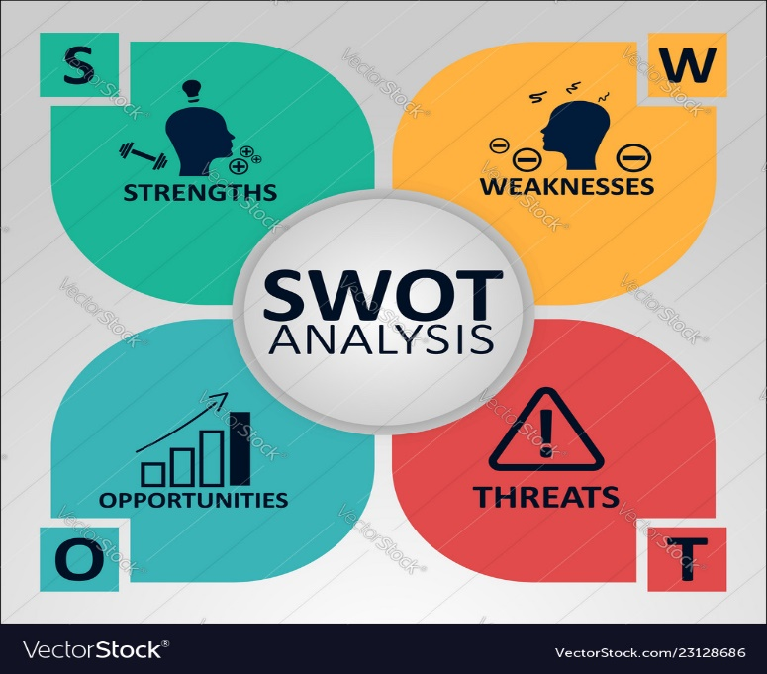
The next following point is SWOT analysis, it is a tool of strategic planification that allows review the state situation of a person, analysing the internal characteristics ( strengths and weaknesses) and the external situation ( opportunities and threats). I’m going to analyse myself with the SWOT method, I work for pizza hut delivery as shift runner at the moment, waiting for my promotion to be a store manager. I have been working with this company for a year and half and I do training courses every few months. When I did my SWOT analysis proforma’s homework I realized how good and helpful it is because I can discover a way to improve my own skills.
- Strengths : - I apply what I learn
- I’m good at problem solving
- Optimist and positive person
- Very good team worker
- Quick learner
- I observe the way my colleague work to get some new skills
- Outgoing and competitive
- Weaknesses : - sometimes I don’t organise myself and I want to do everything at the same time
-Dealing with costumers, face to face is fine even if they have complained but dealing with them by phone is too hard for me
- Sometimes I’m not professional enough specially when I work with people and we have good relationship at work
- Opportunities: - more money
- Promotion
- Better opportunities
- More qualifications
- Less physical work
- Knowledge of how to run a company and getting free courses
- Threats : - not long holydays
- Stayed with the company too long
- Company may have financial issues

PDP STRATEGIES
Strength | PDP opportunity | Strategy required
I apply the things when I learn:  Quick learner | Easy things outgoing | Applying things I learn to get better results
Team working | More opportunities working in a team environment | Showing my way to do my task, learning from team workers way
Competitive | Growing up as worker | Keep going getting qualification and experience

CONVERSION STRATEGIES
Weakness – threats | Conversion strategy | Strength opportunity created or weakness or threat neutralised
Organisation | Planning what I need how I need to do it when I need to do it | Once I know the way to di it ( how, when, what)
Not long holydays | Finding the right thing to match with what I want for my future | See what I want to be in 3-5 years how to get there and how to get that.

CREATIVE STRATEGIES
- Training myself for every situation ( work, life, family, studies..)
- Working out on my weakness and threats with the right key
- Deciding what I want, how to get it, how long it will take me.
I have learnt in the class there are another theories to know which are the needs and humans motivations for example Maslow’s theory, with his pyramid of the human needs published in 1943. This theory can be applied to a personal or business level and focus on whatever situation needs.

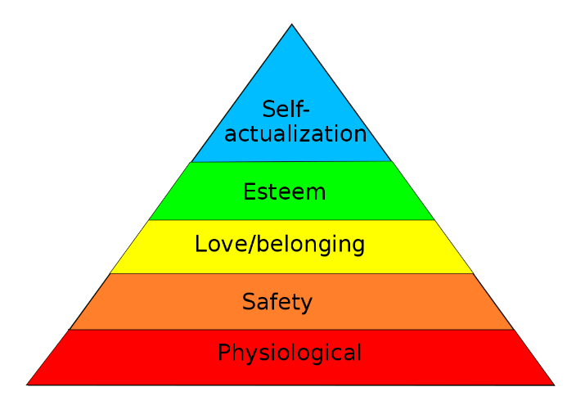
-Johari’s theory is a tool of cognitive psychological
-Alderfer’s Erg theory adjusted three humans needs : existence needs, relatedness needs and growth needs.
Learning style | General characteristic | Positives activities | Negatives activities
ACTIVIST | -learn doing it  - needs have busy hands  -open minded  -involve in new experiences  -Enthusiastic  -act first  -consider  consequences after acting  -like to be around people | Brainstorm problem solving group discussions role play competition | -Adapt a passive role --independent job  -activities theoric
THEORIST | -theory before act  -model needs  -concepts and facts ordered  -prefer synthesize and analyse  -systematic and logic  -perfectionist  -independent  -analytical | -elaborate standard  -statistics  -final background  -apply theory  -have the opportunity of investigate and ask | -Ambiguous activities  -emotional activities  -act without theory foundation
PRAGMATISTS | -don’t like the abstract concept  -Like to try new ideas to apply to the real life  -Their philosophy is if it works it is good | -case study  -time to think how to apply the new things learned.  -problem solving discussions | -useless activities to apply to the real activities without purpose  -activities not related with the reality
REFLECTOR | -observer  - analyse  -see different perspectives of one only thing  -prefer having good support before to get only conclusion  -enjoy observing and listening another people | -self- analysis questionnaires  - observing activities  - to get feedback from others  -interviews | -Time pressure  -leadership  -representing roles  - no planning activities  -to be forced to pass from one activity to another quickly
The GO MAD results framework helps to the organisations to improve the productivity and efficiency transforming the way of people’s thinking and enrol in their work place. The GO MAD is a theory made by Andy Gilbert and Ian Chakrvorty in 1999.

GO MAD

I’ll apply the GO MAD to myself : before I came to UK, I wasn’t sure about what I wanted to be in my life, I stop my studies because I wasn’t sure which course I will do and I didn’t want to pick up a random course which later I was going to regret. So I decided to take a break and try a new experience living abroad, getting the chance to know what I wanted to be or do with my life. Then I came to UK for a few months but it was getting longer and longer, after that I started to work and I realized that without any qualifications I couldn’t get a better future so I decided to return to study. I have very big expectations about the possibilities to achieve my goals, because I believe in it and I’ll do whatever It needs. Before in my life i had different priorities but once I realized what I want automatically, I thought “how can I get it?” and I understand the way to achieve it was to study and get a qualification and I went for it. When I moved to this country I was 21 years old, I didn’t know any English or nothing about life but I believed in myself and I knew that I would get anything that I proposed because believing in myself and follow the rights steps one day will give me some benefits. Today I use my history how self reference, when I want to get something new and I think I’m going to struggle or I have any negative thought I just remember everything what I achieved with believing in myself. Having clear what is my goal for the future Is much easier to be responsible about what I have chosen, the decisions I’m making and obviously the way I act in front of every situation shows up in my life which are my priorities to achieve my targets. Something very important to get my goal is the support from my family is something essential to achieve what I want. I am very luck to get their support, help and advice with my decisions I make even If they know I can be wrong (because they have more experience) and I’m going to fail, they support me and they make me understand I have to fail to learn from mistakes. So having this kind of support to achieve my targets turns easier. Nowadays I can say that I’m acting positively to achieve my goal and clearly I cant see the final result yet because I have a long way to go but I see result day by day for example. When I get a good feedback from my lecturers or when my family tell me how proud they are of me for the effort I give to get what I want.

When I did my questionnaire in class the score which I got was activist, reflector, theorist, pragmatist. I’ll explain a bit of all of the to get into it.
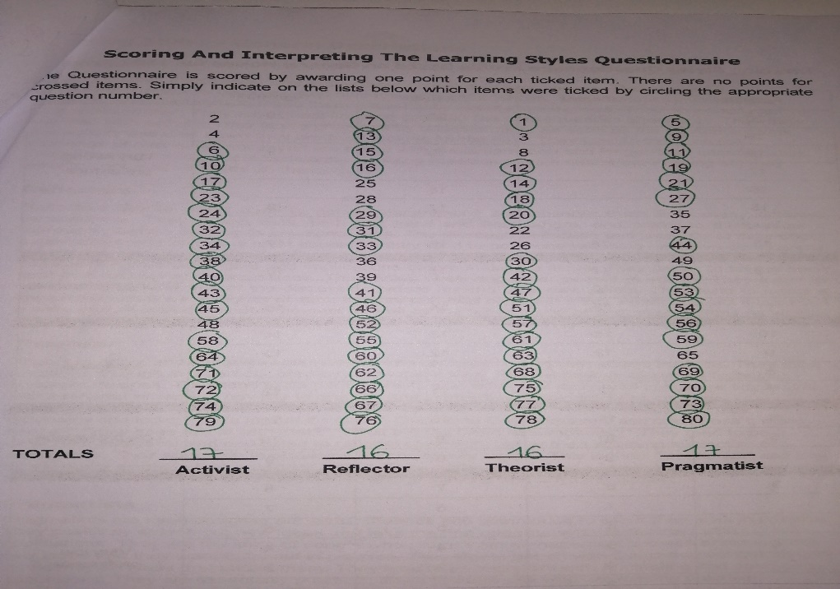

The score I got definitely match with my characteristics and the positive and negative activities. I feel 100 % identified with the activities learning style and I think it describes me very well. About the pragmatists learning style is also matching with me so how I mentioned before the learning styles can be combined between them so in my case my combined learning styles are activists and pragmatists.

VARK
The authors consider the persons receive information all the time, into the senses and the brain is in charge to select part of that information ignoring the rest. Depending on everyone interests people select the information that match with their interests, but also depends on how they receive the information.
VARK : Visual
Aural
Read/Write
Kinesthetic

Visual : this prefer to process the information using tables, diagrams, graphics, maps and other pictures of forms based in graphic to communicate.
Aural : to prefer the oral expressions, conferences, discusses and everything relative with hearing
Read/Write : this style is based on everything related with read and write.
Kinesthetic : everything that involve the experience and practice, it doesn’t matter if is recall or simulated.
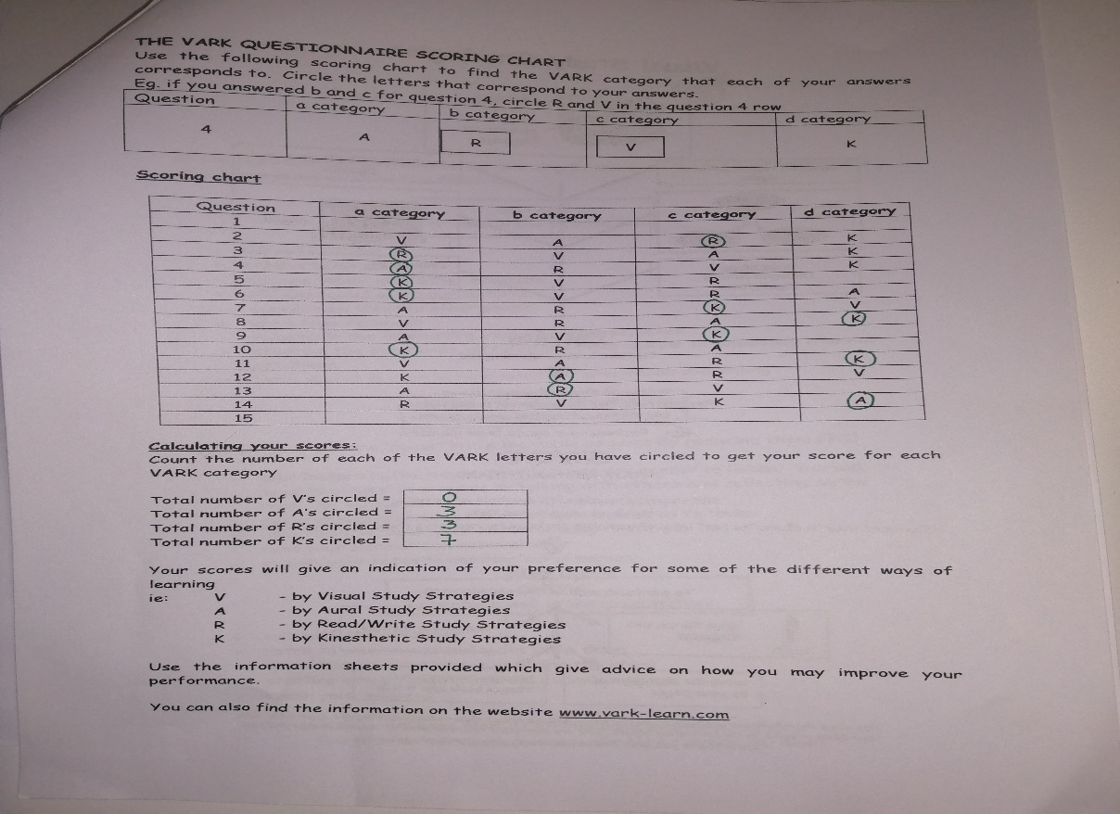
On my questionnaire chart after I done the calculations I understand I am kinesthetic. According with that I can say that a few of the activities supporting my kinesthetic category, using and taking advantage of :
-laboratory
-examples
-reals applications
-projects
-simulations
-role plays.

DEVELOPMENT PERSONAL PLAN
To build my plan , the first thing I need is to check what I want to achieve in my 5 years time, what are my goals, how can I get them. I would like to have my own online business, that’s why I am doing this course. From the company where I am working five me free courses with certificates, these courses give me more knowledge and give me more experience of how run a business. So one of the important things is knowing my strength and weaknesses, take advantage of my strong points and working on my weaknesses to get them better using the strategies seen before on my swot analysis. One of my threats at the moment is the situation of the country because if the Brexit will happen I’m not sure if I will able to finish my studies but I am not much worried because I think it will take more years hopefully. Now I am focused on the promotion of my actual job, I am doing training courses and follow all the instructions in order to get it. About my qualification, my university course, assisting everyday to the class, doing my homework properly helps me a lot. On my work as well getting support from my colleagues with more experience than me improve my own skills. To get experience with the management side I’ll do all the training courses my company facility for me. To use the library and internet to get into online business world, this will be completed the following year after finishing my studies. The way I have planned personal development plan is to achieve everything with my possibilities, abilities and responsibilities (Morgan, 2017)

CONCLUSION

I really enjoy doing this assignment because is the first one, it was about my self, I have been very confused a few times because maybe I overthinking a bit. I have try my best and I found it very interesting because I have been working on my self and working on something very useful for my life, as I never have thought to use a method or an analysis to plan my future goal or simply to know my learning styles, SMART career goal (specific, measurable, achievable, realistic and time frame…) showing me how to plan everything clear the success will get higher possibilities.
The SWOT analysis has been very good to know because I am a person constantly looking for grow up personally and professionally and I never thought to find out any analysis so I really enjoyed with it and I know the strategies to convert my weaknesses into strengths…
GO MAD was a bit hard because I felt a bit lost but once I started to founding information and getting into it, it wasn’t that bad and actually helpful as well.
The methods, analysis, questionnaires, theories are very applicable to my life because before I never thought to analyse myself to see for example how can I get my goals, or to use a method to ensure the success…
So I’m glad to made the decision of doing this course because it’s not only going to be useful to get a qualification, it is going to be good for my life as well.

REFERENCES
Corporate Finance Institute. (2019). SMART Goal - Definition, Guide, and Importance of Goal Setting. [online] Available at: https://corporatefinanceinstitute.com/resources/knowledge/other/smart-goal/ [Accessed 14 Nov. 2019].
Gilbert, A. (n.d.). The art of making a difference.
Gomadthinking.com. (2019). Go MAD Thinking. [online] Available at: https://www.gomadthinking.com/about/our-approach/ [Accessed 14 Nov. 2019].
Gomadthinking.com. (2019). Go MAD Thinking. [online] Available at: https://www.gomadthinking.com/blog/free-e-book-how-to-make-personal-choices-and-take-responsibility/ [Accessed 14 Nov. 2019].
Indeed.com. (2019). SMART Goals: Definition and Examples | Indeed.com. [online] Available at: https://www.indeed.com/career-advice/career-development/smart-goals [Accessed 14 Nov. 2019].
Mcleod, S. (2019). Maslow's Hierarchy of Needs | Simply Psychology. [online] Simplypsychology.org. Available at: https://www.simplypsychology.org/maslow.html [Accessed 14 Nov. 2019].
Morgan, P. (2017). Business student’s guide to study and employability. Los Angeles: Sage.
Ramsey, R. (n.d.). Lead, follow, or get out of the way.
SearchCIO. (2019). What is a SWOT Analysis?. [online] Available at: https://searchcio.techtarget.com/definition/SWOT-analysis-strengths-weaknesses-opportunities-and-threats-analysis [Accessed 14 Nov. 2019].
Self Awareness. (2019). Self Awareness. [online] Available at: https://www.selfawareness.org.uk/news/understanding-the-johari-window-model [Accessed 14 Nov. 2019].
Yourcoach.be. (2019). ERG motivation theory Alderfer | Employee motivation theories | YourCoach Gent. [online] Available at: https://www.yourcoach.be/en/employee-motivation-theories/erg-motivation-theory-alderfer.php [Accessed 14 Nov. 2019].

