

Task 1 – Reading Task Template
Upload your photo of your A3 in-class notes here:
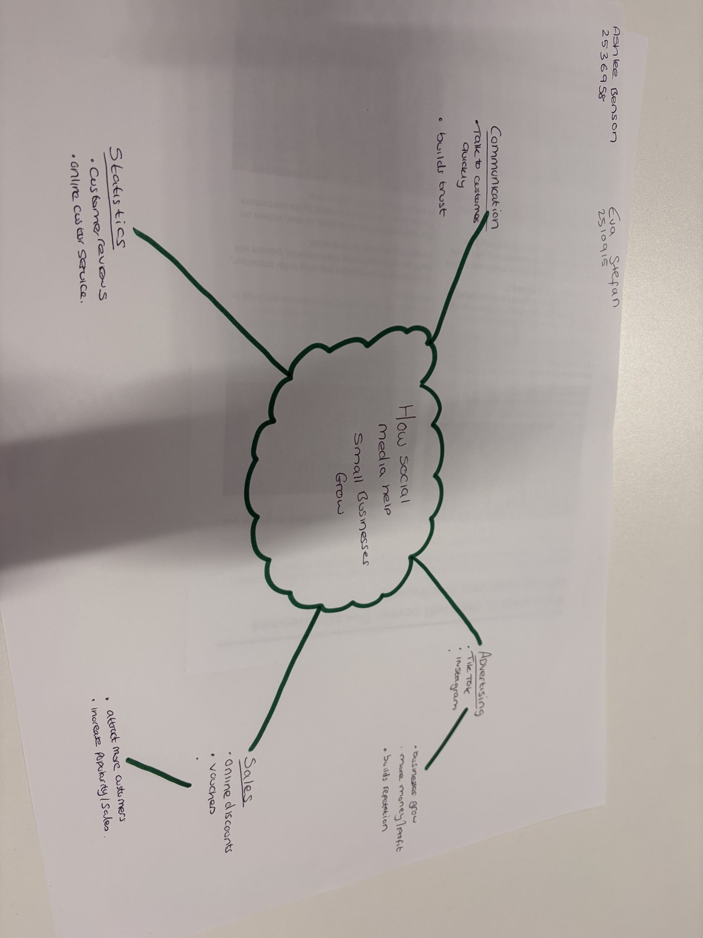

1. Answer these questions using the sentence starters below
a. What is the main idea of the text?
The main idea is that platforms such as TikTok and Instagram can significantly help Business that are small grow and become more popular. By creating and sharing engaging videos on social media businesses can increase and attract a wider audience so they can make more money. Social medial will help business interact directly with customers so they can build stronger relationships and become more trustworthy.
Sometimes word of mouth or flyers won’t allow a business to reach potential customers, but social media will help reach customers on a global scale. By consistently posting videos that show their products or services businesses can accelerate their growth faster, this shows the importance of social media platforms in modern day life and how they are making businesses grow into what they are now.
b. What are two key points?
One key point is that social media plays a big role in supporting businesses to grow and to help achieve their goals. It helps businesses to reach a wider audience, increase sales, and engage with customers more frequently.
Another key point is that businesses with the skills to create and share exciting video content are more likely to attract the correct audience including customers from outside their local area. Businesses who make high quality and intriguing social media post can encourage people to travel significant distances to purchase their products or to just experience the service that they have seen on social media, this shows that social media can expand a business and their range of customers.
c. What part of the text did you find most important? Why?
The most important part is where a customer who travelled almost three hours to try the famous chicken burger after she saw it go viral on TikTok. This clearly shows that social media plays a significant role in communicating and advertising. Without the platforms, advertising could be limited to local customers or spread only through word of mouth. By promoting their products on social media, businesses can reach a much wider audience, attracting customers from different areas and prompt them to travel long distances, this shows how effective platforms can be by promoting their brands visibility on social media.
d. Was anything unclear or difficult to understand?
I read this article, and was able to understand most of it, however I am not certain how it may look by individuals who are unfamiliar with social media. As a young person myself who uses social media daily, I found the article easy to understand. Older individuals or those who are less familiar with platforms may not be aware of the type of business out there only what is around them personally, this is a result of not being active on social media.
e. How did your group help you understand the text better?
The group helped by sharing their in-class notes and showed me how they go about note taking and how they find information that is relevant, we discussed the main parts together and hearing people’s opinions helped me understand the text in different ways. How the group used their own ideas in the mind map challenge showed me how people have different views and ways around breaking things down.
3. One sentence reflection
Question: What did you find challenging about this task?
The hardest part was knowing that this is our first assignment. I haven’t completed an assignment since I was in secondary school, so I was nervous about this. At the same time, I was excited to push myself and learn new things about what I can achieve and what I need to work on.
When starting this task, I didn’t know what to write or how to put information into the correct context. Making notes in class helped me a lot, as if I didn’t write up my notes or concentrate in class, then I wouldn’t know what the exact point of the task was or how to go about achieving the mark I want.

