The Impact of Employment Rights Awareness on Organisational Commitment Among UK Retail Employees

Table of Contents
Introduction and Background 3
Research Problem 3
Research Aim 4
Research Objectives 4
Research Questions 4
Literature Review 4
Employment rights awareness and workplace fairness 4
Organisational commitment in retail work 5
Conceptual framework 5
Research Gap 6
Research Methodology 6
Research Philosophy 7
Research Approach 8
Research Strategy 8
Research Design 8
Data Collection Method 8
Data Analysis Method 9
Expected Contributions 9
Ethical Considerations 9
Limitations 10
Research Timeline 10
Conclusion 10
References 11

Introduction and Background
UK retail is a significant employer, and employment in retail is often characterised by insecure hours, low pay, pressures on workers from customers and high labour turnover. Under such circumstances, the awareness of employment rights is important. Rights are not only legal rules, but they also have implications for employees' perception of fairness in an organisation (Papadopoulos, Lopez‐Andreu and Jamalian, 2021). Retail employees who know they have pay, holiday, sick leave, flexible working, discrimination, dismissal, grievance and union-related rights might feel better equipped to stand up for themselves if poorly treated. But this awareness can be a negative as well when workers find the gap between words and deeds. Thus, the issue of this topic is not about whether the rights are on paper or not. It's about the potential impact of making employees aware of their rights on trust, loyalty and attachment to their retail employers (Zhang, Zhang and Zhou, 2021). Organisational commitment is helpful here as it bridges the gap between legal awareness and organisational behaviours. The Meyer/Allen model breaks commitment down into affective, continuance, and normative components. This approach helps to prevent a short-term and narrow understanding of commitment as ‘loyalty'. A worker can remain due to feeling appreciated, feeling like they cannot afford to leave or feeling like they have to remain (Brown and Souto-Otero, 2020). Each form segment may be impacted by employment rights awareness. For instance, rights communication may enhance affective commitment and rights disputes may elicit continuance commitment in the absence of genuine commitment.

Research Problem
Employment rights in the retail sector are legislated for but may be less consistently understood in practice. This poses a research gap issue as organisational commitment is typically followed up on engagement, satisfaction or retention and employee awareness of employment rights is rather a legal or compliance issue (Anner, 2020). Comparatively little research, therefore, is available on how rights like minimum wage, holiday pay, sick pay, working hours and the right to grievance protection and discrimination protection affect a worker's trust, loyalty and intent to stay. This is significant for retail where a large proportion of workers have flexible hours, low pay, more pressure from customers and less say in the workplace (Khan et al., 2020). So, this study examines the problem by collecting primary survey data from 50 UK retail employees and analysing the relationship between employment rights awareness and organisational commitment using basic quantitative methods.

Research Aim
To examine the influence of employment rights awareness on organisational commitment among UK retail employees.

Research Objectives
- To assess the overall level of employment rights awareness among UK retail employees.
- To examine employees’ awareness of specific employment rights, including pay, holiday entitlement, sick pay, working hours, discrimination protection, grievance procedures and dismissal rights.
- To measure the level of organisational commitment among UK retail employees.
- To examine the relationship between employment rights awareness and organisational commitment among UK retail employees.
- To determine which aspects of employment rights awareness are most strongly associated with organisational commitment among UK retail employees.

Research Questions
Main Research Question
What is the relationship between employment rights awareness and organisational commitment among UK retail employees?
Sub-questions
- What is the level of awareness of key employment rights among UK retail employees?
- What is the level of organisational commitment among UK retail employees?
- Which aspects of employment rights awareness are most strongly associated with organisational commitment among UK retail employees?

Literature Review

Employment rights awareness and workplace fairness
Employment Rights Awareness is the knowledge employees have of their legal rights and rules in the workplace. These can include the statutory right to the minimum wage, statutory right to paid holiday, statutory rights on sick pay, discrimination protection, etc., health and safety, dismissal protection and collective representation in the UK (Kim, Kim and Holland, 2020). No awareness means that a right is hard to use. But awareness can't be a benefit of organisations. Can be used to uphold fairness in management and consistent behaviour. It can reveal contradictions in symbolic policy. This results in an essential tension situation. Employers can communicate rights via handbooks and compliance statements, but employees assess fairness by means of their schedules, workloads, managers' conduct and complaints stored. Learning rights are constrained or not well respected could undermine awareness - and compromise trust. Procedures are a key element in retail, which is generally fast-moving, customer-oriented, and employs many workers (Liang and Yeh, 2020). Thus, rights awareness should be considered as a psychological contract. It informs the employees about the expectations that need to be met by the organisation, and whether those expectations have been met.

Organisational commitment in retail work
Organisational commitment is not one single feeling. Meyer and Allen's three-component model (affective commitment, continuance commitment and normative commitment) remains useful because it considers these relationships individually. It's important for retail (Mustchin and Martínez Lucio, 2020). A worker could go to a local shop and not be dedicated to the brand as a whole. Another might be kept because the employer doesn't have any other choice. Therefore, commitment will be regarded as not indicated by retention for the study (Ahmad and Raja, 2021). Employment quality, including salary, security, voice and respect and predictability, are also contributing factors to retail commitment and employees’ perception of trustworthiness of the employer. Basing the argument on good work literature, the key to motivation and productive organisations is good work (Fernández-Kranz and Rodríguez-Planas, 2021). This implies that rights awareness by itself can play a role in commitment as long as it is linked to real fair treatment. Rights awareness can, however, generate feelings of insecurity and inequity, which can lead to a loss of commitment. It is thus a conditional and not automatic relationship.

Conceptual framework
The conceptual framework puts employment rights awareness as an independent variable and organisational commitment as a dependent variable. Rights awareness is the knowledge of pay, holiday, sick leave, working hours, discrimination, grievance and dismissal rights that employees have (Gallie et al., 2021). Organisational commitment is defined in terms of affective, continuance and normative commitment, using the framework of Meyer and Allen (1991). The framework content is based on the assumption that awareness may indirectly affect commitment via perceived workplace fairness, perceived psychological contract fulfilment, and perceived trust (LeBaron, 2021). This relationship is supported by social exchange theory, which suggests that employees feel committed toward an organisation based on their perception of fairness by the organisation. But if staff are aware, it may mean they are less likely to be committed if their rights are not well communicated or well respected (LeBaron, 2021). In this study, these relationships will be tested using descriptive statistics and correlation analysis from the results of a Google Forms survey of 50 retail employees from the United Kingdom, which will look at measurable patterns in the sample.
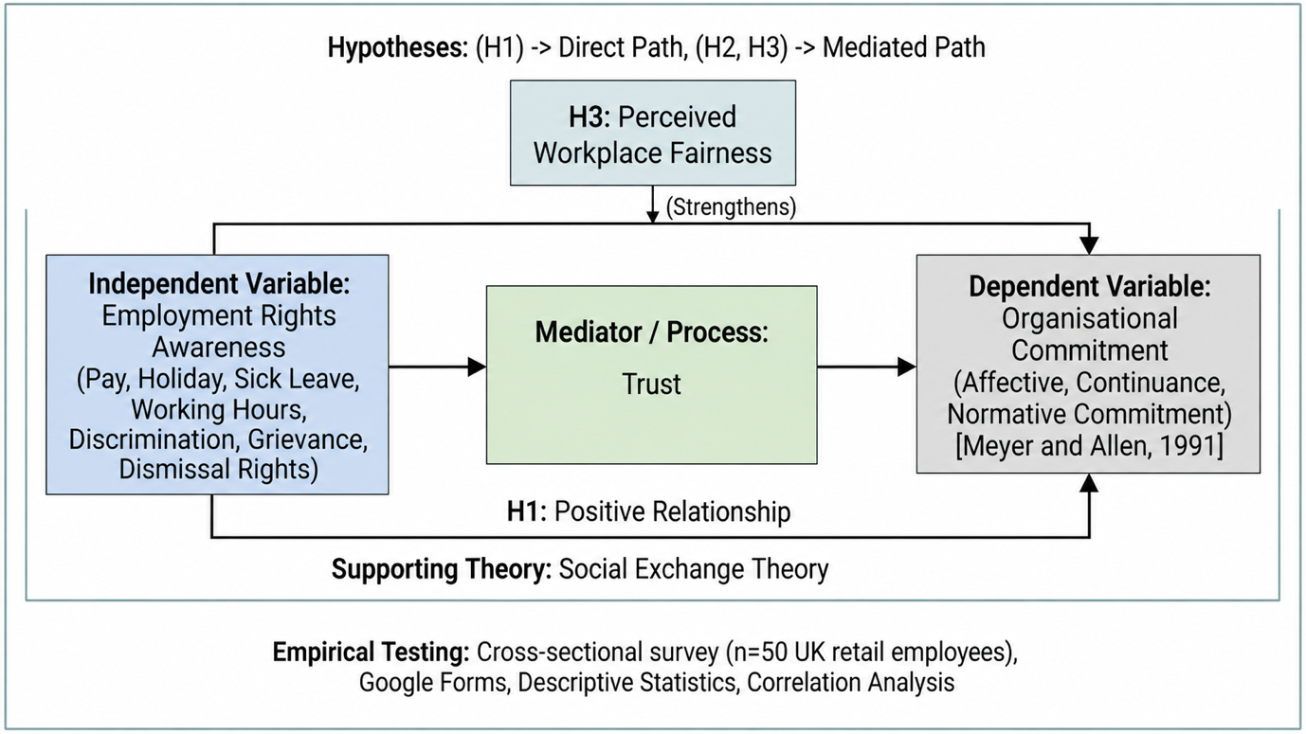
Figure 1: Conceptual framework
Source: Made by Author

Hypotheses
H1: Employment rights awareness is positively associated with organisational commitment among UK retail employees.
H2: Employees with higher awareness of pay, holiday, working hours, and discrimination rights are more likely to report higher perceived workplace fairness.
H3: Perceived workplace fairness strengthens the relationship between employment rights awareness and organisational commitment.
H4: Awareness of employment rights related to grievance procedures and dismissal protection is positively associated with organisational commitment among UK retail employees.

Research Gap
The research gap is that primary evidence relating employment rights awareness to organisational commitment is limited amongst UK retail work employees. Previous research has tended to focus on workers' rights alone, fairness or commitment within the workplace, but not on how workers' rights knowledge translates into employer attitudes (Murray and Holmes, 2021). Furthermore, much of the debate on retail employment is around job insecurity, low wages and low turnover; there is less consideration of whether an awareness of one's specific legal entitlements relates to trust, loyalty and intent to remain (LeBaron, 2021). This research fills the void presented by surveying 50 employees in retailing in the UK and conducting quantitative analysis to determine if there is any pattern between the awareness of rights and commitment to the organisation.

Research Methodology
The research methodology used in this study will be based on Saunders' Research Onion model, in which he explained the legitimacy of the choice. Primary research will be undertaken due to the need for direct research evidence from retail employees with the revised study (Saunders, Lewis and Thornhill, 2023). The data will be collected using an online questionnaire that is designed using Google Forms. The number of respondents to be targeted will be 50 retail employees currently working in the UK retail industry (Aguinis, Bergh and Molina-Azorin, 2022). It is appropriate and relevant as the theme is knowledge about the rights of work and how this knowledge is related to organisational commitment. Similar responses are possible in a survey in a short time.
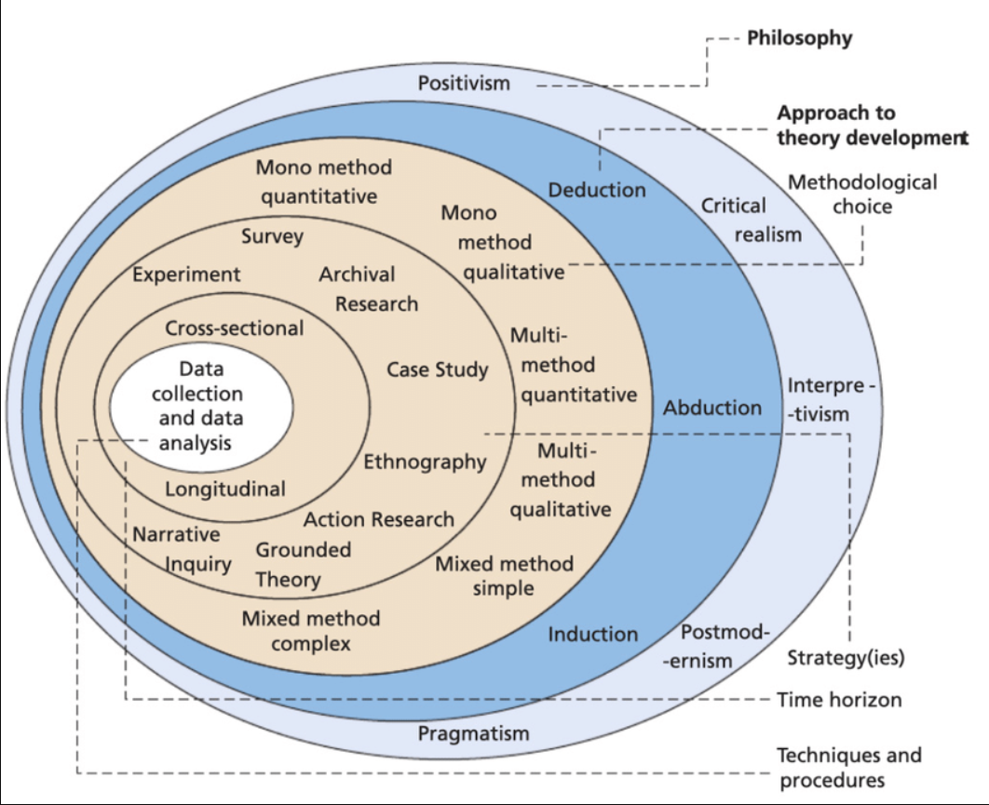
Figure 2: Saunders' Research Onion model
Source: (Saunders, Lewis and Thornhill, 2023)

Research Philosophy
In conducting this research, the philosophy used will be the Positivist orientation. This is suitable as the study will be generating structured data and will be searching for patterns in answers (Saunders, Lewis and Thornhill, 2023). The interest, however, is not in the depth of personal accounts as per interpretivism, but whether the awareness of employment rights seems to have an impact on the level of organisational commitment amongst a small sample (Braojos, Weritz and Matute, 2024). Closed survey questions enable the researcher to measure the concepts of awareness and commitment in a positivistic framework. Employee attitudes, however, are formed as a result of experiences at the place of work, and the results will be considered with caution because findings are not considered as absolute truths.

Research Approach
This study will be carried out using a deductive approach. This implies that the research will start with theory and concepts already available, such as employment rights awareness, psychological contract theory, social exchange theory and organisational commitment (Saunders, Lewis and Thornhill, 2023). These ideas will be used to formulate the survey questions. Without doubt, for instance, when workers feel that the organisation's description of rights is clear, they are more willing to trust their employer, are more loyal to it, and are more likely to stay employed within it. Because the study is not intended to be a theory construction attempt, justifying a deductive approach (Deng et al., 2025). Rather, it will see if there is any evidence in UK retail to show effective support for existing ideas.

Research Strategy
Survey research is the research strategy that will be used. This plan is appropriate for the study, since it requires 50 responses. A survey enables the researcher to pose the same questions to everyone, and then systematically compares their responses to the questions posed (Badru, Karadaş and Olugbade, 2024). It is feasible as the retail workers might not have much time to dedicate to interviews (Li et al., 2021). The online format allows for easier completion of the survey and may boost the response rate. But the survey strategy is shallower, so the questions should be clear and related to the aim.

Research Design
The type of research will be a quantitative type of mono-method cross-sectional type. It's quantitative as most questions will have set answers that are given via a Likert scale - strongly agree to strongly disagree. It is a mono-method as only one data collection method will be employed. Is cross-sectional since data will be collected at one time (Li et al., 2021). This design has been chosen as the aim of this study is to identify patterns between employment rights awareness and organisational commitment of the employees in the United Kingdom in the retail sector (Fantinelli et al., 2023).

Data Collection Method
Google Forms will be used for primary data. There will be a brief introduction and a consent statement in the questionnaire, followed by demographic questions and the questions that will be related to the objectives of the research (Lock and Seele, 2015). Demographic questions could include age group, gender, position/role, work experience, and prior retail experience. The main section will cover the knowledge of the rights to minimum wage, holiday pay, sickness pay, work hours, protection from discrimination, rights of grievance and rights of dismissal. Questions will cover commitment levels of trust, loyalty, job satisfaction, desire to remain, and emotional commitment (Dutta, Mishra and Tyagi, 2023). Convenience sampling will be used as the respondents will be accessed via online contacts and networks.

Data Analysis Method
The data will be analysed using simple quantitative analysis. Results can be organised and presented using Google Forms and/or Microsoft Excel. Frequencies, percentages, and mean scores will be used for descriptive statistics to show the level of Employment Rights awareness and Organisational Commitment among the respondents (Lock and Seele, 2015). Frequencies, percentages and mean scores will answer Objective 1. Correlation analysis will answer Objective 2. Mean comparisons across different rights-awareness areas will help answer Objective 3. Research can be done to compare and contrast between the groups, e.g. full-time/ part-time employees. The researcher might use simple correlation analysis as a means of exploring the relation among the major variables (Tedone and Bruk-Lee, 2022). Where they are present, open-ended comments will be analysed summarily to supplement the numerical findings.

Expected Contributions
The study will support considering the potential influences of awareness of employment rights on organisational commitment in UK retail. It will offer small-scale primary evidence from UK retail employees (Saunders, Lewis and Thornhill, 2023). The study may serve as a reminder for retail employers to avoid shady practices and that it is important to communicate rights clearly, which is not only legally required, but is also good for fostering trust and loyalty (Perkins et al., 2022). The study might also be able to shed light on the role of fair treatment and rights communication in commitment.

Ethical Considerations
The use of human subjects highlights the need for ethical procedures. They will be asked to voluntarily participate and will be fully informed about the aims of the study before responding. Informed consent will be obtained when starting the Google Form (Saunders, Lewis and Thornhill, 2023). You will not have to submit any names, email addresses or other identifying information. Participants will be informed that they are allowed to stop prior to submitting. Data will be kept safe and for academic purposes only (Mogaji and Nguyen, 2022). The researcher will try to steer clear of questions which could develop workplace hazards.

Limitations
The main restriction of this is the small sample size of 50 respondents. This implies that the results are not representative of the overall population of retail workers in the UK (Sainju, Hartwell and Edwards, 2021). Convenience sampling can be problematic as it accesses those the researcher is connected to and so can be biased. A short answer or less thoughtful answer can be caused by online surveys (Lock and Seele, 2015). Self-reported data might not be completely representative of behaviour at work. Yet, this approach can still be used, which does offer direct, manageable and relevant evidence.

Research Timeline
The research will be split into stages. The questionnaire will be designed and checked against the aim and objectives first. Second, where necessary, ethics approval will be sought. Thirdly, the Google Form will be distributed to the participants. Finally, 50 individuals will be subjects in the sample for responses. Fifth, the data will be cleaned and analysed. Lastly, the results will be written, discussed and correlated with literature and questions.

Conclusion
This proposal explores one of the factors that might impact upon levels of organisational commitment for UK retail workers; awareness of employment rights. A primary, quantitative and cross-sectional survey design will be used, and specifically 50 respondents will be sampled using Google Forms. Awareness of important workplace rights will be measured and compared to workplace trust, loyalty, satisfaction and intent to stay (Díaz‐Linhart et al., 2025). Despite the small sample size, which prevents generalisation, the study may help to offer some evidence for the potential to enhance commitment via fair rights discourse in today's UK retail workplaces.

References
Aguinis, H., Bergh, D. and Molina-Azorin, J.F. (2022) ‘Methodological challenges and insights for future international business research’, Journal of International Business Studies [Preprint]. Available at: https://doi.org/10.1057/s41267-022-00578-8.
Ahmad, M.R. and Raja, R. (2021) “Employee Job Satisfaction and Business Performance: The Mediating Role of Organizational Commitment,” Vision: The Journal of Business Perspective, 25(2), p. 097226292098594. Available at: https://doi.org/10.1177/0972262920985949.
Anner, M. (2020) “Squeezing Workers’ Rights in Global Supply chains: Purchasing Practices in the Bangladesh Garment Export Sector in Comparative Perspective,” Review of International Political Economy, 27(2), pp. 320–347. Available at: https://doi.org/https://doi.org/10.1080/09692290.2019.1625426.
Badru, A.F., Karadaş, G. and Olugbade, O.A. (2024) “Employee voice: The impact of high-performance work systems and organisational engagement climate,” The Service Industries Journal, 44(7–8), pp. 1–29. Available at: https://doi.org/10.1080/02642069.2022.2056163.
Braojos, J., Weritz, P. and Matute, J. (2024) “Empowering organisational commitment through digital transformation capabilities: The role of digital leadership and a continuous learning environment,” Information Systems Journal, 34(5). Available at: https://doi.org/10.1111/isj.12501.
Brown, P. and Souto-Otero, M. (2020) “The end of the credential society? An analysis of the relationship between education and the labour market using big data,” Journal of Education Policy, 35(1), pp. 95–118. Available at: https://doi.org/10.1080/02680939.2018.1549752.
Deng, H., Lu, Y., Fan, Di, Liu, W. and Xia, Y. (2025) “The Power of Precision: How Algorithmic Monitoring and Performance Management Enhances Employee Workplace Well‐Being,” New Technology Work and Employment, 40(3). Available at: https://doi.org/10.1111/ntwe.12328.
Díaz‐Linhart, Y., Kochan, T., Minster, A., Park, D. and Yang, D. (2025) “Does Voice Gap Influence Workers’ Job Attitudes and Well‐Being? Measuring Voice as a Dimension of Job Quality,” British Journal of Industrial Relations, 63(3). Available at: https://doi.org/10.1111/bjir.12866.
Dutta, D., Mishra, S.K. and Tyagi, D. (2023) “Augmented employee voice and employee engagement using artificial intelligence-enabled chatbots: A field study,” The International Journal of Human Resource Management, 34(12), pp. 1–30. Available at: https://doi.org/10.1080/09585192.2022.2085525.
Fantinelli, S., Galanti, T., Guidetti, G., Conserva, F., Giffi, V., Cortini, M. and Di Fiore, T. (2023) “Psychological Contracts and Organizational Commitment: The Positive Impact of Relational Contracts on Call Center Operators,” Administrative Sciences, 13(4), p. 112. Available at: https://doi.org/10.3390/admsci13040112.
Fernández-Kranz, D. and Rodríguez-Planas, N. (2021) “Too family friendly? The consequences of parent part-time working rights,” Journal of Public Economics, 197, p. 104407. Available at: https://doi.org/10.1016/j.jpubeco.2021.104407.
Gallie, D., Felstead, A., Green, F. and Henseke, G. (2021) “Inequality at work and employees’ perceptions of organisational fairness,” Industrial Relations Journal, 52(6). Available at: https://doi.org/10.1111/irj.12346.
Khan, Z., Soundararajan, V., Wood, G. and Ahammad, M.F. (2020) “Employee emotional resilience during post-merger integration across national boundaries: Rewards and the mediating role of fairness norms,” Journal of World Business, 55(2), p. 100888. Available at: https://doi.org/10.1016/j.jwb.2017.06.009.
Kim, S.-H., Kim, M. and Holland, S. (2020) “Effects of intrinsic motivation on organizational citizenship behaviors of hospitality employees: The mediating roles of reciprocity and organizational commitment,” Journal of Human Resources in Hospitality & Tourism, 19(2), pp. 168–195. Available at: https://doi.org/10.1080/15332845.2020.1702866.
LeBaron, G. (2021) “The Role of Supply Chains in the Global Business of Forced Labour,” Journal of Supply Chain Management, 57(2), pp. 29–42. Available at: https://doi.org/https://doi.org/10.1111/jscm.12258.
Li, J., Ding, H., Hu, Y. and Wan, G. (2021) ‘Dealing with dynamic endogeneity in international business research’, Journal of International Business Studies, 52(3), pp. 339–362. Available at: https://doi.org/10.1057/s41267-020-00398-8.
Liang, H.-L. and Yeh, T.-K. (2020) “The effects of employee voice on workplace bullying and job satisfaction,” Management Decision, 58(3), pp. 569–582. Available at: https://doi.org/10.1108/md-01-2019-0112.
Lock, I. and Seele, P. (2015) ‘Quantitative content analysis as a method for business ethics research’, Business Ethics: A European Review, 24(51), pp. S24–S40. Available at: https://doi.org/10.1111/beer.12095.
Mogaji, E. and Nguyen, N.P. (2022) “Managers’ understanding of artificial intelligence in relation to marketing financial services: Insights from a cross-country study,” International Journal of Bank Marketing, 40(6), pp. 1272–1298. Available at: https://www.emerald.com/insight/content/doi/10.1108/IJBM-09-2021-0440/full/html.
Murray, W.C. and Holmes, M.R. (2021) “Impacts of Employee Empowerment and Organizational Commitment on Workforce Sustainability,” Sustainability, 13(6), p. 3163. Available at: https://doi.org/https://doi.org/10.3390/su13063163.
Mustchin, S. and Martínez Lucio, M. (2020) “The evolving nature of labour inspection, enforcement of employment rights and the regulatory reach of the state in Britain,” Journal of Industrial Relations, 62(5), p. 002218562090890. Available at: https://doi.org/10.1177/0022185620908909.
Papadopoulos, O., Lopez‐Andreu, M. and Jamalian, M. (2021) “Violation and lack of awareness of employment rights in the United Kingdom’s hotel industry: Isolation, fragmentation and barriers to labour enforcement,” Industrial Relations Journal, 52(4), pp. 315–330. Available at: https://doi.org/10.1111/irj.12337.
Perkins, G., Gilmore, S., Guttormsen, D.S.A. and Taylor, S. (2022) “Analysing the impacts of Universal Basic Income in the changing world of work: Challenges to the psychological contract and a future research agenda,” Human Resource Management Journal, 32(1). Available at: https://doi.org/10.1111/1748-8583.12348.
Ragab, M.A. and Arisha, A. (2017) ‘Research Methodology in Business: a Starter’s Guide’, Management and Organizational Studies, 5(1), p. 1. Available at: https://doi.org/10.5430/mos.v5n1p1.
Sainju, B., Hartwell, C. and Edwards, J. (2021) “Job satisfaction and employee turnover determinants in Fortune 50 companies: Insights from employee reviews from Indeed.com,” Decision Support Systems, 148, p. 113582. Available at: https://doi.org/10.1016/j.dss.2021.113582.
Saunders, M.N.K., Lewis, P. & Thornhill, A. (2023) Research Methods for Business Students (9th ed.). Pearson.
Tedone, A.M. and Bruk-Lee, V. (2022) “Speaking up at work: Personality’s influence on employee voice behavior,” International Journal of Organizational Analysis, 30(2). Available at: https://doi.org/10.1108/ijoa-09-2020-2417.
Zhang, B., Zhang, Y. and Zhou, P. (2021) “Consumer Attitude Towards Sustainability of Fast Fashion Products in the UK,” Sustainability, 13(4), pp. 1–23. Available at: https://doi.org/https://doi.org/10.3390/su13041646.

