

Changemakers: Creativity and Value Creation
Professions (BMHP5014)

Component 1: Online portfolio of set exercises

Student name: Kleber morais da silva
Student number: 2336879
Lecturer’s name: Laila Surani

Table of contents

3 Introduction
Innovation
5 Task 2 – Explanation for Mind Map
7 Task 3 - Self-Reflection of divergent thinking
8 Task 4 - Case Study Analysis of a UK Innovation
9 Task 5 - Research Task
11 Task 6 - Exploring Digital Innovation in Health and Social Care
13 Task 7 - Understanding the NHS Leadership Framework
14 Task 8 - Self-Reflection Journal Entry
15 References

Introduction
This portfolio explores key themes presented in this module, concentrating on innovation and creativity, change research methods, and networking. It will investigate how these concepts relate to healthcare innovations, organizational dynamics, and the development of professionals. The discussion will incorporate personal perspectives and insights, along with links between theory and practice in health and social care.

Innovation
Innovation within Health and Social Care are acknowledged as vital elements for enhancing patient outcomes and the efficiency of service delivery. Commonly defined as the act of producing original and practical ideas, whereas innovation signifies the executing for these ideas to instigate change and reshape the social and economic landscape of healthcare. These ideas are interconnected, with innovation regarded as the preliminary. (Baig, Mirza Noor Ali et al. 2021).
Involving end-users, such as patients, healthcare professionals, and family members, in the development and enhancement of health systems and services is a crucial approach to promote innovation. A generative co-design framework has been established to engage these stakeholders through the stagers of pre-design, co-design, and post-design, allowing their real-life experiences and creative contributions to inform healthcare innovations. This collaborative method ensures that innovations are applicable, practical, and have a higher chance of being embraced in real-word settings (Bird, M. et al. 2021).
An illustration from the healthcare sector in the UK can be seen in the English National Health Service (NHS). Where frontline personnel exhibit creativity by adopting service innovations through the replication of effective practices from various sites. Although there is a top-down strategic framework in place, local clinical and managerial leadership encourages staff to reflect on and creatively tackle new challenges that arise during implementation. Nevertheless, employees frequently their practices as creative, which hinders the conversation and potential further advancement of innovation (Gordon, Shaun MacGregor 2016).

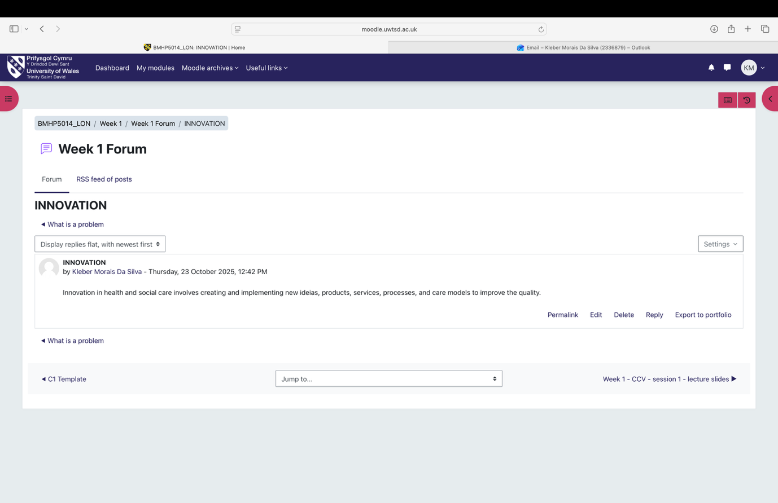

Task 2 – Explanation for Mind Map
A mind map focused on extended wait times in health and social care can effectively outline the issue by highlighting its diverse causes, effects, and possible healthcare environments. The challenge of prolonged wait times is associated with systemic and operational issues such as a lack of staff, inefficient scheduling, and inadequate resources. (Williams, Caitlin R. et al. 2022).
Long wait times not only cause patient dissatisfaction but also lead to adverse health effects. Research has shown that extended waits for outpatient care raise the likelihood of hospitalization for conditions sensitive to ambulatory care, indicating that delays in diagnosis and treatment may worsen health problems (Prentice, Julia C. et al. 2008).
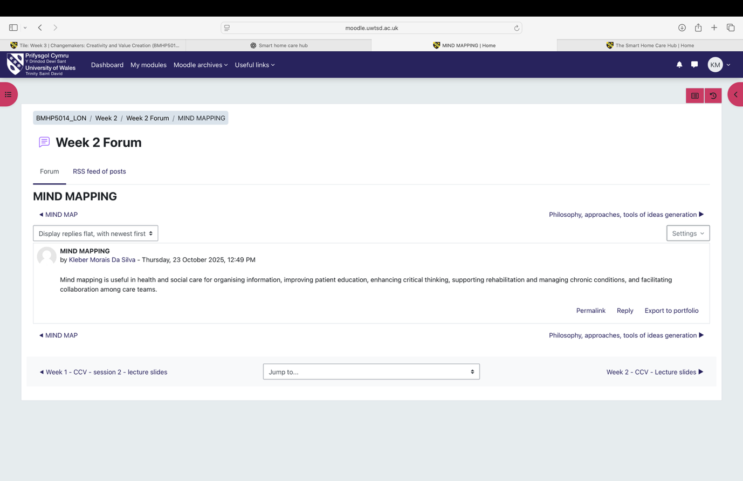
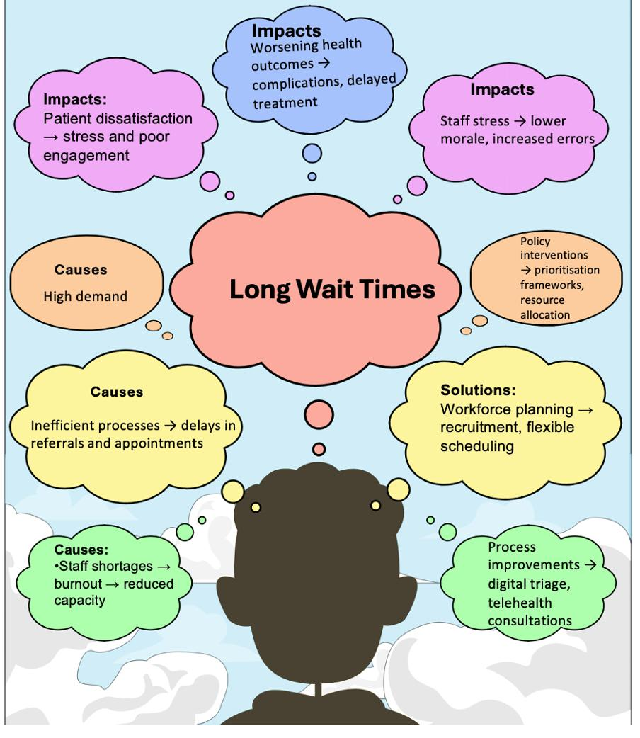

Task 3 - Self-Reflection of divergent thinking
Self-reflection on divergent and convergent thinking can be effectively understood through reflective frameworks like Kolb’s experiential learning cycle, which highlights the importance of ongoing reflection to improve cognitive processes.
Reflective practice, exemplified in the realm of design thinking mindsets, fosters the growth of creative confidence, empathy, and the ability to manage uncertainty, all of which are crucial for both divergent and convergent thinking. By engaging in iterative reflection, individuals can more effectively evaluate and modify their problem-solving approaches, enhancing their ability to produce ideas (divergent thinking) and assess them logically (convergent thinking) (Morris, Thomas Howard 2020).
The function of reflective writing as a tool for fostering reflective thinking withing Kolb’s framework has been investigated, indicating that organized writing assistance can aid leaners in expressing and enriching their comprehension of experimental learning processes. This support allows learners to make their implicit thoughts explicit and assists mentors in offering specific guidance thus improving the overall learning experience (Kingkaew, Chanakarn et al. 2023).
Writing supports learners in developing their skills to analyse, evaluate, and apply knowledge across different contexts. This is evident in experiential learning programs that implement modified frameworks suck as Do Reflect Apply (DRA), reflection stages that culminate in awareness, transformation, and the application of their learning (Ingles, Dusti M. et al. 2025).

Task 4 - Case Study Analysis of a UK Innovation
In health and social care environments, creativity and innovation have been utilized to tackle specific issues such as resource distribution, mental health assistance, and the spread of health technologies. The experience in the UK, particularly through the National Institute for Health and Care Excellence (NICE) occasionally endorses funding for innovation is prioritized in healthcare decision-making. NICE occasionally endorses funding for innovative technologies even when they do not meet conventional cost-effectiveness standards, striving to balance health maximization with equality. However, this method has sparked concerns regarding transparency, accountability, and fairness, highlighting innovation withing the frameworks of health and social care values (Charlton, Victoria et al. 2019).
Participatory techniques such as coproduction, codesign, and coin novation have been utilized to enhance healthcare services, especially in the realm of mental health. The Mental Health Experience Co-design (MH ECO) model created in Australia serves as an example of innovation through peer-driven, participatory methods that promote empowerment, trust autonomy, and choice for individuals with mental health conditions and their caregivers. This innovation approach addresses the necessity for involvement and the voices of users in service enhancement, supported by mechanisms like recognition, dialogue, and collaboration which facilitate positive relational improvements. The goal of such participatory innovation is to elevate quality of life and health outcomes by engaging those with lived experiences in the creation and delivery of care (Palmer, Victoria Jane et al. 2019).
In environments recovering from conflict, advancements in e-health have been implemented to enhance the availability of information and communication for healthcare workers, tackling issues like inadequate infrastructure and lack of knowledge. While these advancements have yielded favourable perceptions and some utilization for communication and education purposes, obstacles persist concerning scalability and sustainability, underscoring the importance of context-specific initiatives led by local health practitioners (Woodward, Aniek et al. 2014).

Task 5 - Research Task
An examination of innovation within the NHS and social care system in the UK uncovers various initiatives aimed at tackling patient wait times, staff fatigue, and employing creativity to as Ambulatory Majors at the Emergency Department of Countess of Chester Hospital, utilized a collaborative team-oriented strategy to minimize patient waiting periods. This approach involved two physicians and a nurse working together to handle patients, where one physician attended to the patient while the other recorded to the patient while the other recorded notes in real time and the nurse performed necessary tests. As a result, this intervention initially decreased the average time from patient arrival to being seen from 139.63 minutes to 112.5 minutes, while the time from arrival to departure dropped from 194 minutes to 162.5 minutes. Nevertheless, these gains were not maintained throughout the year, highlighting multiple challenges in sustaining improvements in patient flow and wait times (Elliott, Charlotte 2020).
In the wider context of social care, innovation changes accountability frameworks and can transform the delivery and assessment of care. Nevertheless, this innovation also carries the risk of perpetuating neglect, especially concerning topics that are overlooked in research and minimal instructional reflection on the effects on innovation. This indicates that while innovation has the potential to promote change, it necessitates continuous critical assessment to ensure that it generates value and avoids unintended adverse effects (O’Donovan, Cian 2023).
Staff burnout in the NHS is closely associated with shortages in personal and overwhelming workloads, which are significant contributors to stress, diminished professional performance, and the desire to leave the job. Reports indicate that COVID-19 pandemic has negatively affected staff availability, worsening care delays and patient waiting times. Proposed parliamentary actions include mandating regular independent evaluation of workforce requirements to tackle these challenges. Furthermore, these are demands for a comprehensive reform of workforce planning to alleviate burnout, particularly acknowledging the unequal effects on staff from ethnic minority backgrounds. Responses from the government involve providing funding form mental health support services for employees (Deakin, Miriam 2022) (Iacubucci, Gareth 2021).
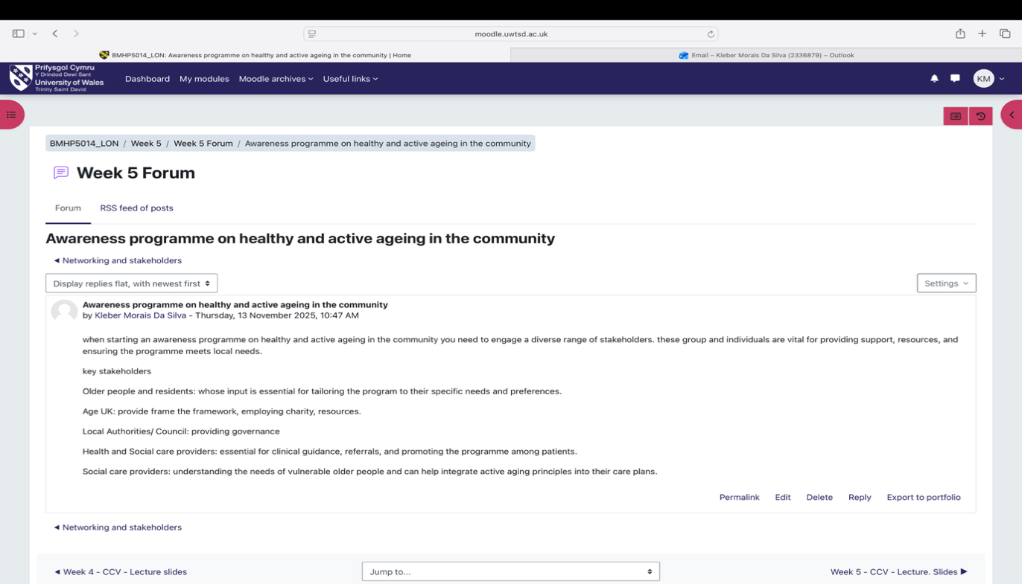

Task 6 - Exploring Digital Innovation in Health and Social Care

Wearable health devices, like smartwatches, provide numerous advantages in managing chronic health issues by allowing constant, non-invasive observation of essential health metrics such as heart rate, glucose levels, sleep patterns, and physical activity. This ongoing monitoring aids in the prompt identification of irregularities and encourages tailored healthcare, which can improve treatment results and minimize the likelihood of complications while fostering patient self-management (Jakubczyk, Natalie et al. 2025). These devices enhance patient involvement by delivering instant feedback and enabling data sharing, which can boost compliance with treatment regimens and foster active participation in health management (Wettstein, Reto et al. 2024).
Digital technology, such as smartwatches, is enhancing health and social care by incorporation data generated by patients into clinical processes. This integration allows for more precise management of personal health journeys and facilitates timely feedback form healthcare professionals. For instance, remote patient monitoring (RPM) systems that utilize consumer wearables have been designed to be easy to use, compatible with other systems, and secure helping patients seamlessly incorporate these technologies into their everyday lives (Wettstein, Reto et al. 2024). These systems have demonstrated usability and acceptance among individual with chronic illnesses, facilitating continuous health monitoring beyond conventional clinical environments (Butler, Sonia et al 2025).
Electronic health records (EHRs) enhance communication and collaboration among healthcare providers by allowing coordinated patient care through shared access to patient data. EHRs enable healthcare professionals to use patient records asynchronously, making it possible for them to coordinate care anytime and anywhere, which aids in informed decision-making across different specialties (Vos, Janita F. J. et al. 2020).
This system offers a detailed patient file that can act as a common overview, encouraging collaborative clinical decision-making based on shared data, although interfaces tailored to specific specialties may hinder a comprehensive understanding the information (Vos, Janita F. J. et al. 2020).
The necessity for in-person communication by allowing messaging and record-keeping within the system, potentially saving time and optimizing workflows. Nonetheless, if not property managed, this decrease could impede shared responsibility and effective coordination of workflows. The documentation of clinical activities and orders directly within the HER facilitate accurate recording at the source, which can improve teamwork across multiple disciplines; however stringent authorization regulations and administrative duties may limit flexibility (Vos, Janita F. J. et al. 2020).
Digital technology provides numerous opportunities to enhance preventive care and health promotion through personalized, accessible, and scalable interventions. For instance, mobile health (mHealth) programs that integrate automated tracking with customized messaging can boost physical activity, which is a crucial aspect of prevention. A randomized clinical trial showed that an automated smartphone intervention offering real-time tracking of activity alongside personalized coaching messages notably improved daily step counts in adults, emphasizing the significance of behavior change motivators in conjunction with technology (Martin, Seth S. et al. 2015).
In primary care, eHealth care, eHealth solutions aid in the regular gathering of patient-reported lifestyle risk factors like smoking lack of physical activity, and inadequate nutrition, which are frequently overlooked. These technologies enhance clinical management programs, thereby bolstering preventive care initiatives. However, challenges related to data security and user engagement must be tackled for successful implementation (Care, Mariko et al. 2015).
The incorporation of cutting-edge technologies like genomics, artificial intelligence, wearable gadgets, and telemedicine is anticipated to expand the realm of preventive medicine. These tools facilitate the early detection of diseases risks and tailored interventions, transforming the healthcare emphasis from treatment to health enhancement. For example, AI-driven applications can offer tailored risk evaluations and lifestyle recommendations for aliments such as breast cancer and diabetes, showcasing the promise of digital health in preventive care (De la Torre, Katherine et al. 2025).
Task 7 - Understanding the NHS Leadership Framework
The NHS leadership framework serves as a systematic collection of documents and resources intended to equip personnel in health and social care sectors for leadership positions. It delineates the key aspects of leadership behaviour that are crucial for successful leadership within the NHS environment. The framework highlights the importance of cultivating leadership capabilities at various levels of the organization, acknowledging that leadership extends beyond official titles and encompasses a variety of leadership styles and behaviours suitable for different phases and contexts of implementation (Mortlock, Sue 2011).
The framework emphasizes the significance of leadership behaviours that foster employee empowerment, encourage collective learning, and sustain enhancements in care delivery, it acknowledges that leadership within health and social care is affected by organizational structures and systems, which determine the interactions among staff members. Consequently, the framework advocates for a leadership style that is developmental, emergent and shared, rather than merely hierarchical or directive. This strategy enables frontline staff to feel empowered to initiate change and promotes leadership initiatives that cross organizational boundaries to share knowledge and uphold quality improvements (Morrow, Elizabeth et al. 2014).

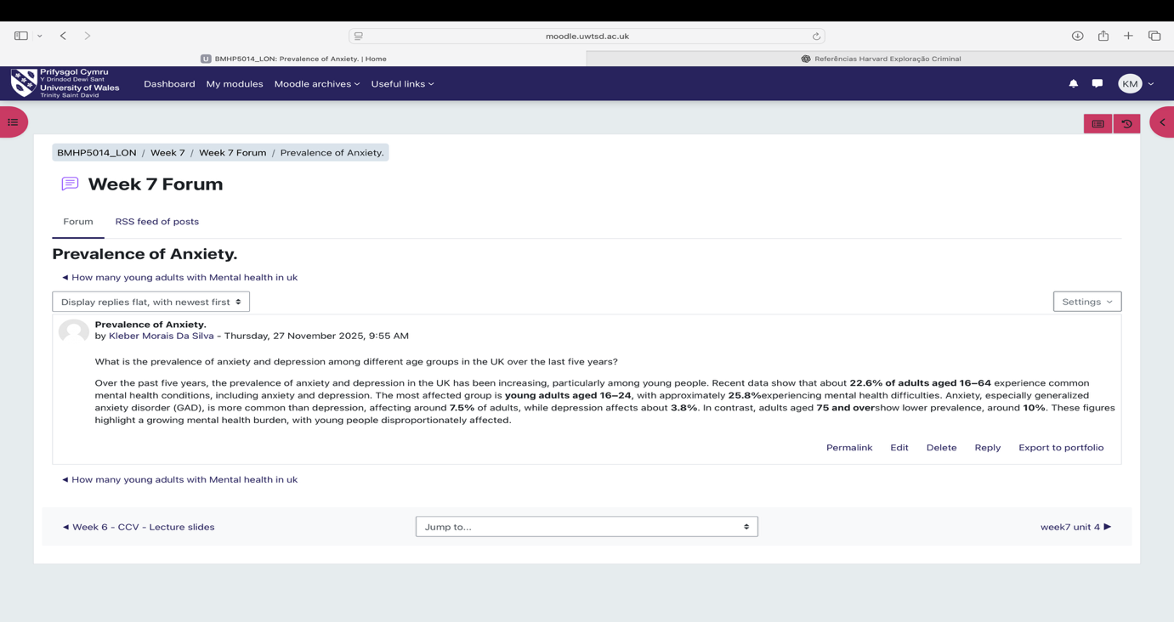

Task 8 - Self-Reflection Journal Entry

Thia module has been a real eye-opener for me in understanding creativity and what it means to create value within means to create value within health and social care. At the beginning, I found myself learning how to spot problems more easily and started to notice just how much innovation influences our daily lives. I realised that finding solutions in this field is not just about what we already know; it is also about challenging assumptions and even considering ideas that might seem a bit out there at first. As I moved through the module, I started to feel more confident in choosing the right approach, coming up with ideas that matter, and recognising how important things like connections, funding, and strolling are when trying to turn an idea into something real. I began to see that value in not just about being efficient or getting results- it is also about making a genuine difference in people’s lives. Looking at data and outcomes helped me understand how we measured and share success. Altogether, this experience has really boosted my creative confidence and shown me the many ways value can be brough to life in practice.

References
Butler, S. et al. (2025) ‘Paediatric Preparedness: Document Analysis of the Challenges Experienced Using Smartwatch Technologies to Support Children Living with a Chronic Health Condition’, International journal of environmental research and public health, 22(2), p. 133. Available at: https://doi.org/10.3390/ijerph22020133. Available at: https://librarysearch.uwtsd.ac.uk/permalink/44WHELF_UWTSD/neci73/cdi_proquest_journals_3170982120 Accessed: 22 Nov 2025.

Baig, M.N.A., Farooqi, W.H. and Mian, A. (2021) ‘Innovation in emergency medicine. a perspective from a low middle income country- Pakistan’, Journal of the Pakistan Medical Association, 71(2(B)), pp. 1–6. Available at: https://doi.org/10.47391/JPMA.1272 Available at: https://librarysearch.uwtsd.ac.uk/permalink/44WHELF_UWTSD/neci73/cdi_gale_infotracmisc_A654226280 Accessed: 13 Nov 2025.

Bird, M. et al. (2021) ‘A generative co-design framework for healthcare innovation: development and application of an end-user engagement framework’, Research involvement and engagement, 7(1). Available at: https://doi.org/10.1186/s40900-021-00252-7. Available at:
https://librarysearch.uwtsd.ac.uk/permalink/44WHELF_UWTSD/neci73/cdi_unpaywall_primary_10_1186_s40900_021_00252_7 Accessed: 14 Nov 2025.

Charlton, V. and Rid, A. (2019) ‘Innovation as a value in healthcare priority-setting: the UK experience’, Social justice research, 32(2), pp. 208–238. Available at: https://doi.org/10.1007/s11211-019-00333-9. Available at: https://librarysearch.uwtsd.ac.uk/permalink/44WHELF_UWTSD/neci73/cdi_unpaywall_primary_10_1007_s11211_019_00333_9 Accessed: 21 Nov 2025.
Carey, M. et al. (2015) ‘The Role of eHealth in Optimizing Preventive Care in the Primary Care Setting’, Journal of medical Internet research, 17(5), p. e126. Available at: https://doi.org/10.2196/jmir.3817. Available at: https://librarysearch.uwtsd.ac.uk/permalink/44WHELF_UWTSD/neci73/cdi_gale_infotracacademiconefile_A769355701 Accessed: 22 Nov 2025.

De la Torre, K. et al. (2025) ‘The Application of Preventive Medicine in the Future Digital Health Era’, Journal of medical Internet research, 27(Suppl 4), p. e59165. Available at: https://doi.org/10.2196/59165. Available at: https://librarysearch.uwtsd.ac.uk/permalink/44WHELF_UWTSD/neci73/cdi_pubmed_primary_40053712 Accessed: 22 Nov 2025.

Deakin, M. (2022) ‘NHS workforce shortages and staff burnout are taking a toll’, BMJ (Online), 377, p. o945. Available at: https://doi.org/10.1136/bmj.o945. Available at: https://librarysearch.uwtsd.ac.uk/permalink/44WHELF_UWTSD/neci73/cdi_proquest_miscellaneous_2649585892 Accessed: 21 Nov 2025.

Elliott, C. (2020) ‘87 Change to reduce patient waiting times’, Abstracts, 4(Suppl 1), pp. A33–A33. Available at: https://doi.org/10.1136/leader-2020-FMLM.87 Available at: https://librarysearch.uwtsd.ac.uk/permalink/44WHELF_UWTSD/neci73/cdi_unpaywall_primary_10_1136_leader_2020_fmlm_87 Accessed: 21 Nov 2025.

Gordon, S.M. (2016) Creativity and service innovation: an examination of differences between theory and practice. ProQuest Dissertations & Theses. Available at: https://librarysearch.uwtsd.ac.uk/permalink/44WHELF_UWTSD/neci73/cdi_proquest_journals_1985632793 Accessed: 13 Nov 2025.

Iacobucci, G. (2021) ‘Staff burnout: MPs demand “total overhaul” of NHS workforce planning’, BMJ (Online), 373, p. n1461. Available at: https://doi.org/10.1136/bmj.n1461. Available at: https://librarysearch.uwtsd.ac.uk/permalink/44WHELF_UWTSD/neci73/cdi_proquest_miscellaneous_2539524254 Accessed: 21 Nov 2025.

Ingles, D.M. and Retallick, M.S. (2025) ‘Reflective Practice in an Experiential Learning Program: An Exploratory Content Analysis of Reflective Writing in Experiential Learning Portfolios’, Journal of agricultural education, 66(2), p. 1. Available at: https://doi.org/10.5032/jae.v66i2.3029. Available at: https://librarysearch.uwtsd.ac.uk/permalink/44WHELF_UWTSD/neci73/cdi_crossref_primary_10_5032_jae_v66i2_3029 Accessed: 21 Nov 2025.

Jakubczyk, N. et al. (2025) ‘The Role of Wearable Devices in Tracking the Well-Being of Patients Suffering from Chronic Conditions - the review’, Journal of education, health and sport, 79, p. 58310. Available at: https://doi.org/10.12775/JEHS.2025.79.58310. Available at: https://librarysearch.uwtsd.ac.uk/permalink/44WHELF_UWTSD/neci73/cdi_doaj_primary_oai_doaj_org_article_7d9bf71984bf4f7d907d3f84e7d9ace2 Accessed: 22 Nov 2025.

Kingkaew, C. et al. (2023) ‘A Learning Environment to Promote Awareness of the Experiential Learning Processes with Reflective Writing Support’, Education sciences, 13(1), p. 64. Available at: https://doi.org/10.3390/educsci13010064. Available at: https://librarysearch.uwtsd.ac.uk/permalink/44WHELF_UWTSD/neci73/cdi_proquest_journals_2767193147 Accessed: 21 Nov 2025.

Morris, T.H. (2020) ‘Experiential learning - a systematic review and revision of Kolb’s model’, Interactive learning environments, 28(8), pp. 1064–1077. Available at: https://doi.org/10.1080/10494820.2019.1570279. Available at: https://librarysearch.uwtsd.ac.uk/permalink/44WHELF_UWTSD/neci73/cdi_crossref_citationtrail_10_1080_10494820_2019_1570279 Accessed: 21 Nov 2025.

O’Donovan, C. (2023) ‘Accountability and neglect in UK social care innovation’, International journal of care and caring, 7(1), pp. 67–90. Available at: https://doi.org/10.1332/239788221X16613769194393. Available at: https://librarysearch.uwtsd.ac.uk/permalink/44WHELF_UWTSD/neci73/cdi_proquest_journals_2783194050 Accessed: 21 Nov 2025.

Prentice, J.C. and Pizer, S.D. (2008) ‘Waiting times and hospitalizations for ambulatory care sensitive conditions’, Health services and outcomes research methodology, 8(1), pp. 1–18. Available at: https://doi.org/10.1007/s10742-007-0024-5. Available at: https://librarysearch.uwtsd.ac.uk/permalink/44WHELF_UWTSD/neci73/cdi_crossref_citationtrail_10_1007_s10742_007_0024_5 Accessed: 20 Nov 2025.

Palmer, V.J. et al. (2019) ‘The Participatory Zeitgeist: an explanatory theoretical model of change in an era of coproduction and codesign in healthcare improvement’, Medical humanities, 45(3), pp. 247–257. Available at: https://doi.org/10.1136/medhum-2017-011398. Available at: https://librarysearch.uwtsd.ac.uk/permalink/44WHELF_UWTSD/neci73/cdi_crossref_citationtrail_10_1136_medhum_2017_011398 Accessed: 21 Nov 2025.

Williams, C.R. et al. (2022) ‘Frequency and impact of long wait times for family planning in public-sector healthcare facilities in Western Kenya’, Global health action, 15(1), p. 2128305. Available at: https://doi.org/10.1080/16549716.2022.2128305. Available at: https://librarysearch.uwtsd.ac.uk/permalink/44WHELF_UWTSD/neci73/cdi_proquest_miscellaneous_2720929408 Accessed: 20 Nov 2025

Vos, J.F.J. et al. (2020) ‘The influence of electronic health record use on collaboration among medical specialties’, BMC health services research, 20(1). Available at: https://doi.org/10.1186/s12913-020-05542-6. Available at: https://librarysearch.uwtsd.ac.uk/permalink/44WHELF_UWTSD/neci73/cdi_pubmed_primary_32698807 Accessed: 22 Nov 2025.

Woodward, A. et al. (2014) ‘Diffusion of e-health innovations in “post-conflict” settings: a qualitative study on the personal experiences of health workers’, HUMAN RESOURCES FOR HEALTH, 12(1). Available at: https://doi.org/10.1186/1478-4491-12-22. Available at: https://librarysearch.uwtsd.ac.uk/permalink/44WHELF_UWTSD/neci73/cdi_crossref_primary_10_1186_1478_4491_12_22 Accessed: 21 Nov 2025.

