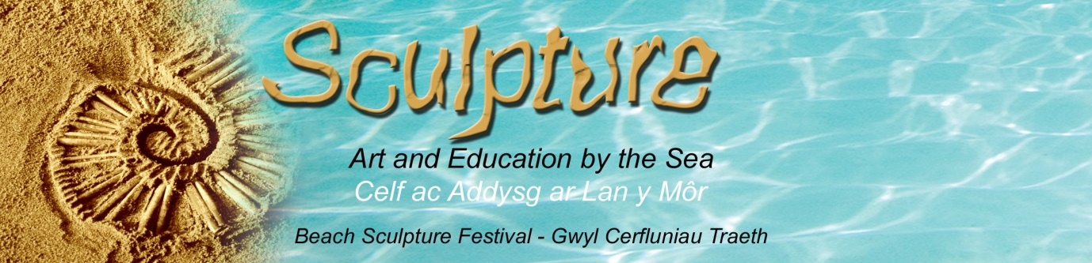
www.artandeducationbythesea.co.uk
SUMMER RESIDENCY OPPORTUNITY FOR TWO YOUNG EMERGING ARTISTS FROM UWTSD
We would like to offer an opportunity for two young emerging artists to work with our team at our annual Beach Sculpture Festival during five days at the end of July. We have been running our festival on Gower and Swansea beaches for the past 14 years. Suitable applicants will be talented, enthusiastic, self-motivated and charismatic who are interested in working with the general public (all ages and abilities) to share art skills. Our festival aims to enhance the creativity and well-being of the people we work with and educate and inspire them about the national environment and local wildlife. At each beach venue, we create site specific temporary sculptures based on marine species using found objects and materials, such as sand, shells, pebbles, etc. to create a wonderful open air gallery of interesting, thought provoking and visually exciting work. Working on the theme of Year of the Sea for 2018, we hope to make this year’s festival even more spectacular than usual so the young artists that we choose will have the opportunity to be involved in a high profile public art event. A small fee will be available for these trainee artists as well the chance to gain valuable experience while working on this project.
Interested applicants should contact in the first instance:
Sara Holden, Managing Artist
sara@artandeducationbythesea.co.uk
Please send a brief outline about yourself and your skills with details of why you would like to be considered for this residency. Max. A4 page 500 words. Deadline: 31.4.18

