Thermal Physics
Temperature scales: Man-made: Celsius and Fahrenheit : we invent these by choosing two points and deciding how any degrees, or intervals between them . The Kelvin or thermodynamic scale is derived from thermodynamic theory.
Celsius : at standard atmospheric pressure: let melting point of ice ( arbitrarily make this 0 ^{O} C) and Boiling point of water (make this 100 º C ) and choose 100 intervals.
Fahrenheit: same two points but melting point is arbitrarily set to 32 º F and boiling point set to 212 º F and there are 180 intervals or degrees
The Kelvin scale - this is derived from thermodynamic theory and the intervals are the same as degrees but with 0 K being absolute zero or -273.15 º C.
0 K = -273.15 º C
Temperature is a measure of the amount of vibration energy that the material’s atoms are experiencing. We call this the Internal Energy .
Thermal energy can be transported in three different ways:

Conduction: here, thermal energy moves through a body by neighbouring atoms causing they neighbours to vibrate . Body does not move
Convection: here, the vibrating atoms move taking their Internal Energy with them.
Radiation: here, thermal energy is transported as an electromagnetic wave (photons/waves)

- Calorimetry:
How much heat energy does it take to increase unit mass (1 kg) by 1 degree ( 1 K ) ? This is the specific heat, C.
Specific Heat = C = energy required to raise unit mass by 1 degree
By simple proportions we can then say:

Heat energy Q required to raise m kg through a temperature difference of ΔT degrees is simply:
Q = m C ΔT

e.g how many Joules is required to raise 2.5 kg of water by from 20 ºC to 100 ºC ?

specific heat of water is 4184 J kg⁻¹ K⁻¹
so that energy required is 2.5 x 4184 x 80 = 836,800 J
- Thermal radiation:

Remember the electromagnetic spectrum. Photons that we can see occupy only a very small portion of the E -M spectrum from about 400 nm to about 750 nm.
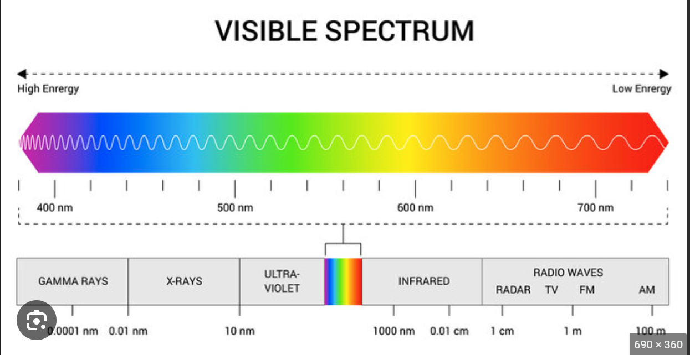

We remind ourselves of incandescent radiation: If the atoms of a body vibrate faster and faster (temperature increasing) then we see the body becoming Red hot , then Yellow hot then Blue hot. In reality the thermal radiation emitted from a body at a certain temperature T covers a range of wavelengths but might dominate (peak) at red, yellow wavelengths for example, depending on the temperature.
Experimentally we observe the range of wavelengths emitted for a perfectly emitting body: :
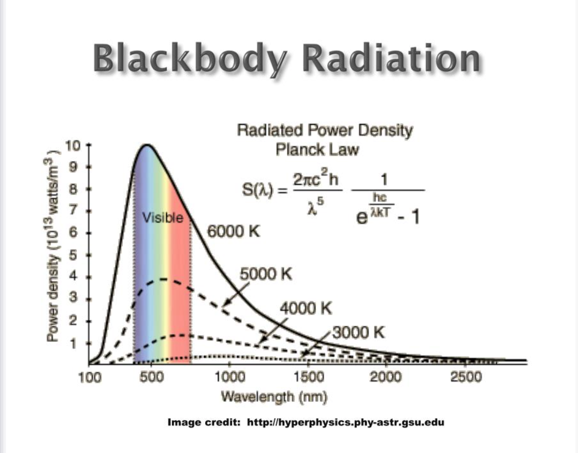
Clearly, for temperatures such as the human body ~ 35 º C ( i.e. 308.15 K ) the peak colour is not in the visible spectrum but is at longer wavelengths in the I.R. range.

Wien’s formula allows us to work out the peak wavelength:

$$λpeak= \frac{2.898 E-3}{T}$$

example: if T = 308.15K then λpeak = 9.4 E-6 m or 9.4 μm which is well into the IR part of the E M spectrum.

What about the thermal radiation emitted from a body at a temperature T?
Consider a perfect (Black Body) body at a temperature T. It will be emitting E M radiation constantly. If the area of the body is A m² then the thermal radiative power emitted ( in Watts i.e. Joules per second) is:

radiative power = $\dot{q}$= σ ε A T⁴ Watts

where σ is Stefan Boltzmann constant = 5.67× 10⁻⁸ W m⁻² K⁻⁴
and ε is the emissivity of the surface of the body and ranges from 0 (totally reflecting) to 1 (black body ) .

example: what is the thermal radiative power from a body of surface area 3 m² and emissivity 0.8 if its surface temperature is 200º C ?
remember S.I. units : 300 C is 573.15 K .

radiative power = 5.67× 10⁻⁸ x 0.8 x 3 x 573.15⁴ Watts
= 14684.78 Watts to 2 D.P.

- Thermal expansion

If we define α to be the coefficient of thermal expansion (CTE) as:
α = change in length due for unit degree increase in temperature per unit initial length .
Then by simple proportions :
Change in length due to ΔT increase in temperature is α ΔT for unit length
If the initial length is not 1 but L say then the change in length due to ΔT increase in temperature is L α ΔT
We can express the change in length as L - L_{o} i.e. from initial length L_{o} to new length , L, due to this increase in temperature
So that the change in length due to increase in temperature is written as :
L - L_{o} = L α ΔT

We can rearrange this to give the well-known form:

L = L_{o} ( 1 + α ΔT )
Example:
Calculate the new length of a steel bar , initially of length 2m, that is increased in temperature by 80 K. (CTE of steel is 11 E-6 K⁻¹)

L = 2( 1 + 11E-6 x 80) = 2(1.00088) = 2.00176 m

- Power and Energy

Power is simply the rate at which Energy is expended.
The simplest example is a laser pulse with rectangular temporal profile:

Pmax
Power
Tpulse
Time

The Pulse energy is the shaded area: i.e. Ulse Energy = Pmax x Tpulse

In general, when the pulse has some general Power function of time , P(t) then

Energy = ∫P(t) dt

