SSIGNMENT 2: Conference Presentation

MODULE: Contemporary Themes in the Hotel and Hospitality Sector

Module Code- BMIH6001

STUDENT NAME: Ruksana Begum

STUDENT NUMBER; 2118820

TUTOR: Dr Ernest Balutie Wavei

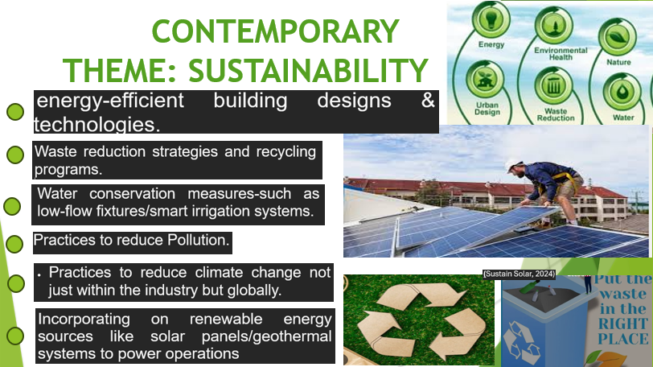

Slide 2:

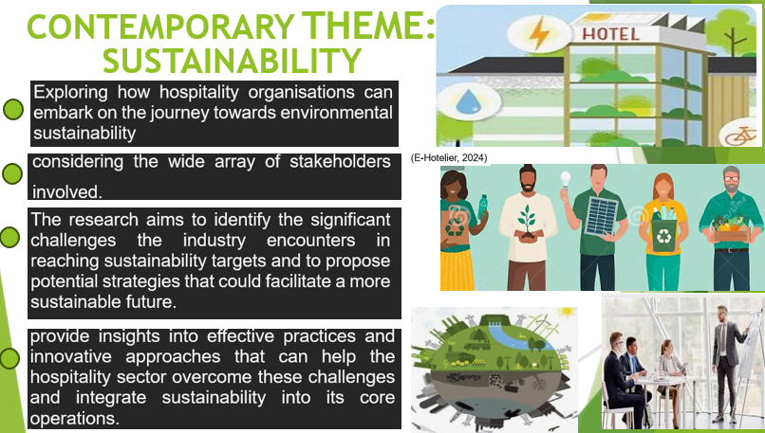

Slide 3:

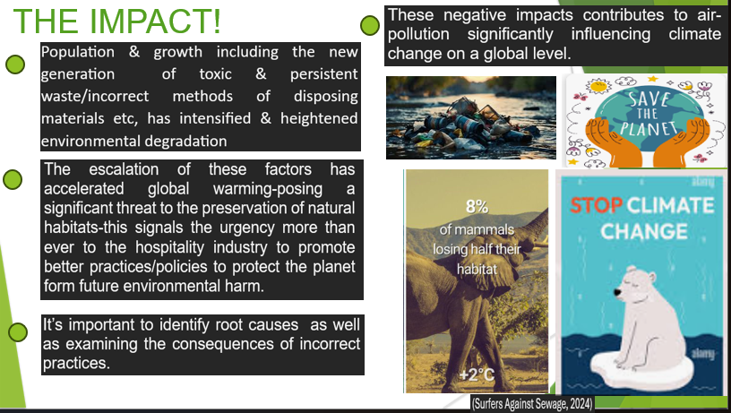

Slide 4:

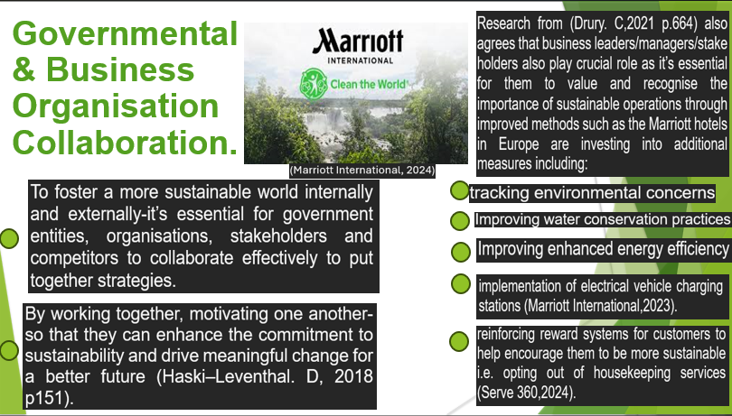
Slide 5:

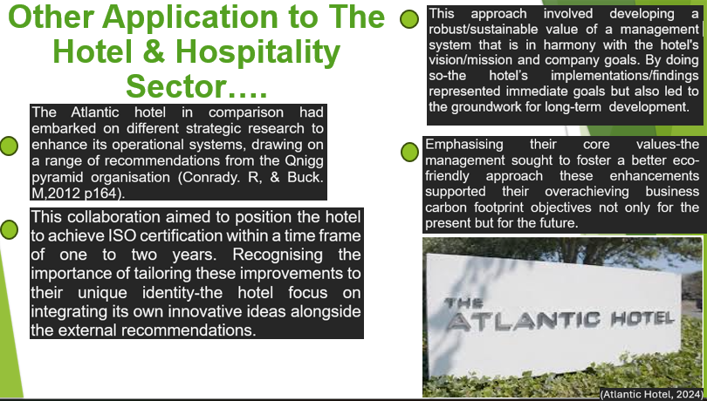

Slide 6:

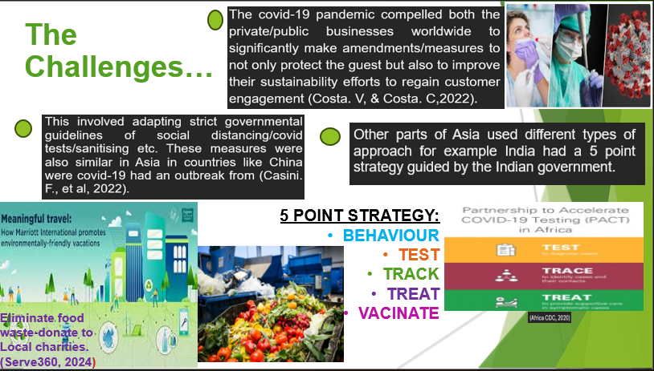
Slide 7:

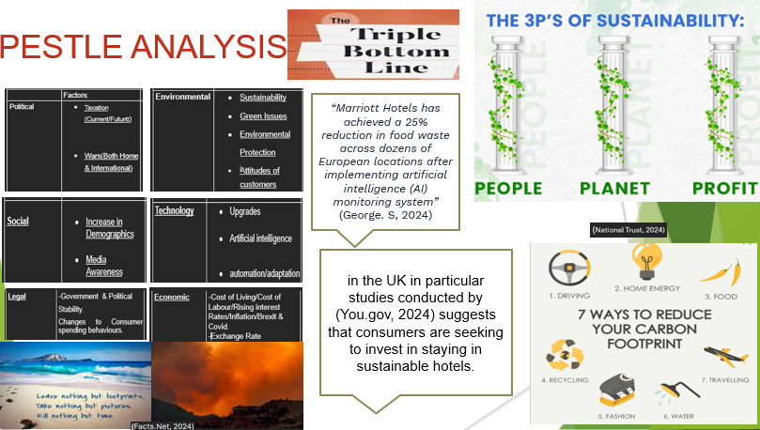

Slide 8:

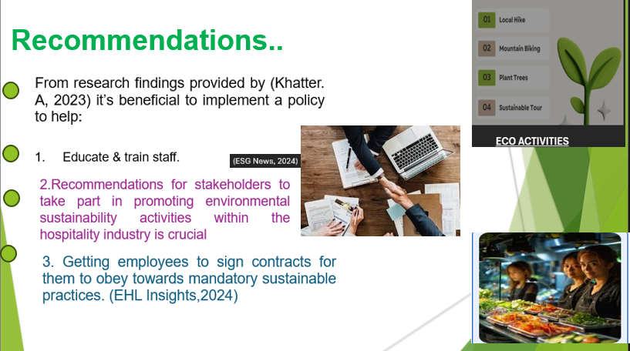
Slide 9:

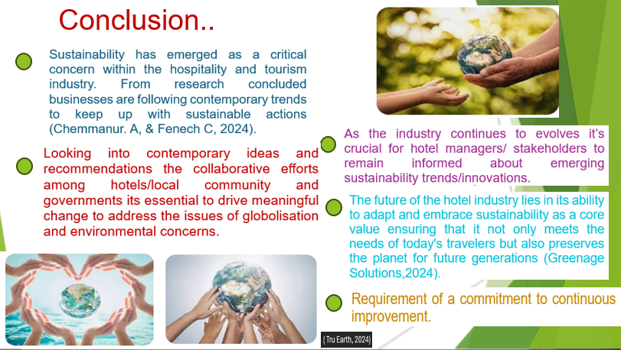

REFERENCES

Africa CDC (2020) Partnership to Accelerate COVID-19 Testing (PACT) in Africa – Social media materials Jersey [Online] Available at: Partnership to Accelerate COVID-19 Testing (PACT) in Africa - Social media materials – Africa CDC (Accessed 12th October 2024)

Atlantic Hotel (2024) The Atlantic Hotel, Luxury Hotel in Jersey [Online] Available at: Travel Agents | The Atlantic Hotel, Luxury Hotel in Jersey (Accessed 12th October 2024)

Casini. F, Faila. G, Gobi. C, et al. (2022) A Cross-Country Comparison of Covid 19- containment measures and their effects on the epidemic curves. BMC Public Health. Vol 22 1765 [Online] Available at: https://doi.org/10.1186s12889-022-14088-7
Accessed 12th October 2024

Conrady. R, & Buck. M, (2012) Trends and Issues in Global Tourism, Springer. Springer Berlin Heidelberg

Costa, V. and Costa, C. (eds) (2022) Sustainability and competitiveness in the hospitality industry. Hershey, Pennsylvania: Business Science Reference

Drury, C. (2021) Management & Cost Accounting, 11th Edition: Cengage Learning UK
EHL Insights (2024) Employee engagement: The method behind hospitality success [online] Available at : Employee engagement: The method behind hospitality success (ehl.edu) (Accessed 8th October 2024)
E-Hotelier (2024) Why small hotels must jump on the sustainability bandwagon [Online] Available at: Why small hotels must jump on the sustainability bandwagon (Accessed 8th October 2024)

ESG News (2024) Marriott Hotels UK Implements Winnow AI to Cut Food Waste by 50% by 2025 [Online] Available at: Marriott Hotels UK Implements Winnow AI to Cut Food Waste by 50% by 2025 - ESG News (Accessed 8th October 2024)
Facts.net (2024) 20 Unbelievable Facts About Human Population Growth [online] Available at 20 Unbelievable Facts About Human Population Growth - Facts.net (Accessed 8th October 2024)

Ford. R.C, & Sturman .M.C (2023) Managing Hospitality Organizations, (3rd ED) U.S: Sage Publications

Goerge. S (2024) AI monitoring helps Marriott Hotels to slash food waste [online] Available at AI monitoring helps Marriott Hotels to slash food waste - edie (Accessed 8th October 2024)

Gowreesunkar, V.G. (2021) Tourism destination management in a post- pandemic context : global issues and destination management solutions. UK: Emerald Publishing.

Greenage Solutions (2024) The importance of environmental sustainability for future generations. [Online Article] Available at: The importance of environmental sustainability for future generations. • Greengage Solutions
(Accessed 11th October 2024)

Haski – Leventhal, D. (2018) strategic corporate social responsibility: tools & theories for responsibility management. Sage

Khatter. A, (2023) Challenges and Solutions for Environmental Sustainability in the Hospitality Sector. VOLUME 15, 11491. [Online] Available at: https://doi.org/10.3390/ su151511491 (Accessed 4th October 2024)

Marriott International, Inc (2024) Sustain Responsible Operations[Online] Available at: Sustain Responsible Operations | Marriott International Serve360
(Accessed 10th October 2024)

Marriott International (2023) Core Value & Heritage [online] Available at: https://www.marriott.com/culture-and-values/core-values.mi#:~:text=Our%20core%20values%20make%20us,history%20and%20a%20thriving%20culture (Accessed 8th October 2024)

Marriott International, (2023) Report Highlights Progress on Marriott’s Environmental, Social & Governance Efforts. [online] Available at:
https://news.marriott.com/news/2023/07/12/marriott-international
(Accessed 30th September 2024)

National Trust (2024) How you can help tackle climate change [online] Available at: How you can help tackle climate change | National Trust (Accessed 30th September 2024)
N. Purohit, Yashika Chugh, Pankaj Bahuguna, and Shankar Prinja (2022) COVID-19 management: The vaccination drive in India. Health Policy and Technology. Volume 11, Issue 2 [Online] Available at: https://doi.org/10.1016/j.hlpt.2022.100636. (Accessed 30th September 2024)

Serve360.Marriott.com (2023). Our Voice [online] CSR-Marriott. [online] Available at: https://serve360.marriott.com/ourvoice/#:~:text=%E2%80%9CServe%20Our%20World%E2%80%9D%20is%20one (Accessed 6 Oct. 2024)
Serve360.Marriott.com (2024). ENVIRONMENTAL POLICY [online] Available at: ENVIRONMENTAL POLICY (marriott.com) (Accessed 6 Oct. 2024)
Surfers Against Sewage (2024) How Does Climate Change Affect Animals? [online] Available at: How Does Climate Change Affect Animals? A Complete Guide - Plastic Free Schools - Surfers Against Sewage (Accessed 6 Oct. 2024)

(Accessed 6 Oct. 2024)
True earth (2024) The 10 Benefits of Making Eco-Friendly Choices [online] Available at: The 10 Benefits of Making Eco-Friendly Choices – Tru Earth US (Accessed 6 Oct. 2024)

You.gov, (2024) WWF and Agoda renew Eco Deals program: Are travellers willing to pay more for sustainable hotels? [online] Available at: WWF and Agoda renew Eco Deals program: Are travellers willing to pay more for sustainable hotels? (yougov.com) (Accessed 6 Oct. 2024)

