Student Name: Mehbuba Tabassum
Student ID: 2516186
Module: Employability and career development
Module Code: LCLM4005
Assignment Title: Mock Interview
Lecturer: Dr. Inderjit Grewal

Job Advertisement

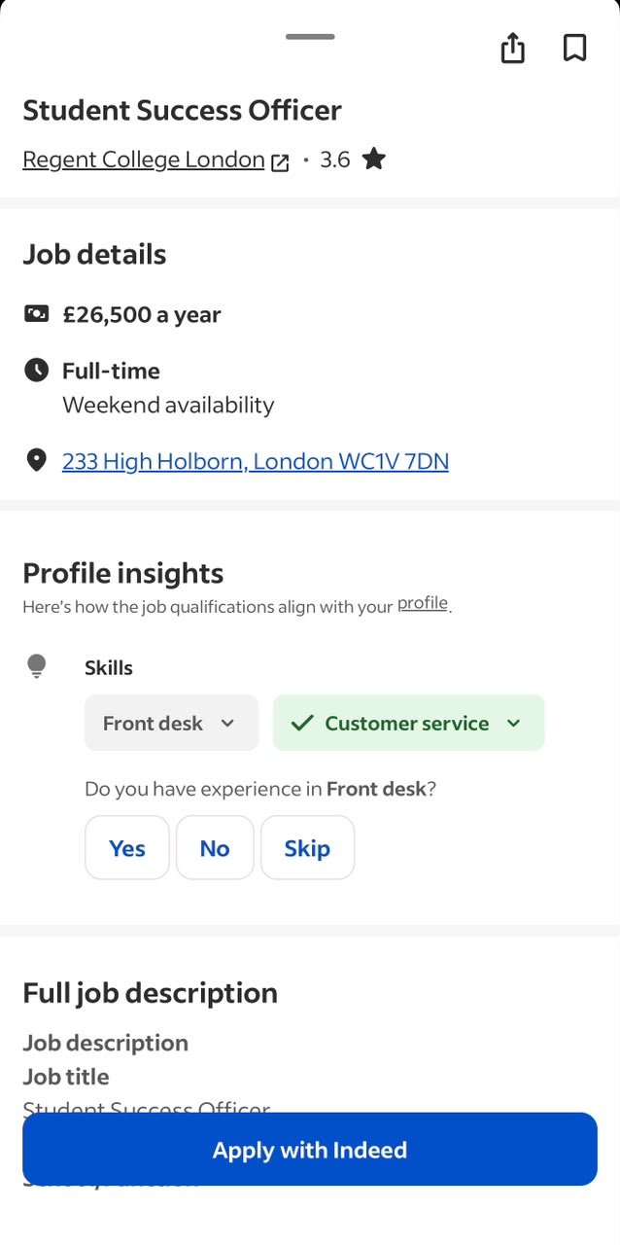
Job Description
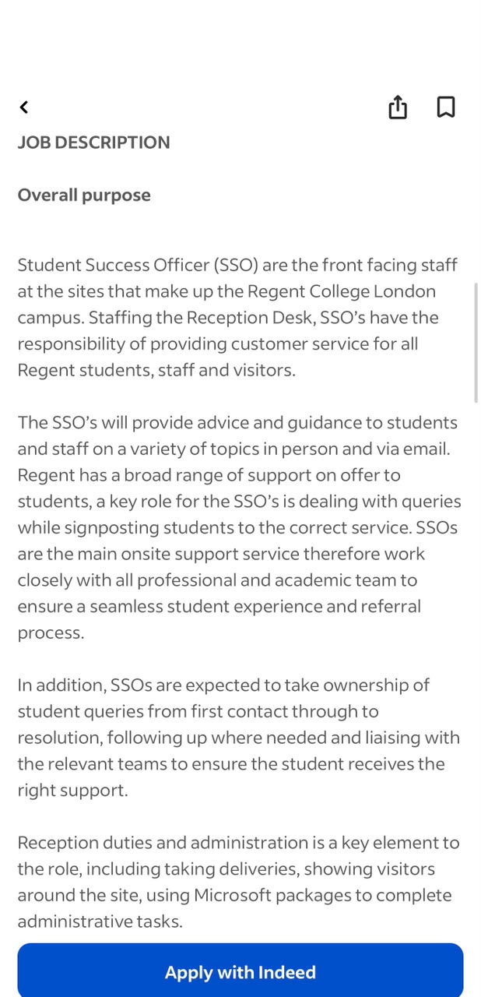
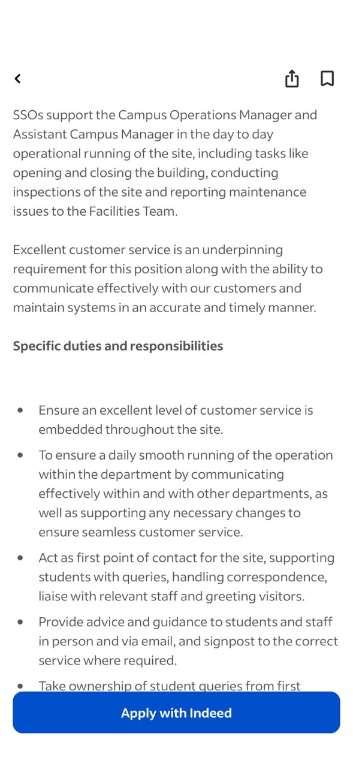
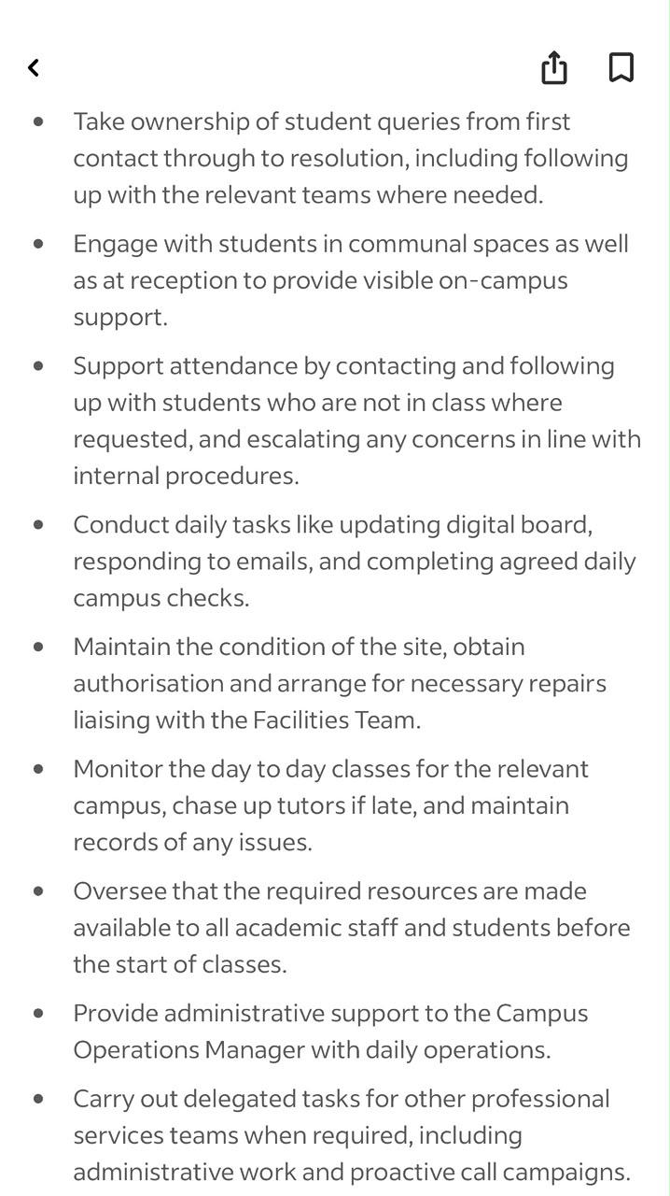
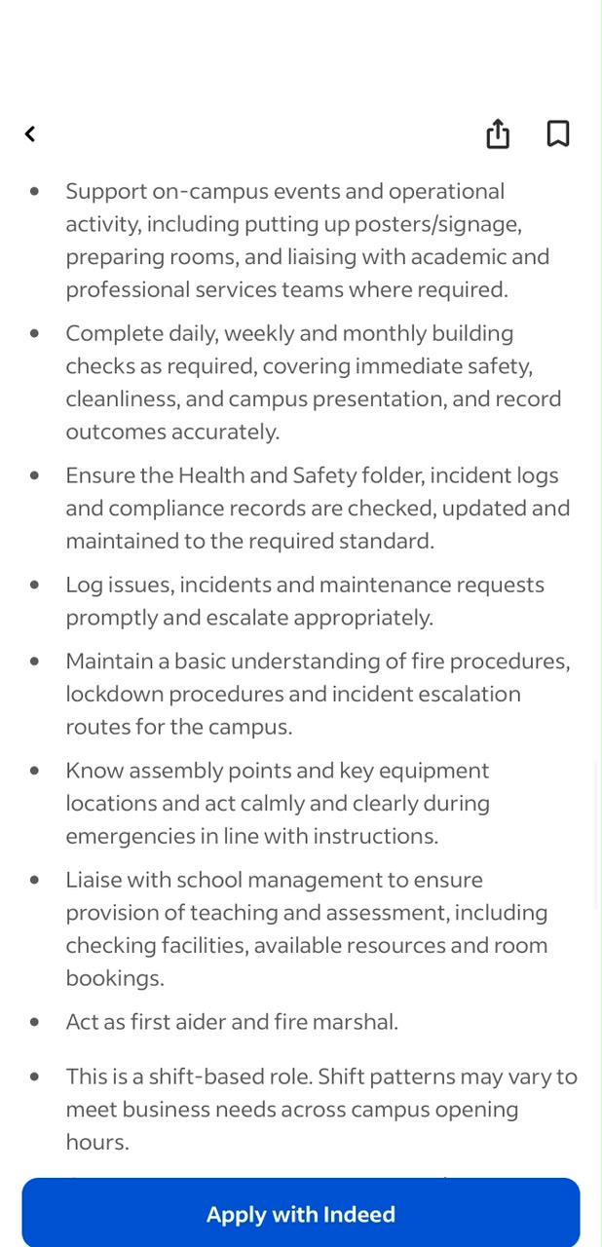
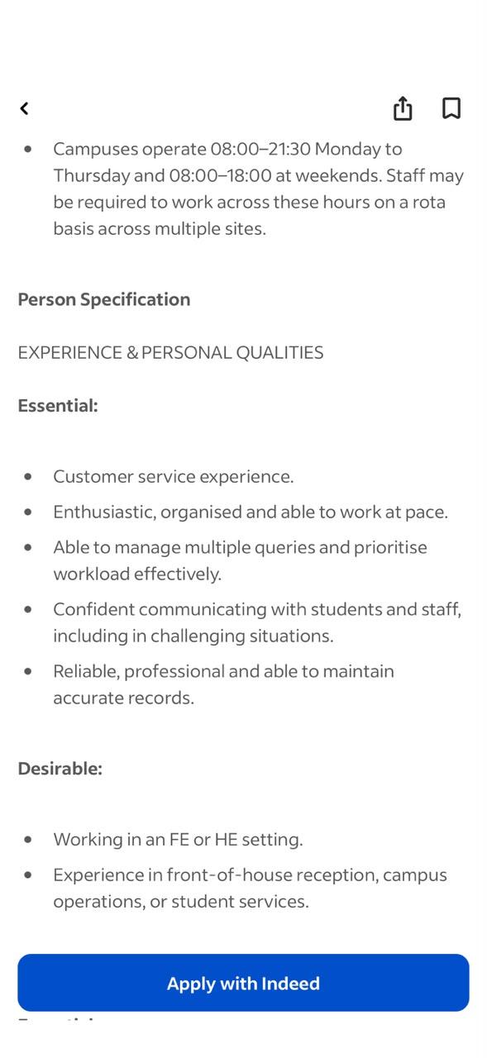
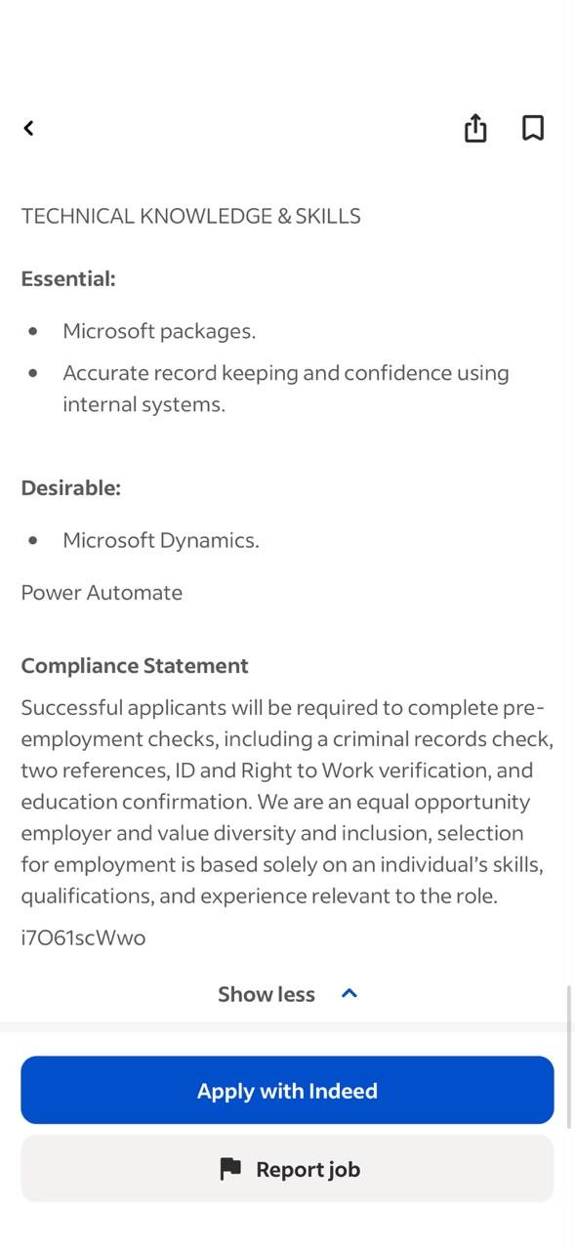
CV

Mehbuba Tabassum
Flat 95 The Lock Building 72 High Street Startford E15 2QG
Summary:
A dynamic, ambitious, and self-motivated individual with a strong work ethic; goal orientated, target-driven and eagerly embraces a challenge. Responsible, disciplined, able to prioritise workloads with good time management skills in addition, I am always very courteous and professional. Able to adapt to new working environments by amalgamating previous attributes and skills gathered with the skills needed for the position. Capable of working under pressure and I have a flexible approach to work commitment and deadlines.
Experience:
Access to Service Officer
Mary Ward Centre 2023 – present
• Provide a friendly and professional first point of contact for prospective and current students, assisting with enquiries in person, by telephone and by email.
• Advise students on suitable courses based on their goals, qualifications and English language level, ensuring they receive accurate information and guidance.
• Support students through the enrolment process, including ESOL assessments, course applications and appointment bookings.
• Use Course Lookup to check course availability, eligibility and provide accurate programme information.
• Maintain accurate student records using EBS, RD Web Access and Microsoft Office applications.
• Respond promptly to student enquiries through Outlook and Zendesk, resolving issues or referring students to the appropriate department when required.
• Process bursary applications, including Oyster card travel payments, ensuring records are accurate and up to date.
• Prepare and issue student ID cards while maintaining confidentiality and data accuracy.
• Create and update spreadsheets, reports and administrative documents using Microsoft Excel and Word.
• Prepare teachers’ files and course documentation to support the smooth delivery of each academic term.
• Record and monitor student feedback, ensuring information is updated accurately in internal systems.
• Provide interpreting support for students who require language assistance, helping them access college services effectively.
• Work collaboratively with colleagues across different departments using Microsoft Teams to provide a positive student experience.
• Complete end-of-day building closing procedures, ensuring the premises remain safe and secure.

Coffee Barista
Crusting pipe/ Covent Garden /Sep 2023- Dec 2023
Delivered excellent customer service, resolved conflicts, lead the team from the front, etc.

Bar Assistant
Crusting Pipe/Covent Garden/Aug 2022- Aug 2023
Delivered excellent customer service, resolved conflicts, lead the team from the front, etc.

Sandwich Artist
Subway/Canning Town/Mar 2021-Aug 2022
Provided quality customer service, maintained brand standards, and ensured team following the standard, maintained inventory and orders, trained staff.

Receptionist
GP /Plumbridge Medical Centre / Mar 2020- Aug 2020
Appointment booking, writing letters to patients, record management, task management, Cooperation with doctors etc.

Customer Service Assistant
Waitrose/Stratford/March 2019- Feb 2021
Demonstrated the ability to work under intense pressure, sell products and services to customers from all backgrounds, handle customer complaints and solve problematic situations as and when they arose.

Care Coordinator | Care solutions Bureau | Jan 2017 to July 2018

- Allocating care workers with the right skills and experience to deliver the best quality care and support to each client.
- Organising care workers rotas to minimise changes to the services and travel between homes.
- To ensure continuity of care provision through effective contingency plans.
- Responding efficiently to day changes in the care and to take new packages.
- Liaising with service users, Local authority, NHS, other health professionals and Care Workers to ensure an efficient service provision is delivered.
- Having the duties of taken on call phone out of hours when require.

Field Care Supervisor/Care Assistant Care Coordinator | Focus Care Link, Tower Hamlets Branch | 2016 to 2017

- Carrying out visits to service user’s home to carry out an initial assessment and continuous monitoring.
- Carrying out risk assessment.
- Attending service user’s first call to introduce care worker.
- Reviewing care package and making care plans.
- Spot check, observation and medicine assessment for the care worker and giving training if needed.
- Liaising with service users, Local authority, NHS and other authorities.
- Ensure company’s policy and procedures are followed.
- Assisting care coordinators to allocate unassigned calls during office hour.
- Undertaking on call duties, record and report all on call activities to the management and care coordinators.
- Reviewing home care diary and archiving them.

Care worker/ support worker | Focus Care Link, Tower Hamlets Branch | Aug 2016 to Dec 2017
- Assisting service users with bathing, showering, strip wash and undressing and dressing, applying cream, lotion and powder or those prescribe by the medical profession.
- Assisting service users with preparation meals and snacks feeds service users where needed.
- Assisting with toileting, emptying of commodes, catheter bag, changing and disposal of incontinent pads.
- Administrating medication from blister pack or dosage box or from original pack which prescribe by doctors and recording in the MAR chart.
- Carrying out any domestic duties such as hovering, bad making, tidying, moping, and washing dishes etc. by following service user’s care plan.
- Supporting service users with shopping and collecting pension as specified in the care plan

Education:
Community interpreting Level 1
HSC (A Level) | Rajshahi Govt. City College |2012-2014
Business Management (Ongoing)

Skills:
- Good communication skills, also able to work to deadlines, producing accurate, wellpresented work. Able to multi-task in a customer service environment.
- Proficient IT skills in windows application (word, PowerPoint, excel and outlook).
- First class communication, interpersonal and persuasive skills.
- Hard working, polite, honest, sociable, good listener and reliable.
- Multi-lingual fluently in English and Bangla.

References:
Available upon request.

Cover letter

Mehbuba Tabassum
Flat 95, The Lock Building
72 High Street
Stratford, E15 2QG

17 July 2026

Hiring Manager
Regent College London

Dear Hiring Manager,
I would like to apply for the Student Success Officer position at Regent College London. I was pleased to see this vacancy because I enjoy supporting students and working in a busy environment where I can help people every day.

I am currently working as an Access to Services Officer at Mary Ward Centre. In my role, I help students with course enquiries, enrolment, appointments and general information. I speak to students in person, over the phone and by email, and I make sure they receive the right support. I also keep student records up to date and use systems such as EBS, Outlook, Excel and Microsoft Teams as part of my daily work.

Before this role, I worked in customer service, administration and reception. These jobs helped me improve my communication skills, learn how to deal with different situations and work well under pressure. I enjoy working with people from different backgrounds and always try to provide a friendly and professional service.
I believe I would be a good fit for this role because I am organised, reliable and enjoy helping others. I am a quick learner, work well as part of a team and always try to give my best in everything I do. I am excited about the opportunity to join Regent College London and support students throughout their studies.

Thank you for taking the time to read my application. I hope to have the opportunity to discuss my application with you.

Yours faithfully,
Mehbuba Tabassum

