The Impact of COVID-19 on the Performance in the Finance Sector in the UK

Kamila Edyta Pausz- 1909921

Dissertation submitted as part of the requirements for the award BA (Hons) Business Management (Finance)

13/05/2022

DECLARATION

This work has not previously been accepted in substance for any degree and is not being concurrently submitted in candidature for any degree

Signed……………KAMILA EDYTA PAUSZ………………………………

Date………………………13/05/2022………………………

STATEMENT 1

This dissertation is being submitted in partial fulfilment of the requirements for the degree of BA.

Signed…………KAMILA EDYTA PAUSZ………………………………….

Date………………………13/05/2022………………………

STATEMENT 2

This dissertation is the result of my own independent work/investigation, except where otherwise stated.

Other sources are acknowledged by footnotes giving explicit references. A bibliography is appended.

Signed……………KAMILA EDYTA PAUSZ………………………………

Date……………………13/05/2022…………………………

STATEMENT 3

I hereby give consent for my dissertation, if accepted, to be available for photocopying and for interlibrary loan, and for the title and summary to be made available to outside organisations.

Signed……………KAMILA EDYTA PAUSZ…………………………………

Date……………13/05/2022……………………………………

STATEMENT 4

I hereby give consent for my dissertation, if accepted, to be available on the university’s IT system to those who have consent to use the system.

Signed……KAMILA EDYTA PAUSZ…………………………………………

Date……………13/05/2022……………………………………

Acknowledgements

First, I would like to thank my supervisors Dr Rachel Cook and Dr Garth Hughes for supporting me during my dissertation journey.
I would like to say a massive thank you to my husband Przemyslaw Pausz for ongoing support and understanding while I was writing my final piece of work. You always motivated me. Thanks to you I did not give up, although I had moments of doubt. I could not do it without you.

A big thank you to my children Maja and Kamil. You always believed in me and supporting me all the way.
I would like to take this opportunity to thank my mum Urszula Pamula for the help and support that she gave me while I was writing my dissertation. Thank you for making me tea, sandwiches and taking care of my children. Also, I would like to thank my dad Zbigniew Pamula, for picking up and dropping off my children while I was chained to the computer looking for sources for my dissertation.
I would like to say thank you to my sister Monika Switala for supporting me, understanding and motivating me.
I would like to thank my friend Alicja Moga for being always for me, supporting me. Coffee always tasted better with you.

Abstract
The COVID-19 epidemic has had a significant impact on the United Kingdom. "Excess deaths" in Europe are among the highest in the continent. According to this research paper, the pandemic's financial impact on UK accrual - based management is examined. It is the purpose of this study to provide comprehensive information about the current and future financial economy's profitability and equity levels. In the UK banking sector, the coronavirus pandemic continues to have a negative impact, according to a new study. In the event of a financial crisis, an empirical assessment of the stability of the UK's banking industry would be based on evidence-based research and quantitative analysis. Coronavirus pandemic consequences in banking sectors across Central and Eastern Europe (CESE) are the primary focus of this study. Since, the research question why are emerging market banks able to tolerate relatively high loan losses without going against regulatory requirements for capital? This question's consequences for the UK financial system are well-documented thanks to study by a variety of scholars and reviews of other scholars' work in the literature. European and British banking industry responses have been widely studied because of this pandemic. Also studied is how the coronavirus impacts the financial industry in the United Kingdom and the country's fiscal policy. The macroeconomics of emerging pandemics have been found in numerous studies.
To sum things up, a theatre review will be included in the literature study. Furthermore, because this study's target audience is the financial system, the qualitative study employs the pragmatism approach and gathers studies from a variety of researchers.

Table of Contents

Chapter 1: Introduction 1
1.1 Background of the Study 1
1.2 Problem Statement and Rationale of the Study 2
1.3 Research Aim 3
1.4 Research Objectives 4
1.5 Research Questions 4
1.6 Structure of the Dissertation 4
Chapter 2: Literature Review 5
2.1 Introduction 5
2.2 Finance industry 5
2.1.1 Response of European Union 6
2.1.2 UK- Response 7
2.3 Impact of coronavirus on banking industry- UK 8
2.3.1 COVID-19: UK Budgetary Responses 10
2.4 The macro-economics of potential pandemics 10
2.5 Theoretical analysis 11
2.5.1 Signalling Theory 11
2.5.2 Real Option Theory 11
2.5.3 Trueman Theory 12
Chapter 3: Research Methodology 13
3.1 Introduction 13
3.2 Research Philosophy 13
3.3 Research Design 14
3.4 Research Approach 15
3.5 Data Collection 15
3.6 Data analysis 16
3.7 Time Horizon 16
3.8 Target Population 17
3.9 Inclusion Criteria 17
3.10 Ethical Consideration 17
Chapter 4: Results and Discussion 19
4.1 COVID-19 and Finance 19
4.2 Influence of COVID-19 on Banks in the UK 21
4.3 Interest Rates and Debts during COVID-19 in the UK 23
4.4 COVID-19 and Financial Policies of UK 24
Chapter 5: Conclusion and Recommendations 26
5.1 Conclusion 26
5.1.1 How objectives have been achieved 27
5.2 Research Contribution 27
5.3 Recommendation 27
5.3.1 Recommendation for Practice 27
5.3.2 Contribution to Theory 28
5.4 Limitations of the study leading to further research work 28
References 29
Appendix- Ethical Form……….………………………………………………………………………………………………………35

Chapter 1: Introduction

1.1 Background of the Study
The COVID-19 pandemic has been highly adverse and created the various crisis in different sectors around the world as it can be termed as the major crisis after the 2007-2009 financial crisis (Bora and Basistha, 2021). For instance, in the 2007-2009 financial crisis the UK financial sector has been adversely hit as discussed in Lindström and Giordano, (2016) that the first major hit of the financial crisis were seen in the UK on Monday 15th September 2008, on which Lehman Brothers a well known financial investment services firm declared bankruptcy and closed their operations. Also, by 11th October 2008, almost £90 billion were lost on the London Stock Exchange. This shows the declining financial performance during the last financial crisis before COVID-19. The pandemic has spread around the world and has created an adverse economic crisis as well that has disturbed the stock market and created uncertainty in the financial sector. For instance, recent volatility in the stock market has been identified exceeding the stock market crashes in October 1987 December 2008, and 1929 (Iqbal et al., 2021). Similarly, Europe has been identified as one of the worst affected continents as more than 1 million people got affected creating severe restrictions and financial disruptions as well (Pillai et al., 2020). For example, the United Kingdom (UK) has seen a severe increase in the pandemic and maintained strict lockdowns that have caused high financial loss due to which businesses have borrowed money from the banks in the UK (Norrestad, 2021). So, it indicates that the UK has been severely hit by the pandemic in its initial stage.
Moreover, the pandemic has halted and slowed the actual performance of the financial sector in the UK as IMF, (2021a) has identified a fall of 3.2% in global GDP in 2020. Also, IMF predicted a loss in different types of economy in the UK that including emerging and developing Europe (EDE) by 2%, emerging market (EM) by 2.1%, and advanced economies by (AE) by 4.6%. Besides, the financial sector of the UK including banks have also been adversely hit by the pandemic in the shape of rigid interest rates and ease policies. For instance, the bank of England in March and June of 2020 announced hundreds of billion pounds in stimulus and cut interest rates twice which has caused serious financial damage within the financial sector (Norrestad, 2021). This pandemic can be best identified as an unforeseen shock that has created recession around the world and their effects have been felt in the UK’s economic and societal aspects. The businesses have been closing and people losing their jobs created unemployment and financial loss within the region. The UK GDP has seen a rise by 1.2% in December 2020 but still, it was below 6.6% as compared with December 2019. Also, headline GDP decreased by 9.9% has been identified as twice the fall in 2009 (ONS, 2021). Hence, it can be inferred that the UK GDP has suffered adversely during the initial pandemic and the financial sector suffered major losses.
Furthermore, it has been identified that the UK has seen a 20.4% decline in the GDP by the end of June 2020 and the UK public sector finances have seen severe damages. These damages have been caused by emergency expenditures and falling revenues as their net debt increased to £1,984 billion comprised of 99.6% of the GDP in June 2020 (Heald and Hodges, 2020). Besides, the UK’s financial sector including banks has seen high-interest rates cut as this process has caused major financial damages during the pandemic within the financial sector (Estrada et al., 2020). Besides, the UK FTSE100 has adversely suffered as it represents the worst quarter since 1987 and indicates a drop of 24.80%. Also, the UK has shown highly negative returns regarding the nonfinancial firms as the market return dropped by 40% during December 2019 and March 2020 (Akhtaruzzaman et al., 2021). Hence, it represents that the UK’s stock market returns have also been negative that has been caused by the pandemic.
Additionally, financial risks have been identified as highly influencing the bank performance in EM due to lack of company capitalisation and family financial resources as compared with the AE that eventually resulted in poor safety buffers regarding the absorption of unexpected losses (Abbas et al., 2021). Similarly, the early stages of the pandemic have seen severe bouts regarding the asset price volatility and market dislocation and the changing policies of the banks have been the major source of declined performance in the UK financial sector (Giese and Haldane, 2020). The pandemic has been highly negative towards the financial sector of the UK as it has helped the businesses of various SMEs through loans and overdrafts in 2020 as the second and third quarter of the year has seen high loans provision. Also, London has been identified as one of the major regions that received high loans from banks and financial institutions in the UK (UK Finance, 2021). Hence, it indicates that the UK has faced severe financial challenges during the initial stages of the pandemic.

1.2 Problem Statement and Rationale of the Study
The UK has seen negative influences of the pandemic on their economic conditions by representing lack of employment and bank’s financial policies in the region. For example, banks in the UK especially the Bank of England have developed policies towards easing the loan restrictions and allowing relatively low-interest rates have backfired as such policies have failed to fulfil the promises and endangered the financial sector. The pandemic has made fundamental calls towards reforming the business and finance sector as the sector has relatively less capital left and are at the risk of being dissolved (Susskind and Vines, 2020). Similarly, the UK stock market has faced various challenges as the stock market highly deviated from market efficiency and caused major risks and uncertainty that has eventually influenced a lack of investment and financial loss as well (Ozkan, 2021). So, it represents one of the major rationales of conducting this research as it can help in understanding the stability of banks, consequences of the pandemic on banks, rise in interest rates, and debts during the pandemic in the UK.
Furthermore, the fear of another COVID variant named Delta has created major problems in the financial sector around the world and the UK as well. For instance, the FTSE100 index in the UK represents 3.7% down shares along with main markets in the US, Germany, and France as well. Also, the FTSE100 index has identified the biggest one day drop in more than a year as the biggest UK lenders are known as HSBC, Lloyds Bank, Barclays, and NatWest have depicted a fall of 7% due to investors scaling back regarding Bank of England interest rate rise in December (BBC, 2021). Besides, it represents that the banks have negatively suffered due to the ever-increasing pandemic and variants and it seems necessary to identify the conditions in the financial sector. So, it can be inferred that another rationale/justification of conducting this research refers towards highlighting the difficulties banks faced in catering to their customers and investment on the stock market in the literature/content analysis and represent the current research results.
Moreover, the UK financial sector including the stock market has been negatively influenced by the pandemic as it has identified decreasing investments and returns as well (Singh et al., 2020). For instance, £44bn have been wiped from the FTSE100 index UK which comprises major companies in the UK as it closed down 2.4% at 6,844 points and identified one of the biggest loss in the region (Inman, 2021). Besides, despite the increasing problems/challenges faced by the stock market and banking sector due to the pandemic the Bank of England has provided significant support to the banks by cutting the interest rate to 0.1%, helping businesses to pay the staff, and helping banks in expanding the lending (Bank of England, 2021). Hence, it also represents that the Bank of England has proposed some significant strategies towards easing the influence of pandemics on the financial sector of the UK. So, another rationale for conducting this research refers to understanding the flexibility and stability of the banking sector in the UK. This research has been highly useful and significant towards highlighting both negative aspects in the financial sector and positive strategies and policies that have helped in the regrowth and development of the sector.

1.3 Research Aim
The research aims to provide detailed insights regarding the existing and future outcomes of the financial economy in terms of profitability and equity level. The study would emphasise the continuing negative impacts of the coronavirus pandemic on the banking sector of the UK. The use of evidence-based literature and quantitative analysis would proportion an empirical assessment towards the stability of the banking sector of the UK during financial crises.

1.4 Research Objectives
The research is primarily designed to reiterate the consequential effects of the coronavirus pandemic in the banking sectors across the Central and Eastern Europe (CESE) region. Alongside, individual bank groups, to shock spikes in credit losses caused, among other things, by the spread of the regulatory and pandemic changes governing public assistance to households and enterprises. Based on the research background and qualitative evidence, the following research objectives were formulated:
- To assess the banking/financial sector of the UK.
- To assess the financial policies and their influence during COVID-19 on banks in the UK.
- To assess the role of interest rates and debts during COVID-19.

1.5 Research Questions
RQ1: What is the influence of COVID-19 on banking/financial sector of the UK?
RQ2: What is the role of financial policies during COVID-19 on banks in the UK?
RQ3: What is the role of interest rates and debts during COVID-19?

1.6 Structure of the Dissertation
The current research/dissertation has been conducted based on five chapters in which the first chapter has included background, problem statement and rationale, research aim, objectives, and research questions. The second chapter has been identified as a literature review and includes theoretical background and literature review based on prior research. The third chapter has been identified as a research methodology that includes research philosophy, research design, target population, data collection procedure, data analysis technique, ethical considerations, and ethics form. The fourth chapter has been identified as results and discussion in which literature/content analysis has been conducted regarding the research topic and objectives. The fifth chapter has been identified as a conclusion and recommendation that includes an in-depth conclusion of the research, theoretical contributions, managerial recommendations, along with limitations and future recommendations as well.

Chapter 2: Literature Review

2.1 Introduction
The second chapter of the research investigates the research and review of other researchers on many studies related to the financial sector of the United Kingdom's Covid-19 implications. Due to the Covid-19, banking industry responses in Europe and the UK have been thoroughly researched. In addition, the impact of the coronavirus on the UK banking industry and the country's budgetary actions are examined. A variety of studies has identified the macroeconomics of future pandemics. For wrapping things up, a theatrical evaluation has been included in the literature review.

2.2 Finance industry
According to Garside, (2020), inadvertently altering financial markets and even the global economy, COVID-19 pandemic has impacted businesses, organisations and communities, organisations all around the world. Moreover, the supply chain has also been disrupted through uncoordinated administrative responses and lockdown. Limitations of Lockdown and self-isolation regulations in China greatly curtailed the output of goods from industries, as well as the consumption, demand and use of the services and products. In light of fact on COVID-19 that it is now affecting civilized world, Also, China will now be able to improve more quickly than other countries, which can provide it an advantage in the trade negotiations with UK (Elmarzouky et al., 2021). When it comes to acquiring Western companies, Chinese corporations will have an advantage because they are less reliant on the stock market than their Western counterparts.
Since, Ibn-Mohammed, et.al., (2021) stated that, Securities markets sector has been harmed by the supply chain disruption (Ibn-Mohammed et al., 2021). The Nasdaq, the S&P and Dow Jones Industrial Average, about 500 all dropped precipitously until the UK government passed the Alphavirus Aid, Relief, and Economic Security (CARES) Act, which resulted in an increase of 7.3%, 7.73%, and 7.33% in the three aforementioned UK stock market indices (Walker, 2022). Ten-year US Treasury note yields have fallen to 0.67 percent, the lowest level since September 2011. Furthermore, the following figure 1 showing how the UK economy has been hits the most among other countries.
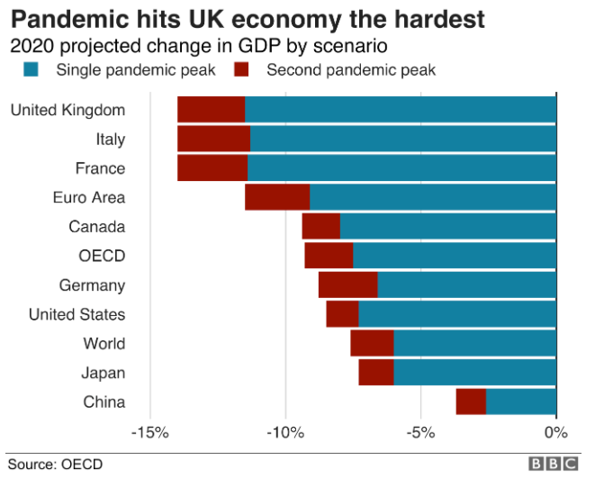
Figure 1: Pandemic hits UK’s economic hardest. Source - Walker (2022)

Chinese and Hong Kong stock markets followed the similar trend, initially declining before rising with government backing, as did the South Korean stock market, KOSPI. The Nikkei 225 index in Japan rose by 2.01 percent. In the eurozone recession of 2011–2012, European bond yields fell to levels not seen since (Walker, 2022). On 23rd march the, FTSE 100, the DAX, and Euros Stoxx 50 both remained down, but after European’s assistance package has been accepted, they all rose abruptly. Also, price of the gold as measured in US dollars fell by 0.65%.

2.1.1 Response of European Union
Since, Agca et al., (2020), COVID-19's economic impact on the eurozone has prompted Europe to commit a €1.7tn rescue package, which includes contributions from all EU member states, as well as regional states that aren't EU members for example: Switzerland. Because of the epidemic, the Eurozone (ECB) has established an asset-purchase programme of €750 billion (Shen, et.al., 2020). There is also a €25 billion investment fund created by the European Commission, as well as an agreement on a more relaxed stance on budget regulations to stimulate public spending and government support for affected enterprises (Assous and Al-Najjar, 2021).
In Germany, the state investment corporation (KfW) would lend €500 billion to enterprises affected first by pandemic, which has been labelled the "largest post-war aid package" by the German government. With the Kurzarbeitergeld, a sponsored plan of the German Senate (the Bundenstag), the virus-afflicted employees will be compensated. In addition, 345 billion euros, 200 billion euros, and 25 billion euros have been pledged by France, Spain, and Italy to assist enterprises.
According to the estimation of Shafi et al. (2020), A total of €1.7tn (£1.6tn) in economic aid has been announced by European nations to tackle the implications of a coronavirus pandemic (Shafi et al., 2020). Economists predict that the sums pledged but central banks in recent statements will rise dramatically (The Guardian, 2022). Cash infusions required within the next three years are expected to be far more than the ones made a year back as during banking crisis, according to these forecasts. "Helicopter cash," payroll tax reductions, and state-backed loan for businesses are among the options being considered by the White House as it seeks congressional support for a $1 trillion spending package (Shen et al., 2020) (see below figure).
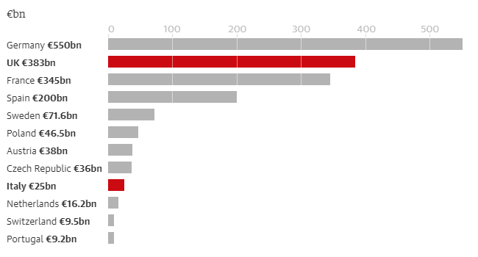

Figure 2: The UK's coronavirus aid package is the second highest in Europe at €383bn. Source - Guardian (2022)

2.1.2 UK- Response
Emergency loan guarantees totalling £330bn were unveiled by Chancellor Rishi Sunak in the UK. In an effort to save UK enterprises, an additional £20 billion in fiscal help has been granted (Shafi et al., 2020). Delaying VAT and Revenue Tax payments are among the provisions included in the package. A relief package for small and medium-sized businesses under the Statutory Sick Pay Act. Though, all retail, hotel, leisure, and nursery firms in England are eligible for a 12-month corporation tax exemption. A grant of £10,000 is available to businesses that get local business rate relief (SBRR) or rural rate relief (RRR) (Shafi et al., 2020). Retail, hospitality, and leisure firms with properties valued at between $15,000 and $51,000 are eligible for a $25,000 grant.
The British Business Bank's Coronavirus Insurance Policy Loan Program provides up to £5 million in loans to small and medium-sized enterprises (SMEs). Moreover, Larger companies will be able to use a different financing facility first from Bank of England that will help them bridge the disruption caused by the coronavirus to of own income through loans (Sherif, 2020).
In an unprecedented move, As, the Bank of England has lowered interest rates to 0.1 percent in an effort to mitigate the consequences of COVID-19 and maintain the trust of investors who have been shaken. According to the Chancellor's announcement on March 20, 2020, the government has to pay up to 80% (or $2500 per month) of the salaries of employees who are held on by their employers and has pledged to support around 3.8 million self-employed workers with a £9bn grant scheme (Sherif, 2020).

2.3 Impact of coronavirus on banking industry- UK
Antwi et al. (2021) has been observed that, the Covid-19 lockout has disrupted economic activity across a wide range of sectors, with significant consequences for businesses and households. Hospitality and transportation businesses that rely on direct consumer contact are losing funding sources; and persons working in these industries are losing cash flow. Indirectly, the financial industry is also impacted (Antwi et al., 2021). In spite of the fact that chequing accounts can be proffered remotely and will not rely on direct contact with customers, the sector's connection also with real sector as a provider of reimbursement, savings, praise and risk managed services broadens the negative impact of both the Covid-19 downturn to financial institutions.
Financial regulators and governments have taken major policy initiatives to support businesses and people during such a period of declining revenues and incomes. To begin with, companies that have ceased operations lose out on revenue and may thus be unable to pay back loans. People who lost their occupations or been furloughed may not be responsible for repaying their loans since their income has been reduced (Antwi et al., 2021). If recovery capacity is permanently reduced, this will have a negative impact on profitability and bank capital. As a result, banks should expect increased losses, results in the need for multiple avenues, which will have a negative impact on their profitability and financial structure.
In the following figure 3, At this point in time, 78% of banking executives interviewed in 2020 say their banks have demonstrated greater agility, while 72% say they've gotten more innovative in the last 12 months (Siddiqui, 2020). This, despite the fact that many of the major processes of banks have become more complex for the responders. For banks, sales and new business acquisition were the most challenging aspects of the Covid-19-induced crash (Consultancy.uk, 2022). More than three-quarters of banks stated they had problems in this sector because investors became more cautious, while only 25% said they had difficulty at the regular level.
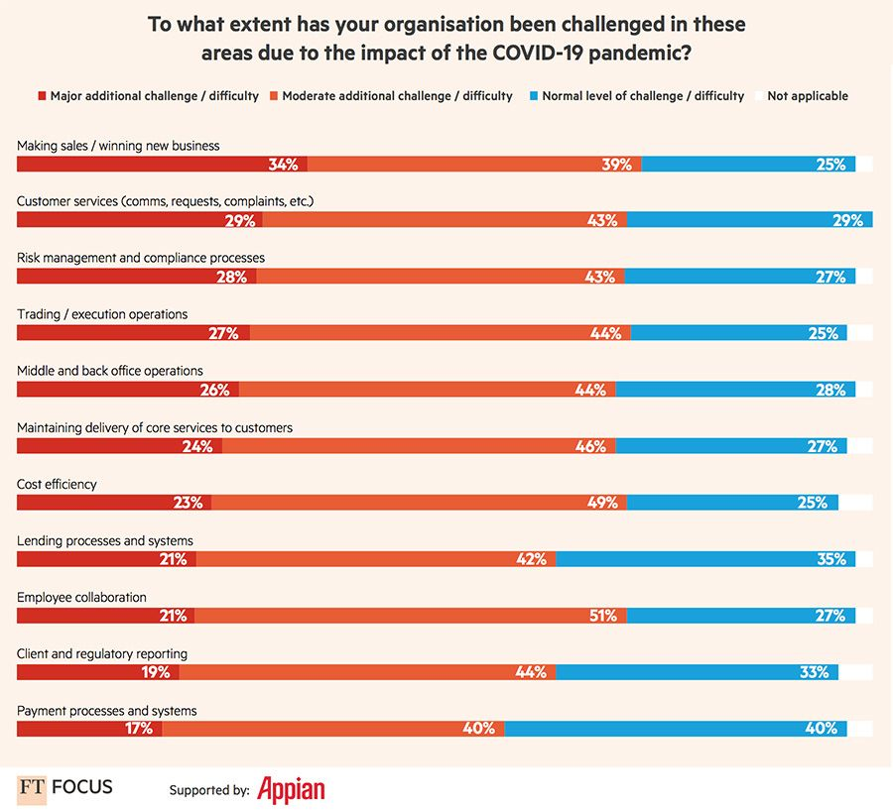
Figure 3: Organisation being challenged during covid'19pandemic. Source – Consultancy.uk (2022)
Also, banks have suffered losses as the value of their bonds and other financial instruments has fallen. It is possible that open derivative positions may have shifted in unforeseen directions due to the financial crisis. As a result, banks are seeing an increase in demand for loans, particularly from businesses that need additional funds to pay their expenses even in the face of lower or no income generation (Consultancy.uk, 2022). Borrowers have used up some of their available credit as a result of the increased demand. As a result of decreased demand for their various services, banks are seeing a decline in non-interest revenue (Gandjour, 2020). Investment banks' fee income is reduced since there are fewer pay-outs and interactions to be made as a result of weaker economic activity and fewer security risks by corporations.
Lanshina et al., (2020) has said that It is possible that losses and weaker mutual fund in banks have negative spill over consequences, which could worsen the banks' solvency position and harm the broader economy. Bond and other trade financial instruments may be sold by banks in order to enhance their level of liquidity or to makes up for losses, and the price of these instruments may decline as a result (Agca et al., 2020). Banks may restrict the amount of credit they provide to the economy, which might have a negative impact on businesses that rely on such buffers for survival. During the 2008/2009 global financial crisis, we observed comparable consequences (OECD, 2020).

2.3.1 COVID-19: UK Budgetary Responses
According to the (OBR, (2018) pre-COVID-19 budgetary estimates, the UK's net public debt ratio could reach 283 percent of GDP in 2067-68, mainly due to low predicted productivity performance and population ageing (Sherif, 2020).
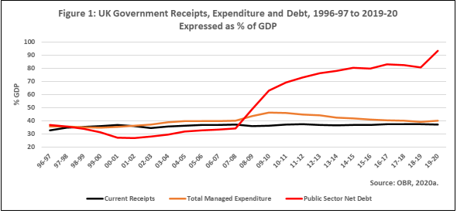
Figure 4: UK Government Receipts, Expenditure and Debt, 1996-97 to 2019-20. Source - Sherif (2020)

Figure: 4 depicts the UK government's receipts, expenditures, and total liabilities spanning 1996-97 to 2019-20, just before pandemic's severe fiscal repercussions were felt (OBR, 2020). Up to fiscal year 2000-01, revenues and expenditures were about equal. During the years leading up to 2008, there was a rise in governmental spending without an increase in tax revenue (Sherif, 2020). As a result, the net debt of the public sector rose, but it remained just under the 40% GDP ceiling set by the Labour Government.
According to Assous and Al-Najjar (2021) from the consequence of 2008, public sector total income reached 70 percent of GDP until March 2011, a level that had not been seen since the Great Depression. Taxes and other state receipts remained at roughly 37 percent of GDP during the period of austerity, which began in 2010 and lasted through 2020 (Sherif, 2020). There was a reduction in the annual deficit, but it was not eradicated. From 2015 onward, civil service net debt remained above 80% of (rising) GDP (Nicola, et.al., 2020). As a result of the COVID-19 emergency measures, we've seen a significant growth in 2019-20.

2.4 The macro-economics of potential pandemics
Garside (2020) said that in spite of the fact that the preceding SARS coronavirus epidemics had no significant economic effect on the Nation, macroeconomic experiments of the impact of outbreaks of infectious diseases were produced around ten years ago, in the setting of a UK flu pandemic, in order to estimate the possible effects of dissociative symptoms and government measures to reduce spread of the virus (Nicola et al., 2020). A possible pandemic's economic impact, both direct and indirect, as well as closings and short-term prophylactic absences from work were all included in these macroeconomic simulations. The results showed that the indirect economic costs may outweigh the direct care effects on the economy by a factor of ten if 30 percent of the UK (Shen et al., 2020). population were to miss research to stop infection and schools were closed or 13 weeks, depending on the intensity of the pandemic.
Covid-19's social distancing restrictions and instructions are likely to have a significantly greater influence than any sickness and policy scenarios that were regarded extraordinary when they initially appeared (Sherif, 2020). Therefore, the aim of this research is to begin producing current estimates of potential environmental and economic impact of such Covid-19 epidemic on the UK economy, taking into account both the direct wellbeing economic implications and the possible impact of assessment methods both to mitigate or inhibit epidemic growth (Connelly et al., 2011).

2.5 Theoretical analysis
According to Connelly et al. (2011), Covid’19 pandemic was the most difficult economic time because since global financial crisis that the UK is facing (GFC). As a result of the Covid-19 epidemic, there has been an increase in uncertainty about the company's performance. While the financial crisis was largely driven by the poor performance of financial institutions, the Covid-19 outbreak is a natural disaster for which no segment of the financial sector can be held responsible. Some areas of the UK economy, such as construction that have had GDP growth fall by 35%, but other industries have not seen this reduction (Siddiqui, 2020). Managers may choose to link their Covid-19 data to more performance disclosure in order to convey this message to stakeholders. It's important for management to reveal their ability to minimise Covid-19, which is a systemic risk. Lockdowns of varying degrees have been implemented in the UK, adding to the general sense of unease over business performance.

2.5.1 Signalling Theory
Covid-19-related information relating to performance disclosure may be disclosed by companies under the signalling theory to convey positive signals both stakeholders and markets about how to handle the current issue as well as offer more confidence in the firm's future performance (Page, 2010).

2.5.2 Real Option Theory
In a view of Pellegrino et al. (2013), To deal only with uncertainty caused by rising external risks, investors choose to postpone investment, according to the genuine option theory. Even factories have been shut down in areas with a high risk of transmission of both the pandemic (COVID-19), which has had a negative impact on business income (Pellegrino et al., 2013). As a result, the operation of energy industry enterprises is more susceptible to external influences since they must ensure that their revenue can pay the high fixed expenses associated with "high energy use."
The level of uncertainty in business operations rises dramatically when revenue declines and costs rise at the same time. Due to COVID-19's inherent uncertainty, investors, particularly lenders like banks, have become more cautious (Antwi et al., 2021). Due to higher financing constraints, listed businesses may experience tighter operating cash flows and a decrease in their overall performance.

2.5.3 Trueman Theory
In accordance to Trueman theory, it has been suggested that managers demonstrate their skills and capacities by raising the level of performances disclosure connected with any Covid-19 information that is communicated. This is done in order to provide stakeholders a good impression of their leadership abilities (Shen et al., 2020). The Covid-19 pandemic's effects will be predicted by the performance disclosure, which will aid in the selection of mitigating plans. As a result, investors may expect the company's stock price to rise as a result of its successful performance in the marketplace.

Chapter 3: Research Methodology

3.1 Introduction
This chapter includes the detailed overview on the research philosophy, design, research approach data collection method, method of data collection, data analysis, time horizon, target population, inclusion criteria and ethical consideration. The research methodology means the discussion that is related to the particular techniques selected and in a research paper. The discussion also encompasses the theoretical concepts which offer the data about methods selected and the application of the theoretical concepts in the given research work.
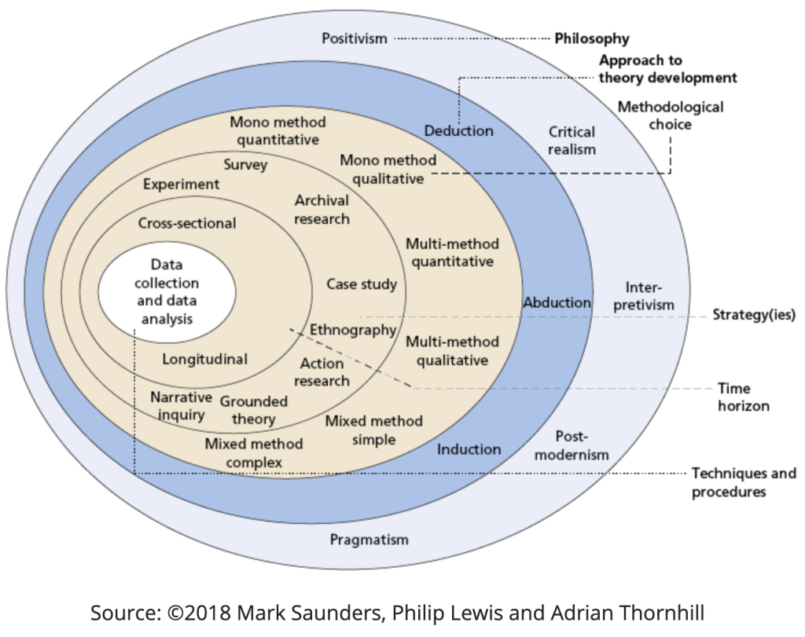

3.2 Research Philosophy
Pragmaticism has been followed as a research philosophy in this research work. The pragmatic study concentrates on the individual decision-maker in the actual real-world condition. The procedure to undertake the pragmatic study is at first to recognise the concern and view it within the broad scenario (Demirguc-Kunt et al., 2021). This leads to the research inquiry, which looks to form a better understanding and ultimately resolves the issue.
By applying the pragmatic research approach, strategic combination, and borrowing from forming the qualitative research approach to fulfil the needs of the given research study, it often includes the instructions provided from the IS structure and has clear research and practice change goals (Ihuah et al., 2013). It is rational to say that Pragmatism permits the potential and likelihood to work back and forth between quantitative and qualitative research data. It is often seen as incompatible. It provides research scholars the chance to search for useful points of connection between quantitative and qualitative data used in the research studies.

3.3 Research Design
A qualitative research study has been applied in this research work. Concise use of qualitative analysis in conjunction with the literature analysis would assist the capability of research scholars to fulfil the research requirements. Furthermore, the qualitative research methodology has been helping the research scholars to justify relevant concerns aims, and objectives of the proposed research study (Donaghy et al., 2019). Qualitative research is developed in the social sciences to enable the research scholars to examine social and cultural phenomena. The illustrations of qualitative methods are action research, use of case studies, and ethnography. It is rational to say that the qualitative research will also contain the data collected from the past research studies literature review or often the researcher conducts interviews to collect the data to be used in the research work.
Qualitative Research is the research method that concentrates on gathering the data through open-ended and conversational communication. The qualitative research study is a situated activity that locates the observer in the globe. It comprises a set of interpretive, and material practices which form the globe visible (Fattore et al., 2019). All these kind of practices changes and modifies the world. They also change the globe in a sequence of representation which also includes field notes, conversations, interviews, and memos. At this phase, qualitative research includes the interpretive and naturalistic approach to the globe. It means that the qualitative researchers study things in their natural situations, all these try to make sense or provide the interpretation and phenomenon in sense of people to carry to the research scholars. It can be said that the qualitative research work has been applied in this research work, it is because it saves time and help us to provide the research findings within short time. Likewise, the quantitative research study is the procedure of collection and analysis of numerical data. The quantitative research involves testing the causal relationship, and furnish the research findings in light of statistical analysis. Quantitative Analysis has not been adopted in this research work because by adopting the quantitative analysis it would be complicated for the researchers to set up the research model as a research framework followed in this research work.

3.4 Research Approach
The inductive research approach has been applied in this research study. Inductive research engages for patterns from observations and the formation of descriptions, and explanation of theories in detail in scenarios of the current research theme (Woiceshyn and Daellenbach, 2018). Inductive Research permits the flexibility to research scholars, attends closely to the contexts, and supports the formation of new theory.
It is rational to say that inductive research works the other way, it moves from specific observations to wider generalisations and the use of theories. Researchers often call this a bottom-up approach. It can be said that the inductive reasoning, research scholars across the globe commence with particular observations and measures, begin to detect the patterns and all the regulations, and formulate some (Bucher, 2021). It is a method used in academic research globally in which the body of observations is created with the general norms followed in the academic research work globally. Inductive Reasoning is different from deductive reasoning. Inductive Reasoning occurs when the conclusion of the research study does not observe essentially from the accessible data. The key difference between deductive and inductive reasoning is that the inductive reasoning wish to form a theory however, the deductive reasoning wish in testing the existing theory. Inductive research approach has been applied in this research study because it helps the researchers to fuels further exploration. It fuels more exploration to test provided that if the judgment or the possible inference is accurate or wrong. Due to these reasons Inductive Research Approach has been applied in this research study.

3.5 Data Collection
Secondary data has been used in this research study. The data has been collected from the research studies published in authentic research journals in the recent past few years. Secondary data. The study uses a substantial literature review to offer a comprehensive picture related to the macroeconomic conditions of banks located across the United Kingdom during COVID-19. Various research studies conducted in the recent past few years would form a considerable element of use of secondary sources which help the definite research objective. One of the key benefits of using secondary data in academic research is that it will save the financial resources of the researchers and they will be able to fetch the required data and conduct the detailed data analysis within short deadlines.
The content research study has been saving time and making it easy for the research scholars to furnish the research findings within a short time. It is rational to say that the ProQuest Dissertation platforms and other research sources are operated to fetch the research studies published in the research journals, peer-reviewed journals, and researchers to add considerable value to furnish the research findings and detailed analysis of the research studies. Therefore, it is rational to say that the secondary data has been used in this research study to conduct the detailed content analysis and to furnish the research findings based on the research analysis.

3.6 Data analysis
To analyse the data used in this research study content analysis has been used in this research work. A content analysis is an argumentative analysis of a literary work. Despite it, a literary analysis also explains the explanations of writers of a text via conducting the detailed analysis of choices adopted by the research scholars in the given scenario. Themes, Motifs, and various other literary instruments have been used in this research study.
In content analysis researchers across the world uses the information gathered from the various published academic journals in the recent past few years. In this kind of data analysis research scholars provides the research findings based on the findings of the research studies conducted in the recent past few years (Li et al., 2021). Data analysis through the literature analysis offers the foundation information on a given topic. It also helps the researchers to recognise the regions of the scholarship to offer credit to other research scholars.

3.7 Time Horizon
A cross sectional research study has been carried out in this research work. A Cross Sectional study is explained as the kind of observational research which examine the data of the variables gathered at a time across various population (Salyer et al., 2021). One of the main benefits of adopting the cross-sectional research study is that the cross-sectional study does not include any cost to incur. However, it also saves time by adopting the cross-sectional study we can examine the impact of multiple variable in contexts of our research study.
Time Horizon explains the time frame for the research. The cross-Sectional or short-term study, which also includes the data collection at a specific point of time, longitudinal study- which includes the data collection repeatedly over the long-time frame to compare the data (Goshua et al., 2020). In this research study, the data has been being collected in the events after COVID-19 related to the financial performance of the finance sector across the United Kingdom. It has been helping the researcher to permits a high level of validity, to make the study successful there should be some rules and regulations in the place in the starting which dictate the way which research scholars should follow in the research study.

3.8 Target Population
The target population of this research study has been conducted on banks located across the United Kingdom. So, it can be said that data related to the performance of banks during COVD-19 has been collected to conduct this research study.
Target Population is the group of individuals, either that group contains a nation or a particular group of people having the same attributes. In statistics, Population is a pool of various individuals from which the statistical sample is drawn from a specific research study. Therefore, based on all the above discussions, it can be said that Commercial Banks working across the United Kingdom are the target population of this research study.

3.9 Inclusion Criteria
Inclusion Criteria are the attributes that the prospective concerns should have provided if they are to be incorporated in the particular research study or the main attributes of the target population that the research scholars shall utilise to respond to their research questions for particular research work (Otani et al., 2020). In this research work, data from 2016 and onwards on the United Kingdom banking industry has been used in this research study. After COVID-19, data has been used in this research study to examine the impact of COVID-19's actual performance in the finance sector in the United Kingdom. Therefore, in the inclusion criteria, the data after COVID-19 shows the impact of COVID-19 on the financial performance of the banking sector across the United Kingdom has been used in this research study. The aim to do so is to check the impact of COVID-19 on the actual performance in the finance sector across the United Kingdom.

3.10 Ethical Consideration
This research work has been conducted after applying all the ethical considerations in this research work. Data used in this research work is genuine and does not contain any kind of data tampering or data manipulation. Furthermore, all the researchers have been provided full credit for this research work. To do so, we cite all the authentic references in this research work. Furthermore, all kinds of other ethical considerations such as the use of genuine content in this research study. All these will increase the credibility of our research study and will also help us to provide the research findings in light of authentic and reliable data. As a part of ethical consideration, an ethical approval form was also filled out and sent for approval to ensure that the current research abides by all the important ethical requirements.

Chapter 4: Results and Discussion

4.1 COVID-19 and Finance
The pandemic has been identified as one of the worst crises in modern times and various researches have been conducted regarding the pandemic as it has negatively influenced the world economy and financial sector especially including stock markets and banks. The value of currencies around the world has decreased as compared with the US$ including the pound as it also decreased from 1.00 to 0.82 from 1 January to 9 April 2020 (Wójcik and Loannou, 2020). Also, see the following figure 5. Besides, Tahat and Ahmed, (2020) identified that the pandemic has been negatively linked with the financial sector and especially stock market returns (SMRs). The research has found that there are two conditions in which investors either exit or hang on in the market as it creates uncertainty and financial loss as well. Also, see the following figure 6.
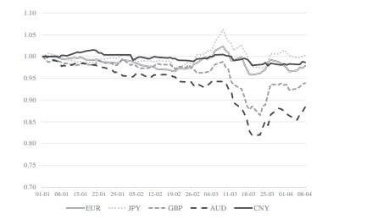
Figure 5: (Source: Wójcik and Loannou, 2020)
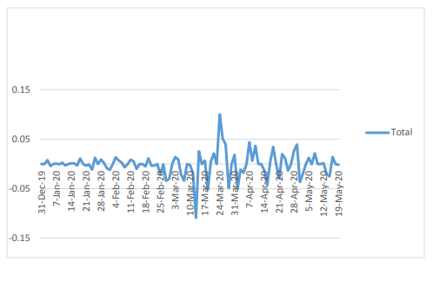
Figure 6: Daily Market Returns (Source: Tahat and Ahmed, 2020)
Furthermore, the pandemic has become an overwhelmingly dominant source regarding uncertainty in the UK in less than a month and the region did not see high growth in their financial activities and SMRs (Altig et al., 2020). Also, see the following figure 7. Similarly, Griffith et al., (2020) highlighted that the pandemic has been negative in such a manner that the price index remained somewhat manageable and maintained in the first few days of the crisis but soon as the lockdown and social distancing started it faced a sharp decline in the UK. The decline in financial aspects has been seen in almost every firm included in the FTSE index of London that also includes various financial institutions that also included banks as well. Hence, it represents that the stock market and its listed companies have also been adversely influenced by the pandemic as it has reduced their financial aspects.
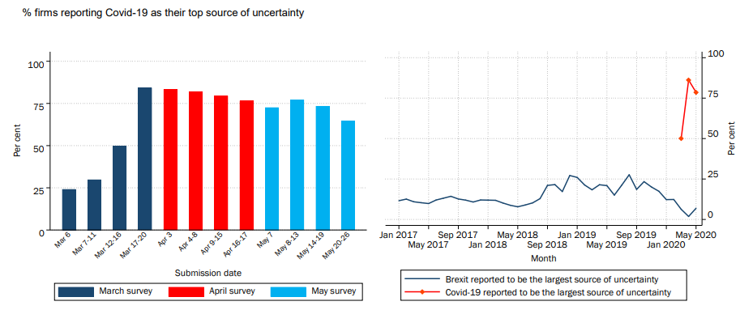
Figure 7: (Source: Altig et al., 2020)

4.2 Influence of COVID-19 on Banks in the UK
The pandemic has influenced various financial centres including banks as customers and businesses were facing severe challenges and were on the brink of being dissolved but the central bank of England has helped the businesses by lowering the interest rates, giving sustainable credits to other banks, businesses, and individuals (Ozili and Arun, 2020). This indicates that the UK significantly focused on having an appropriate balance between interest rates and debts during COVID-19 which helped in understanding the role of the central bank. Besides, The UK’s economic conditions have been identified as continuously uncertain as despite the Central Bank’s positive role the UK and its people have been uncertain regarding the help in getting loans and their increasing debt (Bryce et al., 2020). For instance, the Bank of England, (2021) highlighted that people were asked in a survey regarding the role of the UK financial sector and banks towards helping in mortgages and business loans in 2021 and the answers were more towards being unsure and uncertain regarding the help. Also, see the following figure 8.
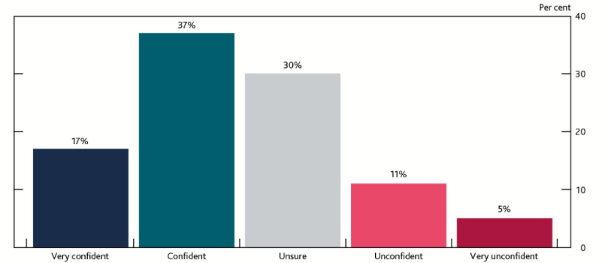
Figure 8: (Source: (Bank of England, 2021)
Additionally, Norrestad, (2022) identified that the market capitalisation of the largest banks has declined in the initial stages of pandemic around Europe. For instance, HSBC holdings in the UK have seen a rapid decline from December 2019 comprising almost $161.5 billion to September 2020 comprising almost $79.8 billion. Also, Lloyds Banking Group has seen similar adverse influence as from December 2019 comprising almost $58 billion to September 2020 comprising of almost $23 billion. These statistics have identified that the COVID-19 pandemic has been very harsh on these banking giants in the UK and it also represents a lack of flexibility and stability in the financial sector as their capitalisation almost declined by half during the almost ten-months-time period. Also, see the following figure 9.
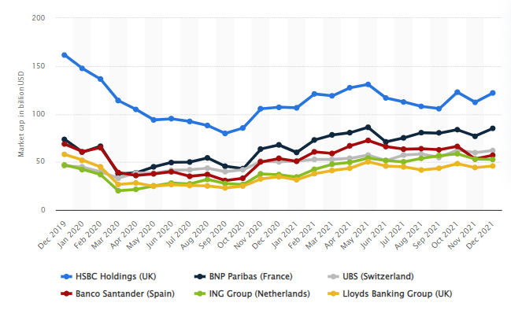
Figure 9: Monthly Market Capitalisation (Source: Norrestad, 2022)

4.3 Interest Rates and Debts during COVID-19 in the UK
The pandemic has the largest influence on UK public finances during 2020-21 as the budget shows a record deficit and it increases the public sector net debt to £2,205 billion comprises of 104.1% of the total GDP (Heald, 2020). Also, Government receipts have decreased by 12% and increased expenditure has been seen by 36% within only first three months of the pandemic as compared with the previous year and it eventually increased Government debt towards £1,984 billion comprising 99.6% of the GDP and it is highest since March 1961 (Heald, 2020; ONS, 2020). This represents that the initiation policy of the UK’s Central Bank towards easing the interest rates and giving stimulus to the businesses and individuals might be the major reason behind the negative relationship between interest rates and debts during COVID-19. Besides, the UK has seen a major pandemic crisis as their debt raised debt service cost as it has been increased by almost 100% in percent of GDP (Odendahl and Springford, 2020). Also, see the following figure 10.
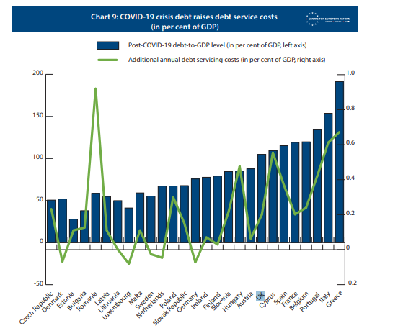
Figure 10: (Source: Odendahl and Springford, 2020)
Moreover, the UK financial sector includes banks that have been providing guaranteed loans as the UK’s Government has ensured such a process and covered one-year coverage regarding the lenders’ charges regarding guaranteed loans. Also, this process might increase the opportunistic behaviour of the borrowers and this total guarantee by the Government can help banks in distributing/giving cash/loans without any worry regarding the creditworthiness of the borrower. Also, there has been a concern that these guarantees might create new creditors and it can lead towards both either good times and bad times that can eventually lead towards complicated restructuring during and after the pandemic (Balloch et al., 2020). Hence, it represents that decreasing the interest rates has been both effective and ineffective as it has helped some in managing their capitalisation but also increased the debts of the financial sector in the UK.

4.4 COVID-19 and Financial Policies of UK
The UK has adopted some useful policies towards dealing with the adverse financial conditions as it can help the region in mitigating the financial degradation in the region and help significantly improve the role of banks as well (Susskind, 2020). This process shows that the UK has helped the people in significantly managing their capitalisation and improved both individual and business aspects as well. Besides, Brown et al., (2020) have highlighted that new equity transactions have been negatively influenced by the pandemic as it has declined in the UK, and finance has been identified as highly influenced by the pandemic. The entrepreneurial or start-ups faced high obstacles during gaining finances for their businesses. The research has also identified that banks do not effectively support such businesses due to a lack of policies and regulations regarding the security and safety of the loan. So, it represents that the UK has faced some difficulties in surviving the pandemic as it creates obstacles in ensuring financial progress.
Furthermore, Shearer and Tetlow, (2021) identified that despite these challenges that businesses have faced the Bank of England has played the biggest significant role in ensuring financial flexibility and stable functioning of other local banks in the UK. For example, the central bank has helped in ensuring a successful market of UK Government bonds and its continuous functioning as well. Also, the bank ensures that businesses and individuals who have struggled towards paying their debts were given ‘repayment holidays’. The bank also gave corporate financing facilities during the pandemic by supporting large non-financial businesses through unsecured short-term corporate debt and also eased global dollar liquidity by easily borrowing in dollars. This process has significantly helped the UK in ensuring proper dollar supply within the funding markets outside the US. Hence, it can be inferred that banks in the UK have significantly developed such policies that can help businesses and individuals in conducting effective businesses and other aspects. At last, the results and discussions have helped in understanding the flexibility and stability in the financial sector of the UK along with the influence of the COVID-19 pandemic on the performance of banks and linkage between interest rates and debt in the UK.

Chapter 5: Conclusion and Recommendations

5.1 Conclusion
COVID-19 Pandemic has been highly adverse and formed various crises in different sectors around the globe as it could be known as the key crises after 2007-2009. The pandemic has scattered across the world at a fast pace and has formed adverse economic crises and has distributed the stocks market of the country and formed uncertainty in the financial sector. For example, the recent volatility in the stocks market has been recognised as increasing crashes in the stocks market that occurred in October 1987, and December 2008 and 2009. Likewise, Europe has been recognised as one of the worst affected continents as more than one million individuals got affected. It had formed severe restrictions and financial-economic crunch across the United Kingdom. For instance, the United Kingdom has been severely rising in pandemic and also imposed lockdowns. It has caused considerable and huge financial losses due to which the businesses have borrowed money from the financial institutions in the United Kingdom. Therefore, it shows that COVID-19 has been having severely affected due to COVID-19 in its initial phase.
After considering the possible effects of the COVID-19 pandemic on the actual performance of the finance sector across the United Kingdom it is rational to say that, the low-interest rate scenario, along with the significant effects of COVID-19, is declining the core banking profitability in the mature markets. It is rational to say that Financial Markets shifts towards the commission-based income generated from likes payments and tech businesses. One of the main and considerable impacts of health emergencies imposed on the economic conditions of the United Kingdom is the increase in the magnitude of the credit risk of corporate and retail customers of banks. To continue financing in the real economy and supports its recovery, commercial banks are called to differentiate between purely temporary singularity, which is developed to be reabsorbed in a short time, and long-lasting effects that would need the actions of management and recategorization.
The primary aspects that need to be considered are the forward-looking information update. Particularly how the new data should be included in risk parameters that are required to be carefully examined and offered the particular nature of COVID-19. It can be said that this might remain for less time as compared to the cyclical economic recessions persuaded by the financial system of the country.
The surge in the COVID-19 cases seen in December 2021, has been caused by the spread of the Omicron variant of coronavirus, it has led to the government of the United Kingdom and it also decentralised the management to introduced the limitations to restrict the transmission of the virus. The economic effects of all such measures that required to keep in consideration alongside some elements such as modifications to the trust of consumers and the consumer behaviour, as well as the effects that are connected to increase the number of individuals having to self-isolated by themselves.

5.1.1 How objectives have been achieved
The Flexibility of the local banking sector across the United Kingdom during and after COVID-19 can be evaluated and could be improved by publicly publishing the eligible credit assessments. All these kinds of flexibility can be included in the framework by including useful information. The banks across the United Kingdom can evaluate the flexibility of the local banking sector in the United Kingdom by conducting a detailed liquidity analysis of the client portfolio. This is how the flexibility of the local banking sector in the United Kingdom can be evaluated across the country.
The effects of COVID-19 on the state of the economy and financial condition of firm changes and is stronger in scenario of country and region with the structure of revenue-focused on tourism and services. All these are directly provided to the clients, micro, small, and medium-sized firms owned and operated by a minority. The decline in the scale of COVID-19 and the increase in the economic activities do not mean that the risk of some extra-ordinary losses on the non-performing loans shall disappear. The increase in Non-Performing Loans might arrive from an increase in illness and the limitations applied to the economic activity that occurred across the United Kingdom. After analysing the whole context, it is rational to say that during COVID-19 the interest rates in the United Kingdom increased due to it the debt level in the United Kingdom declined. It is a favourable condition for banks across the United Kingdom.

5.2 Research Contribution
In this research work the key areas that are affected the most in the banking sector across the United Kingdom during a pandemic. This research study will be helpful for academic purposes. Through this research work, the knowledge development of research scholars also occurred. This research work has also included a detailed literature review and content analysis based on the stocks market and commercial banks data. It enhances the credibility of the research work which is a positive sign for this research study.

5.3 Recommendation

5.3.1 Recommendation for Practice
It is recommended that during such circumstances it is essential that the commercial banks should develop effective risk management strategies. It is the accountability of the portfolio managers working in the commercial banks that they should plan the effective strategies it will help the Commercial Banks to mitigate the risk and enhance the financial performance of financial institutions during pandemic conditions. Furthermore, it is also recommended that the commercial banks also conduct the liquidity analysis of the assets invested by the investors. It will also help the commercial banks across the United Kingdom to get control over the risk during pandemic-like difficult situations and will also help the banks to improve their financial performance. These are some recommended strategies that will help the banks across the United Kingdom to mitigate the adverse impact of COVID-19 on the performance.
It is recommended that professional bankers across the UK should recognise the rising use of Machine Learning and Data Science. It will carry various benefits to the financial institutions, consumers, and financial system. It is recommended that researchers should also consider the associated risks and challenges and ways that will help the banks in the UK to get control over all the bank-related risks. Banks and other financial services firms have already highlighted that risk management and governance frameworks will have to evolve in line with the increasing maturity and sophistication of ML techniques. As our previous work and the first AIPPF meeting highlight, banks and other firms are aware of a widening gap between innovation and governance, and between the demand for data science skills and their supply. These gaps may persist in the near term as the pace of adoption increases.

5.3.2 Contribution to Theory
This research work is based on the Signalling Theory, Real Options Theory, and Truman Theory. This research work gives a new perspective to these theories and contributes a lot to fill out the loopholes that exist in all these theories. Previously research scholars do not consider the COVID type conditions on the Signalling Theory, Real Options Theory, and Truman Theory. So, this research work applies the practical information of the impact of COVID-19 on banking performance after applying the notions discussed in these research theories. In short, it can be said that this research work contains detailed explanations on the application of Signalling Theory, Real Options Theory, and Truman Theory on the proposed research topic.

5.4 Limitations of the study leading to further research work
It is rational to say that future studies might also explore the impact of COVID-19 indicators on the other banking indices and the performance of banks across the UK. It is rational to say that future research work could utilise more economic variables and the use of various banking-related variables to form the early warning mechanism for banks working in the UK. Moreover, further research work might also apply a more specific neural network structure.

References
Abbas, F., Yousaf, I., Ali, S. and Wong, W.K., 2021. Bank Capital Buffer and Economic Growth: New Insights from the US Banking Sector. Journal of Risk and Financial Management, 14(4), p.142.
Akhtaruzzaman, M., Boubaker, S. and Sensoy, A., 2021. Financial contagion during COVID–19 crisis. Finance Research Letters, 38, p.101604.
Altig, D., Baker, S., Barrero, J.M., Bloom, N., Bunn, P., Chen, S., Davis, S.J., Leather, J., Meyer, B., Mihaylov, E. and Mizen, P., 2020. Economic uncertainty before and during the COVID-19 pandemic. Journal of Public Economics, 191, p.104274.
Antwi, S.H., Getty, D., Linnane, S. and Rolston, A., 2021. COVID-19 water sector responses in Europe: A scoping review of preliminary governmental interventions. Science of The Total Environment, 762, p.143068.
Assous, H.F. and Al-Najjar, D., 2021. Consequences of COVID-19 on Banking Sector Index: Artificial Neural Network Model. International Journal of Financial Studies, 9(4), p.67.
Balloch, C., Djankov, S., Gonzalez-Uribe, J. and Vayanos, D., 2020. A restart procedure to deal with covid-19. Covid-19 in Developing Economies. CEPR E-Book.
Bank of England, 2021. Our response to coronavirus (Covid). [online] Bankofengland.co.uk. Available at: <https://www.bankofengland.co.uk/coronavirus> [Accessed 31 January 2022].
Bank of England, 2021. The UK economy during Covid-19: insights from the Bank of England's Citizens' Panels. [online] Bankofengland.co.uk. Available at: <https://www.bankofengland.co.uk/get-involved/citizens-panels/the-uk-economy-during-covid-19-insights-from-the-bank-of-englands-citizens-panels> [Accessed 31 January 2022].
BBC, 2021. Covid: Shares hit as new variant rattles investors. [online] BBC News. Available at: <https://www.bbc.com/news/business-59428927> [Accessed 31 January 2022].
Bora, D. and Basistha, D., 2021. The outbreak of COVID‐19 pandemic and its impact on stock market volatility: Evidence from a worst‐affected economy. Journal of Public Affairs, p.e2623.
Brown, R., Rocha, A. and Cowling, M., 2020. <? covid19?> Financing entrepreneurship in times of crisis: Exploring the impact of COVID-19 on the market for entrepreneurial finance in the United Kingdom. International Small Business Journal, 38(5), pp.380-390.
Bryce, C., Ring, P., Ashby, S. and Wardman, J.K., 2020. Resilience in the face of uncertainty: early lessons from the COVID-19 pandemic. Journal of Risk Research, 23(7-8), pp.880-887.
Bucher, J., 2021. Inductive Reasoning. The Encyclopedia of Research Methods in Criminology and Criminal Justice, 1, pp.200-204.
Connelly, B.L., Certo, S.T., Ireland, R.D. and Reutzel, C.R., 2011. Signaling theory: A review and assessment. Journal of management, 37(1), pp.39-67.
Consultancy.uk. 2022. How Covid-19 is changing the operations of UK banks. [online] Available at: <https://www.consultancy.uk/news/25772/how-covid-19-is-changing-the-operations-of-uk-banks> [Accessed 31 January 2022].
Demirgüç-Kunt, A., Pedraza, A. and Ruiz-Ortega, C., 2021. Banking sector performance during the covid-19 crisis. Journal of Banking & Finance, 133, p.106305.
Donaghy, E., Atherton, H., Hammersley, V., McNeilly, H., Bikker, A., Robbins, L., Campbell, J. and McKinstry, B., 2019. Acceptability, benefits, and challenges of video consulting: a qualitative study in primary care. British Journal of General Practice, 69(686), pp.e586-e594.
Elmarzouky, M., Albitar, K. and Hussainey, K., 2021. Covid-19 and performance disclosure: does governance matter?. International Journal of Accounting & Information Management.
Estrada, M.A.R., Koutronas, E. and Lee, M., 2020. Stagpression: The economic and financial impact of Covid-19 Pandemic. SSRN Electronic Journal· January.
Fattore, T., Fegter, S. and Hunner-Kreisel, C., 2019. Children’s understandings of well-being in global and local contexts: Theoretical and methodological considerations for a multinational qualitative study. Child Indicators Research, 12(2), pp.385-407.
Gandjour, A., 2020. The clinical and economic value of a successful shutdown during the SARS-CoV-2 pandemic in Germany. The Quarterly Review of Economics and Finance.
Garside, J., 2020. Europe’s economic rescue packages worth combined€ 1.7 tn. The Guardian.
Giese, J. and Haldane, A., 2020. COVID-19 and the financial system: a tale of two crises. Oxford Review of Economic Policy, 36(Supplement_1), pp.S200-S214.
Goshua, G., Pine, A.B., Meizlish, M.L., Chang, C.H., Zhang, H., Bahel, P., Baluha, A., Bar, N., Bona, R.D., Burns, A.J. and Cruz, C.S.D., 2020. Endotheliopathy in COVID-19-associated coagulopathy: evidence from a single-centre, cross-sectional study. The Lancet Haematology, 7(8), pp.e575-e582
Griffith, R., Levell, P. and Stroud, R., 2020. The Impact of COVID‐19 on Share Prices in the UK. Fiscal Studies, 41(2), pp.363-369.
Heald, D. and Hodges, R., 2020. The accounting, budgeting and fiscal impact of COVID-19 on the United Kingdom. Journal of Public Budgeting, Accounting & Financial Management.
Ibn-Mohammed, T., Mustapha, K.B., Godsell, J., Adamu, Z., Babatunde, K.A., Akintade, D.D., Acquaye, A., Fujii, H., Ndiaye, M.M., Yamoah, F.A. and Koh, S.C.L., 2021. A critical analysis of the impacts of COVID-19 on the global economy and ecosystems and opportunities for circular economy strategies. Resources, Conservation and Recycling, 164, p.105169.
Ihuah, P.W. and Eaton, D., 2013. The pragmatic research approach: A framework for sustainable management of public housing estates in Nigeria. Journal of US-China Public Administration, 10(10), pp.933-944
Inman, P., 2021. Global markets fall amid pessimism over soaring Covid-19 cases. [online] the Guardian. Available at: <https://www.theguardian.com/business/2021/jul/19/global-markets-fall-amid-pessimism-over-soaring-covid-19-cases> [Accessed 31 January 2022].
Iqbal, S., Bilal, A.R., Nurunnabi, M., Iqbal, W., Alfakhri, Y. and Iqbal, N., 2021. It is time to control the worst: testing COVID-19 outbreak, energy consumption and CO 2 emission. Environmental Science and Pollution Research, 28(15), pp.19008-19020.
Islam, F., 2020. Coronavirus: Chancellor Unveils£ 350bn Lifeline for Economy. BBC News online, 17.
Jallow, H., Renukappa, S. and Suresh, S., 2020. The impact of COVID-19 outbreak on United Kingdom infrastructure sector. Smart and Sustainable Built Environment.\
Lanshina, T.A., Barinova, V.A., Kondratyev, A.D. and Romantsov, M.V., 2020. Sustainable development and digitalization: the unusual COVID-19 crisis requires original solutions. Bulletin of International Organizations, 15(4), pp.91-114.
Li, Y., Tok, A. and Ritchie, S.G., 2021. Deep Ensemble Neural Network Approach for Federal Highway Administration Axle-Based Vehicle Classification Using Advanced Single Inductive Loops. Transportation Research Record, p.03611981211049142.
Nicola, M., Alsafi, Z., Sohrabi, C., Kerwan, A., Al-Jabir, A., Iosifidis, C., Agha, M. and Agha, R., 2020. The socio-economic implications of the coronavirus pandemic (COVID-19): A review. International journal of surgery, 78, pp.185-193.
Norrestad, F., 2021. Lending to key industries UK 2020 | Statista. [online] Statista. Available at: <https://www.statista.com/statistics/1117100/headline-flow-in-lending-to-businesses-in-the-united-kingdom-by-key-sector/> [Accessed 31 January 2022].
Norrestad, F., 2021. Topic: Quantitative easing in the UK. [online] Statista. Available at: <https://www.statista.com/topics/6372/quantitative-easing-in-the-uk/> [Accessed 31 January 2022].
Norrestad, F., 2022. Largest European banks by market cap since COVID-19 | Statista. [online] Statista. Available at: <https://www.statista.com/statistics/1102735/market-capital-of-leading-european-banks-since-the-coronavirus-outbreak/> [Accessed 31 January 2022].
Odendahl, C. and Springford, J., 2020. Three ways COVID-19 will cause economic divergence in Europe. CER Policy Paper, (2020).
OECD, 2020. The impact of the coronavirus (COVID-19) crisis on development finance.
ONS, 2020. Public sector finances, UK Statistical bulletins - Office for National Statistics. [online] Ons.gov.uk. Available at: <https://www.ons.gov.uk/economy/governmentpublicsectorandtaxes/publicsectorfinance/bulletins/publicsectorfinances/previousReleases> [Accessed 31 January 2022].
ONS, 2021. Coronavirus and the impact on output in the UK economy - Office for National Statistics. [online] Ons.gov.uk. Available at: <https://www.ons.gov.uk/economy/grossdomesticproductgdp/articles/coronavirusandtheimpactonoutputintheukeconomy/december2020> [Accessed 31 January 2022].
Otani, T., Sawano, H. and Hayashi, Y., 2020. Optimal extracorporeal cardiopulmonary resuscitation inclusion criteria for favorable neurological outcomes: a single‐center retrospective analysis. Acute medicine & surgery, 7(1), p.e447.
Ozili, P.K. and Arun, T., 2020. Spillover of COVID-19: impact on the Global Economy. Available at SSRN 3562570.
Ozkan, O., 2021. Impact of COVID-19 on Stock Market Efficiency: Evidence from Developed Countries. Research in International Business and Finance, p.101445.
Page, M.E., 2010. Signaling in the labor market. Economics of education. Oxford: Elsevier.
Pellegrino, R., Vajdic, N. and Carbonara, N., 2013. Real option theory for risk mitigation in transport PPPs. Built environment project and asset management.
Pillai, S., Siddika, N., Apu, E.H. and Kabir, R., 2020. COVID-19: Situation of European countries so far. Archives of medical research, 51(7), p.723.
Shafi, M., Liu, J. and Ren, W., 2020. Impact of COVID-19 pandemic on micro, small, and medium-sized Enterprises operating in Pakistan. Research in Globalization, 2, p.100018.
Shearer, E. and Tetlow, G., 2021. Coronavirus: actions taken by the Bank of England during the first lockdown. [online] The Institute for Government. Available at: <https://www.instituteforgovernment.org.uk/explainers/coronavirus-bank-england-first-lockdown> [Accessed 31 January 2022].
Shen, H., Fu, M., Pan, H., Yu, Z. and Chen, Y., 2020. The impact of the COVID-19 pandemic on firm performance. Emerging Markets Finance and Trade, 56(10), pp.2213-2230.
Agca, S., Birge, J.R., Wang, Z.A. and Wu, J., 2020. The impact of COVID-19 on supply chain credit risk. Available at SSRN 3639735.
Sherif, M., 2020. The impact of Coronavirus (COVID-19) outbreak on faith-based investments: An original analysis. Journal of Behavioral and Experimental Finance, 28, p.100403.
Siddiqui, K., 2020. The Impact of COVID-19 on the Global economy. World.
Singh, B., Dhall, R., Narang, S. and Rawat, S., 2020. The outbreak of COVID-19 and stock market responses: An event study and panel data analysis for G-20 countries. Global Business Review, p.0972150920957274.
Susskind, D. and Vines, D., 2020. The economics of the COVID-19 pandemic: an assessment. Oxford Review of Economic Policy, 36(Supplement_1), pp.S1-S13.
Tahat, Y. and Ahmed, A.H., 2020. Stock Market Returns, liquidity and COVID-19 Outbreak: Evidence from the UK. Date of access, pp.12-08.
The Guardian. 2022. Europe's economic rescue packages worth combined €1.7tn. [online] Available at: <https://www.theguardian.com/world/2020/mar/19/europes-economic-rescue-packages-worth-combined-17tn> [Accessed 31 January 2022].
Trueman, B., 1986. Why do managers voluntarily release earnings forecasts?. Journal of accounting and economics, 8(1), pp.53-71.
UK Finance, 2021. Business Finance Review. 1st ed. [ebook] Available at: <https://www.ukfinance.org.uk/sites/default/files/uploads/Business-Finance-Review-2021-Q3-FINAL.pdf> [Accessed 31 January 2022].
Walker, A., 2022. Coronavirus: UK economy could be among worst hit of leading nations, says OECD. [online] BBC News. Available at: <https://www.bbc.com/news/business-52991913> [Accessed 31 January 2022].
Woiceshyn, J. and Daellenbach, U., 2018. Evaluating inductive vs deductive research in management studies: Implications for authors, editors, and reviewers. Qualitative Research in Organizations and Management: An International Journal.
Wójcik, D. and Ioannou, S., 2020. COVID‐19 and finance: market developments so far and potential impacts on the financial sector and centres. Tijdschrift voor economische en sociale geografie, 111(3), pp.387-400.
Lindström, M. and Giordano, G.N., 2016. The 2008 financial crisis: Changes in social capital and its association with psychological wellbeing in the United Kingdom–A panel study. Social Science & Medicine, 153, pp.71-80.
Salyer, S.J., Maeda, J., Sembuche, S., Kebede, Y., Tshangela, A., Moussif, M., Ihekweazu, C., Mayet, N., Abate, E., Ouma, A.O. and Nkengasong, J., 2021. The first and second waves of the COVID-19 pandemic in Africa: a cross-sectional study. The Lancet, 397(10281), pp.1265-1275.

Appendix- Ethical Form

APPLICATION FOR ETHICAL APPROVAL

In order for research to result in benefit and minimise risk of harm, it must be conducted ethically. A researcher may not be covered by the University’s insurance if ethical approval has not been obtained prior to commencement.

The University follows the OECD Frascati manual definition of research activity: “creative work undertaken on a systematic basis in order to increase the stock of knowledge, including knowledge of man, culture and society, and the use of this stock of knowledge to devise new applications”. As such this covers activities undertaken by members of staff, postgraduate research students, and both taught postgraduate and undergraduate students working on dissertations/projects.

The individual undertaking the research activity is known as the “principal researcher”.

Ethical approval is not required for routine audits, performance reviews, quality assurance studies, testing within normal educational requirements, and literary or artistic criticism.

Please read the notes for guidance before completing ALL sections of the form.

This form must be completed and approved prior to undertaking any research activity. Please see Checklist for details of process for different categories of application.

SECTION A: About You (Principal Researcher)
1 | Full Name: |  | Kamila Edyta Pausz
2 | Tick all boxes that apply: |  | Member of staff: | ☐ | Honorary research fellow: | ☐
 | Undergraduate Student | ☒ | Taught Postgraduate Student | ☐ | Postgraduate Research Student | ☐

3 | Institute/Academic Discipline/Centre: | Business school
4 | Campus: | Business Campus Swansea
5 | E-mail address: | 1909921@uwtsd.ac.uk
6 | Contact Telephone Number: | 07427232676
 | For students:
7 | Student Number: | 1909921
8 | Programme of Study: | BA Business Management (Finance)
9 | Director of Studies/Supervisor: | Rachel Cook/ Gareth Hughes

SECTION B: Approval for Research Activity
1 | Has the research activity received approval in principle?  (please check the Guidance Notes as to the appropriate approval process for different levels of research by different categories of individual) |  | YES | ☐ | NO | ☒
 |  |  |  |  | Date
2 | If Yes, please indicate source of approval (and date where known): Approval in principle must be obtained from the relevant source prior to seeking ethical approval | Research Degrees Committee |  | ☐
2 |  | Institute Research Committee |  | ☐
2 |  | Other (write in) |  | ☐

SECTION C: Internal and External Ethical Guidance Materials
 | Please list the core ethical guidance documents that have been referred to during the completion of this form (including any discipline-specific codes of research ethics, location-specific codes of research ethics, and also any specific ethical guidance relating to the proposed methodology). Please tick to confirm that your research proposal adheres to these codes and guidelines. You may add rows to this table if needed.
1 | UWTSD Research Ethics & Integrity Code of Practice | ☒
2 | UWTSD Research Data Management Policy | ☒
3 | [List any other relevant documents here] | ☐

SECTION D: External Collaborative Research Activity
If there are external collaborators then you should gain consent from the contact persons to share their personal data with the university. If there are no external collaborators then leave this section blank and continue to section E.
1 | Institution
2 | Contact person name
3 | Contact person e-mail address
4 | Is your research externally funded? |  | YES | ☐ | NO |  | ☒
5 | Are you in receipt of a KESS scholarship? |  | YES | ☐ | NO |  | ☒
6 | Are you specifically employed to undertake this research in either a paid or voluntary capacity? | Voluntary | YES | ☐ | NO | ☒
7 |  | Employed | YES | ☐ | NO | ☒
8 | Is the research being undertaken within an existing UWTSD Athrofa Professional Learning Partnership (APLP)? | If YES then the permission question below does not need to be answered. | YES | ☐ | NO |  | ☒
9 | Has permission to undertake the research has been provided by the partner organisation? | (If YES attach copy)  If NO the application cannot continue | YES | ☐ | NO |  | ☒

Where research activity is carried out in collaboration with an external organisation
10 | Does this organisation have its own ethics approval system? | YES | ☐ | NO | ☒
 | If Yes, please attach a copy of any final approval (or interim approval) from the organisation (this may be a copy of an email if appropriate).

SECTION E: Details of Research Activity
1 | Indicative title: | The impact of COVID-19 on the actual performance in the finance sector in the UK
2 | Proposed start date: | 16/11/2021 | Proposed end date: | 11/01/2022
Introduction to the Research (maximum 300 words per section)
Ensure that you write for a Non-Specialist Audience when outlining your response to the points below:
- Purpose of Research Activity
- Proposed Research Question
- Aims of Research Activity
- Objectives of Research Activity
Demonstrate, briefly, how Existing Research has informed the proposed activity and explain
- What the research activity will add to the body of knowledge
- How it addresses an area of importance.
3 | Purpose of Research Activity  The impact of COVID-19 on the performance in the finance sector in the UK  (this box should expand as you type)
4 | Research Question  RQ1: What is the influence of COVID-19 on banking/financial sector of the UK?  RQ2: What is the role of financial policies during COVID-19 on banks in the UK?  RQ3: What is the role of interest rates and debts during COVID-19?  (this box should expand as you type)
5 | Aims of Research Activity  The research is expected to gain detailed experience of the current and future results of the monetary economy in terms of profitability and level of value. The review will focus on the continuing negative impact of the Covid pandemic on the UK financial sector. The use of written evidence and quantitative research will expand the accurate assessment of the resilience of the UK banking sector during financial emergencies.  (this box should expand as you type)
6 | Objectives of Research Activity  - To assess the banking/financial sector of the UK.  - To assess the financial policies and their influence during COVID-19 on banks in the UK.  - To assess the role of interest rates and debts during COVID-19.  The objective of the research is to provide the insights related to the future results that consists of the financial economy with the profitability and the equity level. The research has emphasized with the continuation of negative impacts of Covid through the banking sector of UK. However, the use of evidence-based literature has included the quantitative analysis that has been found with the proportion through an empirical assessment that has included the stability of banking sector in UK during the crisis.  (this box should expand as you type)
Proposed methods
The COVID-19 pandemic has triggered emergencies in the global economy following the 2007-2009 global emergencies. The ongoing pandemic was an important reason to stop and return to real demonstration and usefulness of the real and monetary areas in the UK, including banks. According to the International Monetary Fund (IMF), the volume of world GDP in 2020 may fall by 3.2 percent. In the UK, all types of economies are likely to be in recession, including emerging market economies (EDE) with 2%, developing economies (EM) with 2.1% and advanced economies (AE) with 4.6%. percent. In fact, according to various sources in national banks, periodic disruptions in the tourism industry and friendly business have been pushed into the UK currency area, mainly banks, reinforcing and inflexible frontal approach and affecting the financial sustainability of SME lending. professionals.
Proof that this information can be obtained can be found in the case of the Dow Jones Euro STOXX banks, which fell by a record 35% between February 28 and March 12, 2020. The negative impact of COVID-19 was perceived by most donors as frightening. As a result, the financial sector experienced a concentrated deterioration on the part of families and businesses, including other impacts such as reduced profitability and liquidity of companies, and reduced land. costs for the business layoffs, an increase in government liabilities and a decrease in bank loan fees. The influence of such factors increases during a pandemic along with an increase in the likelihood of an event. For each of the three risks, the largest credit risk was associated with transactions with banks, adjusted for market and functional risk.
7 | The dangers weighed on the performance of banks in developing countries, as institutional capitalization and household monetary assets were lower in developing countries than in AE, resulting in less fortunate pillars of safety in the event of unforeseen disasters. In addition, EM was more powerless against COVID-19 due to the lack of innovation and framework. The aftermath of the pandemic has negatively impacted the monetary situation in most organizations and families due to reduced opportunities for improving the structure of income. Subsequently, organizations and families were limited in fulfilling their obligations. However, mitigating the impact of the Covid pandemic did not help eliminate the danger that exacerbated the financial situation in the UK. Major countries across the planet, including Japan, Australia, Croatia, Spain and Greece, have been forced to rethink painstaking sterile rules to sabotage family monetary management and institutional income. According to a report by the Financial Stability Board (FSB), the danger in these countries was caused by the incomplete completion of government leadership programs.  (this box should expand as you type)
Location of research activity
Identify all locations where research activity will take place.
8 | The data has been gathered from the case studies and research journals.  (this box should expand as you type)
Research activity outside of the UK
If research activity will take place overseas, you are responsible for ensuring that local ethical considerations are complied with and that the relevant permissions are sought. Specify any local guidelines e.g. from local professional associations/learned societies/universities that exist and whether these involve any ethical stipulations beyond those usual in the UK provide details of any licenses or permissions required. Also specify whether there are any specific ethical issues raised by the local context in which the research activity is taking place, for example, particular cultural and/or legal sensitivities or vulnerabilities of participants. If you live in the country where you will do the research then please state this.
9 | As research would be carried with the help of secondary qualitative sources, therefore, there is no research activities that will be take place overseas. In addition, as research does not include any primary data collection techniques, therefore there is no issues of ethical issues with respect to the participants. However, considering secondary data source, it would be make sure to properly cite the work of the pervious.  (this box should expand as you type)

10 | Use of documentation not in the public domain: Are any documents NOT publicly available? | NO | ☒
10 |  | YES | ☐
11 | If Yes, please provide details here of how you will gain access to specific documentation that is not in the public domain and that this is in accordance with the current data protection law of the country in question and that of England and Wales.  No, there will be no use of documentation that are not available publicly, all secondary sources are publically available.  (this box should expand as you type)

 | Does your research relate to one or more of the seven aims of the Well-being of Future Generations (Wales) Act 2015? | YES | NO
12 | A prosperous Wales | ☐ | ☒
13 | A resilient Wales | ☐ | ☒
14 | A healthier Wales | ☒ | ☐
15 | A more equal Wales | ☐ | ☒
16 | A Wales of cohesive communities | ☐ | ☒
17 | A Wales of vibrant culture and thriving Welsh language | ☐ | ☒
18 | A globally responsible Wales | ☐ | ☒
19 | If YES to any of the above, please give details:
A healthier Wales has been related to the research as the research topic is related to the impact of COVID-19 on the actual performance in finance sector, which is related to the health and social care organisation as well as they help all sectors particularly in the Covid-19 crisis times to people find new ways of working together

(this box should expand as you type)

SECTION F: Scope of Research Activity
 | Will the research activity include: | YES | NO
1 | Use of a questionnaire or similar research instrument? | ☐ | ☒
2 | Use of interviews? | ☐ | ☒
3 | Use of focus groups? | ☐ | ☒
4 | Use of participant diaries? | ☐ | ☒
5 | Use of video or audio recording? | ☐ | ☒
6 | Use of computer-generated log files? | ☐ | ☒
7 | Participant observation with their knowledge? | ☐ | ☒
8 | Participant observation without their knowledge? | ☐ | ☒
9 | Access to personal or confidential information without the participants’ specific consent? | ☐ | ☒
10 | Administration of any questions, test stimuli, presentation that may be experienced as physically, mentally or emotionally harmful / offensive? | ☐ | ☒
11 | Performance of any acts which may cause embarrassment or affect self-esteem? | ☒ | ☐
12 | Investigation of participants involved in illegal activities? | ☒ | ☐
13 | Use of procedures that involve deception? | ☒ | ☐
14 | Administration of any substance, agent or placebo? | ☐ | ☒
15 | Working with live vertebrate animals? | ☐ | ☒
16 | Procedures that may have a negative impact on the environment? | ☒ | ☐
17 | Other primary data collection methods. Please indicate the type of data collection method(s) below. | ☐ | ☒
 | Details of any other primary data collection method:  The research will include secondary data collection method, therefore there will be no any primary data collection method involves in the study particularly due to access constricts to the primary data.  (this box should expand as you type) | ☐ | ☒
If NO to every question, then the research activity is (ethically) low risk and may be exempt from some of the following sections (please refer to Guidance Notes).

If YES to any question, then no research activity should be undertaken until full ethical approval has been obtained.

SECTION G: Intended Participants
If there are no participants then do not complete this section, but go directly to section H.

 | Who are the intended participants: | YES | NO
1 | Students or staff at the University? | ☐ | ☒
2 | Adults (over the age of 18 and competent to give consent)? | ☐ | ☒
3 | Vulnerable adults? | ☐ | ☒
4 | Children and Young People under the age of 18? (Consent from Parent, Carer or Guardian will be required) | ☐ | ☒
5 | Prisoners? | ☐ | ☒
6 | Young offenders? | ☐ | ☒
7 | Those who could be considered to have a particularly dependent relationship with the investigator or a gatekeeper? | ☐ | ☒
8 | People engaged in illegal activities? | ☐ | ☒
9 | Others. Please indicate the participants below, and specifically any group who may be unable to give consent. | ☐ | ☒
 | Details of any other participant groups:  As research does not involve any primary data collection method, there is no other participants group involve in the research.  (this box should expand as you type) | ☐ | ☒

Participant numbers and source
Provide an estimate of the expected number of participants. How will you identify participants and how will they be recruited?
10 | How many participants are expected? | Qualitative based research in gathering the data from research journals and case studies  (this box should expand as you type)
11 | Who will the participants be? | No participants will be included in the research as research is based on qualitative secondary data collection technique.  (this box should expand as you type)
12 | How will you identify the participants? | Qualitative secondary data will be collected through research journals and case studies  (this box should expand as you type)

 | Information for participants: | YES | NO | N/A
13 | Will you describe the main research procedures to participants in advance, so that they are informed about what to expect? | ☐ | ☐ | ☒
14 | Will you tell participants that their participation is voluntary? | ☐ | ☐ | ☒
15 | Will you obtain written consent for participation? | ☐ | ☐ | ☒
16 | Will you explain to participants that refusal to participate in the research will not affect their treatment or education (if relevant)? | ☐ | ☐ | ☒
17 | If the research is observational, will you ask participants for their consent to being observed? | ☐ | ☐ | ☒
18 | Will you tell participants that they may withdraw from the research at any time and for any reason? | ☐ | ☐ | ☒
19 | With questionnaires, will you give participants the option of omitting questions they do not want to answer? | ☐ | ☐ | ☒
20 | Will you tell participants that their data will be treated with full confidentiality and that, if published, it will not be identifiable as theirs? | ☐ | ☐ | ☒
21 | Will you debrief participants at the end of their participation, in a way appropriate to the type of research undertaken? | ☐ | ☐ | ☒
22 | If NO to any of above questions, please give an explanation
As research does not involve any primary data collection techniques and participants there will be no requirement of above mentioned rules.

(this box should expand as you type)

 | Information for participants: | YES | NO | N/A
24 | Will participants be paid? | ☐ | ☐ | ☒
25 | Is specialist electrical or other equipment to be used with participants? | ☐ | ☐ | ☒
26 | Are there any financial or other interests to the investigator or University arising from this study? | ☐ | ☐ | ☒
27 | Will the research activity involve deliberately misleading participants in any way, or the partial or full concealment of the specific study aims? | ☐ | ☐ | ☒
28 | If YES to any question, please provide full details
 | (this box should expand as you type)

SECTION H: Anticipated Risks

Outline any anticipated risks that may adversely affect any of the participants, the researchers and/or the University, and the steps that will be taken to address them.

If you have completed a full risk assessment (for example as required by a laboratory, or external research collaborator) you may append that to this form.
1 | Full risk assessment completed and appended? |  | Yes | ☒
1 |  |  | No | ☐
2 | Risks to participants  For example: sector-specific health & safety, emotional distress, financial disclosure, physical harm, transfer of personal data, sensitive organisational information
 | Risk to participants:  There is no risk involved. | How you will mitigate the risk to participants:  There is no risk involved.  (this box should expand as you type)
3 | If research activity may include sensitive, embarrassing or upsetting topics (e.g. sexual activity, drug use) or issues likely to disclose information requiring further action (e.g. criminal activity), give details of the procedures to deal with these issues, including any support/advice (e.g. helpline numbers) to be offered to participants. Note that where applicable, consent procedures should make it clear that if something potentially or actually illegal is discovered in the course of a project, it may need to be disclosed to the proper authorities
There will be no risk factors that has involved any activity.
(this box should expand as you type)
4 | Risks to the investigator  For example: personal health & safety, physical harm, emotional distress, risk of accusation of harm/impropriety, conflict of interest
 | Risk to the investigator:  While conducting the research the researcher has observed the qualitative survey with the help of doing research through online as there will be no risk involved.  -  (this box should expand as you type) | How you will mitigate the risk to the investigator:  There is no risk involved.
5 | University/institutional risks  For example: adverse publicity, financial loss, data protection
 | Risk to the University:  There is no risk  (this box should expand as you type) | How you will mitigate the risk to the University:  There is no risk to the university.  (this box should expand as you type)
6 | Environmental risks  For example: accidental spillage of pollutants, damage to local ecosystems
 | Risk to the environment:  The risk of environment is included that is the reason the qualitative research is conducted.  (this box should expand as you type) | How you will mitigate the risk to environment:  Doing the research with the help of case studies.

 | Disclosure and Barring Service
 | If the research activity involves children or vulnerable adults, a Disclosure and Barring Service (DBS) certificate must be obtained before any contact with such participants. | YES | NO | N/A
7 | Does your research require you to hold a current DBS Certificate? | ☐ | ☒ | ☐
8 | If YES, please give the certificate number. If the certificate number is not available please write “Pending”; in this case any ethical approval will be subject to providing the appropriate certificate number.

SECTION I: Feedback, Consent and Confidentiality

1 | Feedback  What de-briefing and feedback will be provided to participants, how will this be done and when?
Though it is found that the debriefing that has been given by the participants required the full explanation in the form of hypothesis that has been tested through the procedures in deceiving the research in which the data has been gathered from the qualitative secondary research. Therefore, no involvement of any participants.

(this box should expand as you type)
2 | Informed consent  Describe the arrangements to inform potential participants, before providing consent, of what is involved in participating. Describe the arrangements for participants to provide full consent before data collection begins. If gaining consent in this way is inappropriate, explain how consent will be obtained and recorded in accordance with prevailing data protection legislation.
The informed consent is one of the documented by means of written, signed and also dated with the informed consent. However, the informed consent is required with the written in the language that is easily understood through the subjects. However, as no primary data collection techniques is involve in the work, there will be no requirement of informed consent, as research will be based on secondary qualitative technique, which is case study.

(this box should expand as you type)
3 | Confidentiality / Anonymity  Set out how anonymity of participants and confidentiality will be ensured in any outputs. If anonymity is not being offered, explain why this is the case.
There is no such anonymity in the research that has been conducted because the data has been gathered from the research as it is required to do the research from the qualitative based.

(this box should expand as you type)

SECTION J: Data Protection and Storage

 | Does the research activity involve personal data (as defined by the General Data Protection Regulation 2016 “GDPR” and the Data Protection Act 2018 “DPA”)? | YES | NO
1 | “Personal data” means any information relating to an identified or identifiable natural person (‘data subject’). An identifiable natural person is one who can be identified, directly or indirectly, in particular by reference to an identifier such as a name, an identification number, location data, an online identifier or to one or more factors specific to the physical, physiological, genetic, mental, economic, cultural or social identity of that natural person. Any video or audio recordings of participants is considered to be personal data. | ☐ | ☒
 | If YES, provide a description of the data and explain why this data needs to be collected:
2 | (this box should expand as you type)
 | Does it involve special category data (as defined by the GDPR)? | YES | NO
3 | “Special category data” means sensitive personal data consisting of information as to the data subjects’ –  (a) racial or ethnic origin,  (b) political opinions,  (c ) religious beliefs or other beliefs of a similar nature,  (d) membership of a trade union (within the meaning of the Trade Union and Labour Relations (Consolidation) Act 1992),  (e) physical or mental health or condition,  (f) sexual life,  (g) genetics,  (h) biometric data (as used for ID purposes), | ☐ | ☒
 | If YES, provide a description of the special category data and explain why this data needs to be collected:
4 | (this box should expand as you type)

 | Will data from the research activity (collected data, drafts of the thesis, or materials for publication) be stored in any of the following ways? | YES | NO
5 | Manual files (i.e. in paper form)? | ☐ | ☐
6 | University computers? | ☐ | ☒
7 | Private company computers? | ☐ | ☒
8 | Home or other personal computers? | ☒ | ☐
9 | Laptop computers/ CDs/ Portable disk-drives/ memory sticks? | ☐ | ☒
10 | “Cloud” storage or websites? | ☐ | ☒
11 | Other – specify: | ☐ | ☒
12 | For all stored data, explain the measures in place to ensure the security of the data collected, data confidentiality, including details of backup procedures, password protection, encryption, anonymisation and pseudonymisation:
I will be using my own personal computers in order to keep my files in secure and save place, which will be password protected.

(this box should expand as you type)

 | Data Protection
 | Will the research activity involve any of the following activities: | YES | NO
13 | Electronic transfer of data in any form? | ☐ | ☒
14 | Sharing of data with others at the University outside of the immediate research team? | ☐ | ☒
15 | Sharing of data with other organisations? | ☐ | ☒
16 | Export of data outside the UK or importing of data from outside the UK? | ☐ | ☒
17 | Use of personal addresses, postcodes, faxes, emails or telephone numbers? | ☐ | ☒
18 | Publication of data that might allow identification of individuals? | ☐ | ☒
19 | Use of data management system? | ☐ | ☒
20 | Data archiving? | ☐ | ☒
21 | If YES to any question, please provide full details, explaining how this will be conducted in accordance with the GDPR and Data Protection Act (2018) (and any international equivalents, where appropriate):
 | (this box should expand as you type)
22 | List all who will have access to the data generated by the research activity:
All team members will have access to the data generated by the research activity
(this box should expand as you type)
23 | List who will have control of, and act as custodian(s) for, data generated by the research activity:
All team members will have access to the data generated by the research activity

(this box should expand as you type)
24 | Give details of data storage arrangements, including security measures in place to protect the data, where data will be stored, how long for, and in what form. Will data be archived – if so how and if not why not.
Till the research project will be completed which will approximately eight weeks, the data will be store in my personal computer, which will be data protected.
(this box should expand as you type)
25 | Please indicate if your data will be stored in the UWTSD Research Data Repository (see https://researchdata.uwtsd.ac.uk/ ). If so please explain. (Most relevant to academic staff)
No, it will be not stored in the UWTSD Research Data Repository
(this box should expand as you type)
26 | Confirm that you have read the UWTSD guidance on data management (see https://www.uwtsd.ac.uk/library/research-data-management/) | YES | ☒
27 | Confirm that you are aware that you need to keep all data until after your research has completed or the end of your funding | YES | ☒

SECTION K: Declaration
The information which I have provided is correct and complete to the best of my knowledge. I have attempted to identify any risks and issues related to the research activity and acknowledge my obligations and the rights of the participants.

In submitting this application I hereby confirm that I undertake to ensure that the above named research activity will meet the University’s Research Ethics and Integrity Code of Practice which is published on the website: https://www.uwtsd.ac.uk/research/research-ethics/
1 | Signature of applicant: | Kamila Edyta Pausz | Date:11/01/2022

For STUDENT Submissions:
2 | Director of Studies/Supervisor: |  | Date:
3 | Signature: |  | Date:

For STAFF Submissions:
4 | Academic Director/ Assistant Dean: |  | Date:
5 | Signature: |  | Date:

Checklist: Please complete the checklist below to ensure that you have completed the form according to the guidelines and attached any required documentation:
☒ | I have read the guidance notes supplied before completing the form.
☒ | I have completed ALL RELEVANT sections of the form in full.
☒ | I confirm that the research activity has received approval in principle
☐ | I have attached a copy of final/interim approval from external organisation (where appropriate)
☐ | I have attached a full risk assessment (where appropriate) ONLY TICK IF YOU HAVE ATTACHED A FULL RISK ASSESSMENT
☒ | I understand that it is my responsibility to ensure that the above named research activity will meet the University’s Research Ethics and Integrity Code of Practice.
☒ | I understand that before commencing data collection all documents aimed at respondents (including information sheets, consent forms, questionnaires, interview schedules etc.) must be confirmed by the DoS/Supervisor, module tutor or Academic Director.

RESEARCH STUDENTS AND STAFF ONLY
All communications relating to this application during its processing must be in writing and emailed to pgresearch@uwtsd.ac.uk , with the title ‘Ethical Approval’ followed by your name.
You will be informed of the outcome of your claim by email; therefore it is important that you check your University and personal email accounts regularly.
STUDENTS ON UNDERGRADUATE OR TAUGHT MASTERS PROGRAMMES should submit this form (and receive the outcome) via systems explained to you by the supervisor/module leader.

This form is available electronically from the Academic Office web pages: https://www.uwtsd.ac.uk/academic-office/appendices-and-forms/

