Component 1: Written Assignment (Report)
The impact of loneliness and social isolation on the elderly population

Student name: Yoanna Uzunova
Student ID: 2124312
Module name: Living with Care: The Older Person
Module code: BMHP6009
Lecturer name: Dr Laila Surani



Table of content

- Introduction.....................................................................................3
- Prevalence and impact of loneliness and social isolation on the elderly population of the United Kingdom and Canada.................3
- Theories and practices....................................................................7
- Recommendations..........................................................................8
- Conclusion....................................................................................10
- References.....................................................................................11



- Introduction.

Loneliness and social isolation are two different but related concepts. Loneliness can lead to social isolation, and social isolation can lead to loneliness. Both feelings can co-occur and affect people of all ages and from all levels of society (Age UK, 2022).
Social isolation is the lack of relationships with others, but it does not necessarily lead to feelings of loneliness. Loneliness makes people feel cut off from others and feel like they do not belong anywhere. Loneliness reflects the difference between a person's actual and desired level of connection. Even a person with many friends can feel lonely (Center for Disease Control and Prevention, 2023).
This report will discuss the impact of loneliness and social isolation on the elderly population of the UK and Canada. Various aspects related to loneliness and social isolation will be examined, as well as methods and programs aimed at addressing this problem among the elderly in these two countries.

2. Prevalence and impact of loneliness and social isolation on the elderly population of the United Kingdom and Canada.

Results from the office for national statistics Census 2021 show that the number of people aged over 65 in England and Wales has increased from 9.2 million in 2011 to over 11 million in 2021 and that the percentage people aged 65 and over grew from 16.4% to 18.6% (Office for national statistics, 2023).
The Center for Aging Better in their annual report ‘Context |The State of Aging 2022’ presents a forecast Proportion of the population by age group (%), England, 2020 to 2065 (projected).

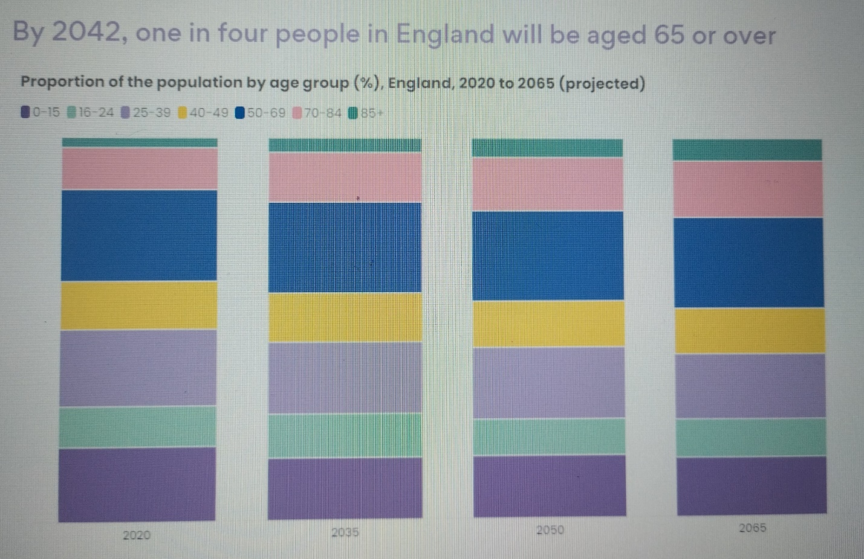Image: Center for Aging Better

The chart shows the increasing of older people in the population:
- People aged 70 and over in England which currently comprise 14% of the population, by 2065, this proportion will have increased to more than one in five (21%).
- The proportion of people aged 85 and over will more than double from 3% to 6% between 2020 and 2065.
- The proportion of the population that is younger than 25 meanwhile, will decline from 30% to 25% (Centre for Aging Better, 2022).
Research by the Fraser Institute (2022) show, that in 2010, 14.1% of Canada's population was 65 or older. This number increased to 19.0 percent in 2022, and Statistics Canada predicts this trend will continue, reaching 22.5 percent in 2030 (Fraser Institute, 2022).
According to the Government of Canada, in 2019, around 6.6 million seniors (54.0% women and 46.0% men) were living in Canada, according to the most recent population estimates. Over half (57.7%) were aged 65–74, 29.6% were aged 75–84 and 12.7% were aged 85+. The number of centenarians (those aged 100+) has reached over 10,000 in 2019 with women accounting for 82% (Government of Canada, 2022).

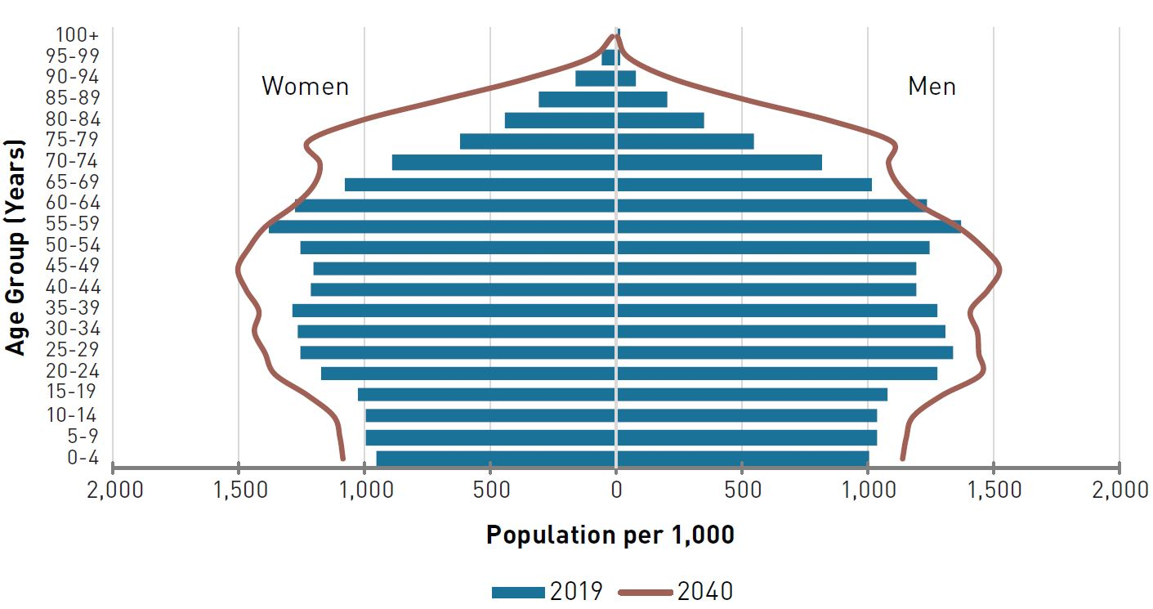Image: Government of Canada (2022).

According to Age UK, 3.6 million older people in the UK live alone, of which over 2 million are aged over 75, 1.9 million older people often feel ignored or invisible. 1.4 million of the over 50s in the UK often feel lonely and this is predicted to increase by a further two million by 2026 (Age UK, 2023).
According to the Office for National Statistics (2023) the percentage of elderly women living alone is lower in 2021 (36.3%) than in 2011 (39.2%). For men, the rate increased slightly in 2021 (22.7%) compared to 2011 (21.8%) (Office for National Statistics, 2023).
A report by the National Institute on Aging (NIA, Canada) shows that about 41 per cent of Canadians aged 50 and over are at risk of social isolation and up to 58 per cent of that age group have felt lonely. Although most older Canadians reported having a network of family and friends they could rely on, more than four in 10 considered themselves socially isolated. The report found that 58 percent of older Canadians experience some degree of loneliness, and almost 20 percent that they are "very lonely." (National Institute on Ageing, 2023). According to Statistics Canada (2022) the prevalence of living alone has always been highest at older ages. In 2021 those living alone represented 42% of all people aged 85 and older (Statistics Canada, 2022).
Loneliness and social isolation can affect anyone, but these experiences often intensify with age.
Elderly people are especially vulnerable to loneliness and isolation. This can have serious consequences for their health and increases the risk of:
- Addiction.
- Dementia.
- Heart disease and stroke.
- Type 2 diabetes.
- Depression and anxiety.
- Suicidality and self-harm.
- Early death.

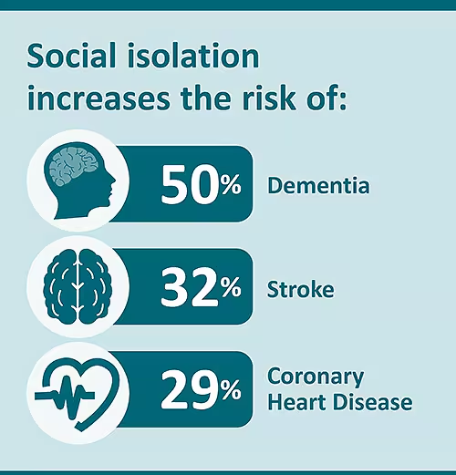
Image: Center for Disease Control and Prevention, 2023

Every person maintains social contacts to some extent and depends on these social connections in different ways, which can be divided into three components.
Structure: The number of relationships, their variety - colleagues, friends, family and how often the person interacts with others.
Function: The extent to which an individual can rely on others for various needs, such as emotional support.
Quality: Determines the positive and negative aspects of the relationship. Levels of social connection change over time due to various reasons - relocation, job change, illness. This necessitates changes in social contacts.
(Dana K. Rosen, 2023)
For many people, especially the elderly, loneliness can take a permanent place in their lives and have a significant impact on their health and well-being.
There are many factors that can lead to loneliness and social isolation, such as:
- Stress due to a lack of resources.
- Having a psychiatric or depressive disorder.
- Having a chronic disease or condition.
- Having a long-term disability.
- Being marginalized or discriminated against.
- Being unmarried, unpartnered, or living alone.
- Challenges to accessing resources, such as living in a rural area, limited transportation, language barriers.
- Major life transitions like getting divorced, losing a job, or loss of a loved one.
(Center for Disease Control and Prevention, 2023).
The COVID-19 pandemic has fundamentally changed the lives of all members of society, and especially the elderly, who are already experiencing age limitations, feeling lonely and suffering from excessive anxiety. Reports from various studies show a deepening of psychological problems and deterioration of the physical condition of the elderly population. Reduced social life, difficulties in accessing services, reduced physical activity during the COVID-19 pandemic have worsened the quality of life of older people and increased depression.

3. Theories and practices.

The population of England and Wales in mid-2022 is estimated to be 60.2 million (Office for National Statistics, 2023). According to Statistics Canada (2024), the population of Canada is 41,127,324 (Statistics Canada, 2024). By a difference of 20 million, seniors in Canada show higher rates of loneliness and social isolation. To properly assess the causes of loneliness and social isolation, the factors leading to loneliness and social isolation such as health and well-being must be assessed; ageism, discrimination; national (cross-cultural) differences in partnership, kinship, and friendship, which are usually associated with standards in society.
Ethnicity: Having a different cultural and linguistic background from the general population or the community in which you live; as from an official linguistic minority community (Government of Canada, 2017). Annual immigration to Canada totals almost 500,000 new immigrants. This is one of the highest levels of immigration of any country in the world. As of 2023, there are more than eight million permanent resident immigrants in Canada, which is approximately 20 percent of Canada's total population (Statista, 2024).
Geography: Those living in a remote region where the provision of services and the distance between families and people in general is greater; residents of areas with a smaller population; residents of poor regions, with a lack of neighborhood values (Government of Canada, 2017).
Another theory relates loneliness and social isolation to individualism-collectivism cultures. Research done by the National Library of Medicine (2021) shows that loneliness increases with individualism, decreases with age, and is greater in men than in women. Age, gender, and culture interact to predict loneliness, although they do not qualify as root causes of loneliness and social isolation, but rather act as an amplifier (National Library of Medicine, 2021).
In general, North American cultures are more individualistic, and American values differ from those of Western Europe in many ways. For example, American culture is more individualistic and lower in collectivist values than the British public. Americans give more priority to personal freedom, while Europeans value more the role of the state and society in ensuring that no one in society is in need (Pew Research Center, 2016).
Government policy:
Loneliness Strategy 2018
In October 2018, the UK Government published 'A Connected Society: A Strategy for Tackling Loneliness.'
Three main goals are set:
What is the cause of loneliness, how can it be measured and what are the ways to deal with loneliness?
Placing loneliness and the importance of social relationships in government policies.
Tackling the stigma surrounding loneliness and encouraging help-seeking (UK Parliament, 2023).
The Canadian government does not have a comprehensive national policy framework to support older adults in coping with loneliness. The lack of a clear pathway to address loneliness at the national level increases the risk of loneliness among Canada's adult population (Women’s Age Lab, 2024).

4. Recommendations.

The 2018 Loneliness Strategy also includes:
• Promoting 'Social Prescribing' where people are encouraged to join community groups and activities.
• Using the housing and planning system to promote better communities, including by embedding well-being in planning and housing design.
• The role of community infrastructure in tackling isolation and preventing loneliness. The strategy set out several commitments aimed at unlocking community spaces.
• Commitments aimed at making the transport network "inclusive and accessible, especially for older people and people with disabilities."
• Addressing digital inclusion.
(The House of Commons Library, 2023)
A key to dealing with loneliness is increasing the relationships that person has and has access to. Everyone can play a part in tackling social isolation and loneliness in older people – including neighbors, friends, family members, faith-based organizations, professionals, and health services (Claire Watts, 2022).
Be available to chat - Say hello and pass the time of day with a neighbor or visiting or phoning an older relative for a chat. Speaking on the telephone, or via video call, is preferable to texting, as you will be able to judge better how the person is feeling by their tone of voice (Claire Watts, 2022).
Embrace volunteering - Volunteering can work in different ways. Recruiting older people as volunteers can be extremely beneficial as it provides them with a purpose for social interaction, access to a wider variety of contacts.
Helping others also has a positive effect on their own well-being (Claire Watts, 2022).
Encourage digital inclusion - Making sure that everyone has access to the internet, and everyone is digitally connected is a priority in the Tackling Loneliness Network Action Plan. This includes plans for low-income adults (Claire Watts, 2022).
Better awareness of community groups and activities.
Research by the Center for Better Aging found that many older people were unaware of the support available to them, including social groups they could access. (Claire Watts, 2022).
Recommendations addressing loneliness should be a strategic priority at all levels of government in Canada to take action in collaboration with relevant ministries, agencies, and provincial/territorial and local governments:
- Building a national strategy to combat loneliness and promote social connections.
- Promote the importance of the relationship through a public awareness campaign.
- Measuring loneliness and deepening knowledge through research.
- Expand strategies and increase investment in social infrastructure and interventions.
(Women’s Age Lab, 2024).
As the reasons behind social isolation and loneliness are both complex and personal to everyone, support and outcomes need to be individually focused.
Help for people who need support either because social isolation is prolonged or because they are experiencing a life event is most effective when it is person-centred and holistic. Support should focus on the individual, taking time to establish what they want to do or achieve, rather than making assumptions. The aim is to identify the individual's personal barriers and then work towards a personalized set of goals. Meeting the person should be in a place where they feel "safe". This is critical, as is taking the time necessary to build a relationship of trust. Taking a person-centred approach recognizes and allows social isolation and loneliness to be understood in the context of the individual and their circumstances – understanding the impact on them, identifying the barriers they face in making connections and then exploring what they want to make achievement and the steps necessary to achieve change (Ageing Better, 2024).

5. Conclusion.

Due to a number of factors, older people are more likely to suffer from loneliness; however, friends, family, neighbors, carers and professionals can help older people cope with loneliness by empowering and supporting them. Despite the potential for electronic communications to play a greater role in coping with loneliness among older residents of rural areas, more people need to become familiar with technology. Furthermore, the benefits depend on whether the technology and infrastructure are accessible to everyone.

5. References.

- Age UK (2023) Loneliness Available at: https://www.ageuk.org.uk/northern-ireland/information-advice/health-wellbeing/loneliness/ (Accessed: 24. April. 2024).
- Age UK (2023) Loneliness research and resources Available at: https://www.ageuk.org.uk/our-impact/policy-research/loneliness-research-and-resources/#:~:text=and%20rural%20communities-,Loneliness%20research%20and%20resources,widely%20recognised%20in%20society%20today. (Accessed: 24. April. 2024).
- Age UK (2022) Loneliness and isolation - understanding the difference and why it matters Available at: https://www.ageuk.org.uk/our-impact/policy-research/loneliness-research-and-resources/loneliness-isolation-understanding-the-difference-why-it-matters/ (Accessed: 24. April. 2024).
- Ageing Better (2024) Person centred delivery – learning from Ageing Better Available at: https://www.tnlcommunityfund.org.uk/media/documents/ageing-better/Ageing-Better-person-centred-learning.pdf?mtime=20220524131704&focal=none (Accessed: 28. April. 2024).

- Centre for Aging Better (2022) Context | The State of Ageing 2022 Available at: https://ageing-better.org.uk/context-state-ageing-2022 (Accessed: 25. April. 2024).
- Center for Disease Control and Prevention (2023) Health Risks of Social Isolation and Loneliness Available at: https://www.cdc.gov/emotional-wellbeing/social-connectedness/loneliness.htm#:~:text=Social%20isolation%20is%20the%20lack,or%20a%20sense%20of%20belonging. (Accessed: 24. April. 2024).
- Fraser Institute (2022) Canada’s aging population—what does it mean for government finances? Available at: https://www.fraserinstitute.org/blogs/canadas-aging-population-what-does-it-mean-for-government-finances#:~:text=A%20recent%20study%20analyzed%20the,22.5%20per%20cent%20in%202030. (Accessed: 26. April. 2024).
- Government of Canada (2022) Aging and chronic diseases: A profile of Canadian seniors Available at: https://www.canada.ca/en/public-health/services/publications/diseases-conditions/aging-chronic-diseases-profile-canadian-seniors-report.html (Accessed: 26. April. 2024).
- Government of Canada (2017) Who’s at risk and what can be done about it? A review of the literature on the social isolation of different groups of seniors Available at: https://www.canada.ca/en/national-seniors-council/programs/publications-reports/2017/review-social-isolation-seniors.html (Accessed: 28. April. 2024).
- National Library of Medicine (2021) Loneliness around the world: Age, gender, and cultural differences in loneliness Available at: https://www.ncbi.nlm.nih.gov/pmc/articles/PMC7768187/ (Accessed: 28. April. 2024).
- National Institute on Ageing (2023) Understanding the Factors Driving the Epidemic of Social Isolation and Loneliness among Older Canadians Available at: https://www.niageing.ca/loneliness23 (Accessed: 26. April. 2024).
- Office for National Statistics (2023) Population estimates for England and Wales: mid-2022 Available at: https://www.ons.gov.uk/peoplepopulationandcommunity/populationandmigration/populationestimates/bulletins/populationestimatesforenglandandwales/mid2022 (Accessed: 27. April. 2024).
- Office for national statistics, (2023) Profile of the older population living in England and Wales in 2021 and changes since 2011 Available at: https://www.ons.gov.uk/peoplepopulationandcommunity/birthsdeathsandmarriages/ageing/articles/profileoftheolderpopulationlivinginenglandandwalesin2021andchangessince2011/2023-04-03#:~:text=Census%202021%20results%20show%20the,from%2016.4%25%20to%2018.6%25. (Accessed: 25. April. 2024).
- Pew Research Center (2016) 5 ways Americans and Europeans are different Available at: https://www.pewresearch.org/short-reads/2016/04/19/5-ways-americans-and-europeans-are-different/ (Accessed: 28. April. 2024).
- Rosen, D.K. (2023) An Epidemic of Loneliness and Isolation Available at: https://www.lifespan.org/lifespan-living/epidemic-loneliness-and-isolation (Accessed: 24. April. 2024).
- Statista (2024) Immigration in Canada: Statistics & facts Available at: https://www.statista.com/topics/2917/immigration-in-canada/#topicOverview (Accessed: 27. April.2024).
- Statistics Canada (2024) Canada's population clock (real-time model) Available at: https://www150.statcan.gc.ca/n1/pub/71-607-x/71-607-x2018005-eng.htm (Accessed: 27. April. 2024).
- Statistics Canada (2022) Living solo Available at: https://www.statcan.gc.ca/o1/en/plus/1908-living-solo (Accessed: 27. April. 2024).
- The House of Commons Library (2023) Loneliness and isolation in elderly and vulnerable people Available at: https://researchbriefings.files.parliament.uk/documents/CDP-2023-0215/CDP-2023-0215.pdf (Accessed: 28. April. 2024).
- UK Parliament (2023) Loneliness and isolation in elderly and vulnerable people Available at: https://commonslibrary.parliament.uk/research-briefings/cdp-2023-0215/ (Accessed: 28. April. 2024).
- Watts, C. (2022) How to Combat Loneliness in Older People Available at: https://www.highspeedtraining.co.uk/hub/loneliness-social-isolation-elderly-be-a-friend/ (Accessed: 28. April. 2024).
- Women’s Age Lab, 2024 Loneliness epidemic among older adults in Canada Available at: https://www.womensacademics.ca/wp-content/uploads/2024/03/Recommendations-for-action-to-tackle-the-loneliness-epidemic-among-older-adults-in-Canada.pdf (Accessed: 28. April. 2024).

