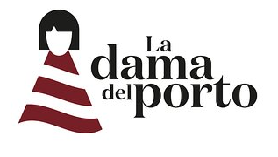

Name of Report: HSK Department - La Dama Del Porto Student: Rocio Garcia (2022578) Company’s name: RG Hotel Strategy Partners Name of client: Davide Gasparini Date delivered to client: 20 / 11 / 23

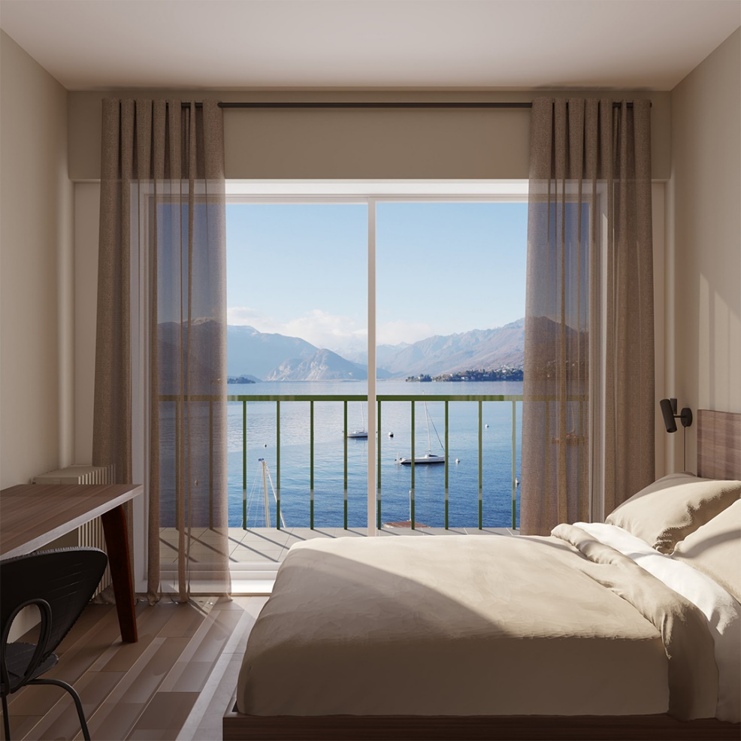
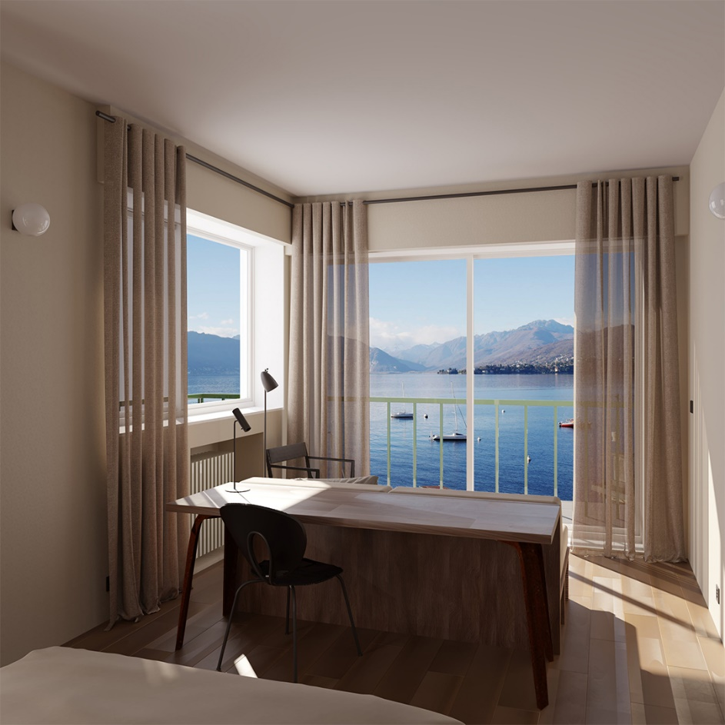

Content List
- Executive Summary……………………………………………………..1
- Introduction……………………………………………………………….2
- Scope and Analysis……………………………………………………..4
- Main Body……………………………………………………………….10
- Finding and Results…………………………………………………….20
- Action Plan………………………………………………………………25
- Recommendation……………………………………………………… 28
- Conclusion………………………………………………………………30
- Reference List…………………………………………………………..32

- Executive Summary
In response to the challenges encountered by La Dama del Porto, our consultancy conducted an in-depth analysis focused on the intricacies of the housekeeping department. The core issue, a noticeable decline in cleanliness standards, prompted a ripple effect leading to decreased guest satisfaction and a surge in negative online reviews. Our findings shed light on the complexities within housekeeping productivity, revealing a need for strategic interventions to enhance operational efficiency and elevate the overall guest experience.
The inadequacies identified in existing staff training programs further compounded these challenges, signalling the necessity for a comprehensive training overhaul to align with evolving guest expectations. Additionally, the online reputation, intricately linked to cleanliness concerns, emerged as a critical threat requiring immediate attention. Consequently, our recommendations converge on strategic initiatives aimed at rectifying these issues.

Proposed actions include the implementation of enhanced housekeeping training programs, a strategic overhaul to address cleanliness concerns and improve overall guest satisfaction. Furthermore, the integration of technology into housekeeping operations is recommended to streamline processes and enhance communication among staff members. Establishing a guest feedback system with rewards is suggested to incentivize positive online reviews, thereby fostering a culture of continuous improvement.
To bolster operational flexibility during peak seasons, the implementation of cross-training initiatives is recommended. This initiative not only addresses immediate concerns but also positions the hotel for sustained operational excellence. Finally, a regular analysis of competitor strategies is advised to proactively respond to industry changes, ensuring La Dama del Porto maintains a competitive edge.

Our gratitude extends to La Dama del Porto for entrusting us with this pivotal task. We are confident that the implementation of these strategic recommendations will usher in an era of heightened guest satisfaction, a positive online reputation, and enduring success for the hotel in the ever-evolving landscape of the hospitality industry.

- Introduction
La Bella del Porto, a boutique hotel gracing the shores of Lake Maggiore, has become synonymous with exquisite dining, panoramic views, and personalized tours. Despite notable successes in these areas, the hotel faces a critical challenge in maintaining the cleanliness standards expected by its discerning guests. The housekeeping department, responsible for ensuring the pristine condition of rooms and common areas, has consistently fallen short of expectations, leading to a surge in guest complaints and negative social media reviews, particularly during peak seasons. This has not only tarnished the hotel's reputation but has also resulted in a tangible decline in bookings.
The core issue lies in persistent dissatisfaction with room cleanliness, perceived inadequacies in the use of cleaning products, and an overall lack of hygiene. Guest complaints range from stale air to substandard cleanliness, including overlooked details such as lingering lint under beds. These concerns have not only impacted the guest experience but have also created a ripple effect on the hotel's online reputation and market competitiveness.

The housekeeping team, constrained by recruitment challenges, struggles to meet required standards. Productivity levels are suboptimal, and existing training programs have proven ineffective in addressing core issues. Despite engaging external training services, the hotel has not witnessed tangible improvements in cleanliness standards. The limited personnel, led by a singular manager, grapple with motivation and skill enhancement.
This consultancy project aims to initiate a strategic intervention to elevate the housekeeping department's performance, meeting, and exceeding industry cleanliness standards. Through systematic analysis of existing data, engaging key stakeholders, and conducting in-depth assessments, the project aims to identify the root causes of cleanliness challenges. Subsequently, realistic, and actionable solutions will be proposed to enhance the efficiency, effectiveness, and overall performance of the housekeeping team.
Close collaboration with the owner will be pivotal. Regular meetings and data-driven discussions will ensure a comprehensive understanding of challenges and the development of targeted solutions. By fostering a participatory approach, the project seeks to create a sustainable framework that not only addresses current issues but also establishes a foundation for continuous improvement within the housekeeping department.

Through this strategic consultancy initiative, La Bella del Porto endeavours to reclaim its reputation for excellence in every aspect, providing guests with a consistently pristine and enjoyable stay.

- Scope and Analysis
Nestled just meters from the serene shores of Cerro beach, La Dama del Porto emerges as a family-run boutique hotel, offering a breathtaking panorama of Lago Maggiore. The hotel, situated in the captivating locale of Laveno-Mombello, strategically positions itself as a haven for those seeking an immersive experience in the natural beauty of the region. With its five unique rooms, La Dama del Porto promises a restorative and inspiring setting, catering to both work and leisure needs. Embracing a commitment to sustainability, the hotel consciously reduces energy consumption by forgoing televisions, fridges, and air conditioners, instead providing each room with an electric fan. This eco-friendly approach aligns with the hotel's dedication to minimizing its environmental footprint while ensuring guest comfort. Guests are invited to enjoy the natural beauty and fresh air from the private balconies that grace each room, further enhancing the overall experience.

The hotel's culinary prowess takes center stage in its revenue dynamics, with the restaurant proving to be a primary contributor to the overall income, surpassing that of the hotel rooms. La Dama del Porto has strategically positioned itself as a culinary destination, channelling attention, and resources into providing an exceptional dining experience. The restaurant, known for its Italian, Mediterranean, and Seafood cuisine, also accommodates various dietary preferences, offering a continental or Italian breakfast with options for vegetarian, dairy-free, and gluten-free choices. Guests have the additional option to savour their meals on a terrace that provides awe-inspiring views of the surrounding landscape, creating a sensory-rich dining atmosphere.

In its commitment to a sustainable operation, the hotel prioritizes conscious choices, emphasizing the reduction of energy-intensive amenities. While the absence of televisions, fridges, and air conditioners is notable, each room compensates with the provision of an electric fan. This eco-conscious approach not only aligns with contemporary environmental standards but also enhances the serene ambiance La Dama del Porto offers its guests.

The hotel's location, with its proximity to key attractions such as Lugano Station, Exhibition Center Lugano, and Mendrisio Station, contributes to its overall appeal. The absence of televisions and air conditioners aligns with the hotel's dedication to sustainability and energy efficiency, creating a distinctive eco-friendly atmosphere. Swiss Miniatur and Mount San Giorgio are notable nearby attractions, complementing the hotel's offering for guests seeking exploration beyond its enchanting confines.
Despite the hotel's successes, recent feedback has illuminated a significant challenge—the housekeeping department. Guests have voiced vivid concerns about room cleanliness, recounting tales of mysterious adventures beneath the beds where ancient lint seems to have found a new home. The air, once crisp and invigorating, now carries whispers of neglect, and the scent of cleaning products has become a distant memory. These tales of overlooked details and the lack of a thorough cleaning regimen have created a symphony of discontent, resulting in a surge of negative reviews and social media complaints.

In essence, La Dama del Porto stands at a critical juncture where its successes in dining and location are overshadowed by challenges in maintaining cleanliness standards. The hotel's commitment to sustainability, unique selling points, and revenue dynamics paint a nuanced picture of a business with immense potential. However, addressing the housekeeping concerns is paramount to preserving and enhancing the overall guest experience, ensuring La Dama del Porto continues to stand as a beacon of tranquillity on the shores of Lago Maggiore.
In the vibrant and competitive realm of the hospitality industry, the success of boutique establishments such as La Dama del Porto hinges upon a profound understanding of the intricate web of factors influencing its operations. In this context, the application of strategic analytical frameworks, notably PESTLE (Political, Economic, Social, Technological, Legal, and Environmental) and SWOT (Strengths, Weaknesses, Opportunities, and Threats) analyses, emerges as an indispensable practice.
These tools offer a systematic and comprehensive approach to unravelling the nuanced dynamics that shape the hotel's present and future.
PESTLE analysis operates as a panoramic lens, capturing the external influences that orchestrate the operational symphony of La Dama del Porto. From political considerations that might impact tourism policies to economic shifts affecting consumer spending patterns, and from societal trends shaping guest expectations to technological advancements transforming the industry landscape – each facet plays a crucial role in shaping the hotel's destiny. A detailed exploration of these external factors provides valuable insights into potential challenges and opportunities, laying the groundwork for proactive strategic planning. For La Dama del Porto, understanding the broader macro-environment is paramount, especially given its reliance on natural beauty, local tourism policies, and its commitment to sustainable practices.

Conversely, SWOT analysis turns the focus inward, peeling back the layers of La Dama del Porto's internal landscape. By identifying the hotel's inherent Strengths and Weaknesses, the analysis unveils the core competencies that have contributed to its success, alongside areas that warrant improvement. Simultaneously, the examination of Opportunities and Threats within the hotel's operational purview provides a roadmap for strategic decision-making. In the case of La Dama del Porto, its strengths lie in its unique selling points – a commitment to sustainability, culinary excellence, and an intimate beachfront setting. However, recent feedback pinpointing housekeeping challenges underscores internal vulnerabilities that demand immediate attention.
The convergence of PESTLE and SWOT analyses is where the true strategic alchemy occurs. By synthesizing external and internal assessments, a holistic understanding of La Dama del Porto's position in the market emerges. This comprehensive view empowers strategic decision-makers to craft initiatives that not only address immediate challenges, such as the housekeeping concerns but also align with the hotel's broader vision and long-term goals. It is within this synthesis that the true power of these analytical framework’s manifests, guiding us to navigate through the currents of external influences and internal intricacies.

In essence, the PESTLE and SWOT analyses serve as navigational instruments, steering the course for La Dama del Porto's strategic journey. As we embark on this consultancy project, these frameworks will not only shed light on the current challenges but will also illuminate pathways for sustainable growth and success, ensuring that La Dama del Porto continues to stand as a beacon of tranquillity on the shores of Lago Maggiore.

- PESTLE Analysis for La Dama del Porto

Political:
-La Dama del Porto benefits from local political stability, which supports a conducive environment for tourism.
-Collaboration with local authorities ensures alignment with tourism policies, fostering a positive relationship with the community.
Economic:
-Economic shifts play a significant role in influencing travel patterns. La Dama del Porto, with its focus on culinary excellence and sustainability, attracts guests seeking unique and premium experiences, contributing to resilience during economic fluctuations.
Social: The hotel strategically positions itself to meet evolving social trends, emphasizing guest experience and personalized services.
-Its commitment to sustainability aligns with the increasing societal consciousness towards eco-friendly hospitality.
Technological:
-Leveraging technology enhances La Dama del Porto's operational efficiency and guest experiences. Online booking platforms, digital marketing, and smart hotel solutions contribute to a seamless and modern guest journey.
Legal: Ensuring compliance with local and international laws safeguards the hotel's reputation. La Dama del Porto's commitment to legality creates a secure environment for guests and builds trust within the industry.
Environmental: Nestled in a location of natural beauty, La Dama del Porto capitalizes on the environmental factor. The hotel's dedication to sustainable practices not only minimizes its ecological footprint but also appeals to eco-conscious travellers, enhancing its market position.

- SWOT Analysis for La Dama del Porto

Strengths:
-Beachfront Location: The hotel's prime location provides guests with an unparalleled beachfront experience, creating a unique selling point.
-Culinary Excellence: La Dama del Porto's restaurant stands out for its culinary excellence, attracting both guests and local patrons.
-Sustainability Commitment: The hotel's dedication to sustainable practices aligns with the growing demand for eco-friendly hospitality.
Weaknesses:
-Housekeeping Challenges: Recent feedback highlights housekeeping concerns, indicating a need for improvement to meet cleanliness expectations.
-Reliance on Seasonal Tourism: A seasonal influx of tourists may pose challenges during off-peak periods.
-Limited Marketing for Hotel Rooms: The hotel's focus on the restaurant might overshadow marketing efforts for its rooms.
Opportunities:
-Collaborations for Tours: Partnering with local businesses for personalized tours can enhance the guest experience and attract a broader audience.
-Diversification of Services: Exploring additional services beyond accommodation and dining can tap into new market segments.
Threats:
-Negative Online Reviews Impacting Reputation: Addressing housekeeping concerns promptly is crucial to mitigate the impact of negative reviews on online platforms.
-Intense Local Competition: Standing out in a competitive local market requires strategic differentiation and marketing efforts.

La Dama del Porto stands as a beacon of tranquillity on the shores of Lake Maggiore. With a nuanced understanding of its strengths and a strategic positioning, the hotel is poised to surmount challenges, leverage opportunities, and consistently provide a distinctive and unforgettable experience for its esteemed guests. The magnetic charm of La Dama del Porto emanates from its idyllic beachfront setting, offering unrivalled views of Lago Maggiore. Complemented by culinary excellence and an unwavering commitment to sustainability, the hotel is not merely a sojourn; it is a sanctuary where guests are immersed in a memorable retreat. As the hotel addresses specific challenges, including housekeeping intricacies, and explores avenues for diversification, it remains steadfast in its commitment to delivering an enduring legacy of hospitality. La Dama del Porto is more than a boutique establishment; it is a destination where every facet is meticulously curated to encapsulate the essence of an unparalleled getaway, ensuring that each guest departs with indelible memories and a heartfelt desire to return.

- Main Body
The main body of this consultancy report aims to comprehensively analyse the operations of La Dama del Porto, exploring both positive and negative aspects with the goal of proposing strategic improvements. The analysis will delve into various facets of the hotel, ranging from the effectiveness of the staff training program to environmental considerations and financial performance. It is essential to maintain a balanced perspective, acknowledging strengths while addressing identified challenges.
This section of the report is structured to provide a detailed examination of key operational areas. By adopting a holistic approach, we aim to offer actionable insights that contribute to the long-term success and enhancement of La Dama del Porto's hospitality accomplishments The subsequent sections will delve into specific aspects, delineating issues, recommendations, and supporting data to facilitate a nuanced understanding of the hotel's current standing and potential areas for improvement.

- Staff Training Program Analysis

- Issues:
- Evaluation of Current Staff Training Program:
The foundation of La Dama del Porto's service excellence rests upon the effectiveness of its staff training program. A comprehensive evaluation is imperative to gauge the program's efficiency in equipping the team with the requisite skills and knowledge essential for delivering exceptional hospitality. This examination encompasses a detailed review of the curriculum, training methodologies, and the overall coherence of the program with the hotel's service standards and mission.
The assessment will delve into the relevance of the content, the clarity of communication, and the practical applicability of the skills acquired during training. By scrutinizing these elements, we aim to identify areas of strength and potential gaps that might hinder the team's ability to meet and exceed guest expectations.

Alignment with Identified Problems from Review Sites:
Customer reviews serve as invaluable insights into the guest experience, shedding light on areas that require attention. An in-depth analysis will be conducted to ascertain the correlation between the identified problems highlighted in these reviews and the coverage of these issues within the current staff training program. By aligning the feedback from guests with the skills imparted during training, we can pinpoint specific aspects that may require refinement.
This process involves a meticulous examination of customer feedback related to housekeeping standards, communication effectiveness, problem resolution, and overall guest satisfaction. The objective is to identify any disparities between the training provided and the expectations voiced by the hotel's valued patrons.

- Recommendations:
- Proposal for Enhancements:
To fortify the effectiveness of the staff training program, we propose a series of enhancements that address the findings of the evaluation. This includes a meticulous review and updating of the training content to ensure it remains current with industry standards and incorporates the unique offerings of La Dama del Porto. Introducing interactive elements, scenario-based training modules, and real-world simulations can elevate the learning experience for staff, fostering a more dynamic and hands-on approach to skill development.
Additionally, an emphasis on soft skills, such as effective communication, conflict resolution, and guest-centric problem-solving, will be integrated into the training framework. By adopting a holistic approach, the program can empower staff members to navigate the intricacies of guest interactions with finesse.
- Addressing Customer Review Issues:
Our recommendations will be tailored to directly address the issues raised in customer reviews. Specific training modules will be designed to equip staff with the skills necessary to tackle common challenges highlighted by guests. Whether it pertains to housekeeping standards, responsiveness to guest requests, or effective communication, the training content will be strategically aligned to directly influence and improve the areas flagged by customer feedback.
A proactive approach to bridging the gap between customer expectations and the skills imparted during training will contribute not only to immediate issue resolution but also to the cultivation of a service culture that prioritizes continuous improvement.

This multifaceted analysis and enhancement strategy for the staff training program aim to ensure that La Dama del Porto's team is not only well-versed in industry best practices but also attuned to the specific needs and expectations of its diverse clientele. By investing in the professional development of its staff, the hotel can foster a culture of excellence that resonates with guests, ultimately enhancing overall service quality and bolstering the hotel's standing in the competitive hospitality landscape.

- Housekeeping Training Program Analysis

- Issues:
- Resource Allocation Challenges:
The dual role of the owner and family members primarily engaged in restaurant operations poses challenges for adequate attention to housekeeping responsibilities. With the hotel's focus on the restaurant, there may be resource limitations hindering the comprehensive oversight required for effective housekeeping management.

- Inadequate Training and Supervision:
The existing housekeeping training program may lack the depth and focus needed to address the nuanced needs of the hotel's rooms. Inadequate training and supervision can result in suboptimal cleanliness standards, leading to negative guest experiences and subsequent complaints.

- Dependency on External Agency:
The reliance on external agencies for housekeeping services may introduce challenges related to consistency, communication, and alignment with the hotel's specific requirements. Coordinating with external entities requires careful management to ensure a seamless integration of services.

- Recommendations:
- Resource Reallocation and Delegation:
To address resource allocation challenges, we recommend a strategic reallocation of responsibilities within the owner and family roles. Delegating specific housekeeping oversight responsibilities to dedicated individuals or hiring a housekeeping manager can ensure focused attention on room cleanliness without compromising restaurant operations.
- Enhanced Training Program:
The housekeeping training program needs augmentation to specifically address the intricacies of room maintenance. This involves incorporating modules on attention to detail, time management, and guest-centric cleaning practices. Regular training sessions, both theoretical and practical, should be conducted to continually improve staff skills and align with the hotel's standards.
- Comprehensive Supervision and Quality Checks:
Implementing a robust system of supervision is critical to maintaining high housekeeping standards. Designate responsible individuals for routine quality checks, ensuring that each room meets the established cleanliness benchmarks. Regular feedback loops and continuous improvement initiatives should be integrated into the supervision process.
- Collaboration with External Agency:
If the hotel continues to utilize external agencies for housekeeping, establishing a clear and detailed collaboration framework is essential. This involves defining expectations, communication protocols, and quality standards. Regular meetings with the agency representatives can facilitate alignment and address any issues promptly.
- Cross-Training Opportunities:
Considering the interplay between restaurant and hotel operations, explore opportunities for cross-training staff. This can enhance flexibility and ensure that team members can seamlessly transition between roles as needed. Cross-training can be particularly beneficial during peak seasons when demands on both the restaurant and hotel are high.
- Technology Integration:
Explore the integration of technology to streamline housekeeping operations. Implementing a digital housekeeping management system can enhance communication, task assignment, and tracking of room cleaning progress. This can lead to more efficient operations and better coordination among the staff.
In conclusion, addressing the challenges in the housekeeping department requires encompassing resource reallocation, training program enhancements, and effective collaboration with external agencies. By investing in these recommendations, La Dama del Porto can elevate the cleanliness standards of its rooms, enhance guest satisfaction, and establish a harmonious balance between the restaurant and hotel operations.

- Positive Aspects of La Dama del Porto
La Dama del Porto stands as a shining example of hospitality, showcasing several positive aspects that contribute to its overall success and positive reputation.

- Culinary Excellence:
The hotel's restaurant is a standout feature, celebrated for its culinary excellence. The fusion of traditional cuisine reimagined in a modern context has garnered acclaim, not only from guests but also from the local community. The restaurant's success is a testament to the hotel's commitment to providing a distinctive and delightful dining experience.

- Prime Beachfront Location:
Nestled in the picturesque setting of Laveno-Mombello, La Dama del Porto enjoys a prime beachfront location with unrivaled views of Lago Maggiore. This natural backdrop enhances the overall guest experience, providing a serene and visually stunning atmosphere that contributes to the hotel's allure.

- Unique Boutique Atmosphere:
The hotel's boutique setting, featuring five unique rooms with private balconies, offers guests a restorative and inspiring environment. This personalized touch creates an intimate and exclusive atmosphere, distinguishing La Dama del Porto from larger, more impersonal establishments.

- Sustainability Commitment:
La Dama del Porto's dedication to sustainability is a commendable aspect of its operations. The conscious decision to forego televisions, fridges, and air conditioners in favour of energy conservation aligns with contemporary environmental values. This commitment resonates positively with eco-conscious travellers seeking responsible and mindful accommodation options.

- Engaging Panoramic Views:
Guests at La Dama del Porto are treated to captivating panoramic views of Lago Maggiore from the dining room and terrace. This engaging visual experience enhances the overall ambiance and contributes to the hotel's appeal, providing guests with a unique and memorable stay.

- Successful Restaurant Operations:
The restaurant's success is not only attributed to its culinary prowess but also to its ability to generate substantial revenue for the hotel. The focus on the dining experience has proven to be a lucrative venture, contributing significantly to the overall financial performance of La Dama del Porto.

- Personalized Services:
The hotel's small size allows for a more personalized and attentive approach to guest services. The intimate scale of operations enables staff to cater to individual needs, fostering a sense of warmth and personalized care that larger establishments may struggle to replicate.
- Local Attraction Collaboration:
Collaborations with local businesses for personalized tours enhance the guest experience. By integrating with the local community, La Dama del Porto provides guests with an opportunity to explore and engage with the unique attractions and offerings of the region, enriching their overall stay.

- La Dama del Porto boasts a range of positive aspects that contribute to its overall success. From culinary excellence and a prime beachfront location to a commitment to sustainability and personalized services, these attributes collectively create a unique and memorable experience for guests. These positive elements form the foundation for continued success and provide a solid platform for addressing areas of improvement identified in the analysis.

- Enhancing Engagement: Reward-Based Feedback Systems for Staff and Guests

Recognizing the significance of feedback from both staff and guests, La Dama del Porto can implement a comprehensive reward-based feedback system. This dual approach aims to foster active participation, gather valuable insights, and cultivate a culture of continuous improvement within the organization.

- Staff Feedback System:
Questionnaire Design:
- Develop a structured questionnaire covering various aspects of the work environment, including job satisfaction, communication effectiveness, training programs, and suggestions for improvement.
- Ensure clarity and relevance of questions to garner actionable insights.
Anonymity and Confidentiality:
- Emphasize the confidentiality of responses to encourage honest and open feedback from staff members.
- Assure employees that their opinions will be treated with discretion.
Reward Structure:
- Establish a reward system for staff members who actively participate in providing feedback.
- Consider recognizing and appreciating contributions through a tiered system, with different levels of rewards based on the depth and quality of responses.
Communication Plan:
- Clearly communicate the purpose and benefits of the feedback system to the staff.
- Highlight the management's commitment to using the feedback for positive changes and emphasize the role of employees in shaping the work environment.
- Benefits:
Increased Staff Engagement:
- The introduction of a reward-based system incentivizes staff members to actively participate in sharing their perspectives.
- Higher participation rates contribute to a more comprehensive understanding of the work environment.
Positive Work Culture:
- Recognizing and rewarding staff feedback fosters a positive work culture, where employees feel valued and heard.
- This positively impacts morale and job satisfaction, leading to a more engaged and motivated workforce.
Targeted Improvement Initiatives:
- Collected feedback helps identify specific areas for improvement, whether in training programs, communication channels, or workplace satisfaction.
- Management gains actionable insights to implement targeted initiatives.

- Guest Feedback System:
Guest Satisfaction Surveys:
- Design guest satisfaction surveys to capture insights into their overall experience, including accommodation, dining, and additional services.
- Include questions about cleanliness, service quality, and any specific aspects the hotel aims to assess.
Rewarding Guest Participation:
- Implement a reward system for guests who complete satisfaction surveys or provide feedback.
- Offer discounts, complimentary services, or loyalty points as a token of appreciation for their valuable input.

Feedback Integration:
- Integrate guest feedback into operational improvements and showcase the impact of their suggestions.
- Communicate how the hotel values and utilizes guest input to enhance the overall experience.
Benefits:
- Enhanced Guest Experience:
- Actively seeking and incorporating guest feedback demonstrates a commitment to providing an exceptional experience.
- Positive changes resulting from guest input contribute to increased satisfaction and loyalty.
Positive Online Reputation:
- Positive guest feedback, especially when acknowledged and rewarded, translates to favourable online reviews.
A positive online reputation attracts new guests and reinforces the hotel's commitment to guest satisfaction.
Continuous Service Enhancement:
- Regular feedback from guests creates a continuous loop for service improvement.
- The reward-based system encourages guests to provide detailed and constructive feedback, leading to ongoing enhancements.
- By adopting a dual approach to feedback, La Dama del Porto can create a holistic feedback ecosystem, engaging both staff and guests in the pursuit of excellence. The reward-based systems not only motivate participation but also contribute to a positive organizational culture and an enhanced guest experience.

- Finding and Results
Housekeeping Department:

Staffing Levels: The housekeeping department, consisting of six junior staff members, caters to the cleanliness and upkeep of the hotel.
Room Types and Features:
Corten Room: This room, featuring a double bed, offers a panoramic view of Lago Maggiore from its balcony. With amenities such as free Wi-Fi, it provides a cozy and intimate experience. Sleeps 2, 1 Double bed and 1 Bathroom.
Ceramica Suite: Ideal for a luxurious experience, this suite boasts a double bed, a sofa bed, and a daybed. The bespoke desk and balcony with a lake view enhance the overall ambiance. Sleeps 3, 1 Sofa bed and 1 Double bed, 1 Bathroom.
Quercia Suite: Overlooking the historic Cerro centre, this suite accommodates three guests with a double bed and a sofa bed. The cozy design and family-friendly features make it a comfortable choice. Sleeps 3, 1 Sofa bed and 1 Double bed, 1 Bathroom.
Lino Suite: Offering a bright and inviting atmosphere, the Lino Suite includes a double bed, a private balcony, and captivating views of Cerro Park. It provides a serene hideaway for a relaxing getaway. Sleeps 2, 1 Double bed and 1 Bathroom.
Noce Room: Designed for optimal comfort, the Noce Room includes a bespoke double bed, a desk, and a private balcony overlooking Cerro Park. Sleeps 2, 1 Double bed and 1 Bathroom.

Venue Design & Environment:
Room Atmosphere: The design philosophy in both rooms and corridors follows a calm and minimalistic approach, fostering a tranquil and harmonious environment for guests.
Room Amenities: The rooms are equipped with various amenities, including Wi-Fi, balconies for breathtaking views, heating, fans, and en-suite bathrooms, ensuring a comfortable stay.

Clientele and Niche:

Niche: La Dama del Porto caters to a niche market seeking a unique and personalized boutique experience. The exclusive design of rooms and the culinary excellence of the restaurant contribute to this niche appeal.
Clientele: The hotel attracts guests seeking a blend of luxury, tranquillity, and culinary delights. The personalized rooms and the picturesque location make it appealing to those looking for a distinctive and intimate getaway.

- TOWS Analysis:
Strengths:
- Culinary Excellence: La Dama del Porto's renowned restaurant is a significant financial contributor, attracting guests for its exceptional culinary offerings.
- Prime Location: The hotel's beachfront location on Lago Maggiore with stunning views distinguishes it as a desirable destination.
- Unique Boutique Atmosphere: The personalized touch in the five unique rooms creates an exclusive and memorable experience for guests.
Weaknesses:
- Housekeeping Productivity: Complaints regarding cleanliness highlight challenges in the housekeeping department, impacting overall guest satisfaction.
- Staff Training: Ineffective training programs contribute to service quality issues, particularly in maintaining cleanliness standards.
Opportunities:
- Cross-Training: Exploring opportunities for staff cross-training can enhance flexibility during peak seasons, ensuring efficient and effective operations.
- Technology Integration: Implementing digital housekeeping management systems can streamline operations, leading to improved efficiency and communication.
Threats:
- Negative Online Reputation: Continued complaints about cleanliness pose a threat to the hotel's online image and may deter potential guests.
- Competitor Advancements: Other boutique hotels in the region may pose competition with superior services, making it imperative to address service quality issues promptly.

- Comments:

-The housekeeping department's current staffing level appears sufficient for the existing room capacity, but operational efficiency needs improvement.
-Guest room features align seamlessly with the boutique and personalized theme, providing a unique and memorable experience.
-The calm and minimalistic design in both rooms and corridors contributes to a serene and pleasant atmosphere for guests.
-Addressing housekeeping complaints is crucial for maintaining positive online reviews and reputation management.
-Opportunities for cross-training and technology integration present avenues for enhancing overall operational efficiency.

This in-depth TOWS analysis offers a thorough exploration of La Dama del Porto's present positioning, shedding light on key elements crucial for strategic planning. By delving into the nuances of the hotel's internal and external landscape, we uncover valuable insights that pave the way for an informed and forward-thinking approach.

Strengths Leveraging:
La Dama del Porto possesses distinctive strengths that set it apart in the competitive hospitality landscape. The culinary excellence showcased in its renowned restaurant not only contributes significantly to the hotel's financial prosperity but also positions it as a gastronomic haven. The prime beachfront location on the shores of Lago Maggiore, providing breathtaking views, stands as a formidable strength, making it an irresistible destination. The unique boutique atmosphere created by the personalized touch evident in the five exclusive rooms further enhances the hotel's appeal, offering guests an intimate and memorable experience. Additionally, the commitment to sustainability through energy conservation aligns seamlessly with contemporary environmental values.
Addressing Weaknesses:
Acknowledging weaknesses is the first step towards improvement. The analysis highlights challenges in housekeeping productivity, particularly evident in guest complaints about cleanliness. This weakness requires immediate attention to uphold the hotel's reputation for excellence. Furthermore, the inefficiencies in staff training programs pose a threat to overall service quality, necessitating a strategic overhaul in training methodologies to ensure the team is well-equipped to meet and exceed guest expectations.
Exploring Opportunities:
Opportunities represent avenues for growth and improvement. La Dama del Porto can explore staff cross-training initiatives to enhance flexibility during peak seasons, ensuring optimal operational efficiency. The integration of advanced technology in housekeeping management systems presents an exciting opportunity to streamline operations, leading to heightened efficiency and improved communication among staff members.
Mitigating Threats:
Effectively addressing threats safeguards the hotel's brand and reputation. Negative online reviews related to cleanliness issues pose a significant threat to the hotel's online image. A proactive approach to addressing and rectifying housekeeping concerns is essential to mitigate this threat. Additionally, keeping a vigilant eye on competitor advancements ensures that La Dama del Porto remains at the forefront of providing superior services, thereby maintaining its competitive edge.
Strategic Foundation for the Future:
These insights collectively form a robust strategic foundation, guiding La Dama del Porto towards informed decision-making and future planning. Leveraging strengths, addressing weaknesses, exploring opportunities, and mitigating threats are integral components of a dynamic strategy that positions the hotel for sustained success. As the hospitality landscape evolves, this strategic framework empowers La Dama del Porto to adapt, innovate, and continue providing an exceptional and distinctive experience for its discerning clientele.

- Action Plan
N | Problem | Solution | Desired Outcome | Time Scale | Completion Date | Planning Budget
1. | Housekeeping Productivity and Cleanliness Issues. | Enhance Housekeeping Training Program. Investment in comprehensive training programs to address cleanliness concerns and elevate service quality. Costs include external training resources and materials. | Improved cleanliness standards, increased guest satisfaction. | 3 months | 20/02/2024 | £10,000
2. | Ineffective Staff Training Programs. | Implement Technology Integration for Housekeeping. Investment in digital management systems. Costs cover software acquisition/hardware and staff training on new systems.. | Streamlined operations, enhanced communication among staff. | 4 months | 20/03/2024 | £15,000
N | Problem | Solution | Desired Outcome | Time Scale | Completion Date | Planning Budget
3. | Negative Online Reputation Due to Cleanliness Complaints. | Establish a Guest Feedback System with Rewards. Implementation of a reward-based feedback system to encourage guest participation and positive reviews. Costs include incentives, platform subscriptions, and ongoing monitoring. | Increased positive online reviews, improved reputation. | Ongoing | Continuous | £5,000 (Annual)
4. | Staff Cross-Training Opportunities. | Develop Cross-Training Initiatives. Investment in cross-training programs to enhance staff versatility. Costs cover training materials, external trainers, and potential temporary staffing during training periods. | Increased staff flexibility during peak seasons. | 6 months | 20/05/2024 | £7,000

N | Problem | Solution | Desired Outcome | Time Scale | Completion Date | Planning Budget
5. | Competitor Advancements | Regular Competitor Analysis and Strategy Updates. Costs include subscription fees for industry analysis tools and consultancy time for strategy updates. | Proactive response to industry changes, maintained competitive edge. | Ongoing | Continuous | £3,000 (Annual)

Consultancy Fees Allocation:
- Initial Investigative Work: £8,000
- Initial Site Visit: £5,000
- Interim Feedback Visit: £7,000
- Final Feedback Visit: £5,000
- Total Consultancy Fees: £25,000

- Recommendation

Enhance Housekeeping Training Program:
- Desired Outcome: Improved cleanliness standards and increased guest satisfaction.
- Time Scale: 3 months
- Completion Date: 20/02/2024
- Planned Budget: £10,000
- Justification: Comprehensive training to address cleanliness concerns.

Implement Technology Integration for Housekeeping:
- Desired Outcome: Streamlined operations and enhanced communication among staff.
- Time Scale: 4 months
- Completion Date: 20/03/2024
- Planned Budget: £15,000
- Justification: Digital housekeeping management systems for improved efficiency.
Establish a Guest Feedback System with Rewards:
- Desired Outcome: Increased positive online reviews and improved reputation.
- Time Scale: Ongoing
- Completion Date: Continuous
- Planned Budget: £5,000 (Annual)
- Justification: Reward-based feedback system for guest engagement.

Develop Cross-Training Initiatives:
- Desired Outcome: Increased staff flexibility during peak seasons.
- Time Scale: 6 months
- Completion Date: 20/05/2024
- Planned Budget: £7,000
- Justification: Cross-training programs for enhanced staff versatility.
Regular Competitor Analysis and Strategy Updates:
- Desired Outcome: Proactive response to industry changes and maintained competitive edge.
- Time Scale: Ongoing
- Completion Date: Continuous
- Planned Budget: £3,000 (Annual)
- Justification: Regular analysis of competitor advancements for informed decision-making.

These proposed actions aim to address the identified issues systematically, considering the time frame, desired outcomes, completion dates, and justified budgets. Prioritizing the recommendations allows the client flexibility in choosing the most impactful solutions based on their preferences and budget considerations.

- Conclusion
In the culmination of our consultancy endeavours with La Dama del Porto, we have diligently examined the operational landscape of this exquisite boutique hotel, specifically homing in on challenges within the housekeeping department. Through a comprehensive SWOT analysis, we unearthed the distinctive strengths that set the hotel apart, identified critical weaknesses requiring immediate attention, explored promising opportunities for growth, and acknowledged potential threats demanding proactive mitigation.

Our tailored recommendations aim to propel La Dama del Porto towards operational excellence. Initiatives such as enhancing housekeeping training programs, implementing technology integration for streamlined operations, and establishing a guest feedback system with rewards all contribute to an overarching strategy for improvement. Additionally, developing cross-training initiatives for staff flexibility and ensuring a vigilant eye on competitor advancements form integral parts of our proposed action plan.

The meticulously outlined action plan is designed to guide the hotel towards tangible improvements in cleanliness standards, guest satisfaction, and overall operational efficiency. These strategic interventions, accompanied by a transparent breakdown of consultancy fees, reflect our commitment to providing not just insights but actionable solutions.

In extending our deepest gratitude, we want to express appreciation to La Dama del Porto for entrusting us with this critical task. Your dedication to delivering a unique and memorable experience aligns seamlessly with our shared commitment to excellence. It has been a privilege to collaborate with your esteemed team, and we anticipate the potential for future partnerships.

I extend my sincere appreciation to Mr. Davide Gasparini, one of the esteemed owners of La Dama del Porto, for initiating and facilitating this consultancy engagement. Your proactive approach and commitment to addressing operational challenges have been instrumental in the depth and quality of our analysis. It has been a pleasure working with you, and I look forward to the continued success and growth of La Dama del Porto. Thank you for the opportunity to contribute to the enhancement of your boutique hotel.

- Reference List
(2020) Strategic Planning Consulting: Hotel case - revista espacios. Available at: https://www.revistaespacios.com/a20v41n45/a20v41n45p04.pdf (Accessed: 13 November 2023).
(No date a) Employee motivation and performance - theseus. Available at: https://www.theseus.fi/bitstream/handle/10024/22787/akah_william.pdf (Accessed: 10 November 2023).
(No date b) Pestel analysis of the hospitality industry - howandwhat.net. Available at: https://www.howandwhat.net/pestel-analysis-hospitality-industry/ (Accessed: 10 November 2023).
(No date c) A useful guide to SWOT analysis - Chartered Insurance Institute. Available at: https://www.cii.co.uk/media/6158020/a-useful-guide-to-swot-analysis.pdf (Accessed: 10 November 2023).
17, J. et al. (2023) Hotel reputation management tips and examples hoteliers need to know, Hotel Reputation Management Tips and Examples Hoteliers Need to Know | Cvent Blog. Available at: https://www.cvent.com/uk/blog/hospitality/hotel-reputation-management-tips (Accessed: 12 November 2023).
20, O. et al. (2023) The Ultimate Hotel SWOT analysis in 7 simple steps, Hotel SWOT Analysis: The Secret to Powerful Decision-Making | Cvent Blog. Available at: https://www.cvent.com/en/blog/hospitality/hotel-swot-analysis (Accessed: 13 November 2023).
5 small hotel management tips that improve operations (2023) Xenia. Available at: https://www.xenia.team/articles/small-hotel-management-tips-checklist (Accessed: 11 November 2023).
Admin (2023) Hilton Hotels Pestel Analysis - The Strategy Story, The Strategy Story - Simplifying Business Strategies. Available at: https://thestrategystory.com/blog/hilton-hotels-pestel-analysis/ (Accessed: 10 November 2023).
Aslan, I., Çınar, O. and Kumpikaitė, V. (2012) ‘Creating strategies from TOWS matrix for Strategic Sustainable Development of kipaş group / darnaus Vystymosi Kipas Grupėje strategijų kūrimas remiantis GGSS matrica’, Journal of Business Economics and Management, 13(1), pp. 95–110. doi:10.3846/16111699.2011.620134.
Bigelow, S.J., Pratt, M.K. and Tucci, L. (2023) What is a SWOT analysis? definition, examples and how to: TechTarget, CIO. Available at: https://www.techtarget.com/searchcio/definition/SWOT-analysis-strengths-weaknesses-opportunities-and-threats-analysis (Accessed: 10 November 2023).

Binujacob (2022) Key indicators of demotivated employees - and how to inspire them, Engage for Success. Available at: https://engageforsuccess.org/productivity/key-indicators-of-demotivated-employees-and-how-to-inspire-them/ (Accessed: 14 November 2023).
boldnew (2020) 7 ways managers can use technology for better productivity, Management Training Institute. Available at: https://managementtraininginstitute.com/7-ways-managers-can-use-technology-for-better-productivity/ (Accessed: 15 November 2023).
Britton, A. (2023) Six tips for running your hotel with a reduced team, Six tips for running your hotel with a reduced team | Mews Blog. Available at: https://www.mews.com/en/blog/six-tips-for-running-your-hotel-with-a-reduced-team (Accessed: 10 November 2023).
Buhalis, D. (2022) Encyclopedia of Tourism Management and Marketing. Cheltenham, UK: Edward Elgar Publishing.
Bunzl (2018a) Hotel hospitality: The importance of excellent housekeeping, Bunzl Catering Supplies. Available at: https://www.bunzlcatering.co.uk/hotel-hospitality-the-importance-of-excellent-housekeeping/ (Accessed: 11 November 2023).
Bunzl (2018b) Hotel hospitality: The importance of excellent housekeeping, Bunzl Catering Supplies. Available at: https://www.bunzlcatering.co.uk/hotel-hospitality-the-importance-of-excellent-housekeeping/ (Accessed: 11 November 2023).
Cloudbeds (2023) How to conduct your Hotel SWOT analysis in 6 steps, Cloudbeds. Available at: https://www.cloudbeds.com/articles/hotel-swot-analysis/ (Accessed: 10 November 2023).
Darios, I. (2023) 10 tactics for Successful Hotel Reputation Management, Cloudbeds. Available at: https://www.cloudbeds.com/articles/10-tactics-for-successful-hotel-reputation-management/ (Accessed: 12 November 2023).
Detailed Pestel analysis of Hotel Industry: EdrawMax Online (no date) Edrawsoft. Available at: https://www.edrawmax.com/article/hotel-industry-pestel-analysis.html (Accessed: 10 November 2023).
Dieffenbacher, S.F. (2023) Tows matrix explained: How to make informed Business Decisions, Digital Leadership. Available at: https://digitalleadership.com/unite-articles/tows-matrix/ (Accessed: 13 November 2023).
Farooq, U. (2020) Pestle analysis of the tourism industry, Marketing Tutor. Available at: https://www.marketingtutor.net/pestle-analysis-of-the-tourism-industry/ (Accessed: 10 November 2023).
Frue, K. (2023) Pestle analysis for hotel industry, PESTLE Analysis. Available at: https://pestleanalysis.com/pestle-analysis-for-hotel-industry/ (Accessed: 10 November 2023).
Gazija, MSc.A. (2011) ‘Importance of staff training in Hotel Industry Case Study: Hotel dukagjini’, ILIRIA International Review, 1(2). doi:10.21113/iir.v1i2.191.
Giove, G. (2021) How to address cleanliness, environmental concerns in hotels, Hotel Management. Available at: https://www.hotelmanagement.net/operate/how-address-cleanliness-environmental-concerns-hotels (Accessed: 11 November 2023).
Holger Arians, PLDx. org (2023) The impact of technology on leadership, People Development Magazine. Available at: https://peopledevelopmentmagazine.com/2023/04/07/impact-of-technology/ (Accessed: 15 November 2023).
Home (no date) SWOT: Strengths, Weaknesses, Opportunities, Threats – BusinessBalls.com. Available at: https://www.businessballs.com/strategy-innovation/swot-analysis/ (Accessed: 10 November 2023).
HotelMinder et al. (2019) How to improve hotel operations with an independent consultant?, Hotel Speak. Available at: https://www.hotelspeak.com/2019/07/how-to-improve-hotel-operations-with-an-independent-consultant/ (Accessed: 10 November 2023).
How to create a SWOT analysis for your small business (no date) Bank of America - Banking, Credit Cards, Loans and Merrill Investing. Available at: https://www.bankofamerica.com/smallbusiness/resources/post/how-to-create-a-swot-analysis-for-your-small-business/ (Accessed: 10 November 2023).
How to do a SWOT analysis for better planning (2023) Bplans. Available at: https://www.bplans.com/business-planning/how-to-write/marketing-sales/swot-analysis/ (Accessed: 10 November 2023).
How to manage a boutique hotel (2023) Hostaway. Available at: https://www.hostaway.com/blog/how-to-manage-a-boutique-hotel/ (Accessed: 15 November 2023).
How to teach leadership (2020) tonyrobbins.com. Available at: https://www.tonyrobbins.com/what-is-leadership/how-to-teach-leadership/#:~:text=Challenge%20your%20employees&text=Bring%20out%20the%20leader%20in,different%20roles%20at%20your%20company. (Accessed: 12 November 2023).
An introduction to the tows matrix: Putting swot into action (no date) Accredited Qualifications & Training for Professionals. Available at: https://www.professionalacademy.com/blogs/an-introduction-to-the-tows-matrix-putting-swot-into-action/ (Accessed: 10 November 2023).
An introduction to tows analysis (no date) Lucidity. Available at: https://getlucidity.com/strategy-resources/an-introduction-to-tows-analysis/ (Accessed: 10 November 2023).
Ivan (2023) 10 hotel housekeeping issues that hurt hotel profitability, Impruve. Available at: https://www.impruvellc.com/hotel-housekeeping-issues/ (Accessed: 11 November 2023).
Kenton, W. (no date) SWOT analysis: How to with table and example, Investopedia. Available at: https://www.investopedia.com/terms/s/swot.asp (Accessed: 10 November 2023).
Lacalle, E. (2021) Hotel Reputation Management: What are the best strategies?, Hotel reputation management | What are the best strateg... | Mews Blog. Available at: https://www.mews.com/en/blog/hotel-reputation-management (Accessed: 12 November 2023).
Lacalle, E. (2023a) How to build and Organize Your Hotel Housekeeping Team, How to build and organize your hotel housekeeping team | Mews Blog. Available at: https://www.mews.com/en/blog/how-to-organize-a-housekeeping-team (Accessed: 11 November 2023).
Lacalle, E. (2023b) How to manage a boutique hotel: Tips and best practices, How to manage a boutique hotel | Tips and best practice... | Mews Blog. Available at: https://www.mews.com/en/blog/boutique-hotel-management (Accessed: 15 November 2023).
Lu, J. (2022) Pestle analysis, pestle analysis template, GroupMap. Available at: https://www.groupmap.com/portfolio/pestle-analysis#:~:text=A%20PESTLE%20analysis%20helps%20a,fits%20into%20the%20broader%20environment (Accessed: 10 November 2023).
Magnini, V.P. and Zehrer, A. (2021) Subconscious influences on perceived cleanliness in hospitality settings, International journal of hospitality management. Available at: https://www.ncbi.nlm.nih.gov/pmc/articles/PMC8631804/ (Accessed: 12 November 2023).
Mandlik, C. (2023) How to build a team of hotel staff and effectively lead them, SiteMinder. Available at: https://www.siteminder.com/r/trends-advice/hotel-management/build-lead-team-hotel-staff/ (Accessed: 11 November 2023).
Maniscalco, P. (2023) The importance of Training & Development in hospitality, Novative. Available at: https://www.novative.com/en/hospitality-the-importance-of-training-development-in-hospitality/#:~:text=Trained%20Employees%20Equals%20Happy%20Customers,knows%20what%20they%20are%20doing. (Accessed: 15 November 2023).
Martin, S. (2023) Why is hotel housekeeping important for the success of your hotel?, Preno HQ - Hotel Management Software. Available at: https://prenohq.com/blog/why-is-hotel-housekeeping-important-for-the-success-of-your-hotel/#:~:text=They%20play%20a%20critical%20role,room%20access%2C%20and%20other%20regulations. (Accessed: 12 November 2023).
Martin-Woodgate, S. (2023) 5 ways to train reluctant employees, skillcast. Available at: https://www.skillcast.com/blog/train-reluctant-employees (Accessed: 13 November 2023).
Measom, C. (2016) The warning signs of the decline in employee motivation, Small Business - Chron.com. Available at: https://smallbusiness.chron.com/warning-signs-decline-employee-motivation-43082.html (Accessed: 14 November 2023).
Monica McCutchen et al. (2018) 6 time saving tips to manage your hospitality team, Hotel Speak. Available at: https://www.hotelspeak.com/2018/10/6-time-saving-tips-to-manage-your-hospitality-team/ (Accessed: 11 November 2023).
Nicolae, P. (1970) Use of the Pestel model in the management of the Tourism Bra, Ovidius University Annals, Economic Sciences Series. Available at: https://ideas.repec.org/a/ovi/oviste/vxviiiy2018i1p370-375.html (Accessed: 10 November 2023).
The only 3 ways to use technology to improve employee experience (2023) Totara Learning. Available at: https://www.totara.com/articles/the-only-3-ways-to-use-technology-to-improve-employee-experience (Accessed: 16 November 2023).
Revfine (2023) Housekeeping department in Hotel Businesses: Is it important?, Revfine.com. Available at: https://www.revfine.com/housekeeping-department-in-hotel/ (Accessed: 12 November 2023).
Sahmad (2020) Benefits for hotel cleanliness , Atalian Philippines. Available at: https://atalian.ph/2019/10/04/benefits-for-hotel-cleanliness/#:~:text=A%20hotel’s%20reputation%20can%20suffer,welcoming%20environment%20at%20all%20times. (Accessed: 11 November 2023).
Starkov, M. (no date) Independent Hotels: An action plan to win The direct booking, Hospitality News & Business Insights by EHL. Available at: https://hospitalityinsights.ehl.edu/independent-hotels-win-direct-bookings (Accessed: 13 November 2023).
Swot Analysis (no date) MindTools. Available at: https://www.mindtools.com/amtbj63/swot-analysis (Accessed: 10 November 2023).
SWOT analysis: Factsheets (no date) CIPD. Available at: https://www.cipd.org/uk/knowledge/factsheets/swot-analysis-factsheet/ (Accessed: 10 November 2023).
Townsend, L. (2023) Unveiling the secrets of Successful Boutique Hotel Management, Lulu’s Luxury Lifestyle. Available at: https://www.lulusluxurylifestyle.uk/travel-and-lifestyle/unveiling-the-secrets-of-successful-boutique-hotel-management (Accessed: 16 November 2023).
The true role of housekeeping in Hospitality (2020) Rubbermaid Commercial Products. Available at: https://www.rubbermaidcommercial.com.au/blog/hospitality/the-true-role-of-housekeeping-in-hospitality/ (Accessed: 11 November 2023).
Venzin, P.M. (no date) Boosting hospitality profitability with a learning and development strategy. Available at: https://hospitalityinsights.ehl.edu/learning-and-development-strategy (Accessed: 15 November 2023).
Wallbridge, A. (2023) The tows matrix – a guide for leaders and managers, TSW Training. Available at: https://www.tsw.co.uk/blog/leadership-and-management/the-tows-matrix/ (Accessed: 10 November 2023).
Watkins, E. (2023) How to motivate your unmotivated employees, Entrepreneur. Available at: https://www.entrepreneur.com/leadership/how-to-motivate-your-unmotivated-employees/456858 (Accessed: 10 November 2023).
Wendt, M. (2022) How to address hotel hygiene and cleanliness?, Amadeus Hospitality. Available at: https://www.amadeus-hospitality.com/insight/hotel-hygiene-and-cleanliness/ (Accessed: 11 November 2023).
What is a SWOT analysis of a hotel? (2022) Catala Consulting. Available at: https://catalaconsulting.co.uk/swot-analysis-hotel/ (Accessed: 10 November 2023).
What is a SWOT analysis? how to use it for business (no date) Business News Daily. Available at: https://www.businessnewsdaily.com/4245-swot-analysis.html (Accessed: 10 November 2023).

