Designing a Data Security Approach for NatureGarden

Student ID：2304603 Name：Xiuyuan Zheng

Abstract: Various information security governance frameworks are researched and compared. NatureGarden's (NG's) challenges in information security governance are explored. The major security issues faced by NG are analyzed and a comprehensive information security governance framework for NG is designed using the NIST CSF-based IPDRR model.
Key words: Information Security; NIST CSF; IPDRR

Abstract: 1
1 Introduction 3
2 Security Frameworks and Models 4
2.1 ISO 27000 Series 4
2.2 NIST Security Model 5
2.2.1 NIST SP800 Series 6
2.2.2 NIST Cyber Security Framework 6
2.2 Information Technology Infrastructure Library (ITIL) 8
2.3 Comparison of Models and Frameworks 8
3 Designing Information Security Governance Approaches for NatureGarden (NG) 8
3.1 Existing Data Security Problems in NG 8
3.2 Information Security Framework for NG 9
3.2.1 Identify 9
3.2.2 Protect 10
3.2.3 Detect 11
3.2.4 Respond 12
3.2.5 Recover 12
4 Conclusion 13
References 14

1 Introduction
With the rapid development of modern society, science and technologies continue to innovate, Internet technology, as one of them, is also constantly optimized.
Cloud computing as a type of information technology was first introduced as a technical term by John McCarthy in 1996. In 2006, Google CEO Eric Schmidt used the term in a Google conference transcript, suggesting that "data services and architectures should be on servers" and calling it "cloud computing"[1]. The emergence of cloud computing has greatly contributed to the development of Internet technology.
The continuous development of Internet technology brings more and more information and data, whose value is also increasing with the development of information technology. For the development of an enterprise, handling information data has become as important as handling customers. The leakage of data information and other data security issues are affecting the normal operation and development of enterprises, so the level of enterprise data security needs to be improved urgently, and data security governance is very necessary.
The challenges of cloud computing are manifold and certainly tricky. Because most organizations are now moving their operations to the cloud, it doesn't mean that they have figured out how to overcome all the risks it brings[2]. In order to avoid potential losses from these risks, organizations should continuously improve their information security governance mechanisms and develop an information security system that follows certain procedures and specifications[3]. NatureGarden (NG), a globally recognized company focuses on healthy living, heavily relies on cloud services and wireless network. NG is under pressure to allow global employees and customers to access the company's network and resources via personal devices. While securing employee and customer data, the company also needs to protect its valuable intellectual property. As a result, information security is one of NG's most important goals today. Currently, NG’s security management lacks an established policy to meet its security needs. A comprehensive information security management governance system is what NG desperately needs today.

2 Security Frameworks and Models

2.1 ISO 27000 Series
The ISO 27000 series of standards provide a set of control objectives, specific controls, requirements and guidelines for the protection of information and information systems. Organizations can follow such a set of standards to develop an information security system to safeguard their own information as well as that of their customers.
ISO 27000 was formerly known as BS 7799-2. BS 7799 was written by the Department of Trade and Industry and published by the British Standards Institution in 1995.
BS 7799 has been published in three main parts so far. The first part, "Code of Practice for Information Security Management", mainly contains the best practices for information security management. After the revision in 1998, and after a long period of discussion and research, ISO decided to accept BS 7799-1 in 2000, named ISO/IEC 17799 - Code of Practice for Information Security Management. ISO/IEC 17799 was revised in 2005 and merged into the ISO 27000 series in 2007, named ISO/IEC 27002. The second part of BS 7799, Information Security Management System - Specification with guidance for use, was published in 1999. BS7799-2 identifies and elaborates on the establishment of an Information Security Management System (ISMS) by an organization in accordance with its own Information Security Architecture and Control Points. BS7799 was revised in 2002 including PDCA (Deming's Circle). In 2005, BS7799-2 was adopted as the ISO/IEC 27001:2005 specification and Part 3 of BS7799 was published in 2005, covering risk analysis and management. The third part of BS7799 was published in 2005, covering the Risk Analysis and Management section, and was later incorporated into the ISO/IEC 27001:2005 specification along with BS 7799-2[4].
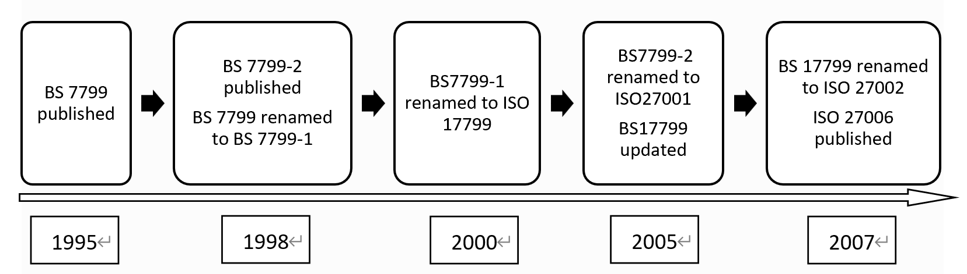
Fig 2.1 ISO/IEC 27000 Timeline
The ISO/IEC 27000 Series is constantly growing. Currently, the ISO/IEC 27000 series of standards has become a global series of common safety standards that are accepted and used by many organizations.
An information security management system is a set of cyclic processes that conform to the Deming Ring, as shown in Fig 2.2. It can also be seen that since the birth of the information security management system, risk assessment and risk control are the focus of the ISO/IEC 27000 standard system, and they not only need to be carried out at the beginning of the establishment, but also need to be carried out repeatedly and cyclically during the operation.
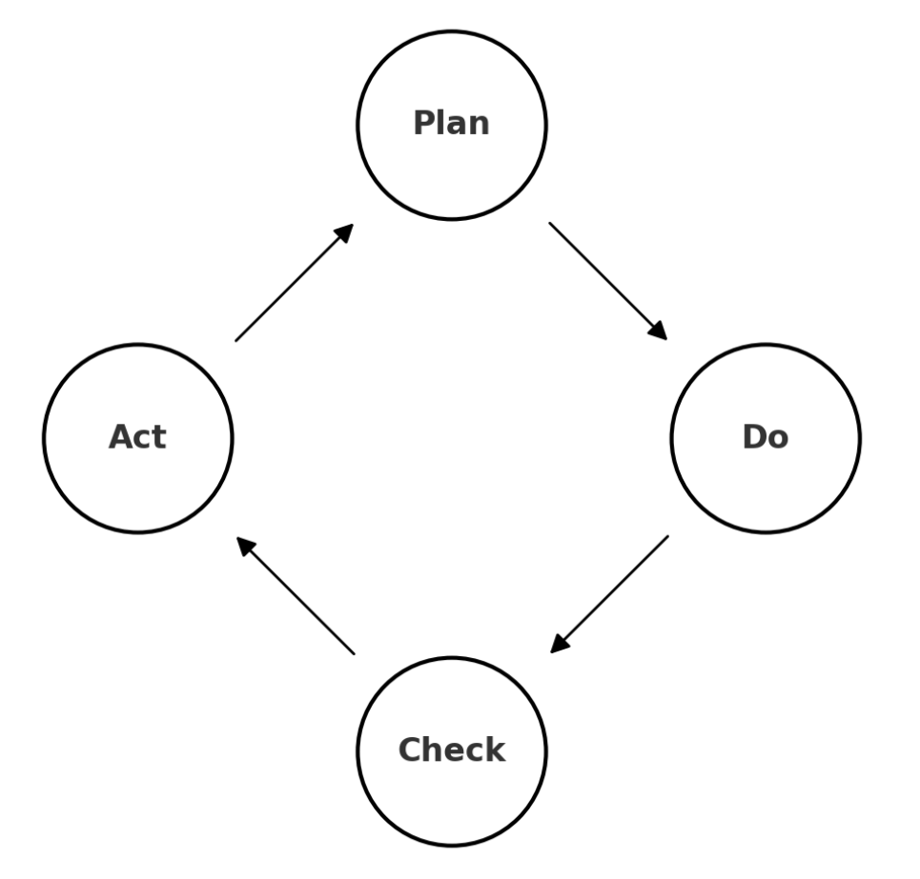
Fig 2.2 ISO/IEC 27001:2005 Deming Cycle

2.2 NIST Security Model
The National Institute of Standards and Technology (NIST) is a federal technical agency that serves industry, promotes industry, and helps it adapt to changes in technology, measurements, and standards. The NIST Security Model is commonly referred to as a framework of information security standards and guidelines developed by NIST to help organizations protect their information systems. The model includes a series of published documents, such as the Special Publications (SP) series, that provide detailed guidance on risk assessment, information system security controls, information security management, and more.

2.2.1 NIST SP800 Series
Of NIST's many publications, the NIST SP800 series is the most widely recognized and used. This series addresses everything from information security governance to specific technical controls.
For instance, NIST SP800-53: Security and Privacy Controls for Federal IS and Orgs provides security and privacy controls for federal information systems and organizations, NIST SP800-37: Guide for Applying the Risk Management Framework to Federal IS involves a risk management framework which is a process used to manage an organization's information security risks.
These documents can be used as a guide and reference for a number of key tasks in the implementation of information security management and are complementary to the ISO 27000 series of standards.

2.2.2 NIST Cyber Security Framework
The NIST Cyber Security Framework (CSF) framework evolved from the Federal Information Security Management Act (FISMA), and it proposes the CSF framework in the form of output standards based on the content and characteristics of FISMA. The NIST CSF states that organizations planning to implement the framework can place their existing security governance framework on top of the NIST framework to discover the gaps with the framework. This means that the NIST CSF is more comprehensive in its coverage than other frameworks such as ISO/IEC 27000[5].
The NIST CSF consists of three components: Framework Core, Framework Implementation Tiers, and Framework Profiles:
- Framework Core:
The Framework Core is a set of cybersecurity activities and outcomes that an organization is expected to achieve in an easy-to-understand language and is characterized by the use of layman's descriptions to enable cross-departmental communication within the organization. Framework Core consists of three parts: Functions, Categories and Subcategories, of which Functions consists of five parallel functions: Identify, Protect, Detect, Respond and Recover.
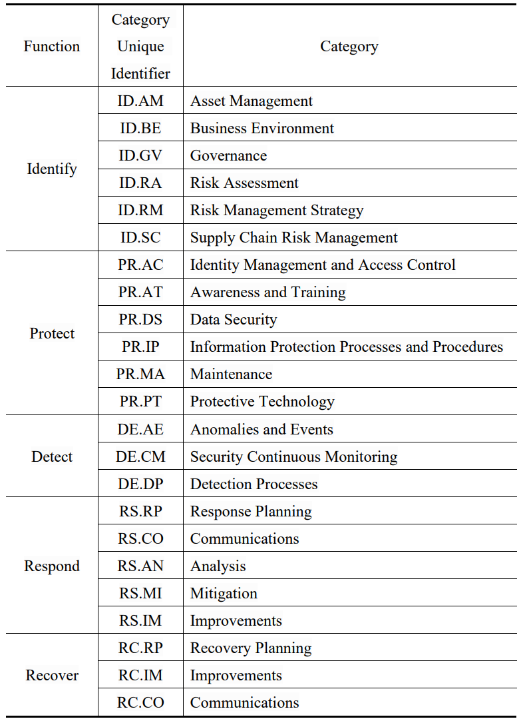
Table 2.1 Function and Category Unique Identifiers
- Framework Implementation Tiers:
Framework Implementation Tiers describe the extent to which an organization's cybersecurity risk management practices achieve the characteristics defined by the framework. Framework Implementation Tiers are categorized into four tiers, Tier-1: Partial, Tier-2: Risk Informed, Tier-3: Repeatable and Tier-4: Adaptive. Organizations should determine which Tier they need to achieve on a practical basis and assess which Tier they are at this stage based on their cybersecurity situation.
- Framework Profiles:
The Framework Profiles contain the organization's unique requirements, goals and risk preferences for information security governance. By comparing the Current Profile with the Target Profile, it is possible to identify the gaps between the organization's current information security management practices and its goals.

2.2 Information Technology Infrastructure Library (ITIL)
The Information Technology Infrastructure Library (ITIL) is a set of standards for IT service management and a comprehensive, consistent and extensible framework for IT service management architecture. The framework summarizes the best practices in IT service management from various industries and provides a standardized process description of them. It also provides a framework-theoretic overview of the transitions between service management modules, forming a systematic set of normative theories to help organizations manage and improve the quality and reliability of IT services.

2.3 Comparison of Models and Frameworks
The ISO 27000 series focuses on information security management systems and has the advantage of being comprehensive and internationally recognized. However, it is more costly to implement and less flexible.
The NIST SP800 series has the advantages of specificity and practicality but is relatively lacking in globalization and adaptability.
NIST CSF focuses on improving cybersecurity for critical infrastructure, which has the advantage of being flexible and actionable, but may have limitations for industry-specific applications.
ITIL focuses on IT service management, which has the advantage of its service lifecycle approach, but may lack specialized guidance for information security.
The NIST CSF's IPDRR model (Identify, Protect, Detect, Respond, Recover) was chosen for its flexibility and comprehensiveness in cybersecurity, which meets current needs for NG.

3 Designing Information Security Governance Approaches for NatureGarden (NG)

3.1 Existing Data Security Problems in NG
Numerous problems NG faces in its actual operation will be analyzed so that solutions can be better tailored to them. Problems are analyzed below:
- High Dependence on Wireless Networks: Almost 95% of NG's network is based on wireless technology, which increases the risk of data leakage. Wireless networks are more vulnerable to attacks such as signal interception and Wi-Fi phishing compared to wired networks.
- Personal Devices’ Access to Company Network: Allowing employees and customers to use personal devices to access the company network may introduce security risks. The security standards and management of personal devices may not be in line with the company's requirements.
- Massive Online and Social Media Presence: While it helps in business promotion, it also exposes more attack surfaces. Social media accounts and websites can be targeted for hacking, such as obtaining sensitive information through social engineering attacks.
- Lack of a Unified Security Policy: The company does not have a unified policy covering its security needs for now. This means that there may be weaknesses in security management, for example, data protection, access control and network monitoring may not be adequately managed and maintained.
- Protection of Intellectual Property and Customer Data: Companies need to protect valuable intellectual property and customer data. Without a clear security strategy and technical protection measures, these assets are highly vulnerable to threats.

3.2 Information Security Framework for NG
To address the problems mentioned above, NG needs to develop a comprehensive information security strategy. The IPDRR model (Identify, Protect, Detect, Respond, Recover), which is extracted from the NIST CFS, is used to design a data security framework for NG.

3.2.1 Identify
- Asset Identification and Management: Considering NG's reliance on the wireless network and allowing access to personal devices, a comprehensive asset management system should be developed that includes all wireless devices and employees' personal devices. Assets and data are categorized by security level, and the higher the security level, the higher the risk. At the same time, it implements full life-cycle management of assets and data, clarifies the risk points of each link, and dynamically exposes risks through process management, security defense technology, security detection technology and other means.
- Risk Assessment: Conduct regular assessments for security risks to wireless networks, potential threats to personal device use, and risks to social media and online platforms.
- Considering that NG is highly dependent on wireless networks, there is a need to identify potential security vulnerabilities in the network, such as weak encryption, unauthorized access, and signal interception.
- As employees may use a variety of personal devices to access the company network, the security of these devices needs to be assessed, including the vulnerability of the operating system, the frequency of security updates and the risk of malware.
- Assess the risk of employees being exposed to phishing attacks on social media and online platforms that could compromise important information, and also analyze the damage that negative content or cyber-attacks on social media could cause to NG's brand reputation.
- Evaluate the risk of internal or external attacks on the company's intellectual property, such as trade secrets, patent information, which may include technology leaks or espionage by competitors.

3.2.2 Protect
- Wireless Network Security Enhancement: Adopt advanced security protocols, such as WPA3[6], to protect the wireless network from unauthorized access and data interception. Implement strict access control of wireless access points, including device authentication and user authorization, to ensure that only authorized users and devices can access the network.
- Personal Equipment Security Management: Monitor and manage personal devices accessing the company's network with Mobile Device Management (MDM) to ensure that they meet the company's security standards[7]. Use virtual local area networks (VLANs) or other network isolation techniques to isolate personal devices from the core business network and reduce potential threats[8].
- Data Encryption and Protection: Encrypt sensitive data that is stored and transmitted, especially data involving customer information and intellectual property using end-to-end encryption techniques, such as the SSL/TLS protocol[9]. Perform strict access control and implement role-based access control (RBAC) to ensure that only authorized personnel have access to sensitive data[10].
- Data Loss Prevention (DLP) Strategies: Use DLP tools to monitor and block unauthorized transfers of sensitive data, as well as classify and tag sensitive data so that DLP tools can effectively identify and protect it.
- Continuous Monitoring and Auditing: Monitor all access and transmission activities to sensitive data so that any unusual behavior can be detected in a timely manner. Conduct regular security audits to assess the effectiveness of existing data protection measures and keep them up to date to address new threats and challenges.
- Staff Training: Regularly train all staff on the basics of network security, including password management, recognizing phishing emails, and safe Internet habits. Educate employees on how to safely use their personal mobile devices to access company resources, including installing security software, regularly updating operating systems, and so on. Training content also needs to be regularly updated to ensure that the latest security threats and protection techniques are covered.
- Promotion of Safety Culture: Raise employees' awareness of cybersecurity by setting up a special Security Awareness Month or Week and by organizing lectures, seminars and interactive activities. Posters and slogans with security tips and guidance in line with NG's information security objectives can be displayed in office areas, and brochures and pamphlets on cybersecurity can be distributed.

3.2.3 Detect
- Network Activity Monitoring: Given NG's heavy reliance on the wireless network, an advanced network monitoring system needs to be deployed to monitor network activity in real time, including traffic patterns, access attempts and potential anomalous behavior.
- Security Monitoring of Personal Devices: Monitor the use of employees' personal devices through the MDM system to ensure that they comply with company security policies, especially when accessing sensitive data. Regularly check security settings and operating system updates for personal devices to prevent security vulnerabilities in older versions.
- Social Media and Online Platform Monitoring: Monitor social media accounts and online platforms to detect signs of information leakage, inappropriate content posting, or brand reputation damage. Use automated tools to monitor and identify potential phishing attacks, especially targeted attacks against employees and company executives.

3.2.4 Respond
- Develop Incident Response Plans: Develop a detailed response plan that includes a variety of possible security incidents, such as data leakage, network attacks, and system failures. The plan should specify the procedures, responsibility allocation, and communication processes for each scenario. Regularly update emergency response plans based on the latest security threats and business changes.
- Establish an Incident Response Team (IRT): Assemble a cross-functional team of IT security specialists, network administrators, legal counsel and communications specialists to handle security incidents. Assign clear roles and responsibilities to IRT members and ensure they are supported with appropriate training and resources[12].
- Communication Strategy and Coordination: Develop an effective internal communication mechanism to notify appropriate personnel and management in time when a security incident occurs. Also develop a communication strategy with customers, suppliers and regulators to ensure that incidents and actions taken can be reported quickly and accurately to external parties when necessary.

3.2.5 Recover
- Develop a Disaster Recovery Plan (DRP): Develop a comprehensive recovery strategy that includes hardware, software, data, and people to ensure that business operations can be resumed quickly in a variety of disaster scenarios. First, a disaster recovery team should be assembled and tasked with developing a policy statement for disaster recovery. Next, conduct a business impact analysis review of the organization in order to identify preventive controls. Next, develop a disaster recovery strategy and produce the appropriate disaster recovery plan documents. Finally, ensure that the disaster recovery plan is adequately tested and monitor compliance with the disaster recovery plan[13].
- Data Backup and Recovery Strategy: Regularly back up critical data, including customer information, financial records, and intellectual property, to ensure the integrity and availability of the data. Ensure that backup data is stored in a secure location, preferably offline or in the cloud, to prevent damage to data in the event of cyber-attacks.
- Post-incident Assessment and Improvement: Conduct a detailed after-action analysis after a security incident has been handled to identify deficiencies and lessons learned in the incident handling process. Based on the results of the after-action analysis, the DRP could be adjusted and improved to enhance the ability to respond to similar incidents in the future.

4 Conclusion
By analyzing and comparing the various information security governance models, it was found that by implementing the IPDRR model, NG can more effectively identify and manage security risks to protect its network infrastructure and sensitive data. This requires NG to continually evaluate and improve their information security policies and ensure that technology and processes are kept up to date with current security threats. In this way, NG is able to enhance its overall information security capabilities and protect its brand and customer data from threats from all sides.

References
- Hayes, Brian. "Cloud computing." (2008): 9-11.
- Subashini, Subashini, and Veeraruna Kavitha. "A survey on security issues in service delivery models of cloud computing." Journal of network and computer applications 34.1 (2011): 1-11.
- Wang, Chi-Hsiang, and Dwen-Ren Tsai. "Integrated installing ISO 9000 and ISO 27000 management systems on an organization." 43rd Annual 2009 international carnahan conference on security technology. IEEE, 2009.
- Disterer, Georg. "ISO/IEC 27000, 27001 and 27002 for information security management." Journal of Information Security 4.2 (2013).
- Almuhammadi, Sultan, and Majeed Alsaleh. "Information security maturity model for NIST cyber security framework." Computer Science & Information Technology (CS & IT) 7.3 (2017): 51-62.
- Reddy, B. Indira, and V. Srikanth. "Review on wireless security protocols (WEP, WPA, WPA2 & WPA3)." International Journal of Scientific Research in Computer Science, Engineering and Information Technology 5.4 (2019).
- Eslahi, Meisam, et al. "BYOD: Current state and security challenges." 2014 IEEE Symposium on Computer Applications and Industrial Electronics (ISCAIE). IEEE, 2014.
- Alabady, Salah A. Jaro. "Design and implementation of a network security model using static VLAN and AAA server." 2008 3rd International Conference on Information and Communication Technologies: From Theory to Applications. IEEE, 2008.
- Satapathy, Ashutosh, and Jenila Livingston. "A Comprehensive Survey on SSL/TLS and their Vulnerabilities." International Journal of Computer Applications 153.5 (2016): 31-38.
- W. Yamazaki, H. Hiraishi and F. Mizoguchi, "Designing an agent-based RBAC system for dynamic security policy," 13th IEEE International Workshops on Enabling Technologies: Infrastructure for Collaborative Enterprises, Modena, Italy, 2004, pp. 199-204, doi: 10.1109/ENABL.2004.22.
- Liu, Simon, and Rick Kuhn. "Data loss prevention." IT professional 12.2 (2010): 10-13.
- Ahmad, Atif, Justin Hadgkiss, and Anthonie B. Ruighaver. "Incident response teams–Challenges in supporting the organisational security function." Computers & Security 31.5 (2012): 643-652.
- Whitman, Michael E., and Herbert J. Mattord. Management of information security. Cengage Learning, 2013.
- Dey, Manik. "Business Continuity Planning (BCP) methodology—Essential for every business." 2011 IEEE GCC Conference and Exhibition (GCC). IEEE, 2011.

