UWTSD
WISA



Soapbox Car
Integrated Project ACHA4008

Daniel Briggs 2312568/ Luke Davies 2305546/ Luke Neame 2310322
11/12/23

Contents
1 Introduction 1
1.1 Justification 1
1.2 Aims 1
1.3 Objectives 1
2 Team Organisation 1
3 Timeline 2
4 Soapbox Car 3
4.1 Designs 3
4.2 Soapbox Background 6
4.3 Material 7
5 Meeting Minutes 8
6 Conclusion 9
7 References 10

Figure 4.1-1 (This image show the first Design) 3
Figure 4.1-2 (This image shows the second Design) 3
Figure 4.1-3 (This image shows the third design) 4
Figure 4.1-4 (This Image is the Design of the steering System) 4
Figure 4.1-5 (Ackerman Steering Formular) (Vogel,J.(2021) 5
Figure 4-6 (this image shows Ackerman steering) (Vogel,J.(2021) 5

Table 3-1 (This shows the timeline plan) 2
Table 4.3-1 (This shows the Cost of the Materials) 5

Introduction
In this project we were given a task to Design a soapbox car and plan what type of materials we would use and why.

Justification
To evaluate how we work as a team and get us working together as a team.

Aims
- Evaluate the Designs.
- Evaluate the Materials.
- Evaluate how we worked as a team.

Objectives
- To complete tasks individually.
- Assemble individual tasks.
- To work and discuss tasks as a team.
- To attend meetings to keep up to date.

Team Organisation
Daniel Briggs (2312568) - DB
- Soapbox Designs
- Materials and Cost
- Timeline Plan
- Meeting Minutes
Luke Davies (2305546) - LD
- Design Ideas
- CAD
Luke Neame (2310322) - LN
- Steering Design
- Design Ideas
- CAD
- Meeting Minutes

Timeline

Table 3-1 (This shows the timeline plan)
Date and Time | What work is done | Initial of who done it | Work Done
09/10/23 | Discuss the team roles | DB, LD, LN | /
16/10/23 | Design the 1st soapbox car | DB | /
16/10/23 | Discuss the first Design | DB, LD, LN | /
16/10/23 | Design the steering System (Ackermann) | LN | /
23/10/23 | Design the 2nd soap Box car | DB | /
23/10/23 | Discuss the second Desing | DB, LD, LN | /
30/10/23 | Design the 3rd soap Box car | DB | /
30/10/23 | Discuss the third design | DB, LD, LN | /
20/11/23 | Discuss what design we will utilize | DB, LD, LN | /
20/11/23 | Discuss what steering we will utilize | DB, LD, LN | /
20/11/23 | Discuss what material we will use | DB, LD, LN | /
04/12/23 | Work out the cost of materials | DB, LN, | /
04/12/23 | Work out how the materials will be used | DB, LD, | /
11/12/23 | Create Word document | DB, LD, LN | /
 | Put design on CAD | LD, LN,
 | Create the Power Point | DB, LD, LN
 | Build the 3d model | LD, LN,

Soapbox Car

Designs
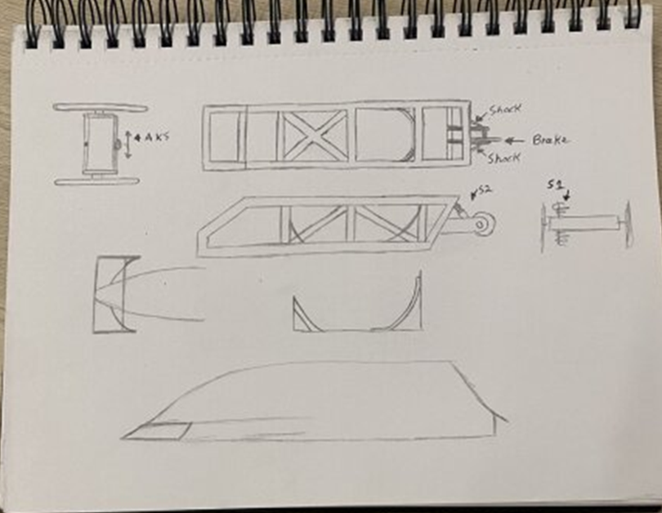
Figure 4.1-1 (This image show the first Design)
In this design we talked about having the soapbox car using 3 wheels instead of having 4 in order to reduce weight and simplify the design. LN suggested we use Ackermann steering because it was a steering system that he was very knowledgeable about.
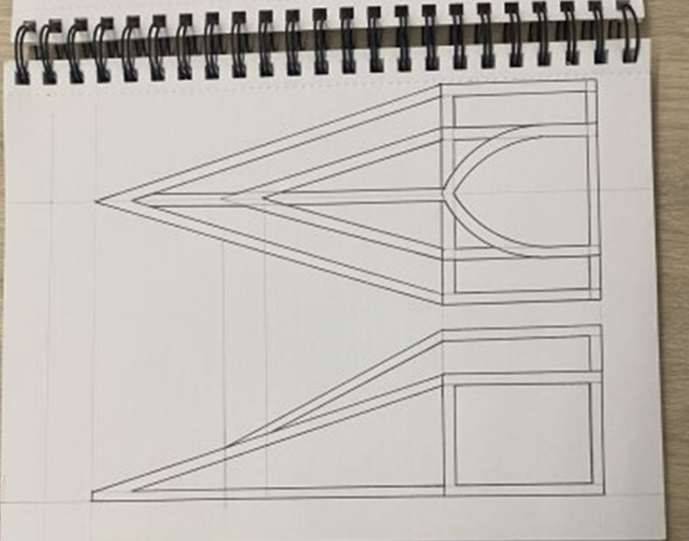
Figure 4.1-2 (This image shows the second Design)
In this design I looked at aerodynamics and the inspiration for this Design was the F-117 Nighthawk (which is a stealth Plane). This design was not selected because of the steering system was too complicated in its design and would have to be advanced for the trike to work.

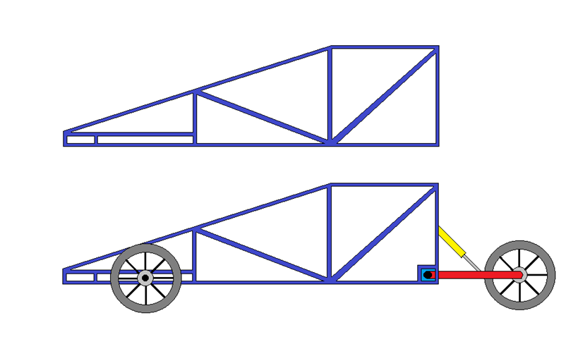
Figure 4.1-3 (This image shows the third design)
This is the third design; it utilizes parts from both designs such as the Ackermann steering system from the first design but also utilizes a similar aerodynamic shape as the second design.

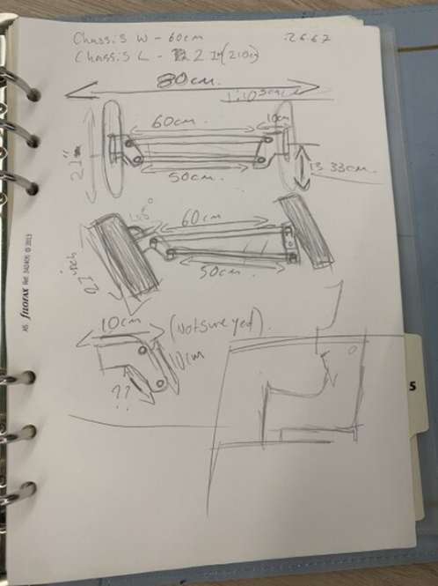
Figure 4.1-4 (This Image is the Design of the steering System)
The steering system is Ackermann steering and was Designed by Luke Neame
What is Ackerman steering?
Ackerman steering is a reliable and cheap steering system that many types of vehicles use, from F1 cars (Anti-Ackerman) to even forklifts.
The most important aspect of Ackerman steering is the turning angles, the inside front tire must be at a larger angle than the outside tire. If we take turn radius as R, Wheelbase as L and track width as T, you can calculate the front steering angle using this formular. (Vogel, J. (2021)
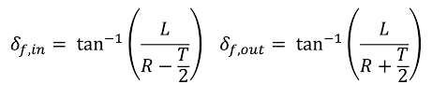
Figure 4.1-5 (Ackerman Steering Formular) (Vogel,J.(2021)
Determining our soapbox rally car in terms of size we can use this formular to create a custom Ackerman steering system which will suit our preferences.
Why we Chose Ackerman Steering as the system for our soapbox car?
Ackerman steering is something most people will come across every day, every car that is currently on the road will most likely use a modified version of the Ackerman steering system. Even though cars do not use pure Ackerman steering. This makes resources and information about this steering system abundantly available for everyone.
One of the most notable vehicles that uses a pure Ackerman steering system are go-karts. Making these systems available for purchase from any reputable go-karting website (Such as Commit Kart Sales). This is where the inspiration came from to use this system in our project and the reason for why I chose Ackerman steering, its cheap, easy, and reliable as it has been around since 1886. The history is fascinating as it was reinvented by Georg Lankensperger in 1886. (Events, Uk.M. & (2021)
The Ackerman steering system is a simplistic steering system, that uses pins and bars on pivot points or an arrangement of linkages, therefore achieving a desired turning circle dependant on the angles and lengths of such components.
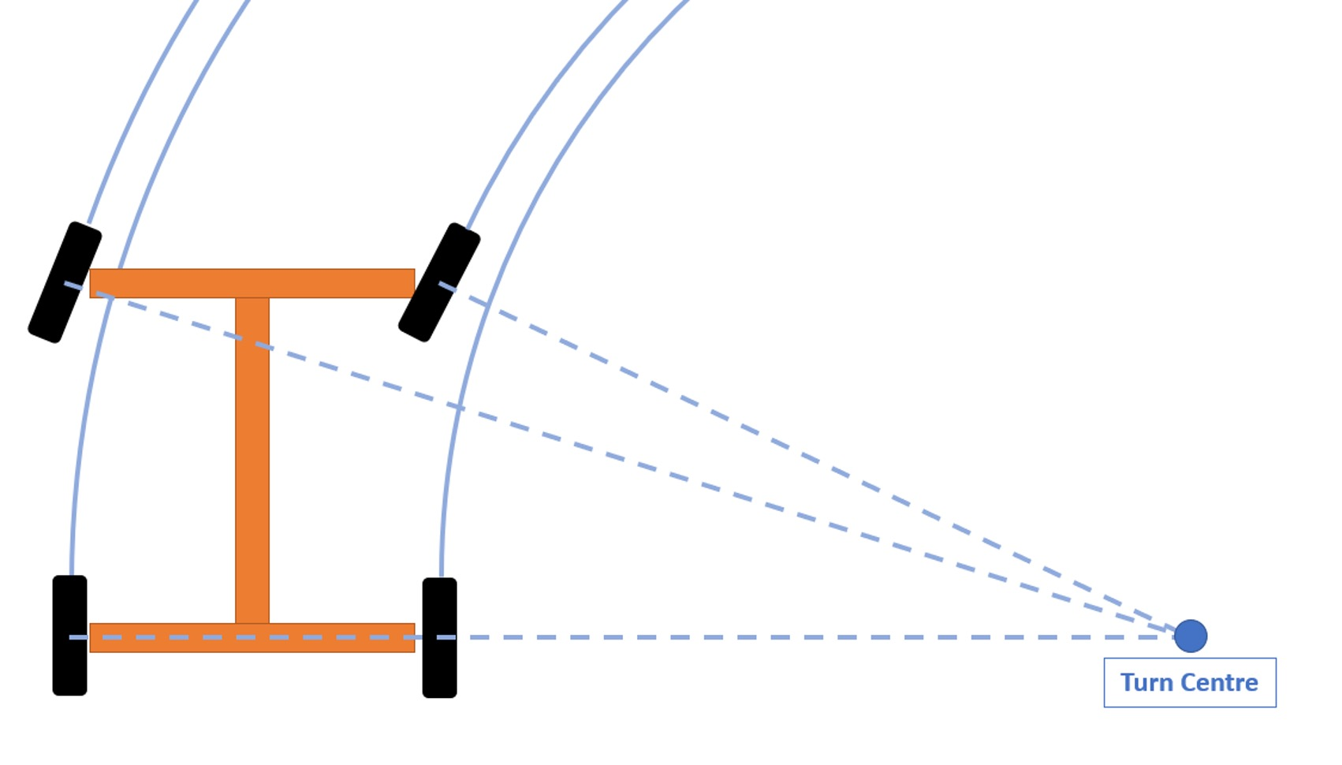
Figure 4-6 (this image shows Ackerman steering) (Vogel,J.(2021)

Soapbox Background
When building a soapbox car, it is often a clever idea to start with a proven design. Which it is why many people start with a bicycle frame or go kart chassis. To ensure that the soap box is stable you want a chassis with a low centre of gravity and want the wheel track as wide as possible to help with cornering. Whist also being too strong enough to withstand the forces faced when going down the course. The weight of the soap box plays a crucial role. You need enough weight to ensure you build up speed when going down the course but too much can affect how the Soap box handles. According to Krazy races you should aim for a total weight of around 70-80 kg, before any additional ballast is added. Weight distribution is also a bit factor when building a soap box. You want the weight to be evenly balanced between the front and rear of the car. As too much weight at the front will cause the car to nosedive when taking on obstacles such as jumps on the course.

Material
Table 4.3-1 (This shows the Cost of the Materials)
 | Cost | Quant | Total
https://www.ukbamboo.com/
4m Natural Bamboo Pole 60/70mm Diameter, Round Pole | £13.88 | 6 | £83.28
4m Natural Bamboo Pole 40/45mm Diameter, Round Pole | £8.32 | 8 | £66.56
2.4m Natural Bamboo Slat 45/50mm Diameter, Slat | £4.80 | 10 | £48.00
https://www.herondrums.co.uk/shoplist/p/pineresin
Pine Resin 60g | £5.00 | 25 | £125.00
https://fabricland.co.uk/product-category/buy-fabric-online/hessian-fabric/
Superior Hessian Fabric (Per Meter) | £4.25 | 8 | £34.00
Hessian Fabric Coloured Yelow (Per Meter) | £3.89 | 6 | £23.34
Hessian Fabric Coloured purple (Per Meter) | £3.89 | 6 | £23.34
https://www.amazon.co.uk/
Baldy's 26" Alloy REAR Mountain Bike Wheel Bicycle MTB | £49.99 | 3 | £149.97
Fincci 26" Bike Tyre 57-559 Foldable with Inner Tube for MTB Hybrid | £39.99 | 2 | £79.98
Complete Bike Brake Set MTB Hybrid Brake | £20.99 | 1 | £20.99
Niome Go-Kart Steering Wheel Kit, Steering Wheel, Gear Rack Pinion Adjustable Shaft Set | £88.84 | 1 | £88.84
Total Cost |  |  | £743.30

The team decided that we wanted to use environmentally friendly materials. So, the soap box car could be easily disposed of after the event, without have a lasting effect on the environment. We decided that the chassis will be constructed using build bamboo. The reason for this is that bamboo has a much higher tensile strength compared to other types of wood and is easily capable of carrying the weight of a driver. Bamboo is also naturally very flexible which we believe will also be beneficial as part of the suspension system. Each section of the chassis will slot together which then we will reenforced with hessian wrap which will add addition strength to the joints of the bamboo frame. As a secondary measure we have also decided to cover the hessian wrap joints with a strong environmentally friendly resin. We will also use both hessian and the resin to construct the body work of the soap box by creating panels in a similar way that carbon fibre panels are created. This will ensure that the body work is as strong as possible whist also being light weight and most importantly biodegradable.

Meeting Minutes
9/10/23 (Daniel Briggs, Luke Davies, Luke Neame and Abdi Elmi Nur)
We decided that DB would design the soapbox cars and then we would discuss improvements and he would try and apply them in the next design also LD would look at materials to implement in the design. LN would come up with the steering system Because he was familiar with this field. AN would look at getting cost for materials together (unfortunately AN didn’t complete this and DB and LN had to completed this assignment). AN and DB went to Screw Fix to get a Catalogue but was told it is all online.
16/10/23 (Daniel Briggs, Luke Davies, Luke Neame and Abdi Elmi Nur)
We look at the first design and discussed possible Materials for the body work and we came up with some improvement suggestions for the design. LN suggested that we use Ackermann steering system in the soapbox car because the system is easy to employ on the car.
23/10/23 (Daniel Briggs, Luke Davies, Luke Neame)
We had a look at DB second design and compared it to the first and decided the second design would be too complicated Because of the Steering system, suspension system and working out the aerodynamics of the soapbox car.
30/10/23 (Daniel Briggs, Luke Davies, Luke Neame)
We looked at the Third design witched used parts from the first and second designs and discussed possible improvements that we could implement to make the design more stable and not at too much weight.
20/11/23 (Daniel Briggs, Luke Davies, Luke Neame)
As a group we decided that the first design was the design we would utilize and the Ackermann steering system would also be used. we would use Bambo and other eco materials in the soapbox car to keep it environmentally friendly. We also discussed Abdi Elmi Nur lack of work and absent from the group and brought this up with Richard Sutton (the lecture for the integrated project) and discussed who was going to cover AN assignment.

Conclusion
Improvements for the next integrated project
- We could have put more designs together.
- We could have had more meetings.
- We could have looked at more alternative materials for our soap-box car.
- We could have researched more into different soapbox cars.

References

Design 1
- Bloodhound. (n.d.). About Bloodhound LSR. [online] Available at: https://www.bloodhoundlsr.com/about-bloodhound-lsr/.
- slingshot.polaris.com. (n.d.). Slingshot: Open-Air Roadster - 3 Wheel Motorcycle | Polaris. [online] Available at: https://slingshot.polaris.com/en-us/.
- www.rcmodelz.co.uk. (n.d.). King Motor KM001 29cc 1/5th Scale RC Baja Buggy. [online] Available at: https://www.rcmodelz.co.uk/king-motor-km001-29cc-1-5th-scale-rc-baja-buggy.html [Accessed 4 Dec. 2023].
Design 2
- Lockheed Martin. (2018). F-117 Nighthawk. [online] Available at: https://www.lockheedmartin.com/en-us/news/features/history/f-117.html.
Design 3
- Harley-Davidson. (n.d.). 2023 Tri Glide Ultra Motorcycle. [online] Available at: https://www.harley-davidson.com/gb/en/motorcycles/tri-glide-ultra.html [Accessed 4 Dec. 2023].
- www.rcmodelz.co.uk. (n.d.). King Motor KM001 29cc 1/5th Scale RC Baja Buggy. [online] Available at: https://www.rcmodelz.co.uk/king-motor-km001-29cc-1-5th-scale-rc-baja-buggy.html [Accessed 4 Dec. 2023].
Ackermann steering
- Vogel, J. (2021). Tech Explained: Ackermann Steering Geometry. [online] Racecar Engineering. Available at: https://www.racecar-engineering.com/articles/tech-explained-ackermann-steering-geometry/.

- cometkartsales.com. (n.d.). Steering Shafts :: Steering Components :: Chassis & Parts :: Comet Kart Sales. [online] Available at: https://cometkartsales.com/Steering-Shafts/ [Accessed 26 Jan. 2024].

- Events, Uk.M. & (2021). The story of Ackermann steering. [online] Tire Technology International. Available at: https://www.tiretechnologyinternational.com/opinion/the-story-of-ackermann-steering.html.
Research
- Limited, S.T. (n.d.). Krazy Races top tips on building a fantastic Soapbox. [online] www.krazyraces.co.uk. Available at: https://www.krazyraces.co.uk/krazy-news/krazy-races-top-tips-on-building-a-soapbox/#:~:text=You%20need%20strong%20wheels%20and.

- Red Bull. (n.d.). How to build a winning Red Bull Soapbox racer. [online] Available at: https://www.redbull.com/gb-en/how-to-build-a-soapbox-car.

