Software Development
ACCA4017
Matthew James
1809299

Table of Contents
Part C 2
1 2
1.1 action plan breakdown 2
1.2 annotated code 3
1.3.0 Asked to play (normal values) 7
1.3.1Asked to play (other values) 7
1.3.2 Asked to play (numbers) 7
1.3.3 selecting card1 (normal values) 7
1.3.4 Selecting card1 (out of range value) 8
1.3.5 Selecting card1 (using letters) 8
1.3.6 Check to see you can pick a card that has already been matched 9
1.3.7Selecting card2 (normal values) 9
1.3.8 selecting card2 (out of range) 9
1.3.9 selecting card2 (with letters) 10
1.4.0 selecting card2 (if selecting same card 10
1.4.1 selecting card2 (if selecting already chosen card) 10
1.4.2 Game over (all matched) 11
1.4.3 Game over (selecting yes to play again) 11
1.4.4 Game over(with faults) 11
1.4.5 Game over (selecting no to play again) 11
1.4.6 array shuffle 12
1.4.7 array being reset 12

Part C

1

Develop a C program to allow the user to play a version of a popular card matching game.

action plan breakdown

- as we are using random, we will need to include more than the standard library, time and stdlib will be needed
- user will be asked if they wish to start the game (y/n)
- function used to shuffle game
- user selects card one (this will be stored in card1 variable (int))
- checks to see if card is already picked
- checked if it has already been chosen before
- fault is added where user doesn’t select a good card
- user selects card two (this will be stored in card2 variable (int))
- checks to see if card is already picked
- checked if it has already been chosen before
- fault is added where user doesn’t select a good card
- variables are compared to see if the array values match
- changes card1 & card2 to -1 value
- adds point to counter
- if not matched, adds 1 to fault counter

- all matched cards
- display how many faults the user had
- user inputs if they want to play again
- function: card gen is ran to recreate array
- function: shuffle is ran to shuffle the values in the array
- points and turned to 0
- faults are turn to 0

annotated code
- #include <stdio.h>
- #include <time.h>
- #include <stdlib.h>

- int pairs[12] = { 1,1,2,2,3,3,4,4,5,5,6,6 }; // sets array values for first time play
- int cardgen(); // prototype for cardgen
- int shuffle(); // prototype for shuffle

- void main()
- {

- int card1; // user input for card 1
- int card2; // user input for card 2
- int point = 0; // points for matching cards
- int fault = 0; // fails of mis-matching cards
- char input; // gets user input to play/replay game
- char cont = 'n'; // decalred to validate if card picked is already been picked before

- printf("Would you like to play match up? (y/n)");
- scanf(" %c", &input);
- shuffle(); // shuffles the cards
- while (input == 'y') // if user inputs to play this will run until they say no 'n'
- {
- while (point != 6) // if points are not 6 meaning if all cards are not matched
- {
- while (cont == 'n') // used to validate card input
- {

- printf("Pick your first card (0-11):\n");
- scanf("%d", &card1); // users picks card 1

- if (pairs[card1] == -1) // checks to see if card 1 value in the array is -1
- {
- printf("You have already chosen that card\n");
- fault = fault + 1;
- }
- else if (card1 < 0 || card1>11) // validation to only accept numbers between 0 & 11
- {
- printf("Sorry out of range\nplease select a number between 0-11\n");
- }
- else
- {
- cont = 'y'; // if the if the card is within the if statement then the user csan pick the second card
- }

- }
- cont = 'n'; // restarts the validation on the second card pick

- while (cont == 'n')
- {

- printf("Pick a different card (0-11):\n");
- scanf("%d", &card2);

- if (pairs[card2] == -1)
- {
- printf("You have already chosen that card\n");
- fault = fault + 1;
- }
- else if (card1 < 0 || card1>11)
- {
- printf("Sorry out of range\nplease select a number between 0-11\n");
- }
- else
- {
- cont = 'y';
- }
- }
- cont = 'n';

- if (card1 == card2) // checks if the user has tried to compare the same card
- {
- printf("You must pick different cards!\n");
- fault = fault + 1; // adds a fault to the counter
- }

- else if (pairs[card1] == pairs[card2] && pairs[card1] != -1) // checks to see if the array values match and do not have the value of -1
- {
- printf("That's a match!\n");
- pairs[card1] = -1; // changes card 1 to -1 value
- pairs[card2] = -1; // changes card 2 to -1 value
- point++; // adds to the point counter
- }
- else
- {
- printf("Sorry no match ;)\n");
- fault++; // another way to add one to the counter
- }
- }
- printf("Congrats you won :D\n you had this many faults %d\n would you like to play again? (y/n)\n", fault); // displays faults at end of game
- scanf(" %c", &input); // gets user input if they want to play again
- cardgen(); // regenerates the array of numbers
- shuffle(); // shuffles the array values around
- point = 0; // sets points back to 0 to play the game again
- fault = 0; // sets faults back to 0 to play the game again
- }

- }

- int cardgen() // card generation function
- {
- int i; // used as a counter

- for (i = 0; i < 12; i++) // runs the for loop 12 times
- {
- if (i == 0 || i == 1) // does the counter == 0 or 1
- {
- pairs[i] = 1; // sets array value(no 0 to 1) this itterates through the code so that the pairs are established
- pairs[i] = 1;
- }
- if (i == 2 || i == 3)
- {
- pairs[i] = 2;
- pairs[i] = 2;
- }
- if (i == 4 || i == 5)
- {
- pairs[i] = 3;
- pairs[i] = 3;
- }
- if (i == 6 || i == 7)
- {
- pairs[i] = 4;
- pairs[i] = 4;
- }
- if (i == 8 || i == 9)
- {
- pairs[i] = 5;
- pairs[i] = 5;
- }
- if (i == 10 || i == 11)
- {
- pairs[i] = 6;
- pairs[i] = 6;
- }
- }

- return i; // used to return back to main would not do it without

- } // this regenerates the array to the default 1,1,2,2 etc

- int shuffle()
- {
- int i; // counter
- int low = 0; // lowest
- int high = 12; // highest
- int myrand1; // random value no1
- int myrand2; // random value no2
- int temp; // temp value to store an array value while swapping around
- srand(time(NULL)); //seed randomness

- for (i = 0; i < 40; i++)//shuffles the card 40 times

- {
- myrand1 = rand() % (high - low + 1) + low; // formula for random value between 0 and 12
- myrand2 = rand() % (high - low + 1) + low;

- temp = pairs[myrand1]; // stores value that is random in temp

- pairs[myrand1] = pairs[myrand2]; // random value will replace random value 2
- pairs[myrand2] = temp; // random value 2 will become the temp
- //this code stores a value within the 'temp' variable and then swaps it around so that the array jumbles up
- }
- return i; // used to return abck to the main
- }

1.3.0 Asked to play (normal values)
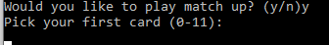
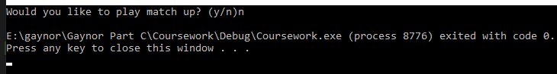
Result: ran as expected, game continues to run

1.3.1Asked to play (other values)
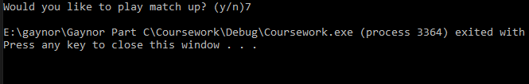
Result: ran as expected, only accepts ‘y’ to start the game

1.3.2 Asked to play (numbers)
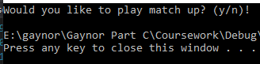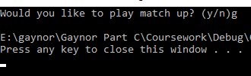
Result: Game broke, ran as expected as no validation has been done

1.3.3 selecting card1 (normal values)
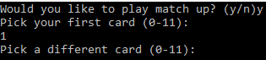
Result: ran as expected, game continues

1.3.4 Selecting card1 (out of range value)
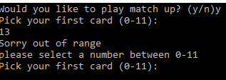

Result: ran as expected, user stopped on card selection1 and asked to re-input value for card 1 selection

1.3.5 Selecting card1 (using letters)
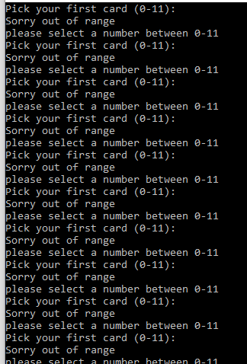
Result: Ran as expected, causes program to crash as not validated.

1.3.6 Check to see you can pick a card that has already been matched
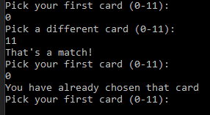
Result: Ran as expected, asks users to input another card1 selection as already chosen

1.3.7Selecting card2 (normal values)
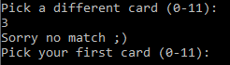
Result: ran as expected, value accepted, no match was made

1.3.8 selecting card2 (out of range)
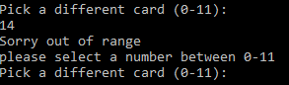
Result: ran as expected, asks user to input value between range

1.3.9 selecting card2 (with letters)
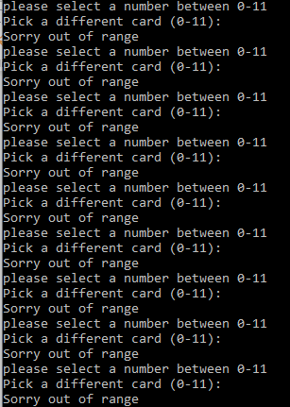
Result: ran as expected, no validation in for letters

1.4.0 selecting card2 (if selecting same card
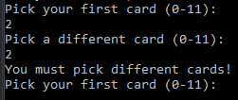
Result: ran as expected, asks user to select new card

1.4.1 selecting card2 (if selecting already chosen card)
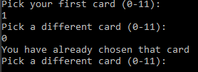
Result: ran as expected, asks user to select a different card

1.4.2 Game over (all matched)
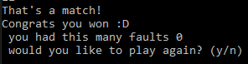
Result: ran as expected, displays faults, asks user to play again.

1.4.3 Game over (selecting yes to play again)
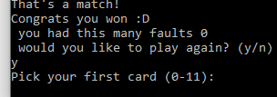
Result: ran as expected, starts game again

1.4.4 Game over(with faults)
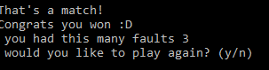
Result: ran as expected, faults added when failed to match cards

1.4.5 Game over (selecting no to play again)
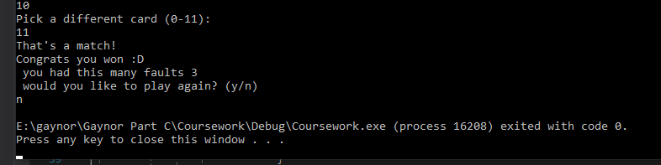
Result: ran as expected, game ends

1.4.6 array shuffle
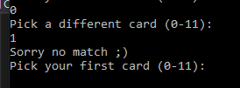
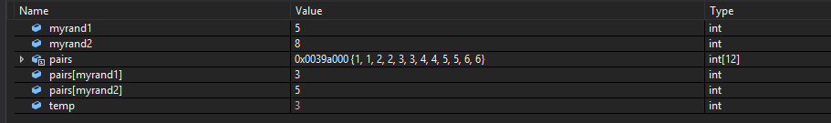
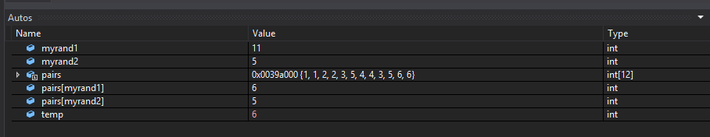
Result: ran as expected, after matching all cards, array was shuffled so that they cannot select the same combinations to match cards.

1.4.7 array being reset

Debug view of array being reset


Result: ran as expected, reset array to default values

