Charlie Williams (2235685)
Computing (Networks and Cyber Security)
Computer Architecture and Operating Systems

Operating Systems

Table of Contents
- Introduction
- Key Functions of Operating Systems
  - System Resource Allocation
- Windows CLI Commands
- Linux CLI Commands
- Bat Scripting
- Bash Scripting
- Appendix
  - OS Tutorial 1
  - Evidence of Engagement- MS Learn Powershell
- Reference List

Introduction
Hello! I hope you are well. The warmest of welcomes to my report on computer architecture and operating systems. Herein, I will discuss and reflect on various aspects of operating systems, such as their key functions, CLI commands within those OS, and a brief example of scripting within Linux and Windows. A full list of the contents of this report can be viewed in the table of contents above. Appended to the end of this report is the tutorial activity from OS Tutorial 1, and some screenshots of my experience with Microsoft Learn’s Automating Tasks with PowerShell course.

Key Functions of Operating Systems

At the core of the vast majority of modern computer systems is the operating system. They are designed to initiate and manage hardware and software on a computer, and essentially facilitates the way we work today, often with an array of different instances of software/hardware active at once.
In line with the article written by geeksforgeeks.org [3], the OS generally handles these tasks:
- Memory Management- the OS manages the main memory, which is known as fast storage, and it is generally where programs are executed.
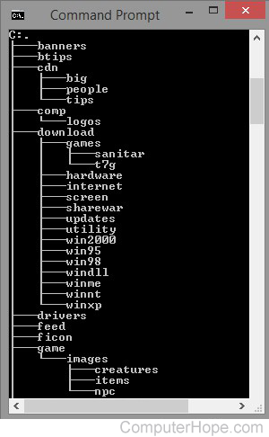
- Processor Management- The OS dictates the amount of time each process can access the processor, and what order they do so. It oversees the allocation of jobs to the processor and ensures sufficient time is provided to allow the processor to complete the jobs.
- Device Management- the OS manages communication to and from devices, using their respective drivers as intermediaries. As part of this role, the OS will allocate a program to each device to be the Input/Output controller and uses these to keep track of all the different devices in use simultaneously. It also dictates what processes can access what devices at any given time.
- File management- The OS performs file management activites on file system directories. It must track where information is stored, the status of said information/file etc. It also manages the security of these files by restricting access to these files.
- User Interface/Command Interpreter – The OS acts as the intermediate between the user and the hardware on the computer. This can either be as a GUI (graphical user interface), such as the one you are likely reading this essay on right now, or through a command line interface.
An example file directory from ComputerHope.com
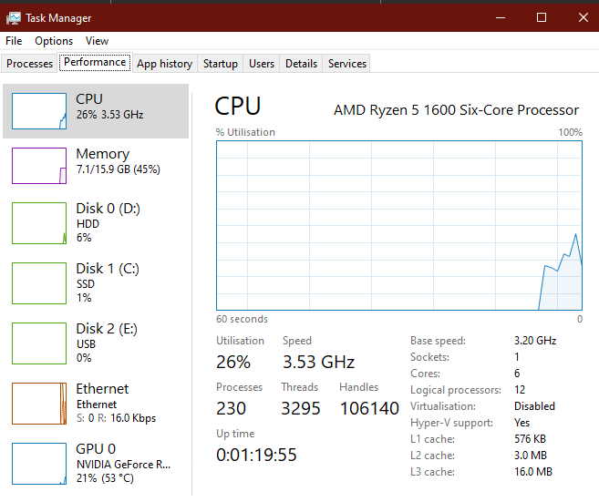
- Booting- the OS oversees the process of starting or restarting the machine.
- Security- The OS is responsible for the security of users’ data through various techniques, such as encryption [5], password protection, firewalling and vulnerability monitoring.
- System Performance Monitoring- It is the responsibility of the OS to monitor, control, and optimise the performance of the computer. A large part of this is resource allocation, which I have covered in greater detail below.
- Error Detection- the OS constantly checks the system for errors, malicious activity, and damage. Detected problems in the system will usually be flagged and an alert sent to the respective user for investigation and remediation.
An active Window of task manager, wherein I can see basic details of what processes are using what resources, the performance of the computer split down into various components like CPU, memory etc.
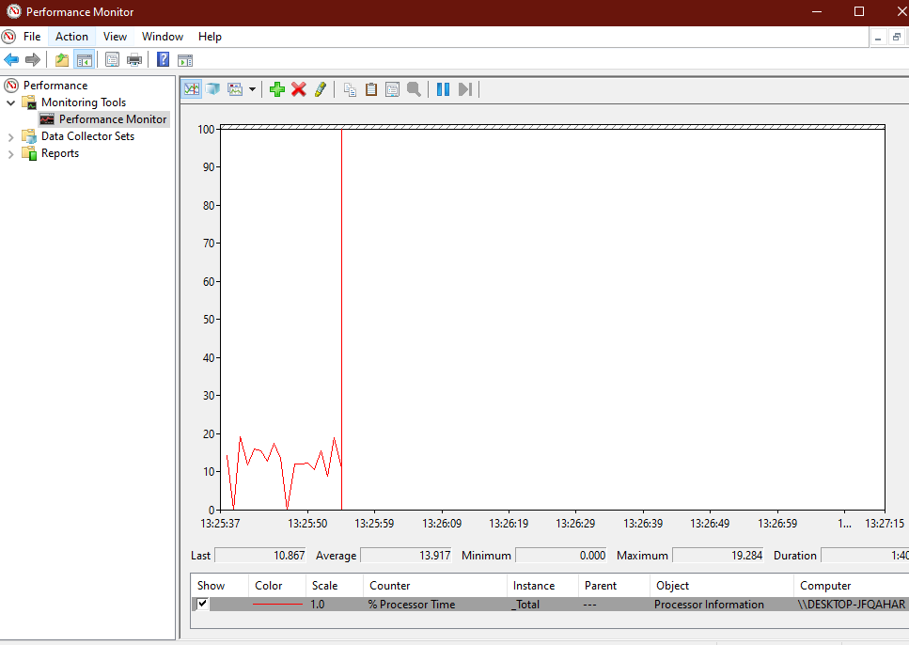
- Basic Computer Tasks- The use and management of peripheral devices is overseen by the OS. This includes devices such as the keyboard, mouse, and printers.
- Network Management- oversees the traffic to and from the computer. Manages data packaging, addressing, and also manages the security of information sent to or from networks.

This is performance monitor, which houses several monitoring tools. This one is performance monitor, which is currently showing my computer’s processing time in a graphical view.
System Resource Allocation
One of the main things that an operating system oversees is system resource allocation. The OS will ensure that each program running on your computer is sufficiently supplied with the necessary resources for it to run effectively. These system resources are often things like CPU usage, storage, memory, energy and network resources, disk, etc. It is also the OS’ role to prioritise between these applications and to optimise performance. It is necessary for the OS to allocate these resources in a way that “maximizes the overall performance and satisfaction of the system, while avoiding conflicts, waste, or starvation.” [1]

The next logical question is “how does the operating system prioritise some programs over others?”, and I will be using LinkedIn’s article on OS resource allocation [1] to help me answer it. The operating system will utilise a series of processes and policies in order to decide what programs get what resources. Some examples of these are:
- First come, first served (FCFS) (more info on this below)
- Shortest Job first (SJF)
- Priority
- Round Robin [1]
The OS uses these policies to work out what gets the resources, when, and for how long. It also uses a variety of mechanisms to enable these applications to run simultaneously. Examples of these would be:
- Multiprogramming – enables the use of multiple programs simultaneously by alternating allocated resources between them rapidly. This should allow the use of these programs to be as seamless as possible.
- Multitasking- Similarly to multiprogramming but on a lower level, enables multiple processes within one piece of software to be run simultaneously.
- Multiprocessing – Similar to the previous two, this process uses multiple processors or cores to run multiple programs and processes in parallel to each other.
- Virtualization – The process of creating a virtual layer within the machine that inherits some of the machine’s total divided resources. Used for virtual machines.

First Come, First Served, also known as First in, First out (FIFO) or First come, first choice (FCFC) is an algorithm employed in OS and networks to “efficiently and automatically execute queued tasks, processes, and requests by the order of their arrival.” [2]. FCFS is one of the most simple, predictable, and efficient types of these algorithms.

Windows CLI Commands

The next section of my essay will be dedicated to a series of batch commands. I will be researching and documenting the functions, and uses each command has. I want to prioritise looking for commands that will benefit me in my line of work, so I am mostly going to be looking at networking commands, such as ipconfig, nslookup, ping etc. Simplilearn [6] has a good section that displays some of the networking commands I intend to utilise for this section, but I will be supplementing the use of other sources to provide greater detail on each command.
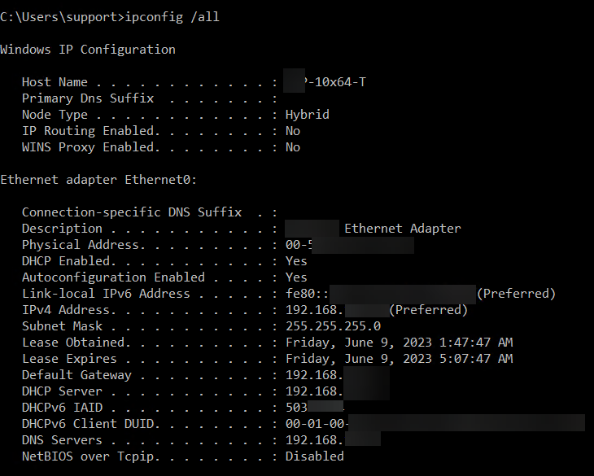
- Ipconfig- Ipconfig is a command used to view TCP/IP network configuration and performs a refresh on DHCP and DNS settings [7]. Ipconfig also supports the switch /all, which displays considerably more information. Ipconfig shows IP address, subnet mask, and default gateway be default. /all adds information such as MAC addresses, DHCP connections, lease times, and details on IPV6 [8]. This command is used frequently by all levels of IT professionals, but especially network engineers.
- Nslookup – Nslookup is another networking tool used for querying and providing information on your DNS infrastructure [9], or to issue queries to other servers.
Ipconfig /all being executed in the command prompt, from intermedia.com [I2]
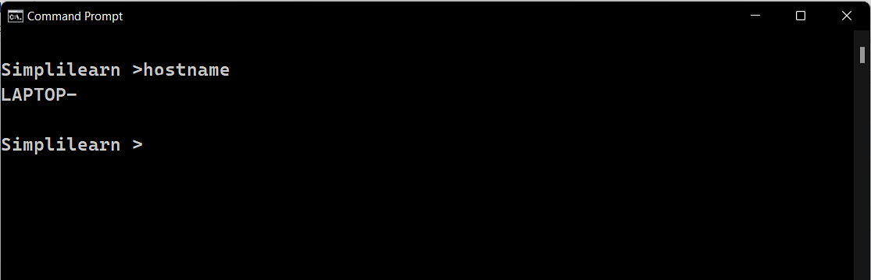
- Hostname- the hostname command is a simple yet very effective and helpful one. It displays the hostname of the device the command is executed on. This is usually a much faster way of getting the hostname than without command prompt, as you would usually need to dig through system settings to find it.
- Ping – ping is another simple but very helpful command. Ping sends a package to a specified domain or IP address, and then measures the time taken for the packet to bounce back. This enables the user to measure the network speed between two hosts. Ping by default will send 4 packets, but you can use the switch -t to continue sending until interrupted [10]. Ping also has several other switches that are less frequently used.
An example of the hostname command from simplilearn [I3]
- Tracert – Tracert is another command frequently used in networking. Like the name suggests, traces the route taken during transmission of the data packet to a destination host [6]. It provides numbers of hosts transferred through, time taken between hosts, and host information such as hostnames (if applicable) and IP addresses.
- Netstat – Netstat displays active TCP connections, listening ports, and IP information such as IPV4, IPV6 and IP routing [11]. It also has various switches, such as -e, which displays statistics for ethernet specifically.
- ARP – ARP, or address resolution protocol, displays how IP addresses are mapped to the computer’s MAC address. [6]
- Systeminfo- Systeminfo is another self-explanatory command. It displays the specs and details of the system, including hostname, registered owners/organizations, and hardware details such as processor.
- Nbtstat- Nbtstat displays NetBIOS over TCP/IP protocol statistics [12]. It is mainly used for diagnosing issues with the NetBIOS name resolution [13]. This command is used considerably less than previous commands, as it is part of the NetBIOS over TCP/IP networking protocol which is used for the integration of legacy computer which rely on the NetBIOS API [13].
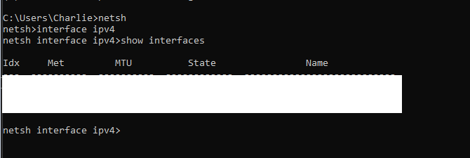
- Netsh- netsh is a command line utility used for displaying and modifying network configuration for the host computer or remote computers. The netsh commands itself enters the netsh (net shell) command shell, in which commands are run. [14]
Me running netsh commands on my machine

Linux CLI Commands

For this section, I intend to cover some basic linux OS CLI commands. Similarly to the previous section, I intend to focus on commands that are related to my line of work, which means they mostly will be related to networking.
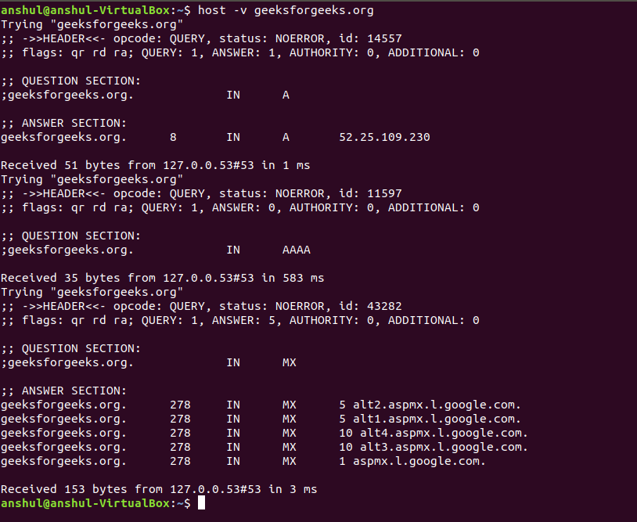
- host- the host command in Linux is similar to the nslookup command in Windows, as they both are used for DNS query operations. The command has several options that show different information, such as -l, which will list all hosts in a domain using AXFR. This requires you to be an admin or a node server. [15]
“AXFR is a protocol for ‘zone transfers’ for replication of DNS data across multiple DNS servers. Unlike normal DNS queries that require the user to know some DNS information ahead of time, AXFR queries reveal resource records including subdomain names…” [16]
Screenshot of the host command being used on a linux machine, from geeksforgeeks.com [I4]
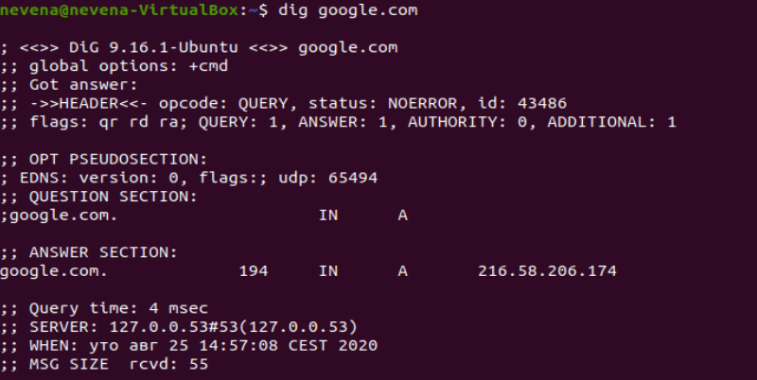
- Nc- nc, or netcat, is a powerful and versatile command. It is used for linux commands related to TCP or UDP [17]. It can also be used for port related operations, such as port scanning, port redirection, and creating listening connections on a port. By nature, it has a huge variety of uses, including network debugging, exploration, and creating connections [18].
Screenshot of the dig command from phoenixnap.com [I5]
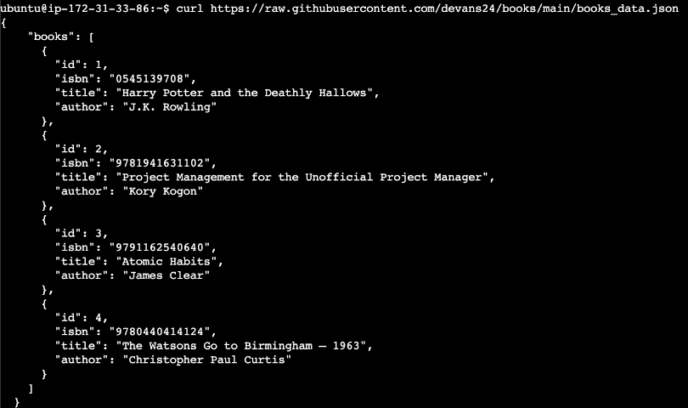
- Dig- dig, or domain information groper [19], is a command in Linux used to gather DNS information. It is primarily used for network debugging.
- curl- curl, also known as Client URL or cURL is a Linux CLI command that facilitates data transfer between devices and servers.[20]. The command sends a request to the specified URL and the data sent.
- Pwd- returns the full path for the current working directory. [21]
- Ls- usually used in conjunction with pwd, lists the contents of the current directory.
Screenshot of the curl command being run to fetch a list of books from github from hubspot.com [I6].
- Rmdir- rmdir will delete an empty directory. Rmdir -r can be run to delete a directory with files still present within. This operation requires sudo privileges [22].
- Mkdir- mkdir will create a new directory within the current directory. By default, the syntax for this command is mkdir <directory name> [22], however it is also possible to create a directory somewhere else by replacing the directory name with the theoretical path for your new directory. For example, if I wanted to create a new directory at file path C:\Users\CWilliams\Documents\University called Operating Systems, the command would be mkdir C:\Users\CWilliams\Documents\University\Operating Systems.
- Ps- displays the currently running processes of the user and terminal [23]. It includes details such as the process ID, terminal associated, elapsed CPU utilisation time, and the executed command line for that process.
- Wget- wget is used for downloading files from the internet using the terminal. The downloading process is a background process [22].

Bat Scripting

For the next part of my essay I will be documenting the process in which I have written a .bat script within Windows. My script is a short text based game set in the fantasy land of Gloobenfenark. If you would like to play the game yourself, a link is available here: bat game.bat
As with other games of this nature, the bulk of the game is built off text input and output. I will document the decisions I made with my code as I created it.
First, I turn off Echo, using @Echo off. This causes the rest of my code to be executed silently and therefore will not disturb the other output on screen. This is necessary for most text based games.
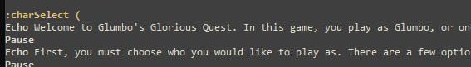
Next, I use labels for some of my lines within the script. This enables me to both keep track of where certain things happen and where I am in the script, and also enables me to go back to those lines if necessary. For example, the first of my labels is called :charSelect, which is where the player will decide what character they would like to play as during their journey through Gloobenfenark. By setting this line as a label, I can return users to the character select at any point [24]. The character select itself is essentially all meaningless. The game itself is a joke, as you are unable to pick anyone except Terry, the boring and forgettable character who no one remembers. Picking Terry causes the game to congratulate you and compliment your character selecting abilities before closing. The game pauses between each line to prevent a wall of text being prevented all at once and to pace out the game a bit.
An example of one of these labels in my code
After the game prints the different characters and their features, it awaits user input, and tells you to pick a character. Your input is saved as, “character”. This will be used later. In .bat, variables are used with % [25], so within the script character is called at various points with %character%.
If %character% is equal to Terry (case sensitive), then the script goes to :terryIntro, which is a label I have further down into the script. This part essentially congratulates you and closes the program. I am relying on the fact that Terry is the least interesting character in the character select screen and no one should really be picking him the first time around, as this would result in an instant closure to the program.
Picking anyone else causes the game to go through a variety of prompts trying to convince you to change your mind and play as Terry instead. As part of this, it mocks your character choice, bringing up the %character% input from before.

Bash Scripting

Next, I intend to create a Linux script. I am quite inexperienced with Linux, so I am hoping this will help me learn. My goal with this script is to create a program that will allow me to create reminders. There are a few requirements for the script:
- Give a brief introduction on the purpose of the program
- Ask user for some information. First, ask user if they would like to save to current directory, which looks for Y/N input. If N, ask user for directory path and browse to that location. Also ask if a new directory needs to be created for the reminders.
- Ask user for input for subject and title, then ask user for details on what the reminder is.
- Write a .txt file in the current directory with the details provided by the user.
To write my script, I intend to use an online linux terminal. I am currently using cocalc.com as it offers an online terminal that suits my needs [26].
First, I need to set up a way to for the user to input variables. Input is different to .bat scripting in that you do not need to add switches or set variables with input, instead, I can just do read (variable), which will then prompt the user to input and set that as the variable. This is considerably simpler than bat [27]. I also want to be able to pause the script from time to time, similar to my .bat script, to allow the text to flow and not present the user with a wall of text. This can be done with sleep (duration) [28].
Next, the “if” and “or” statements. I have found a couple of helpful articles online which take the form of questions asked by beginners similar to myself and answered by the online community for linux. [29] [30].
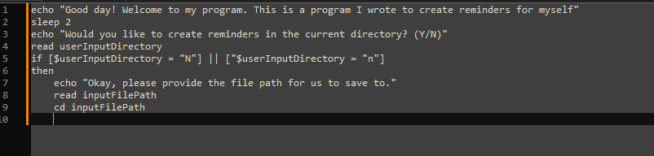
Here is my script so far. I’m not sure if this would be the correct approach as I don’t have a tremendous amount of experience working with new scripting languages, but I’m attempting to build out the skeleton for my script, and then debug it later on.
My script so far, largely untested
Unfortunately, I have struggled to find somewhere to test the script and am unable to get a Linux virtual machine running on my machine. I will include the full script below, thought it seems at this time I will be unable to debug it.

echo "Good day! Welcome to my program. This is a program I wrote to create reminders for myself"
sleep 2
echo "Would you like to create reminders in the current directory? (Y/N)"
read userInputDirectory
if [$userInputDirectory = "N"] || ["$userInputDirectory = "n"]
then
echo "Okay, please provide the file path for us to save to."
read inputFilePath
cd inputFilePath
fi
echo "Would you like to create a new directory? (Y/N)"
read inputND
if [$inputND = "Y"] || [$inputND= "y"]
then
mkdir Reminders
cd Reminders
echo "Reminder title?"
read fileNameInput
Echo "Reminder subject?"
read inputSubject
echo Almost done, input the body of the reminder:
read fileBody
if [ -e $fileNameInput ]; then
echo "A file with that name already exists."
fi
echo -e "$inputSubject\n$fileBody > $fileNameInput.txt

Conclusion

There have been a few major findings during the creation of this essay. The main thing I learned about was the way that operating systems allocate resources between software/hardware and how it can prioritise between them, and some of the algorithms used, such as First Come, First Served or First come, first choice (FCFC).

I also learned a large amount about bash and bat scripting, which I had not done before, and I think will be beneficial for me in the area I work in.

Appendices

OS Tutorial 1
There are a variety of different types of operating systems used today. Some examples would be Microsoft Windows, Linux, and macOS, which are used by billions of people and devices worldwide. I’ve listed some of the major players below and included some information on what they excel in where they are typically used.

- Microsoft Windows- Windows is, by a wide margin, the most widely used operating system. With a market share of 71.29% [1], familiarity with Windows is a given among everyone who use computers, professionals or not. Windows is defined by strong versatility, compatibility with other devices, and an easy to digest GUI, which makes it more popular among those who prefer GUI over CLI interfaces. Being the most widely used operating system also means that Windows has the largest range of software/hardware available for use. However, this also means that more vulnerabilities are discovered in the Windows operating system, and they are attacked more often [2].
- macOS- macOS boasts Apple’s typical sleek, minimalist design, focused on solid graphical interfaces and high performance [1]. Mac is typically more expensive than other operating systems [2].
- Linux- Linux is a UNIX-based operating system that is primarily used by IT professionals. It is free, open source, and typically very stable [3]. The main downsides of Linux would be its smaller catalogue of software compared to other OS.
- ChromeOS- ChromeOS is primarily used with the appropriately named Chromebook and other tablets and netbooks [1]. It is a secure, easy to understand operating system.
- Android- Android is the most widely used operating system for mobile devices. Android devices typically have greater customisation and helpful widgets. The main downside of Android compared to its rival, iOS, is that Android usually has more inconsistent hardware. iOS devices are usually very solid pieces of hardware, with good security, and excellent long term performance and battery life. Android devices do have a great amount of excellent hardware, however, they also have considerably more devices of lower quality.
- iOS- iOS devices share lots of the macOS’s strengths. They maintain the sleek design of the Mac, along with the excellent usability and performance.

- https://online.keele.ac.uk/names-and-types-of-computer-operating-systems/
- https://en.woodcessories.com/blogs/news/macbook-vs-windows-comparison
- https://www.ionos.co.uk/digitalguide/server/know-how/linux-vs-windows/
- https://www.makeuseof.com/android-pros-and-cons/

Automate Administrative Tasks by using Powershell- Microsoft Learn
I’ve chosen to begin the Automate Administrative Tasks course on Microsoft Learn. I would like to be able to use it efficiently as I believe it would greatly increase my skillset.
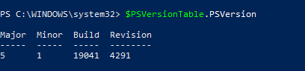
$PSVersionTable reveals information about your version of Powershell. You can use a full stop to limit the information to a specific property. In this example, I’ve limited it to PSVersion.

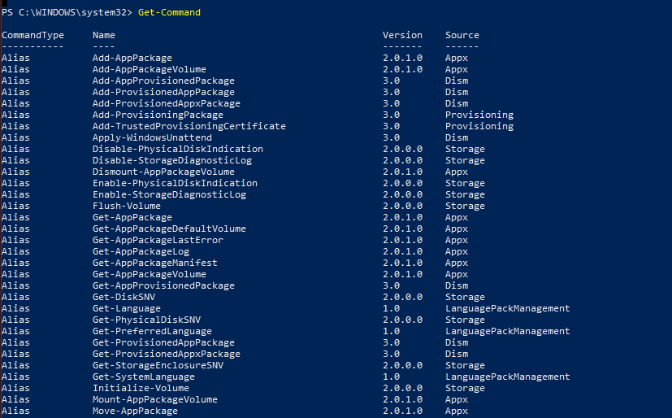
Cmdlets are an essential part of PowerShell. They are used in a “verb-noun” format, which means that you can use another command, Get-Verb and Get-Command, Get-Help, and Get-Member can assist with finding more commands or to try and figure out what the commands do.

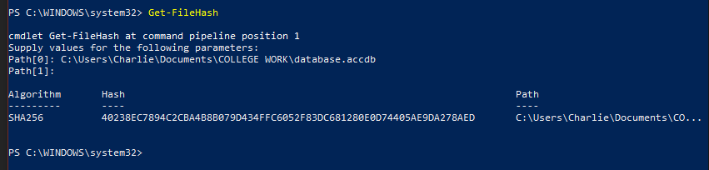
An example of me using a cmdlet is here. It enables me to obtain the SHA-256 hashes for various files, which is very helpful for the area I work in.


Here is the module achievement I have obtained from completing the first module of this course.

Reference List: (fix formatting)
Operating system resource allocation:
- https://www.linkedin.com/advice/0/how-do-you-allocate-resources-different-applications
Tentative:
An article on LinkedIn about OS system resource allocation
- https://www.indeed.com/career-advice/career-development/types-of-operating-systems
- https://www.geeksforgeeks.org/functions-of-operating-system/
- https://www.techopedia.com/definition/23455/first-come-first-served
- https://ico.org.uk/for-organisations/uk-gdpr-guidance-and-resources/security/encryption/encryption-and-data-storage/#:~:text=Most%20modern%20operating%20systems%20have,the%20user%20accesses%20the%20device.
Windows CLI Commands
- https://www.simplilearn.com/tutorials/cyber-security-tutorial/understanding-the-networking-commands
- https://en.wikipedia.org/wiki/Ipconfig (sense checked for obvious reasons)
- https://www.quora.com/Whats-the-difference-in-the-command-prompt-between-ipconfig-and-ipconfig-all (sense checked)
- https://learn.microsoft.com/en-us/windows-server/administration/windows-commands/nslookup
- https://www.itprotoday.com/compute-engines/what-switches-can-be-used-ping
- https://learn.microsoft.com/en-us/windows-server/administration/windows-commands/nbtstat
- https://en.wikipedia.org/wiki/NetBIOS_over_TCP/IP (sense checked)
- https://learn.microsoft.com/en-us/windows-server/networking/technologies/netsh/netsh-contexts#running-netsh-commands
- https://www.geeksforgeeks.org/host-command-in-linux-with-examples/
- https://www.cisa.gov/news-events/alerts/2015/04/13/dns-zone-transfer-axfr-requests-may-leak-domain-information
- https://www.tecmint.com/netcat-nc-command-examples/
- https://www.computerhope.com/unix/nc.htm
- https://www.geeksforgeeks.org/dig-command-in-linux-with-examples/
- https://blog.hubspot.com/website/curl-command
- https://www.hpc.iastate.edu/guides/introduction-to-hpc-clusters/linux-commands-in-more-detail/pwd-and-ls
- https://www.geeksforgeeks.org/basic-linux-commands/
- https://www.baeldung.com/linux/ps-command
- https://learn.microsoft.com/en-us/windows-server/administration/windows-commands/goto
- https://stackoverflow.com/questions/10552812/defining-and-using-a-variable-in-batch-file
- https://cocalc.com
- https://ryanstutorials.net/bash-scripting-tutorial/bash-input.php
- https://stackoverflow.com/questions/21620406/how-do-i-pause-my-shell-script-for-a-second-before-continuing
- https://ryanstutorials.net/bash-scripting-tutorial/bash-if-statements.php
- https://unix.stackexchange.com/questions/657941/how-to-create-a-bash-script-with-alternative-of-goto-and-labels

Image References
(Image references are referenced with I followed by a number)
I1. https://www.computerhope.com/jargon/d/director.htm
I2. https://support.intermedia.com/app/articles/detail/a_id/27175/~/how-do-i-use-ipconfig-in-the-command-prompt-or-terminal%3F
I3. https://www.simplilearn.com/tutorials/cyber-security-tutorial/understanding-the-networking-commands
I4. https://www.geeksforgeeks.org/host-command-in-linux-with-examples/
I5. https://phoenixnap.com/kb/linux-dig-command-examples
I6. https://blog.hubspot.com/website/curl-command

