Charlene Griffiths
Student number: 1904882

Targets | How you have worked on this | An example can be found on
Target 1
Target 2
Target 3
ECAD6009 Learners, Schools, and Communities: where am I teaching?

Contents
Assignment Title 2
Introduction 3
Literature review 3
Reflection and evaluation 7
Conclusion 8
References 10
Appendices 14
Appendix 1- Rights of the Child 14
Appendix 2- Courses identified for staff 15
Appendix 3- ALN Provision Triangle 15

Assignment Title

Component 2: How a school develops one aspect of its SDP: a report that critically reflects on the actions, impact, and evidence base.

Introduction

Schools need to ensure that all learners have an equal chance to achieve their potential and support all learners to overcome barriers and challenges in developing all skills through the school encouraging high aspirations from a thoughtful and active leadership. These qualities can be seen within a School Development Plan (SDP) (Welsh Government, 2014; Welsh Government, 2015; Estyn, 2018). This assignment will critically reflect a priority within an SDP based on actions, impact, evidence and supported by literature. An SDP is a strategic plan to improve learner outcomes through self-evaluation performance and practice reflection in order to develop strategies to overcome the priorities listed in an SDP (Welsh Government, 2014).

The school will be addressed as school X throughout the assignment in order to keep all information confidential and follow the British Educational Research Association (BERA) guidelines (2018). School X is a small school in a semi-rural village in Wales. There are 124 pupils in the school. Welsh Government statistics show that 2.3% of pupils are eligible for free school meals which is significantly lower than the national average of 21.3%, 15.7% of pupils have Additional Learning Needs (ALN) which is above the national average of 14.7% and approximately 7% of pupils have English as an Additional Language which is lower than the national average of 8.9% (School X, 2021; Welsh Government, 2021b; Welsh Government, 2022b).

The priority I have chosen to evaluate is ‘To implement the ALN Bill’ further evaluating the strand ‘To identify the training needed for teachers and learning support assistants’ (School X, 2021). The rationale behind this priority is that the school needs to meet legal requirements of Welsh Government policies and all staff must be involved in the ALN Bill’s implementation (Welsh Government, 2018; Welsh Government, 2021; School X, 2021).

Literature review

SDP’s focus on school improvements and identifies priorities and looks at strategies to overcome issues identified when self-evaluating school performance. Through developing a priority the school will look at resources available and set out how much funding is needed to achieve the outcomes wanted (MacGilchrist et al, 1995; Welsh Government, 2014).

An SDP provides an opportunity for future planning as a whole school approach as it can be carried over three years. SDP’s have become a legal requirement in Wales since 2014 (Welsh Government, 2014). However, MacGilchrist et al. (1995) suggested that SDPs should be more than just responding to policy changes, schools need to identify potential updates, consider future scenarios and most of all build a reflective learning community which can adapt to challenges and opportunities with ease.

SDPs can also be referred to as School Improvement Plans. Both should include improvements identified by school, the need to establish measurable objectives for progress and improvements, who will be involved in the implementation and how the strategy will affect the community and funding (Fernandez, 2011). McNamara (2003) suggests strategic planning should determine where the school wants to go, what's needed to get there regarding what resources are available and how to measure progress of reaching there.

Through creating SDPs it allows educators to create improvements which are cost-effective by looking at available resources in the school and the local community to help guide leaders to make effective and efficient policy decisions (Hummel-Rossi and Ashdown, 2002). Some studies have looked at the determination if increasing costs impacts a better performance (Hanushek, 1989). Fernandez (2011) and Phillips and Moutinho (2000) found there was not enough evidence to show how effective SDPs were to improve schools’ performance, however the data they did find suggested that strategic planning in an SDP should improve performance. Furthermore, Bobic and Davis (2003) suggest when a school continuously reviews an SDP it could waste valuable time and resources as there is not much evidence to prove it will impact the performance positively. Additionally, Fernandez (2011) found that educators needed to look at improving the quality of the school through developing the efficiency of courses carried out for staff and various leadership techniques as this would decrease school costs.

School X’s SDP includes cross reference links which involves developing the Curriculum for Wales (Welsh Government, 2022a) which includes promoting equity through providing universal provision that meets the needs of all learners (Smith, 2018) and will link to the UNCRC article 23, 28, 29,30 (UNICEF, 2022) (appendix 1). The school Additional Learning Needs Coordinator (ALNCO) and head teacher are responsible for implementing this element as they need to consider which staff needs training and the cost as there will be need to cover staffing costs with supply. Training and resources will be provided by local authority and advice and documentation from cluster ALNCO’s will support the transition of the ALN Bill (School X, 2021).

School X’s aim is to create a comprehensive provision map for universal provision which meets the needs of the majority of pupils. To do so training must be provided to all staff to ensure understanding of the Additional Learning Needs and Education Tribunal Act 2018 (ALNET) Bill (Welsh Government, 2018a) and the ALN Code for Wales 2021 (Welsh Government, 2021) and the role of universal provision in everyday school. This element was agreed in a meeting with Governors through the head teacher’s self-evaluation of the whole school performance (Davies, 2022). An Estyn (2020c) report shows how an inclusive ethos promotes effective learner participation. Through valuing all learners this report shows that the school has created an environment where all learners have equal access to the life and work of school. This can be provided through creating clear policies which emphasis on how the school engages with the local community. This is also supported by the social justice principles where everyone has the opportunity to knowledge to become ambitious capable learners, to ensure equity is promoted through meeting the needs of all the learners and that all learners have the opportunity to participate and voice opinions through different school councils to create an inclusive ethos (Alfattal, 2015).

The ALNET Act 2018 and The ALN Code for Wales 2021 both support and ensures a system where all learners with additional learning needs are met placing their views, wishes and feelings at the heart of the process in order to provide the required support to enable all learners to develop effectively and achieve full potential (Welsh Government, 2018a; Welsh Government, 2021). School X developed this priority through identifying the schools need to start transferring the children to the new ALN system to meet the new ALNET legal obligations. The ALN Code for Wales 2021 requires schools, further education institutes and local authorities to respect all decisions about whether a learner has ALN and the preparation to create Individual Development Plans (IDPs) and the process which is taken to review and revise each one in order to maintain producing correct IDPs following the United Nations Convention of the Rights of the Child when filling in the IDP paperwork (Welsh Government, 2021; UNICEF, 2022).

Through implementing the ALN Bill school X are looking at developing all learners equally ensuring they have the best support for them. There is need to create equal opportunities in school to equip all learners to compete in the future, this is very similar to the four purposes of the Curriculum for Wales where practitioners provide all learners with skills and knowledge to succeed in life (Smith, 2018; Welsh Government, 2022). Furthermore, this is supported through developing schools as learning organisations in Wales as it encourages to develop a shared vision which places all learners at the centre of their learning, as school X is trying to put support in place for all ALN learners following new legislation (Welsh Government, 2018b; OECD, 2019).

To incorporate this bill and adhere to all legal requirements, they found that staff needed further training regarding ALN as not many had experience with ALN previously. Estyn (2020b) reports staff need to keep up to date with training as most staff use this information to create different interventions to support each individual learners needs as best as possible. A key element for supporting learners with ALN is how the staff complete referral documentation early to ensure access to outside agencies (Welsh Government, 2021). Estyn (2018) reports to be successful there should be a whole school approach in recognising strengths in all staff and enabling them to use the strengths when teaching through understanding the different needs. The school ALNCO identified there was a need for updated training for all staff (appendix 2). School X identified if the staff could understand the structure of support and the value of their role in providing universal provision in meeting the needs of the learners the wider community would benefit in the future (School X, 2021). In regard to stakeholders’ school X would like to see parents engage in the process and take on board the holistic approach of the new review process. They would also like to see Governors understand there is need for time to overcome the implications of the ALNET Bill and for all staff to take part in training days in order to fulfil the objective of providing appropriate universal provision to all learners. This is supported by Smith (2018) as to have a successful SDP there is need to include a vision for the whole community.

School X created a survey to identify the staff’s understanding of the ALN bill before and after training was carried out on how the new ALN bill will be incorporated into everyday school. This survey helped school X measure the impact of the training provided. The training delivered on the INSET day was provided by the school ALNCO who had attended the same course the week before with input from the local authorities. Estyn (2020a) found most schools gain effective leadership in ALN through providing well-planned ALN training for all staff working closely with the schools ALNCO in order to ensure all staff understand their responsibility to each learner with ALN.

Universal provision should enhance the curriculum experiences for all learners and focus on their strengths in order to build self-esteem, confidence, and communication skills (Estyn, 202d). School X will implement a triangle provision (appendix 3). This triangle will balance the ALN needs as the lowest level- Universal provision will support all learners through differentiation (Smith, 2018) and extra support provided through good teaching and learning strategies including Assessment for Learning (Black et al, 2004). If a learner is in need of extra support in a specific area, then early intervention will be introduced to ensure reduction in the attainment gap (Welsh Government, 2015). If a learner is continuing to show signs of additional support and a specific need has been identified, then consideration for an IDP will be introduced at the targeted level together with input from the school ALNCO and parents to ensure the learners needs are met (Estyn 2020d). The last level is a specialist level where a learner has an IDP and needs outside agency support such as speech and language or physiotherapist to enable them to progress within their learning.

When creating universal provision there is need to create a positive learning environment as it helps learners to feel safe and enhances their learning. School X head teacher wants to foster elements of different interventions previously used in the school and tailor them to create the most suited universal provisions for all learners. This is shown within Estyn’s (2018) report to have impacted the learners the most in an inclusive environment. Estyn (2020d) report shows through creating an inclusive pathway for learners with universal provisions programmes based on the learners’ needs could improve attendance and attainment.

When looking at monitoring the impact school X has not begun to do so yet, however the head teacher has expressed that there will be observations and regular meetings within staff and leadership as monitoring the impact is critical to the success of the SDP outcomes (Estyn, 2020d; Davies, 2022). Ensuring the staff have the appropriate training is beneficial to implementing universal provision as staff need to monitor and support all learners to ensure their needs are met and that they are having the best education path designed for them which will show that school X is building an inclusive ethos and sees everyone as equal learners (Smith, 2018; Estyn, 20202c; Estyn, 2020d). To evaluate this aspect of the SDP I would suggest that school X could create progress trackers for all children so that the teachers can ensure all needs are met as seen in previous schools (Welsh Government, 2020).

Reflection and evaluation

To improve the impact of a SDP there is need for input from pupils, staff, governors, and the community such as parents when self-evaluating school practice and ethos, as it would create more valuable priorities when looking at supporting the learners’ individual needs. This process would include collaboration between all stakeholders as seen in Estyn’s (2020b) report. Through involving stakeholders such as parents they know their children best and can support how their children need to be supported (Arshad, Wrigley, and Pratt, 2012). Furthermore, working relationships between stakeholders and school are vital to the success of the school and helps to raise the schools’ standards (Smith, 2004; Smith, 2018). Involving all learners when setting targets or planning support will help them develop a good understanding of their targets and expectations and how they will achieve this (Estyn, 2020a). Estyn (2020c) report shows that school X could benefit further by having a more pupil voice approach through creating different groups for different aspects of the school to gain learner perspectives of different priorities of the SDP. As this Estyn report found that pupil outcome increased as they were involved in developing school improvements and through creating an inclusive ethos all learners had developed a sense of belonging in school and valued themselves as motivators of their own learning.

To ensure self-evaluation is carried out on school X’s practice, they use the SDP to reflect on current and past practices which is reviewed termly and allows the school to adopt their practice to support the ever-changing environment and also to adapt to new challenges which occur in everyday school (Huber, 1991; Beach and Lindahl, 2004; Fernandez, 2011). McLaughlin and Talbert (2006) suggest a school needs to be a learning community which shares a vision with all to achieve an increase in student achievement through sharing SDP priorities and practices. Welsh Government (2015) states that community engagement has a positive impact on learners and through involving the community they can help the learners improve basic skills and help develop understanding of the world around them through building positive relationships with the community. This corresponds with Bronfenbrenner’s Ecological Systems Theory (1979) where the learner is placed at the centre and there are different aspects of the community placed around the learner in order of importance of impact on the learners’ behaviours and attitudes (Gray and Macblain, 2012).

There is need for staff training to ensure that all staff are confident to implement the ALN Bill to ensure that the development, implementation, and monitoring of the priority will improve the school’s performance and impact the learners positively through providing equal rights for all (Kelly and Lezotte, 2003; Smith, 2018; Welsh Government, 2021). Through training staff will be able to create different universal provision for all children to ensure that their needs will be met and through early interventions and support will provide a positive impact on all learners (Welsh Government, 2015). There is need for early universal provision as underachievement increases as the learners move through education which widens the attainment gap and as practitioners, we need to close the attainment gap (Welsh Government, 2015).

Conclusion

This whole experience has shown me how much I want to develop my own practice within ALN and how to develop provisions and interventions which best support all children in my future practice. As this has been proven to be a great early system of the new ALN Bill and retaining the attainment gap between learners (Welsh Government, 2015; Welsh Government, 2018a; Welsh Government, 2021).

This assignment has shown me the impact of the leadership structure on staff. Staff will gain confidence when the school is creating an inclusive ethos where respect and support is given to all staff and learners (Estyn, 2018).

I have learned that staff need training in order to keep up to date with the ever-changing legislations and findings within research. Training supports staff to evaluate the progress of all learners and helps the staff adapt the provision accordingly through self-evaluation (Estyn, 2020a). This process also informs staff training as it lets staff review the learners progress and shows what skills are needed to further support the learners needs (Estyn 2020a).

References

Alfattal, E. (2015) Principles for social justice in Education. Available at: https://www.linkedin.com/pulse/principles-social-justice-education-eyad-alfattal/ (Accessed 24 April 2022).

Arshad, R, Wrigley, T. and Pratt, L. (2012) Social Justice re-examined- dilemmas and solutions for the classroom teacher. London: UCL Institute of Education Press.

Beach, R. H., & Lindahl, R. (2004) ‘Identifying the knowledge base for school
Improvement’, Planning and Changing, 35(1&2), pp. 2-32.

BERA (2018) Ethical Guidelines for Educational Research. 4th edn. Available at: https://www.bera.ac.uk/publication/ethical-guidelines-for-educational-research-2018-online (Accessed 2 April 2022).

Black, P. et al. (2004) ‘Working inside the black box: Assessment for Learning in the Classroom’, Phi Delta Kappan, 86(1), pp. 8-21. Available at: https://journals.sagepub.com/doi/10.1177/003172170408600105 (Accessed 10 April 2022).

Bobic, M. P., & Davis, W. E. (2003) ‘A kind word for Theory X: Or why so many
new-fangled management techniques quickly fail’, Journal of Public Administration Research and Theory, 13(1), pp. 239-264.

Bronfenbrenner, U. (1979) The Ecology of Human Development. Cambridge, MA: Harvard University Press.

Davies, T. (2022) Conversation with Charlene Griffiths, 14 March.

Estyn (2018) School encourages caring and inclusive learning environment. Available at: https://www.estyn.gov.wales/effective-practice/school-encourages-caring-and-inclusive-learning-environment (Accessed 10 April 2022).

Estyn (2020a) Pupils with Special Educational Needs in mainstream school. Available at: https://gov.wales/sites/default/files/publications/2018-04/additional-learning-needs-and-education-tribunal-wales-act-2018-explanatory-memorandum.pdf (Accessed 14 April 2022).

Estyn (2020b) Including all staff in the self-evaluation process. Available at: https://www.estyn.gov.wales/effective-practice/including-all-staff-self-evaluation-process (Accessed 14 April 2022).

Estyn (2020c) An inclusive ethos and culture promotes effective pupil participation. Available at: https://www.estyn.gov.wales/effective-practice/inclusive-ethos-and-culture-promotes-effective-pupil-participation (Accessed 11 April 2022).

Estyn (2020d) A philosophy of inclusion. Available at: https://www.estyn.gov.wales/effective-practice/philosophy-inclusion (Accessed 11 April 2022).

Fernandez, K.E. (2011) ‘Evaluating School Improvement Plans and their Effect on Academic Performance’, Educational Policy, 25(2), pp. 338-367. Available at: https://journals.sagepub.com/doi/pdf/10.1177/0895904809351693 (Accessed 14 April 2022).

Gray, C. and Macblain, S. (2012) Learning Theories in Childhood. London: SAGE Publications Ltd.

Hanushek, E. A. (1989) ‘The impact of differential expenditures on school performance’, Educational Researcher, 18(4), pp. 45-65.

Huber, G. P. (1991) ‘Organizational learning: The contributing processes and the literatures’, Organization Science, 2(1), pp. 88-115

Hummel-Rossi, B., & Ashdown, R. (2002) ‘The state of cost-benefit and costeffectiveness analyses in education’, Review of Educational Research, 72(1), pp. 1-30.

Kelly, L. K., & Lezotte, L. W. (2003) ‘Developing leadership through the school
improvement process’, Journal of School Improvement, 4(1), pp.1.

MacGilchrist, B. et al. (1995) Planning Matters, The impact of development planning in Primary School. London: SAGE Publications Ltd. Available at: https://books.google.co.uk/books?hl=en&lr=&id=ZwWtnSon-kgC&oi=fnd&pg=PR7&dq=school+development+planning&ots=nzOPCgmSpK&sig=q_f7v2bjfp1laBt-TwkKN028voE#v=onepage&q=school%20development%20planning&f=false (Accessed 14 April 2022).

McLaughlin, M. W. and Talbert, J. E. (2006) Building school-based teacher learning communities: Professional strategies to improve student achievement. New York: Teachers College Press.

McNamara, C. (2003) Field guide to non-profit strategic planning and facilitation.
Minneapolis, MN: Authenticity Consulting, LLC.

Phillips, P. A., & Moutinho, L. (2000) ‘The Strategic Planning Index: A tool
for measuring strategic planning effectiveness’, Journal of Travel Research, 38(1), pp.
369-379

OECD (2019) Developing Schools as Learning Organisations in Wales. Available at: https://hwb.gov.wales/api/storage/3c7ac963-4059-4f15-bdf9-368b16c3ecf7/developing-schools-as-learning-organisations-in-wales-highlights_0.pdf (Accessed 14 April 2022).

[School X] (2021) [School X] School Development Plan. Swansea: [School X].

Smith, R. (2004) Creating the effective Primary School- a guide for school leaders and teachers. London: Routledge Falmer.

Smith, E. (2018) Key issues in Education and Social Justice. 2nd edn. London: SAGE Publications Ltd.

UNICEF (2022) A summary of the UN Convention on the rights of the child. Available at: https://www.unicef.org.uk/wp-content/uploads/2019/10/UNCRC_summary-1_1.pdf (Accessed 8 April 2022).

Welsh Government (2014) School Development Plans. Available at: https://gov.wales/sites/default/files/publications/2018-03/school-development-plans.pdf (Accessed 12 April 2022).

Welsh Government (2015) Rewriting the future Rising ambition and attainment in Welsh Schools. Available at: https://gov.wales/sites/default/files/publications/2018-03/rewriting-the-future-2015-a-year-on.pdf#:~:text=The%20Welsh%20Government%20wants%20to%20change%20this.%20This,from%20a%20deprived%20background%20do%20better%20in%20school (Accessed 18 April 2022).

Welsh Government (2018a) Additional Learning Needs and Education Tribunal Act, Explanatory Memorandum Incorporating the Regulatory Impact Assessment and Explanatory Notes. Available at: https://gov.wales/sites/default/files/publications/2018-04/additional-learning-needs-and-education-tribunal-wales-act-2018-explanatory-memorandum.pdf (Accessed 14 April 2022).

Welsh Government (2018b) Schools in Wales as learning organisations. Available at: https://hwb.gov.wales/api/storage/f87e720f-8568-4a60-9383-55e20b9a1bb7/schools-in-wales-as-learning-organisations.pdf (Accessed 14 April 2022).

Welsh Government (2020) Online personalised assessments in reading and numeracy. Available at: https://hwb.gov.wales/api/storage/cb4e32c2-6a2b-445d-9ef4-c364c566b7f7/online-personalised-assessments-in-reading-and-numeracy-information-for-parents-and-carers-of-children-in-years-2-9-in-wales.pdf (Accessed 27 April 2022).

Welsh Government (2021a) The Additional Learning Needs Code for Wales 2021. Available at: https://gov.wales/sites/default/files/publications/2021-03/the-additional-learning-needs-code-for-wales-2021.pdf (Accessed 14 April 2022).

Welsh Government (2021b) My Local School. Available at: https://mylocalschool.gov.wales/School/6702023?lang=en#0 (Accessed 4 April 2022).

Welsh Government (2022a) Developing a vision for curriculum design. Available at: https://hwb.gov.wales/curriculum-for-wales/designing-your-curriculum/developing-a-vision-for-curriculum-design/#curriculum-design-and-the-four-purposes (Accessed 2 April 2022).

Welsh Government (2022b) Pupil Level Annual School Census summary data by local authority (pupils aged 5 to 15 in primary, middle or secondary schools).available at: https://statswales.gov.wales/catalogue/education-and-skills/schools-and-teachers/schools-census/pupil-level-annual-school-census/pupillevelannualschoolcensussummarydata-by-localauthority (Accessed 11 April 2022).

Appendices

Appendix 1- Rights of the Child

Source: UNICEF, 2006.

Appendix 2- Courses identified for staff

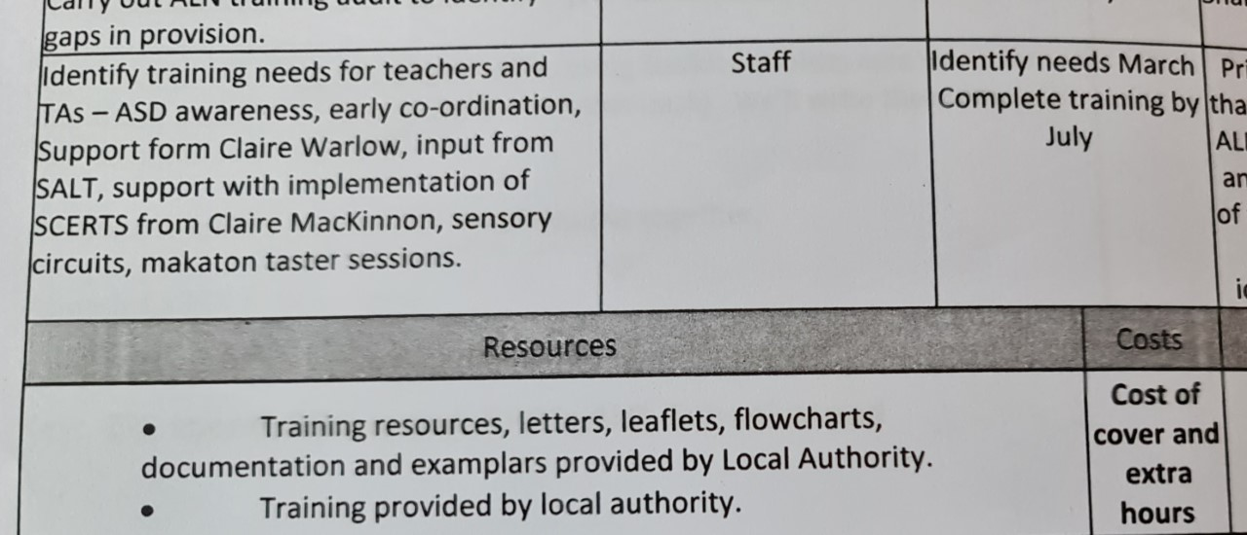
Source: School X SDP, 2021.

Appendix 3- ALN Provision Triangle

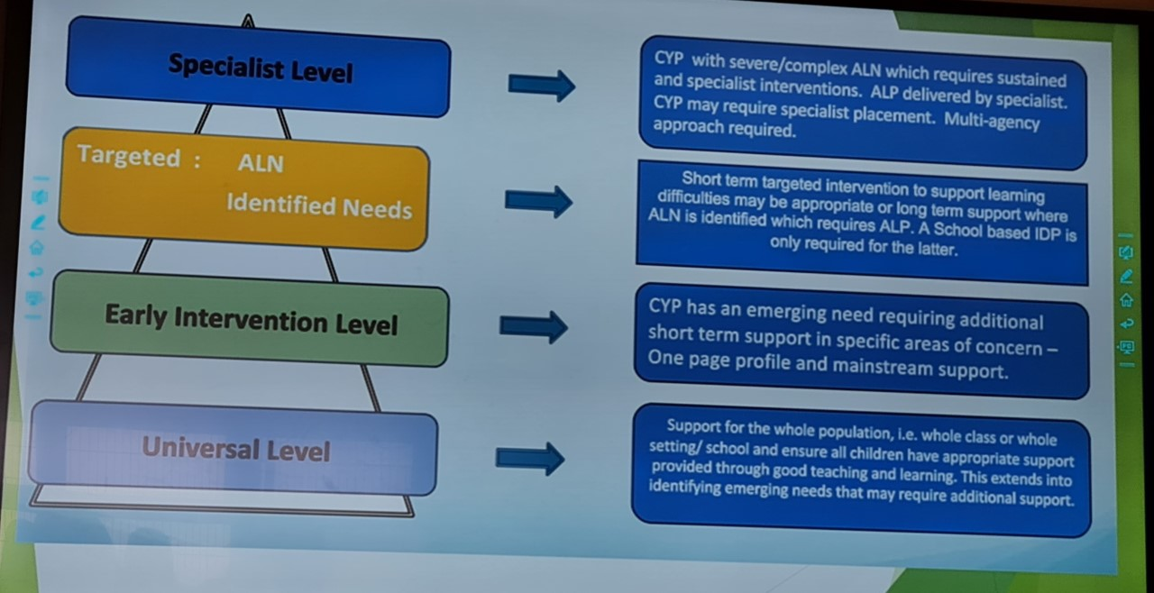
Source: Davies, 2022

