UWTSD (1800042)

Software Development
Kaylie shoulder

Table of Contents
Explaining Elements of C 2
A.1: 2
A2: 3
A3: 3
Implementing C 4
Exercise 1 4
Exercise 2 5
Testing Exercise 2 6
Exercise 3 7
Testing Exercise 3 8
Exercise 4 10
Testing Exercise 4 12
References 13

C Programming
As like any programming language, C has its own personal elements which make the language function. Things such as: variables, loops, and arrays, are implemented within the C programming language which help us program efficiently, setting up an easy way for us to develop applications which are both user-interactive, and write-only. Throughout the course of this assignment, you will be able to view an explanation as to why these elements are important within C, and how they can be used. You will also be able to view fully-functioning snippets of C in action, creating different platforms of user-interactive calculators and games.

Explaining Elements of C0
A.1: One of the first elements of C that is very important is entitled a ‘variable’ - a variable is essentially a name that has been applied to storage types which the user is able to manipulate [1]. There are different types of variables and those are: int, float, void, char, void, and double. These different types of variable can be used in your program to declare something – you do not necessarily have to provide the value of the variable upon declaration, however, declaring it creates a storage point which can be used later. The variables int, float, and double are all ways to store numerical values – whether that’s a large value, a small value, or a decimalised value, they can be used to store numbers. Char, however, is the way in which one can store letters, you simply set the number of letters that you need in order to store the word, and then declare it. Void, on the other hand, is an easy way to store values that do not have their own type.
Variables are essential in programming and the reason behind this is because they allow us to refer to them at later dates, we can store important values in them either upon declaration or store further on.
Example: If one is attempting to program a calculator which requires a specific aspect of it to always be ‘4’, such as the ‘area’ of something, one can simply declare the area like the following:
Float area=4;
Then, at a later date, whilst programming, the programmer can recall ‘area’ by implementing it within the code, like this:
Total =Area * userinput;
Area will always be 4.
This is simply a storage point for the user, which is why it is so important as it not only allows us to declare different things within the code what the complier would not recognise otherwise, and then apply a value to it, which means that the complier will recognise that whenever area is called, you are calling the value stored within it, in this instance, 4. It is also useful as you can set the value of the variable at a later date through calculations, and then storing the end calculation into that variable.

A2:
You may have heard of the term ‘for-loop’ which is commonly used in C, and some others may say that it should be entitled the ‘counting-loop’, and whilst it may seem a little peculiar, there is a reason behind this. For-loops are used to control the amount of times that something is looped. To explain, here is an example of a for-loop/counting-loop:
For (counter= 1; counter <5; counter++)
The first counter is essentially the start of the loop, the second counter is the end of the loop, and the third is what is known as the ‘update’. The loop starts at 1, and then the updater will continue to add 1 value, so the second time the loop loops, the first value will be read as 2, and it will continue to do this until it has looped five times as the second counter dictates how many times the loop is able to loop. The simple reason as to why the for loop is known as the counting loop is essentially because the loop is controlled by count. [2] The counter is utilised to keep record of the amount of times that the algorithm has been iterated.
A great example of when one would use a for-loop/counting-loop is under the circumstance when you’re coding a program that will allow the user to participate in a counter – the user is able to input the times table it wishes the program to display; the program will then utilise a loop to dictate how many of the times table it is going to use – as we only learn up to our 12 times table, the loop could be set as something like this:
For (i=1; i=<13; i++)
And this will ensure that only 12 tables are generated.

A3:
Arrays are another important factor of programming – in fact, a lot of tasks in programming require not only storing but also processing a few different data items [3]; a good example of this would be:
Storing a list of employee’s salary rates to be processed – you may need to order them and search for the highest/lowest, averaging the salaries, or simply searching for specific salaries.
And arrays are perfect for doing so – this is because arrays are data structures, using them you are able to store a fixed-size collection of elements that fall under the same data type category [4]- using arrays you are able to declare multiple variables under one section rather than having to declare each variable individually. Example:
Int Arrays = [1], [2], [3], [4], [5]
Arrays are a lot more complicated than they appear on the forefront and have many features that aren’t that widely known, for example, within C, one is able to use something called a ‘multi-dimensional array’ which are usually 2D or 3D arrays – whilst this name sounds very fancy, it is essentially an array that contains multiple arrays, however the most popular multidimensional array is the 2D array, and this is essentially when the array stores two pieces of data, this could be something like the amount of stock a shop has and how many the products have been sold, and to follow suit, a 3D array can store 3 pieces of data, perhaps: amount in stock, amount sold, and the amount to order. You can have deeper levels of multidimensional arrays however the larger the array capacity, the more complex they become to manage. Multidimensional arrays are incredibly useful for grouping figures together. [5]
By using arrays, you’re essentially making your programming experience easier and this is because you’re able to access any element of your array simply by using its name and index, which makes calling the value of an array easy. Arrays are also great for sorting data as mentioned above, using arrays, if done correctly, you’re able to implement algorithms which make it easy for the user to not only search for specific arrays but also sort them based on a number of filters.
There are many ways to use arrays however an example of when you’d use arrays is when you’re programming a game – maybe something like a roulette wheel… you would store the different locations of each colour and where they are located on the board within arrays, then, when the ball lands on ‘red’ for example, the array would be compared to its counter-part, and it would be able to detect which colour the ball has landed on – in this case red.

Implementing C

Exercise 1

#include <stdio.h>

void main()
{
float myheight; //variables to hold the numerical values
int myage;
char myname[7]= {'K', 'A', 'Y', 'L', 'I', 'E'}; //variable to hold characters

myheight = 1.81; //inputted height
myage = 20; //inputted age

printf("My height is %f\n\n", myheight); // outcome, print the values
printf("My name is %s\n\n", myname);
printf("My age is %d\n\n", myage);
}

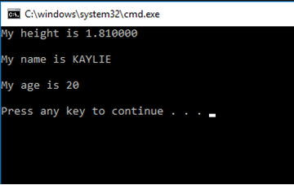

Everything prints correctly and displays the correct figures and letters.

This particular exercise posed no issue – it worked well as soon as it was programmed and ran.

Exercise 2
Solution break-down:
- Welcome the user
- Ask the user to enter the circle radius
- Store the result within a float
- Calculate the area of circle
- Print the result on the screen
- Ask the user to provide base size of triangle
- Store result within a float
- Ask the user to provide the height of the triangle
- Store result within float
- Work out the area of the triangle
- Circle – triangle
- Produce result on screen

#include <stdio.h>
#define PI 3.142 //declaration of PI, stating its value
float radius; //variables to store numerical values generated later within code
float areac;
float areat;
float base;
float height;
float shadedarea;
void main()
{
printf("Welcome to the program that will calculate the area for you\n\n");
printf("Please enter the radius of the circle"); //requesting the user input
scanf("%f",&radius); //storing user input in radius
areac = PI * (radius*radius) ; //calculating the area of the circle using user radius input
printf("The area of the circle is %f\n\n", areac); //printing the result for the user, calling areac which was generated using user input

printf("Please enter the base of the triangle"); //requesting user input
scanf("%f", &base); //storing user input in base
printf("Please enter the height of the triangle"); //requesting user input
scanf("%f", &height); //storing user input in height
areat = base*height / 2; //calculation to work out the area of the triangle using user input
printf("The area of your triangle is %f\n\n",areat); //printing the area of the triangle and calling areat which was generated through user input

shadedarea = areac - areat; //working out the area of the shaded area
printf("The shaded area is %f\n\n" , shadedarea); //displaying the result to the user calling shadedarea which is where the result was stored and generated using areat and areac

}

Testing Exercise 2
Testing with normal values:
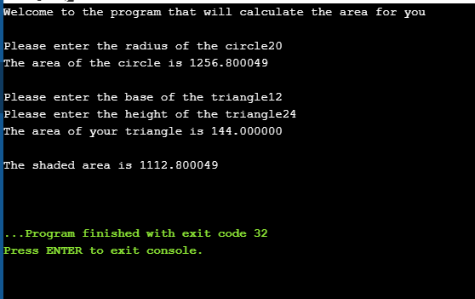
Result: ran as expected
With ridiculously large numbers:

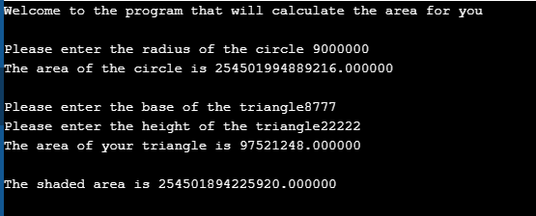

Result: ran as expected

Entering letters:
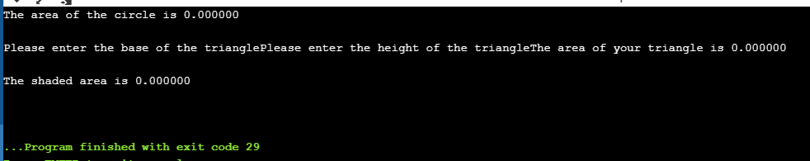
Result: program crashed as expected

Exercise 2 was not too challenging, the only ‘problem’ that was met was thinking logically about the order of the code – how should it be completed and how should it be programmed? One issue that arose during the development stage was dealing with testing in decimals – at first, decimal numbers did not work correctly but after reviewing the code it was found that there was a small miss-type which allowed for the error to occur, once corrected the code ran smoothly.

Exercise 3
Solution break-down:
- Declare float as prices[5] to allow for 5 inputs
- Declare vat as 1.2
- Generate a loop which asks the user to input the price of the product five times
- Store each input as a float
- Add each product
- Store within float
- Display result before VAT
- Then, VAT/100 *total *100
- Store within float
- Display total WITH VAT
#include <stdio.h>

float addnumbers(int v1, int v2, int v3, int v4, int v5);
void main()
{
float prices[5]; //declaring that the user can only input 5 prices
int i, input; //variable to hold user interaction
float total = 0;
float percentage;
float vat = 1.2; //declaring that VAT’s value is 1.2

for (i = 0; i < 5; i++) //stating that this should be looped 5 times and once user has inputted 5 times, break
{

printf("Welcome. Please enter the price of your item.");
scanf("%f", &prices[i]); //storing the user input in prices

}

for (i = 0; i <= 4; i++)
{
printf("%.2f\n", prices[i]);

}

total = addnumbers(prices[0], prices[1], prices[2], prices [3], prices [4]); //declaring that total is each of the prices added
printf("Your total amount before VAT is %f\n\n", total); //displaying the price before VAT for the user, calling total

percentage = ((vat / 100)) * total*100; //calling percentage, and storing the VAT value within it, calling VAT and using calculation
printf("With VAT it is %f", percentage); // displaying the price to the user, calling percentage

}

float addnumbers(int v1, int v2, int v3, int v4, int v5) //declaring each variable
{
float total;
total = v1 + v2 + v3 + v4 + v5; //add all 5 values
return total; //return to main addnumbers

}

Testing Exercise 3
With reasonable numbers:
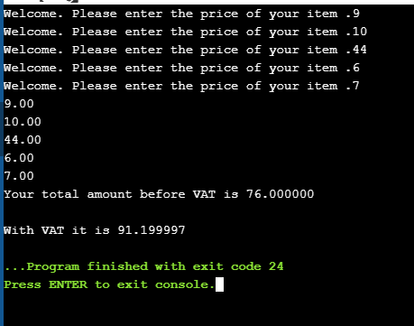
Result: worked as expected, correct answer

With ridiculously high numbers:
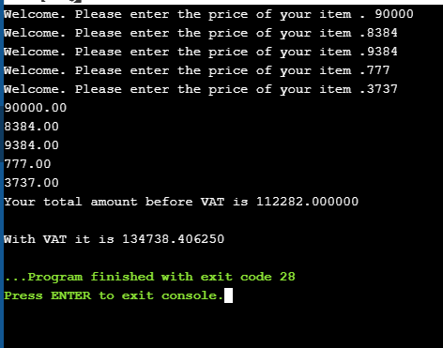
Result: works as expected

With decimals:
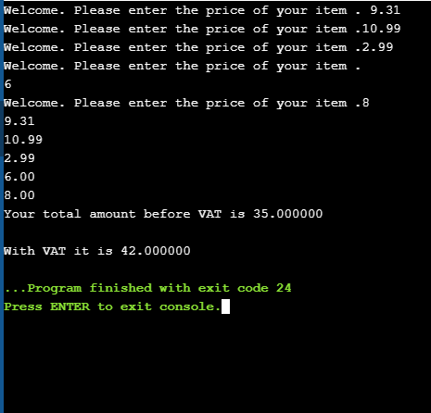
Result: works as expected

Inputting letters:
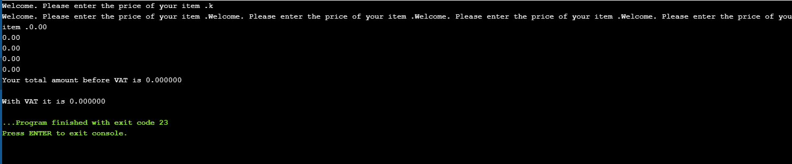
Result: crashes, as expected
This particular exercise was more challenging than the previous two; a few issues were met whilst programming this particular element. The first issue that arose was the struggle to conjure up a logical, functional plan of how to set this code out. One struggled to understand how to combine the elements of this code, thus a review was conducted of the possible ideas and the efficient structure was conjured. Then, working out the VAT posed an issue – there are many ways in which can work out a percentage and one struggled to decide on the correct method and how to implement it into the code using the float addnumbers and percentages – however, upon trial and error this issue was rectified and the code worked correctly.

Exercise 4
Solution break-down:
- Declare myarray as [3] to allow only 3 numbers to generate
- Set the lowest number to 100
- Highest number to 500
- Declare choice as car to allow user input
- Ask the user if they wish to play
- Store user input within char choice
- If the user presses Y, proceed to while statement
- Generate loop – within that loop ensure that there is a number randomiser – produce 3 random numbers
- Store the result within float myarray
- Produce the result on-screen
- Display to the user the result and inform them of the amount of points they have acquired
- Ask the user if they wish to play again
- If yes return to while loop
- If no, display goodbye message and end program

#include <stdio.h>
#include <stdlib.h>
#include <time.h>

void main()
{
int myarray[3];
int low = 100; //lowest of range
int high = 555; //highest of range
char choice;
srand(time(NULL));
int i;//seed randomness

printf("Do you want to play Fruit Machine? (y/n)"); //ask user for input
scanf(" %c", &choice); //scan user input

while (choice == 'y') // if user enters Y proceed with following code
{

for (i = 0; i < 1; i++) //loop this once
{
myarray[i] = rand() % (high - low + 1) + low; //generate the random numner
}

printf("The numbers are: "); //print number result

for (i = 0; i < 1; i++)
{
printf("%d ", myarray[i]); //print the value within float myarray
}
if (myarray== 555) //if number is 555, proceed with this statement
{
printf("\n\nCongratulations! You won the jackpot.. You now have 2000 points.. sweet!\n\n");
}
else if (myarray >= 550 && myarray <= 559) // if the values lie between these bounds, proceed with this statement
{
printf("\n\nYou didn't hit the jackpot but you got 100 points \n\n");
}

else if (myarray == 111 || myarray == 222 || myarray == 333 || myarray == 444) // if the number lies in these numbers, proceed with this statement
{printf("Wow, you got 20 points! "); }
else //otherwise proceed with this statement

{
printf("\n\nSorry to tell you this, but you got nothing.(\n\n");
}
printf("Do you want to play Fruit Machine? (y/n)"); //ask for user input again after game
scanf(" %c", &choice); //collect user choice, if they press Y, return to while choice
}
printf("\nOk, thanks for coming!\n\n"); //if the user presses N, print and end.
}

Testing Exercise 4

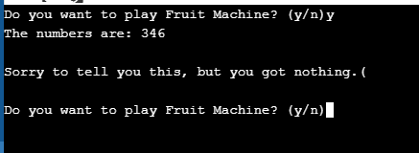

The no match works as expected – number generates fine, and correct if statement displays along with pressing Y or N

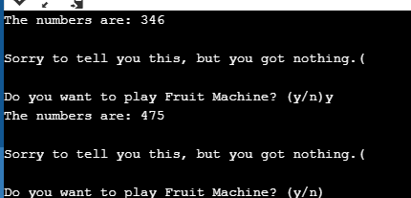

User Input Y works as expected, when user enters Y it reloads the loop and allows the user to play again

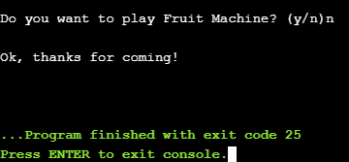
Pressing N works fine, it displays the correct statement and then ends the game.
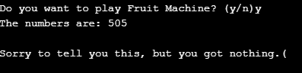
The number generates fine but the wrong if statement is displayed

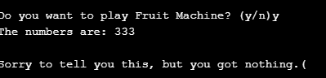
The number generates fine but the wrong if statement is displayed

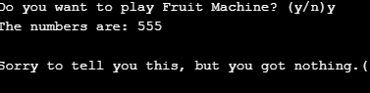
Again, the wrong statement is displayed but the number generates fine and so do the user input statements

This exercise was by far the most challenging and intricate exercise – unfortunately, the issue that was encountered within this exercise was not rectified. The first issue that was met deciding on how this challenge was going to be tackled – as it was expected of one to generate 3 separate numbers, this was the first attempt that was made – this did not work very well. Upon attempting to do this, there were many statements within the code that were showing errors and one simply could not find a way to rectify them, the entire program would not work at all; because of this, one decided to make the decision to change the bounds of the higher and lower figures to 100 and 555, this would mean that only one number needed to be generated, and the if statements that were used would be easier to program, with ‘555’ being the jackpot. After doing this, the program itself ran, with the Y/N user input working correctly, the random number generating correctly and printing on screen, however the if statements simply would not work when the user hit a jackpot or managed to match two fives, or 3 same numbers, it seemed that in these instances the code was defaulting to the losing statement and after hours of trying to correct this, one was unable to create a fully functional solution.

References

[1] | T. Point, “Learn C Programming,” [Online]. Available: https://www.tutorialspoint.com/cprogramming/c_variables.htm. [Accessed 10 02 2019].
[2] | “BBC Bitesize - Iteration in Programming,” [Online]. Available: https://www.bbc.com/bitesize/guides/z3khpv4/revision/2.
[3] | C.-B. CHIRILĂ, in GENERATIVE MODELS FOR COMPUTER PROGRAMMING DISCIPLINES., 2015.
[4] | Tutorials, “Computer Programming - Arrays,” [Online]. Available: https://www.tutorialspoint.com/computer_programming/computer_programming_arrays.htm.
[5] | C. Singh, “2D Arrays in C Programming”.

