

University of Wales Trinity Saint David School of Engineering

development of a new race helmet
Workshop and practice (acha4011)

oliver powell
2206640
BEng motorcycle engineering
October 22

Contents

introduction 3
Engineering team structure 4
product development 7
issues, legislation and standards 9
personal development plan 12
Conclusion 14
References 15

introduction

This technical report has been conducted to review the relative areas of an effective engineering team needed to develop a new product. The report will investigate the bare minimum that would be expected from an engineering team, and the other departments and parties that may be needed in addition to the mandatory for the product to be successful.
Each independent department of the team will be analysed to justify their placement within the engineering team. Their responsibilities within their roles will be considered and consequences discussed where applicable. Legislation, working conditions and industry standards will all be considered for each team, and analysed to show their affect with or without consideration.
The product being developed is a state of the are racing helmet aimed at motorcycle racing applications on tarmac off-road tracks. This product has been chosen since safety within the motorcycle racing industry has come under a lot of scrutiny within the last 2 years, following the passing of several elite level motorcycle racers. The final goal of the report is to enable a team leader to effectively orchestrate a successful product that exceeds in its target market.

Engineering team structure
There are many types of engineering team structures that can be implemented to create an effective team, although, some team structures are more effective than others. This is due to many different factors. The project or product being produced needs to be considered when defining a team structure as there are some departments that may or may not be needed within the team. Having unnecessary team members or departments can lead to unnecessary expenditure, offices that are over packed or too big and project perspectives that might not be needed. In addition to this, the location of the product being developed should also be taken into hand. There are different ways of working, depending on where employees are in the world. Factors such as religion, local customs or traditions, working time directives, environmental factors can all have an effect on the way a team may be structured. If a product is to be developed with a globally based working group, the previously mentioned must be considered in order to ensure effectivity of the team.
Below is a diagram that dissects all the different areas of the product development. Some of these areas can be covered by the same department, and some by more than one department. The use if this diagram is a great tool to fully understand the scale of the project being chosen and give scale to the tasks at hand.
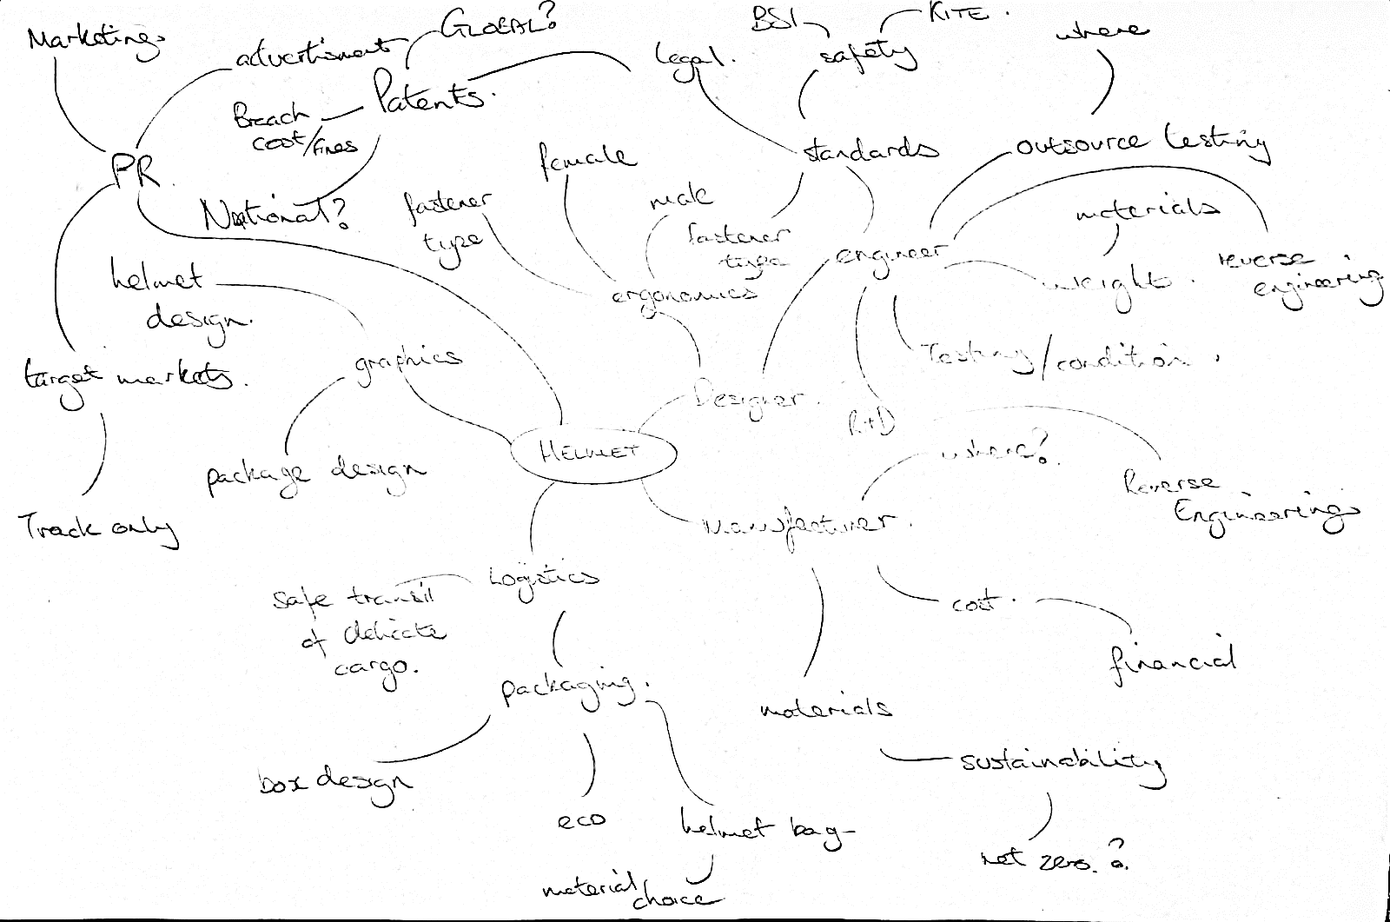
Figure 1
Considering the above, the different types of team management structures have been reviewed to understand how they can benefit the project from a team leaders’ role and how the management and team structure can affect how different problems are tackled.
Pyramid
The pyramid structure is a typical style that is used in businesses that can be applied to engineering teams where less responsible work that is of high volume and low importance is managed from an above leader or manager. This effectively carries on for all tiers of the process until the tier points to one significant figure, who oversees all responsibilities. This is a simple hierarchical management structure that can be implemented into teams.

Figure 2
In Figure 2, a basic 3 tier hierarchical pyramid is shown. At the bottom of the pyramid, a larger area of the triangle is occupied. This visually represents the number of workers in this role, and can be inversely proportional to their importance within the working structure (they are seen as less important than those in fewer occupied roles). As the pyramid goes up by tier, it is expected that the skill level also increases.
Matrix
The matrix team or management style removes the hierarchical aspects of the workplace, instead enabling teams to work more cohesively by linking different departments, or levels, directly. This is quite different to the pyramid style, whereby a decision or a product needs to work its way through a filter of approval, which can be very inefficient, especially in a fast-moving industry such as engineering.

Figure 3
Figure 3 shows how a matrix team structure may look. It is easy to see how there are more independent layers to the team, and various areas of expertise as well. Given their place within the diagram, it also shows how the levels of the hierarchy are formed, and areas where certain processes might happen at the same time, for instance quality control checks.
Having looked at these two common team structures that are commonly used, it would be advisable to use the matrix style team structure. By utilising the matrix team structure, the level of quality control would likely be higher, as there is more cohesiveness between engineering layers. This is something that could easily be incorporated into the product development cycle. This will help to tackle any issues that arise and allow for more angles to tackle said problems, and invite different points of view and perspective.

product development
When looking back at Fig 1, consideration was made to where the product could potentially be made. Given the financial leverage that western countries have on producers and manufacturers in the far east, it is a logical choice to consider manufacture in those regions. In fact, according to research conducted in the first 2 quarters of 2021, “Chinese firms inked service outsourcing contracts worth about 976 billion yuan (about $150.47 billion) from January to July, up 27.8 percent year-on-year.” (Xinhua, 2021). Statistics gathered between 2016 and 2020 and published by C.Textor in 2022 that fully supports the statement by Xinhua. The table below, figure 4, shows how the Chinese economy has grown as a direct result of outsourced services.
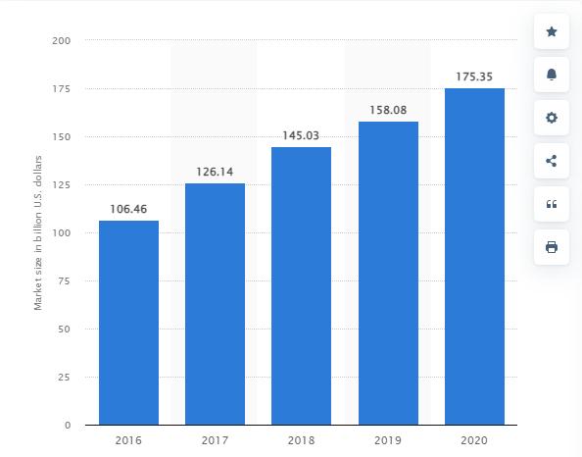
Figure 4 (Textor, 2022)
Given the above, research was done to see if premium motorcycle helmets are within the scope of this research. Multiple premium helmet manufacturers outsource partial and entire model lines to China, these include AGV (MotoGeek, 2021) and Scorpion Helmets (ScorpionUSA, 2022). This shows that the possibility of the helmet being developed could be manufactured in China and meet the high standards that the industry, and customer, would expect.
Given the directive above, the team will have to understand the importance of global working and communication to ensure the project is successful. When making communication to places such as China, there is a geographical time difference that could have a massive knock-on effect on the progress of the project and meeting deadlines. By communicating early in the working day, or at the end of the day, will ensure that the project is worked around the clock, and there as little dead time as possible.
Quality control could become an issue when outsourcing some of the manufacturing and engineering for any product. Given this, steps can be taken to minimise the chance of below quality expectations when the product is complete. By choosing a manufacturer that already has experience in the field of development and the product itself would be a massive advantage. Furthermore, to have a member of the team located in one of the regions that the product might be produced in allowing a member of the team to oversee the product more closely and relay progress and updates back to the team leader.
The use of industry standard management tools should also be incorporated to ensure that the product development stays on track. Smaller teams, such as those exemplified in Figure 3, can also be managed much more easily, and quality control can be upheld. The use of a Ghantt chart is highly recommended and used industry wide as it allows for simple and pictorial time management of multiple streams, in this case, different teams in different countries. In addition to this, it allows for easy implication of milestones. Milestones that would be expected in a project such as this might be design testing and certification, quality control checks and interim reviews.
When ensuring that quality is met, the industry has already put legislation in place make sure that safety standards are already met. This legislation is discussed in the “issues, legislation and standards” chapter. Considering this legislation as a mandatory requirement for helmets within the target market, we can use this legislation as a metric of quality control, whereby a threshold must be met for us to deep the quality sufficient. For example, exceed the minimum safety requirement by 10 points.

issues, legislation and standards
There are many different areas of legislation and standardisation that must be understood and followed when developing a project. As a team leader, it is important to implement safe working practice so that the working team can work confidently and be productive without worrying about being at risk while working. In addition to this, there are certain standards that must be met. Whereby Health and Safety at work Act 1974 (HSWA) covers all areas of professional work regarding working conditions and safety, there are standards that are specific to the motorcycle and helmet industry and are applicable to the product. The legislation that should be considered is highlighted below and further explained.
- Health and Safety at Work Act 1974 (HSWA)
- British Standards Institution (BSI)
- FIM Homologation (FRHPhe)
- Measurement standards (ISO, metric, imperial, BSA…)
HSWA covers all areas of working condition and safety within a workplace. It ensures that the employees are protected against neglect, poor working conditions and working unsafely and will have a legal stance if their employer allows or forces them to work unsafely. The opening legislative section of HSWA states that “it shall be the duty of every employer to ensure, so far as reasonably practicable, the health, safety and welfare at work of all his employees” (legislation.gov.uk, 2022). Having an understanding of this will mean that a team leader can make precautions for working conditions and expectations from their employees.
The BSI is a national standard that is upheld within the UK. It regulates what can and cannot be sold within the UK on a safety standard basis, “the only helmets and visors that could be legally sold for use on the UK's roads had to be Kitemarked to show they met the requirements of BS 6658 and BS 4110” (British Standards Instituition, 2002). The BSI conducts testing on all helmets being sold in the UK, and the product being developed would have to meet the requirements of the BSI scrutineering process to be deemed successful.
Considering the helmet being produced is aimed at racing professionals, for road, off road and competitive racing at elite level, the helmet would need to meet the requirements specified within the FIM homologation (FRHPhe-01). The FIM is the governing body of the highest level of motorcycle racing in the world. They utilise existing standard recognised in different regions of the world and also have their own standards, to ensure that competitors are as safe as possible when racing.
The FIM state that:
Testing procedures described in this document imply the use of 10 Helmet Samples per Size and per Combination of accessories, distributed in the different test phases as follows:
• Samples #1, #2 and #3: Conditioning, Weight, Linear impact tests
• Samples #4 and #5: Conditioning, Weight, Oblique impact tests
• Sample #6: Conditioning, Weight, Penetration tests
• Sample #7: Storage
• Sample #8, #9 and #10: Conditioning, Weight, Extra tests if needed
(FIM, 2019)
Considering the above, it is important that all parties involved are aware of the legislation that impacts the product being produced. If external parties, such as those highlighted in Figure 1, there is a possibility that the product will be poorly designed without knowledge until the final testing and scrutineering stage.
As mentioned in the product development section, the proposal is to utilise China for the manufacturing of the product, as there is score for high standards and cheaper fulfilment of the product. Although, working internationally to countries such as China does come with some issues, one of which would be the language barrier. This issue can be resolved by ensuring that a diverse work force is encouraged within the team and having a mandarin speaker within the manufacturing/research and development team a must. Not only this, working in collaboration with already established manufacturers and development firms in China would minimise the risk of any language barriers.
The wellbeing of the environment and the planet is also a huge area where legislation has been created and built as new world agendas and scientific research emerges. The overall “eco-friendliness” of a product can be a major factor for the target user. This can be a win-win situation, as sometimes, eco-friendly products can sometimes work out cheaper than their more carbon emitting counterpart. Considering the product, research should be conducted by the graphic design, packaging and logistics team to see if there are ways that the product can be packaged and transported with a smaller carbon footprint. An area where the carbon footprint could be reduced would be using cleaner inks on packaging and decals. Given that:
“Soy inks – Some inks contain even fewer volatile chemicals than vegetable-based inks. Soy inks are so gentle on the environment but are still able to ensure vivid, high quality print images. Again, these inks can be reused into newer inks.” (Faulkner, 2021)

personal development plan
As an aspiring engineering, it is important to take steps to ensure the continuous development so that employability is optimum during the span of a career. Not only this, personal improvement should also be encouraged, as this will help to make working tasks more fluid when working in teams. In a continuously evolving sector like engineering, applying oneself to new methods and moving with change whilst retaining and understanding the value of old methods is a must.
As a mature student, and already established within an industry, there is already the opportunity to more within the aviation sector. This is an option that is kept in mind. To work on the next generation of aircraft or engine would be desirable, as some of my interests, such as 3D printing, are beginning to make their make in the professional atmosphere.
In contrast to the former, I would love to break out of the aviation industry, and pursuit engineering within a different field, most hopefully the automotive or motorcycle industry. This would be in pursuit of fulfilment, and to work with others that share the same passion and interests as myself. My current studies are aligned with this perspective and aimed to open more doors into this sector of engineering.
If this route is to be taken, working abroad is something that would be a great opportunity, not only to move forward with respects to my career, but also to broaden my perspective to the different cultures of the world and the way they work. This is also an excellent way to network, which is an area that admittedly is not my strong suit, therefore, an excellent opportunity not to be neglected. Working in a developing country would be a great moral ambition for me, even though the methods, or resources may not be as cutting edge as already developed countries. To be a part of something that is beneficial outside of just the final product would give me a great sense of achievement and fulfilment.
With regards to either of the above outcomes, I would ultimately love to become self-employed, where I can take on project that I am enthusiastic about. Considering this, it allows me to work with others that also have enthusiasm towards the same projects. I have worked on projects over the past 15 years alongside my studies and work, and never given myself full credit for the skills that I have gained from trial and error and learning from my mistakes.
Upon self-reflection, I have thought about areas that have held me back, and why my projects haven’t been successful. I would love to learn more about business, and what makes a successful business run in the engineering sphere, as I feel that I have the technical skill to be effective in making a project work.
Finally, to be a registered chartered engineer would be a great personal achievement. I see it as a true validation of the work that I would have accomplished, and peer recognised by leaders within engineering.

Conclusion
The technical report has successfully looked at various areas where a team leader would need to have knowledge and understanding for a project to be deemed successful. Research has been done into the different types of team structures that would be favourable to the product choice being developed. The matrix team structure was discussed to be a more appropriate team structure than the pyramid or linear type teams for this given product. This was decided as it allowed more processes to occur at once, a greater level of collaborative working, and a more powerful position for the team leader to oversee various steps of the process.
A team leader would also need to have a clear understanding of the professional tools that can be used as enablers to better track progress of the project. The use of a Ghantt chart would me a crucial tool to use a sit would allow for the incorporation of milestones, such as testing, when overseeing the multiple work stream mentioned in the report.
The technical report demonstrates that this could vary massively depending on the target user, their local national standards and the target market. Therefore, it is important for the technical leader to have a clear understanding of all the legislation that is applicable to the product being developed.
For myself to be a successful team leader, I would have to have an understanding of an effective team structure that enables correct oversight and management of different production streams. To be efficient and accurate with leading the team, good communication with teams would be very important. The use of the various professional tools that are available would also be favourable and allow workflow to be monitored more easily. Finally, a good understanding of the legislation that affects the product being developed. Both from a moral, whereby the wellbeing and equality of the workforce should be considered, and a technical perspective, where the product must meet specification.

References
British Standards Instituition, 2002. Motorcycle helmets - be safe, look for the Kitemark. [Online]
Available at: https://www.bsigroup.com/en-GB/about-bsi/media-centre/press-releases/2002/11/Motorcycle-helmets---be-safe-look-for-the-Kitemark/
[Accessed 27 11 2022].
Faulkner, E., 2021. Eco-Friendly Large Format Digital Printing Materials, Methods and Applications. [Online]
Available at: https://soyang.co.uk/eco-friendly-digital-printing-materials/#htoc-what-kind-of-printing-methods-are-eco-friendly
[Accessed 1 12 2022].
FIM, 2019. Homologation manual n. FRHPhe-01. [Online]
Available at: https://www.fim-moto.com/fileadmin/library/FRHPhe-01-amended2_web_extract.pdf
[Accessed 30 11 2022].
legislation.gov.uk, 2022. Health and Safety at Work etc. Act 1974. [Online]
Available at: https://www.legislation.gov.uk/ukpga/1974/37/section/2
[Accessed 28 11 2022].
MotoGeek, 2021. Should I Avoid Buying an AGV Helmet Made in China?. [Online]
Available at: https://motogeek.co.uk/are-agv-helmets-made-in-china/#:~:text=AGV%20helmets%20are%20made%20in,RR%20is%20made%20in%20Italy.
[Accessed 8 November 2022].
ScorpionUSA, 2022. WE ARE SCORPIONEXO. [Online]
Available at: https://www.scorpionusa.com/#:~:text=SCORPIONEXO%C2%AE%20is%20factory%20owned,the%2Dart%20construction%20methods%20available.
[Accessed 28 10 2022].
Textor, C., 2022. Execution value of service outsourcing industry in China from 2016 to 2020. [Online]
Available at: https://www.statista.com/statistics/1300775/china-market-size-of-service-outsourcing-industry/#statisticContainer
[Accessed 8 November 2022].
Xinhua, 2021. 'China's service outsourcing industry reports steady growth'. [Online]
Available at: http://english.www.gov.cn/archive/statistics/202108/28/content_WS6129d9b6c6d0df57f98df4f9.html
[Accessed 1 november 2022].

