MBA

IKEA CHINA
Module - INTERNATIONAL MARKETING (LCMB7006)
Module Professor - Vasilios
Raj Sanjaybhai Modi (2240350) | 11/16/23 | MBA

Introduction of IKEA
Meaning behind IKEA name - IKEA is named after the founder, Ingvar Kamprad, the farm where he was raised, Elmtaryd, and the neighboring town of Agunnaryd. (IKEA website)
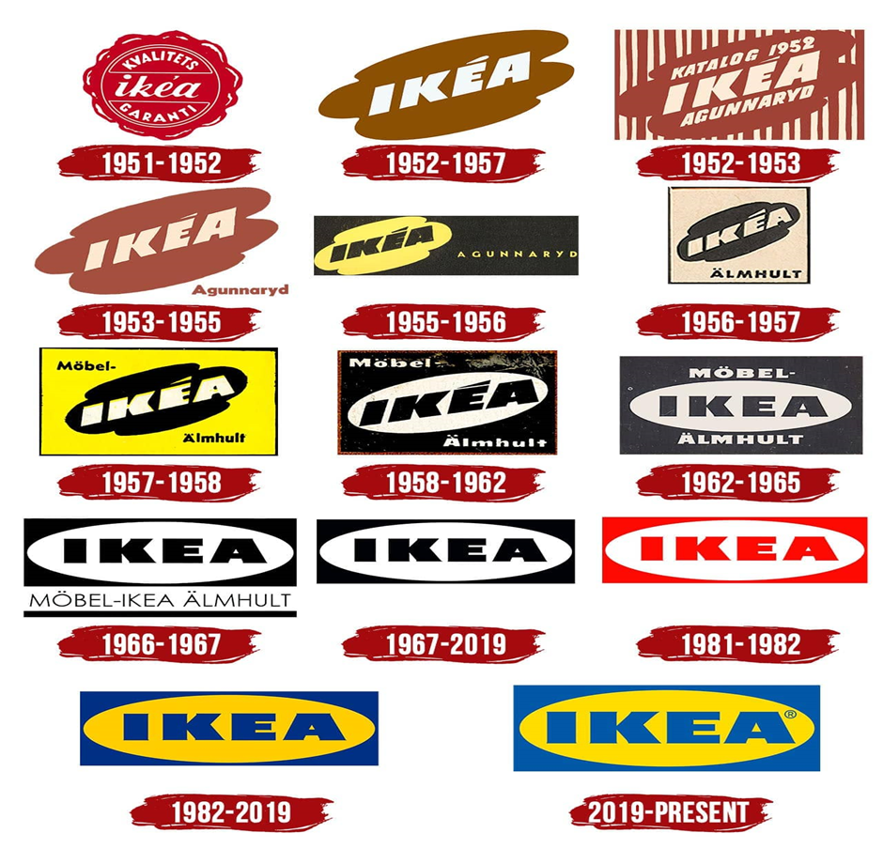
(Source – IKEA Website)

•Swedish private company, 1943
•Parent company
•INGKA Holding B.V.
•Company culture
•Togetherness, Cost-consciousness,
•Respect, Simplicity
•Products
•more than 10,000 in its range
•Social responsibilities:
•WWF, UNICEF
•Swedish private company, 1943
•Parent company
•INGKA Holding B.V.
•Company culture
•Togetherness, Cost-consciousness,
•Respect, Simplicity
•Products
•more than 10,000 in its range
•Social responsibilities:
•WWF, UNICEF
IKEA was founded by Ingvar Kamprad in 1943 in Sweden at the age of 17. At that time, they sold goods like pens and wallets. IKEA has more than 9500 variety of products in its range. The debut IKEA household goods inventory was released in Sweden in 1950. IKEA locations only sold coffee and cold meals in June 1960. By the end of the fiscal year, the IKEA eating place's cooking area was fully operational and involved a microwave, an innovation at the time. 1970 The expansion continued in countries outside of Scandinavia including Australia, Canada, Germany, Hong Kong, Japan, Kuwait, Netherlands, Singapore, and Switzerland. 1990 The first environmental regulation. In 1997 IKEA website and Children’s IKEA were introduced. Finally, in 1998, Ikea opened its first store in Shanghai and has since then opened several stores across major cities in the country. With its wide range of affordable, stylish, and functional furniture, Ikea has become one of the most popular retailers in China. In 2001, IKEA had a popular product called the "IKEA Grundtal" rail. The Grundtal rail was a wall-mounted stainless steel rail system that was primarily designed for kitchen and bathroom organization. The world's biggest IKEA seller, INGKA Group, which is owned by the INGKA organisation, provides financing to the IKEA charity. Due to the management of the INGKA organisation, the INGKA Trust has the funding required to fulfill its social mission.
The IKEA Foundation, a charitable organisation, donated €283 million to charities worldwide in 2021 with a focus on enhancing lives and halting the effects of global warming. More than €1.6 billion has been donated by the IKEA Charity since 2009 to improve the lives of kids as well as their families.
IKEA has 37 stores in China as of September 2023. IKEA has since expanded to major cities across the country, including Beijing, Guangzhou, Shenzhen, and Chengdu. Currently, IKEA operates in 61 countries around the world, with over 460 stores.
Country | Debut | First store location
Colombia | 2023 | Bogotá
New Zealand | 2025 | Auckland
Peru | 2026 | Lima
Luxembourg | TBA | Luxembourg City
Vietnam | TBA | Hanoi or Ho Chi Minh City

(IKEA Website)

Contents
1 Introduction of IKEA 1
2 Vision, Mission and Objectives 4
3 PESTEL Analysis for IKEA 4
3.1 Political 5
3.2 Economic 6
3.3 Social 6
3.4 Technological 6
3.5 Environmental 7
3.6 Legal 8
4 International Market Entry Strategies that IKEA has Employed in China 9
4.1 Benefits that IKEA Gained from Using Joint Venture Strategy to Enter The Chinese Market. 10
4.2 Drawbacks Faced by IKEA From A Joint Venture 12
4.3 The Uppsala Model in China For IKEA 13
5 Cultural And Social Factors Influence Consumer Buying Behaviour and Current Marketing Strategies Employed By IKEA China 14
5.1 Cultural Factors 15
5.2 Social Factors 15
5.3 IKEA China's Marketing Strategies 16
5.4 Hofstede's Cultural Dimensions for IKEA in CHINA – 17
6 The Marketing Challenges Encountered By IKEA in China 20
7 Marketing Strategy Adapt by IKEA to Gain the Sustainable Competitive Advantage 24
7.1 Porter’s Generic Strategies 26
8 Implementation Plan for The Proposed Strategy, Taking Into Consideration All Factors 29
8.1 7P’s of Marketing 30
8.2 Key Performance Indicators 31
9 Reference 33

Vision, Mission and Objectives

Vision - The goal of IKEA China is to improve the lives of numerous individuals by becoming the most adored and esteemed home furnishings brand in China. IKEA's dedication to offering premium, reasonably priced home furnishings that satisfy Chinese consumers is reflected in this goal. It also demonstrates IKEA's aim to use its commercial methods and charitable efforts to positively influence the areas in which it conducts business.

Mission - The goal of IKEA China is to provide an extensive selection of well-thought-out, useful, and reasonably priced home furnishings at costs that are reasonable for all Chinese citizens. The main goals of IKEA's business in China are outlined in this mission statement. IKEA is dedicated to offering items that are reasonably priced for the typical Chinese customer, in addition to being fashionable and useful. The firm is also dedicated to providing as many people with access to its items as it can, which is why it is growing its network of stores and creating e-commerce platforms.

Objective - Achieve 20% of the market in China by the year 2030. As a result, IKEA China would become the biggest retailer of home furnishings in the nation. By 2030, establish 100 new shops in China. This would increase the number of IKEA stores in China to over 300. Become the top supplier of home décor options to Chinese customers. This suggests that if Chinese buyers are looking to buy housewares, IKEA is their first option. By 2030, get a Net Promoter Score (NPS) of 80. A gauge of client loyalty is NPS. An 80 would suggest that a very high proportion of IKEA consumers are brand ambassadors. IKEA's activities in China should have a 50% lower ecological impact by 2030. Since China is the country that purchases the most furniture worldwide, this would be an outstanding achievement. (IKEA China)

PESTEL Analysis for IKEA

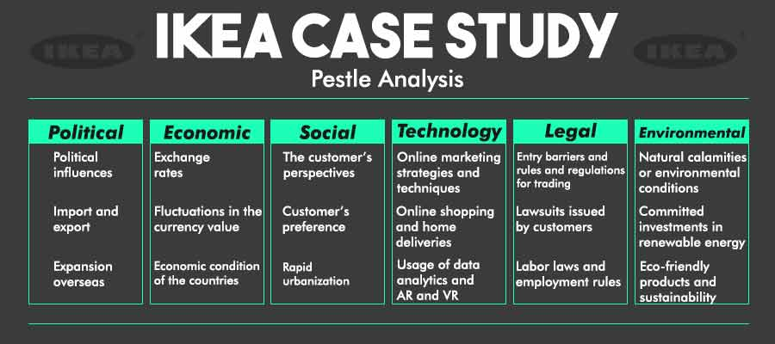
(Source – AU Global)

PESTEL is a method for analysing a company's macroenvironment and it has six components: political, economic, social, technological, environmental, and legal.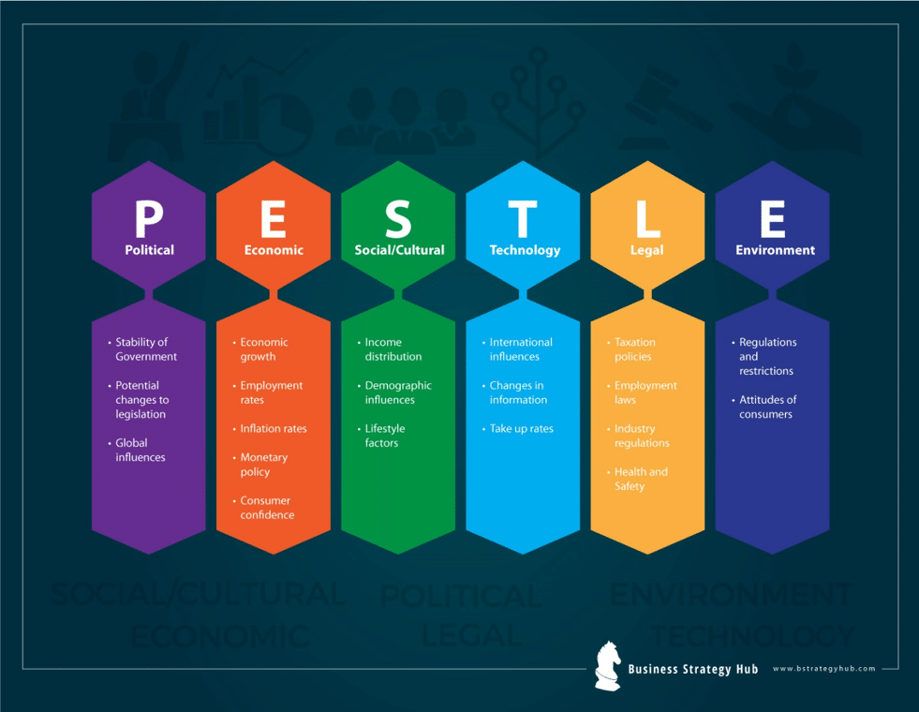
(Source - Bstrategy)

Political
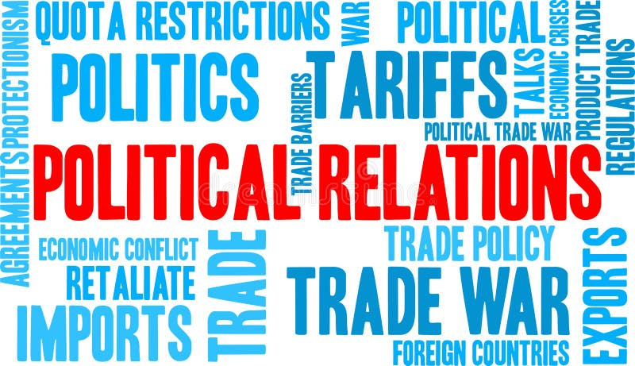
(Source – Dreamstime website)
Government Regulations - IKEA must abide by Chinese laws governing foreign firms, import/export, and labour legislation.
Political Stability - The political stability of China has an influence on IKEA's operations and investment decisions.
Business Policy - shifts in trade regulations and taxes can have an impact on IKEA's logistics and price. (Frnas, 2015).

Economic
Economic Development - China's strong economic growth gives chances for IKEA's sales growth and development.
Revenue Amounts - China's growing middle class provides a broader client base for IKEA's items.
Exchange Rates - Money swings can influence IKEA's marketing and revenue. (Wu, 2020).

Social
Lifestyle Changes - As cities get smaller, consumer interest in IKEA's storage solutions can increase.
Environmental Awareness - Chinese customers are getting more environmentally concerned, which is in line with KEA's commitment to sustainability.
Differences In Culture - Addressing Chinese buyer habits and social standards is critical for IKEA's item adaptation and promotional activities. (Sin et al., 2021).

Technological
Online Purchasing Expansion - IKEA should use technological advances to reach out to Chinese consumers via its website and digital advertisements.
Innovation - Maintaining up with technical improvements in production and development is critical for being effective. (Capdevielle and Nogal, 2007).


(Source – Public Domain)

Environmental
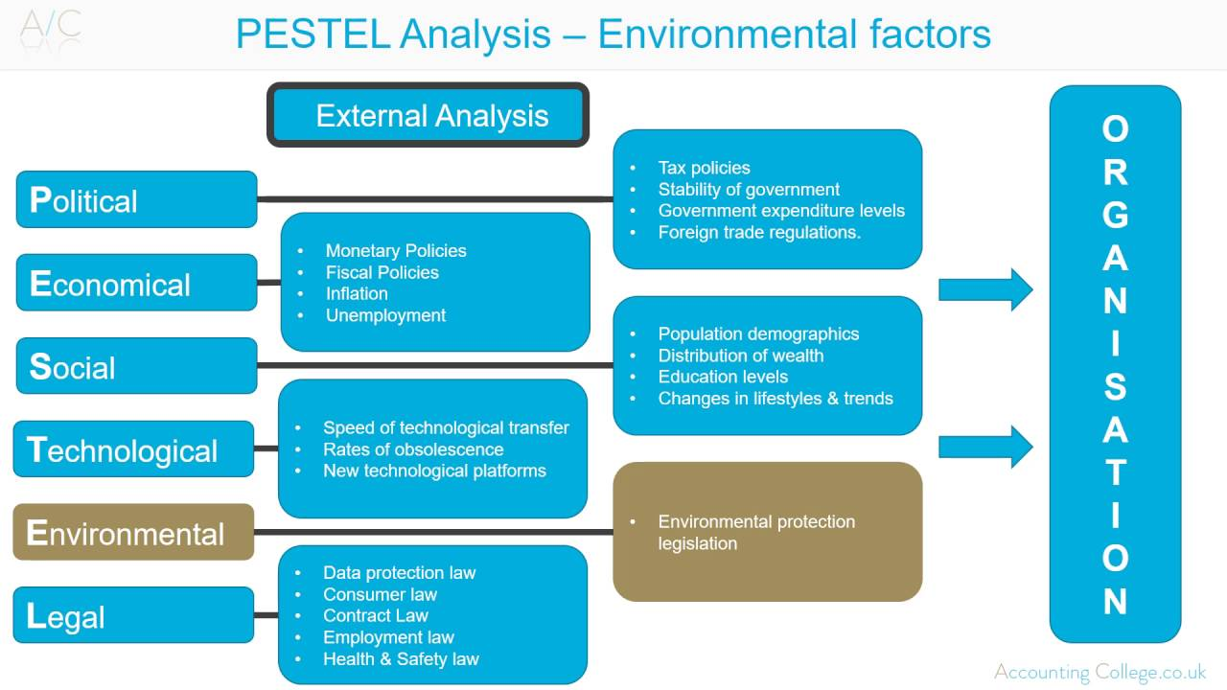
(Source- Youtube)
Initiatives For Ecology - IKEA's dedication to the environment matches China's increasing understanding of environmental problems.
Supply Chain Sustainability - Achieving ecological objectives requires obtaining environmentally friendly materials and lowering carbon emissions. (Harapiak, 2013).

Legal

This Photo by Unknown Author is licensed under CC BY-SA
(Source – Course Hero Website)
Property Rights - Ownership of intellectual property must be protected in the Chinese market.
Customer Protection Legislation - IKEA is required to follow Chinese consumer protection regulations as well as security of products rules. (Frynas and Mellahi, 2015.).

Conclusion
Based on the PESTLE research, IKEA confronts a lot of problems in the Chinese market, however, there are also numerous possibilities. IKEA may flourish in the Chinese market by concentrating on its advantages, such as brand awareness, environmental dedication and variety of goods. IKEA must additionally carefully evaluate its issues and devise solutions to address them.

- •1943 IKEA was founded by Ingvar Kamprad
- •1951 The first catalog was published
- •1958 The first IKEA store opened in Sweden
- •1963 IKEA arrived in Europe
- • In 1985 IKEA arrived in the USA
- •1990 The first environmental policy
- •1997 IKEA website & Children’s IKEA
- •1998 IKEA arrived in China
- •2001 IKEA rai
International Business
IKEA stores around the world：
"United States, Denmark, Germany, Spain, Israel, Saudi Arabia,"

International Market Entry Strategies that IKEA has Employed in China

IKEA used a Joint Venture (JV) strategy to enter and operate in the Chinese market.

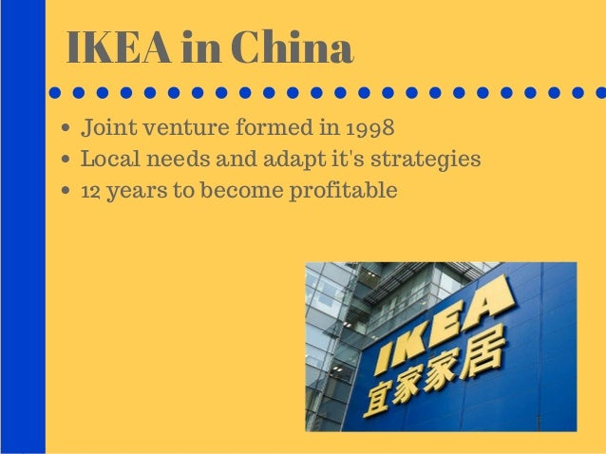
(Source – IKEA Website)
Joint Venture - A Joint Venture is a business arrangement in which two or more companies agree to work together on a specific project or venture. IKEA company partnered with a local Chinese furniture company to enter the Chinese market in 1998. (Burt, Johansson and Thelander, 2011). Joint ventures are a common and most preferable market entry strategy for foreign companies in China. This is because joint ventures can help foreign companies reduce their risk, gain access to local knowledge and expertise, and navigate the complex Chinese regulatory environment. IKEA's joint venture with the Chinese company was successful, and IKEA was able to expand its operations rapidly in China. In 2013, IKEA acquired full control of its Chinese operations.

Benefits that IKEA Gained from Using Joint Venture Strategy to Enter The Chinese Market.

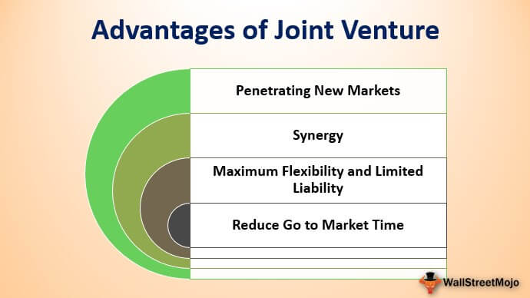
Reduced Risk - A joint venture allows IKEA to share the risks of entering a new market with a local partner. This is important in China, where the regulatory landscape can be complex, and the business environment can be challenging for foreign companies. (Shan, 1991).
Access To Local Knowledge and Expertise - IKEA's joint venture partner in China, Beijing IKEA Company Limited, is a subsidiary of China National Furniture Association. This gives IKEA access to a wealth of local knowledge and expertise, which has been invaluable in helping the company navigate the Chinese market and adapt its products and services to meet the needs of Chinese consumers. (Inkpen and Beamish, 1997).
Accelerated Market Entry - A joint venture can help a company enter a new market more quickly than it would be able to do on its own. This is because IKEA's joint venture partner in China already has a strong presence in the market and an established distribution network. (Lukas, 2007).
Access To Resources and Capabilities – A joint venture can give a company access to resources and capabilities that it would not have access to on its own. For example, IKEA's joint venture partner in China has several factories in China, which IKEA has been able to utilize to produce its products at a lower cost. (Beamish and Lupton, 2009).
Source Products Locally – IKEA's joint venture partner in China has a strong network of suppliers, which has allowed IKEA to source more of its products locally. This has helped IKEA to reduce its costs and to improve the responsiveness of its supply chain. (Zhao, Anand and Mitchell, 2005).
Develop A Strong Brand Presence in China – IKEA's joint venture partner in China has helped IKEA to develop a strong brand presence in China. For example, IKEA has partnered with its joint venture partner to launch a few marketing campaigns that are tailored to the Chinese market. (Henderson et al., 2003).
Government Relations and Compliance – A local partner can help navigate the complex regulatory environment and establish positive relationships with government authorities. This is crucial in countries like China, where government policies and regulations can have a significant impact on business operations. (Johnston, 2019).

Drawbacks Faced by IKEA From A Joint Venture
Cultural Differences – IKEA is a Swedish company, while its joint venture partner in China is a Chinese company. This can lead to cultural differences that can make it difficult to communicate and collaborate effectively. (Tarnovskaya and Chernatony, 2011).
Transparency – Joint ventures can be complex and opaque, which can make it difficult for IKEA to track its performance and ensure that its interests are being protected. (Boström, 2015).
High costs – IKEA has had to invest heavily in its joint venture in China. This has included the cost of building new stores and factories, as well as the cost of transferring its knowledge and expertise to its joint venture partner. (Jonsson, 2008).

The Uppsala Model in China For IKEA
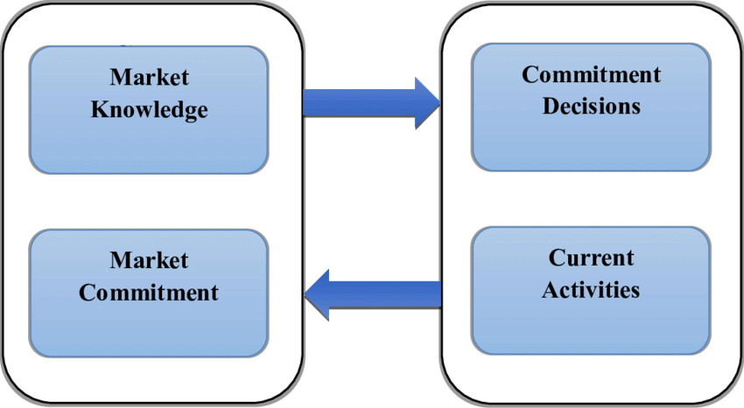
(Source – Resource Gate)

Low Commitment Entry – IKEA initially entered the Chinese market through a joint venture with a local partner. This allowed IKEA to gain experience in the Chinese market and to learn about the local business culture without making a large upfront investment. (Carneiro, Rocha and Silva, 2008).
Incremental Commitment – IKEA gradually increased its commitment to the Chinese market over time. The company started by opening small stores and then gradually expanded to larger stores. IKEA also expanded its product range over time to meet the needs of its Chinese customers.
Experiential Learning – IKEA learned from its experiences in the Chinese market and used this knowledge to improve its operations. For example, IKEA learned that Chinese customers prefer to have their furniture delivered to their homes, so the company began offering delivery services. (Forsgren, 2002).

Cultural And Social Factors Influence Consumer Buying Behaviour and Current Marketing Strategies Employed By IKEA China

Cultural Factors

(Source – Fareedsiddiqui)

Cultural Values and Preferences - Influence on IKEA's Strategy: IKEA may adapt its product offerings to align with Chinese cultural values and preferences. For example, understanding the significance of certain colours, symbols, or designs in Chinese culture and incorporating them into product design. (Guo, Li and Yu, 2017).
Social Class and Status - Influence on IKEA's Strategy: China has a diverse socioeconomic landscape. IKEA might offer products that appeal to different social classes, ensuring a broad customer base. Marketing messages might also highlight the aspirational aspects of IKEA products. (Gao, 2014).

Social Factors


(Source - Dreamstime)

Use Of Chinese Social Media Platforms – IKEA uses Chinese social media platforms, such as Weibo and WeChat, to connect with Chinese consumers and build guanxi with them. IKEA uses these platforms to share information about its products and services, as well as to run marketing campaigns. (Denizci Guillet, Kucukusta and Liu, 2016).

IKEA China's Marketing Strategies


(Source – Skills Lab)
Localized Product Offerings - IKEA may offer products tailored to Chinese tastes and preferences, considering cultural aesthetics and functional needs.
Digital Marketing and E-commerce - Given the prominence of e-commerce and digital platforms in China, IKEA is likely to have a robust online presence with an e-commerce platform and engage in digital marketing campaigns. (Yu et al., 2017).

Hofstede's Cultural Dimensions for IKEA in CHINA –

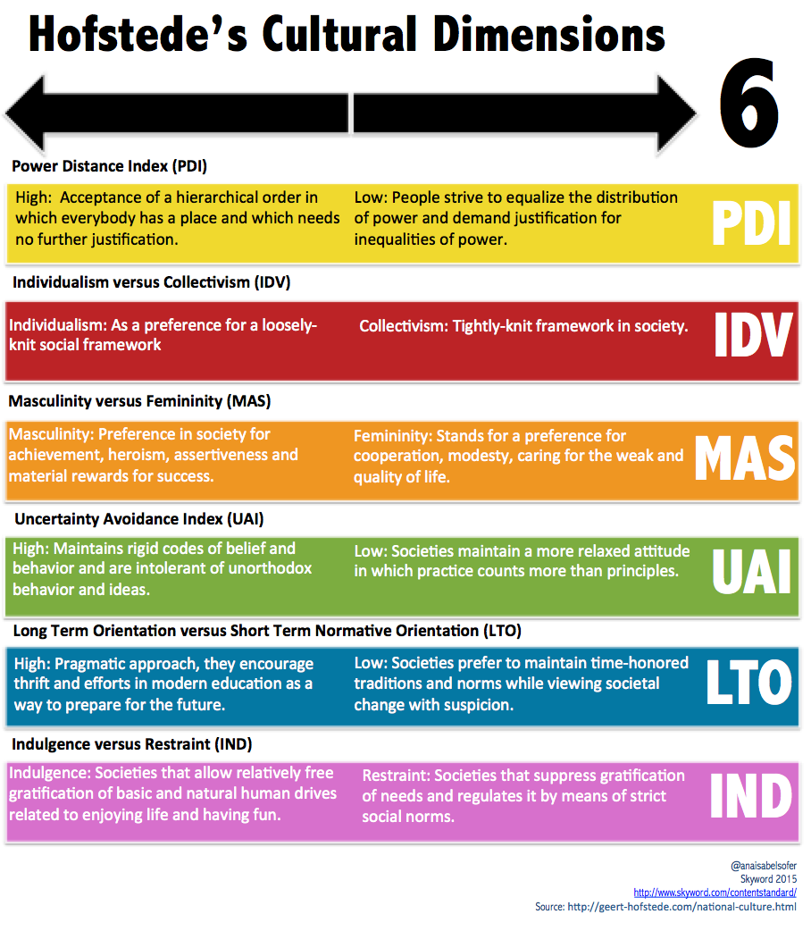
(Source – Webpage of Sky Word)
Individualism vs Collectivism – China is a collectivist society, which means that people in China value group harmony over individual autonomy. This is reflected in the way that people interact with each other in China, with a focus on building relationships and avoiding conflict. IKEA has adapted to this by emphasizing the importance of teamwork and cooperation in its Chinese operations.
Masculinity vs Femininity – China is a relatively masculine society, which means that people in China value competition and achievement. This is reflected in the way that business is conducted in China, with a focus on efficiency and results. IKEA has adapted to this by focusing on providing its customers with a high-quality shopping experience and efficient customer service. (Fang, 2012).
Long-Term vs Short-Term Orientation – China has a long-term orientation, which means that people in China value long-term planning and investment over short-term results. This is reflected in the way that businesses are run in China, with a focus on building long-term relationships with customers and suppliers. IKEA has adapted to this by investing heavily in its Chinese operations and focusing on building long-term relationships with its Chinese customers. (Le Breton–Miller and Miller, 2006).

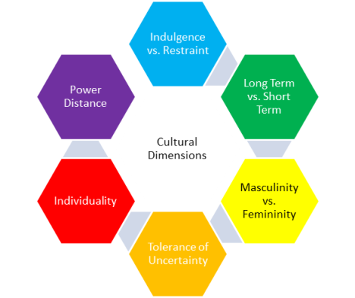

(Source – Hpo Centre)

The Marketing Challenges Encountered By IKEA in China

Adapting Its Product Range to Chinese Consumer Preferences - IKEA has added more traditional Chinese designs to its product range and has adjusted the size and features of some of its products to meet the needs of Chinese consumers. (Burt, Johansson and Thelander, 2011).
Partnering With Local Businesses – IKEA has partnered with local Chinese businesses to help it reduce its costs and to better understand the Chinese market.


(Source - Godaddy)
Investing In Marketing and Advertising – IKEA has continued to invest heavily in marketing and advertising in China to build brand awareness and promote its products. (Laierre et al., 2017).
Negative Perceptions of Swedish Furniture – Some Chinese consumers have negative perceptions of Swedish furniture, seeing it as being cheap and low-quality. IKEA has had to work hard to overcome these perceptions. (Jonssoon et al., 2014)

(Source – psychologytoday).
Competition - The Chinese market can be highly competitive, with local and international brands vying for market share. Understanding the competitive landscape and differentiating the brand is essential.
Supply Chain and Logistics - Establishing and managing an efficient supply chain in China can be challenging. Logistics, distribution, and inventory management may require adjustments to suit local conditions. (Stank, Davis and Fugate, 2005).
Localization of Marketing Strategies – Tailoring marketing messages and strategies to resonate with the local audience is essential. This includes language, imagery, and cultural references. (Cheon, Cho and Sutherland, 2007).
Lack Of Brand Awareness Among Chinese Consumers - IKEA was not as well-known in China as it was in other countries when it first entered the market. This meant that IKEA had to invest heavily in marketing and advertising to build brand awareness.
Difficulty In Reaching Rural Chinese Consumers – Rural Chinese consumers make up a large portion of the Chinese population, but they can be difficult to reach with traditional marketing channels. IKEA has had to experiment with new ways to reach rural Chinese consumers, such as through e-commerce and mobile marketing. (Sun and Wu, 2004).
Regulatory Compliance – Example: Complying with local regulations is essential. IKEA must ensure that its business practices align with Chinese laws and standards, including those related to product safety, labeling, and employment. (Zhao and Qi, 2020).
Social and Environmental Responsibility - Example - Chinese consumers may have specific expectations regarding corporate social responsibility. IKEA's marketing in China may highlight its commitment to sustainable practices and community engagement to align with these expectations. (Chen and Hamilton, 2020).
Localization of Product Offerings - Example - Chinese consumers may have different preferences for furniture styles, sizes, and materials compared to Swedish consumers. IKEA has likely adapted its product range to include items that are popular and practical in Chinese homes. For instance, furniture designed for smaller living spaces or with specific cultural aesthetics. (Liu et al., 2016).

Marketing Strategy Adapt by IKEA to Gain the Sustainable Competitive Advantage

IKEA is a global leader in the home furnishings industry, with a strong presence in many countries around the world. However, the Chinese market is one where IKEA has faced some challenges. The Chinese market is highly competitive, with a few domestic and international players. Additionally, Chinese consumers have different preferences and needs than consumers in other markets.

Product Strategy - IKEA needs to offer a product range that is tailored to the needs of Chinese consumers. This means offering products that are designed for smaller living spaces, that are made from high-quality materials, and that are priced affordably. IKEA focus on selling products that are relevant to Chinese culture and lifestyle. For example, IKEA could sell more furniture that is designed for multiple generations living together, or furniture that is suitable for use in traditional Chinese homes.

Distribution Strategy - IKEA should continue to expand its store network in China. IKEA should also focus on opening stores in smaller cities, as this will allow IKEA to reach a wider range of consumers. In addition to its physical stores, IKEA should also focus on developing its e-commerce presence in China. This will allow IKEA to reach consumers in more remote areas of China and to offer a more convenient shopping experience.

Focus on the unique needs of Chinese consumers - IKEA should focus on understanding the unique needs and preferences of Chinese consumers. This can be done through market research, customer surveys, and focus groups. Once IKEA has a better understanding of Chinese consumers, it can tailor its product offerings and marketing messages accordingly. (Li, Zhao, 2020).

Promotion Strategy - IKEA's promotion strategy in China should focus on building brand awareness and educating consumers about the IKEA concept. IKEA can do this through advertising, public relations, and social media marketing. IKEA should also focus on developing partnerships with local businesses and organizations. This will help IKEA to reach a wider range of consumers and to build trust with Chinese consumers.

Build relationships with local suppliers – IKEA should build strong relationships with local suppliers to ensure that it has a reliable source of high-quality products at competitive prices. This will help IKEA to maintain its cost leadership position in the Chinese market. (Sun and Zhang, 2017)

Invest in digital marketing – IKEA should invest in digital marketing to reach Chinese consumers where they are spending their time online. This includes social media marketing, search engine optimization (SEO), and pay-per-click (PPC) advertising. IKEA should also develop a mobile app for Chinese consumers. (U & Wang, 2019).

Offer a superior customer experience –
IKEA should focus on providing a superior customer experience to its Chinese customers. This includes offering friendly and helpful customer service, as well as a variety of convenient shopping options, such as online ordering and delivery. (Chen, Li, Chen, 2018).

Justification –
This marketing strategy is sound because it is based on a deep understanding of the Chinese market and the needs of Chinese consumers. By focusing on the unique needs of Chinese consumers, localizing its marketing campaigns, building relationships with local suppliers, investing in digital marketing, and offering a superior customer experience, IKEA can gain a sustainable competitive advantage in the Chinese market.

Sustainable Competitive Advantage –

Innovation - IKEA needs to continue to innovate and develop new products and services that meet the needs of Chinese consumers.
Customer experience - IKEA needs to focus on providing a superior customer experience. This includes offering a wide range of products, competitive prices, and a convenient shopping experience.
Brand - IKEA needs to continue to build its brand in China. IKEA is a well-known brand globally, but it needs to increase its brand awareness and recognition among Chinese consumers.

Standardization Strategies -
Consistent Brand Image - Maintain a standardized brand image globally to leverage the strength of the IKEA brand. Ensure a consistent visual identity, including the iconic blue and yellow colour scheme, to enhance brand recognition.

Global Core Product Range - Retain a core product range that remains consistent across markets to achieve economies of scale and operational efficiency. Iconic and popular products should be consistently available to meet the global expectations of IKEA customers.

Localization Strategies -
Adaptation of Product Offerings - Customize product offerings to align with Chinese consumer preferences and lifestyles. Introduce products that cater specifically to local tastes and cultural nuances, ensuring that the product range resonates with the Chinese market.
Store Layout and Design - Customize the layout and design of stores to accommodate the specific shopping habits and preferences of Chinese consumers. Incorporate elements of Chinese culture and aesthetics into store design to create a localized and welcoming atmosphere.
E-commerce Localization - Tailor the online shopping experience to suit the preferences of Chinese consumers. Implement local payment options, integrate with popular Chinese social media platforms, and ensure a seamless digital experience that aligns with local expectations.

Porter’s Generic Strategies

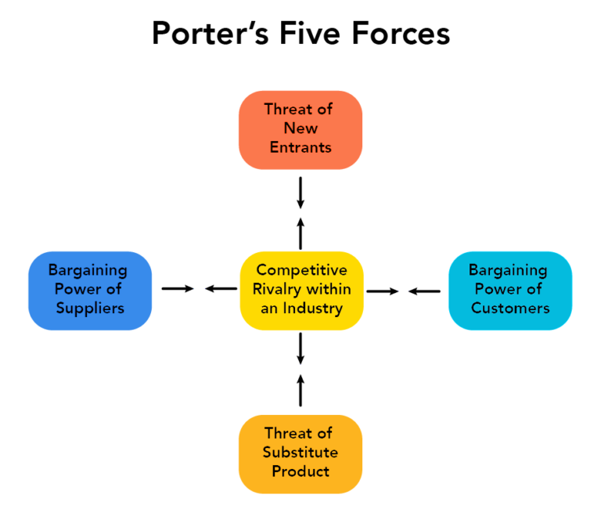
(Source - Amazonaws)

- Barriers to Entry - The speed at which new businesses can join an industry is referred to as this force. When there are little economies of scale, cheap capital needs, low customer switching costs, and low barriers to entry, the danger of new entrants is significant. (Yunna and Yisheng, 2014).
- The Threat of Substitute Products or Services - A replacement item is not a comparable item from a competition, but rather an entirely distinct item or service that serves the same objective in the consumer's view. A municipal underground system, for example, may be a replacement product for an automotive company. Similarly, e-mails may be used instead of emails, olive oil can be used in place of butter, and tea can be used in place of coffee. When there are good replacements for a product, the industry suffers. (Baburaj and Narayanan, 2016).
- Competitive Rivalry Within the Industry - The danger of new goods or services that could displace the current offerings in the sector is referred to as this force. When near replacements are readily available, when their performance is increasing, and since their cost is decreasing, the danger of alternatives is greatest. (Hao and Chen, 2012).
- The Bargaining Power of Buyers - The power of consumers to bargain for better conditions and pricing for the goods or services they buy is referred to as this force. When there are relatively few buyers, they are highly concentrated, their cost of switching rise, and there are plenty of alternatives to the goods or services, and consumers have significant bargaining power. (FENTON, IKEA in China).
- The Bargaining Power of Suppliers - The capacity of providers to bargain for advantageous terms and pricing for their goods or services is referred to as this force. When there are few vendors, when the items offered by the manufacturers are special or necessary, and when the switching expenses for customers are considerable, the producers have significant negotiating leverage. (Lindh and Södergren, 2012).

Implementation Plan for The Proposed Strategy, Taking Into Consideration All Factors

Glocalization
Products -
- Conduct Market Research – Utilization of surveys, focus groups, and social media analysis to understand the preferences, needs, and aspirations of Chinese consumers. As well as identify specific pain points and unmet needs in the Chinese furniture market. Furthermore, analyze competitor offerings to identify gaps and opportunities for IKEA. (Al-Abdallah, 2015).
- Develop Products - Create a product development team dedicated specifically to the Chinese market. Next, incorporate insights from market research into product design and development. Collaborate with Chinese designers and manufacturers to ensure products are culturally appropriate. And offer a variety of sizes, styles, and colours to cater to diverse Chinese consumer tastes.
- Marketing – First of all adapt marketing campaigns to resonate with Chinese cultural values and traditions. Utilize Chinese language and imagery in all marketing materials, including signage, brochures, and website content. Engage with Chinese influencers and celebrities to promote IKEA products and brand values. Last, create targeted marketing campaigns for specific segments of the Chinese population, such as young couples, families, and urban professionals. (Taylor, 2000).
Digital Marketing
Social Media -
- Strong Presence - Create dedicated social media accounts on platforms like Weibo, WeChat, and Douyin. As well as develop a consistent brand voice and messaging across all social media channels. Next, tailor social media content to the specific interests and preferences of Chinese users. And utilize social media analytics to track engagement and measure the effectiveness of campaigns. (Tsimonis and Dimitriadis, 2014).
- Engage With Chinese Consumers – Respond promptly to comments and messages from Chinese consumers. Host interactive contests and giveaways to generate excitement and engagement. Encourage user-generated content by running photo contests and social media challenges. Collaborate with Chinese social media influencers to promote IKEA products and brand awareness.
E-commerce
- Collaboration With Popular Chinese E-Commerce Platforms - Establish partnership agreements with online shopping giants like as Alibaba, JD.com, and Pinduoduo. As well as make item listings and descriptions more appealing to search engines and e-commerce websites. Use the marketing and advertising resources e-commerce platforms provide to reach a wider demographic. Offer Chinese customers convenient and safe digital payment choices to make smoother shopping. (Li, Frederick and Gereffi, 2019).
Omnichannel Marketing
- Increase IKEA's Outlet Presence in Important Chinese Cities - Identify advantageous spots for new retail establishments, considering the density of population, demography, and traffic availability. Create layouts for stores that adapt to Chinese consumer tastes, such as greater display areas and more engaging aspects. As well as teach store employees how to give outstanding client service, including assembling furniture help and architectural consultancy. Organise within-the-store events and seminars to highlight IKEA items and excite consumers. (Burt, Johansson and Thelander, 2011).
Additional Considerations
- Pricing - Perform an affordable study to gain insight into market trends and rivals' pricing tactics. Create reasonably priced strategies which are accessible for Chinese customers while remaining consistent with IKEA's overall marketing strategy. Provide flexible pricing techniques in which prices are adjusted depending on demand, availability of goods, and seasonal trends.
- Customer Service - Create a specialised client service crew with Cantonese as well as Mandarin proficiency specifically for the Chinese region. Offer a variety of communication routes, such as social media, email, online chat, and telephone. And teach client service representatives to handle questions and problems raised by consumers in a professional, sympathetic, and informed manner. (Innis and La Londe, 1994).

7P’s of Marketing
- Product - This refers to the products or services that a business provides. When establishing an unfamiliar marketplace, it is critical to examine the regional customs, customer preferences, and demands. Companies can alter their products to match the local market, or they may need to produce whole new items.
- Price - This is the price that a corporation charges for its goods or services. Pricing methods might differ based on geography, cost of goods, and target market. To compete in the neighbourhood market, businesses may have to modify their prices.
- Place - This relates to the routes that an organisation uses to get its goods or services to customers. Transmission routes might vary based on the nation, facilities, and the target market. Businesses may need to engage with regional suppliers or shops to reach customers in the fresh market. (Cavusgil, and Peterson, 2017).
- Promotion - The communication efforts used by a firm to enlighten and convince customers regarding the goods or services. Advertising campaigns might differ according to the nation, society, and customer base. To be successful in a nearby market, businesses may need to modify their advertising tactics. (Borden, 1953).
- People - Train employees to recognise and accept cultural differences. Hire local people to improve relationships with clients. Guarantee that personnel mirror the desired audience's range.

- Process - Reduce operational procedures to account for local norms and traditions. Improve operations related to client service meet cultural standards. Establish effective order fulfilment and client service processes.
- Physical Evidence - Create a physical environment that resonates with local aesthetics and preferences. Ensure consistency in brand presentation across different international locations. Use tangible elements to communicate quality and reliability.

Key Performance Indicators
- Sales Growth - This is an indicator of revenue growth over an extended period.
- Market share - This is the portion of the consumer base that a business's goods and services make up. (Gutiérrez-Pulpin and López-Cózar, 2021).
- ROI - This is a measurement of the profitability of an investment. (Eely, Adams and Crowe, 2003).

- Customer Satisfaction - This indicates the level of satisfaction customers have with the goods or services provided by a business.
- Brand awareness - This is a measure of how well consumers recognize and remember a company's brand.

Reference

- Al-Abdallah, G.M., 2015. The impact of internet marketing research on achieving competitive advantage. International Journal of Arts & Sciences, 8(1), p.619.
- Baburaj, Y. and Narayanan, V.K., 2016. Five Forces Framework. M. Augier, & D. Teece, The Palgrave Encyclopedia of Strategic Management. Stanford: Palgrave Macmillan.
- Beamish, P.W. and Lupton, N.C., 2009. Managing joint ventures. Academy of management perspectives, 23(2), pp.75-94.
- Borden, N. H. (1953). The concept of the marketing mix. Journal of Advertising Research, 2(2), 2-7.
- Boström, M., 2015. Between monitoring and trust: commitment to extended upstream responsibility. Journal of business ethics, 131, pp.239-255.
- Burt, S., Johansson, U. and Thelander, Å., 2011. Standardized marketing strategies in retailing? IKEA’s marketing strategies in Sweden, the UK and China. Journal of Retailing and Consumer Services, 18(3), pp.183-193.
- Burt, S., Johansson, U. and Thelander, Å., 2011. Standardized marketing strategies in retailing? IKEA’s marketing strategies in Sweden, the UK and China. Journal of Retailing and Consumer Services, 18(3), pp.183-193.
- Burt, S., Johansson, U. and Thelander, Å., 2011. Standardized marketing strategies in retailing? IKEA’s marketing strategies in Sweden, the UK and China. Journal of Retailing and Consumer Services, 18(3), pp.183-193.
- Capdevielle, L., Li, M. and Nogal, P., 2007. A creation of competitive advantage by using differentiation of company´ s strategy actions: The case study of IKEA Sweden with experiences on Chinese and French markets.
- Carneiro, J., Rocha, A.D. and Silva, J.F.D., 2008. Challenging the Uppsala internationalization model: a contingent approach to the internationalization of services. BAR-Brazilian Administration Review, 5, pp.85-103.
- Cavusgil, S., & Peterson, J. L. (2017). International marketing management (9th ed.). McGraw-Hill Education.
- Chen, Z. and Hamilton, T., 2020. What is driving corporate social and environmental responsibility in China? An evaluation of legacy effects, organizational characteristics, and transnational pressures. Geoforum, 110, pp.116-124.
- Cheon, H.J., Cho, C.H. and Sutherland, J., 2007. A meta-analysis of studies on the determinants of standardization and localization of international marketing and advertising strategies. Journal of International Consumer Marketing, 19(4), pp.109-147.
- Denizci Guillet, B., Kucukusta, D. and Liu, L., 2016. An examination of social media marketing in China: how do the top 133 hotel brands perform on the top four Chinese social media sites?. Journal of Travel & Tourism Marketing, 33(6), pp.783-805.
- eely, A. D., Adams, C. E., & Crowe, P. D. (2003). The performance and measurement revolution: Why now and how to get started. Financial Times – Prentice Hall.
- Fang, T., 2012. Yin Yang: A new perspective on culture. Management and organization Review, 8(1), pp.25-50.
- FENTON, E., IKEA in China.
- Forsgren, M., 2002. The concept of learning in the Uppsala internationalization process model: a critical review. International business review, 11(3), pp.257-277.
- Frynas, J.G. and Mellahi, K., 2015. Global strategic management. Oxford University Press, USA.
- Frynas, J.G. and Mellahi, K., 2015. Global strategic management. Oxford University Press, USA.
- Gao, F., 2014. Social-class identity and English learning: Studies of Chinese learners. Journal of Language, Identity & Education, 13(2), pp.92-98.
- Guo, Q., Li, Y. and Yu, S., 2017. In-law and mate preferences in Chinese society and the role of traditional cultural values. Evolutionary Psychology, 15(3), p.1474704917730518.
- Gutiérrez-Pulpin, E., & López-Cózar, L. D. (2021). A systematic review of key performance indicators in the supply chain management context. International Journal of Production Research, 59(17), 5305-5345.
- Hao, S. and Chen, L., 2012. Exploring coopetition in single firm and its contribution to service management: a case study in red star Macalline and IKEA China.
- Harapiak, C., 2013. IKEA's International Expansion.
- Henderson, P.W., Cote, J.A., Leong, S.M. and Schmitt, B., 2003. Building strong brands in Asia: Selecting the visual components of image to maximize brand strength. International journal of Research in Marketing, 20(4), pp.297-313.
- https://assets.coursehero.com/study-guides/lumen/images/wmopen-introbusiness/meaning-and-purposes-of-the-law/rules-1339917_640-300x2312.png
- https://au.globalassignmenthelp.com.au/images/GAH_AU/data/page_upload/images/gah.au-pestle-analysis_ikea_2_5fe2cc7a72dbf.jpg
- https://bstrategyhub.com/wp-content/uploads/2018/05/Picture1-3.png
- https://cdn.psychologytoday.com/sites/default/files/styles/article-inline-half-caption/public/field_blog_entry_images/2019-08/perception.jpg?itok=GP6IJp54
- https://fareedsiddiqui.files.wordpress.com/2015/06/culture_network_s2.jpg
- https://i2.wp.com/www.skillslab.io/app/uploads/2019/02/Types-of-Marketing-Strategies.jpeg?resize=1024%2C683&ssl=1
- https://s3-us-west-2.amazonaws.com/courses-images/wp-content/uploads/sites/1972/2017/07/05164839/Porters5Forces2.png
- https://www.dreamstime.com/word-writing-text-social-factors-business-concept-things-influences-lifestyle-cultural-differences-view-young-man-photo-image155449960
- https://www.godaddy.com/garage/wp-content/uploads/2016/11/godaddy-partnering-with-local-businesses.png
- https://www.hpocenter.de/wp-content/uploads/2015/03/Hofstede%E2%80%99s-cultural-dimensions-and-the-HPO-Framework-1.png
- https://www.ikea.com/ext/ingkadam/m/26a65c6012caf4aa/original/GC-logos-with-years.jpg?imwidth=800
- https://www.publicdomainpictures.net/pictures/330000/velka/technology-2020-15851598640jb.jpg
- https://www.researchgate.net/profile/Hamidreza-Radmanesh/publication/328448705/figure/fig2/AS:684775870304258@1540274698305/Mechanism-of-internationalization-Uppsala-model.png
- https://www.skyword.com/wp-content/uploads/2015/10/hofstede-s-cultural-dimensions.png
- https://youtu.be/yCokvdX5IC0
- Inkpen, A.C. and Beamish, P.W., 1997. Knowledge, bargaining power, and the instability of international joint ventures. Academy of management review, 22(1), pp.177-202.
- Innis, D.E. and La Londe, B.J., 1994. Customer service: the key to customer satisfaction, customer loyalty, and market share. Journal of business Logistics, 15(1), p.1.
- Johnston, A.I., 2019. China in a world of orders: Rethinking compliance and challenge in Beijing's international relations. International Security, 44(2), pp.9-60.
- Jonsson, A., 2008. A transnational perspective on knowledge sharing: lessons learned from IKEA's entry into Russia, China and Japan. The international review of retail, Distribution and Consumer Research, 18(1), pp.17-44.
- Jonsson, O., Östlund, B., Warell, A. and Dalholm Hornyánszky, E., 2014. Furniture in Swedish nursing homes: a design perspective on perceived meanings within the physical environment. Journal of Interior Design, 39(2), pp.17-35.
- Lapierre, M.A., Fleming-Milici, F., Rozendaal, E., McAlister, A.R. and Castonguay, J., 2017. The effect of advertising on children and adolescents. Pediatrics, 140(Supplement_2), pp.S152-S156.
- Le Breton–Miller, I. and Miller, D., 2006. Why do some family businesses out–compete? Governance, long–term orientations, and sustainable capability. Entrepreneurship theory and practice, 30(6), pp.731-746.
- Li, F., Frederick, S. and Gereffi, G., 2019. E-commerce and industrial upgrading in the Chinese apparel value chain. Journal of Contemporary Asia, 49(1), pp.24-53.
- Lindh, K. and Södergren, K., 2012. Textile Sourcing Development in Increasingly Expensive China An Investigation of Future Sourcing Strategies at IKEA.
- Liu, S., Perry, P., Moore, C. and Warnaby, G., 2016. The standardization-localization dilemma of brand communications for luxury fashion retailers' internationalization into China. Journal of Business Research, 69(1), pp.357-364.
- Lukas, E., 2007. Dynamic market entry and the value of flexibility in transitional international joint ventures. Review of Financial economics, 16(1), pp.91-110.
- Shan, W., 1991. Environmental risks and joint venture sharing arrangements. Journal of International Business Studies, 22, pp.555-578.
- Sin, L.G., Utama, A.G.S., Pandey, S., Pandey, R., Harsha, Y.S.S.V.S., Massand, A., Safitri, A.D.I., Yan, N.P., Kee, D.M.H., Yue, W.S. and Zhin, P.M., 2021. A case study of the factors that affect consumer behavior in IKEA. Asia Pacific Journal of Management and Education (APJME), 4(2), pp.20-28.
- Stank, T.P., Davis, B.R. and Fugate, B.S., 2005. A strategic framework for supply chain oriented logistics. Journal of business logistics, 26(2), pp.27-46.
- Sun, T. and Wu, G., 2004. Consumption patterns of Chinese urban and rural consumers. Journal of consumer marketing, 21(4), pp.245-253.
- Tarnovskaya, V.V. and de Chernatony, L., 2011. Internalising a brand across cultures: the case of IKEA. International Journal of Retail & Distribution Management, 39(8), pp.598-618.
- Taylor, R.K., 2000. Marketing strategies: Gaining a competitive advantage through the use of emotion. Competitiveness Review: An International Business Journal, 10(2), pp.146-152.
- Tsimonis, G. and Dimitriadis, S., 2014. Brand strategies in social media. Marketing Intelligence & Planning, 32(3), pp.328-344.
- Wu, Y., 2020, February. The marketing strategies of IKEA in China using tools of PESTEL, five forces model and SWOT analysis. In International Academic Conference on Frontiers in Social Sciences and Management Innovation (IAFSM 2019) (pp. 348-355). Atlantis Press.
- Yu, Y., Wang, X., Zhong, R.Y. and Huang, G.Q., 2017. E-commerce logistics in supply chain management: Implementations and future perspective in furniture industry. Industrial Management & Data Systems, 117(10), pp.2263-2286.
- Yunna, W. and Yisheng, Y., 2014. The competition situation analysis of shale gas industry in China: Applying Porter’s five forces and scenario model. Renewable and Sustainable Energy Reviews, 40, pp.798-805.
- Zhao, X. and Qi, Y., 2020. Why do firms obey?: The state of regulatory compliance research in China. Journal of Chinese Political Science, 25, pp.339-352.
- Zhao, Z., Anand, J. and Mitchell, W., 2005. A dual networks perspective on inter‐organizational transfer of R&D capabilities: international joint ventures in the Chinese automotive industry. Journal of management studies, 42(1), pp.127-160.

