Zakir Hussain-0251055

SULLIVAN’S TOY WORLD

Executive summary
The researcher will in this report aim to advise Michelle Sullivan, how to effectively expand her toy store ‘SULLIVAN’S TOY WORLD’. The researcher will advise on how to adopt and implement an effective two-way communication system. The researcher will advise which relevant team work theories to be aware of, and what company management structures to implement, which will enable the expansion to be much smoother going forward. The researcher will draw a conclusion, recommendations and action plan from materials taken from, websites, journals and textbooks.

Contents Page

Content page no

Executive summary 1
1.0 - Terms of Reference 3
2.0 – Procedure 3
Introduction 4
3.0 – Findings 5-7
4.0 – Conclusion 8
5.0 – Recommendations 9
Reference list 10

1.0
Terms of Reference
This report was requested by Michelle Sullivan of ‘Sullivan’s Toy World’ on the 07/2/19 from Zakir Hussain (junior business consultant ‘UK Business Consultant Ltd’). The purpose of this report is to advise on effective team working, communication and an efficient structure implantation for a smoother transition into the expansion of the store.

2.0
Procedure
Journals, websites and textbooks were consulted to help prepare this report.

3.0
Introduction
Sullivan’s toy store started as a small business in Swansea with five employees, rapid success has seen demands for an expansion. The company currently employees 27 members of staff, job roles ranging from; stockroom staff, two cleaners, fourteen sales assistants, two security staff, three managers, and most staff are part-time, and one employee is off sick. The researcher has found Sullivan’s Toys Store has enough staff members to appoint a supervisor in every shift and opening hour of business. The researcher had found from own self-employed experience that, the fulfilling of, his or her dreams of running a successful profitable business there are certain pitfalls. A solo leader is constantly under the pressure of continued vision and direction, does not know when and who to delegate task to, because the team trust is not there. He or she would never belong to a team, and the whole company will be in forever at a forming-storming stage which is, groups of people and not an effective team, this would be prudent to avoid when expanding (Belbin.com, 2019). The researcher has found certain disadvantages of structure-less small business; working excessive hours due to previous ‘walking around management style’ due to, no deputising roles being implemented. Health and stress level will be higher due to ineffective management systems, personal growth of staff would be limited because of lack of procedure and training being shared on all working hours (Leonard, 2019). The researcher has found a business can have effective communication and avoid the breakdown of communication by applying Tuckman & Belbin, also implementing a good two-way communication process.

Findings

Effective Communication

Managers would need to develop an effective training procedure for all new staff with good understanding of Bruce Tuckman’s team building model. The managers would need to communicate with each other effectively using, the ‘Shannon Weaver Model’ (see appendices 1). This model was created in 1948 by Shannon, a mathematician and Weaver a scientist, the concept would apply in the toy store by the following: sender would be the brain of the member of management. Mouth would be the encoder that picks the relevant language and content. The channel will be airwaves, the receiver’s ears would be the receptor and his or her brain would be the decoder and receiver.
Manager and supervisors must be aware of the five stages of Bruce Tuckman’s team development and give presentations to all staff members outlining company procedures and policies. The researcher has found effective communication must be from top of the hierarchy, to all the way down to every employee in the company to have maximum productivity and success for the business (Johnson, 2019). They must be aware of how to effectively communicate through it, according to (Crainer, 2015) it’s by changing a company’s structure for the better, you will get people to change bad behavior. The researcher advises the toy store re-structure its company in the following structure;

Mangers (1)

Effective two-way communication/feedback loop

Supervisors (2)

Effective two-way communication/feedback loop

All other staff; checkout staff, security staff, stockroom staff, cleaners (3)

Managers and supervisors
1/2
Managers and supervisors must have good verbal, nonverbal and excellent paralinguistic communication, because they are the head of the hierarchy. The researcher has found by using the ‘A communication cycle’ model (see appendices 5) managers can have an effective flow of communication, with a feedback loop. Mangers must encourage feedback to employees through e- mails or face to face. Managers and supervisors must be tactful in criticism, they must be; specific, keep it impersonal and descriptive, ensure it is goal oriented and time the delivery well. The communication cycle is best used face to face, the negative elements to consider and avoid is the noise, which can be a barrier to effective communication when using this model. Noise disturbance of; surrounding environment such as colleagues talking, traffic from outside, concentration on mobile phones, thinking of something else and not fully understanding the topic of communication. These could all break down the communication process. Feedback in such a situation is available in this model, and the receiver requesting clarification in any misunderstood communications can avoid such incidents (Communication Theory, 2019).
The researcher has found verbal and nonverbal forms of communication extremely important for the success of this toy store (Cherry, 2019). The researcher highly recommends all managers and supervisors to have an understanding of verbal and nonverbal communication and to attaint self-awareness on this topic (see appendices 6).The researcher found 55% of communication is made through body language (Debenham, 2019). According to Lucas (2019) human beings’ success as a species depends on good verbal and nonverbal communications. It has been vitally important in human species history, from teams of hunters to the workplace today.

Supervisors
2
The researcher has found, being aware of your own paralinguistic vocal strengths and weaknesses are very beneficial when communicating. A good paralinguistic style of conversing is advised as an awareness of good: rate/speed, rhythm, volume, pitch, inflection/vocal variety, quality of voice, intensity and tone of voice will allow the speaker to subtly influence speaking and listening so that the speaker will be a more powerful communicator.

All other staff members (3)

The manager and supervisors of this newly restructured company will have a group of people in the forming stage. Leaders will have to be open for question, be polite in feedback, boundaries, strength, and weakness will be tested. Staff members will have baggage from past experiences in the company. Managers and supervisors must invest time in their staff and be empathetic. Managers must state and take questions in job description and how the new training manual helps staff (Belbin.com, 2019).

The nearly formed team as explained by Bruce Tuckman will be in the storming faze. They are new groups of individuals, misunderstanding, misinterpretation and a power struggle will take place. Mangers will need to be empathetic, at the norming faze encourage strategic planning offer coaching on leadership styles. At the performing stage recognize team member’s contributions, to ovoid resentments of a member, and adjourning, a time for team recognition of individual achievements and reflection. Managers and supervisors will need this model as advised, using while developing training procedures (Belbin.com, 2019). Effective communication would reduce conflict, one main reasons for long-term absentees and low team morale in the workplace, is lack of good communication and management structures (Bosworth, 2019).

4.0 Conclusion
In conclusion there are various changes that can be made to the structure of the organisation including the possibility of appointing a supervisor in every shift and opening hour of business. The busines having more formal methods of effective communication can avoid the breakdown of communication by applying Tuckman & Belbin, also implementing a good two-way communication process. Managers would need to develop an effective training procedure for all new employees with good understanding of Bruce Tuckman’s team building model. Managers would need to communicate with each other effectively using, the ‘Shannon Weaver Model’. Management staff must be aware of the five stages of Bruce Tuckman’s team development and give presentations to all staff members outlining company procedures and policies. The researcher has found effective communication must be from the top of the hierarchy, to all the way down to every employee in the company to have maximum productivity and success for the business and business expansion. The is a need for Ggood verbal, nonverbal and excellent paralinguistic communication is crucial to the store. Managers must have effective flow of communication, with a feedback loop; the criticism must be sandwiched with praise on both outer layers and proactive criticism in the middle to create a positive and constructive work culture.

5.0
Recommendations

All supervisor to record shift performance records as part of job duties per shift. The researcher recommends staff presentation in monthly intervals to encourage staff bonding, increase trust. Supervisors should receive feedback off staff in each session in which supervisors should try aim to reach a level 5 in listening to be more emphatic towards staff (see appendices 7). Ensure the feedback is understood, ensure the behaviour is controllable and tailor the message well, sandwich the feedback, in the method of layer of praise with proactive feedback in middle and praise in outer layer. Checkout -staff are to be introduced to the ‘Berlo method of communication’ (see appendices 4), this will increase better understanding of customer service. Berlo’s Model has mainly, four components to describe the communication process. The check-out staff are sender, the message of product price or customer requirements, channel would be air waves and receiver would be customers earing and brain would be decoder. The check-out staff can use his or her product knowledge to increase productivity with knowledge; Familiarity with the subject of the message, which would be product of customer choice, makes the communicated message have more of a positive effect. Knowledge on the subject matter makes the communicator send the message effectively. This model believes that the thinking pattern and all other factors mentioned in appendices 4 must be in sync to that of the sender for the communication to be effective (Businesstopia, 2019).

Action plan

The managers would need to have a two way communication using the communication cycle to create a training manual. The supervisors would need to use Shannon weaver model to train new staff. The checkout staff would need a presentation on awareness of the berlo method of commination by managers or supervisors. The researcher recommends managers and supervisors to go on short training courses yearly and in required durations if necessary, intervals in future depending on acquired knowledge from course. Managers must recommend supervisor to go on these courses after a one to one consultation and only staff with desired hunger to career advancement must be recommended. The required course must be on topic of; effective communication, Tuckman and Belbin team building course, conflict management course, and an ACAS course recommended. The cost of the courses varies from £250-£450 and duration 3-5 days. The management should create a daily store performance recording system, which would cost £2200. The managers must make a night shift rotational on all staff members, that is unbiased and fair, which will decrease resentment and absentees in the future. The cost for this would be extra wages increase for night shift workers £2 an hour.

6.0
Appendices

Image from (Researchgate.net, 2019)

Appendices 1

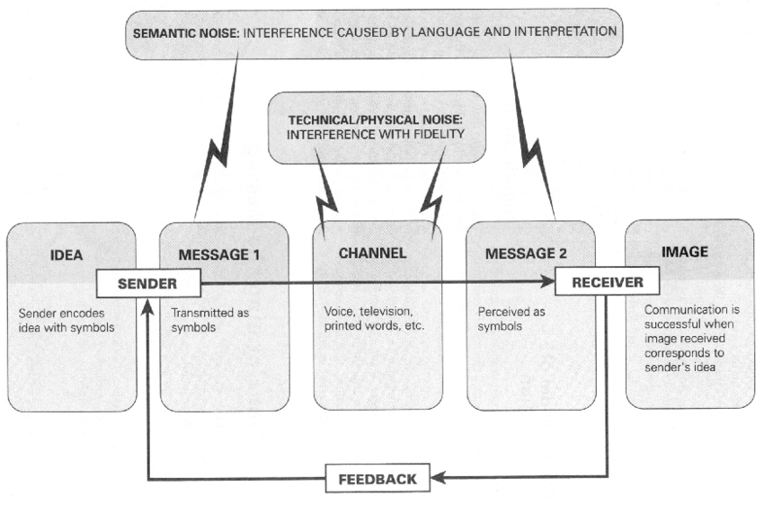

Image from (Google.co.uk, 2019).

Appendices 2

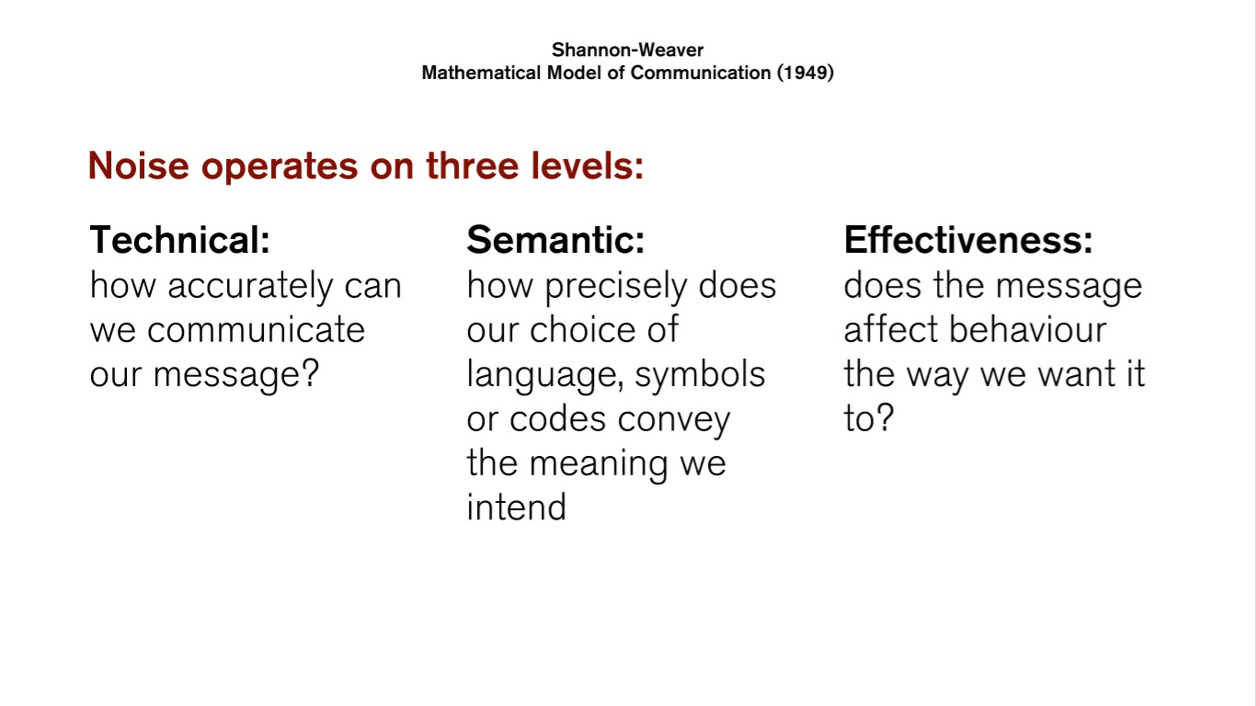

Appendices 3

Image from (Bing.com, 2019)

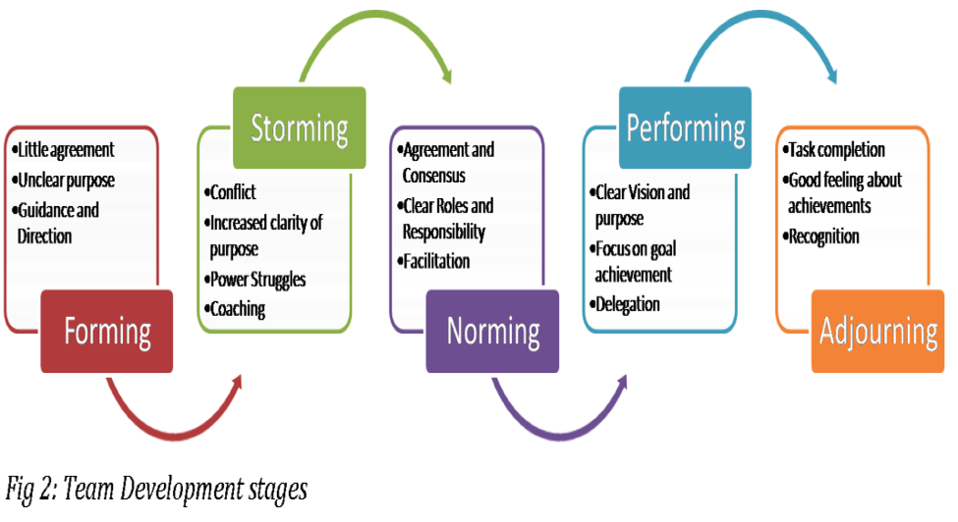

Appendices 4

Image from (Bing.com, 2019)

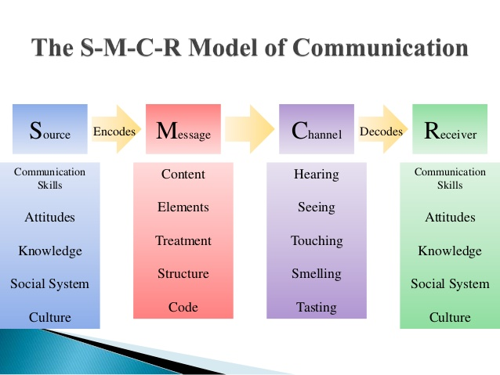

Appendices 5
Image from (Bing.com, 2019)

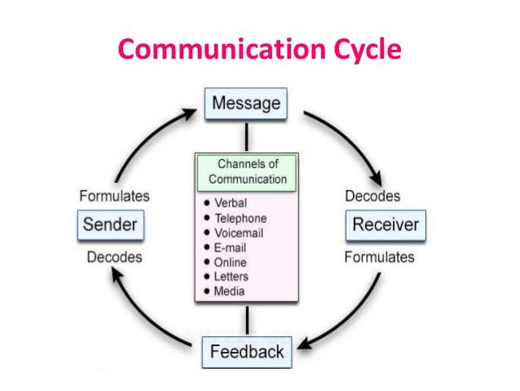

Appendices 6
Image from (Bing.com, 2019)

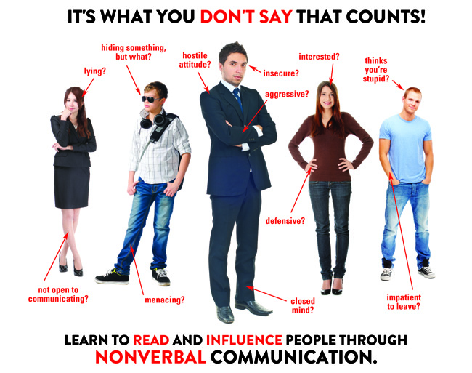

Appendices 7

Image from (Bing.com, 2019)
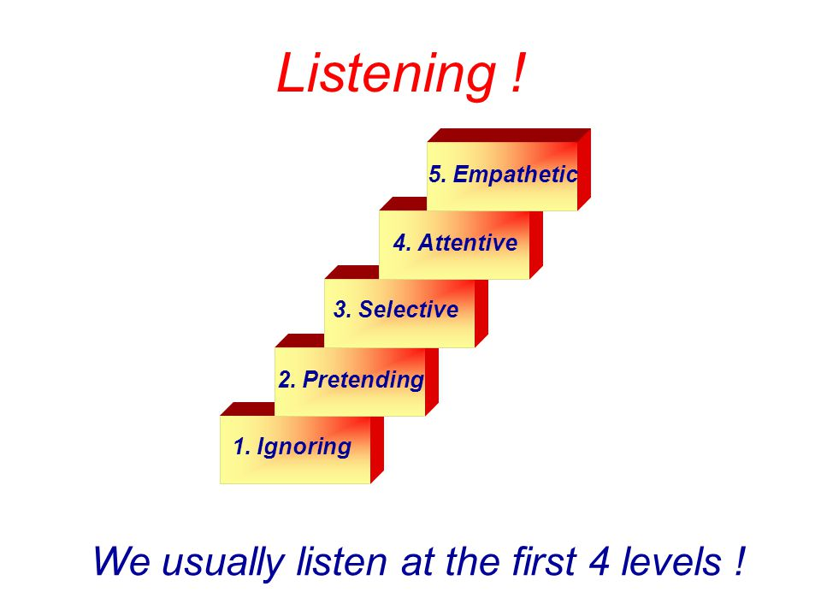

8.0
Reference list
Belbin.com. (2019). Solo vs. Team Leadership. [online] Available at: https://www.belbin.com/resources/blogs/solo-vs-team-leadership/ [Accessed 1 Apr. 2019].

Bing.com. (2019). empathetic listening level 5 - Bing. [online] Available at: https://www.bing.com/images/search?view=detailV2&ccid=92s0zq3C&id=2DCD83CC32063D9C6B43BC6E86095876F49DFFEB&thid=OIP.92s0zq3CFJ1eW0QfiAYBeAHaFj&mediaurl=https%3A%2F%2Fslideplayer.com%2Fslide%2F4691800%2F15%2Fimages%2F18%2FWe%2Busually%2Blisten%2Bat%2Bthe%2Bfirst%2B4%2Blevels%2B%2521.jpg&exph=720&expw=960&q=empathetic+listening+level+5&simid=608017164245404757&selectedindex=70&ajaxhist=0&vt=0 [Accessed 5 Apr. 2019].

Bing.com. (2019). TUCKMAN GROUP AND TEAM DEVELOPMENT - Bing. [online] Available at: https://www.bing.com/images/search?view=detailV2&ccid=4OMcX1uD&id=06DB5197B8C0D01B1A33886A723972DEA41676C0&thid=OIP.4OMcX1uDyNcJL39xUg6MCwHaEC&mediaurl=http%3A%2F%2Fwww.mspguide.org%2Fsites%2Fdefault%2Ffiles%2Fimages%2Ftuckman_okpalad.png&exph=532&expw=975&q=TUCKMAN+GROUP+AND+TEAM+DEVELOPMENT&simid=608036233909242116&selectedindex=1&ajaxhist=0&vt=0 [Accessed 2 Apr. 2019].
Bing.com. (2019). a communication cycle model - Bing. [online] Available at: https://www.bing.com/images/search?view=detailV2&ccid=SR6BBTfg&id=6AFE616818CDEF47B7F0BD2B129B3816B3DA37C6&thid=OIP.SR6BBTfgjzRi6ylqVv247gHaFj&mediaurl=https%3A%2F%2Fimage.slidesharecdn.com%2Fcommunicationskillunit1-170516022221%2F95%2Fcommunication-skill-principles-of-communication-38-638.jpg%3Fcb%3D1494901407&exph=479&expw=638&q=a+communication+cycle+model&simid=608016459914084979&selectedindex=4&ajaxhist=0&vt=0 [Accessed 5 Apr. 2019].

Bing.com. (2019). non-verbal communication - Bing images. [online] Available at: https://www.bing.com/images/search?view=detailV2&ccid=O2mBc1RQ&id=2E4006B1EBB68D95F40443F0EE7407B7B1D28963&thid=OIP.KSdih7pistZEP1THgvDghQHaF2&mediaurl=https%3a%2f%2fopenanswer.files.wordpress.com%2f2014%2f08%2fnon-verbal-communication.jpg&exph=513&expw=650&q=non-verbal+communication&simid=607994254893253356&selectedIndex=0&ajaxhist=0 [Accessed 5 Apr. 2019].

Bosworth, P. (2019). The Power of Good Communication in the Workplace | Leadership Choice. [online] Leadership Choice. Available at: https://leadershipchoice.com/power-good-communication-workplace/ [Accessed 1 Apr. 2019].
Businesstopia. (2019). Berlo's SMCR Model of Communication - Businesstopia. [online] Available at: https://www.businesstopia.net/communication/berlo-model-communication [Accessed 5 Apr. 2019].

Crainer, S. (2015). HAIER CALLING. London Business School Review, 26(1), pp.24-30.

Communication Theory. (2019). Shannon and Weaver Model of Communication. [online] Available at: https://www.communicationtheory.org/shannon-and-weaver-model-of-communication/ [Accessed 3 Apr. 2019].
Cherry, K. (2019). What Are the 9 Types of Nonverbal Communication You Might Be Missing? [online] Verywell Mind. Available at: https://www.verywellmind.com/types-of-nonverbal-communication-2795397#3-paralinguistics [Accessed 1 Apr. 2019]
Debenham, L. (2019). Communication - What Percentage is Body Language?. [online] Bodylanguageexpert.co.uk. Available at: http://www.bodylanguageexpert.co.uk/communication-what-percentage-body-language.html [Accessed 5 Apr. 2019].

Google.co.uk. (2019). Shannon weaver model - Google Search. [online] Available at: https://www.google.co.uk/search?q=shannon+weaver+model&source=lnms&tbm=isch&sa=X&ved=0ahUKEwijgYXMrbHhAhWtUBUIHZt3BV8Q_AUIDigB&biw=1242&bih=593#imgrc=dLNV_EEjr-3OgM: [Accessed 2 Apr. 2019].
Johnson, S. (2019). How Do the Levels of the Communication Hierarchy Work in an Organization? [online] Smallbusiness.chron.com. Available at: https://smallbusiness.chron.com/levels-communication-hierarchy-work-organization-65717.html [Accessed 1 Apr. 2019].

Leonard, K. (2019). Advantages & Disadvantages of Owning Your Own Company. [online] Smallbusiness.chron.com. Available at: https://smallbusiness.chron.com/advantages-disadvantages-owning-own-company-21125.html [Accessed 1 Apr. 2019].
Lucus, A. (2019). The Importance of Verbal & Non-Verbal Communication | Livestrong.com. [online] LIVESTRONG.COM. Available at: https://www.livestrong.com/article/156961-the-importance-of-verbal-non-verbal-communication/ [Accessed 3 Apr. 2019].
Researchgate.net. (2019). [online] Available at: https://www.researchgate.net/profile/Rowland_Lorimer/publication/318874024/figure/fig1/AS:523170014216192@1501744859386/Shannon-and-Weavers-Mathematical-Model-of-Communication-1949.png [Accessed 2 Apr. 2019].

