Name: Michael Andrew Elliott

Student No.: 1809306

Lab - Accessing Network Devices with SSH
Topology
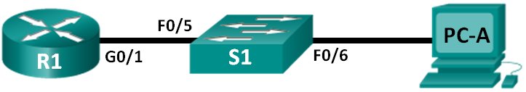
Addressing Table
Device | Interface | IP Address | Subnet Mask | Default Gateway
R1 | G0/1 | 192.168.1.1 | 255.255.255.0 | N/A
S1 | VLAN 1 | 192.168.1.11 | 255.255.255.0 | 192.168.1.1
PC-A | NIC | 192.168.1.3 | 255.255.255.0 | 192.168.1.1
Objectives
Part 1: Configure Basic Device Settings
Part 2: Configure Basic Security Measures on the Router and Switch
Part 3: Configure the Router for SSH Access
Part 4: Configure the Switch for SSH Access
Part 5: SSH from the CLI on the Switch
Background / Scenario
In the past, Telnet was the most common network protocol used to remotely configure network devices. Telnet does not encrypt the information between the client and server. This allows a network sniffer to intercept passwords and configuration information.
Secure Shell (SSH) is a network protocol that establishes a secure terminal emulation connection to a router or other networking device. SSH encrypts all information that passes over the network link and provides authentication of the remote computer. SSH is rapidly replacing Telnet as the remote login tool of choice for network professionals. SSH is most often used to log in to a remote device and execute commands; however, it can also transfer files using the associated Secure FTP (SFTP) or Secure Copy (SCP) protocols.
The network devices that are communicating must be configured to support SSH in order for SSH to function. In this lab, you will enable the SSH server on a router and then connect to that router using a PC with an SSH client installed. On a local network, the connection is normally made using Ethernet and IP.
Note: The routers used with CCNA hands-on labs are Cisco 1941 Integrated Services Routers (ISRs) with Cisco IOS Release 15.2(4)M3 (universalk9 image). The switches used are Cisco Catalyst 2960s with Cisco IOS Release 15.0(2) (lanbasek9 image). Other routers, switches, and Cisco IOS versions can be used. Depending on the model and Cisco IOS version, the commands available and the output produced might vary from what is shown in the labs. Refer to the Router Interface Summary Table at the end of this lab for the correct interface identifiers.
Note: Make sure that the routers and switches have been erased and have no startup configurations. If you are unsure, contact your instructor.
Required Resources
- 1 Router (Cisco 1941 with Cisco IOS Release 15.2(4)M3 universal image or comparable)
- 1 Switch (Cisco 2960 with Cisco IOS Release 15.0(2) lanbasek9 image or comparable)
- 1 PC (Windows 7 or 8 with terminal emulation program, such as Tera Term, and Wireshark installed)
- Console cables to configure the Cisco IOS devices via the console ports
- Ethernet cables as shown in the topology
- Configure Basic Device Settings
In Part 1, you will set up the network topology and configure basic settings, such as the interface IP addresses, device access, and passwords on the router.
  - Cable the network as shown in the topology.
  - Initialize and reload the router and switch.
  - Configure the router.
    - Console into the router and enable privileged EXEC mode.
    - Enter configuration mode.
    - Disable DNS lookup to prevent the router from attempting to translate incorrectly entered commands as though they were host names.
    - Assign class as the privileged EXEC encrypted password.
    - Assign cisco as the console password and enable login.
    - Assign cisco as the VTY password and enable login.
    - Encrypt the plaintext passwords.
    - Create a banner that will warn anyone accessing the device that unauthorized access is prohibited.
    - Configure and activate the G0/1 interface on the router using the information contained in the Addressing Table.
    - Save the running configuration to the startup configuration file.
  - Configure PC-A.
    - Configure PC-A with an IP address and subnet mask.
    - Configure a default gateway for PC-A.
  - Verify network connectivity.
Ping R1 from PC-A. If the ping fails, troubleshoot the connection.
- Configure Basic Security Measures on the Router
  - Encrypt the clear text passwords.
R1(config)# service password-encryption
  - Strengthen passwords.
An administrator should ensure that passwords meet the standard guidelines for strong passwords. These guidelines could include combining letters, numbers and special characters in the password and setting a minimum length.
Note: Best practice guidelines require the use of strong passwords, such as those shown here, in a production environment. However, the other labs in this course use the cisco and class passwords for ease in performing the labs.
    - Change the privileged EXEC encrypted password to meet guidelines.
R1(config)# enable secret Enablep@55
    - Require that a minimum of 10 characters be used for all passwords.
R1(config)# security passwords min-length 10
  - Secure the console and VTY lines.
    - You can set the router to log out of a connection that has been idle for a specified time. If a network administrator was logged into a networking device and was suddenly called away, this command automatically logs the user out after the specified time. The following commands cause the line to log out after five minutes of inactivity.
R1(config)# line console 0
R1(config-line)# exec-timeout 5 0
R1(config-line)# line vty 0 4
R1(config-line)# exec-timeout 5 0
R1(config-line)# exit
R1(config)#
    - The following command impedes brute force login attempts. The router blocks login attempts for 30 seconds if someone fails two attempts within 120 seconds. This timer is set especially low for the purpose of this lab.
R1(config)# login block-for 30 attempts 2 within 120
What does the 2 within 120 mean in the above command?
Failed 2 login attempts within 120 seconds

What does the block-for 30 mean in the above command?
Login in attempts are blocked for 30 seconds if condition is met of 2 failed attempts within 120 seconds
  - Verify that all unused ports are disabled.
Router ports are disabled by default, but it is always prudent to verify that all unused ports are in an administratively down state. This can be quickly checked by issuing the show ip interface brief command. Any unused ports that are not in an administratively down state should be disabled using the shutdown command in interface configuration mode.

R1# show ip interface brief
Interface IP-Address OK? Method Status Protocol
Embedded-Service-Engine0/0 unassigned YES NVRAM administratively down down
GigabitEthernet0/0 unassigned YES NVRAM administratively down down
GigabitEthernet0/1 192.168.1.1 YES manual up up
Serial0/0/0 unassigned YES NVRAM administratively down down
Serial0/0/1 unassigned YES NVRAM administratively down down

- Configure the Router for SSH Access
Using Telnet to connect to a network device is a security risk because all information is transmitted in a clear text format. SSH encrypts the session data and provides device authentication, which is why SSH is recommended for remote connections. In Part 2, you will configure the router to accept SSH connections over the VTY lines.
  - Configure device authentication.
The device name and domain are used as part of the crypto key when it is generated. Therefore, these names must be entered prior to issuing the crypto key command.
    - Configure the domain for the device.
R1(config)# ip domain-name ccna-lab.com
  - Configure the encryption key method.
R1(config)# crypto key generate rsa modulus 1024
The name for the keys will be: R1.ccna-lab.com

% The key modulus size is 1024 bits
% Generating 1024 bit RSA keys, keys will be non-exportable...
[OK] (elapsed time was 1 seconds)

R1(config)#
*Jan 28 21:09:29.867: %SSH-5-ENABLED: SSH 1.99 has been enabled

When I typed the command above packet tracer to not accept the command. In order to enable the configure the encryption key method I had to type in the following:

R1(config)#crypto key generate rsa
The name for the keys will be: R1.ccna-lab.com
Choose the size of the key modulus in the range of 360 to 2048 for your
General Purpose Keys. Choosing a key modulus greater than 512 may take
a few minutes.

How many bits in the modulus [512]: 1024
% Generating 1024 bit RSA keys, keys will be non-exportable...[OK]

R1(config)#

  - Configure a local database username.
R1(config)# username admin privilege 15 secret adminpass
Note: A privilege level of 15 gives the user administrator rights.

I had an issue that go the following error message
% Password too short - must be at least 10 characters. Password not configured.
R1(config)#
I had to change admin secret to adminpass1, so command
R1(config)#username admin privilege 15 secret adminpass1
R1(config)#
  - Enable SSH on the VTY lines.
    - Enable Telnet and SSH on the inbound VTY lines using the transport input command.
R1(config)# line vty 0 4
R1(config-line)# transport input telnet ssh
The above command did not work

    - Change the login method to use the local database for user verification.
R1(config-line)# login local
R1(config-line)# end
R1#
  - Save the running configuration to the startup configuration file.
R1# copy running-config startup-config
Destination filename [startup-config]?
Building configuration...
[OK]
R1#
  - Establish an SSH connection to the router.
    - Start Tera Term from PC-A.
    - Use Tera Term to telnet to R1.
Does R1 accept the Telnet connection? Explain.
No, the connection is not established and the following error message below
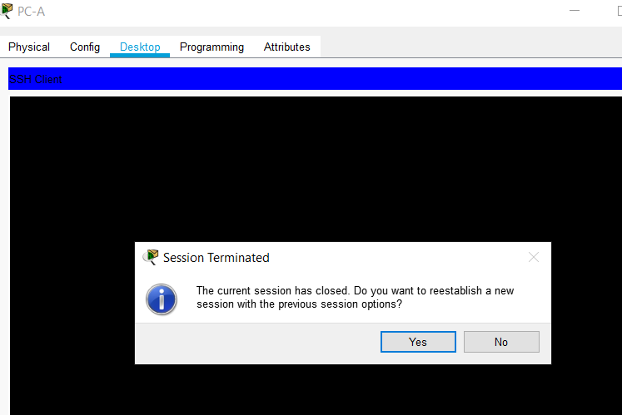
This is due to the fact that the telnet connection has been disabled and replaced by ssh in step 4.
    - Use Tera Term, establish an SSH session to R1. Use the username admin and password ciscocisco. You should be able to establish an SSH session with R1.
Does R1 accept the SSH connection? It does see the image below
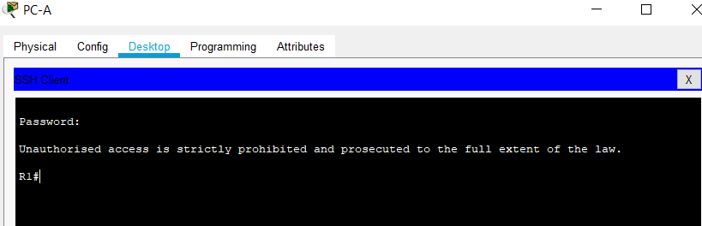
    - Intentionally mistype the user and password information to see if login access is blocked after two attempts.
What happened after you failed to login the second time?
The session closed (see below), when I selected yes to the session the message kept re-appearing which showed that I was unable to log on until 30 seconds has passed.

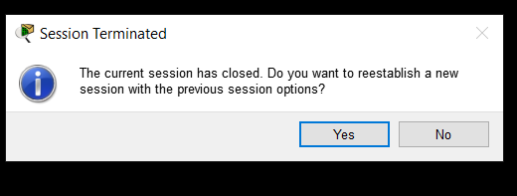
    - Sho From your console session on the router, issue the show login command to view the login status. In the example below, the show login command was issued within the 30 second login blocking period and shows that the router is in Quiet-Mode. The router will not accept any login attempts for 14 more seconds.
R1# show login
A default login delay of 1 second is applied.
No Quiet-Mode access list has been configured.

Router enabled to watch for login Attacks.
If more than 2 login failures occur in 120 seconds or less,
logins will be disabled for 30 seconds.

Router presently in Quiet-Mode.
Will remain in Quiet-Mode for 14 seconds.
Denying logins from all sources.
R1#
    - After the 30 seconds has expired, SSH to R1 again and login using the SSHadmin username and Admin1p@55 for the password.
After you successfully logged in, what was displayed? We have not set up the above username and password so I used the normal admin username and password. When I successfully logged in I received the message of the day, see below.
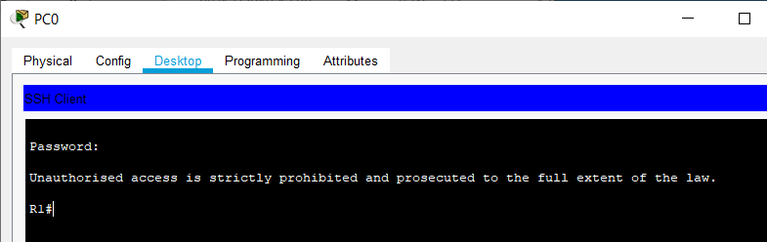

    - Enter privileged EXEC mode and use Enablep@55 for the password.
If you mistype this password, are you disconnected from your SSH session after two failed attempts within 120 seconds? Explain.
Yes you are due to the policy set up to disconnect after two failed attempts after 30 seconds using the command above login block-for 30 attempts 2 within 120
    - Issue the show running-config command at the privileged EXEC prompt to view the security settings you have applied.
The following configuration was shown from the ssh connection session
R1#show running-config
Building configuration...

Current configuration : 1226 bytes
!
version 15.1
no service timestamps log datetime msec
no service timestamps debug datetime msec
no service password-encryption
security passwords min-length 10
hostname R1
!
login block-for 30 attempts 2 within 120
!
!
enable secret 5 $1$mERr$5wXi8fVAu3dNc0gNCjvIQ1
!
!
!
!
!
!
no ip cef
no ipv6 cef
!
!
!
username admin privilege 15 secret 5 $1$mERr$2kSZR9DN2ofxLllbGij.S1
!
!
license udi pid CISCO1941/K9 sn FTX1524LIVU-
!
!
!
!
!
!
!
!
!
ip ssh version 2
no ip domain-lookup
ip domain-name ccna-lab.com
!
!
spanning-tree mode pvst
!
!
!
!
!
!
interface GigabitEthernet0/0
no ip address
duplex auto
speed auto
shutdown
!
interface GigabitEthernet0/1
ip address 192.168.1.1 255.255.255.0
duplex auto
speed auto
!
interface Vlan1
no ip address
shutdown
!
router rip
!
ip classless
!
ip flow-export version 9
!
!
ip access-list extended sl_def_acl
deny tcp any any eq telnet
deny tcp any any eq www
deny tcp any any eq 22
permit tcp any any eq 22
!
banner motd ^CUnauthorised access is strictly prohibited and prosecuted to the full extent of the law. ^C
!
!
!
!
!
line con 0
exec-timeout 5 0
login
!
line aux 0
!
line vty 0 4
exec-timeout 5 0
logging synchronous
login local
transport input ssh
!
!
!
end

R1#
- Configure the Switch for SSH Access
In Part 3, you will configure the switch in the topology to accept SSH connections. After the switch has been configured, establish an SSH session using Tera Term.
  - Configure the basic settings on the switch.
    - Console into the switch and enable privileged EXEC mode.
    - Enter configuration mode.
    - Disable DNS lookup to prevent the router from attempting to translate incorrectly entered commands as though they were host names.
    - Assign class as the privileged EXEC encrypted password.
    - Assign cisco as the console password and enable login.
    - Assign cisco as the VTY password and enable login.
    - Encrypt the plain text passwords.
    - Create a banner that will warn anyone accessing the device that unauthorized access is prohibited.
    - Configure and activate the VLAN 1 interface on the switch according to the Addressing Table.
    - Save the running configuration to the startup configuration file.
  - Configure the switch for SSH connectivity.
Use the same commands that you used to configure SSH on the router in Part 2 to configure SSH for the switch.
    - Configure the device name as listed in the Addressing Table.
    - Configure the domain for the device.
S1(config)# ip domain-name ccna-lab.com
    - Configure the encryption key method.
S1(config)# crypto key generate rsa modulus 1024
    - Configure a local database username.
S1(config)# username admin privilege 15 secret adminpass
    - Enable Telnet and SSH on the VTY lines.
S1(config)# line vty 0 15
S1(config-line)# transport input telnet ssh
The above command did not work in packet tracer, and I had to use the following command
S1(config-line)# transport input ssh
    - Change the login method to use the local database for user verification.
S1(config-line)# login local
S1(config-line)# end
  - Establish an SSH connection to the switch.
Start Tera Term from PC-A, and then SSH to the SVI interface on S1.
Are you able to establish an SSH session with the switch?
Yes I am and I get the banner message as shown in the diagram below
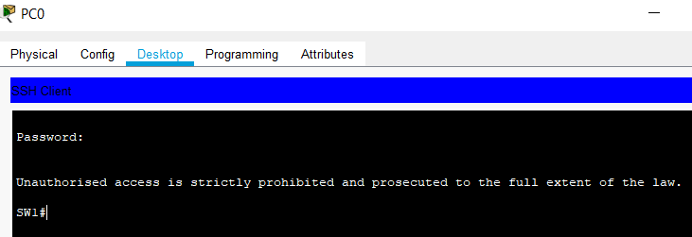
- SSH From the CLI on the Switch
The SSH client is built into the Cisco IOS and can be run from the CLI. In Part 4, you will SSH to the router from the CLI on the switch.
  - View the parameters available for the Cisco IOS SSH client.
Use the question mark (?) to display the parameter options available with the ssh command.
S1# ssh ?
-c Select encryption algorithm
-l Log in using this user name
-m Select HMAC algorithm
-o Specify options
-p Connect to this port
-v Specify SSH Protocol Version
-vrf Specify vrf name
WORD IP address or hostname of a remote system
  - SSH to R1 from S1.
    - You must use the –l admin option when you SSH to R1. This allows you to log in as user admin. When prompted, enter adminpass for the password.
S1# ssh -l admin 192.168.1.1
Password:
***********************************************
Warning: Unauthorized Access is Prohibited!
***********************************************

R1#
    - You can return to S1 without closing the SSH session to R1 by pressing Ctrl+Shift+6. Release the Ctrl+Shift+6 keys and press x. The switch privileged EXEC prompt displays.
R1#
S1#
    - To return to the SSH session on R1, press Enter on a blank CLI line. You may need to press Enter a second time to see the router CLI prompt.
S1#
[Resuming connection 1 to 192.168.1.1 ... ]

R1#
    - To end the SSH session on R1, type exit at the router prompt.
R1# exit

[Connection to 192.168.1.1 closed by foreign host]
S1#

What versions of SSH are supported from the CLI?
Versions 1 and 2, see image below
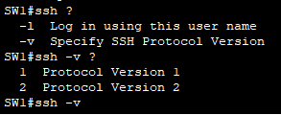

How would you provide multiple users, each with their own username, access to a network device?
By creating the accounts for each user in the local database with individual usernames and password. You would achieve this with the username command.

Reflection (max 800 words):
Write a research report comparing various Encryption standards, e.g AES, SHA, DES, RSA.

Report on Various Encryption Standards
All encryption methods have the basic two functions in common[1].
- A complex algorithm underlying the encryption.
- A key or keys used to encrypt and decrypt the text.
There are two types of encryption symmetric-key encryption and asymmetric-key encryption. Symmetric-key encryption uses the same key for both encryption and decryption. Asymmetric-key encryption uses different keys for encryption and decryption[1].
The main weakness in symmetric-key encryption is that anyone who is able to get hold of the key is then able to encrypt and decrypt the data, this is not the issue with asymmetric-key encryption.
For this report we will look at 4 types of encryption standards Data Encryption Standard (DES), Advanced Encryption Standard (AES), Secure Hash Algorithms (SHA) and Rivest, Shamir and Adleman cryptosystem (RSA).
DES, AES and SHA (although not technically encryption) use the symmetric-key encryption standards, whilst RSA uses the asymmetric-key encryption standards.
The following part of this report will briefly discuss each encryption standard.
Data Encryption Standard (DES)
DES encrypts data in blocks and is useful for encrypting IP packets over a network. DES uses a 56 bit key to encrypt and decrypt the data. However, this over time made it insecure and susceptible to brute force attacks due to the size of the key being too small. To increase the security of DES over time derivatives appeared such as 3DES, International Data Encryption Algorithm (IDEA) and blowfish. Eventually DES was replaced by the Advanced Encryption Standard (AES) and eventually was withdrawn as a standard[2].
Advanced Encryption Standard (AES)
AES replaced DES and its derivatives. AES is more flexible than DES and has the ability to be implemented on many types of platforms. AES combines a block size of 128 bits with different size key lengths which are 128, 192 and 256 bits[1].
AES is now the most popular symmetric-key encryption used today. AES is faster than DES and is ideal for use with firewalls and routers that require either low latency or high throughput. In addition it is used in such protocols as Secure Socket Layer (SSL) and Transport Layer Security (TLS)[2].
Secure Hash Algorithms (SHA)
SHA is technically not encryption as it does not use a cypher to encode the data, instead it uses cryptographic hashing that cannot be reversed. The Cryptographic hashing function can have a number of uses but the most common use is to verify file integrity[1]. Hashing is a core component of digital signatures.
SHA can also be used for operating systems and applications to store passwords securely and not in plain text. Hashing is a more secure method rather than encrypting the password which can have the possibility of being hacked.
There have been a number of Secure Hashing Algorithms. The first most commonly used algorithim is the Message-Digest Algorithm version 5 or MD5. MD5 produces a 128-bit hash value or better known as a 128-bit message digest[1]
There are a number of SHA algorithms, these include SHA-1 through to SH-3. SH-1 uses a 160-bit message digest and is no longer recommended as being safe to use. The most popular algorithm is SH-2, and has message digests of 224-bit, 256-bit, 384-bit and 512-bit. SH-3 has the same message digests of SH-2.
Rivest, Shamir and Adleman cryptosystem (RSA)
RSA uses asymmetric-key encryption whereby a different key is used for encrypting and decrypting the data and is commonly known as Public Key Infrastructure (PKI)[2].
Although use of asymmetric-key encryption enhances the functions of integrity, confidentially, authentication and nonrepudiation it is much slower than symmetric-key encryption which may not be ideal for certain types of data encryption[2].
From the information contained in this report it can be concluded that the various encryption standards can be used in different situations. This would depend on what the encryption is to be used for and whether speed is a high consideration. It may also depend on the security and type of data being encrypted and whether it is highly confidential, classified, etc. In addition, the choice will depend on whether the encryption standard is to be used just for confidentiality or whether other factors are required such as integrity.
A solution to the issue of both speed and security of encryption can lie in the use of Hybrid Cryptography. This is where the strengths of both symmetric-key encryption and asymmetric-key encryption are combined. An example would be where symmetric cryptography is used to encrypt large files where the impact on delivery times and performance is small, whilst asymmetric-cryptography is used the for initial setup of the session[2].

References
[1] M. Myers, “Securing TCP/IP,” in CompTIA Network+ Certification Exam N10-007, Seventh., McGraw Hill, 2018, pp. 349–360.
[2] (ICS), “Security Engineering,” in Official Guide to the CISSP CBK, Fourth., A. Gordon, Ed. CRC Press, 2015, pp. 249–451.

