LCHS4010 Psychology in Health and Social Care

LCHS4010
Psychology in Health and Social Care

PowerPoint Presentation

Student Name: Mary Vicentina Novais
Student ID: 2436907
Module lead: Farah Wiita
Assignment Title: Assessment 1- Individual Presentation

Table of Contents
Slide 1: 3
Slide 2: Introduction to the Scenario 4
Slide 3: Chosen Lifespan Development Theory 5
Slide 4: Key Concepts of Attachment Theory 6
Slide 5: Impact on Jenny’s Development 7
Slide 6: Biological Influences (Nature) 8
Slide 7: Environmental Influences (Nurture) 9
Slide 8: Support Plan for Jenny 10
Slide 9: Attachment-Based Interventions 11
Slide 10: Evaluation of Attachment Theory 12
Slide 11: Conclusion 13
Slide 12: References 14

Slide 1:
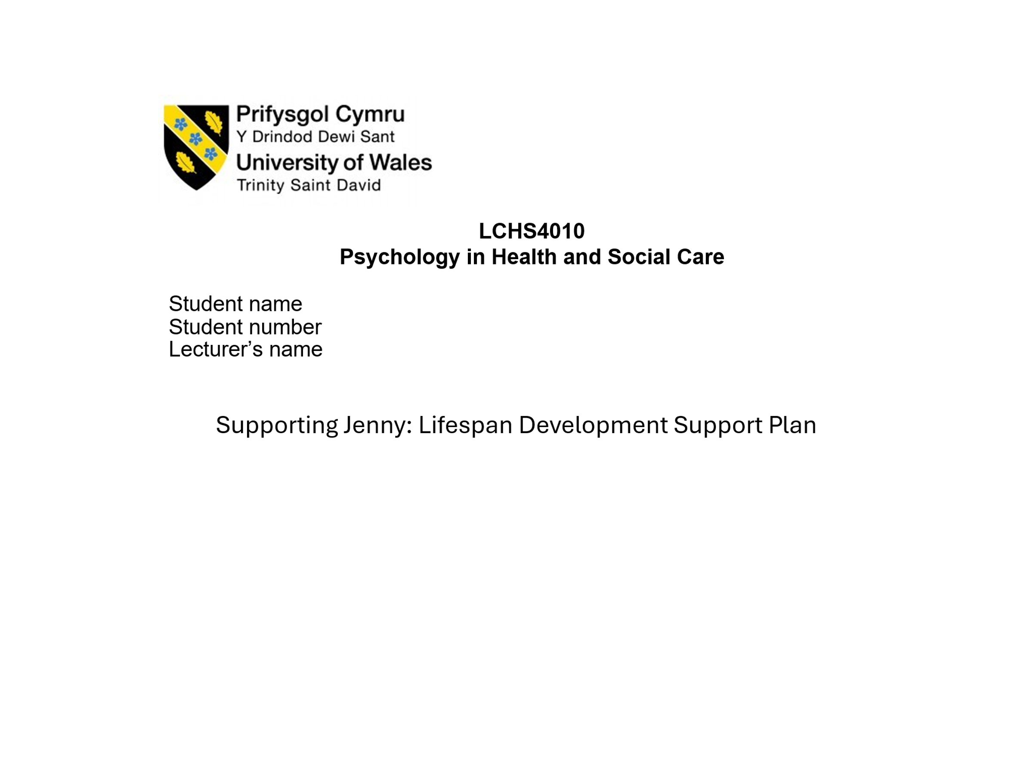
In this paper, I shall provide a support plan of Jenny based on the Attachment Theory developed by Bowlby. Jenny is a teenager at the age of sixteen who has been taking care of her mother since her father passed away half a decade ago. The presentation will discuss the way in which Jenny experiences can influence her psychological development.

Slide 2: Introduction to the Scenario
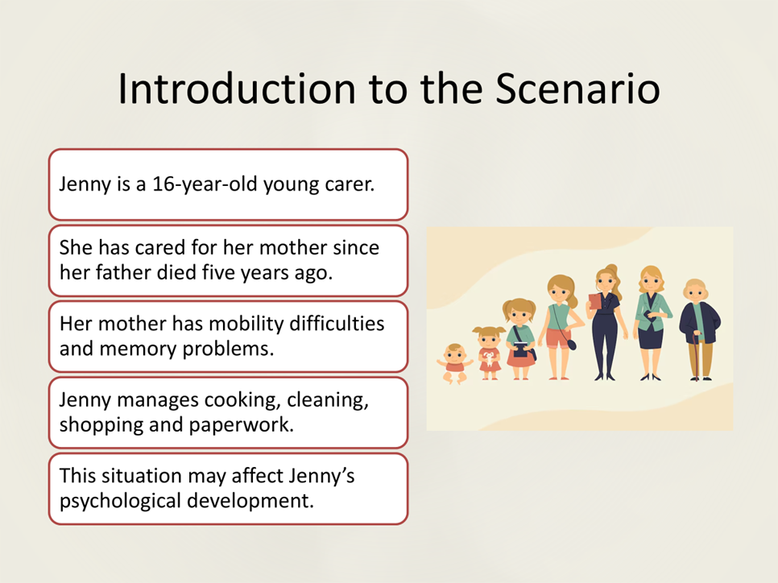
Jenny is a sixteen-year-old female who has assumed a lot of caring roles within her family. Her father died five years ago, and since that time, she took care of her mother. The mother of Jenny has mobility, memory and low mood problems. Due to this, Jenny assists in the day-to-day activities like cooking, cleaning, shopping and paperwork. Although Jenny can be of help, these responsibilities can influence her development as well. The adolescence period is a critical period of emotional and social development and therefore, lifelong caring responsibilities can exert extra responsibility on her mind and spirit (Lacey, Xue and McMunn, 2022).

Slide 3: Chosen Lifespan Development Theory
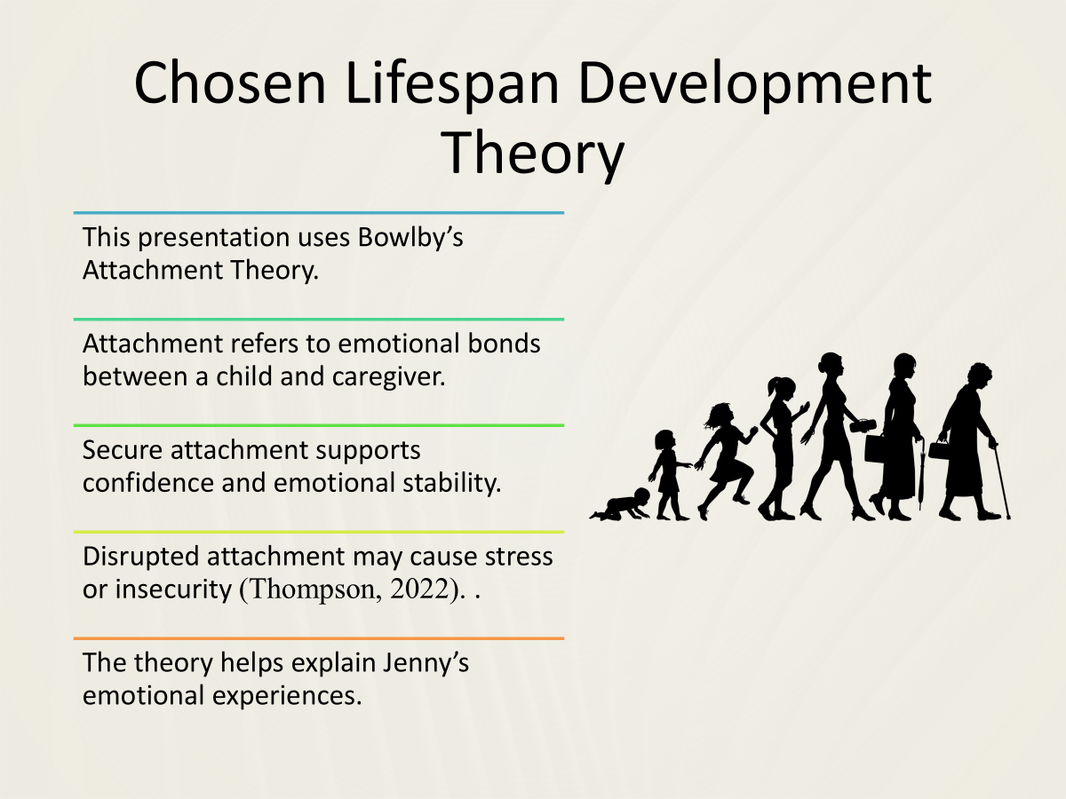
The theory applied in this presentation is the Attachment Theory developed by Bowlby. This theory is used to understand the role of emotional attachment between caregivers and children in the development of psychology (Thompson, 2022). Bowlby argues that a secure attachment between a caregiver and a child makes him/her feel safe and confident. This emotional security helps to have healthy social relationships and emotional control in the later life. Nevertheless, in the case of attachment relationship disruption, children can be stressed, anxious or feel insecure. The above theory is applicable in the case of Jenny since she has lost her father and assumed an adult role of care giving at a tender age.

Slide 4: Key Concepts of Attachment Theory
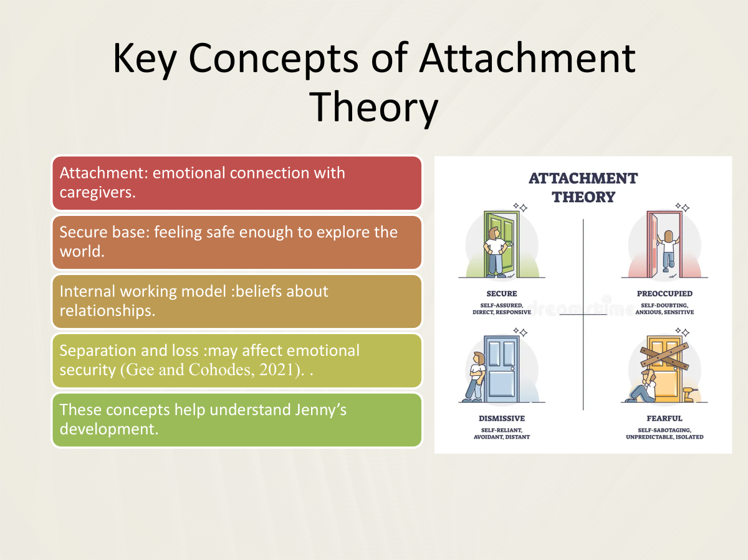
Attachment theory has a number of concepts. The first one is the very notion of attachment which is an emotional connection between a child and a caregiver (Gee and Cohodes, 2021). The second one is the secure base. A safe foundation enables a youth to be safe enough to venture out in the world and acquire independence. The next notion is internal working model that is defined as beliefs that people build on themselves and their connection with others. Lastly, emotional security might suffer separation and loss. The death of her father and the fact that Jenny has more responsibilities, might affect Jenny in terms of her feelings towards trust, support, and relationships.

Slide 5: Impact on Jenny’s Development
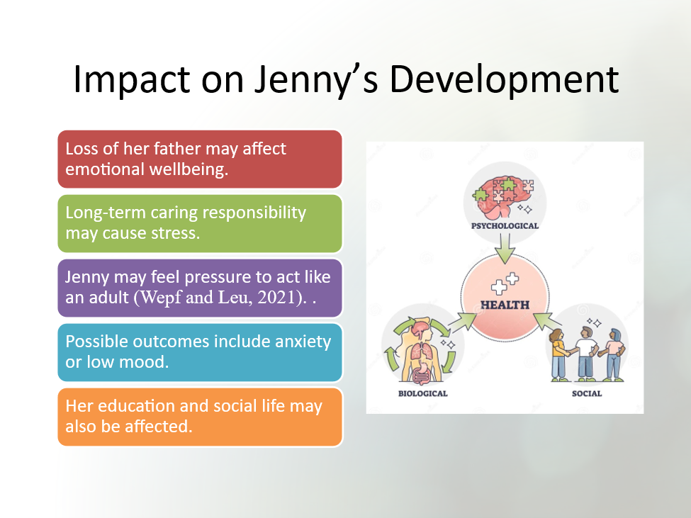
The events that Jenny has undergone can affect her emotional and psychological growth. Her father might have died, and this might have influenced her feeling of security and emotional stability. Meanwhile, her nurturing roles can be a burden to her in her everyday life. Jenny will be pressured to behave like an adult and be responsible to the family wellbeing. This has the potential to cause emotional problems like anxiety, sadness or exhaustion (Wepf and Leu, 2021). It can also impact on her school life and social relationships as well since she might have less time to pay attention to education or friends.

Slide 6: Biological Influences (Nature)
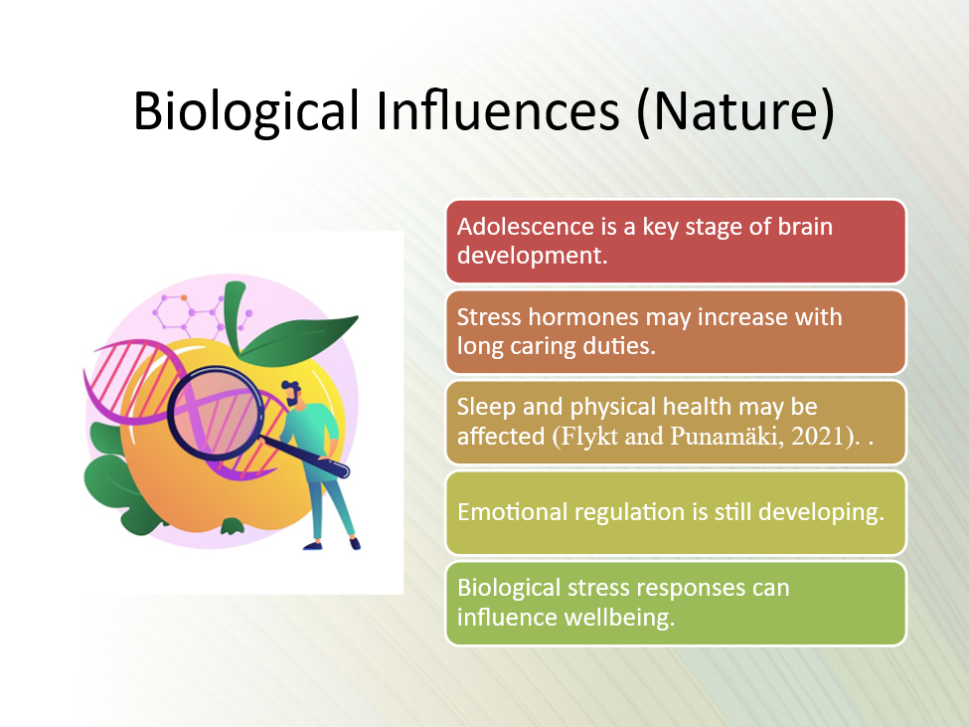
Biological factors are important in the development of Jenny. The adolescence stage is a time when the brain is still developing particularly in the emotional regulation and decision-making aspects. Biological functions which include sleep pattern, level of stress hormone and general health may be influenced by exposure to stress in the long term (Flykt and Punamäki, 2021). Provided Jenny is subjected to continuous stress, which is caused by caring responsibilities, it is possible that this stress affects her emotional and physical health. Thus, there is the interaction of biological factors with life experiences to form her development.

Slide 7: Environmental Influences (Nurture)
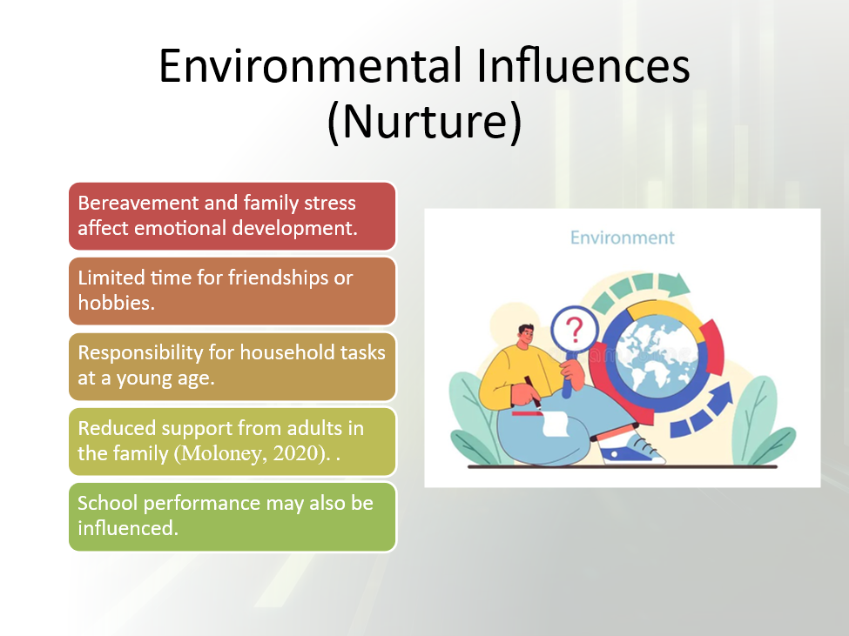
The environmental factors are also quite significant in the case of Jenny. Her environment is formed by the death of her father, the necessity to take care of her mother, and little adult attention in the family (Moloney, 2020). These aspects could limit the time Jenny can spend in school, friendship and personal interests. The development can be greatly affected by social settings like family, school and community services. Positive surroundings would cushion the youth against stress and enable them to build resilience.

Slide 8: Support Plan for Jenny
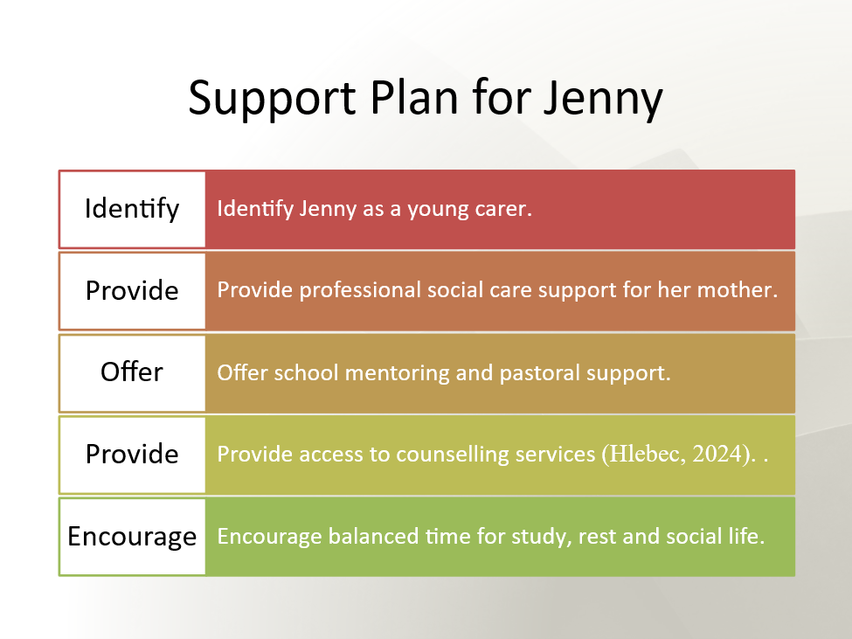
The support plan must aim at alleviating the burden and enhancing Jenny wellbeing. To start with, Jenny is to be referred to as a young carer to be helped by way of receiving support services(Hlebec, 2024). The social care professionals might also offer viable support to support her mother in the day-to-day activities. Another role that can be played by schools is through provision of pastoral care and mentoring. The counselling or emotional support services can assist Jenny to overcome stress and grief. Lastly, Jenny should be advised to make a balanced routine to enable her concentrate on learning, sleeping and social life.

Slide 9: Attachment-Based Interventions
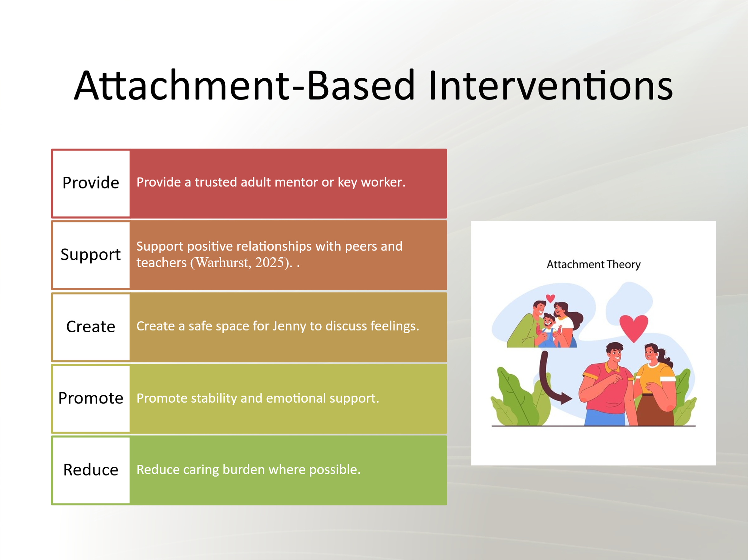
Emotional security can be restored through the use of attachment-based support strategies (Warhurst, 2025). Provision of a key worker or a trusted adult to Jenny is one of them. This individual may provide counsel and emotional provisions. The positive relationship with teachers, peers and support workers can also contribute to Jenny feeling less alone. It is possible that her emotional wellbeing can be enhanced by offering her safe opportunities to discuss her feelings. All in all, these interventions are aimed at establishing stability and building up the feeling of security in Jenny.

Slide 10: Evaluation of Attachment Theory
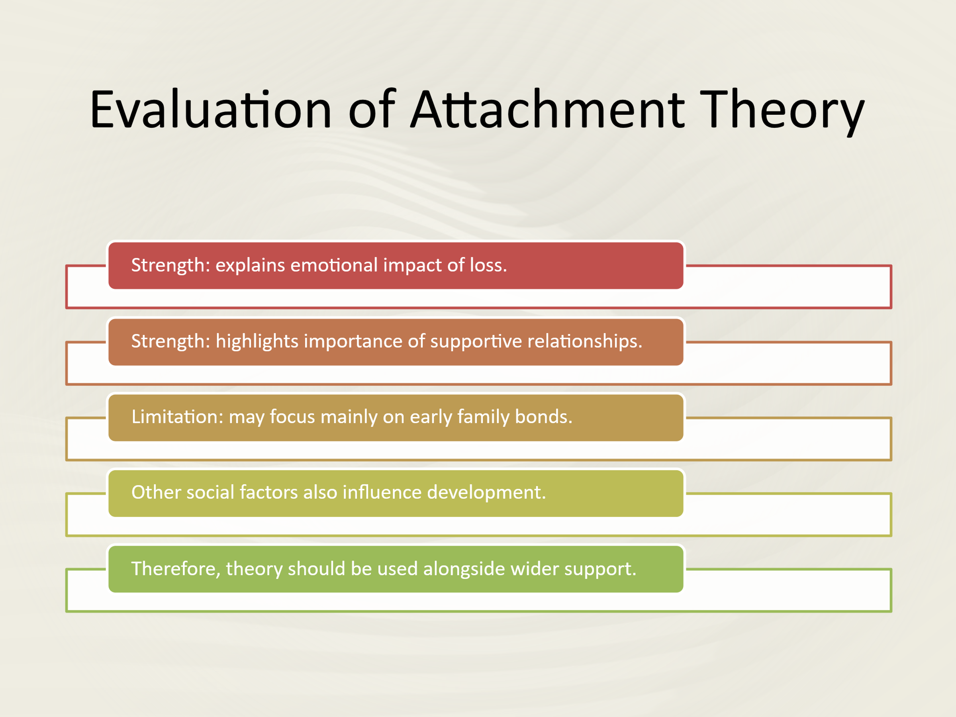
The attachment theory is an effective theory that can be used to make sense of the experiences of Jenny. It draws a spotlight on the impact that emotional development can have on loss and disrupted caregiving relationships. The theory also informs of the value of supportive relationships in fostering wellbeing (Farella Guzzo, 2023). There are however limitations of the theory. It is also primarily concerned with early relations and, therefore, is unlikely to comprehensively describe broader social influences like economic status, school resources, or community services. Thus, although the theory of attachment comes in useful, other social and environmental factors must also be used to assist Jenny by the professionals.

Slide 11: Conclusion
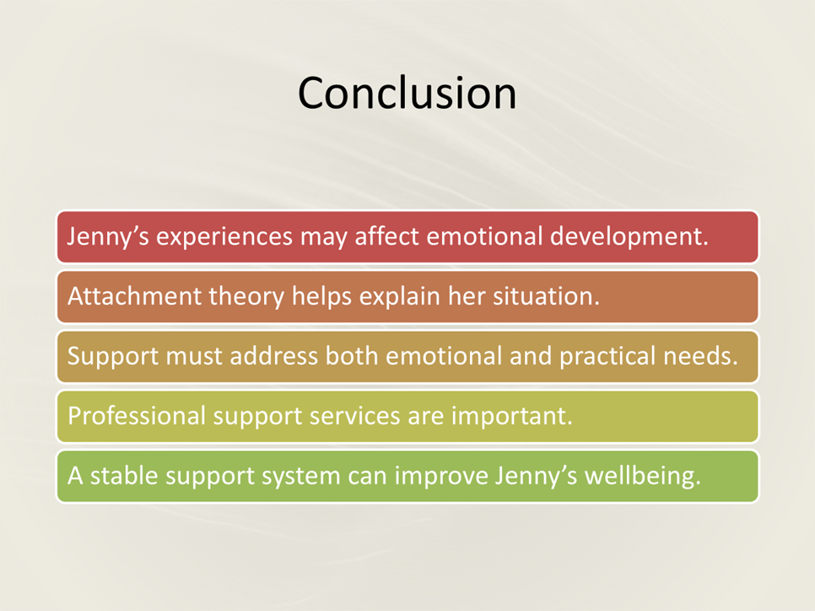
To summarize, Jenny as a young carer and the death of her father could have an implication on her psychological growth. The Attachment Theory by Bowlby can be used to understand how these experiences can affect emotional security and wellbeing. The biological and environmental influences are significant to her development. The support plan developed should help Jenny with her caring activities and provide more emotional support by the professionals and community services. Jenny is able to keep growing positively with the proper support and keep her wellbeing.

Slide 12: References
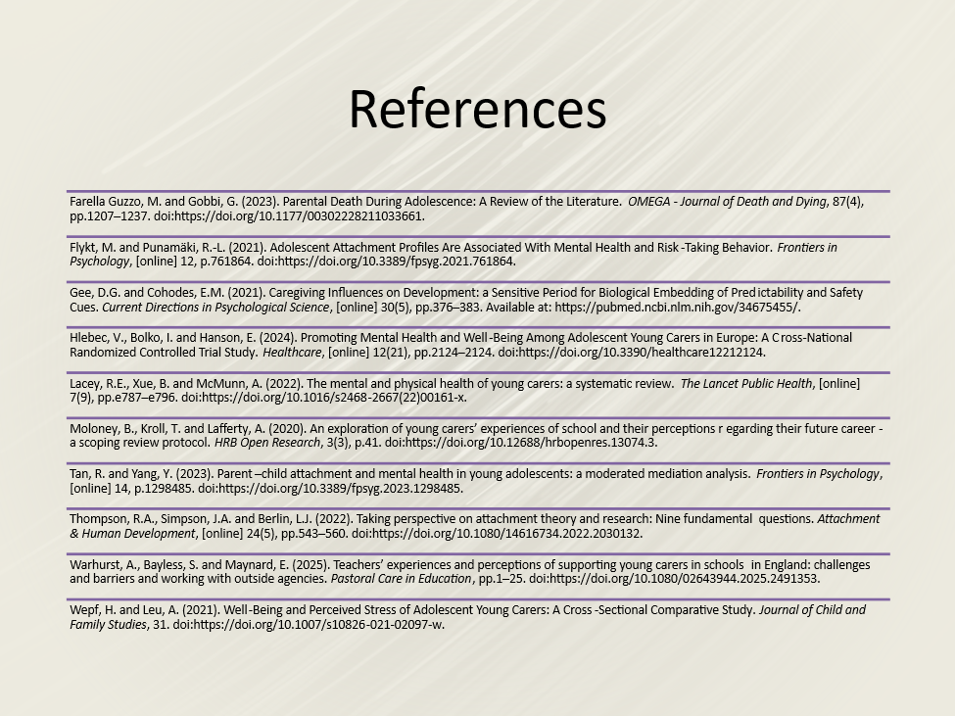
Farella Guzzo, M. and Gobbi, G. (2023). Parental Death During Adolescence: A Review of the Literature. OMEGA - Journal of Death and Dying, 87(4), pp.1207–1237. doi:https://doi.org/10.1177/00302228211033661.
Flykt, M. and Punamäki, R.-L. (2021). Adolescent Attachment Profiles Are Associated With Mental Health and Risk-Taking Behavior. Frontiers in Psychology, [online] 12, p.761864. doi:https://doi.org/10.3389/fpsyg.2021.761864.
Gee, D.G. and Cohodes, E.M. (2021). Caregiving Influences on Development: a Sensitive Period for Biological Embedding of Predictability and Safety Cues. Current Directions in Psychological Science, [online] 30(5), pp.376–383. Available at: https://pubmed.ncbi.nlm.nih.gov/34675455/.
Hlebec, V., Bolko, I. and Hanson, E. (2024). Promoting Mental Health and Well-Being Among Adolescent Young Carers in Europe: A Cross-National Randomized Controlled Trial Study. Healthcare, [online] 12(21), pp.2124–2124. doi:https://doi.org/10.3390/healthcare12212124.
Lacey, R.E., Xue, B. and McMunn, A. (2022). The mental and physical health of young carers: a systematic review. The Lancet Public Health, [online] 7(9), pp.e787–e796. doi:https://doi.org/10.1016/s2468-2667(22)00161-x.
Moloney, B., Kroll, T. and Lafferty, A. (2020). An exploration of young carers’ experiences of school and their perceptions regarding their future career - a scoping review protocol. HRB Open Research, 3(3), p.41. doi:https://doi.org/10.12688/hrbopenres.13074.3.
Tan, R. and Yang, Y. (2023). Parent–child attachment and mental health in young adolescents: a moderated mediation analysis. Frontiers in Psychology, [online] 14, p.1298485. doi:https://doi.org/10.3389/fpsyg.2023.1298485.
Thompson, R.A., Simpson, J.A. and Berlin, L.J. (2022). Taking perspective on attachment theory and research: Nine fundamental questions. Attachment & Human Development, [online] 24(5), pp.543–560. doi:https://doi.org/10.1080/14616734.2022.2030132.
Warhurst, A., Bayless, S. and Maynard, E. (2025). Teachers’ experiences and perceptions of supporting young carers in schools in England: challenges and barriers and working with outside agencies. Pastoral Care in Education, pp.1–25. doi:https://doi.org/10.1080/02643944.2025.2491353.
Wepf, H. and Leu, A. (2021). Well-Being and Perceived Stress of Adolescent Young Carers: A Cross-Sectional Comparative Study. Journal of Child and Family Studies, 31. doi:https://doi.org/10.1007/s10826-021-02097-w.

