Richard Jones - 1809132
rojones@gmail.com & 1809132@student.uwtsd.ac.uk
Network Operating Systems and Services
ACCA5023 – Nitheesh Murugan Kaliyamurthy

Abstract

The Author was tasked with conducting a two part document with a number of tasks within each part in the following paper. Part 1 consisted of five pre-defined tasks. These tasks included multiple steps in setting up the continuing labs form worksheet 1 with pre-requisite tasks on the server 1 VM, Deploying Active Directory role/feature based installation on server 1 VM, Creating user objects within the Active Directory Console, amending user object attributes in Active directory and lastly adjoining client 1 VM to the domain and testing out amendment to the user objects made in the earlier tasks.
Part 2 contained 4 topic as to which the author was to observe and comment on from the previous part 1 tasks, along with providing researched material to underpin the author’s statements. These 4 topics included explaining what the DNS service significance is within Active Directory Domain Services, Identify and provide a brief overview of 2 additional critical roles within ADDS which the author highlighted as DHCP and File Storage Services, explain and expand on why it is important to have different levels of access to build in ADDS roles such as Domain admins and DNS admins. And lastly the author was asked to share his ideas in-detail on the Microsoft recommendations of AGDLP and AGDULP.

Table of Contents
Abstract 1
Table of Contents 2
Introduction 1
1. Part 1 – Practical Work 2
1.1 Worksheet 2 Task 1 – Prerequisite Tasks 2
1.2 Worksheet 2 Task 2 – Deploying Active Directory as a role or feature based installation 4
1.3 Worksheet 2 Task 3 – Creating user account objects using AD Users and Computers Console 7
1.4 Worksheet 2 Task 4 – Object Attributes of interest 8
1.5 Worksheet 2 Task 5 – Adjoining the Domain and testing user logins 9
2. Part 2 – Observational Tasks/Work. 13
2.1 What is DNS and what is its significance within ADDS 13
2.2 Brief overview of 2 critical roles within an enterprise network 14
2.3 The Importance of levels of Access/Roles within Network Accounts 16
2.4 AGDLP and AGUDLP – Perspective of implementing within a network 18
3. References 21

Introduction
In the following document the author was tasked with multiple tasks split across 2 sections which are pinned as Part 1 and Part 2. Part 1 consisted of a pre-defined step by step configuration and setup of a lab server/client following on from worksheet 1.
The Part 1 section consisted of 5 tasks with the aim of deploying Microsoft Active Directory Domain services on the Server 1 VM already in place from worksheet 1. These 5 tasks included prerequisite tasks to rename the server 1 VM and ensure that Windows Firewall service(s) are turned off. The author then moved on to deploying the ADDS role/feature via the server manager console which guided the author through a set of GUI steps. Part of this role install required the author to setup the nwtraders.msft domain name and enabled the DNS server feature and setting a Directory Services Restore Mode Password, which would allow the author to restore the domain in the event of a failure such as database corruption.
Once the domain has been installed and in place, the author was then tasked with creating an amending user objects that could be later utilised to test the behaviour and effectiveness. An example in this situation was configuring domain device login restriction times on a specific user account. Lastly once the ADDS was setup and user objects had been created and configured to desired behaviour the author then tested the domain was configured correctly and was applying user configurations by renaming and joining client 1 VM to the domain and testing login behaviour. Throughout the process the author collected screenshots and explained in each step what was being undertaken with visual evidence and explanation.
The Part 2 section consisted of a number of observational tasks. Firstly the author explained what DNS was and demonstrated via research and suitable illustrations how it worked and its significance within the ADDS. Then the Author expanded on 2 other roles that are critical to an ADDS deployment, these two roles were, the DHCP service which allows for domain/network connected devices to be allocated dynamical either random IP addresses within designated pools of addresses, or pre-defined reserved addresses. And the File Storage Service which allows for Windows servers to be configured to host shares for a range of duties including but not limited to user shares, departmental share or even hosting app or web services shares.
The author was then asked to explain and expand on the differing levels of access/roles within the built-in accounts within ADDS. An example of this included but not limited to the Domain admins group or DNS admin group for example. The author detailed the benefits to splitting the admin rights across a range of accounts and not limited a single or small number of accounts to having domain wide services administrator privileges for a number of reasons including but not limited to security.
Lastly in part 2 the author was asked to share ideas and expand on the view from a system administrator the AGDLP and AGDULP recommendations for assigning permissions. The author documented and researched the explanation of AGDLP and AGDULP and the ideas behind why this should be implemented in an RBAC design for delegated permissions in a network design. The author gave examples to the benefits of using these methods which included but not limited to security benefits and audit benefits

Part 1 – Practical Work
In Part 1, the practical work set out in worksheet two has been undertaken and documented by the author. The author was tasked with completing and documenting five specific defined tasks within the worksheet. These five tasks were.
- Pre-Requisite Tasks
- Deploying Active Directory as a role or feature based installation
- Creating user account objects using AD Users and Computers Console
- Object Attributes of interest
- Adjoining the Domain and testing user logins

Worksheet 2 Task 1 – Prerequisite Tasks
As to the first task, the author is asked to confirm that the Server 1, which will be primarily used is the following task work, has both the private and public network adapters set to static entries rather than DHCP. As shown in Figure 1 the PrivateNet1 adapter and Figure 2 the PublicNet adapter are both set to utilise a static IP address entry, and that there is no DNS configuration entered either Network adapter configurations.
There are a number of reasons for static entry of IP’s address on Servers, one example but not limited to is that by entering a static entry there is no reliance on a DHCP server for IP addressing and that any mistakes made on the configuration of DHCP reservations wouldn’t filter through to the server. As Server can sometimes have hardcoded IP lookups from other systems and/or software packages.
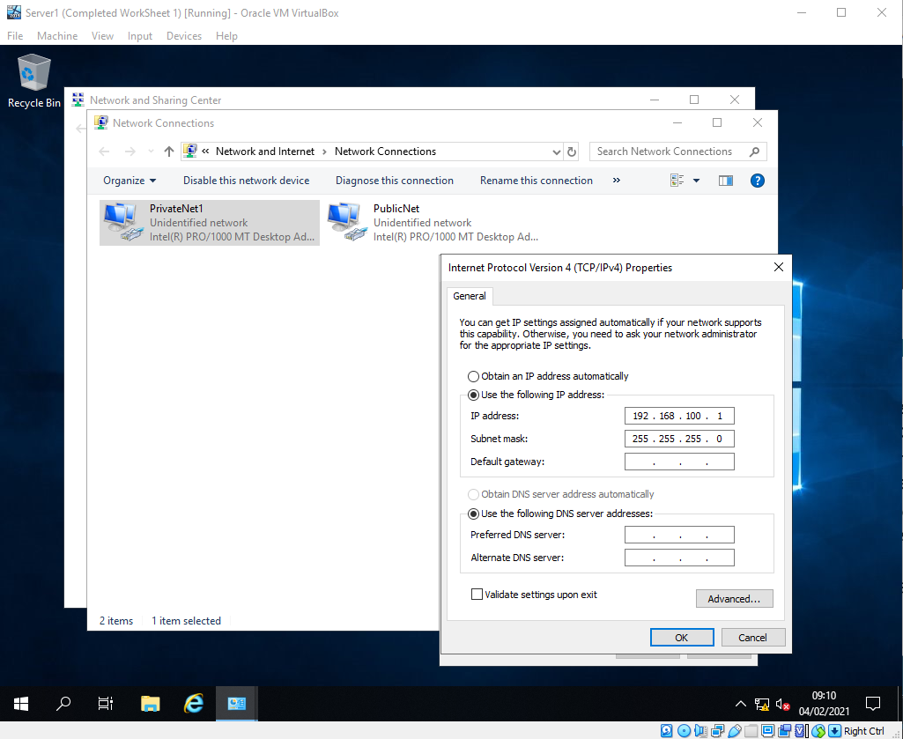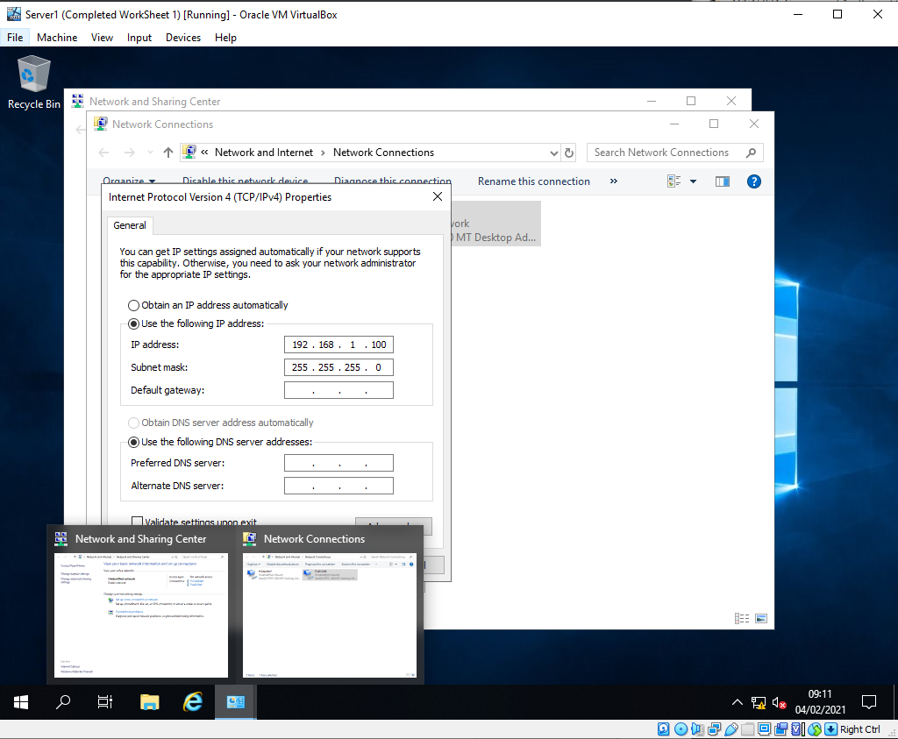
Figure 1. Server 1 PrivateNet1 Static IP Entry Figure 2. Server 1 PublicNet Static IP Entry

It was also tasked that the author confirm that the Windows Firewall settings were set so that all of the network firewall profiles on the device were set to be disabled or “turned off” as shown in Figure 3. This was done in this setup example as discussed in worksheet 1 to simply allow for the firewall not to be in anyway a technical barrier to the concepts being demonstrated in the worksheets.
Best practise would be to leave the firewall profiles turned on, and then assign rules to allow for the traffic that is allowed through the firewall as required. Alternatively you could disable the firewall and rely on a third party product from a vendor such as Sophos or McAffee to manage the firewall access on the device.
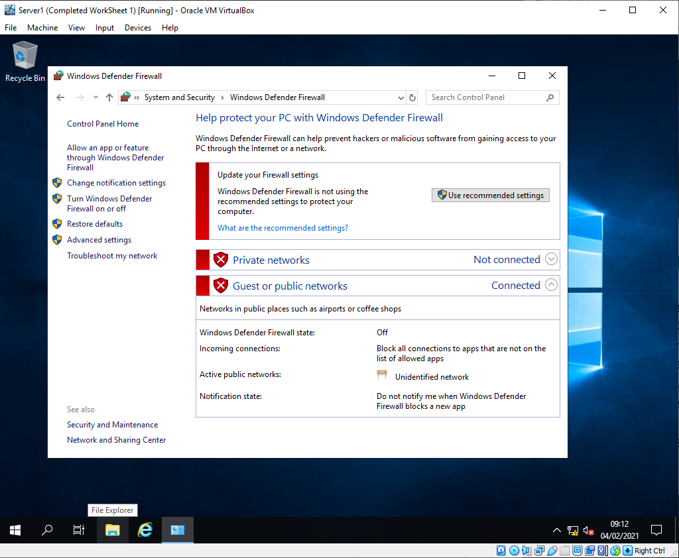
Figure 3. Server 1 Windows Firewall profiles turned off.
Once the author had completed the confirmation of the IP address of the device, along with confirmation that the Windows firewall had been disabled the author was then tasked with renaming the Server 1 computer. This was being done as it was to later be configured as the Domain controller for the network environment.
As shown in Figure 4. The author has navigated to the System control app, and then selected the “Change Settings” option which allows the author to then select a new name and apply the settings, this would typically require a reboot for the name to apply for further tasks. By default the name of a Windows installation will generate a random[1] name utilising for example the WIN- or Desktop-Abbreviation depending on the OS install and then random digits afterwards. The name of the Server 1 computer was set to DC1-NWT.
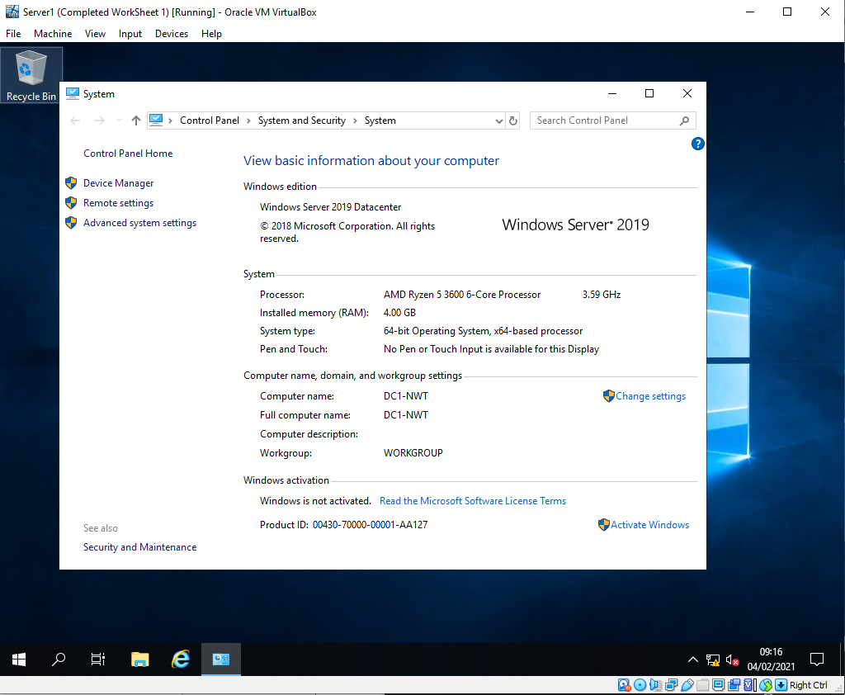
Figure 4. Server 1 Computer name renamed to DC1-NWT

Worksheet 2 Task 2 – Deploying Active Directory as a role or feature based installation
The author having now completed the pre-requisite stages of worksheet 2, is now directed to setup and configure the Active Directory Role for the server 1.
To setup and configure Server 1 as the Active Directory server, the author runs the Server Manager program that comes as a default application on Windows Server operating systems post 2012. From this application the author is able to run the “Add Roles and Features Wizard”, this wizard allows for various roles that can be carried out by the server to be installed through a GUI Wizard to make the process simpler and smoother.
Once select as shown in Figure 5 the author was then presented with a “before you begin” statement screen. This screen informed the author that certain pre-requisites need to be completed before selecting roles or features. It stated that the pre-reqs we have already carried out in the earlier stages of task 2 had been completed. The reasons for this are around security and potential miss-configurations such as DHCP later in the process.
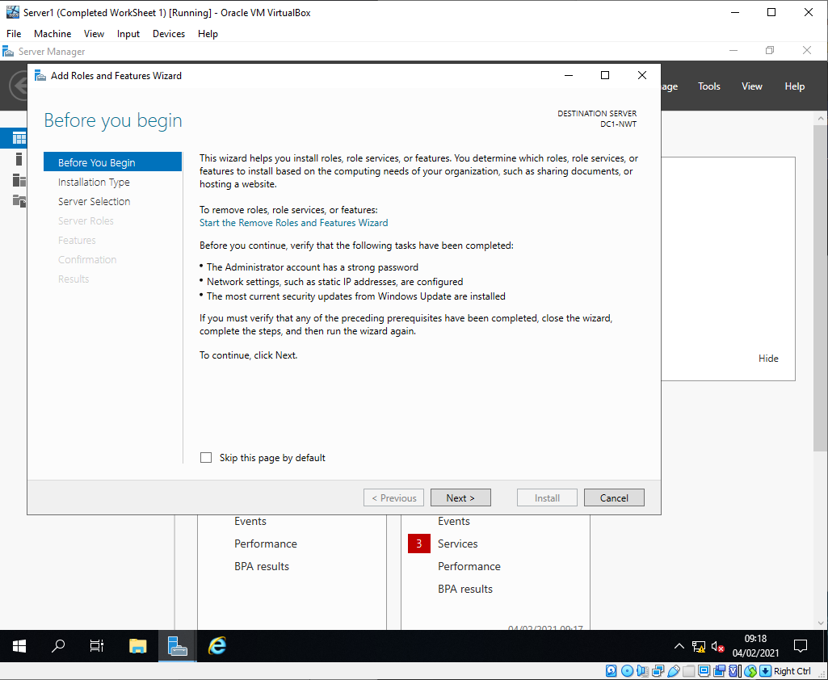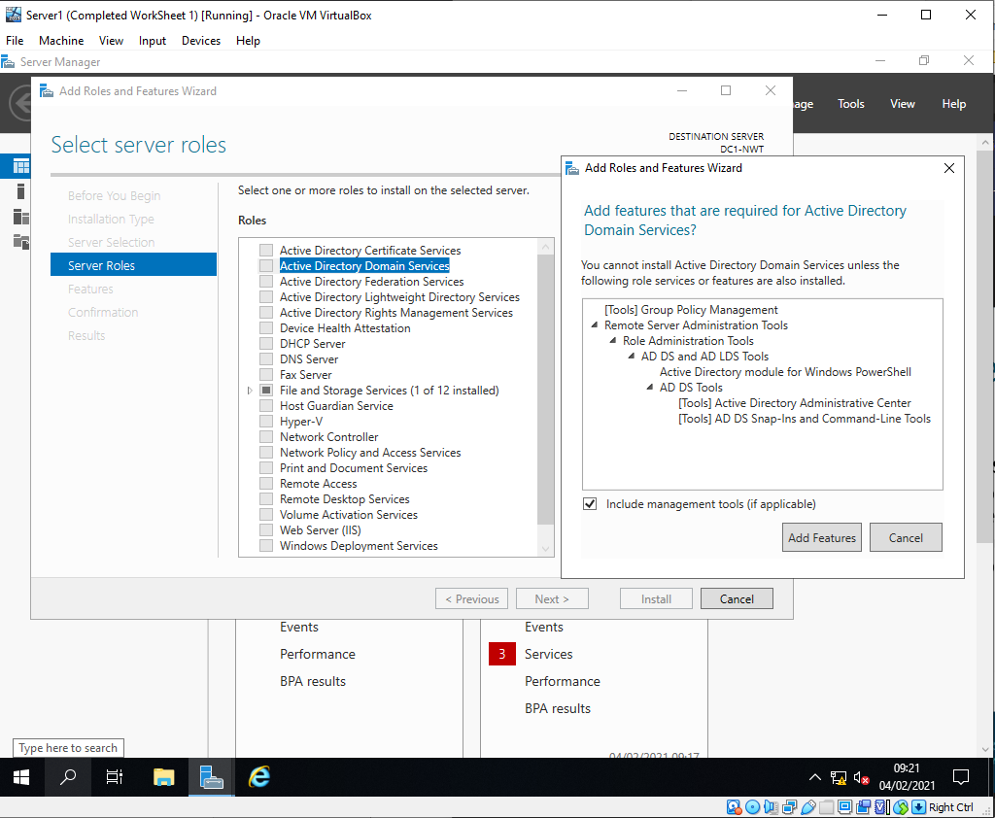
Figure 5. Roles & Features initial screen. Figure 6. Roles and Features selection screen.
Once the initial screen has been adhered to, the author then moved on to the selection of the role/features required at this point in the task. The author is presented with a list of possible roles[2] as shown in Figure 6 that can be configure including but not limited to DHCP, DNS, Hyper-V and Web Server (IIS). The author selected the role “Active Directory Domain Services” and was then prompted with a confirmation screen of the features that would need to be enabled to carry out the enablement of the roles.
For example the features including but not limited to “Remote Server Administration tools was required along with modules for Windows PowerShell. These are all required to enable the install and future management of the Active directory server.
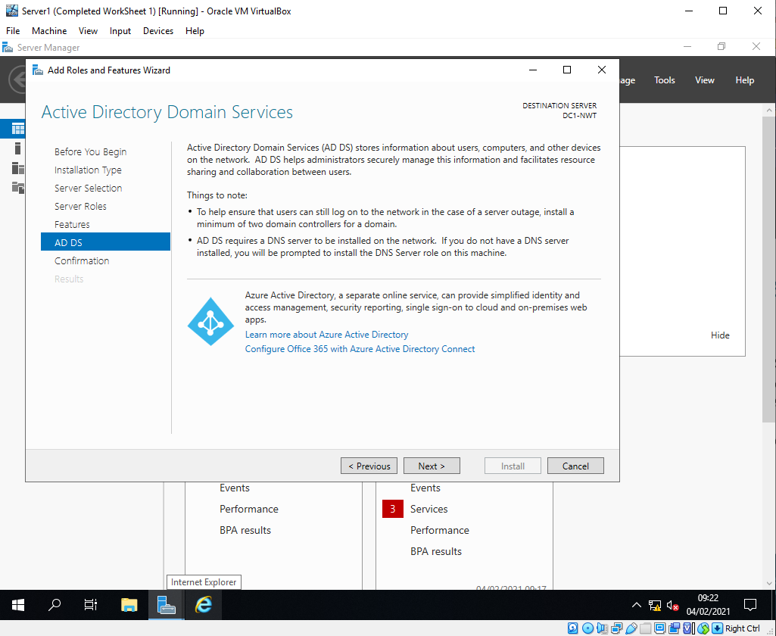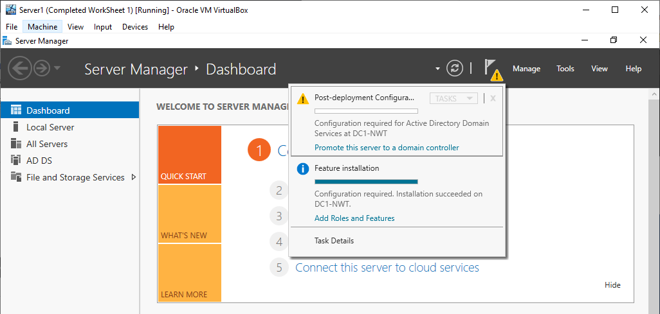
Figure 7. AD Role setup Screen Figure 8. AD Roles & Feature Post Deployment

Once the author selected the role and continued through the enablement Wizard. The author is then presented with a prompt as shown in Figure 7 which refers to AD DS which is known as Active Directory Domain Services, this prompt details a general overview of what AD DS will allow and enable for the administrators of the network once complete.
After the completion of the role enablement and install, the author was then presented with a popup as shown in Figure 8 within the Server Management application. This popup confirms the role and feature installation progress, and once complete prompted the author to complete the AD DS configuration by enabling the Server to be promoted as the domain controller[3] for the Active directory.
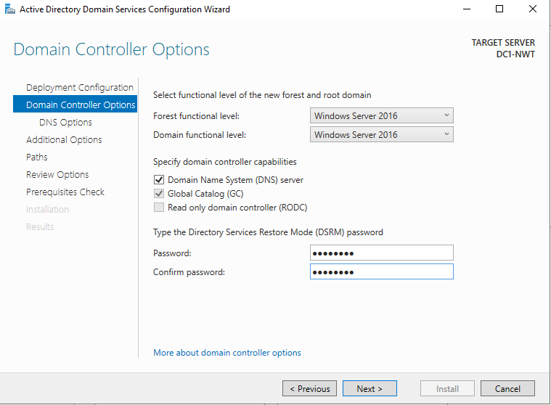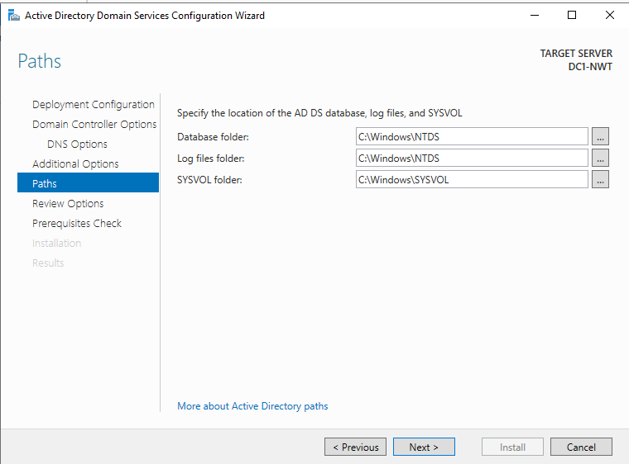
Figure 9. Domain Controller Setup Figure 10. Domain Controller Setup continued.
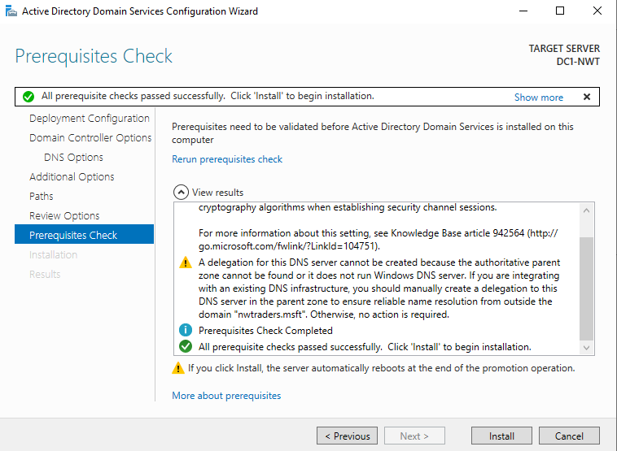
Figure 11. AD DS Controller Setup Prerequisites Check Screen.
As shown in Figure 9 and Figure 10 the author was presented with an additional GUI wizard to complete the promotion of the server to be the domain controller. At this point a number of options are presented. An example but not limited to these options are Configuring the Forest and Domain Function levels along with assigning and confirming the AD Services Restore mode password also known as (DSRM) and the install location for Database, Log Files and System volume folders.
The Function and Domain levels in short allow for the level of enhanced features that can be enabled and support within the domain[4], along with the highest level of OS that can be supported to act as domain controller within the domain. The DSRM password is set to allow for the domain controller to be safe mode boot option that allows for the administrator to recover, repair and restore[5] faulty Active directory database.
The author is then at the end of the GUI presented with a Prerequisite check as shown in Figure 11 which will detail and validate the system before finalizing the install.
The domain controller is the central host as to where all information is stored on the domain configuration, and where allow requests for access and configuration also route through. It is often best practise to create an additional domain controller to allow for but not limited to disaster recover in potential failures of the original controller, along with load balancing for the responsibilities of the domain controller.
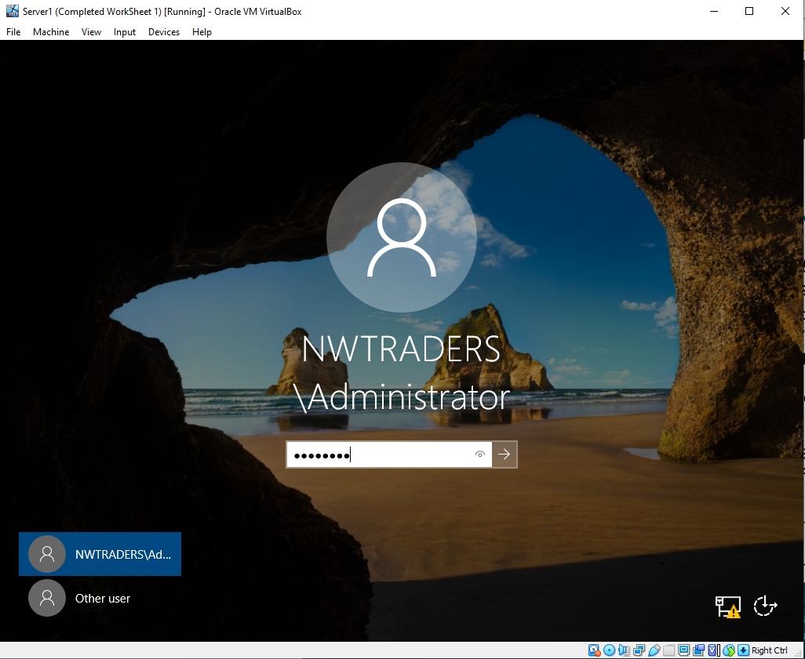
Figure 12. Server 1 DC1-NWT post configuration and reboot screen.
Once the roles/feature and domain controller configuration have all be configured and completed. The author reboots the Server as part of the completion process and demonstrates the login screen as shown in Figure 12. This screen now presents the author with the Administrator account as a login to the setup NWTraders Domain.

Worksheet 2 Task 3 – Creating user account objects using AD Users and Computers Console
Once the completion of the Domain configuration and Setup has been completed. The author is now tasked with creating an additional user and assigning them to the Domain Administrator group.
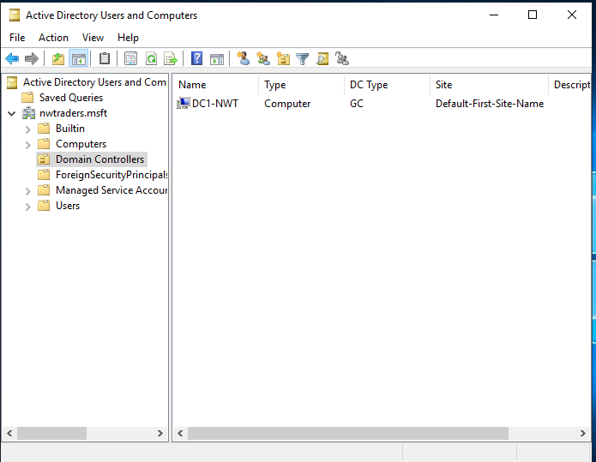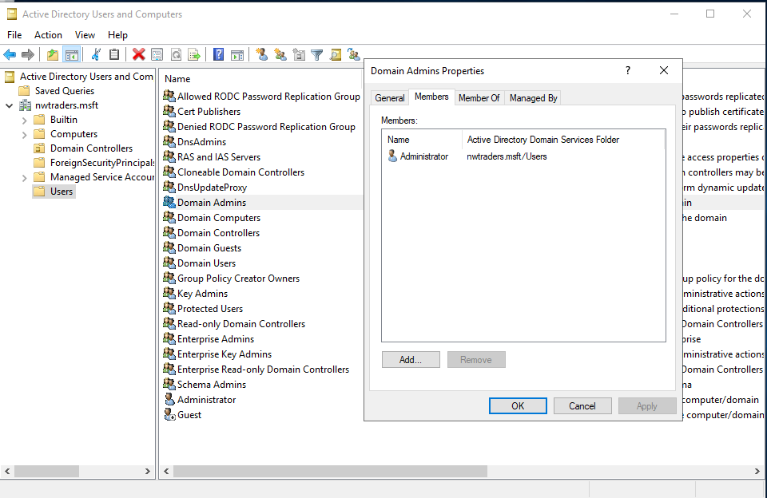
Figure 13. AD users and Computer MMC. Figure 14. Domain Admins Group Members.
Firstly the author runs the Active Directory User and Computer Snap in or sometime referred to as MMC (Microsoft Management console), and Verify that the domain created is correct as shown in Figure 14 nwtraders.msft. Once the author confirmed this he was then tasked with locating the “User” container within the MMC and locate and open the Domain Admin Group. The author has confirmed that the only account with elevated domain admin permissions is the Administrator account as shown in Figure 14.
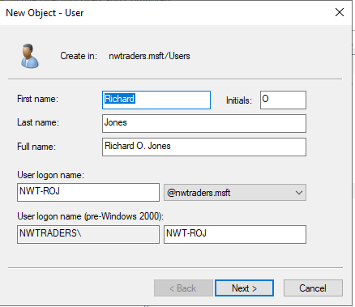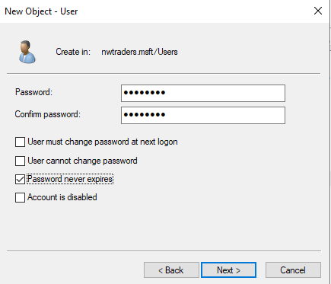
Figure 15. New User Object Creation. Figure 16. New User Object Password Setup.
The Author is now tasked with creating a new user object. To carry out this task the author right clicked on the Users container within the MMC and selected the new user option. As shown in Figure 15 a GUI Wizard is then presented with a number of field to populate for the account create including but not limited to Name and User Login name with domain suffix. Once the author had completed the initial GUI windows requirements he was then presented with a Password creation window for the user as shown in Figure 16.
There are many varying thoughts on best practise in relation to password complexity and expiry. There are default complexity settings within Active directory, but further enhanced complexity rules can be set utilising group policy objects[6]. In this instance the author has set the password to not expire, and often with domain administrator account complex password are set and set not to expire to prevent the loss of access to such an important account.
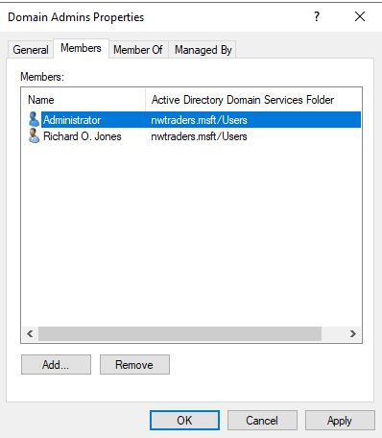
Figure 17. Domain Admins group with additional user added.
Once the new user account creation wizard has then been completed. The Author was tasked with adding the account to the domain admins group. The group was selected from within the MMC and under the member tab as shown in Figure 17. The author was able to select the “add” button and enter the username for the newly created account to be added to the group.

Worksheet 2 Task 4 – Object Attributes of interest
The author had now completed the creation of an additional domain administrator account and is tasked with moving on to create additional users and explore the uses of GPO (Group Policy Object) to restrict and unrestricted a number of controls upon set groups of users.
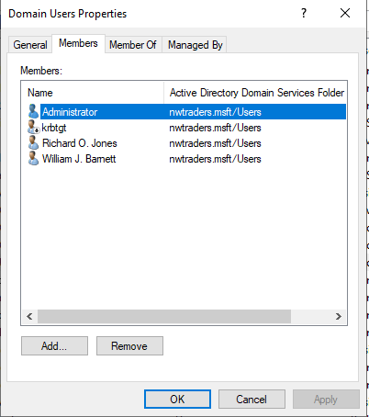
Figure 18. Domain User group with newly created user.
The author is now tasked with creating an additional user to use at a later date for testing of various domain restrictions. The author created a new account for a user called William J Barnett with the username NWT-WJB as shown in Figure 18. By default all user account will be populated in to the Domain Users Group also shown in Figure 18. Users are then able to be populated in to other groups to provide additional access or restriction in various methods.
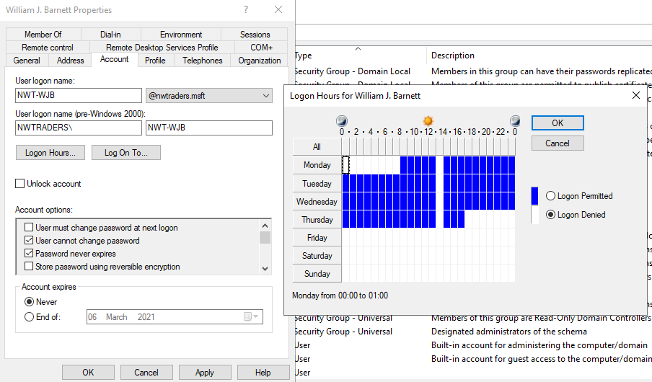
Figure 19. User NWT-WJB account properties and logon hour’s settings.
With the newly created user NWT-WJB, the author is tasked with viewing the properties of the account and navigating to the “Account” tab. Here the author is able to view the details of the account which were set at creation along with a “Logon Hours” and “Log On To” tabs. For this task the author will restrict the user from being able to change the password for security purposes, while also restricting the logon hours/times that the NWT-WJB user is able to log in to devices that are connected to the domain.
As shown in Figure 19 the user NWT-WJB has been permitted to log on to the domain adjoined device between the hours of 8am Monday and 5pm Thursday. There is also an exception on each day at 1pm to 2pm on Monday through to Thursday where the NWT-WJB user is prevented from being able to log in.

Worksheet 2 Task 5 – Adjoining the Domain and testing user logins
In task 5 the author is tasked with now adjoining one of the previously created client Windows 10 devices to the domain and confirming the author is able to log in to the device utilising the domain credentials already setup for the nwtraders.msft.
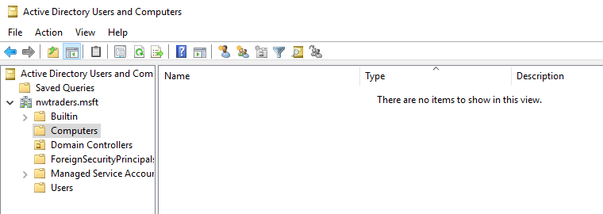
Figure 20. AD Users and Computer. Computer OU container currently empty.
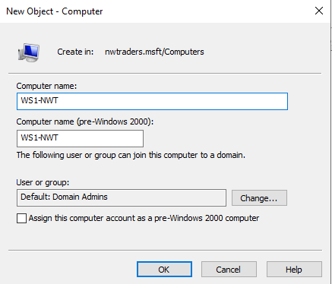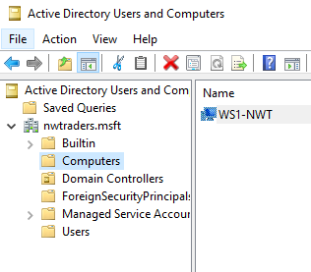
Figure 21. Computer Object Creation GUI Figure 22. Computer Object Created in OU.
To Adjoin the Windows 10 Client one device to the domain. The author firstly pre-provisions and created a computer object with a specified name within the “Computers” OU. As shown in Figure 20 the Computer OU is empty.
Much like the user creation process by right clicking on the Computers container the author is able to create a new computer object as shown in Figure 21. Once the Wizard creation process was completed the author confirms the device object has been created and is present by viewing the “Computers” container as shown in Figure 22 and confirming the device is present.
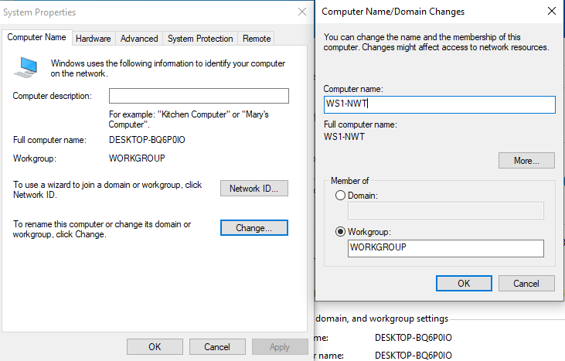
Figure 23. Windows 10 Client 1 PC Renaming.
With the provisioned computer object now in place, the author continued the process of adding the Windows 10 client to the domain by firstly renaming the device to the correct name, this was done via the “system” properties menu on the client device and selecting the “change” button and providing a new name as show in Figure 23. For this to take effect the device then required a reboot.
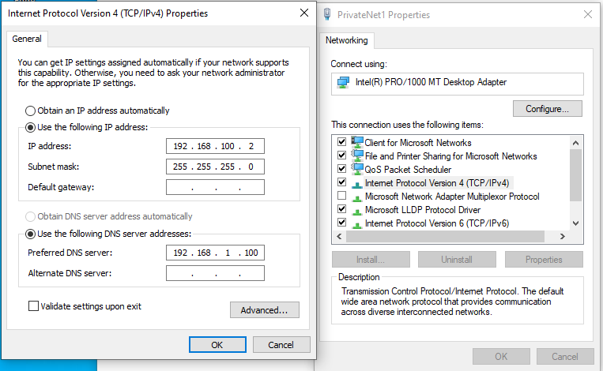
Figure 24. IPv4 Network settings DNS IP address entry.
Once the device is rebooted and back online with the correct name, the author was then tasked with adding the Windows Server 1 (Domain controller) DC1-NWT IP address to the DNS fields on the Windows 10 client PC (WS1-NWT) as shown in Figure 24. It was noted that on the worksheet the IP address was incorrect and the correct address of 192.168.1.100 was added.
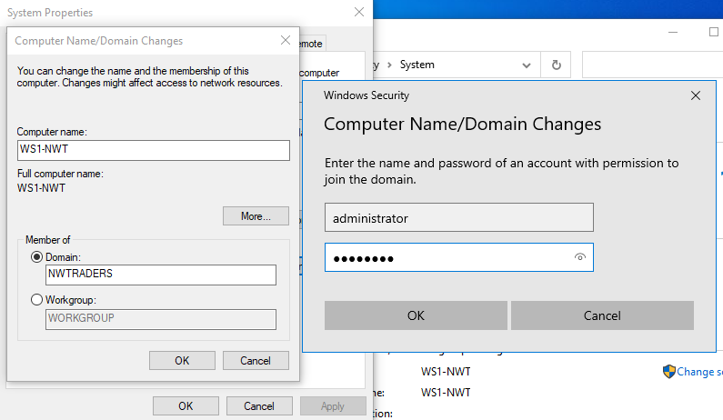
Figure 25. Windows 10 Client WS1-NWT adjoining domain.
The author is now ready to complete the adjoining of WS1-NWT to the domain since the device object has been provisioned along with the device itself being renamed in windows and provided with a DNS IP location.
As shown in Figure 25 again under the system properties control panel, the author selected the “Change” button, this directed the author to the same screen for the device name change. As this has been completed the final step is to change the “member of” section to Domain rather than workgroup.
At this point the Domain name is entered and a prompt for a domain administrator account is prompted to allow for the device to be authorised to be connected to the domain.
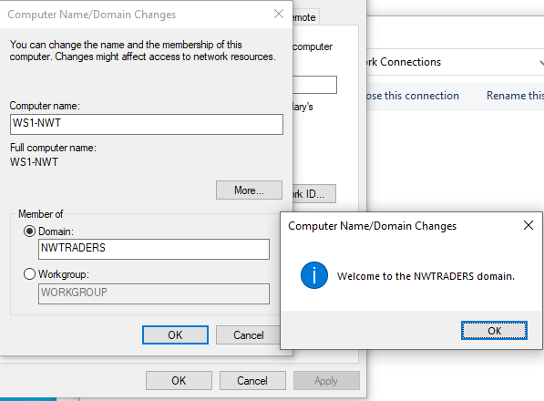
Figure 26. Confirmation of device WS1-NWT joining domain.
Following the completion of this step the device have a notification confirming the joining to the domain and will be prompted to reboot.
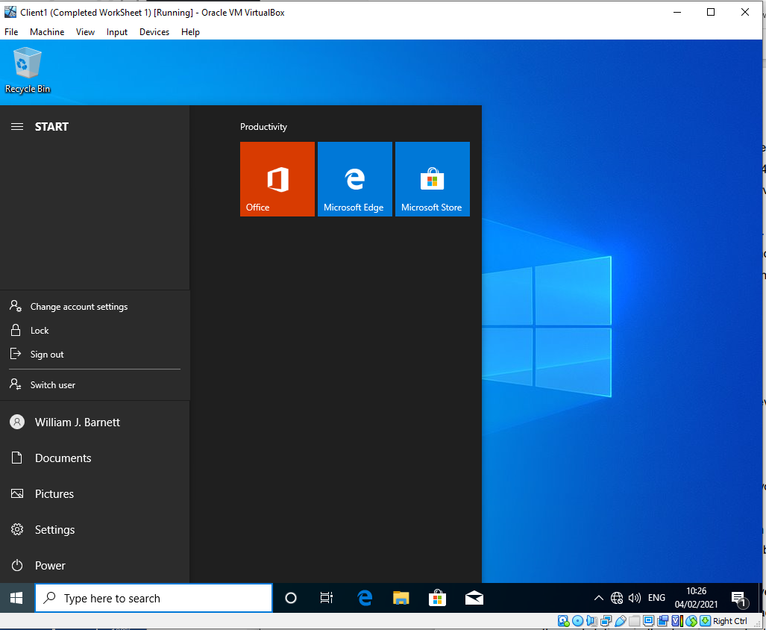
Figure 27. Login to WS1-NWT by user NWT-WJB.

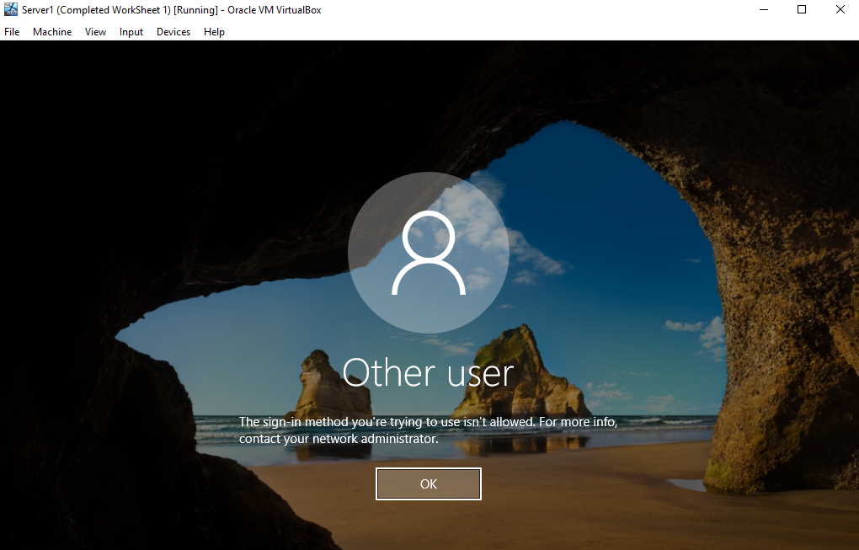
Figure 28. Attempted login to Server 1 DC1-NWT by non admin account NWT-WJB.
Once the device is rebooted the author is tasked with login in to the device with a standard non administrative account and confirming the identify. As shown in Figure 27 the user NWT-WJB has logged in to the Windows 10 client successfully.
To demonstrate that this non administrative account does not have the permission to log on to the domain controller. The author is tasked with attempting to log in with the same NWT-WJB account to the Server 1 (DC1-NWT). As shown in Figure 28 the user is presented with message stating the user account is not allowed to log in to the device. This is because only domain admin accounts are able to log in to Domain Controllers.

Part 2 – Observational Tasks/Work.

What is DNS and what is its significance within ADDS
DNS is a shortened acronym for Domain Name Systems. DNS in its most basic form is essentially a directory of names often referred to as DNS names that are then related to the devices assigned IP address, it is a bit like a telephone directory for the network. When a hostname is queried the DNS service is able to lookup the DNS and reply back with the corresponding IP address. This allows for the devices to communicate utilising the underlying network protocols.
DNS is utilised in all network types, varying from small home private networks all the way through to the likes of Google and Amazon.
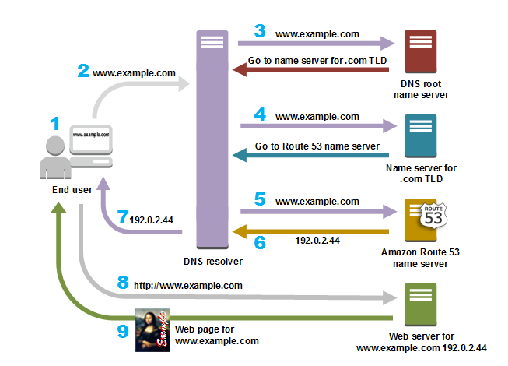
Figure 29. An example of DNS flow for communication[7].
As shown in Figure 29. This graphical flow demonstrates a very high level overview of how DNS works and its purpose. DNS[8] by nature is a hierarchical and de-centralised system. While internally on network private or business owned network DNS server are controlled by the systems administrators, for the process to work DNS inevitably communicates with other DNS services and this allow for DNS to navigate across not only private networks but the wider WAN/Internet. With this information in mind DNS is a significant part of an Active Directory Domain Services solution, as it allows for ADDS to utilise DNS to in the job of locating device objects within an AD deployment.

Brief overview of 2 critical roles within an enterprise network
Within an enterprise network, alongside AD and DNS there are other critical roles. These include but are not limited to the following two examples.
- DHCP:
DHCP Server also known as “Dynamic Host Configuration Protocol”, is a role within a corporate network that allows for automatic assignment of network configuration for endpoint devices, including but not limited to IP address, default gateway and DNS configuration.
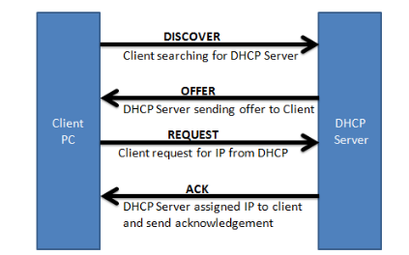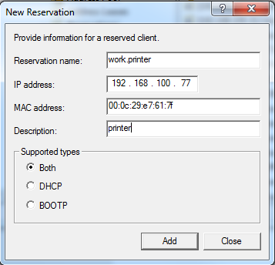
Figure 30. Client and DHCP interaction. Figure 31. DHCP Reservation example.
As shown in Figure 30 Clients looking for an IP address within a network search the network looking for DHCP serving services. Network devices such as Routers can be configured with DHCP helps to aid in the efficient discovery of DHCP services on a network, once the client discovers a DHCP server the communication between the client and server then allow for DHCP requests and acknowledgements.
On the DHCP server Pools of addresses for various scoped pools can be assigned to allow for random assignment of pre-defined pools of addressing, or the administrators can configure what is known as reservations as shown in Figure 31. These reservations are set manually to specific if a specific client with a mac address requests a DHCP address, the server will provide the pre-defined address. Essentially this is like having static addresses for end devices, but managed centrally on DHCP.
- File Services Server:
The File Services Server role within a Windows Server and ADDS environment. The File Services Server role or sometimes referred to as File and Storage Services was first made available in the Windows Server 2012 release and all subsequent release. The Role helps administrators setup and manage one or more file servers as shown in Figure 32.
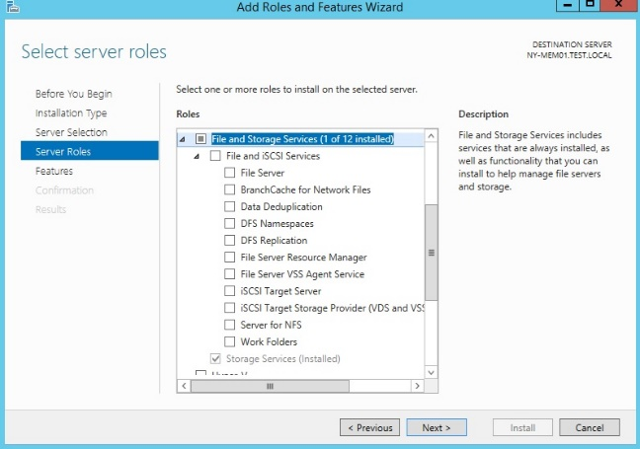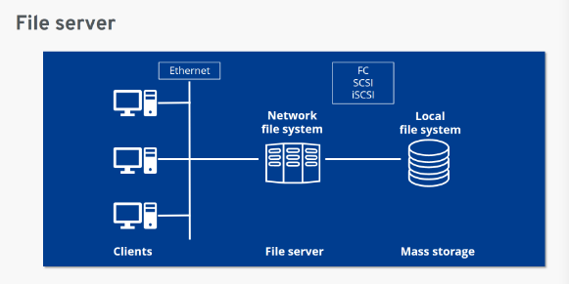
Figure 32. File and Storage Role Figure 33. File Server Network overview
The aim of these file servers is to provide central locations on the ADDS network where users are able to create and store files utilising underlying network file sharing protocols including but not limited to SMB (Server Message Block) or CIFS (Common Internet Files System) . A very high level overview is shown in Figure 33 as to the network structure and connectivity of a basic File and Storage system.
The File and Storage services allow for not only file creation and storage, but sharing of files/documents within a corporate network between the ADDS user base. These services can also be used for a number of other activities including but not limited to Application File Hosting, Web Hosting Services and backend data housing for other enterprise systems such as VHD (Virtual Hard Disk) for Virtual Server/Access systems such as ESXi or Hyper-V for example.
One other key area of File and Storage systems is that they can either be used as Backup solutions for other file store locations or provide a central housing of file hosting services[9], which can then be consolidated in a much easier fashion with other backup vendors such as Rubrik, Veeam and Veritas. In more modern deployments local file storage solutions are being utilised to provide and on premise cache/offline backup for cloud hosted storage including but not limited to Microsoft One drive for example as shown in Figure 34.
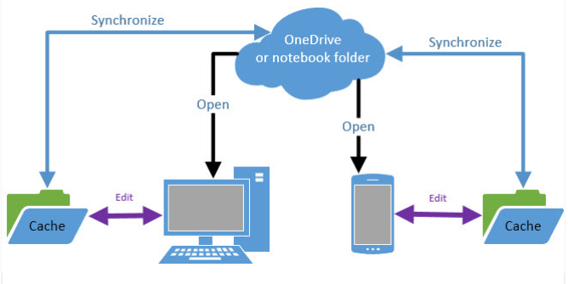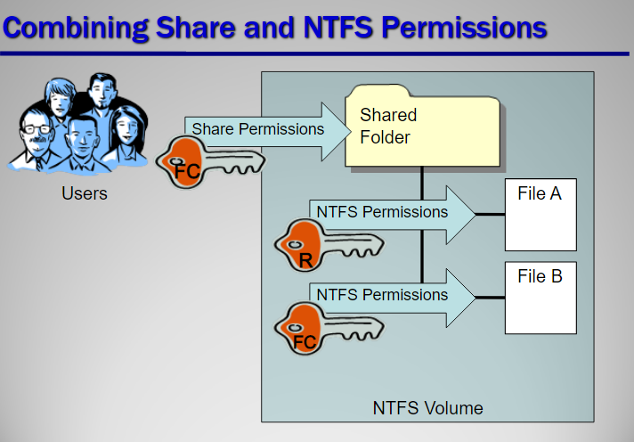
Figure 34. One Drive Cache Local File Server Figure 35. NTFS Permission overview[10]
To summarise File and Storage backup implementations allow for Pools or Folder locations to be created and shared utilising NTFS permissions for example as shown in Figure 35.and presented to the end user using DNS or IP Paths. This allows for manageable storage, backup and collaboration of files.

The Importance of levels of Access/Roles within Network Accounts
It is important to have different delegated roles for varying admin functions within g an ADDS environment. There are many default built-in network account user groups provided out of the box in a default Windows ADDS setup. As shown in Figure 36. These include but are not limited to Domain Admins, DNS admins, DHCP Admins and Enterprise Admins, these built-in roles provide a description as to their intended purposes as shown in Figure 37 but are often self-explanatory.
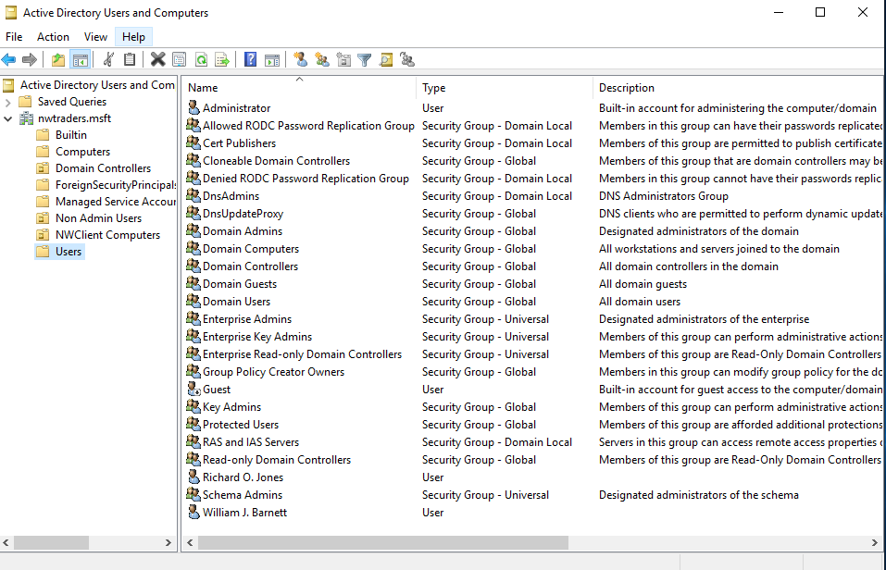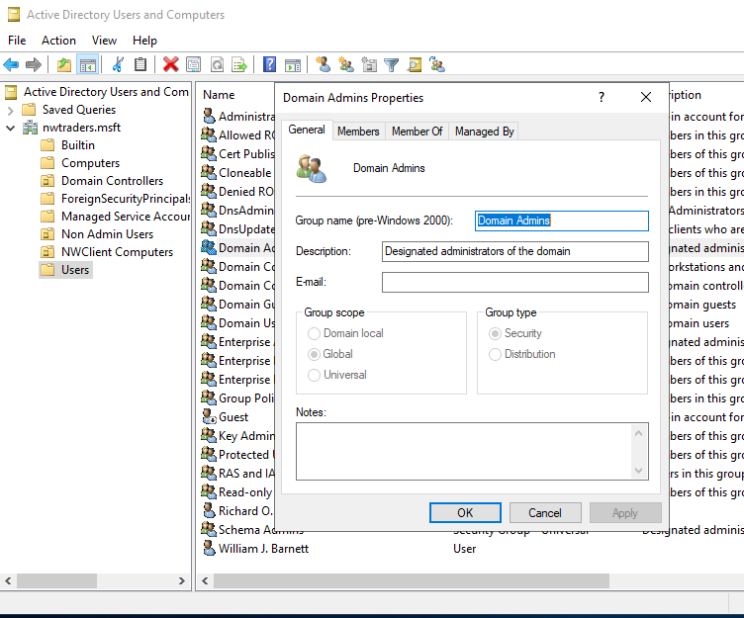
Figure 36. Built-In ADDS admin groups. Figure 37. Example of Group & associated tabs
The reasons for having these groups and also not permitting a number of users to be members of all group or all members of “domain admin”, is to prevent the ability for a single account to be compromised and then having access to all key administrative systems within the ADDS network.
For example if all ICT staff of a business are members of all of the high level Groups listed previously, but do not necessarily have the need to be. If one account is compromised by a hacker he/she would then be able to leverage that single account to gain administrative access across the business entire estate to gain access or cause larger amounts of damage.
Best practise in an ADDS environment it to allow/limit staff access to the minimum required level to allow them to operate in the role. So for example if you have a staff member or team that deal with DHCP and DNS aspects of your business, they should be limited to only those roles not only to prevent account compromise situation, but to prevent either intentional or accidental missuses of their abilities within aspects of the organisation they are not responsible for.
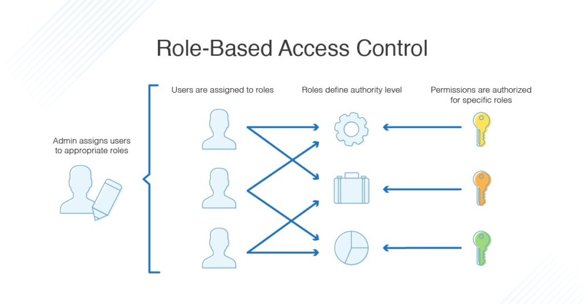
Figure 38. example of RBAC flow overview[11].
The idea of role based access in modern terminology is often referred to RBAC[12] and expands even further than the default groups provided. It is leveraged to make sure that all staff and users within an organisation only have access to the resources they require as demonstrated in Figure 38, whether this is administrative responsibilities or purely file access abilities for example.

2.4 AGDLP and AGUDLP – Perspective of implementing within a network
AGDLP known as “Accounts, Global Group, Domain Local groups, Permissions” and AGUDLP known as “Accounts, Global Group, Universal, Domain Local groups, Permissions” are a form of nesting and role based access control (RBAC) within either single domain environment (AGDLP) or multi-domain/multi forest environments (AGDULP).
The aim of AGDLP is to allow for nesting of groups within groups and providing a tiered down permissions level access approach. An example of this shown in Figure 39 demonstrated the following
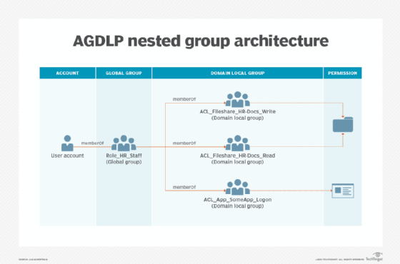
Figure 39. Example overview of AGDLP implementation[13].
- Account: This example we are demonstrating a HR Staff member, this is purely their ADDS account.
- Global Group: As a member of the HR department the staff members account is a member of a global group called “Role_HR_Staff” which will provide the staff member with a level of access deemed suitable for all HR staff regardless of their role within the department.
- Domain Local Group: In this example the staff members account has access to specific file share locations within the business, this may not be all of the file shares available and also may be limited in scope as to whether the user is able to write or read on for example. This staff member has read only access to “ACL_FileShare_HR-Docs_Read” and Write permissions to “ACL_FileShare_HR-Docs_Write”. Also included here is a permission group that allows access to a specific application for the user “ACL_App_SomeApp_Logon”
- Permissions: The Groups mentioned previously are now assigned with the set permissions needed on the specific locations. So for example the “ACL_FileShare_HR-Docs_Read” is assigned to the folder on the file share and limited to read only permissions.

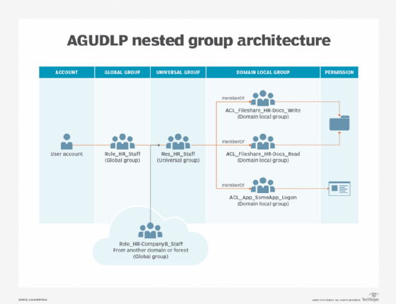
Figure 40. Example overview of AGUDLP implementation[13].
As shown in Figure 40. The addition of U “Universal” is specific to either multi domain or multi-forest environments. This is when Additional Global groups from the multi-domain/multi Forest are also utilised as part of the AGDLP flow. So in this example as well as Role_HR_Staff then having access to the nested groups to follow as shown in Figure 39 the “Role_HR_companyB_Staff” external group is also provided with the same level of access flowing down from the created universal group “Res_HR_Staff” to the remaining Domain Local groups and permission sets.
The authors personal view on AGDLP and AGDULP is that it is a recommended way to build/setup an ADDS RBAC access method design, this is because it provides the Administrators of the ADDS with the following benefits[14].
- Documented and easy to follow design when it comes to the setup and delegation of access based enumeration within a domain and its services.
- Also if the process has been carried out in a correct manner and well documented it allows for easier troubleshooting.
- Always for easy to follow delegated administration within a domain as permission can be easily assigned or removed via AD groups.
- Reduces the security risk of leaving orphaned permission entries within files shares or application share resources
- Allows for greater visibility of the entire ADDS and because the process is well documented it allows for a process flow to train staff on how permissions are delegated
- Provides Audits with a clear and concise explanation on the permission setup and access within your organisation.
One of the issues with implementing AGDLP and AGDULP comes when implementing in an existing network. The work required to clean up an existing RBAC design can be very time consuming and cause some issues, but it is worth it if possible once implemented.

References
[1] “windows 10 - How are Dell’s default computer names (DESKTOP-XXXXXX) generated? - Super User.” https://superuser.com/questions/1224430/how-are-dells-default-computer-names-desktop-xxxxxx-generated (accessed Mar. 07, 2021).
[2] “Install or Uninstall Roles, Role Services, or Features | Microsoft Docs.” https://docs.microsoft.com/en-us/windows-server/administration/server-manager/install-or-uninstall-roles-role-services-or-features (accessed Mar. 07, 2021).
[3] “What Is a Domain Controller, and Why Would I Need It?” https://www.parallels.com/blogs/ras/domain-controller/ (accessed Mar. 07, 2021).
[4] “Windows Server 2016 Functional Levels | Microsoft Docs.” https://docs.microsoft.com/en-us/windows-server/identity/ad-ds/active-directory-functional-levels (accessed Mar. 07, 2021).
[5] “What is Directory Services Restore Mode (DSRM)? - Definition from WhatIs.com.” https://searchwindowsserver.techtarget.com/definition/Directory-Services-Restore-Mode-DSRM (accessed Mar. 07, 2021).
[6] “Security Watch: Windows Domain Password Policies | Microsoft Docs.” https://docs.microsoft.com/en-us/previous-versions/technet-magazine/cc137749(v=msdn.10)?redirectedfrom=MSDN (accessed Mar. 07, 2021).
[7] “What is DNS? – Introduction to DNS - AWS.” https://aws.amazon.com/route53/what-is-dns/ (accessed Mar. 08, 2021).
[8] “What is DNS and how does it work? | Network World.” https://www.networkworld.com/article/3268449/what-is-dns-and-how-does-it-work.html (accessed Mar. 08, 2021).
[9] “File Server | What is a file server and how does it work? - IONOS.” https://www.ionos.co.uk/digitalguide/server/know-how/file-server/ (accessed Mar. 11, 2021).
[10] “Sharing Resources Lesson 6. Objectives Manage NTFS and share permissions Determine effective permissions Configure Windows printing. - ppt download.” https://slideplayer.com/slide/6537756/ (accessed Mar. 11, 2021).
[11] “RBAC vs. ABAC Access Control: What’s the Difference? - DNSstuff.” https://www.dnsstuff.com/rbac-vs-abac-access-control (accessed Mar. 11, 2021).
[12] “What is Role-Based Access Control (RBAC)? Examples, Benefits, and More | Digital Guardian.” https://digitalguardian.com/blog/what-role-based-access-control-rbac-examples-benefits-and-more (accessed Mar. 11, 2021).
[13] “Active Directory nesting groups strategy and implementation.” https://searchwindowsserver.techtarget.com/tip/Active-Directory-nesting-groups-strategy-and-implementation (accessed Mar. 11, 2021).
[14] “AGDLP | tenfold.” https://www.tenfold-security.com/en/wiki/agdlp/ (accessed Mar. 11, 2021).

