Ionut Marius Rosu (1910143)
architecture student uwtsd | 1910143@STUDEnt.uwtsd.ac.uk
Architecture in your hometown

For the following essay, I have chosen to compare the Saint David`s Church and the Church of Saint Cattwg, both located in Neath, Port Talbot. This comparison will be made using the following structure:
- Context and historical background
- Plan and Section
- Materials and Light
- Use
- Conclusion

1.Context and historical background
Saint David`s Church (Coflein.gov.uk, 2020) (Cadwpublic-api.azurewebsites.net, 2020) is located near Victoria Gardens Park at the junction of St. David`s Street and Orchard Street, in the heart of Neath town centre. This makes it a landmark of Neath (Parishofneath.org, 2020) and probably the most salient church in town. The design is credited to John Norton (Parishofneath.org, 2020) who used 13th C French Gothic style (Coflein.gov.uk, 2020). Construction took place between 1864-1866 on a land donated by Howell Gwyn (Cadwpublic-api.azurewebsites.net, 2020). 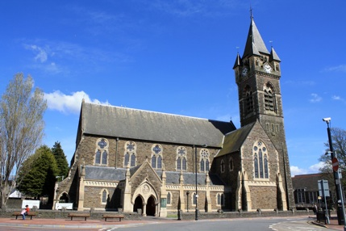
St. David`s Church. Source: (Parishofneath.org, 2020)

In contrast , the Church of Saint Cattwg (Cadwpublic-api.azurewebsites.net, 2020) is located at the edge of Neath town on the S-E side of Church Road, in the locality of Cadoxton-Juxta-Neath, on the bank of Tennant Canal . It is said that the founder is Adam of Carmarthen, Abbot of Neath in late 13th Century. Much of the church was restored and enlarged in 19th C. This includes an addition of a N aisle between 1843-1844 by William Richards of Swansea. More work took place between c1871-1881 which included the N arcade, chancel arch and N-E organ chamber. 1897 saw the restoration of west tower by C.B. Fowler, and an altar and font were added in 1909 by Arthur Grove.
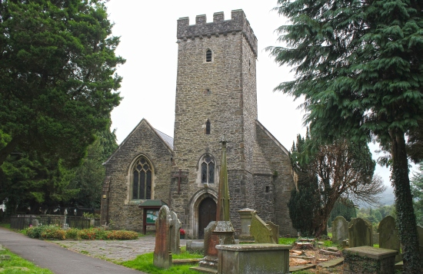
Church of St. Cattwg. Source: (Spanglefish.com, 2020)
2. Plan and Section
Saint David`s Church has a roman basilica plan, with an E-W orientation. The plan (Parishofneath.org, 2020) includes a Nave (2) , High Altar (3), a choir vestry extension (4), Chancel (5), Sanctuary (6), a Lady Chapel (7) and a tower (8). Entrance is made through the South Porch (1) towards the E-W facing Nave. A series of arches with a column base guide you through the Nave, towards the Chancel. On the north side of the Chancel , you can find the choir vestry extension and opposite that, resides the Lady Chapel. The eastern extremity is defined by a circular shaped Sanctuary.
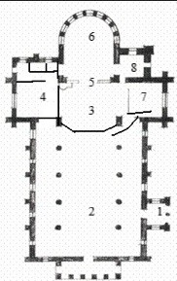Plan of St. David`s Churh. Source : (Parishofneath.org, 2020)
In section (Cadwpublic-api.azurewebsites.net, 2020) the west porch is characterized by the use of stepped buttresses and a open cusped arcade. South elevation shows a gabled porch with a double pointed decorated gothic arch doorway (a mouchete with the figure of St. David above them) ,clasping buttresses, tracery windows. An imposing tower adds lancet arches , louvered archways and a clock.
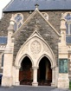 Entrance to St. David`s Church. Source: (Parishofneath.org, 2020)

Having a Norman period plan, the Church of Saint Cattwg has a different layout. The plan (Cadwpublic-api.azurewebsites.net, 2020) includes a west tower, Nave, Chancel and the later addition of the north aisle.
Entrance is made through the west tower via a single Decorated Gothic style arch ( encapsulating a double door). The Nave exhibits a barrel-vaulted ceiling that guides you towards the Chancel. The Chancel is divided from the Nave by a large Decorated Gothic style arch. North side of the Nave, shows the later added aisle. The division of the two is made with a series of Decorated Gothic style arches, supported by a column base.
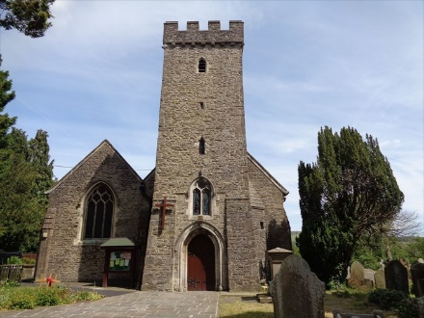
Entrance of St. Cattwg Church. Source: (Waymarking.com, 2020)

In section, (Cadwpublic-api.azurewebsites.net, 2020)the west elevation displays the tower, with a heavy base and a double lancet arch window just above the door. Another two lancet arch windows can be seen on the face of the tower. To the left, a triple lancet arch window luminates the N aisle. This window is encapsulated in a Decorated Gothic plastered arch. North side has Decorated Gothic Style arches that encapsulate stained glass windows and buttresses. Except for a raised plinth in the south elevation, the church doesn’t show any notable differences in style from the rest.
3. Materials and Light
St. David`s Church (Coflein.gov.uk, 2020) is made of snecked bull-nosed, red sandstone bands and freestone dressings, steep- gabled slate roofs, over-sailing eaves, gable parapets and ironwork cross finials. Facing of the interior is obtained using red brick with broad embellishing bands of blue brick diaper work and freestone dressing. The tiled floor leads you towards brass separated sanctuary.
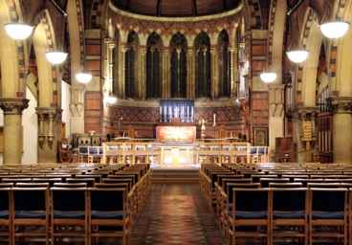
St. David`s Church interior. Source: (Parishofneath.org, 2020)
Stone is used because of it`s durability but the alternating colours give a warm feeling , given the fact that this is a place of worship and peace.

St. Catwg Church (Cadwpublic-api.azurewebsites.net, 2020) is made with rubble stone, tooled stone, and with slate roofs.
Rubble stone was easy to source, tooled stone was needed for the buttresses and the slated roof provides a better protection and durability.
The inside (Cadwpublic-api.azurewebsites.net, 2020) is made using a restored late medieval panelled barrel vault, timber screens with leaded glazing. Nave floor uses cream tiles, and the Chancel has patterned tile flooring and brass altar rails. Throughout the church, we find ashlar, white limestone, alabaster, painted wood, marble, gothic oak panelling.
All this elements and additions show a contradiction between the desire of keeping the original style, and the desire of outdoing the previous builder.
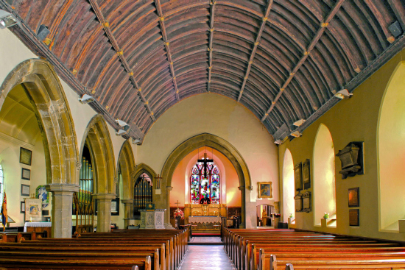
St. Cattwg Church interior. Source: (Spanglefish.com, 2020)

4. Use
St. David`s Church (Parishofneath.org, 2020) is used for regular worship, concerts, public events and as a Sunday school. The private zones are the Altar and the choir vestry. The Lady Chapel is used as a quiet prayer zone. The layout allows for an easy flow circular of people.
St. Catwg Church is purely a place of worship, with a private zone in the Altar. Flow of circulation is similar with St. David`s Church.
- Conclusion
I learned that even though St. Catwg Church is less imposing, it`s history spans for more than 8 centuries. Background research is vital in the study of old buildings, because of the multitude of styles applied to them and the fact that you cannot date them based on just what you see. When I first learned about the architectural styles over the centuries , I always thought that St. David`s Church was first built during the Gothic period. After my research I was surprised to find out that it is a relatively recent building, with less history behind it.
In the future , on similar project, I would try to get access to historical archives, because the information from there can give you other perspectives.

Bibliography:
Cadwpublic-api.azurewebsites.net. (2020). Listed Buildings - Full Report - HeritageBill Cadw Assets - Reports. [online] Available at: https://cadwpublic-api.azurewebsites.net/reports/listedbuilding/FullReport?lang=&id=11818 [Accessed 18 Jan. 2020].
Cadwpublic-api.azurewebsites.net. (2020). Listed Buildings - Full Report - HeritageBill Cadw Assets - Reports. [online] Available at: https://cadwpublic-api.azurewebsites.net/reports/listedbuilding/FullReport?lang=&id=11767 [Accessed 18 Jan. 2020].
Spanglefish.com. (2020). NEATH GUARDIAN | 27 St Catwgs Church. [online] Available at: http://www.spanglefish.com/neathguardian/index.asp?pageid=507665 [Accessed 18 Jan. 2020].
Coflein.gov.uk. (2020). ST DAVID'S CHURCH, NEATH | Coflein. [online] Available at: https://coflein.gov.uk/en/site/156/details/st-davids-church-neath [Accessed 18 Jan. 2020].
Parishofneath.org. (2020). St. David. [online] Available at: http://www.parishofneath.org/St._David.html [Accessed 18 Jan. 2020].
Waymarking.com. (2020). St Catwgs Church - Cadoxton-juxta-Neath, Wales. Image. [online] Available at: https://www.waymarking.com/gallery/image.aspx?f=1&guid=35d83932-d135-467b-b5ff-cd8cf613c286&gid=3 [Accessed 19 Jan. 2020].

