

My Action Plan: From Reflection to Action

Purpose
You will identify one realistic academic, professional and personal goal, consider potential barriers, identify sources of support and commit to your first action.

Part 1 – My Destination
Imagine it is the end of the academic year. Looking back, what would make you think...
"This has been a successful year."
Write one goal in each area (examples provided below)
Academic | Professional | Personal
What would I like to achieve? | What experience or opportunity would I like? | What habit or personal achievement would improve my university experience?
Examples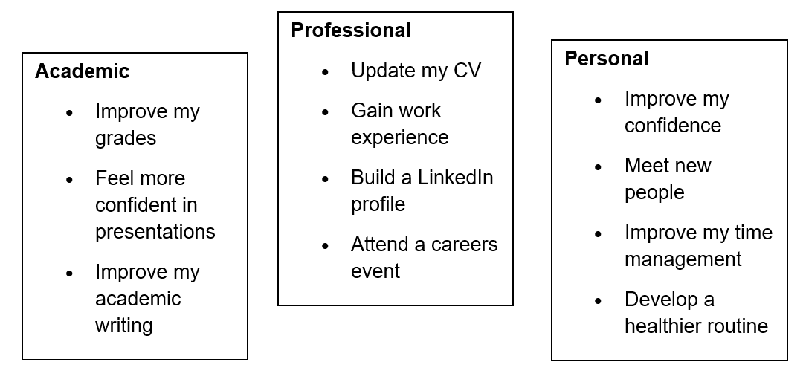

Part 2 – Reality Check
Choose one goal that is most important.
Complete the table.
My Goal | What might stop me? | What could help me?

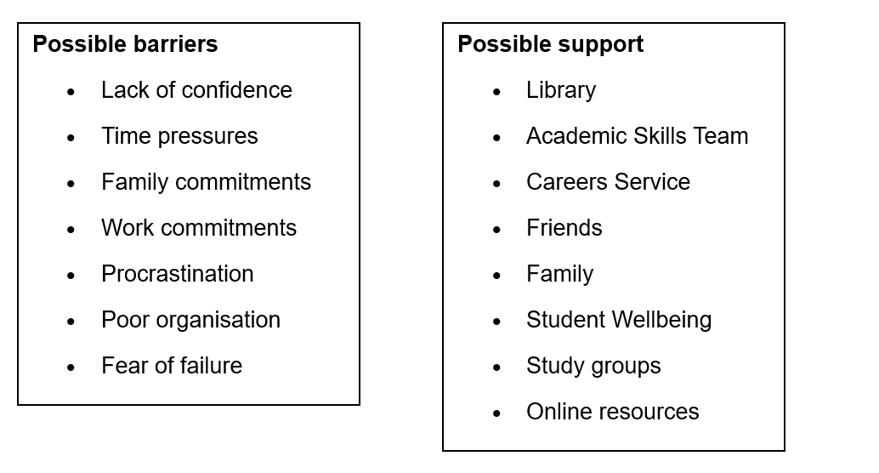
Remember to think realistically rather than ideally.

Part 3 – Turning Goals into Actions
A goal without an action is simply a wish.
Complete:
My Goal | My First Step | When will I do it?

Examples


